Leadership, Governance and Systems Thinking in Health and Social Care:
A Case Report on the Lewis Blackman Story and the Transformation of
Post-Operative Patient Safety at the Medical University of South Carolina

Assignment Title: Case Study Analysis Report
Module Code and Title: LCHS7002
Lecturer's Name: Dr Pascal Navelle
Student Name: Priyanka Thokala
Student Number: 2530797

Leadership, Governance and Systems Thinking in Health and Social Care: A Case Report on the Lewis Blackman Story and the Transformation of Post-Operative Patient Safety at the Medical University of South Carolina

Introduction

Background and Purpose of the Case Study
In November 2000, Lewis Blackman, an otherwise healthy fifteen-year-old boy, died four days after routine elective surgery at the Medical University of South Carolina (MUSC). He had undergone a minimally invasive procedure to correct pectus excavatum, a congenital chest-wall deformity, marketed as safer than the traditional open operation (Post and Courier, 2016). Lewis did not die from the operation itself; he died because a preventable post-operative complication, a perforated ulcer caused by the analgesic ketorolac, was not recognised or escalated in time, despite his mother, Helen Haskell, repeatedly asking staff to contact a senior physician (QSEN, 2023). This case, now taught internationally as "The Lewis Blackman Story", is the chosen case study of a transformation within a health and social care organisation.

What Leadership Means in Health and Social Care
Leadership in health and social care can be defined as the process of influencing individuals and teams, whether through formal authority or informal example, so that they work towards shared goals of safe, high-quality, person-centred care (West et al., 2014). It is distinct from management in that it is concerned less with control of resources and more with vision, culture and the mobilisation of people around a common purpose, particularly during periods of uncertainty, crisis or change.

Centralisation, Decentralisation and Leadership Theories
Centralisation refers to a structure in which authority is concentrated at a small number of senior points, while decentralisation distributes authority across many actors closer to the point of care (Sreeramareddy and Sathyanarayana, 2019). Both carry implications for how quickly a deteriorating situation can be escalated to someone able to act. Leadership theory offers further lenses: transformational leadership emphasises vision and the reshaping of culture (Bass, 1985; Burns, 1978); transactional leadership relies on routine exchange, supervision and compliance with existing rules (Bass, 1985); and situational leadership argues that style should depend on followers' competence and confidence and the demands of the task (Hersey and Blanchard, 1969).

Why Leadership Style Matters in Change and Crisis
Selecting the right leadership style matters enormously in change and crisis situations. A purely transactional, command-and-control style may suit routine care but can fail when a situation escalates and no one with authority is present to reassess the plan. A purely transformational style with no operational structure behind it cannot alone guarantee a deteriorating patient is seen quickly. The Lewis Blackman case shows both failure modes together: a rigidly centralised, transactional clinical hierarchy at the point of care, followed by a transformational, externally-driven change process led by a bereaved parent turned patient-safety advocate.

Structure of This Report
This report addresses, in turn: the problem and its wider systemic and global context, using systems thinking, a rich picture and CATWOE analysis; whether MUSC's ward-level structure was centralised or decentralised; the leadership theories most relevant to the failure and the reform that followed; the lessons learned and evidence base for the resulting improvements, principally the Lewis Blackman Hospital Patient Safety Act 2005; and practical recommendations and concluding reflections on leadership, governance and systems thinking.

Main Body and Analysis

a. Identifying the Problem and Setting the System Context- Applying Systems Thinking and the Rich Picture

The Central Problem
The central problem in this case study is straightforward to state but complex in its causes: a clinically stable fifteen-year-old boy developed a recognisable, survivable surgical complication and died because the people around him did not, or could not, escalate their concerns to someone able to intervene in time. Over roughly fourteen hours, Lewis's abdominal pain worsened, his heart rate climbed, his abdomen distended, and he became progressively paler and weaker; these were treated by nursing and junior medical staff as normal post-operative discomfort and constipation rather than signs of internal bleeding (123 Help Me, 2013; TopEssayWriting, 2022). His mother asked several times to speak to an experienced doctor and was not able to do so until Lewis collapsed at noon the next day; a code was called, and he was pronounced dead just over an hour later, having lost a fatal volume of blood from a perforated stress ulcer (Monk, 2002, cited in 123 Help Me, 2013). MUSC subsequently acknowledged that a chain of negligent acts by inexperienced staff contributed to his death (Post and Courier, 2016).

Global and National Statistical Context
A single death, however tragic, only qualifies as a "system" problem worth this level of analysis if it is representative of a wider pattern rather than an isolated accident, and national and global statistics confirm that it is. In the United States, the Institute of Medicine's landmark 1999 report, To Err Is Human, estimated that between 44,000 and 98,000 patients died every year in American hospitals because of preventable medical error, a toll exceeding deaths from road traffic accidents or breast cancer at the time (Kohn, Corrigan and Donaldson, 2000; Institute of Medicine, 1999); a later 2013 re-analysis in the Journal of Patient Safety put the figure over 200,000 (ProPublica, 2020). At a global level, the World Health Organization's first Global Patient Safety Report found that roughly one in ten patients is harmed while receiving hospital care, that around half of this harm is preventable, and that unsafe care contributes to more than three million deaths annually worldwide, with the greatest burden falling on low- and middle-income countries (World Health Organization, 2024); a related synthesis in Frontiers in Public Health estimated approximately 134 million adverse events occurring in hospitals each year globally, with around 2.6 million associated deaths (Frontiers in Public Health, 2025).
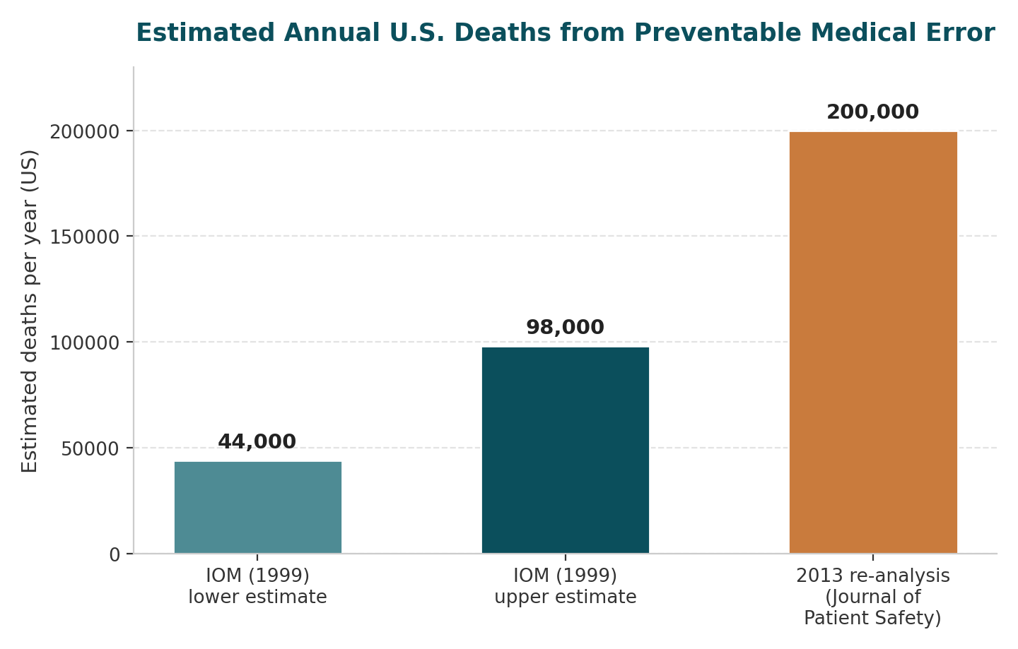
Figure 2: Estimated annual U.S. deaths attributable to preventable medical error, comparing the Institute of Medicine's 1999 range with the 2013 Journal of Patient Safety re-analysis (Institute of Medicine, 1999; Kohn, Corrigan and Donaldson, 2000; ProPublica, 2020).
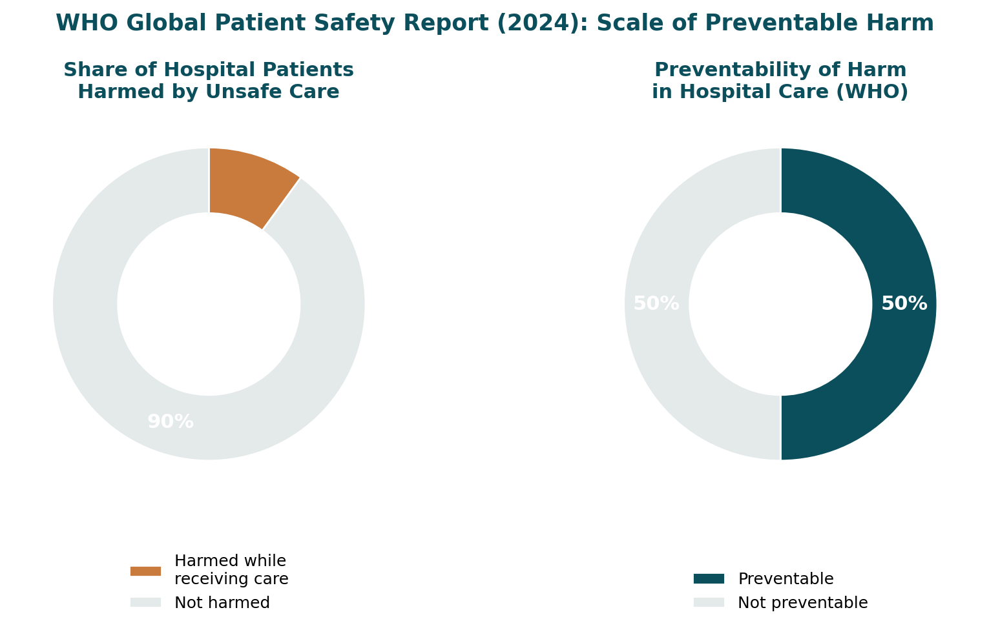
Figure 3: Proportion of hospital patients harmed by unsafe care and the proportion of that harm judged preventable, per the WHO Global Patient Safety Report 2024 (World Health Organization, 2024).
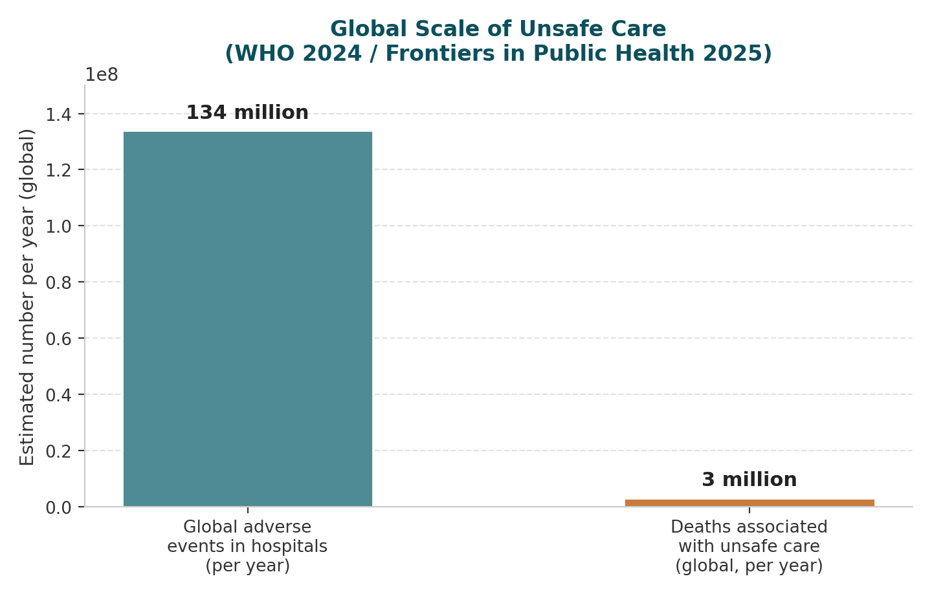
Figure 4: Global scale of unsafe hospital care, showing estimated annual adverse events and associated deaths worldwide (World Health Organization, 2024; Frontiers in Public Health, 2025).

Failure to Rescue: International Patient Safety Frameworks
This specific pattern, a patient whose deterioration is missed until it becomes a crisis, is formally known in the patient safety literature as "failure to rescue": the failure or delay in recognising and responding to a hospitalised patient who is deteriorating (AHRQ, 2024). The Institute for Healthcare Improvement's Global Trigger Tool methodology, and the broader "afferent-efferent limb" model of rapid response systems used by the Agency for Healthcare Research and Quality, were both developed specifically because failure-to-rescue events of the type that killed Lewis Blackman were found to be common and systemic rather than the result of one negligent individual (AHRQ, 2024).

Systemic Weaknesses: Communication, Accountability and Leadership
Locating the problem within Checkland's (1981) tradition of systems thinking helps explain why. Soft Systems Methodology argues that complex, "messy", human-centred problems such as a missed clinical deterioration cannot be understood by isolating a single faulty component, but as the product of interacting people, processes, information flows and structures (Checkland and Scholes, 1990). Systemic weaknesses evident here include a communication structure in which family concerns had to pass through several layers of staff before reaching a senior decision-maker; an accountability structure in which it was unclear to the family, and arguably to some staff, who was actually "in charge" of Lewis's care, since attending physicians could change and trainees were heavily involved without always being clearly identified (South Carolina Legislature, 2005); and a leadership structure in which inexperienced junior staff were not adequately supervised to escalate an ambiguous but worsening picture.

Levels of Governance and Underlying Challenges
The governance level implicated spans all three tiers used in health systems analysis. Locally, ward staff lacked a standardised early-warning tool or escalation protocol. Organisationally, MUSC had not, prior to 2000, established any patient- or family-activated emergency response mechanism, relying on staff-initiated escalation alone. At state and national level, South Carolina had no statutory requirement for such a mechanism until the 2005 Act (South Carolina Legislature, 2005), and it was not until 2009 that The Joint Commission made rapid response access a National Patient Safety Goal (Knight, 2022). Underlying challenges included heavy reliance on inexperienced residents for frontline monitoring, unclear differentiation of staff roles to families, and no formalised audit of "near miss" escalation failures prior to Lewis's death.

Underlying Challenges: Statistical Evidence
Underlying challenges of the kind identified above are also measurable at scale rather than anecdotal. Workforce data show the problem is structural: the World Health Organization's State of the World's Nursing 2025 report estimates a persisting global nursing shortfall of 5.8 million in 2023, projected to fall to only 4.1 million by 2030 even under optimistic assumptions (World Health Organization, 2025), while 87% of United States healthcare providers identify staffing shortages as their single biggest operational challenge (Deloitte, 2024). This links directly to patient safety outcomes: Aiken et al.’s (2002) landmark study of surgical patients, the same patient group as Lewis Blackman, found that each additional patient added to a nurse’s workload increased the odds of 30-day mortality and failure-to-rescue by approximately 7%. Budget constraints compound this cycle: the OECD estimates that treating patients harmed by unsafe care already consumes 13–15% of hospital expenditure in developed countries, resources that could otherwise fund the staffing levels needed to prevent such harm (Slawomirski, Auraaen and Klazinga, 2017).

The Rich Picture: Visualising the System
A rich picture, in the Checkland tradition, is used here to visualise how these people, processes and structures interacted (see Figure 1). It depicts the patient and his mother on one side, repeatedly attempting to trigger an escalation; a chain of nursing staff, resident physicians, an on-call covering physician who was not the primary surgeon, and an off-site attending surgeon on the other side, each a potential but unrealised point of intervention; and hospital administration and governance sitting above the clinical chain, influencing but not directly present in it. The picture highlights three critical feedback gaps: a communication gap between family and senior clinicians, a diffusion of responsibility among successive junior staff who each assumed someone else would escalate, and a hierarchy bottleneck in which the only clearly defined route to senior clinical authority ran through people who were themselves too junior, too busy or too far away to use it quickly. These gaps, rather than any single clinical error, are what the subsequent legislative and organisational reforms specifically targeted.
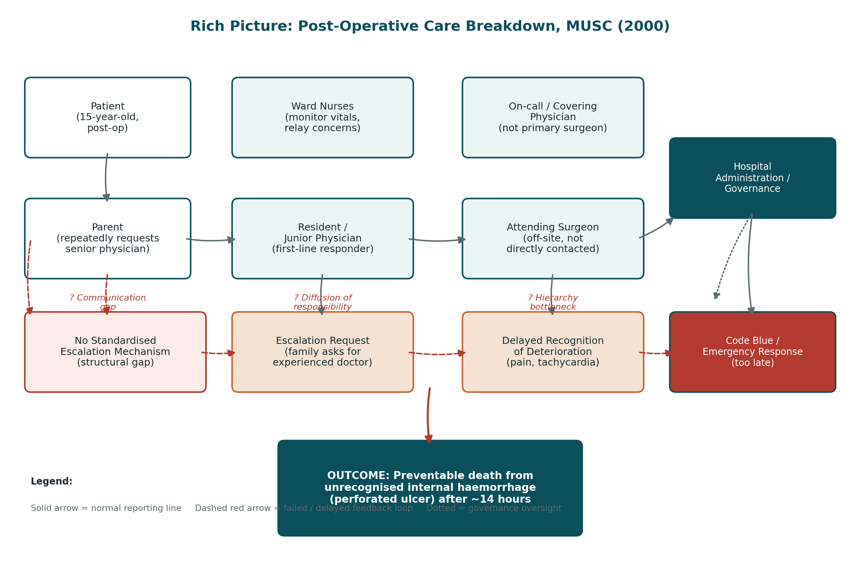
Figure 1: Rich Picture of the post-operative care system at MUSC, 2000, showing actors, escalation processes and the communication, responsibility and hierarchy gaps that contributed to the failure to rescue Lewis Blackman.

CATWOE Analysis
A brief CATWOE analysis (Checkland and Scholes, 1990) sharpens this systemic view. The Customers, directly affected by the system, were Lewis and his family. The Actors carrying out the process were the ward nurses, resident physicians, the on-call covering physician and the attending surgeon. The Transformation sought was converting a reactive, hierarchy-dependent system of post-operative monitoring into a proactive, multiply-triggered system capable of recognising and escalating deterioration quickly regardless of who was on duty. The Worldview of the pre-2000 system was that appropriately trained junior staff, following standard orders, would recognise and escalate genuine emergencies, and that family concern about "normal" post-operative pain did not, by itself, warrant senior review. The Owners, with power to change or abolish the system, were MUSC's hospital administration and, ultimately, the South Carolina state legislature. The Environmental constraints included residency staffing structures, a prevailing culture of hierarchical deference, and, until 2005, the absence of any external regulatory requirement to do things differently. This demonstrates that the "problem" was never simply a single missed diagnosis; it was a designed system never required, or resourced, to catch the specific type of failure that killed Lewis Blackman.

b. Centralisation or Decentralisation within the Case Study

Centralised Decision-Making at MUSC
MUSC's post-operative ward in 2000 operated, in practice, as a centralised clinical decision-making system. Authority to change Lewis's care plan or escalate beyond routine post-operative management rested with a small number of senior clinicians: principally the attending surgeon and, in his absence, an on-call covering physician. Information had to travel upward, step by step, from bedside nursing observation through resident physicians, before it could reach someone with the authority to change course (South Carolina Legislature, 2005). A clear example is the family's repeated, unsuccessful attempts to speak directly to an experienced physician: there was no formal right of access that guaranteed this, and requests were filtered through whichever junior staff member happened to be available.

Advantages and Disadvantages of Centralisation
Centralised structures are generally argued to offer consistency of clinical decision-making, since fewer experienced decision-makers apply a more uniform standard of judgement, and clearer nominal accountability, since responsibility formally sits with a named attending physician (Frontiers in Health Services, 2025). In this case, however, these advantages did not materialise: the attending surgeon was not physically present, and the "clear line of accountability" was not visible or accessible to the patient and his family. The disadvantages of centralisation are well documented: it can create bottlenecks when the central decision-maker is unavailable, weaken the use of frontline knowledge, and produce a mismatch between formal accountability and actual, moment-to-moment decision-making capacity (Sreeramareddy and Sathyanarayana, 2019). All three are directly evidenced here: the surgeon's unavailability created exactly the bottleneck the literature warns about, and the nursing staff closest to Lewis had no formal authority to trigger an emergency response themselves.

Decentralised Systems: The Family-Activation Model
Decentralised systems, by contrast, distribute authority to escalate across a wider range of actors, including, in the reformed post-2005 system, patients and families themselves. Authority is not concentrated in a single named senior clinician but is instead granted, for specific safety-critical triggers, to whoever is closest to the emerging problem. A clear example is the "family activation" or patient-activated rapid response mechanism mandated by the Lewis Blackman Hospital Patient Safety Act of 2005, requiring South Carolina hospitals to provide a mechanism, available at all times, through which a patient or family member who believed a patient was deteriorating could summon help directly, bypassing the ordinary chain of command if necessary (Knight, 2022; South Carolina Legislature, 2005). The Act's badge-identification requirement further decentralised information, giving families the knowledge to identify who held the seniority to make a clinical decision, and the explicit right to speak to the attending physician directly (South Carolina Legislature, 2005).

Advantages and Disadvantages of Decentralisation
The advantages of this shift are considerable. A stronger link between decision-makers and service users tends to improve accountability and responsiveness (Frontiers in Health Services, 2025); decentralised decision-making makes better use of the knowledge held by those closest to the patient, whether a bedside nurse or, here, a family member who had spent days observing Lewis and knew something was wrong (Sreeramareddy and Sathyanarayana, 2019). Decentralisation is not a panacea, however: the Cochrane review by Sreeramareddy and Sathyanarayana (2019) and the World Health Organization's European Observatory both note that decentralised decision-making without proper coordination risks fragmentation and over-triggering, which is why effective family-activation systems are typically layered onto, rather than instead of, centrally agreed clinical protocols.

Critical Analysis: Comparing the Two Structures
A critical comparison of MUSC's system structure before and after 2000 shows that the purely centralised model hindered crisis management, decision-making and accountability. It hindered crisis management because there was no mechanism to bypass an unavailable decision-maker in an emergency; it hindered decision-making because information about Lewis's deterioration had to survive several rounds of subjective interpretation by junior staff before reaching someone empowered to act; and it hindered accountability because, with role identification not mandatory and the attending physician liable to change without clear notice, it was genuinely difficult for the family, and arguably for some staff, to know who was accountable at any given moment. Numerical evidence on the decentralised, patient-activated model that followed reinforces this conclusion. A systematic review and meta-analysis by Solomon et al. (2016) of rapid response team implementation found a pooled risk ratio for in-hospital mortality of 0.85 and for cardiac arrest of 0.65, indicating a meaningful reduction in both outcomes. A subsequent review in the Journal of Patient Safety similarly found moderate evidence linking rapid response teams to decreased non-ICU cardiac arrest and hospital mortality, though benefits take time to be realised as safety culture changes (Journal of Patient Safety, 2020). This supports the conclusion that decentralising, or at minimum broadening, the authority to trigger an escalation was a proportionate and effective response to the systemic weakness that caused Lewis Blackman's death.

c. Leadership Theories and Application to the Case Study

Overview of Relevant Leadership Theories
Three leadership theories are of particular relevance to this case study: transactional leadership, situational leadership, and transformational leadership.

Transactional Leadership
Transactional leadership, as described by Bass (1985), is built on structured exchange: leaders set clear expectations, monitor performance against standards, and reward compliance or correct deviation, largely through existing rules and hierarchy. This theory helps explain the ward-level leadership style operating around Lewis Blackman in the hours before his death. Post-operative care was governed by standard orders and a hierarchical reporting structure in which junior staff were expected to follow protocol and refer upward only when a situation clearly exceeded that protocol. This is a transactional model of leadership applied to clinical supervision: compliance-based, rule-bound and reactive rather than adaptive. The data available on outcomes at MUSC around this period, most directly the hospital's own subsequent admission of a "chain of negligent acts by inexperienced staff" (Post and Courier, 2016), indicates that this transactional structure did not equip junior staff with the confidence, authority or support to depart from the standard script when Lewis's presentation began to fall outside it.

Situational Leadership
Situational leadership, developed by Hersey and Blanchard (1969), argues that effective leaders adapt their style to the competence and confidence of those they are leading and to the demands of the specific task at hand: a highly directive, "telling" style is appropriate when followers are inexperienced and the task is high-stakes, while a more delegating style suits experienced, confident followers. Applied to this case, the residents and junior physicians managing Lewis's care were, by the hospital's own account, relatively inexperienced (Post and Courier, 2016), facing an atypical, high-acuity, low-frequency situation, precisely the combination for which situational leadership theory would recommend a directive style with close senior support. In practice, the senior, more experienced clinicians were not present to provide that directive support until after Lewis had already collapsed, at which point the response, a code call and resuscitation attempt led by Dr Adamson, was necessarily reactive and command-driven rather than proactive (123 Help Me, 2013). This is a clear example of leadership style being mismatched to the situation, not because any individual chose the wrong style deliberately, but because the system did not ensure that a senior, directive presence was available at the moment the task demanded it.

Transformational Leadership
Transformational leadership, by contrast, is concerned with inspiring a shared vision, challenging existing assumptions and building the emotional and cultural commitment needed to sustain lasting change (Burns, 1978; Bass, 1985; Bass and Avolio, 1994). This theory is most useful for understanding the period after Lewis's death. Helen Haskell's advocacy, culminating in the Lewis Blackman Hospital Patient Safety Act, MUSC's establishment of a Chair of Clinical Effectiveness and Patient Safety in Lewis's name, and the opening of a hospital simulation centre for rapid-response training, together constitute a transformational leadership process: a vision of a fundamentally safer system was articulated, stakeholders across clinical, administrative and legislative domains were mobilised around it, and the underlying culture and assumptions of the organisation, not merely its written protocols, were challenged and reshaped (Post and Courier, 2016; Patient Safety Action Network, n.d.). Dr Jerry Reves, dean of MUSC's College of Medicine, captured this transformational reframing directly, describing the case as evidence that "systems can be reviewed and improved" even though human error can never be entirely eliminated (Post and Courier, 2016).

Linking Theory, Examples and Evidence
Considering the three points suggested for critical analysis: first, the theories most relevant are transactional leadership (explaining the pre-2000 failure), situational leadership (explaining the specific mismatch of style to task on the day Lewis died) and transformational leadership (explaining the successful post-2000 reform); second, each theory connects to a concrete example within the case, the standard-orders hierarchy, the absent directive senior presence, and Haskell's advocacy respectively; and third, each is supported by data already discussed, the hospital's admission of systemic negligence, the timeline showing collapse before senior review, and the measurable reduction in mortality and cardiac arrest associated with the rapid response systems that followed (Solomon et al., 2016).

Appropriateness, Reactivity and Emotional Intelligence
The leadership style operating at ward level in 2000 was not appropriate for the situation: a transactional, compliance-based approach is defensible for routine, low-acuity care, but left no room for adaptive escalation once Lewis's presentation became atypical. The leaders present were, by necessity, reactive rather than proactive; action was only triggered once collapse had occurred, rather than being purpose-driven around early recognition. Inexperienced staff were, in effect, left to exercise leadership functions, prioritising, escalating, deciding, that exceeded both their formal authority and their situational readiness, a pattern consistent with West et al.'s (2014) argument that healthcare organisations perform best under collective and distributed leadership models in which senior expertise is genuinely accessible at the point of care rather than concentrated and remote. Emotionally intelligent leadership, in Goleman's (1998) sense of self-awareness, empathy and relationship management, was also largely absent: Helen Haskell's repeated, escalating concern was treated as ordinary parental anxiety rather than clinically significant information, a failure of empathetic listening as much as of clinical protocol. A more distributed, emotionally intelligent and situationally adaptive leadership model, empowering nursing staff to trigger senior review on family concern alone, could plausibly have changed the outcome.

d. Improvement, and Lessons Learned

How Leadership and Governance Interacted
Leadership and governance interacted directly to produce the outcome seen in this case study, and continued to shape what happened afterwards. Prior to 2000, weak governance, no legal requirement for identifiable staff, no mandated escalation mechanism, no statewide safety standard, combined with a transactional, centralised leadership culture at ward level to leave no reliable safety net beneath the formal hierarchy. When that hierarchy failed to respond, as it did for Lewis Blackman, there was no alternative route to safety.

Problem, Data and Improvement
The problem was delayed recognition and escalation of a deteriorating patient within a centralised clinical hierarchy that offered no alternative escalation route and weak accountability for who was responsible for a patient's care at any given time. The supporting data is the case timeline itself, corroborated by MUSC's own admission of a chain of negligent acts (Post and Courier, 2016), and by the broader national picture in which the Institute of Medicine estimated tens of thousands of similarly preventable deaths occurring annually around the same period (Institute of Medicine, 1999). The improvement was twofold: a legislative intervention, the Lewis Blackman Hospital Patient Safety Act (2005), mandating staff identification badges, a guaranteed right to speak to the attending physician, and a round-the-clock, patient-or-family-activated emergency response mechanism in every South Carolina hospital (South Carolina Legislature, 2005); and an organisational and cultural intervention led by MUSC itself, including a simulation centre for rapid-response training and an endowed chair in clinical effectiveness and patient safety named for Lewis (Post and Courier, 2016).

Missed Opportunities
Missed opportunities are also instructive. Ellis Knight (2022) notes that although the Act was the first large-scale United States effort to create a patient-activated emergency response system, its actual effect has never been rigorously evaluated at state level, and that this focus on patient-activated escalation may have overshadowed equally important upstream questions about ward staffing and patient flow. This is a legitimate lesson: reactive escalation systems, however well designed, are a safety net rather than a cure, and evidence-based solutions should also address the upstream causes of deterioration, adequate staffing, appropriate trainee supervision and standardised early-warning observation, not only the downstream response.

Linking System Structure, Leadership and Feedback
System structure, leadership style and system feedback interacted in a mutually reinforcing way both before and after 2000. Before 2000, a centralised structure combined with transactional, non-adaptive leadership produced effectively no feedback loop for family or nursing concern that did not fit existing protocol. After 2005, a partially decentralised structure, family-activation rights layered onto existing protocols, combined with transformational leadership from Haskell and MUSC's own leadership to create a new, functioning feedback loop, evidenced nationally by The Joint Commission's adoption of rapid response access as a National Patient Safety Goal in 2009 (Knight, 2022) and by the broader evidence of reduced mortality and cardiac arrest linked to rapid response systems (Solomon et al., 2016; Journal of Patient Safety, 2020).

Transferable Lessons for Other Organisations
Other organisations can learn several transferable lessons. First, any single, unbroken hierarchical escalation pathway is a structural risk, regardless of individual competence, because it has no redundancy if the person at the top of the chain is unavailable, distracted or wrong. Second, family and patient concern is a legitimate clinical data point, not merely an emotional one, and systems with no formal mechanism for treating it as such will systematically under-respond to atypical deterioration. Third, transformational change of this kind, legislative, cultural and structural, tends to require a visible, sustained advocate working across clinical, administrative and political boundaries, a role occupied here by Helen Haskell (Patient Safety Action Network, n.d.). Finally, evidence and data can ensure continuous improvement through mechanisms such as the Global Trigger Tool and structured case review (AHRQ, 2024), transparent public reporting, board-level patient safety committees with family representation, and ongoing outcome monitoring, so that improvement claims are tested against real data rather than assumed.

Recommendation
Building directly on the analysis above, the following recommendations are proposed for MUSC and for comparable health and social care organisations seeking to sustain and extend the improvements that followed the Lewis Blackman case.

Sustaining Patient- and Family-Activated Escalation
First, patient- and family-activated rapid response mechanisms, of the kind mandated by the 2005 Act, should be a baseline standard rather than a static achievement: organisations should regularly audit how frequently they are used, by whom, and with what outcome, given Knight's (2022) observation that South Carolina's own system has never been rigorously evaluated.

A Hybrid Leadership and Governance Model
Second, given the evidence reviewed in section (b), the most effective leadership and governance model for sustaining improvement is a deliberately hybrid one: centrally agreed, evidence-based clinical protocols combined with genuinely decentralised authority for nurses, junior staff and families to trigger escalation without prior senior sign-off. This directly addresses the systemic weakness, an unbroken, single-route hierarchy, identified as the root cause in this case.

Recommended Leadership Style
Third, the most effective leadership style for sustaining this improvement is transformational leadership operating at the organisational and system level, supported by situational leadership at the ward level. Senior leaders should continue to articulate a shared safety vision, as MUSC did through its simulation centre and endowed chair, while ward-level training should teach staff to recognise when a directive, high-support style is required, particularly for inexperienced trainees managing atypical presentations, consistent with Hersey and Blanchard's (1969) situational model.

Strengthening Governance, Communication and Systems Integration
Fourth, governance, communication and systems integration should be strengthened through mandatory staff identification of role and seniority, clearly communicated patient rights to request senior review, structured early-warning protocols with mandated escalation thresholds, and regular simulation training of the kind pioneered at MUSC, so staff practise high-stakes decision-making before they must use it on a real patient (Post and Courier, 2016).

Enhancing Technical and Allocative Efficiency
Fifth, to enhance technical and allocative efficiency, resources currently directed at downstream harm, extended admissions, litigation and settlement costs, of the kind MUSC itself incurred (Post and Courier, 2016), should be partially reallocated toward upstream prevention: adequate staffing ratios, protected senior clinician availability, and investment in simulation and early-warning technology, consistent with the World Health Organization's (2024) finding that unsafe care itself consumes a substantial share of health expenditure through the cost of managing its consequences.

Continuous Learning, Stakeholder Engagement and Co-Production
Sixth, continuous learning, stakeholder engagement and co-production should be embedded structurally rather than treated as one-off responses to a single tragedy. This includes retaining patient and family representation on hospital quality councils, as Helen Haskell did as the first patient-consumer member of the South Carolina Hospital Association Quality Council (Post and Courier, 2016); maintaining structured incident-review processes modelled on the Global Trigger Tool (AHRQ, 2024); and sustaining annual recognition mechanisms, such as the Lewis Blackman Patient Safety Champion Awards, that keep the lessons visible to new generations of staff rather than fading once the crisis has passed.

Risk Mitigation Strategy
Finally, a structured risk mitigation strategy should sit alongside these recommendations rather than being assumed: a live risk register tracking single points of failure in the escalation pathway and staffing levels against the mortality thresholds identified by Aiken et al. (2002); regular unannounced simulation drills rather than reliance on written protocol alone; and predefined trigger thresholds, such as unreported medication errors exceeding 48 hours, that automatically prompt governance review rather than waiting for another sentinel event.
Taken together, these recommendations are practical, evidence-based, and explicitly linked to the systemic weaknesses, centralised, single-route escalation; transactional, non-adaptive ward leadership; and weak governance around role identification, identified through the analysis above.

Conclusion

Summary of Main Findings
This case report has used the death of Lewis Blackman and the subsequent transformation of post-operative patient safety practice at MUSC to examine how systems thinking, organisational structure and leadership theory combine to produce, and later correct, catastrophic failures in health and social care. A single preventable death, set against a backdrop of tens of thousands of similar preventable deaths annually in the United States and millions globally, was shown to result not from an isolated clinical error but from a centralised, transactional system of escalation with no redundancy and no formal channel for family concern. Applying a rich picture and CATWOE analysis revealed specific, addressable gaps in communication, accountability and hierarchy, while comparing centralised and decentralised structures showed that the reforms which followed, most importantly the 2005 Act, succeeded precisely because they decentralised the authority to trigger an emergency response without abandoning centrally agreed clinical standards.

The Importance of Leadership, Governance and Systems Thinking
Examining the case through transactional, situational and transformational leadership theory demonstrated that the leadership style operating at the point of care in 2000 was mismatched to the demands of an ambiguous, high-stakes situation, and that the successful reforms that followed depended on a transformational leadership process led substantially by a non-clinical stakeholder, Lewis's mother, working in partnership with clinical and administrative leaders at MUSC. This underlines a broader point of relevance well beyond this single case: sustainable improvement in health and social care rarely results from structural change or leadership commitment alone, but from the deliberate alignment of the two, supported by data, evaluated through evidence, and continuously reinforced through governance and organisational culture. The Lewis Blackman story, now used to train clinicians internationally, stands as a clear illustration of why leadership, governance and systems thinking must be treated as interdependent, rather than separate, levers for driving safer, more accountable health and social care.

References
123 Help Me (2013) 'The Lewis Blackman Story summary'.
Agency for Healthcare Research and Quality (AHRQ) (2024) Making Healthcare Safer IV: Failure to Rescue – Rapid Response Systems. Rockville, MD: AHRQ.
Aiken, L.H., Clarke, S.P., Sloane, D.M., Sochalski, J. and Silber, J.H. (2002) 'Hospital nurse staffing and patient mortality, nurse burnout, and job dissatisfaction', JAMA, 288(16), pp. 1987–1993.
Bass, B.M. (1985) Leadership and Performance Beyond Expectations. New York: Free Press.
Bass, B.M. and Avolio, B.J. (1994) Improving Organizational Effectiveness through Transformational Leadership. Thousand Oaks, CA: Sage.
Burns, J.M. (1978) Leadership. New York: Harper & Row.
Checkland, P. (1981) Systems Thinking, Systems Practice. Chichester: Wiley.
Checkland, P. and Scholes, J. (1990) Soft Systems Methodology in Action. Chichester: Wiley.
Deloitte (2024) 2024 Global Health Care Sector Outlook: Responding to the Looming Global Shortfall in Health Care Workers. London: Deloitte.
Donabedian, A. (1988) 'The quality of care: how can it be assessed?', JAMA, 260(12), pp. 1743–1748.
Frontiers in Health Services (2025) 'The impact of centralization on structural changes in healthcare: when it works', Frontiers in Health Services.
Frontiers in Public Health (2025) 'Poor quality care in healthcare settings: an overlooked epidemic', Frontiers in Public Health.
Goleman, D. (1998) 'What makes a leader?', Harvard Business Review, 76(6), pp. 93–102.
Hersey, P. and Blanchard, K.H. (1969) Management of Organizational Behavior: Utilizing Human Resources. Englewood Cliffs, NJ: Prentice Hall.
Institute for Healthcare Improvement (2003) The Breakthrough Series: IHI's Collaborative Model for Achieving Breakthrough Improvement. Boston, MA: IHI.
Institute of Medicine (1999) To Err Is Human: Building a Safer Health System. Washington, DC: National Academies Press.
Journal of Patient Safety (2020) 'The use of rapid response teams to reduce failure to rescue events: a systematic review', Journal of Patient Safety, 16(3S).
Knight, E. (2022) 'Lewis Blackman: lessons learned from a ninth-grader', Medium, 23 March.
Kohn, L.T., Corrigan, J.M. and Donaldson, M.S. (eds) (2000) To Err Is Human: Building a Safer Health System. Washington, DC: National Academies Press.
Kotter, J.P. (1996) Leading Change. Boston, MA: Harvard Business School Press.
Patient Safety Action Network (n.d.) 'Helen Haskell, MA'.
Post and Courier (2016) 'In honor of a son who died too soon … mother helps others through boy's legacy', 8 December.
ProPublica (2020) 'How many die from medical mistakes in U.S. hospitals?', 14 February.
QSEN (2023) 'The Lewis Blackman Story'.
Reason, J. (2000) 'Human error: models and management', BMJ, 320(7237), pp. 768–770.
Slawomirski, L., Auraaen, A. and Klazinga, N. (2017) The Economics of Patient Safety: Strengthening a Value-Based Approach to Reducing Patient Harm at National Level. OECD Health Working Papers No. 96. Paris: OECD Publishing.
Solomon, R.S., Corwin, G.S., Barclay, D.C., Quddusi, S.F. and Dannenberg, M.D. (2016) 'Effectiveness of rapid response teams on rates of in-hospital cardiopulmonary arrest and mortality: a systematic review and meta-analysis', Journal of Hospital Medicine, 11(6), pp. 438–445.
South Carolina Legislature (2005) Lewis Blackman Hospital Patient Safety Act, Bill 3832, 2005–2006 Session. Columbia, SC: South Carolina Legislature.
Sreeramareddy, C.T. and Sathyanarayana, T.N. (2019) 'Decentralised versus centralised governance of health services', Cochrane Database of Systematic Reviews, (9), CD010830.
The Joint Commission (2009) National Patient Safety Goals. Oakbrook Terrace, IL: The Joint Commission.
TopEssayWriting.org (2022) 'The case of Lewis Blackman'.
Vincent, C. (2010) Patient Safety. 2nd edn. Chichester: Wiley-Blackwell.
West, M., Eckert, R., Steward, K. and Pasmore, B. (2014) Developing Collective Leadership for Health Care. London: The King's Fund.
Within3 (2025) '4 challenges in decentralization of health services'.
World Health Organization (2021) Global Patient Safety Action Plan 2021–2030. Geneva: WHO.
World Health Organization (2024) Global Patient Safety Report 2024. Geneva: WHO.
World Health Organization (2025) State of the World's Nursing 2025. Geneva: WHO.
World Health Organization, European Observatory on Health Systems and Policies (n.d.) 'Centralization and decentralization in health systems'.

