

Master of Business Administration Programme
LCMB7035
Dissertation Proposal

Topic
“The Relation Between Online Customer Reviews and Purchase Decisions in the UK Restaurant Sector”

Student Name: Md Tareq Hossain
Student ID: 2408228
Supervisor Name: Gladius David Kulothungan

Word count: 2502

Submission Date: Friday, 7th November 2025
Table of Contents
Introduction 1
1.1 Background of the Research 1
1.2 Research Rationale 1
1.3 Research Aim, Objectives and Questions 1
Chapter 2: Methodology 2
Chapter 3: Literature Review 4
3.1 Consumer behaviour & electronic word of mouth (eWOM) 4
3.2 Trust, credibility and review content 5
3.3 The Role of review quantity and valence 5
3.4 Impacts on restaurant performance 5
3.5 The UK context 6
3.6 Research gap and justification 6
Chapter 4: Research Limitations 6
Chapter 5: Research Ethics 7
Chapter 6: Timeline 7
Chapter 7: Conclusion 8
References 9

Introduction

1.1 Background of the Research
In the United Kingdom, these restaurant industries are gradually becoming dependent on electronic communication and customer feedback (De Marco, 2025). In the past few years, exposure from online customer reviews has become an essential factor in where people choose to eat. Platforms such as TripAdvisor, Google Reviews, and Yelp provide customers with real-time, user-generated reviews of restaurants, which can significantly impact a restaurant's reputation and success. These reviews have become a critical determinant of consumer behaviour, as they should be, since restaurants rely on their customers to give them a reason to return.

1.2 Research Rationale
The customer review is discussed as influencing restaurant purchases in the UK market (Hollebeek and Sprott, 2019). This research will explore how aspects of aggregate review scores, the number of restaurant reviews, and consumers' sentiment influence people's restaurant choices. The study will also analyse the effects of online reputation on a restaurant's sales, customer loyalty and competition in finding and pricing.

1.3 Research Aim, Objectives and Questions
Research Aim:
The main aim of this research is to discuss the importance of counterfeiting in online reviews for customers' purchasing decisions in the UK restaurant industry.
Research Objectives:
- To discover the role played by online reviews in restaurant pick and customer trust.
- To test hypotheses relating to the factors of reviews that are influential in the purchase decision.
- To analyse how the case trends of reviews correlate with the performance of restaurants.
Research Questions:
- How do customer reviews online affect restaurant choice and customer trust in the UK restaurant sector?
- Which review factors, such as ratings, number of reviews, and sentiment, have the most significant influence on customer purchase decisions?
- How do patterns and trends in reviews on the websites relate to the business performance of restaurants?

Chapter 2: Methodology
The section characterises the research design to examine the correlation between online consumer reviews and purchase behaviours in the UK restaurant industry (Luo, 2019). It specifies the approach to collecting and organising the data, as well as the way the data will be presented, to achieve the research objective. The research design adopted is based entirely on secondary quantitative data. This means that the research will be based on existing data from resources such as reports, review sites, and published research, not on new information acquired from respondents.
2.1 Research approach
The research design applied in the present study is quantitative research. The goal is to analyse trends and correlations between digital reviews and customers' online purchase decisions using statistical data. A quantitative research approach is suitable for this research, as it allows to make objective comparisons of variables, including review rating, review frequency, and the correlation between these variables and consumer behaviour. No primary research, including interviews or surveys, will be conducted. Instead, all results will be derived from existing literature.
2.2 Research design
The research is descriptive and analytical (Creswell and Creswell, 2018). It aims to characterise the impact of online reviews on restaurant diners' choices and to examine patterns in the data. Data will be manually gathered from credible websites and printed resources, e.g. review sites, government and industry reports, and academic articles. Then the data will be summarised in simple tables that clearly show patterns, averages, or trends. The tables will be used to visualise the correlation between the review aspects and customer behaviour, without the need for complicated software or statistical models.
2.3 Data sources
The research will rely on the following secondary sources of data:
- Online platforms such as TripAdvisor, Google Reviews, and Yelp will provide quantitative data on average ratings, review volume, and sentiment balance.
- Industry and market reports from sources such as Statista, Mintel, and UK Hospitality will provide information on customer behaviour, restaurant sales, and dining trends.
- Academic studies and case reports will be utilised to support findings and provide background on how online reviews affect restaurant performance.
- Government statistics, such as those from the Office for National Statistics (ONS), can provide broader information on consumer spending in the restaurant industry.
- These sources are credible, trustworthy public sources which are suitable for academic research. Only credible or peer-reviewed sources will be used to make sure the information is accurate and reliable.
2.4 Data collection process
The information will be collected manually by applying a systematic search. Relevant data, graphs and conclusions will be extracted and tabulated in organised tables. For example, one table can compare restaurants with different average ratings and demonstrate the corresponding changes in customer visits or sales. Another table could summarise trends in review volume or sentiment for popular restaurant chains. Such tables will be easy to visualise, allowing clear patterns to be noticed even without complex analysis tools.
2.5 Data analysis
Data will be analysed manually through number crunching and visual inspection for cues and trends (Upton and Brawn, 2023). For example, if it is found that restaurants with higher average ratings may have higher customer traffic or revenue, that will be noted as a key finding. In addition, changes in customer behaviour after increases or decreases in the review scores will be emphasised. By simplifying the analysis, the study will make sense and yield relevant findings on the impact of online reviews on customer purchase decisions in the UK restaurant industry.
2.6 Limitations of the method
When utilising secondary data, the study is limited by the level and quantity of available information. Some information may be a little out of date, conflicting, or generalised. Having more than one credible source will help reduce problems. Compared with software-based studies, the manual method is more straightforward but may have limits in depth of analysis (Hesse-Biber and Johnson, 2015). Still, the research aims to put the results clearly, without too much technical information.
2.7 Expected Findings
The theme of customer reviews on the internet as a predictor of purchasing intention in the restaurant industry is studied in the UK. The reasoned forms of consumer behaviour, based on previous studies and logical explanations, are expected to predict that the impact of consumer online reviews on consumer food choice location is of considerable, measurable size (Carfora, 2025).
The results will most likely indicate that restaurants with higher scores and more positive reviews attract more customer traffic than those with lower scores. In most cases, features such as star ratings, the number of reviews, and the overall tone of reviews are likely to be the most critical factors in customer choice. Negative reviews can harm a business by creating a bad image, eroding trust, or discouraging potential customers from visiting.
The quantity will obviously have a significant influence, as consumers are more confident when deciding if there are several consistent reviews for a given restaurant. In addition to attracting customers and meeting sales goals, online reputation can directly affect customer loyalty, making digital reputation management critical for restaurant owners.
Overall, the research will demonstrate that online reviews are part of online WOMM marketing and significantly affect consumers' perceptions and behaviours towards restaurants in the UK. The findings are beneficial to restaurant managers, as they will enable them to communicate effectively with customers and boost restaurant performance through online communication (Olubiyi, Suppiah, and Chidoko, 2024).

Chapter 3: Literature Review
Digital communication and online review platforms have brought dramatic changes in the restaurant business in the United Kingdom. Additionally, people now use online reviews to guide their food choices and how to spend their money. In this part, the studies conducted in the past and the literature review of online customer reviews and their effects on decision-making in consumer purchase have been reviewed, with a focus on the hospitality industry in the UK, specifically restaurants.

3.1 Consumer behaviour & electronic word of mouth (eWOM)
Electronic Word of mouth (eWOM) is the sharing of customer opinions through online platforms (Ismagilova et al., 2017). Unlike traditional advertising, eWOM is from real customers and is considered more credible. According to Sparks and Browning (2011), online reviews are considered by customers as the word of mouth from other members. This makes them a critical factor in the decision-making process, especially when customers are presented with numerous options and have limited time to choose. Filieri (2016) reported that customers rely more on other customer reviews than on marketing materials when forming an opinion about restaurant quality. This means that now, reviews from the internet could be the leading factor for customers when they decide to go to a restaurant before they actually do.

3.2 Trust, credibility and review content
In purchasing decisions, trust is an essential factor in reviews. Detailed, objective and factual reviews appear to be more credible. Filieri (2015) reveals that the more reviews are genuine and from confirmed users, the more trust the review. As a result, restaurants and brands with a steady stream of positive reviews are perceived as more trustworthy than those with fewer. At the same time, negative reviews can severely damage customer trust and interest. Luca (2016) suggested that even slight changes in rating means can result in significant changes in restaurant revenue. This implies that online reputation has a direct correlation with customer purchase behaviour.

3.3 The Role of review quantity and valence
Review volume (the size of the reviews) and review valence (the overall tone of the reviews) are predictors of customer decision-making. The more reviews there are, the more customers feel the information provided is accurate, according to Zhang et al. (2010). A restaurant with hundreds of reviews is perceived as more reliable than one with few reviews. Furthermore, the reasons that customers come are, on the one hand, positive valence or a higher percentage of positive feedback. On the other hand, there are too many nasty comments, which serve as a disincentive. For example, studies in the tourism and hospitality field have shown that review quantities and review valence have measurable effects on reservation rates and on spending (Ye et al., 2011).

3.4 Impacts on restaurant performance
Besides influencing consumer views, online reviews affect business performance. According to Anderson (2012), online reviews have a significant impact on restaurants' sales and customer loyalty, depending on the ratings they receive. Reviews are free advertising; they can be given out immediately and in large numbers. In addition, restaurant owners use positive online reviews to justify price increases or to up the ante and court alternative customers. Negative feedback can have the opposite effect, leading to lost revenue or a negative reputation. These results provide important insight regarding the importance of restaurant managers having knowledge of and reacting to online reviews.

3.5 The UK context
In the UK, the restaurant industry is highly competitive, and restaurants use digital data to make decisions. Perrin (2025) reports that over 70% of the British population reads online reviews before deciding where to eat. This proves that online feedback is now becoming a part of the new normal of the consumer journey. Thus, very few academic research studies on the UK Restaurant Sector are explicitly drawn using secondary quantitative data. Most previous studies have examined hotels or the hospitality sector, and no research on this sickness has examined how review ratings affect restaurant purchase decisions in the market.

3.6 Research gap and justification
The existing literature makes clear that online reviews affect customer behaviour, yet there is a need to examine their application to UK restaurants in more detail. Many studies are either based on international samples or on qualitative feedback. In this research, will use previous research as a foundation for analysis and, using secondary quantitative data, examine genuine, measurable relationships between review statistics and consumer purchasing patterns. It will explore the relationships among ratings, sentiments, and volume, and how these characteristics affect customer trust and decision-making in the restaurant industry (Brotherton, 2012).
By adopting the UK restaurant industry as a study subject, this research will produce data-driven findings to help restaurant managers improve their online reputation, attract more customers, and sustain a competitive edge in a digital environment. This results in the research being not only academically valid but of relevance to the practical operation of business.

Chapter 4: Research Limitations
The research is secondary, meaning it utilises previously available data on the internet or in reports. Because of this, one limitation is that one can't control the data-collection method or timing. Some of the information on websites or in reports will be a little out of date or incomplete. The research will not involve any primary data gathered from customers or restaurant managers, so it does not offer considerable depth of personal insight (Gordon and Brezinski, 2016).
Another downside is that online reviews can sometimes be skewed or inaccurate because customers post extreme opinions after a single experience. Since the analysis will be done manually in the form of tables, regular analysis is needed to catch every subtle pattern that advanced software may miss.

Chapter 5: Research Ethics
The study is fully compliant with the UWTSD Research Ethics and Integrity Policy. No human subjects are involved in the study; secondary quantitative data are generated from reliable, publicly available online sources. All details will be treated responsibly, and no personal or sensitive data will be required. The information will be stored securely on a password-protected laptop, backed up to the University OneDrive, and then deleted after grading. Under the guidance of Mr Gladius David Kulothungan, the researcher is conducting the research work with complete transparency, accuracy, and academic integrity, and ensures that it follows the ethical standards and provisions for the protection of data.

Chapter 6: Timeline
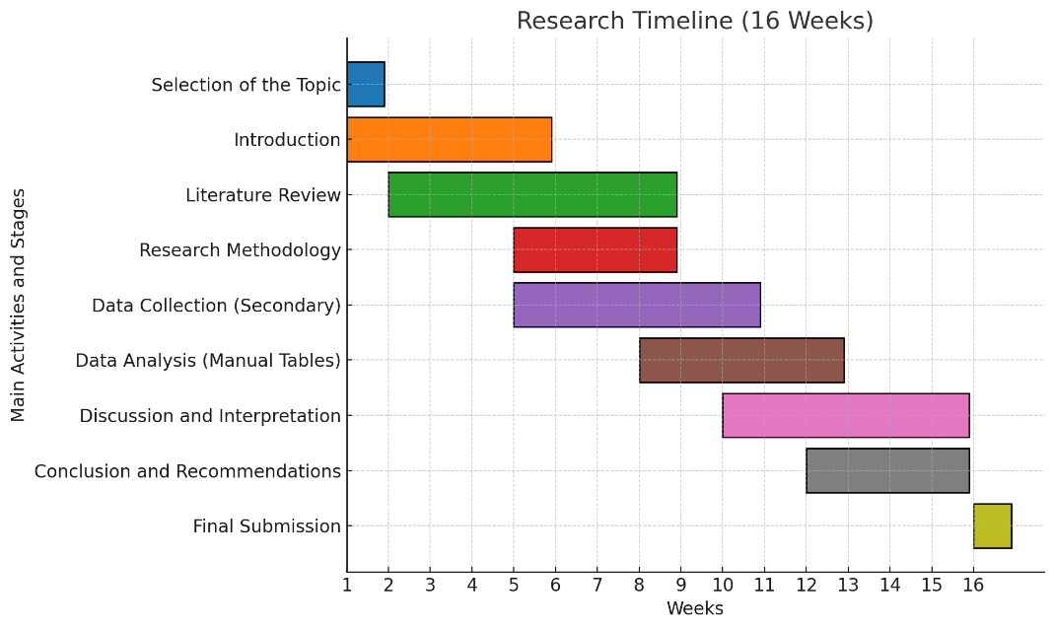
Figure: Research Timeline (Self-Created).
The research project will be completed in sixteen weeks. Week 1 will be spent finalising the topic and confirming the research direction. Weeks 2-5 will be used to prepare for the introduction and to review the literature, providing a strong foundation. Between weeks 5 and 8, the research methodology will be developed and secondary data sources selected (Kumar, 2018). Data collection through reports, articles and review platforms will occur in weeks 8-10. Weeks 10-15 will focus on analysis, discussion, and recommendations, and week 16 will focus on proofreading and submission.

Chapter 7: Conclusion
The proposal assesses the impact of online customer reviews on decisions to visit restaurants in the UK. First of all, the secondary quantitative data will allow identifying clear patterns on the main variables of importance – including ratings, comments, how comments are perceived, and their influence on customer choice. The research intends to use only the most credible sources of data to assess the impact of online feedback on success and operations in the restaurant industry. The current proposal is important because online reviews are an essential part of marketing and image-making in the hospitality industry. Understanding the nature of these relationships can help improve customer service and attract more clients for restaurants. The chosen simple information-based methodology will yield results that are feasible and replicable. In conclusion, this research will contribute to current academic and practical research on the impact of online consumer attitudes on the behaviour of the digital audience in the UK restaurant industry.

References
Anderson, C. (2012). The impact of social media on lodging performance. The Center for Hospitality Research, Cornell University.
Brotherton, B. (2012) International hospitality industry. Routledge.
Carfora, V. (2025) The sustainable food choice: An Interdisciplinary Approach to Consumer Food Behavior. Academic Press.
Creswell, J.W. and Creswell, J.D. (2018) Research design: Qualitative, Quantitative, and Mixed Methods Approaches. SAGE Publications, Incorporated.
De Marco, P. (2025) Customer service excellence: Mastering the art of customer delight. Pasquale De Marco.
Filieri, R. (2015) What Makes Online Reviews Helpful? A Diagnosticity-Adoption Framework to Explain Informational and Normative Influences in e-WOM. Journal of Business Research, 68(6), pp.1261–1270. Available at: https://www.sciencedirect.com/science/article/abs/pii/S014829631400349X
Filieri, R. (2016). What makes an online consumer review trustworthy? Annals of Tourism Research, 58, 46–64. Available at: https://doi.org/10.1016/j.annals.2015.12.019
Gordon, R.T. and Brezinski, M.H. (2016) The Complete Restaurant Management Guide. Routledge.
Hesse-Biber, S.N. and Johnson, B. (2015) The Oxford Handbook of Multimethod and Mixed Methods Research Inquiry.
Hollebeek, L.D. and Sprott, D.E. (2019) Handbook of Research on Customer Engagement. Edward Elgar Publishing.
Ismagilova, E., Dwivedi, Y.K., Slade, E., Shareef, M.A. and Hughes, D.L. (2017). Electronic Word of Mouth (eWOM) in the Marketing Context: A State of the Art Analysis and Future Directions. New York: Springer International Publishing. Available at: https://www.scirp.org/reference/referencespapers?referenceid=3103135
Kumar, R. (2018) Research methodology: A Step-by-Step Guide for Beginners. SAGE.
Luca, M. (2016). Reviews, reputation, and revenue: The case of Yelp.com (HBS Working Paper No. 12-016). Harvard Business School.
Luo, L. (2019) Temporal modelling of customer behaviour. Springer.
Olubiyi, T.O., Suppiah, S.D. and Chidoko, C. (2024) The Future of Small Business in Industry 5.0. IGI Global.
Perrin, B. (2025). How do online reviews impact restaurants? 3sixfive. Available at: https://3sixfive.co.uk/blog/how-do-online-reviews-impact-restaurants/ (accessed on: 31/10/2025).
Sparks, B.A. and Browning, V. (2011) The Impact of Online Reviews on Hotel Booking Intentions and Perception of Trust. Tourism Management, 32(6), pp.1310–1323. Available at: https://www.sciencedirect.com/science/article/abs/pii/S0261517711000033
Upton, G. and Brawn, D. (2023) Data analysis: A Gentle Introduction for Future Data Scientists. Oxford University Press.
Ye, Q., Law, R., Gu, B. and Chen, W. (2011) The Influence of User-Generated Content on Traveler Behaviour: An Empirical Investigation on the Effects of e-Word-of-Mouth to Hotel Online Bookings. Computers in Human Behavior, 27(2), pp.634–639. Available at: https://www.sciencedirect.com/science/article/abs/pii/S0747563210000907
Zhang, Z., Ye, Q., Law, R. and Li, Y. (2010) The Impact of e-Word-of-Mouth on the Online Popularity of Restaurants: A Comparison of Consumer Reviews and Ratings. International Journal of Hospitality Management, 29(4), pp.694–700. Available at: https://www.sciencedirect.com/science/article/abs/pii/S0278431910000198

