

Managing a Hardware/Software Project Integrated with Enterprise and Innovation Group Project

Student Name: Ruzy Aktar
Student ID: 1708215
Subject: Project Management and Research Methods
Module Code: ACDA5005
Lecturer: Sue Maw
Date: 06/12/19

The aim of this project management and professional skills, is centred around the Enterprise and innovation group project. This report the author will be demonstrating a prototype project resource and plan.
Objectives
The project is about a fitness app called ‘J&J fitness’ the app has 5 requirements that has been put together. The following details of the 5 requirements are;
App forum
This app revolves around a community forum where individuals can distribute diet & workout plans, this can be done through apps e.g. YouTube. Bodybuilders, and other fitness enthusiasts can share videos to help new comers to the fitness industry. And, to allow a system where users can comment, ask questions. And, anything that is shared on the app.
Login System
The author and group have allowed users to login to a personal account which will posses and track their fitness as well as their activity.
Friend System
However, allowing users personal account system, individuals are able to add friends on the account, this is a valuable asset as its good for the scoring system.
Daily Fitness Diary

Users are allowed to add their workout plans in order to be on track of their own details e.g. reps, and how many sets & the amounts of time required for each exercise & intake of food.
Fitness Competing
This being the projects second valuable asset, it allows people to compete with others in the community with small to medium workouts. This can range from swimming, weight lifting and running. Top requirement for this is to take a photo completing the activity to show friends for confirmation and will earn points to participate each month.
Scope
There are many points to cover, such as the boundaries. The author has come to conclusion it is a social media platform for fitness. Anything else that is shared or posted is not allowed as it has got no link with fitness.
The product is an app therefore the product is global because it’s also a social media app targeting individuals everywhere in the world, who have access to the internet. The clients for the product would be personal trainers, bodybuilders, fitness companies and fitness bloggers. Other companies or individuals can come together to create something bigger in the future by collaborating.

Constraints
The project members have come together and come to a rough estimate of how much the budget will be, below is a rough estimate for each role and the money that will be needed to accomplish this project.
Web Developer - £350
Mobile Developer - £650
Business developer -£1,200
Marketing -£3,800
Business & Usability Analyst £0
Project Manager £0
Total = 6,000
Authorities
Individuals in this project have 6 members, so the roles have been divided.
Project sponsor & project manager has been given to Scott Jones. His responsibility is to make sure everyone in this project has completed their task, he also covers the budgeting, time management, meetings, he has the ultimate authority.
Project chart

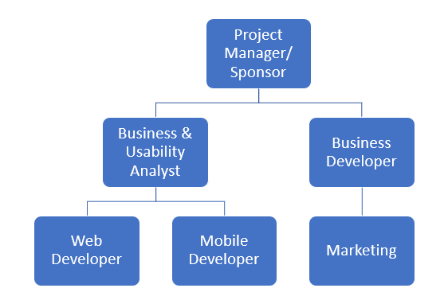

Resources /People
In this group project there are 6 individuals including the author. Below are the names and roles associated with the individuals.
Scott Jones
Project Manager/Sponsor has full authority and lead to the project, he is responsible for setting targets, getting tasks done. He has full access to the budget & finance, and setting every meeting. He is using a database to do this
Lowri Jones
Responsible for developing the app, she will be using visual studio to create a responsive app that is compatible on any type of phone. She also implements the design of the app and its features.
Lloyd Johnson
The business developer, he ‘looks for ways to bring in more revenue to a company. This can mean anything from looking for new markets, partnering with other companies, selling new products to existing markets, or developing new products or services for a global market’ [1].
Rosiey Aktar
The authors role in this project is marketing, she is required to find the competitors and what target audience are for the app. Also, her role is to compare how J&J fitness is different from the competitors. ‘Marketing plays an important role in establishing relationships between customers’ [2].
Habib Muin
The role is to create a website that’s linked to the fitness app. He will be making a responsive website which allows users to do the concept the app does, which is to enable users to upload and share and keep their details safe. He will be using visual studio.

References
- https://smallbusiness.chron.com/
- https://www.linkedin.com/

