University of Wales
Trinity Saint David
School of Applied Computing

Title: JavaScript / JQuery - Enabled Website

Module: Web and Mobile Technologies
Code: ACCA 5031
Student: Martin Darzins
Student no.: 1909722
Programme: Computing Portfolio – Applied Computing: Year 2
Lecturer: Gaynor Thomas
Due Date: 13th December 2021

Acknowledgements
The author acknowledges the content from the current UWTSD Moodle module course Web and Mobile Technologies and previous year works within Introduction to Web and Database Concepts.

Table of Contents
1 Acknowledgements ii
3 Introduction 1
3.1 Aims 1
3.2 Objectives 1
4 website 2
5 report 2
5.1 Introduction 2
5.2 Implementation 2
5.3 Concepts 3
5.4 Home (index.html) 4
5.4.1 Enlarge Text 4
5.4.2 Navigation 5
5.4.3 Real-Time Updates (as at 6th Dec 2021) 6
5.4.4 Alerts 6
5.4.5 Validations & Feedback 7
5.4.6 Contact (Direct email/media links) 8
5.4.7 Footer - Copyright 8
5.5 Background 9
5.5.1 Night Mode 10
5.6 Fun & Games 11
5.6.1 Quiz Interaction & Feedback 12
5.6.2 Required Fields (Sign Up) 13
5.6.3 Confirmation Message 13
5.6.4 Response (to User Choice) 14
5.6.5 Drop Down Menu (Other Web Resources) 15
5.6.6 Race (Timers & Winner Alert) 16
6 Conclusion 18
7 References 20
8 Report Planning Methodology 21

Figure 1: Walking Football Wireframe 2
Figure 2: Website Overview 3
Figure 3: Screenshot – Home 4
Figure 4: Screenshot - Enlarge Text 4
Figure 5: Code - Enlarge Text 5
Figure 6: Screenshot - Navigation 5
Figure 7: Code - Navigation & Hover 5
Figure 8: Screenshot - Date, Time and Calculation 6
Figure 9: Code - World Cup Countdown 6
Figure 10: Screenshot - Alerts 6
Figure 11: Code - Alerts 7
Figure 12: Screenshot - Subscribe Validation & Feedback 7
Figure 13: Code - Validations & Feedback 7
Figure 14: Screenshot - Contact 8
Figure 15: Code - Direct links 8
Figure 16: Screenshot - Footer (copyright) 8
Figure 17: Code - Footer (copyright) 8
Figure 18: Screenshot – Background page 9
Figure 19: Screenshot - Change Screen Appearance 10
Figure 20: Code - Screen Change (Night Mode) 10
Figure 21: Screenshot - Fun & Games page 11
Figure 22: Screenshot – Quiz 12
Figure 23: Code - Quiz 12
Figure 24: Screenshot - Required Fields 13
Figure 25: Code – Required Fields 13
Figure 26: Screenshot - Confirmation Message 13
Figure 27: Code - Confirmation Mess 14
Figure 28: Screenshot - Choice Determines Response 14
Figure 29: Code - Checked Box Choice 14
Figure 30: Screenshot - Drop Down Menu Web Links 15
Figure 31: Code - Drop Down Menu Direct Website Links 15
Figure 32: Screenshot - Race (Timers) 16
Figure 33: Code - Timers etc 17

Introduction

Aims
The aim of this report is to evaluate the concepts, principles, technologies and techniques used in the development of web and mobile applications, in relation to creating a (JavaScript/JQuery enabled) website.

Objectives
Along with the designed web pages, HTML (Hypertext Markup Language), CSS (Cascading Style Sheets) and JS (JavaScript) codes, to design and implement Web & Mobile applications using Client/Server-side programming languages, to resolve a range of problems.
To develop a website with suitable JavaScript/JQuery features allowing User interaction, utilising ‘raw’ JavaScript components, without the use of ‘Libraries:

website
Please refer to the separately submitted (zipped) file, which contains the individual website folders/files for; images, HTML, CSS, and JS codes utilised throughout this website.

report

Introduction
The created website is fictitious, but relates to a personal activity, that of Walking Football and is believed to be a valuable source of information and interest to those new (and familiar) to the sport.
The report section headings, screenshots and explanations will detail the website home and landing pages, detailing various User interaction and validation utilities, as well as the required JavaScript/JQuery features.

Implementation
The website was planned and designed using a 2(two) dimensional illustration (Wireframe) technique, which resulted in the creation of 3(three) web pages. This technique allowed the overall visualisation to be considered, constructing an overall look, space and content priority/hierarchy.
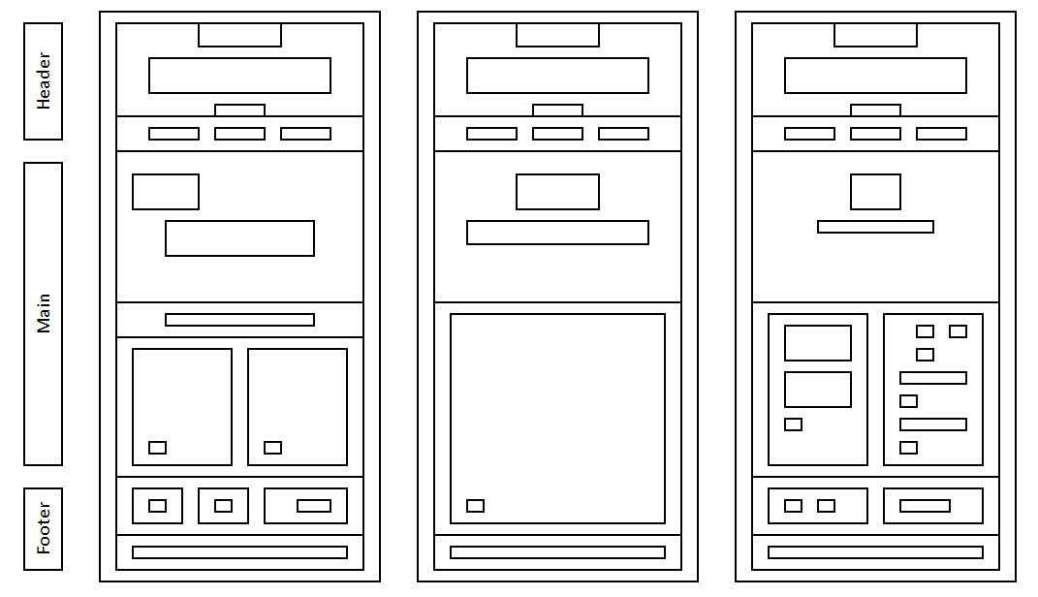
Figure 1: Walking Football Wireframe

Concepts
The Walking Football website developed the following: Home, Background and Fun & Games pages.
Via the Navbar function, each page has the ability to connect with previous and latter elements of the website, along with various links to offsite pages, relating to:
- Enlarge Text
- Navigation
- Real-time Updates (& Countdown to 2022 Football World Cup in Qatar)
- Alerts
- Validations & Feedback (Newsletter Subscription)
- Contact (Email & Social Media)
- Footer (Copyright)
- Night Mode - screen changes to colour/text
- Quiz Interaction & Feedback
- Required Fields
- Confirmation (Message & Response)
- Drop Down Menu (Other Web Resources)
- Race (Timers & Winner Alert notification)
From these concepts the following website pages were developed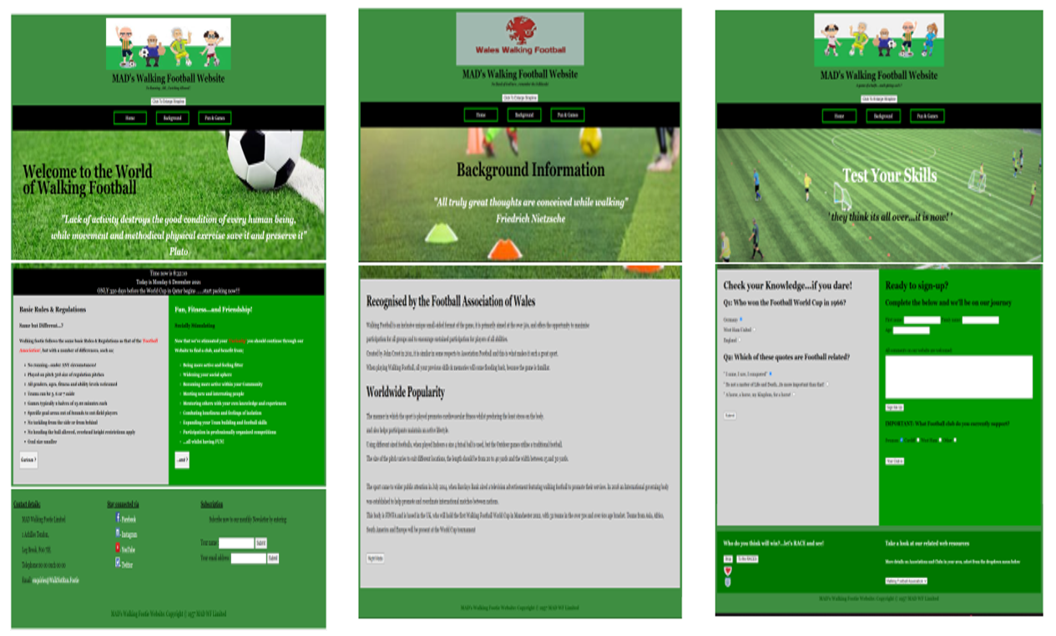
Figure 2: Website Overview
All maintaining an overall (football) colour theme (green tones) throughout, standardising on font- family (Georgia), layouts, positioning and media/communication techniques. Should the website be developed further, then a single standard logo would be created and utilised throughout to help maintain Company ethos/branding images.

Home (index.html)

Figure 3: Screenshot – Home

Enlarge Text

Figure 4: Screenshot - Enlarge Text
On click button code used to allow User to view strapline and humorous comment more readily.
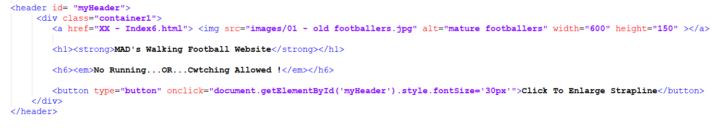
Figure 5: Code - Enlarge Text

Navigation
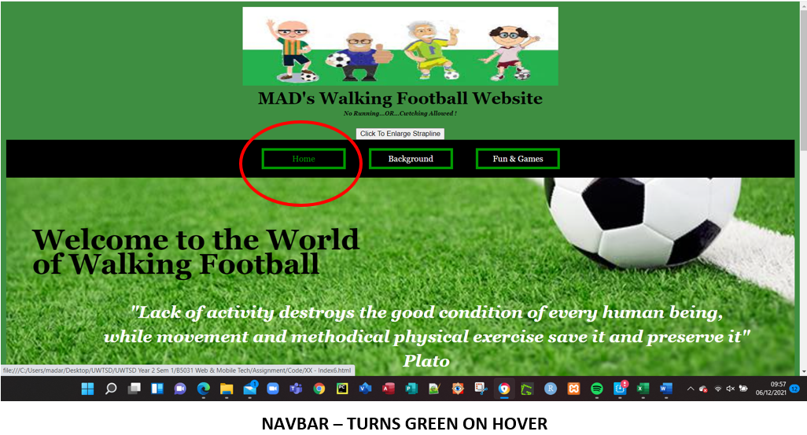
Figure 6: Screenshot - Navigation
On hover navigation bar text change colour to green, on Click moves to the page selected.
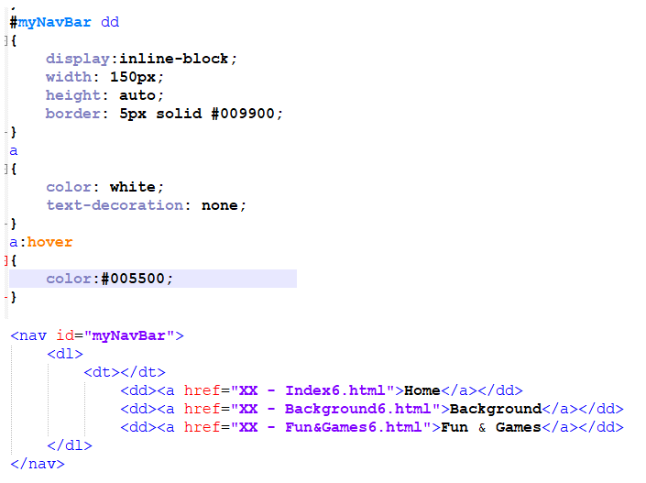
Figure 7: Code - Navigation & Hover

Real-Time Updates (as at 6th Dec 2021)
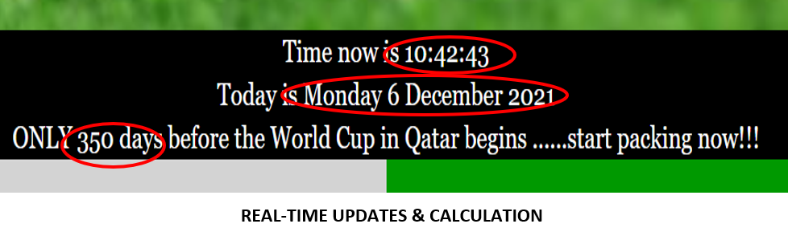
Figure 8: Screenshot - Date, Time and Calculation
Utilising the OnLoad managedates function, the current date/time is determined and performs calculation as to how many (whole) days remain before the start of the Football World Cup in Qatar (on 21 November 2022). Dates converted to seconds using 4WebHelp Unix Timestamp Converter.
This is a real-time function and will update/re-calculate upon Refresh.
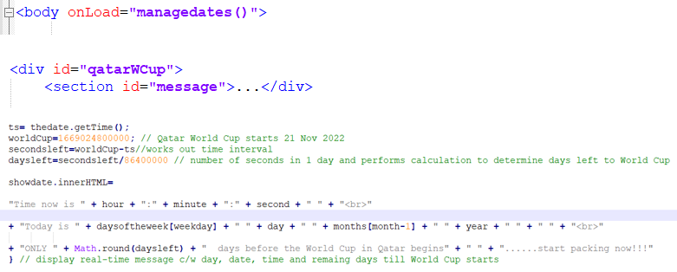
Figure 9: Code - World Cup Countdown

Alerts
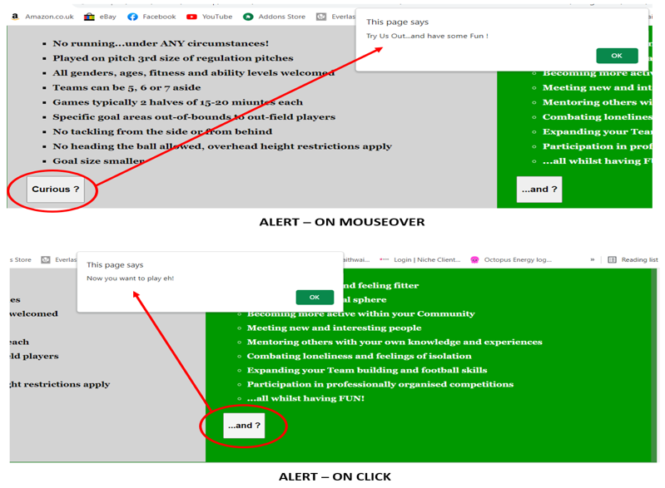
Figure 10: Screenshot - Alerts
Using the Form function, the User is issued with alert messages via onMouseover (Curious button) and onClick (…and? button), to add to the website experience.
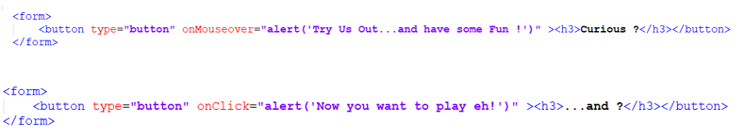
Figure 11: Code - Alerts

Validations & Feedback

Figure 12: Screenshot - Subscribe Validation & Feedback
Subscription facility informs User if details entered are incomplete/invalid, and equally confirms whether they are acceptable.
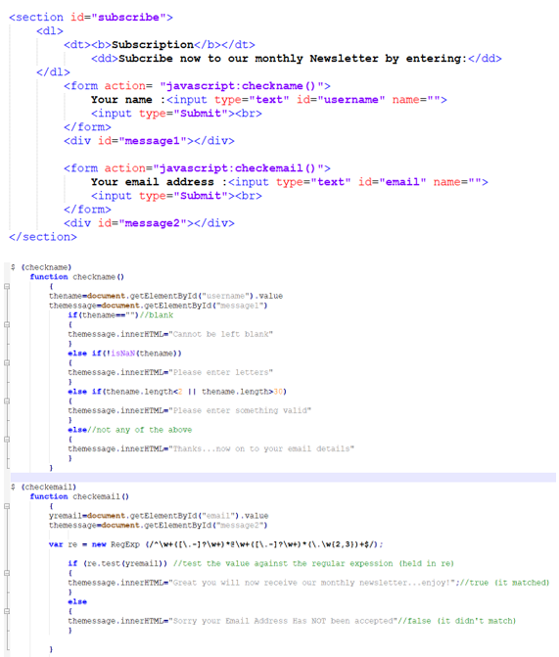
Figure 13: Code - Validations & Feedback

Contact (Direct email/media links)
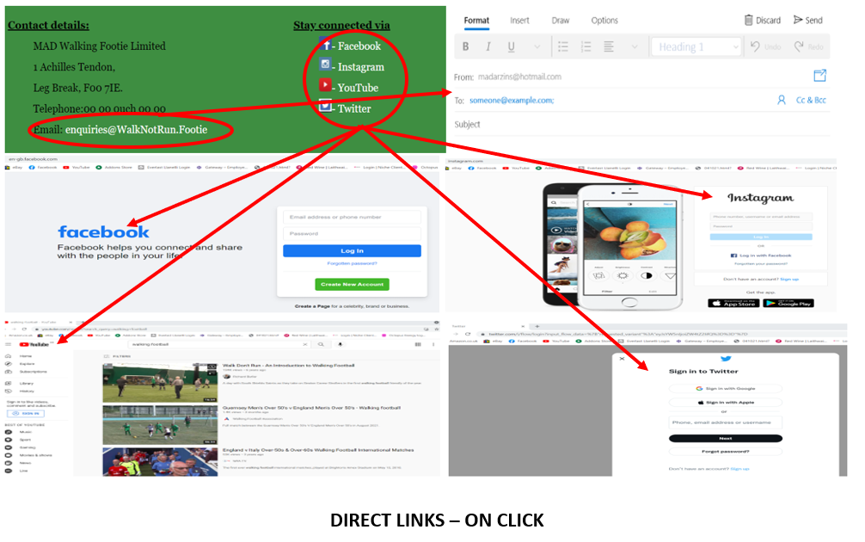
Figure 14: Screenshot - Contact
User able to contact us direct via email or other social media sources listed.
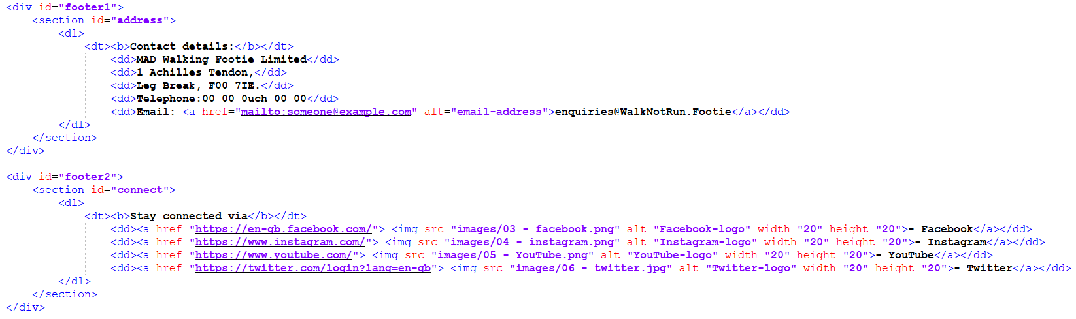
Figure 15: Code - Direct links

Footer - Copyright

Figure 16: Screenshot - Footer (copyright)
Same footer material maintained throughout website.
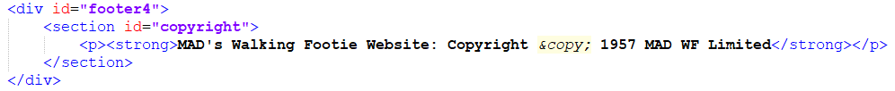
Figure 17: Code - Footer (copyright)

Background

Figure 18: Screenshot – Background page

Night Mode
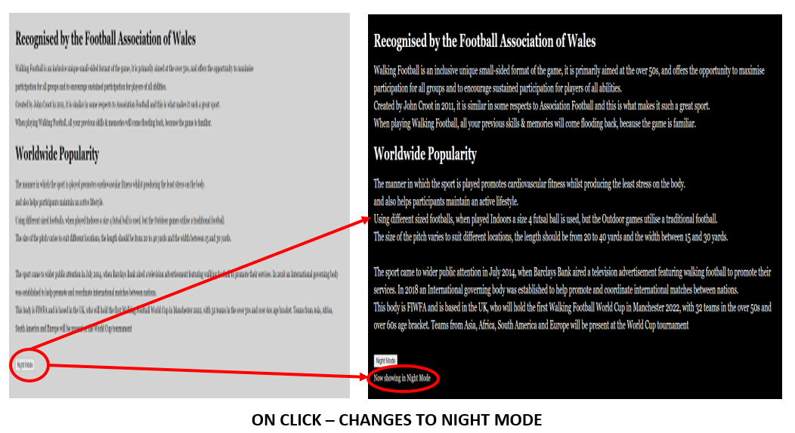
Figure 19: Screenshot - Change Screen Appearance
Allows User the opportunity (onClick) to change screen appearance (to Night mode) and increase text size with added comment, confirming new mode.
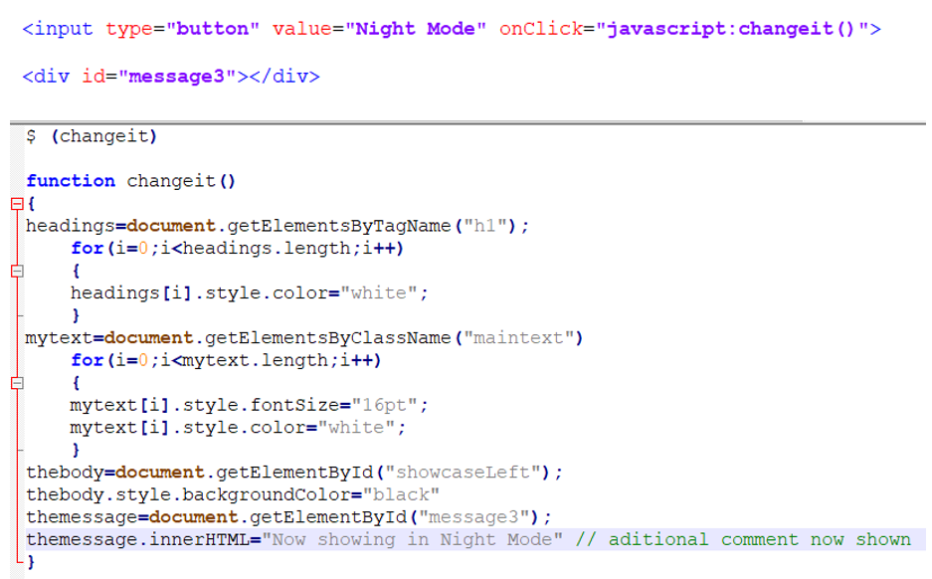
Figure 20: Code - Screen Change (Night Mode)

Fun & Games

Figure 21: Screenshot - Fun & Games page

Quiz Interaction & Feedback
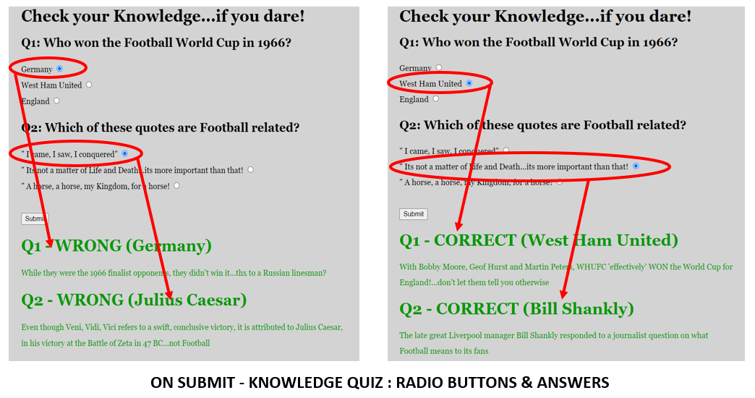
Figure 22: Screenshot – Quiz
Using radio buttons via the Form and JS code, the User is requested to select answers from the questions posed. The responses are determined by the if/else function and a combined return (message) is given showing the results, when submitted.
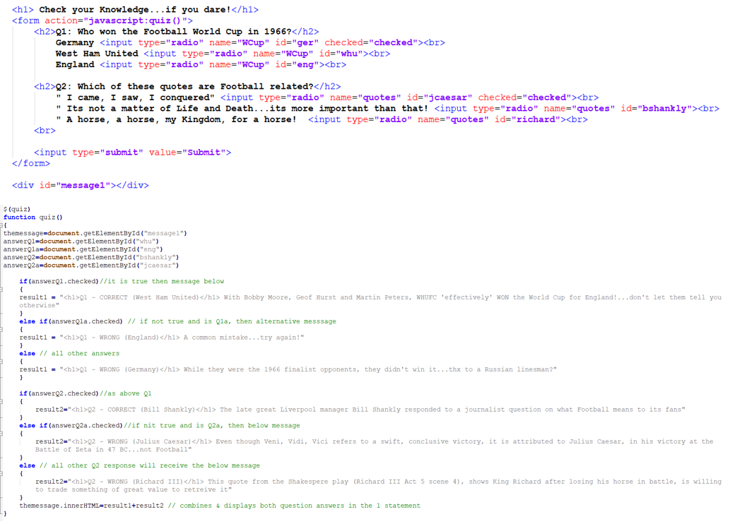
Figure 23: Code - Quiz

Required Fields (Sign Up)
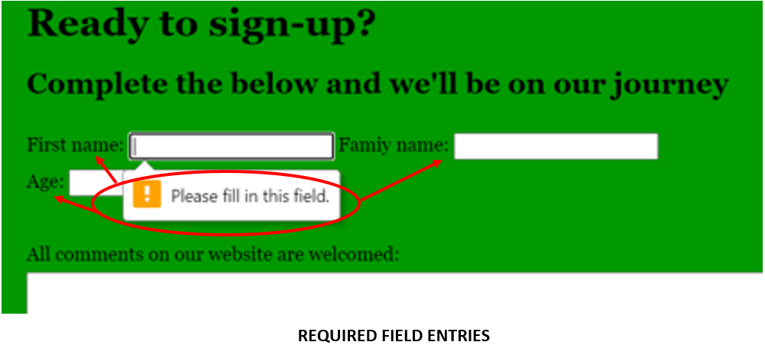Figure 24: Screenshot - Required Fields
Feedback issued to User confirming data required, otherwise unable to proceed.
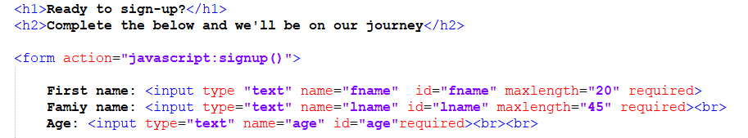
Figure 25: Code – Required Fields

Confirmation Message
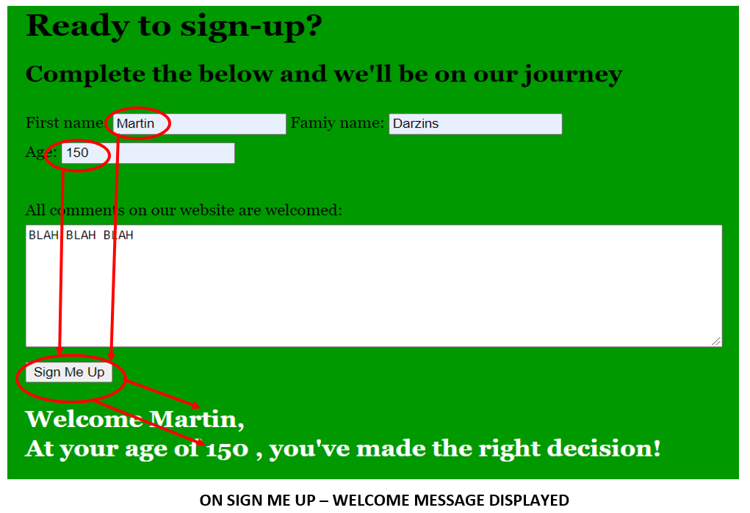
Figure 26: Screenshot - Confirmation Message
If successfully completed, upon submit (via sign me up button), User is greeted with a message extracting certain data from original input, thru the JS $ signup function.
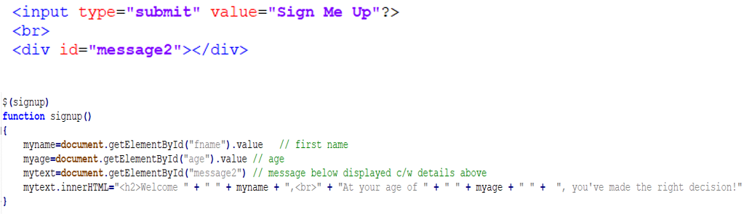
Figure 27: Code - Confirmation Mess

Response (to User Choice)
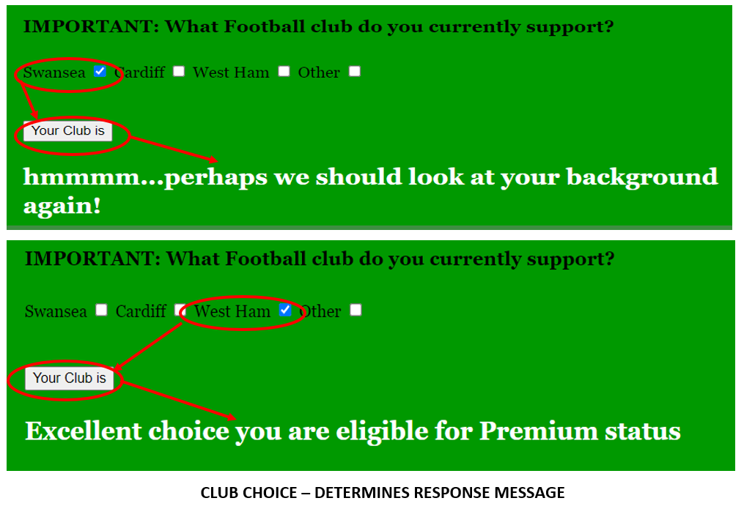
Figure 28: Screenshot - Choice Determines Response
When User selects, via checked box options presented and submits (via Your Club is button), different responses are given, as pre-determined by Form, JS $ clubchoice (if/else) function.
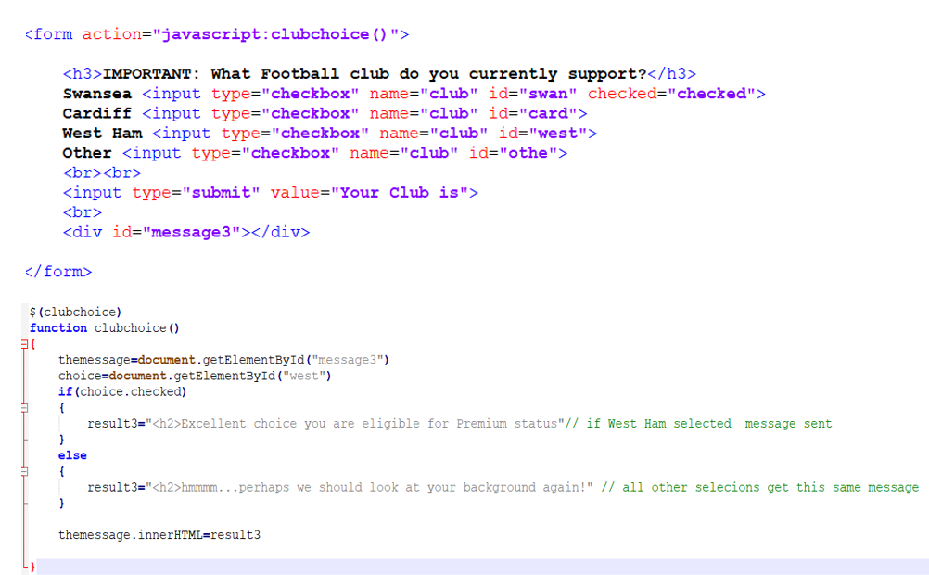
Figure 29: Code - Checked Box Choice

Drop Down Menu (Other Web Resources)
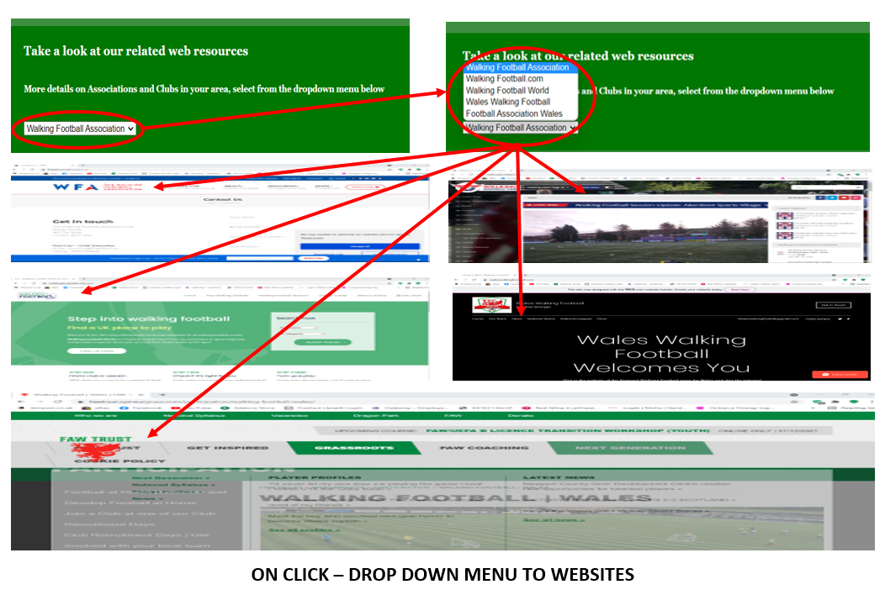
Figure 30: Screenshot - Drop Down Menu Web Links
Using the JS $ navigateto, select/values option and the onClick button, a drop-down menu is presented offering various direct website links to choose from.
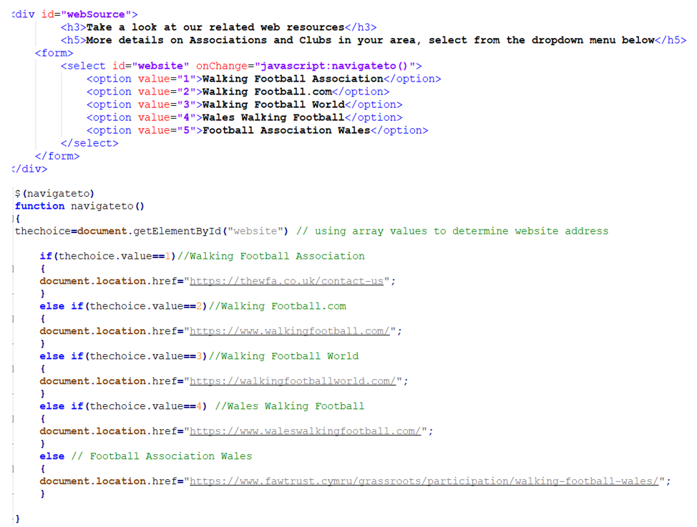
Figure 31: Code - Drop Down Menu Direct Website Links

Race (Timers & Winner Alert)
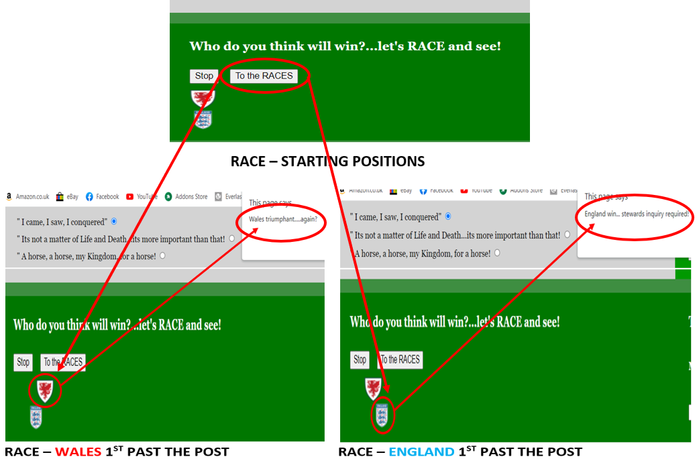
Figure 32: Screenshot - Race (Timers)
Onclicking button ‘To the Races’, the two club crests (Wales v England) move across to the right and the winner is announced via an alert.
The race is determined via the timer function and random Math number generator in JS $ raceright, with variable (timers for each) being declared up front.
The below detailed code from the .html and .js files, details the if/else loop function, which initially positions the club crests, whereas the while loop, ensures that there is always a Winner (no dead heats).
Four JavaScript functions are required to enable movement, $ raceright, $ stoprace (both with input buttons), and 2 x $ moveright functions [1 for each crest = W (Wales), E(England)].
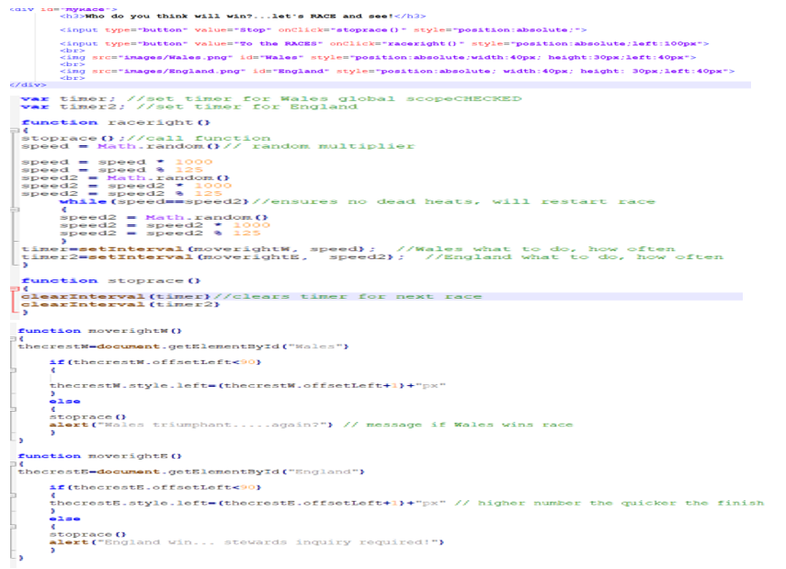
Figure 33: Code - Timers etc

Conclusion
Overall, this website is a good starting point for the uninitiated and whilst it offers an insight, general knowledge and a background flavour of what Walking Football is like, the intent would be to enhance the details by linking the User to Walking Football clubs local to their address. This may require access to a club database, c/w postcodes, so as to link the two and co-ordination with the various website resources already in existence.
Further enhancements would see (from the club of their choice) League tables, Results, Fixtures, Events and a secure Payment method for becoming a member/subscriber.
On a technical side, another area to investigate would be the inter-actions between, .html, .css and .js code, to ensure that there is no conflict, and which has priority.

.

Word count: 1,109 (excluding Title page and sections 1 - 3, and 7 - 8)

References

Images courtesy of:
- - https://www.facebook.com/CalneWalkBall/
- - https://www.activityalliance.org.uk/news/6070-game-on-football-foundation-launches-new-funds
- - https://www.stickpng.com/img/icons-logos-emojis/tech-companies/facebook-icon
- - https://www.dreamstime.com/search.php?srh_field=instagram+logo&s_il=y
- - https://pixabay.com/images/search/youtube%20logo/
- - https://www.shutterstock.com/search/twitter+logo
- - https://www.walkingfootball.com/
- - https://www.shutterstock.com/search/football+training+session
- - https://www.fawtrust.cymru/grassroots/participation/walking-football-wales/
- - https://www.facebook.com/CalneWalkBall/
- - https://logowik.com/wales-national-football-team-vector-logo-7306.html
- - https://seeklogo.com/vector-logo/275625/england-football

Report Planning Methodology
This Web and Mobile Technologies report assignment was completed by adhering to the following activities:
- Read and understand the report brief.
- Make plan (Gantt chart) including time management – planning/research most time consuming, catering for other exams.
- Create report format and style – using Moodle template example.
- Follow structure of:
  - Title Page
  - Acknowledgements
  - Introduction
  - Main Body
  - Reference
  - Appendices
- Define the problem and purpose of the report – decide assignment title, aims & objectives.
- Define audience – Lecturer/Tutor (Gaynor Thomas).
- Brainstorm (Mindmaps) and determine ideas to include.
- Research and gather information (Library, internet etc).
- Collect, sort, evaluate organise material.
- Complete references (as you go) during all research phases.
- Analyse research/material.
- Prepare outline drafts.
- Write the draft report, check spelling and grammar.
- Submit draft into Turnitin for similarity check.
- Incorporate changes into final redraft.
- Submit final report via Turnitin before 13th December 2021.

