

STUDENT NAME: VRUSHABH RAKESHBHAI PATEL
STUDENT ID: 2528085
MODULE NAME: HUMAN CAPITAL MANAGEMENT
MODULE CODE: LCMB7023
LECTURER’S NAME: DR. LAKSHANI MENDIS
WORD COUNT: 2736
DATE OF SUBMISSION: 20/03/2026

ASSESSMENT COMPONENT 1: INDIVIDUAL REPORT – HR STRATEGY

INTEGRATED HUMAN CAPITAL BLUEPRINT: ALIGNING PEOPLE AND PERFORMANCE AT AETHER INNOVATIONS

Table of Contents
1. Introduction 3
2. PART 1 – Re-Engineering Performance and Job Design 3
2.1 Performance Appraisal Practices in Technology Companies 3
2.2. A Modern Growth-Focused Performance Appraisal System 5
2.3 Job Analysis and Job Design for Key Leadership Positions 8
2.4 Integrating Job Design and Performance Systems to Build a Performance-Driven Culture 11
3. PART 2 – Reflective Learning 12
3.1 Reflective Learning Using Kolb’s Model 12
3.2 Staying Relevant in the Age of Artificial Intelligence 14
4. Conclusion 15
5. References 16

Introduction
The technology industry is highly competitive and innovation-driven, making human capital management essential for organizational growth. Aether Innovations, a fast-growing technology company with approximately 300 employees, is facing challenges, including low growth, high employee turnover, and poor customer satisfaction. These issues reflect misalignment in organizational strategy and people management practices. This report proposes a human capital blueprint focusing on performance management and job design to enhance innovation, employee engagement, and organisational performance through strategic HRM practices.

PART 1 – Re-Engineering Performance and Job Design

2.1 Performance Appraisal Practices in Technology Companies
The technology sector is dynamic and innovative demanding performance management systems to synchronize employee input with strategic goals. Nevertheless, numerous technology companies use traditional methods of annual appraisal focused on past evaluation rather than future development (Cappelli and Tavis, 2016).
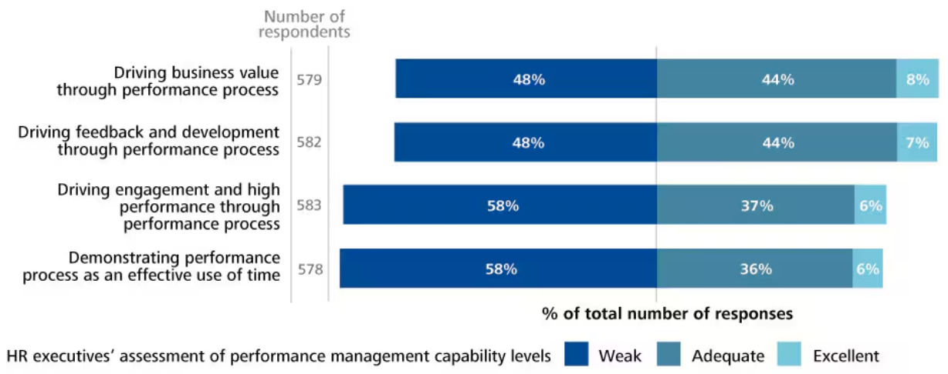
Figure 1: HR Executive’s Assessment of Performance Management
Source: (Deloitte, 2014)
Conventional appraisal mechanisms entail the yearly review of superiors with regard to fixed targets (Osman, Opoku and Kyeraa, 2024). Nonetheless, these systems have been accused for not sustaining innovation-driven environments. For example, global survey by Deloitte (2014) found that 58% of executives feel traditional performance management systems fail to drive employee engagement or performance. These systems are bureaucratic, subjective, and unsuitable to real time organisational goals.
Another weakness is lack of regular feedback. Firms with short-term cycles in technology cannot sustain performance based on annual feedback (Balcerak and Wozniak, 2025). Throughout pre-assessment phase, staff members are able to accomplish several projects, reducing usefulness of feedback. Additionally, hierarchical appraisals result in decision-making capacity centralization, risk of bias, and uncertainty that workers face during evaluation process (Schweisfurth et al., 2023).
The practice of job design has also been redefined although performance appraisal in the technology firms has proved challenging. In the past, organizations had strict job descriptions, which restricted the roles. Although this pattern ensured role demarcation, it discouraged innovation and flexibility (Aparna and Sahney, 2022). The pace of technology change in technology companies and workers is expected to follow the changing jobs and innovate in other areas of working.
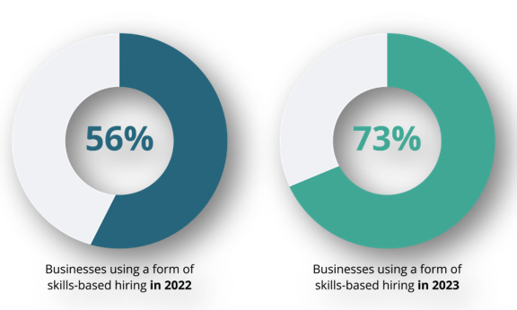
Figure 2: Skill-Based Hiring in 2022-2023
Source: (Gorilla, 2023)
Agile and skills-based job design focusing on competencies has become increasingly common in modern organizations (Nair, 2019). This approach enables employees to apply diverse skills in cross-functional projects. For instance, research by Gorilla (2023) suggests that skills-based hiring increased globally from56% in 2021 to 73% in 2023, indicating rising role of flexible talent.
Nonetheless, despite these advancements, several companies are yet to completely align between job design and performance management. Conversely, performance systems promote short production rather than creativity or collegiality, thus employees may strive to achieve limited goals at the expense of diversification (Agrawal, 2012). Therefore, technology organizations must have a proportionate HR strategy which would unify the new job appraisal systems and empowering job designs.

2.2. A Modern Growth-Focused Performance Appraisal System
To overcome the shortcomings of traditional appraisal systems, Aether Innovations should implement a contemporary performance management model founded on ongoing feedback, alignment, and joint assessment.
Objectives and Key Results (OKRs)
OKRs are performance models popular in technology companies. Originally popularised by Intel and subsequently acquired by Google, OKRs balance the performance of individuals and organisations (Stray et al., 2022).
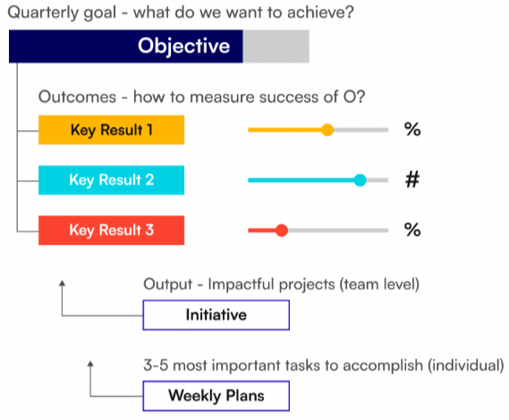
Figure 3: Objectives and Key Results (OKRs)
Source: (Yadav, 2024)
The OKR system involves two key components (Stray et al., 2022):
- Objectives: qualitative goals that define strategic priorities
- Key Results: measurable indicators used to track progress toward objectives
For example, an objective such as “Improve customer satisfaction” may be supported by measurable key results such as increasing Net Promoter Score by 20% or reducing product defects by 30%.
The main strength of OKRs is that it enhances transparency and alignment throughout the organization (Rompho, 2023). Staff is educated about the significance of their effort applied to business performance, which enhances responsibility and incentive. The internal HR study made by Google showed that the OKR system proved handy in enhancing goal clarity and responsiveness between team members (Marr, 2021).
However, the OKRs have disadvantages. When applied manipulatively, employees will focus more on measurable targets, rather than qualitative innovation attainments (Rompho, 2023). Therefore, to avoid short due performances, companies must find a balance between quantitative and developmental performances.
Continuous Feedback and Development Conversations
Another critical area of modern performance management is continuous feedback. Managers also engage employees in periodic performance discussions instead of periodic assessment (Harrison, 2017). The ongoing feedback allows detecting performance problems much faster and enhances learning possibilities and manager-employee relations. Kemp (2024) states that receiving regular feedback, employees are more engaged at workplace than employees who get feedback yearly. Permanent feedback, however, requires strong managerial competencies (Idrus, 2025). Managers should be trained on how to provide constructive feedback and empower workers. Regular feedback exercises can be erratic or useless without proper training.
360-Degree Feedback

Figure 4: 360-Degree Feedback
Source: (Stimpson, 2024)
The 360-degree feedback is another innovation over performance appraisal where the evaluation data of supervisors, peers, and subordinates are collected (Kanaslan and Iyem, 2016). This system will remove several shortcomings of traditional appraisal. By integrating different opinion, firms can reduce prejudice and provide a more profound evaluation (Kanaslan and Iyem, 2016). For example, manager can assess technical performance of worker, and colleagues can assess teamwork and cooperation skills. Technology firms are slowly adopting this practice, which makes them accountable and learn in groups. However, organizations should make the process private and clear to ensure trust among employees (Fleenor, Taylor and Chappelow, 2020).
HR Analytics and Data-Driven Performance Management
Modern organizations are also utilizing HR analytics and digital HR systems to enhance performance management. Data analytics can assist organisations in tracking productivity, engagement, and turnover. Madhuri and Kumar (2025) argue that firms using people analytics are five times more likely to make timely and impactful HR decisions than their intuition-driven decision-making counterparts. Predictive analytics can also indicate a threat of attrition and take proactive steps. Despite these positive aspects, organizations have to consider ethical issues like privacy of information and algorithmic bias (Madhuri and Kumar, 2025). HR leaders must ensure that decision-making is objective and data-driven.

Job Analysis and Job Design for Key Leadership Positions
Job design starts with job analysis, which is a process of identifying tasks, responsibility, and skills in every job systematically. The basis of job description and job specification is a job analysis (Taylor, 2014).
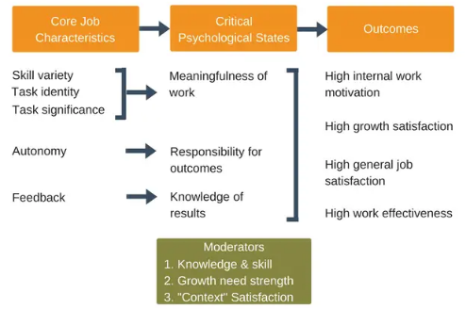
Figure 5: Job Characteristics Model
Source: (Denis, 2017)
Aether Innovations must use the Job Characteristics Model to increase both innovation and employee morale because it has five fundamental dimensions: skill variety, task identity, task significance, autonomy, feedback (Ali et al., 2014). Jobs based on these dimensions increase motivation and innovation.
Job Descriptions and Specifications for Key Leadership Roles
Category | Details
Job Title | Chief Executive Officer (CEO)
Job Description | Provides strategic leadership, sets the organisational vision, and ensures sustainable growth through innovation and strategic partnerships (Glick, 2011).
Key Responsibilities | Develop long-term strategy; lead organisational transformation; represent company to investors and stakeholders; drive innovation and competitive advantage.
Job Specification | MBA or equivalent leadership experience; extensive technology industry leadership; strong strategic decision-making; excellent communication and stakeholder management skills.
Job Design Consideration | High autonomy, strategic decision authority, broad task significance and feedback from board and stakeholders.

Category | Details
Job Title | Chief Financial Officer (CFO)
Job Description | Oversees financial planning, resource allocation and financial sustainability to support organisational growth (Bedard, Hoitash and Hoitash, 2014).
Key Responsibilities | Manage budgeting and financial reporting; develop financial strategies; monitor financial performance; support executive decision-making.
Job Specification | Professional accounting qualification (ACCA/CPA); expertise in financial analysis; experience in technology sector finance.
Job Design Consideration | High analytical skill use, autonomy in financial planning, clear feedback through financial performance metrics.

Category | Details
Job Title | Chief Technology Officer (CTO)
Job Description | Leads technology strategy and oversees development of digital systems and engineering operations (van der Hoven, 2011).
Key Responsibilities | Lead software development teams; evaluate emerging technologies; ensure system scalability and security; align technology with business strategy.
Job Specification | Advanced degree in computer science/engineering; experience in agile development; strong leadership and technical expertise.
Job Design Consideration | High skill variety, autonomy in technological decisions, strong feedback through innovation and product performance.

Category | Details
Job Title | Chief Innovation Officer (CIO)
Job Description | Drives innovation strategy and manages initiatives that create new products and processes (Cheng and Love, 2022).
Key Responsibilities | Manage innovation projects; promote intrapreneurship; collaborate with research partners and technology teams.
Job Specification | Experience in innovation or R&D leadership; strategic thinking; ability to lead cross-functional teams.
Job Design Consideration | High creativity, autonomy, cross-functional collaboration and continuous feedback from innovation outcomes.

Category | Details
Job Title | HR Director
Job Description | Aligns HR strategy with business objectives to enhance workforce performance and engagement (Lussier and Hendon, 2025).
Key Responsibilities | Workforce planning; talent management; employee engagement initiatives; compliance with employment laws.
Job Specification | Postgraduate qualification in HRM; leadership capability; expertise in employee relations and HR strategy.
Job Design Consideration | High task significance, decision autonomy in people strategy and continuous feedback through workforce metrics.

Category | Details
Job Title | Head of Research & Development (R&D)
Job Description | Leads research teams to develop innovative products and technological solutions (Ochieng, 2023).
Key Responsibilities | Manage R&D projects; develop new technologies; collaborate with universities and industry partners.
Job Specification | Advanced degree in engineering/technology; experience in innovation management; strong analytical skills.
Job Design Consideration | High skill variety, autonomy in experimentation and strong feedback through research outcomes and product innovation.

2.4 Integrating Job Design and Performance Systems to Build a Performance-Driven Culture
Job design and performance management systems are vital in determining the effectiveness of HR strategies. When they run separately, organizations may end up developing conflicting incentives that will deter innovation.
The proposed approach for Aether Innovations integrates both systems to create a performance-driven organizational culture.
First, job roles enable employees to know clearly what to do and how to perform. Knowledge eliminates role ambiguity and improves accountability.
Second, performance management tools such as OKRs ensure that employee goals align with organizational strategic priorities (Stray et al., 2022). Employees are able to see how their jobs make bigger organizational outcomes.
Third, job designs that are both autonomous and skillful encourage employees to pursue new concepts and practices. Employees are likely to emerge with creative solutions when they are empowered to make decisions and apply diverse skills.
Finally, the feedback systems lead to organizational learning and collaboration. Performance management can be a developmental process contrary to evaluation, which helps the employee grow (Harrison, 2017). Through a combination of these HR practices, Aether Innovations can establish an atmosphere of workplace innovation, higher employee involvement, and better organizational performance.

PART 2 – Reflective Learning

3.1 Reflective Learning Using Kolb’s Model
Reflective learning is vital in postgraduate education because it allows individuals to analyse their experiences, assess knowledge acquired, and transfer learning to work-related situations. Kolb’s Experiential Learning Model provides a useful framework for understanding this process through four stages: concrete experience, reflection, conceptualisation, and experimentation (Devi and Thendral, 2023). Based on this model, this reflection examines my learning experience in the Human Capital Management module and how can be used to build my own learning and development approaches to foster innovation and a growth mindset.
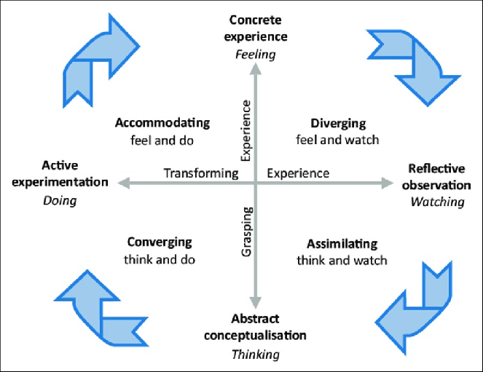
Figure 6: Kolb’s Experiential Learning Model
Source: (ResearchGate, 2021)
- Concrete Experience
The initial step of Kolb’s model is reflection on learning experiences that occured place during the module. The Human Capital Management module presented some critical issues such as workforce planning, performance management, diversity and the future of work. The themes increased the applicability of human capital as a strategic organizational resource.
The other valuable experience that I gained was the relations between organizational performance and HR strategies. An example of how the HR practices can increase employee motivation, engagement, and efficiency is job design and performance management. The module was also about technological change and the emergence of HR analytics with their growing importance.
- Reflective Observation
The reflection on these experiences enabled me to critically examine the impact of HR practices on the organisational outcomes. Before this module, my idea of HR as an administrative job predominantly involved solely recruitment and compliance. However, the module has also revealed that HR plays a strategic role in innovation, leadership and corporate culture development.
For example, ineffective performance management systems may reduce employee participation and creativity. Similarly, low job designs can restrict employee ability to use their skills and creativity (Brannick, Levine and Morgeson, 2007). This experience taught me that organisations must create HR practices to empower employees and facilitate teamwork and lifelong learning. I also thought about the role of diversity and inclusion within organizations. Various teams might introduce new perspectives that can aid in enhancing creativity and problem solving (Leroy et al., 2021).
- Abstract Conceptualisation
Relating the experience to theoretical knowledge is the third step of Kolb’s model (Devi and Thendral, 2023). The module has outlined HR models through which organizations can boost employee performance and engagement. For example, Job Characteristics Model describes the importance of skill variety, autonomy, and feedback in employee motivation (Ali et al., 2014). These will create understandable working conditions where individuals will feel valued and motivated to offer new ideas.
Additionally, life-long learning appeared as a crucial element of modern organization. The high pace of technology implies that employees should frequently upgrade their skills to stay competitive in the labour market. This lesson made me realize that becoming growth minded is key to a long-term professional success.
- Active Experimentation
The last phase of Kolb’s model focuses on applying learning to future actions (Devi and Thendral, 2023). Depending on my thoughts, I will use various strategies to facilitate my personal learning and development. First, I will also engage in a lifelong learning process by training, workshops, and certifications to better understand HR strategies and the trends at the workplace. Second, I will seek to acquire soft skills, including communication, leadership, and collaboration, which are essential in the HR practice. Lastly, I will proactively utilize theoretical knowledge by working in the field on behalf of professional networking, projects, and internships.
These strategies will help me to develop a growth mentality and work in innovative and inclusive organizational cultures. The reflective model by Kolb is thus an important tool in translating academic learning into actual professional development.

3.2 Staying Relevant in the Age of Artificial Intelligence
Artificial intelligence (AI) is redefining the operational aspects of work in most sectors as it automates routine tasks and enhances efficiency by making evidence-based decisions (George, 2024). Traditionally repetitive administrative tasks are increasingly aided or replaced by AI technologies. However, instead of fully substituting people, AI will rather redefine job descriptions and ask specialists to acquire new competencies (George, 2024). To remain relevant in AI era, therefore, one must constantly learn and build capabilities to be complementary to technology and not competitive.
To be competitive, I will invest in developing skills that are not easily mimicked by AI like critical thinking, creativity, emotional intelligence, and strategic decision making. Such human-oriented capabilities are especially critical in such fields as leadership, problem-solving, and relationship management. (López Jiménez and Ouariachi, 2020) For example, AI can examine large volumes of workforce data or screen recruitment processes, but it cannot perceive emotions of every employee, organizational culture, and even ethical considerations in decision-making processes.
Simultaneously, I will apply AI as supportive to boost productivity and the quality of my work. AI-powered technologies will be helpful in areas like HR data analysis, trends in employee engagement, and better recruitment efforts (Rani, Priya, and Prasad, 2024). Through AI automating tedious processes, professionals will spend more time on strategic operations, like talent management strategies, innovation, and organizational strategies.
However, AI should be utilized in a moderated manner. Dependence on technology can pose threats of bias, data privacy and diminishing human communication (Madhuri and Kumar, 2025). Thus, I intend to integrate technology with human reasoning and awareness to make impartial and responsible decisions. Ultimately, combining digital literacy, high-quality interpersonal, and critical literacy will enable me to employ AI as an effective helper without making it a primary focus of professional activity.

Conclusion
This report suggested an integrated human capital strategy to assist in addressing performance and engagement challenges in Aether Innovations. The organization can strengthen innovation, accountability, and staff motivation by incorporating modern performance management tools such as OKRs, 360-degree feedback and planned leadership roles. The reflection showed the need to continue learning and adapt to AI-based workplaces, as it is necessary to integrate technological factors with human capabilities, leadership, strategic thinking.

References
Agrawal, V. (2012). Managing the diversified team: challenges and strategies for improving performance. Team Performance Management: An International Journal, [online] 18(7/8), pp.384–400. doi:https://doi.org/10.1108/13527591211281129.
Ali, S.A.M., Said, N.A., Yunus, N.M., Kader, S.F.A., Latif, D.S.A. and Munap, R. (2014). Hackman and Oldham’s Job Characteristics Model to Job Satisfaction. Procedia - Social and Behavioral Sciences, [online] 129(2014), pp.46–52. doi:https://doi.org/10.1016/j.sbspro.2014.03.646.
Aparna, S.M. and Sahney, S. (2022). Examining resilience: the role of creativity-oriented high-performance work practices and role clarity. Journal of Organizational Change Management. doi:https://doi.org/10.1108/jocm-11-2021-0356.
Balcerak, A. and Wozniak, J. (2025). Factors Influencing the Expected Advantages and Disadvantages of Continuous Feedback-Based Performance Appraisal Systems. Forum Scientiae Oeconomia, [online] 13(2), pp.76–102. doi:https://doi.org/10.23762/FSO_V%20OL13_NO2_4.
Bedard, J.C., Hoitash, R. and Hoitash, U. (2014). Chief Financial Officers as Inside Directors. Contemporary Accounting Research, [online] 31(3), pp.787–817. doi:https://doi.org/10.1111/1911-3846.12045.
Brannick, M.T., Levine, E.L. and Morgeson, F.P. (2007). Job and work analysis: Methods, research, and applications for human resource management. [online] Google Books. Available at: https://books.google.com/books?hl=en&lr=&id=g7m1xrZnHxwC&oi=fnd&pg=PP1&dq=Brannick.
Cappelli, P. and Tavis, A. (2016). The performance management revolution. [online] Harvard Business Review. Available at: https://prod-edxapp.edx-cdn.org/assets/courseware/v1/0d740b595eaebef7a8cdd812f86f6760/asset-v1:WhartonOnlineProfessionalEd+MGMT1x+4T2017+type@asset+block/Performance-Appraisal-HBR.pdf.
Cheng, J.L.C. and Love, E.G. (2022). Designing chief innovation officer positions: a strategic contingency framework. Journal of Organization Design. doi:https://doi.org/10.1007/s41469-022-00126-6.
Deloitte (2014). Performance management is broken. [online] Deloitte Insights. Available at: https://www.deloitte.com/us/en/insights/topics/talent/human-capital-trends/2014/hc-trends-2014-performance-management.html.
Denis (2017). Job Characteristics Model. [online] Expert Program Management. Available at: https://expertprogrammanagement.com/2017/09/job-characteristics-model/.
Devi, M.K.K. and Thendral, M.S. (2023). Using Kolb’s Experiential Learning Theory to Improve Student Learning in Theory Course. Journal of Engineering Education Transformations, [online] 37(1), pp.70–81. doi:https://doi.org/10.16920/jeet/2023/v37i1/23133.
Fleenor, J.W., Taylor, S. and Chappelow, C. (2020). Leveraging the Impact of 360-Degree Feedback, Second Edition. [online] Google Books. Available at: https://books.google.com/books?hl=en&lr=&id=-SvJDwAAQBAJ&oi=fnd&pg=PP1&dq=360-Degree+Feedback&ots=llJT2x72m7&sig=iiRK_ySyD5Aeo9zrgeY8IoA5FJI [Accessed 13 Mar. 2026].
George, A.S. (2024). Automated Futures: Examining the Promise and Peril of AI on Jobs, Productivity, and Work-Life Balance. Partners Universal Innovative Research Publication, [online] 2(6), pp.1–17. doi:https://doi.org/10.5281/zenodo.14544519.
Glick, M.B. (2011). The Role of Chief Executive Officer. Advances in Developing Human Resources, 13(2), pp.171–207. doi:https://doi.org/10.1177/1523422311415642.
Gorilla (2023). The State of Skills-Based Hiring 2023 - TestGorilla’s Annual Report. [online] www.testgorilla.com. Available at: https://www.testgorilla.com/skills-based-hiring/state-of-skills-based-hiring-2023/.
Harrison, C.J. (2017). Feedback: The need for meaningful conversations. [online] Kglmeridian.com. Available at: https://jgme.kglmeridian.com/view/journals/jgme/9/2/article-p171.xml [Accessed 13 Mar. 2026].
Idrus, S. (2025). Performance Management Reimagined: Moving Beyond Annual Reviews to Continuous Feedback. The Journal of Academic Science, [online] 2(1), pp.222–231. doi:https://doi.org/10.59613/q0e78r85.
Kanaslan, E.K. and Iyem, C. (2016). Is 360 degree feedback appraisal an effective way of performance evaluation? International Journal of Academic Research in Business and Social Sciences, 6(5), pp.172–182. doi:https://doi.org/10.6007/IJARBSS/v6-i5/2124.
Kemp, A. (2024). Organizations Can Redefine Feedback by Including Recognition. [online] Gallup.com. Available at: https://www.gallup.com/workplace/651812/organizations-redefine-feedback-including-recognition.aspx.
Leroy, H., Buengeler, C., Veestraeten, M., Shemla, M. and J. Hoever, I. (2021). Fostering Team Creativity through team-focused inclusion: the Role of Leader Harvesting the Benefits of Diversity and Cultivating value-in-diversity Beliefs. Group & Organization Management, [online] 47(4), pp.1–42. doi:https://doi.org/10.1177/10596011211009683.
López Jiménez, E.A. and Ouariachi, T. (2020). An exploration of the impact of artificial intelligence (AI) and automation for communication professionals. Journal of Information, Communication and Ethics in Society, 19(2), pp.249–267. doi:https://doi.org/10.1108/jices-03-2020-0034.
Lussier, R.N. and Hendon, J.R. (2025). Human resource management: Functions, applications, and skill development. [online] Google Books. Available at: https://books.google.com/books?hl=en&lr=&id=F99nEQAAQBAJ&oi=fnd&pg=PA22&dq=Job+Descriptions+and+Specifications+ROLE+OF+HR+Director&ots=TaDrXDSnE7&sig=9jqNNe5DUXpW8wEhdRD99H0DP1c [Accessed 13 Mar. 2026].
Madhuri, A. and Kumar, B. (2025). HR analytics and decision-making: A data-driven approach to employee performance management. Journal of Neonatal Surgery ISSN, [online] 14(7s), pp.409–423. Available at: https://www.researchgate.net/profile/Br-Kumar/publication/390477819_HR_Analytics_and_Decision-Making_A_Data-Driven_Approach_to_Employee_Performance_Management/links/67fcfa7cbd3f1930dd5d8dd2/HR-Analytics-and-Decision-Making-A-Data-Driven-Approach-to-Employee-Performance-Management.pdf.
Marr, B. (2021). How Google Sets Goals: The OKR Approach. [online] Bernard Marr. Available at: https://bernardmarr.com/how-google-sets-goals-the-okr-approach/.
Nair, S. (2019). Building a skill-based system for better employee engagement in a software organization. [online] Esource.dbs.ie. Available at: https://esource.dbs.ie/bitstreams/47fc1433-7490-451f-86c4-4bf4256551fe/download [Accessed 13 Mar. 2026].
Ochieng, E.M. (2023). A Study of the History, Functions, Roles, and Challenges of Human Resources Management. Journal of enterprise and business intelligence, 3(1), pp.54–64. doi:https://doi.org/10.53759/5181/jebi202303006.
Osman, A., Opoku, V. and Kyeraa, A. (2024). The Impact of Performance Appraisal Systems on Employee Motivation and Organizational Success: A Comprehensive Review of Best Practices and Challenges. Convergence Chronicles, [online] 5(5), pp.2955–7844. Available at: https://scholarindexing.com/uploads/files/lhn_omk86iqyv01.pdf.
Rani, J., Priya, L.V. and Prasad, C.B.V.K., (2024). AI in HR: revolutionizing recruitment, retention, and employee engagement. Journal of Informatics Education and Research, 4(3), pp.959-968. https://www.researchgate.net/profile/Jhansi-Rani-M-R-2/publication/383744810_AI_in_HR_Revolutionizing_Recruitment_Retention_And_Employee_Engagement/links/66d8768bf84dd1716c96d7d2/AI-in-HR-Revolutionizing-Recruitment-Retention-And-Employee-Engagement.pdf.
ResearchGate (2021). Kolb’s experiential learning cycle. [online] Researchgate.net. Available at: https://www.researchgate.net/figure/Kolbs-experiential-learning-cycle-Source-Kolb-et-al-1984_fig1_354152236.
Rompho, N. (2023). Do objectives and key results solve organizational performance measurement issues? Benchmarking: An International Journal, 31(3), pp.669–682. doi:https://doi.org/10.1108/bij-07-2022-0464.
Schweisfurth, T., Schöttl, C.P., Raasch, C. and Zaggl, M.A. (2023). Distributed decision‐making in the shadow of hierarchy: How hierarchical similarity biases idea evaluation. Strategic Management Journal, 44(9). doi:https://doi.org/10.1002/smj.3497.
Stimpson, D. (2024). How Often Should You Give 360 Degree Feedback? [online] Thomas International. Available at: https://www.thomas.co/resources/type/hr-blog/how-often-should-you-give-360-degree-feedback.
Stray, V., Gundelsby, J.H., Ulfsnes, R. and Brede Moe, N. (2022). How agile teams make Objectives and Key Results (OKRs) work. Proceedings of the International Conference on Software and System Processes and International Conference on Global Software Engineering. doi:https://doi.org/10.1145/3529320.3529332.
Taylor, M.A.S., (2014). Armstrongs handbook of human resource management practice. Kogan Page Limited.
van der Hoven, C. (2011). The role and contribution of the Chief Technology Officer. www.repository.cam.ac.uk. [online] Available at: https://www.repository.cam.ac.uk/items/cf9843b1-368c-4393-b8d6-c7dcdae3de96.
Yadav, V. (2024). OKRs (Objectives and Key Results). [online] peoplestrong. Available at: https://www.peoplestrong.com/blog/okr/.

