Marketing plan written for

Premier Inn

Student Name

Ioana Alexandra Frumusanu

Student ID number
2212521

Marketing Essentials BMIH4005

Lecturer
Gayathri Senanayake Mudiyanselage

Table of Contents
Introduction 3
Situation Analysis 4
Marketing Mix 8
Action 9
Objectives 10
Strategy 11
Control 12
Conclusion 12
References 14
Presentation …………………………………………………………………………………….16

Table of Figures
Figure 1: Premier Inn 3
Figure 2: SWOT Analysis 4
Figure 3: Porter Five Forces 5
Figure 4: PESTEL Analysis 7
Figure 5: Marketing Mix 8
Figure 6: Bowman’s Strategy Clock 11

Introduction
This report shows how Premier Inn properties are effective in promotion and the company's internal climate. It also discusses outside influences on the hotels. To increase sales and enhance profits, show how the firm uses online marketing and communicates with consumers. Premier Inn is a fast-growing hotel brand in the UK. Its UK and Ireland budget includes 590 hotel locations and 42,000 hotel stays. Due to its high-quality services, many consider it one of the top hotels in the UK (Premier Inn, 2021). Premier Inn hotels are worldwide. Dubai has three facilities in addition to Germany. Therefore, they perform well globally.
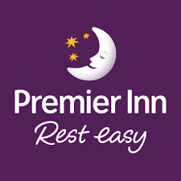
Figure 1: Premier Inn (Premier Inn, 2021).

Situation Analysis
SWOT Analysis
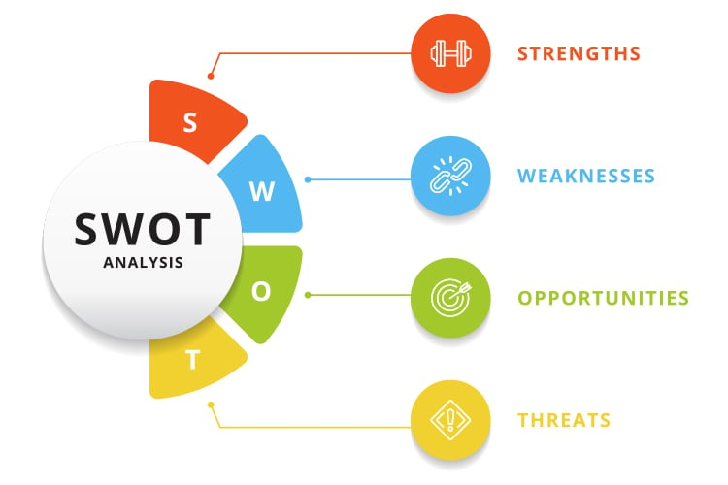
Figure 2: SWOT Analysis (Warhurst, Lloyd and Dutton, 2019).
Strength | Weakness
- 76.3% market share  - Powerful Representation in the Great Britain market with 800 hotels including 8000 rooms (Warhurst, Lloyd and Dutton, 2019).  - The great location most of the hotels are by airports and sea beaches.  - Strong brand image. | - Global presence is low  - Has issues regarding the refund of payment  - Hygiene issues
Opportunity | Threat
- New promising market in Germany.  - New décor which brings new customers. | - Competition from easy hotels along with Ibis  - Legal threats

STP Analysis
Segmentation
Families and Businesses That Are Looking for Accommodations on a Budget (Tarrant, 2020). People with mid-budget, are enthusiastic about the tour.
Target Market
Backpackers and other kinds of tourists are the target market of this company.
Positioning
UK's top budget hotel. There are around 800 hundred hotels in the UK of Premier inn including 8000 rooms.
Porter 5 forces
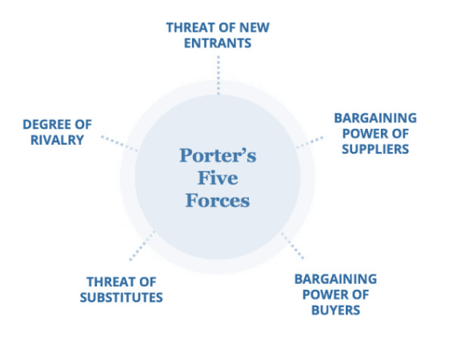
Figure 3: Porter's Five Forces (Tarrant, 2020).
The threat of new entrants | Finding hotel locations is difficult and construction expenditures are expensive. Investing takes time, particularly during development. This hinders market entry (O’ Brain, 2021). In recent years, UK housing values have risen rapidly. The recession hurt the building sector.
Competition | The upmarket, middle market and economy hotels compete during recessions. Mid-market resorts cater to infrequent travellers and have pricier accommodations than cheap hotels. In a recession, customers have less buying power and may select cheaper lodging. Competition is very high.
The threat of new entry | Camping, caravan clubs, B&Bs, and country residences are alternatives. These vacations are affordable. In 2019 and 2020, more families will remain in the UK for financial reasons, benefiting from these replacements (Nickson and Wood, 2021). Easy hotels and Ibis are threats.
Buyer Bargaining power | Hotel competition is tough. To keep customers, companies may establish long-term contracts. Customers have high negotiating power. Consumers have little negotiating leverage with major hotel conglomerates (Neupane, 2020). Small hotels have higher consumer negotiating power, making it difficult to meet their expectations.
Bargaining power of supplier | Hotels have standards for buying furniture. Furnishings are frequently bought in quantity, not individually. So, orders must be based on room count. Specialist contract providers, who also serve the residential market, provide furnishings.
Affiliation: Premier Inn affiliates with local hotels and motels to have local benefits of locations.
PESTEL Analysis
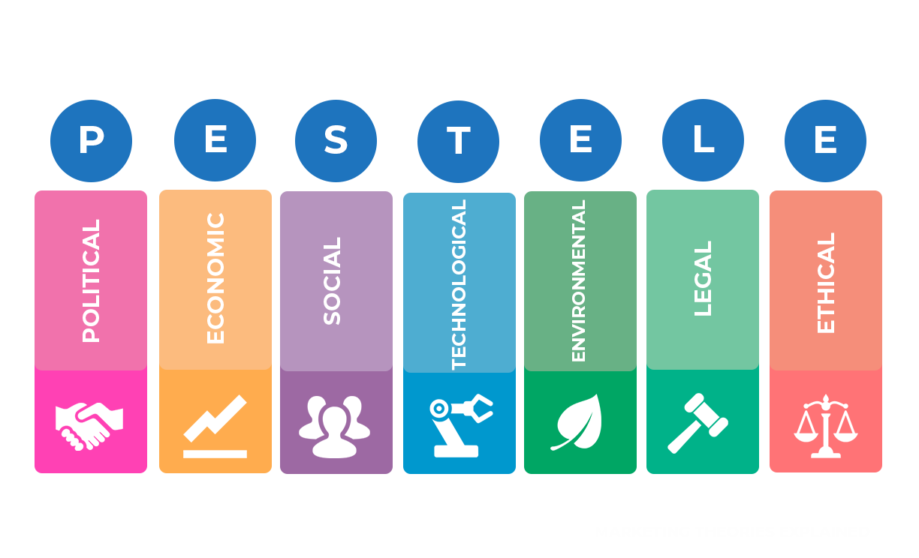
Figure 4: PESTEL Analysis (Nickson and Wood, 2021).
Political factors | There is a risk that the hotel's management may need to make adjustments to their strategies due to sudden changes in government policy and legislation.
Economic Factors | Utility expenditures, wage costs, building leases, corporation tax, and other economic issues all have an impact on that hotel's bottom line.
Social Factors | Customers' requirements and anticipations in the hospitality sector have undoubtedly increased over time (Mitchell, 2021). Besides, the UK, Germany, and The UAE culture support the business.
Technological factors | Premier Inn recently utilised what3words geolocation technology to help customers. Guests may locate their hotel using 3 random words.
Ecological Factors | Environmental impacts include carbon dioxide emission reduction and trash, property cleanliness, and local traffic reduction.
Legal Factors | Premier Inn is bound by several laws and ordinances, including those pertaining to land use and construction, worker health and safety, including minimum pay.

Marketing Mix
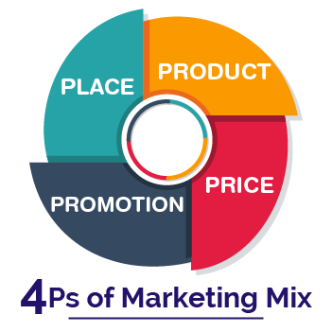
Figure 5: Marketing Mix (Franklin, 2020)
Product
Premier Inn's diversified suite of accommodations caters to a wide range of guests' needs. For example, its family accommodations have a king-sized bed for the parents, two twin-sized pull-out mattresses or couch beds for the youngsters, and a baby crib Many hotels provide linked rooms so that guardians may keep a watch on their children (Harrington and Akehurst, 2020). There are typically three types of hotel rooms: single, double, and big accessible. Premier Inn boasts superior quality with its king-sized Hypnos beds. With free view TV, Hairdryer, coffee maker and free Wi-Fi 24/7, visitors' stay pleasurable. Nearly all Premier Inn hotels offer a bar and restaurant so customers don't have to venture far for meals and beverages.
Price
Premier Inn offers a variety of price options, including "flexible," "semi-flexible," "advanced," "standard," and "non-flexible" rates. The variety of choices they provide to consumers is facilitated by these. The Flex plan is the most accommodating, allowing guests to make changes or cancel their reservation up to 1 pm the day before their scheduled arrival (Fred, 2021). The motel has a reasonable pricing structure with the overarching goal of giving guests excellent value for spending money.
Place
Premier Inn is a budget hotel chain with over 800 locations in the United Kingdom and abroad (among them, Ireland, the UAE, Qatar, and Germany) (Premier Inn, 2021). The hotel's website and mobile app both allow guests to make reservations with ease (Harrington and Akehurst, 2020). Similar to how they may do this directly, they can also use a third-party service like Booking.com, Lastminute.com, or another similar site.
Promotion
Premier Inn relies heavily on promotion as part of its overall marketing strategy. The hotel spends on many types of marketing, including billboards, radio, newspapers, and online and social media (Adam, 2021). In 2022, the company plans to spend £20 million on marketing, with an emphasis on expanding its increased access.

Action
Gantt Chart of Marketing Activity (1 year)
It might take one month of the business to take preparation and decide what should be included in marketing plans. Then the organisation should go for market research. What is the customer expectation from this business? After market research, the business would go for a marketing channel schedule as per the result of market research. It would continue for the rest of the months. After that, the business would collect feedback from potential customers and control the marketing activities and readjust strategies according to that.

Objectives
Primer inn follows SMART objectives where S indicates sustainable, M indicates Measurable A indicates Achievable, and T indicates time-bound. Premier Inn Wishes to gain the most market share in the hotel industry. It currently has a 76% Market share in the UK but it wants to extend its market share all over the world. By providing the best quality service they want to achieve these objectives within 2027 (Clifford, 2020). And it will be measured by various ratios like market share ratios, earning per share ratios, total service earnings etc. And this target is quite achievable and realistic as well for the premier inn.

Strategy
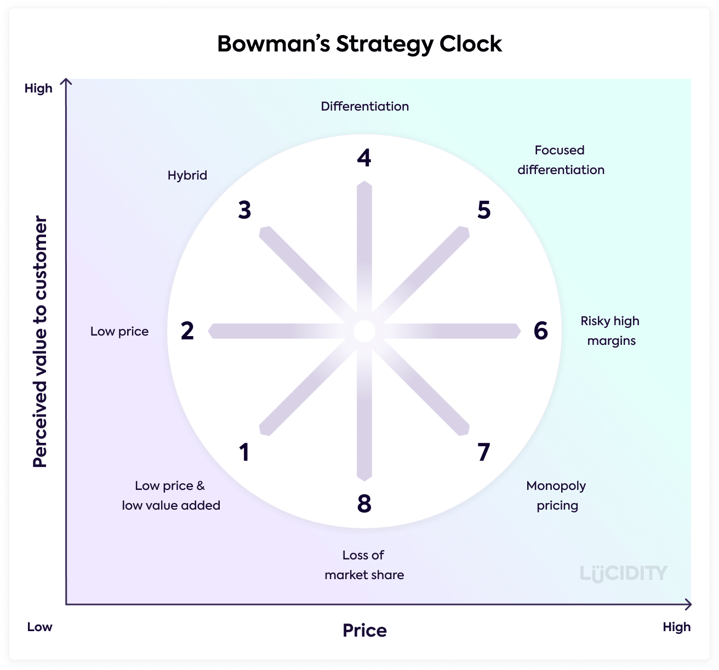
Figure 6: Bowman’s Strategy Clock (Clifford, 2020)
Low Price and High value-added
In this tactic, the focus is on making many sales. The prices are rock bottom, and the quality of the goods or services is as dismal. As a result of these factors, it is the lowest competitive industry of the Strategy Clock (Franklin, 2020). Premier Inn's offer starts at 19 Euros. And this has been able to attract so many customers.
Low price
Low Price is a method for being the cheapest alternative for purchasers. It's a low-margin approach, therefore process productivity and cost reduction are crucial (Harrington and Akehurst, 2020). As the service charges start at 19 Euro, it is quite cheap from the UK people's perspective.
Hybrid
Hybrid combines cheap pricing and distinctiveness. It's about assuring competitive pricing, preferably with a low psychological price from customers, while promoting extra value. The hybrid approach balances cost and distinctiveness while retaining strong profitability. Premier inn tries to readjust its pricing based on competition.
Differentiation
Premier Inn gives the best comforting services at a lower price. Which differentiates the business from its competitors (Jemison and Tavio, 2020). Besides that, the convenience of booking services is also a positive factor for the business.
Focused differentiation
The business targets middle-class people who are interested in travel and touring. And offers the best services at a lower price.
High-risk Margin
Providing the best services at a lower price sometimes proves risky for the business. Especially in the UAE markets.
Monopoly Pricing
Due to existing competition, the business cannot do monopoly pricing.
Loss of Market Share
Premier Inn is losing market share slightly due to increased competition in the hotel industry.

Control
USP
The USP of Premier Inn is its comfort and quality. Premier Inn provides the best services for customers at a reasonable price. The customers don’t have to face any inconvenience in booking hotels or any services from the Premier Inn. One of the biggest features of the business is the convenience of services (Nickson and Wood, 2021). Success is measured by the traffic on the websites of the business. The amount of service ordered and booked is measured through digital data analysis which provides the base for measuring success. And the positive feedback from the customers is what differentiates the business from its competitors.

Conclusion
Premier Inn restaurants have an excellent marketing approach that promotes its goods, rates, offers, and locations. They're well-known within the UK travel and tourism sector because they possess a lot of things going for them. The economy and the government are unsteady, which might lead their sales to decline if they're not ready. The firm's marketing ensures that its goods provide value and that consumers' stays in its hotels are calm and trouble-free. Their internet marketing is effective at attracting and retaining clients since they employ social media and an influential website.

References
Adam, A. (2021). The Hotel industry in Europe. 6th ed. Verlag: Hampton: Icc Business Publications. Clifford, E. (2020). Hotel Industry and Its Contribution to Europe. 2nd ed. London: Samuel Davis.
Devis, F. (2021). Premier Inn Affiliate Program. [online] VigLink.com. Available at: https://www.viglink.com/merchants/35058/premier-inn-affiliate-program [Accessed 1 Dec. 2022].
Franklin, J. (2020). Trends in the UK hotel industry. International Journal of Contemporary Hospitality Management, 8(7), pp.6–10. doi:10.1108/09596119610791682.
Fred, G. (2021). Hotel Industry in the UAE. 8th ed. Verlag: Ottawa: Information Directorate, Translation Bureau = Direction De L’information, Bureau Des Traductions.
Harrington, D. and Akehurst, G. (2020). Service quality and business performance in the UK hotel industry. International Journal of Hospitality Management, 15(3), pp.283–298. doi:10.1016/s0278-4319(96)00021-7.
Jefferson, M. (2021a). Premier Inn pins recovery hopes on marketing with ‘invest to win’ strategy. [online] Marketing Week. Available at: https://www.marketingweek.com/premier-inn-recovery-marketing/.
Jefferson, M. (2021b). Premier Inn pins recovery hopes on marketing with ‘invest to win’ strategy. [online] Marketing Week. Available at: https://www.marketingweek.com/premier-inn-recovery-marketing/.
Mitchell, P. (2021). The hotel industry. Verlag: Milton Keynes: Open University Press.
Neupane, R. (2020). Effects of Coaching and Mentoring on Employee Performance in the UK Hotel Industry. International Journal of Social Sciences and Management, [online] 2(2), pp.123–138. doi:10.3126/ijssm.v2i2.12323.
Nickson, D.P. and Wood, R.C. (2021). HRM in the UK hotel industry: a comment and response. Human Resource Management Journal, 10(4), pp.88–93. doi:10.1111/j.1748-8583.2000.tb00008.x.
O’ Brain, E. (2021). Hotel Industry Research Progresses At Cornell. Cornell Hotel and Restaurant Administration Quarterly, 6(4), pp.40–40. doi:10.1177/001088046600600406.
Premier Inn (2021). Premier Inn Home. [online] Premier Inn. Available at: https://www.premierinn.com/gb/en/home.html.
Tarrant, C. (2020). UK hotel industry — market restructuring and the need to respond to customer demands. Tourism Management, 10(3), pp.187–191. doi:10.1016/0261-5177(89)90068-x.
Warhurst, C., Lloyd, C. and Dutton, E. (2019). The National Minimum Wage, Low Pay and the UK Hotel Industry. Sociology, 42(6), pp.1228–1236. doi:10.1177/0038038508096943.

Presentation


