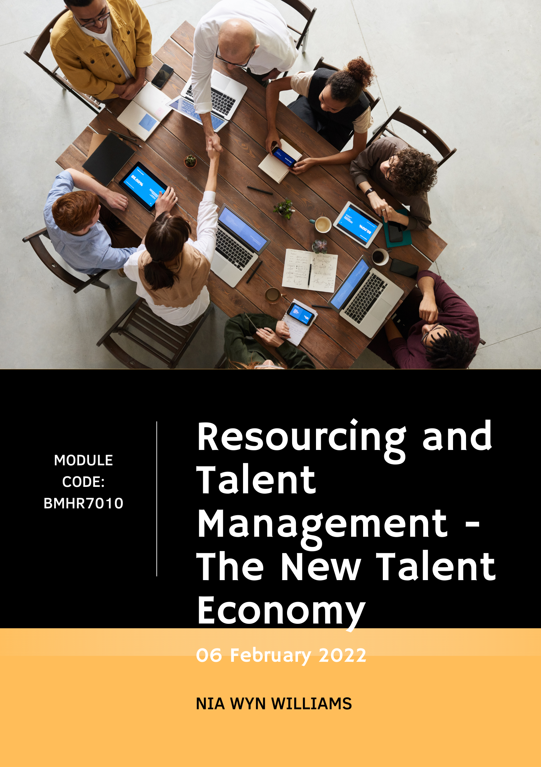



Qualification: Post Graduate Diploma in HRM
Module Name: Resourcing and Talent Management
Module Code: BMHR7010
Word Count: 4500
Student Name: Nia Williams
Student Number: 1806523
CIPD Membership Number: 53274221

By signing below, I confirm that the work presented is my own, unaided work. I understand the regulations pertaining to candidate malpractice and the action that may be taken as a result.

Signed: N.Williams
Date: 06 February 2022

Glossary of Terms

- ATS – Application tracking system
- CSG&CC – Coleg Sir Gar and Coleg Ceredigion
- COVID-19 – Coronavirus
- PEST - (Political, Economic, Social and Technological)
- SWOT – Strengths, Weaknesses, Opportunities and Threats
- TM -Talent Management
- VUCA – Volatility, uncertainty, complexity and ambiguity

Executive Summary

To be written at the end
Contents
Glossary of Terms 3
Executive Summary 4
1.0 Introduction 6
2.0 Literature Review 8
• 2.0.1 External Environment 9
➢ Economic 9
➢ Technological 12
• 2.0.2 Internal environment 15
• 2.0.3 CSG&CC process with meeting the challenges of future of work 17
3.0 Conclusion 25
3.0 Recommendations – NOT YET WRITTEN 26
4.0 References 27

Introduction

This report will relate to Coleg Sir Gar and Coleg Ceredigion (CSG&CC) that addresses the challenge “Increasing use of technology in the recruitment process” as identified by CIPD (2020).
CSG&CC is a Further and Higher Education college made up of seven campuses with five located in Carmarthenshire and two located in Ceredigion. There are approximately 850 employees which are made up of academic and business support staff who have various contracts such as permanent, temporary, and casual contracts. CSG&CC is a hierarchical organisation where decisions are made at the top and filtered down. The college’s mission statement is “to be excellent, the college of choice”. Figure 1 outlines the values and behaviours that the college champions to become “excellent” (Coleg Sir Gar, 2022). These are outlined in job descriptions to attract the right person whose values and behaviours align with the company.
Figure 1 - Values and Behaviours at CSG&CC (Coleg Sir Gar, 2022)
To support this, the HR strategic priorities at CSG&CC are to deliver excellent recruitment, people learning and development, internal partnership working, and organisation performance. How these are achieved is listed in appendix 1. The HR strategy was created in 2020 but has not yet been implemented fully. The strategic priority to deliver “excellent recruitment” is to establish a strong employer brand, develop a competency framework and specification, develop workforce planning and forecasting, develop and implement best candidate attraction, deliver best practice selection techniques, provide excellent candidate experience from application to onboarding and to establish and manage a talent pool (Coleg Sir Gar, 2022).
According to Taylor (2018) resourcing activities aim to help six central HRM objectives. These include staffing, administration, performance, change management, reputation-building and promoting employee well-being. CIPD (2021) defines talent management (TM) as “seeking to attract, identify, develop, engage, retain and deploy individuals who are considered valuable to an organisation. It should align with business goals and strategic objectives”. Managing TM successfully will lead to a high-performance organisation and add value to the organisation’s brand (Armstrong, 2017).
The aim of this report is:

This will be achieved by the following objectives:

This report is produced for consideration by the Executive board. Formal approval will need to be given to implement the recommendations suggested to improve TM within the college.

Literature Review

CSG&CC is currently operating in a VUCA (Volatility, Uncertainty, Complexity, and ambiguity) environment where there are constant, unpredictable changes emerging. To survive in this environment organisations, need to adapt and become agile to cope with unpredicted change (Adani, 2021).

2.0.1 External Environment

According to CIPD (2021) organisations need to understand external factors that influence TM especially when operating in a VUCA environment. A useful method for exploring this is through a PEST (political, economic, social, and technological) analysis. From undertaking this, the main factors that influence on TM at CSG&CC is Economic and Technological changes.

Economic

- Constraint recruitment budgets
According to CIPD (2020), the pandemic has resulted in recruitment budgets being increasingly constraint and it is more important than ever to ensure that the money is being spent effectively within this process. With this in mind, it means that organisations like CSG&CC have tight budgets to invest in improvements within the recruitment process like increasing technology.
- Tight labour market
CSG&CC are operating in a tight labour market where there is an increased level of employment (Reid, 2022). According to ONS (2021) unemployment rates in the UK are currently 4.2% which is 0.2% higher than before the pandemic and employment rates currently at 75.5% which is 1.1% lower than before the pandemic. When operating in this labour market, there are not enough people with specific skills and the demand for people outstrips supply and employees have increased bargaining power (CIPD, 2021). This is evident within CSG&CC where the college has experienced difficulty in recruiting specialist roles such as Lecturers in Health and Social Care with the current recruitment process that is in place. This corresponds with data by CIPD (2021) where data suggests that recruitment difficulties have increased and that the proportion of employers with hard-to-fill vacancies has jumped from 39% to 47% in the last quarter of 2021. The increase in bargaining power has also been experienced where employees are demanding more in terms of autonomy, flexibility, working conditions, development opportunities, and pay. According to Christian (2021), the pandemic has also resulted in the “Great Resignation” where employees have re-evaluated their careers, work/life balance, and long-term goals. Within CSG&CC data from September 2020 – August 2021 saw 60 employees resigning in comparison to 36 employees from September 2019-August 2020 with some reasons being retirement and new job opportunities which offer more flexibility. This has impacted on retention and recruitment as employees are looking for jobs where they can have a better work-life balance and flexibility. According to Reid (2022), it will be the most creative employers who are best able to hire and retain in the “Great Resignation” environment.

- Aging population
According to ONS (2019), the UK’s population is ageing. By 2050 it is projected that one in four people in the UK will be aged 65 years and over. This impacts on TM as with age comes experience which is a benefit for organisations. According to Business Wales (2021), it is important to invest in these employees and encourage them to stay. Ways this is done within CSG&CC is through offering flexible working in terms of decreasing their hours. This will result in new employees working alongside experienced employees. Another way is through training and development. If organisations do not invest in these groups it can result in a large group retiring at once and a loss of skill and experience. The three largest age profile within CSG&CC is 51-55 (108 employees), 56-60 (104 employees) 61-65 (66 employees).
An aging population can also be affected by the increase of technology in general and within the recruitment process. Older employees are less familiar and confident with using technology compared to generation Z where preferred communication methods differ (Mayhorn, 2012), (Hackle, 2020). Currently, CSG&CC offers training to employees around technology. This will benefit employees if they wanted to apply for internal vacancies through the use of technology.

Technological

- Increase desire for remote working
The increased desire to work remotely and work more flexibly can have an impact on TM (Acas, 2021). Since the pandemic and the increase in home working, people have enjoyed the flexibility of being able to work from home and not have to travel into work. According to ONS (2021), when asked about homeworking, working adults stated work-life balance was the greatest positive that came out of the pandemic. 85% of employees wanted a “hybrid” approach of both home and office working going forward and as a result, employees are seeking jobs where employers offer them this. Those organisations that do not provide this in their job descriptions will lose out to competitors that offer this new way of working. Existing employees will also want to seek employment elsewhere where flexible working is offered causing these organisations to struggle with retaining employees and surviving (Brown, 2021). According to McKinsey (2021), the future of work will be hybrid but less intensely than at the pandemic’s peak. It is important for organisations not to go back to their old ways of working but to keep elements of home working in case of other pandemics. This will allow for a smoother transition to home working. The increase desire for home working is affecting CSG&CC as this type of working has now disappeared since COVID-19 restrictions have eased. This has brought challenges which will be explored under section 2.0.2.
- Increase in AI
The increase in Artificial Intelligence (AI), and robots has also impacted TM as it means that AI and robots can now perform roles that are easier to perform such as administrative jobs (PricewaterhouseCoopers, 2017). According to McKinsey (2017), automation will displace between 400-800 million jobs by 2030 which means that these people will need to retrain to harder performed jobs such as Lecturers where it is harder for automation to replicate. It is important CSG&CC develop and invest in these people through short- and long-term courses so they are able to retain to harder performed jobs in the future. If these people do not retrain it could result in redundancies with CSG&CC as AI will replace them. This is seen in most organisations in recruitment where technology and AI are increasing within the process removing the need for humans to perform tasks such as application screening.
- Increase of technology in recruitment
Organisations are now focusing on increasing technology in their recruitment to keep up with labour market changes and to gain a competitive advantage.
In the public sector the top effective attraction methods in 2020 according to CIPD (2020) were:
- Recruitment/search consultants – 75%
- Own corporate website – 65%
- Professional networking sites for example LinkedIn – 62%
- Internal advertising to existing talent pool – 63%
- Commercial job boards – 58%
The top methods used to select applicants in 2020 were:
- Previous work history/experience – 89%
- Through CV/Application screening – 78%
- Competency-based interviews – 76%
There is less interest in using methods such as personality/psychological questionnaires (35%) assessment centres (32%) and gamification (2%) in their selection methods.
Overall the top use of technologies in the recruitment process in 2020 were:
- Video or Skype interviews - 68%
- Telephone interviews – 65%
- Applicant tracking systems – 43%
- Online tests/assessments – 35%
Google is an organisation that makes extensive use of technology within its recruitment process. Some ways they use this is through online assessments, virtual chats over the phone or video, and application tracking systems to simplify the hiring process (Google, 2022), (Kalibrr, 2016).
The increase of technology in recruitment has had an impact on TM within CSG&CC as it has meant that candidates are applying for jobs with competitors who have a simpler and effective recruitment process in place. The current process at CSG&CC will be explored in detail in section 2.0.3.

2.0.2 Internal environment

The external environment has helped to identify the internal factors that are affecting TM within CSG&CC. A useful method to identify these factors is through a SWOT (strengths, weaknesses, opportunities. and threats) analysis. Figure 2 is a SWOT analysis identifying internal factors that effects CSG&CC resourcing and TM (BBC, 2022).
Figure 2 - SWOT analysis on CSG&CC
- Little use of technology within recruitment
The main internal factors affecting TM within CSG&CC is that the college makes little use of technology within the recruitment process. The recruitment process currently is heavily paper-based, the onboarding process is outdated, there is poor candidate experience throughout and there is no ability to talent pool. The current process in place may impact attracting and recruiting candidates and it can lead to poor candidate experience and could impact on retention in the organisation.
- Decrease in recruitment budget
As identified by external factors (CIPD, 2020), budgets within CSG&CC decreased during the pandemic and the main focus was on survival. Now that restrictions are easing and COVID-19 cases are reducing, budgets for recruitment are slightly increasing within the college. CSG&CC is still acting with caution and are trying to effectively spend this money. This has therefore had implications on improving the recruitment process.
- HR Strategy not implemented
Another internal factor that is affecting TM within the college is the HR strategy (Appendix 1). This was developed in September 2020 which details how HR will improve the recruitment process. This strategy has not been implemented which means that what recruitment does in practice is not aligning with the HR strategy which does not support the overall organisations strategy (XpertHR, 2021). The HR strategy is to make use of more technology in our recruitment process which is not what is happening in reality.
- Lack of flexibility
During the pandemic working from home was greatly welcomed and employee feedback suggested that they wanted this to continue as it allowed them to have a better work-life balance. Now that COVID-19 is more controlled and organisations have re-opened, CSG&CC’s expectation since September 2021 is for all staff to be back on site. Since this requirement, there has been an increase in turnover impacting and an increase in sickness. With more people leaving this has impacted on recruitment. It has also been impacted as the number of candidates applying for roles has decreased. Not allowing for a hybrid working approach is not attractive to applicants when competitors are offering this new way of working. This results in lower applications and makes the process difficult to fill roles (The Economist, 2022).
The organisation values and behaviours are currently not aligning with what the organisations do in practice as one value is “flexibility”. Not offering a hybrid approach to working could mean that we are missing out on the best talent for the organisation and competitors that do offer this are gaining a competitive advantage (pwc, 2021).

2.0.3 CSG&CC process with meeting the challenges of future of work

Research has suggested that the main challenges of the future of work for CSG&CC are the increased use of technology within the recruitment process and the increasing desire for home/hybrid working (McKinsey, 2020). Below is an analysis of the current process/practices CSG&CC have in place for the two. Currently CSG&CC are not meeting the challenges of the future of work.
Recruitment process
According to CIPD (2021), it is important to have good recruitment within organisations to have an impact on longer-term issues such as employer brand, performance, and future skills development. Recruitment and resourcing involve attracting and selecting individuals into a job role. Recruiting the right individual is crucial for organisations that need people with the right skills and capabilities to deliver their goals (Ridding, 2019).
Within CSG&CC the recruitment process is heavy on administrative tasks such as preparing job packs, advertising on social media, indeed, FE Jobs and the college website and tracking equality and diversity statistics manually. Applicants are asked to either complete an electronic application form or a paper version. When the vacancy has closed, HR prepares a folder for the line manager which contains the applications forms, job description, and shortlisting criteria. They will shortlist the appropriate candidates and arrange with HR the date of the interview and HR send out letters inviting them to interview. Depending on the post title, the interview process varies. For a lecturer, the interview process consists of a formal interview involving a few questions and a micro-teach lesson to view their teaching style and capability.
After the interview HR create a contract and offer letter along with starter documentations to the successful candidate. HR also has to manually request references by sending them either by post or by email.
This process involves very little technology. The only technology that the organisation uses is advertising on social media, job boards such as FE jobs, and on the college website which were some of the effective ways to attract candidates in 2020. The recruitment processes overall is very dated in comparison to organisations that are making use of more technology in recruitment as mentioned previously. According to CIPD (2021), candidate experience is a key part of resourcing. They must experience a good recruitment process.
CSG&CC’s main issue with recruitment are the length of time it takes from advertising to getting the employee on board as it involves a huge number of administrative tasks by HR which can delay the process. This demonstrates how paper-based the recruitment process is that is currently in place.
Hybrid working policy
According to Moss (2020), a blend of home and office working (hybrid) is seen as most productive and is the future of work after the pandemic. Hybrid working is the new way of working as research suggests that It has a positive impact on employee motivation, commitment and engagement. According to CIPD (2021), if organisations do not explore hybrid working options, their competitors may be willing to do so, something that could deprive the organisation of valuable member of staff.
Currently, the college does not have a hybrid working policy in place. A hybrid working policy should be considered as employees have demonstrated that they have been able to work from home successfully during the pandemic. A clear hybrid policy would outline how processes work and how to make a hybrid working request etc (Acas, 2022). Implementing a hybrid policy will also demonstrate that the organisation are delivering on their value of “flexibility”. It will also allow the organisation to gain a competitive advantage and attract a greater audience to work for the college (Stern, 2022). Currently the college is only attracting a small niche of candidates which is why the number of applications is low.
2.0.4 Advantages and Disadvantages of technology in recruitment
As research has suggested, organisations are increasing technology within the recruitment process. It is important to analyse the advantages and disadvantages of some of these methods in the recruitment process and to determine which methods CSG&CC could implement to improve TM.

Social Media
CSG&CC currently utilise social media to market their vacancies. Social media is a cheap way for organisations to reach large audiences. It also attracts people that are not necessarily looking for a vacancy to seek more information. LinkedIn in particular provides employers with an unrivaled opportunity to open up direct channels of communication about job opportunities with target groups of candidates and to build relationships with them. There are some disadvantages to advertising on social media as posts can generate negative comments from rejected applicants and social media may not always be the best way to advertise to attract certain candidates. CSG&CC should continue with this way of advertising as it is one of the top effective selection methods by organisations (62%). It should also be continued as 41% of applicants stated that they saw the vacancy being advertised through social media within CSG&CC.
Application Tracking system (ATS)
ATS can help reduce time spent with administrative tasks as it can post to multiple job boards, track candidate applications, notify candidates individually, schedule interviews and interview feedback, and schedule references without having to do it manually (CIPD, 2021).
The system can also screen CV/applications and filter out candidates that do not meet the minimum requirements. This system improves the quality of hire and speeds up the recruitment cycle which boosts employer brand and enhances the experience. It means that onboarding is improved as candidates will be able to start quicker. Implementing this type of system is expensive and is only beneficial if an organisation receives a high number of applications.
In some organisations, the system is used mainly to screen out applications that do not meet the job expectations by removing applications that do not include specific words. By doing this it could mean that organisations can miss out on good applicants.
CSG&CC does not currently have a system like this in place however, although they are expensive to implement in the long term it would help speed up the recruitment process as currently it is heavily paper-based. Companies such as Pinpoint is an example of a system that helps organisation to attract, hire and retain top talent. Organisations such as M&S, Burger King, and Costa use Pinpoint. Pinpoint’s main features are a job board marketplace, branded career site, recruitment agency portal, recruitment advertising, employee referrals, talent pools, interview scheduling, candidate profiles, video interviewing (PinPoint, 2022). This should be considered going forward as the system helps with cutting down on administrative tasks.

Gamification
Gamification is on the rise within the selection phase of the recruitment process. This is when organisations use game activities to test job applicants’ ability to do certain tasks. It can be beneficial as the organisation can see how someone reacts in different types of situations. Gamification can include computer games and simulations. There are disadvantages to this as only 2% of organisations in the UK have adopted this in their selection process and not much research has been done on the effectiveness of these game-based selection techniques (CIPD, 2017), Hawkes et al (2018). CSG&CC does not use gamification as part of their selection process and based on the little research that has been done this option does not seem sensible to implement currently.
Online Tests – adv and dis of this ??

Overall the benefits outlined in the CIPD (2020) report suggested that the use of technology in the recruitment process has resulted in increasing accessibility for candidates, resulted in a speedier recruitment process, and an improved candidate experience. For many organisations, technology has allowed them to attract a wider pool of applicants, both suitable and unsuitable. According to CIPD (2020), tech recruitment solutions must be tested and deployed to ensure that they are not disadvantaging candidates and that they are accessible. Some ways that this can be done is through continuingly evaluating and improving the technology and by asking candidates for feedback and acting on that feedback. It is important to review the impact of the use of technology in recruitment on the diversity of the hires and the number of suitable versus unsuitable candidates of positions within the college.
When evaluating the process that is in place at CSG&CC against the benefits of the increasing technology in the recruitment process it is important that CSG&CC make use of technology more in order to compete with competitors, to make sure that the right person is selected for the role and to provide a better applicant experience. Currently, CSG&CC makes use of social media, website and, job boards at the attraction stage but does not make use of any other technology within the process. Although some methods are not suitable for CSG&CC such as gamification and personality tests CSG&CC could benefit significantly from the implementation of an ATS.

3.0 Conclusion

External factors highlighted that there is an increase desire in employees wanting to continue home working after the pandemic. The pandemic highlighted that working from home allowed them to have a better work-life balance. Since COVID-19 restrictions have eased, CSG&CC asked for all employees to return to work which has impacted the organisation as it has increased sickness and turnover rates. There is an increase in people resigning as they have re-evaluated their lives after the pandemic and are seeking employment elsewhere where other organisations are allowing for employees to work from home. This has a direct impact on recruitment as job descriptions are not attractive compared to competitors. Employees have now got more bargaining power to demand things like flexible working because of the labour market that organisations are now operating in.
To address this issue, a hybrid working policy should be considered to retain employees and to make job descriptions more attractive against competitors. This would also lead to happier employees that would be more motivated, committed, and productive. It will also mean that the organisation is achieving “flexibility” as part of one of the values of the college.
Secondly, external factors highlighted the increase of technology within the recruitment process and the methods used by organisations. CSG&CC’s current recruitment is heavily paper-based and involves heavy administrative duties by HR. CSG&CC should consider implementing an ATS to help with this and improve the quality of hire and speed up the recruitment cycle and enhance customer experience. If implemented, it should not be used to filter applications as this can result in loosing suitable candidates for the role. This should be considered alongside the current process of advertising on social media and the website.
Introducing more technology into the recruitment process will help achieve the HR strategy vision to deliver excellent recruitment by developing and implementing the best candidate attraction. Currently what the HR strategy says is not what is being delivered in practice. This will then be closely aligned with the organisation’s strategy in “achieving excellence”.

Recommendations – NOT YET WRITTEN

- Hybrid working policy - this will align with values and behaviours of org “flexibility”
- Application tracking system (ATS) - Implement Pinpoint:– this will align with the HR Strategy
Create a action plan with costings etc.

4.0 References

This is on a separate document currently

Appendix 1



