Saima Hussain

1809067

Mumtaz Goolam

BMHP 5003

Introduction to physiology

Poster

THE URINARY SYSTEM
The urinary system preserves water balance within the body by utilising the ADH hormone and varying the concentration of the urine. It eliminates left-over substances which are absorbed from food and eliminates waste products from metabolism such as urea from the breakdown of proteins (Lawrie and Kearsey, 2016, P.89). The urinary system is the main removal system which is made of the following components kidneys, ureters, urinary bladder, urethra renal artery and renal vein (Waugh and Grant, 2018, P.369).

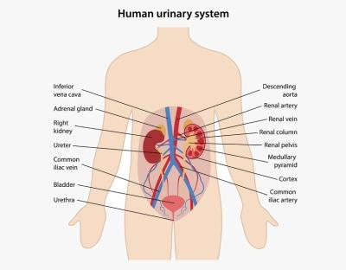
LEFT KIDNEY
- Descending aorta- travels down from the heart carrying oxygenated blood to the other organs.
- Renal artery- carries a third of the blood to the kidneys to be filtered.
- Renal vein- carries blood from the kidney and the ureter to the inferior vena cava.
- Renal column- between the renal cortex and renal pyramids (Waugh and Grant, 2018, P.371).

- Common iliac vein- drains blood and connects to the femoral vein (blue thick vein).
- Bladder- the bladder stores urine and is lined with layers of muscle tissue that can stretch and hold up to 600ml of urine.
- Urethra- transports urine out if the body (tube, not a vein because it doesn’t carry blood) (Waugh and Grant, 2018, P.370).

RIGHT KIDNEY
- Inferior vena cava- caries deoxygenated blood to the heart.
- Adrenal gland - is the glands that produce hormones such as adrenaline and cortisol (yellow mass).
- RIGHT KIDNEY
- Ureter- is a tube that carries urine from the kidney to the bladder (Waugh and Grant, 2018, P378).

- Medullary pyramid- supports the kidneys
- Cortex- provides space for the blood to diffuse into the nephrons
- Common iliac artery- provides blood to the bones and other organs in the abdomen.

(BIOLOGY DICTIONARY, 2020)
VIEW INSIDE OF THE KIDNEY
THE NEPHRONS
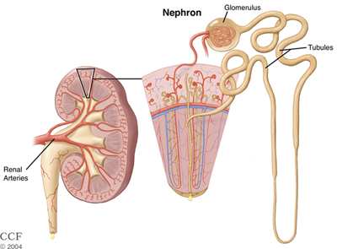
Kidneys have millions of tiny nephrons. These tiny nephrons are responsible for filtering all of our body’s blood and can filter up to 170 litres a day. A nephron contains a glomerulus, which is a small blood vessel, and a tubule, which collects urine (Cleveland clinic, 2020).
A nephron is used to filter water, ions and small molecules from the blood, as well as wastes and toxins, and return needed molecules to the blood. The nephron functions through ultrafiltration (Biology Dictionary, 2020).

(Cleveland clinic, 2004)
What is selective reabsorption?
Selective reabsorption occurs in the kidneys and it involves removing the useful substances from the waste duct and puts it back into the bloodstream. Most of the selective reabsorption happens through the proximal convoluted tubule which extends from the bowman’s capsule. It has microvilli which increase the tubes surface are for selective reabsorption the tubule is single celled and has no gaps for substances to leak out. The selective reabsorption allows for efficient use of our reassures one demonstration of faulty nephrons is foamy urine due to escaped urine (BioNinja, 2020).
What minerals do we reabsorb from the blood in the nephrons? Amino acids and glucose.
Why do we filter out urea from the blood?
Urea is the waste product form the body and contains harmful levels of nitrogenous waste and it is necessary to remove the urea to balance the mineral and salt content in the bloodstream (BBC Bitesize, 2020).
What other molecules do we remove from the blood via the nephrons?
Sodium, Calcium, Phosphorus, and Potassium.

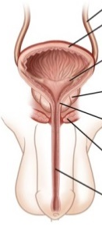
MALE AND
- Ureter- carries urine from the kidneys to the bladder (Medlineplus, 2020).
- Smooth muscle- contracts to push the urine through the sphincter .
- Ureteral opening (role)- are covered with mucosa(small flaps that regulate the amount of urine entering the bladder).
- Prostate gland is a minor gland, positioned in the pelvis in the middle of the penis and bladder (NHS, 2020).
- Internal sphincter- is in the inside surface of the canal it is collated of concentric
Layers (Jung et al, 2012).
- External urethral sphincter is made of skeletal muscle fibres (Hubert, 2019).
- Urethra.

- Urethra- is the tube that allows the urine to leave the bladder (Waugh and Grant, 2018, p. 370)
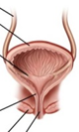
FEMALE
UNRINARY
TRACT
SYSTEM
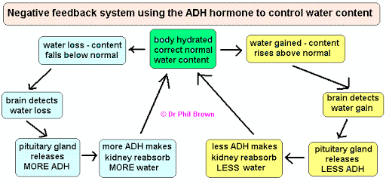
(neuropt,

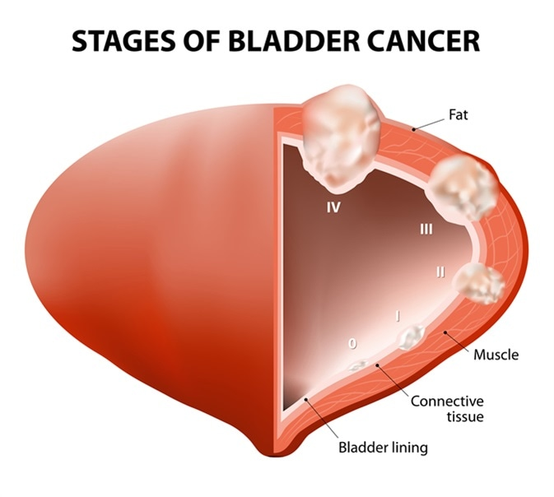
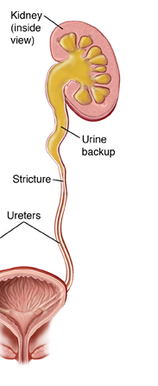
2019)
This is one of the complications the urinary system can experience. There is a backup of urine due to the stricture which prevents the passage of urine by narrowing the ureter’s lumen (Saint Lukes 2020).
Ureteral Stricture Surgery (Ureteroplasty) (Saint Lukes 2020)

Cancer of the bladder is when abnormal tissue growth commonly named a tumour, develops in the structure of the bladder. And in some instances it spreads into the bladder muscle. The most common symptom of this is blood in the urine (NHS, 2018).
Symptoms of bladder cancer are as follows;
Haematuria (streaks of blood in the urine),” a need to urinate on a frequent basis, sudden urges to urinate, a burning sensation when passing urine, pelvic pain, bone pain, unintentional weight loss and swelling of the legs” (NHS, 2018).

ADH HORMONE REGULATION.
ADH which stands for anti-diuretic hormone is responsible for regulating the concentration of the urine in order to have the most efficient amount of water in our body (Healthline, 2020).
“Antidiuretic hormone (ADH) is a chemical produced in the brain that causes the kidneys to release less water, decreasing the amount of urine produced. A high ADH level causes the body to produce less urine. A low level results in greater urine production ”(My health Alberta .ca, 2020).
2001
The effects of age on the ability to retain urine?
Over time our urinary system begins to degrade, we lose the capacity of our bladders and often find that we need the toilet more frequently. This is because our bladders cannot hold as much fluid as it used to and our sphincter loses its rigidity over time which causes our urine retention and ability to wait for the toilet becomes more difficult (Preminger, 2019).
In women the urethra shortens and the lining becomes thin.
Ureters do not change with age however the flow out of the bladder and into the urethra becomes slow due to the weak smooth muscle.
Also the chance of sporadic bladder contractions increases as age does leading to a higher chance of wetting yourself and there is often more residual urine which can lead to urinary tract infections.
After around 30 to 40 years the kidneys begin to slow down on the blood filtering as the arteries have narrowed. This makes it harder for the nephrons to filter out toxins and drugs from the blood.

Haematuria doss not always mean that you have bladder cancer, there are other causes of haematuria which are as follows “a urinary tract infection, such as cystitis. A kidney infection. Kidney stones and urethritis as well as finally in men an enlarged prostate gland” (NHS, 2018).

REFERENCES
BBC B itesize (2020) Maintaining water balance in the body. [Online] Available at: http/www.bbc.co.uk>bitesize>guide>revision. (Accessed: 5th November 2020).
Biology Dictionary (2020) Urinary system. Definition, Function and …. [Online] Available at: http://www biologydictionary.net/urinary-system/. (Accessed: 24th October 2020).
BioNinja (2020) Selective Reabsorption. [Online] Available at: https://ib.bioninja.com.au/higher-level/topic-11-animal-physiology/113-the-kidney-and-osmoregu/selective-reabsorption.html. ( Accessed: 31st October 2020).
Brown (2020) ADH flow chart. [Online] Available at: https://www.docbrown.info/ebiology/homeostasis3.htm. (Accessed: 5th November 2020).
Clevelan Clinic (2020) Chorionic kidney disease: causes, symptoms. [Online] Available at: http://wwwmy.clevelandclinic.org/health/diseases/15096-kidney-diseses-chonic-kidney-disease. (Accessed: 24th October 2020).
Jung, J., Ahn, K, Hyo and Huh, Youngbuhm., (2012).’ Clinical and Functional Anatomy of the Urethral Spincher’. International Neurourology Journal, 16 (3), pp102-106. Available at: https://www.ncbi.nlm.nih.gov/pmc/articles/PMC3469827/. (Accessed:5th November 2020).
Healthline (2020) What is an AHD test. [Online] Available at: https://www.healthline.com/health/adh. (Accessed: 29th October 2020).
Hubert (2019) Anatomy and physiology of the urinary tract. [Online] Available at: http://wwwneuropt.org/doc/default.source/sci-sig/facts-sheet/. (Accessed : 5th November 2020).
Lowrie, P and Kearsey, S (2016) The Urinary System. London
Medlineplus (2020) Ureteral Disorders/Ureters/Ureter Function/Medlineplus. [Online] Available at: http://wwwmedlineplus.gov/urereraldisohtml.. (Accessed:22nd October 2020).
My Health.Alberta.Ca (2020) Antidiuretic Hormone (ADH). [Online] Available at: https://www.myhealth.alberta.ca/Health/page/conditions. (Accessed: 31st October 2020).
Neuropt (2019) Components of the urinary tract. [Online] Available at: https://www.neuropt.org/docs/default-source/sci-sig/fact-sheets/sci-sig-fact-sheet-urinary-tract-anatomy-physiology.pdf?sfvrsn=6da25343_2&sfvrsn=6da25343_2. ( Accessed: 5th November 2020).
NewsMedicalLifeSciences (2001) Bladder Cancer Type. [Online] Available at: https://www.news-medical.net/health/Bladder-Cancer-Types.aspx. (Accessed: 31st October 2020).
NHS (2018) Bladder Cancer. [Online] Available at: http://www.nhs.uk/conditions/bladder-cancer/. (Accessed: 31st October 2020).
NHS (2020) Benign prostate enlargement-NHS. [Online] Available at: http://www.nhs.uk>conditions>prostate.enlargement. ( Accessed: 3rd November 2020).
NHS (2018) Symptoms Bladder Cancer. [Online ] Available at: http://www.nhs.uk/conditions/bladder-cancer/symptoms/. ( Accessed: 31st October 2020).
Pathophysiology (2020) What is urinary retention? Urinary tract anatomy. [Online] Available at: sites.google.com/site/whatisurinaryretention/home/pathophysiology. (Accessed: 24th October 2020).
Preminger, M. G. (2019) Effects of aging on the urinary tract, kidney and urinary. [Online] Available at: http://www.msdmanuals.com>en-gh>home>effects –of-aging. (Accessed: 30th October 2020).
Saint Lukes (2020) Ureteral Structure Surgery (Ureteroplasty). [Online] Available at: https://www.saintlukeskc.org/health-library/ureteral-stricture-surgery-ureteroplasty. (Accessed:31ST October 2020.
Waugh, A. and Grant, A. (2018) Ross and Wilson Anatomy and Physiology in Health and Illness. 13th edition. Elsevier.

