Assignment
Portfolio For Linux Operating Systems

COMPUTER Architecture and Operating Systems

Assignment 1 Portfolio – Operating Systems

Student Name: Richard Valentine Mamuto

Student ID: 2442383

Lecturer’s Name: REDWAN AL AMRI

Contents
Introduction 3
Task 1. Key Functions of General Operating Systems 3
Task 2. Use of Windows OS CLI Commands 6
Task 3. Use of Linux OS CLI Commands 14
Task 4. Use of Windows OS Scripts 20
Task 5. Use of Linux OS Scripts 23
Conclusion 25
References 26

Introduction
My report presents a practical and analytical discussion of the major operating system functions in both Windows and Linux operating systems. It shows how basic administrative features such as file handling, process monitoring, inspection of memory, network troubleshooting and automation are done using command-line interfaces and scripting languages. All activities are backed up with actual execution outputs, screenshots and descriptions to show system behaviour and administrative processes. The report analysing PowerShell scripts on Windows and Bash scripting on Linux shows the advantages of both systems in terms of supporting system administration, troubleshooting, and automation. On the whole, the report enhances skills that are necessary in competent OS-level management.

Task 1. Key Functions of General Operating Systems
Recent operating systems (OS) like Microsoft Windows are set up to handle hardware resources, run programs and offer a friendly user interface enabling users to effectively interact with the system. These universal operating systems combine primary capabilities such as file system operations, process management, memory management, device operations and security implementation [1]. The screenshots below show how Windows exposes the user to these functions using graphical tools like File Explorer, Task Manager, and Device Manager, all of which depict a fundamental field of OS functionality.
The initial picture, Windows file explorer, shows that the OS is in charge of the file system. The operating systems arrange data in hierarchical directory trees and facilitate file operations like creation, deletion, copying and modification. Under the File Explorer interface, one can use it to navigate files by folders, run program directories, as well as access storage devices in a single environment. As observed in the screenshot, the displays of WindowsPowerShell, Microsoft SQL Server, Common Files, and user folders (Desktop, Documents, Pictures) are arranged in a navigable format. Under this interface, Windows relies on NTFS (New Technology File System) to keep metadata, enforce access controls, make journaling, and preserve system integrity. Managing files is a core operation of the OS as it allows effective access to data and a safe distinction between system files and user files [2].
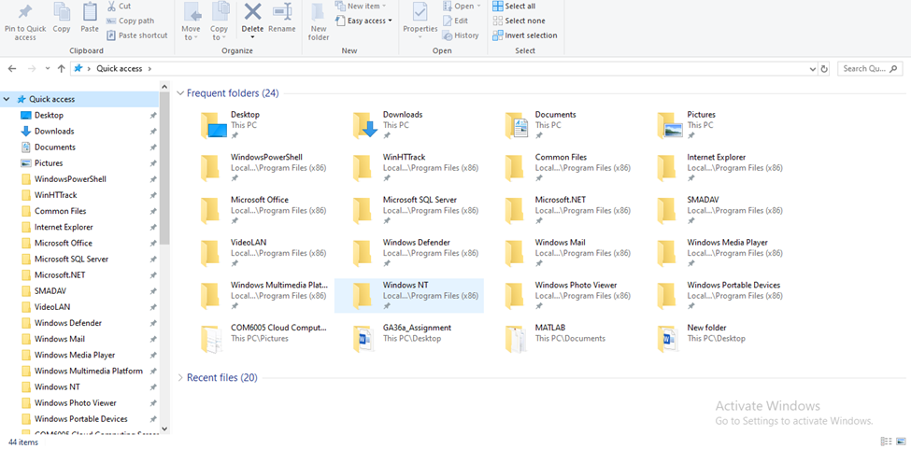
Figure 1: File Management
The second screenshot, which was taken in Task Manager, shows how the OS manages processes and memory. Windows operates several applications that are currently running by distributing CPU time, process scheduling and monitoring memory usage. In the screenshot, there are some active processes, i.e., Antimalware Service Executable, AnyDesk, Client Server Runtime Process, and various system services. The memory and CPU load, disk activity, and power consumption are shown in each process. Windows is based on a hybrid scheduler to provide an equitable distribution of the CPU. The memory manager is used to oversee the allocation of RAM and to page to physical memory when it is full. The screenshot displays that memory usage is 93, which is a high load, and the OS actively manages memory allocation to avoid instability of the system. Task Manager, users can use it to kill non-responsive applications, monitor services running in the background, and examine real-time performance, a must-have feature of the OS to ensure responsiveness and stability [3].
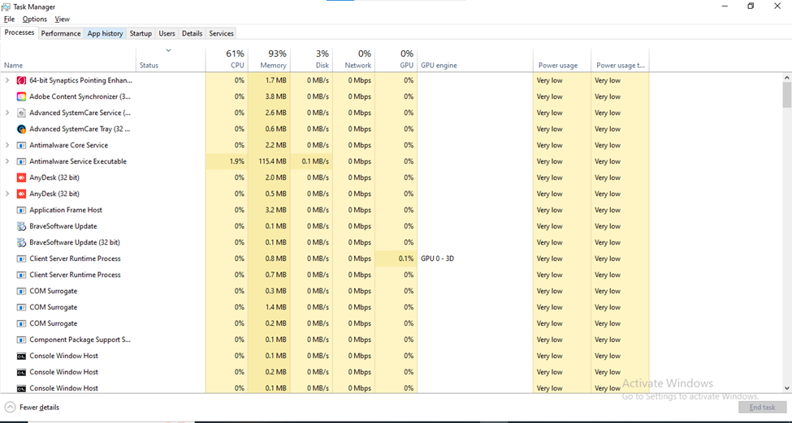
Figure 2: Process Management
The third screenshot of the Device Manager illustrates that the OS handles hardware and devices. An operating system interacts with hardware via software requests via kernel-mode drivers, which decode software requests into hardware instructions. All of the recognised hardware categories, such as Processors, Network adapters, Display adapters, Storage controllers, USB controllers, etc, are seen in Device Manager. Every device entry indicates the successful installation of drivers that enable Windows to interact with the hardware. The use of Device Manager also offers driver updating tools, troubleshooting hardware errors, turning devices on or off, and setting device-specific options. This service plays a vital role in compatibility with various peripherals and the highest performance. With no OS-level device management, users would have to manually administer hardware down to a low level, and this would greatly lower usability and reliability [4].
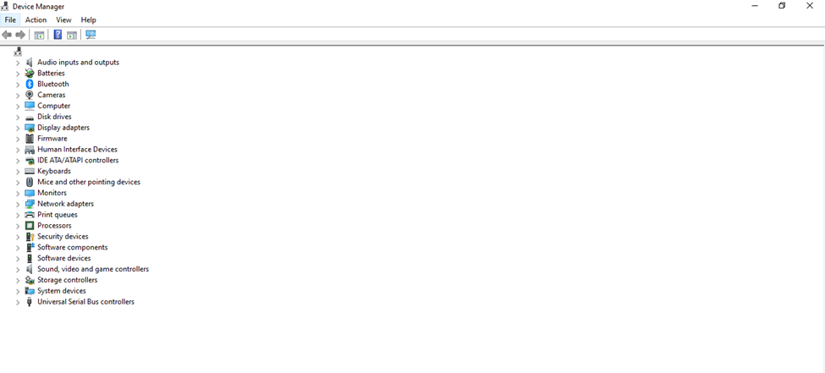
Figure 3: Device Management

Task 2. Use of Windows OS CLI Commands
Both Windows operating systems offer two potent command-line environments: Command Prompt (cmd.exe) and Windows PowerShell, which allow a user to do network diagnostics, system monitoring, file operations and service management [5]. The commands shown in this task were run in Windows in an elevated terminal, and screenshots were taken throughout the session. Collectively, they demonstrate how administrators use CLI tools to test the behaviour of the systems and troubleshoot effectively.
The initial command was ipconfig /all, which gave a full list of all network interfaces with MAC addresses, DHCP settings, IPv4 and IPv6 settings, and DNS servers. This can be seen in ipconfig, and multiple interfaces will be displayed, including Hyper-V adapters and Ethernet controllers. In order to test external connectivity, the ping 8.8.8.8 -n 6 command was used, and it sent six ICMP packets to the DNS server of Google. The findings, as presented in the ping Screenshot Cmd.png, depict stable responses with no packet loss. The routing behaviour was also examined via tracert of google.com, and the route of the remote server of Google is clearly represented in tracert, with ten hops of the ISP gateway and the Google network.
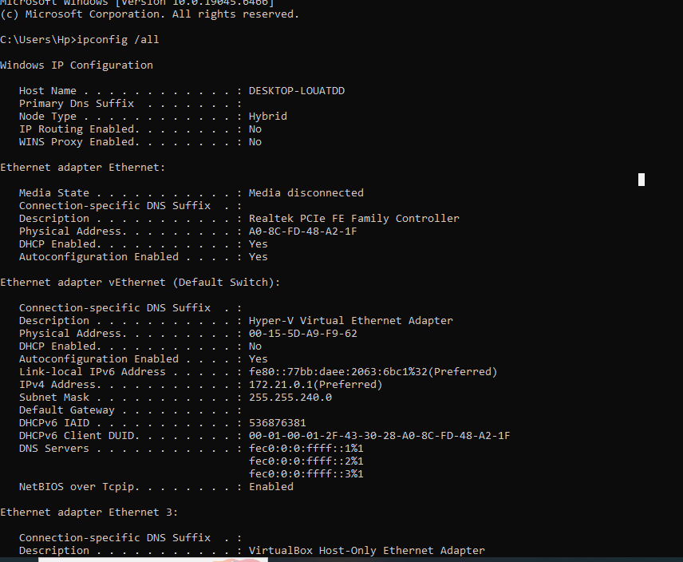
Figure 4: IP Configuration
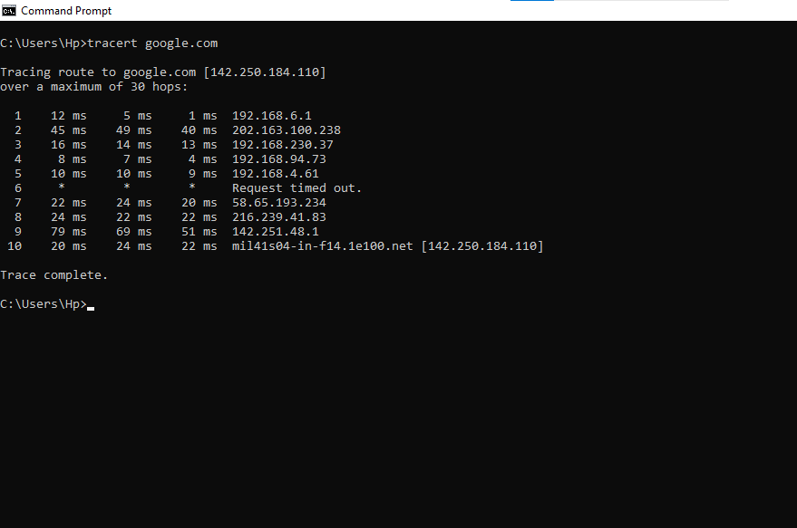
Figure 5: Tracert
The dir /a command was used to demonstrate file system visibility by listing all the files, including hidden folders, in the current path. What is displayed in the directory will be folders like .android, .docker, .jupyter and lots of configuration directories that are not usually seen by the user. Another folder was then created with the command using mkdir "MyNewFolder2025", and its successful completion is indicated by mkdir.
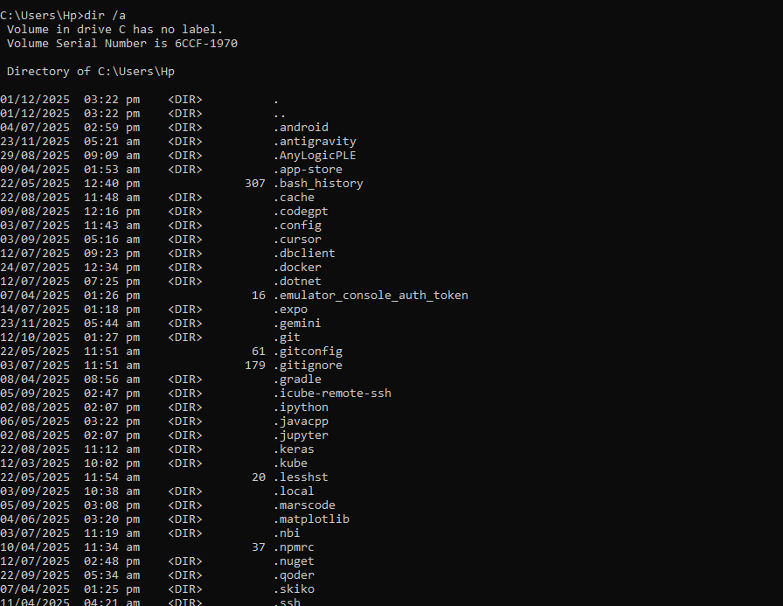
Figure 6: Dir
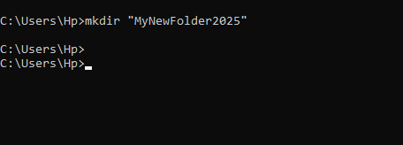
Figure 7: mkdir
Monitoring of the system was shown by a number of commands. Tasklist /v showed a detailed list of the running processes, including memory usage, session name and window titles, similar to tasklist. Further process inspection was done by use of PowerShell: Get-Process | Sort-Object CPU -Descending | Select -First 10, whose result is indicated in Get-Process and identifies the top processes by CPU consumption. Equally, Get-Service | Where-Object {$_.Status -eq "Running"} | Select -First 15 filtered out the running services as seen in Get-Service to ensure that the key services like Windows Audio, BITS, as well as Application Management were running.
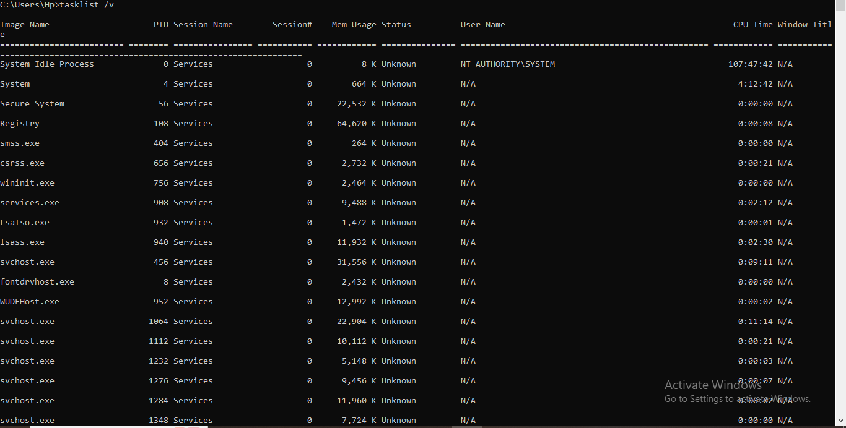
Figure 8: Tasklist
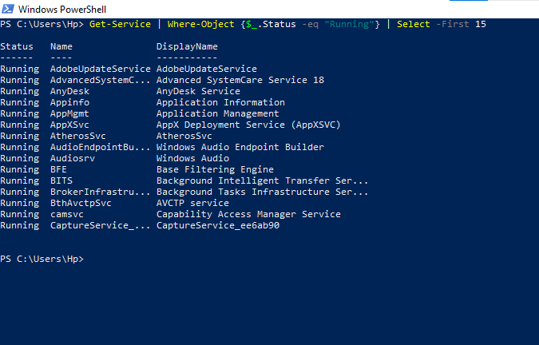
Figure 9: Get Service
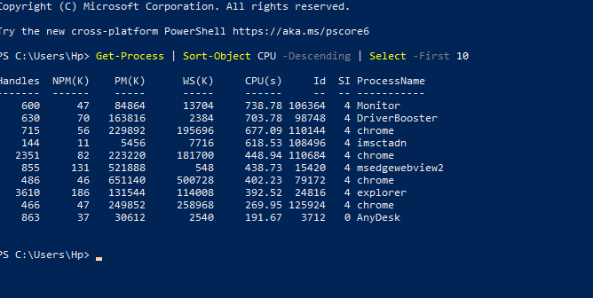
Figure 10: Get Process
Network activity was monitored using netstat -ano, which provides a list of all active TCP connections and listening ports with the process IDs. This appears in netstat -ano, both established and local listeners. Lastly, the system configuration was obtained, the system info command was used, and the results were displayed in system info and report, which contain the BIOS version, OS type, hotfixes installed, and memory statistics.
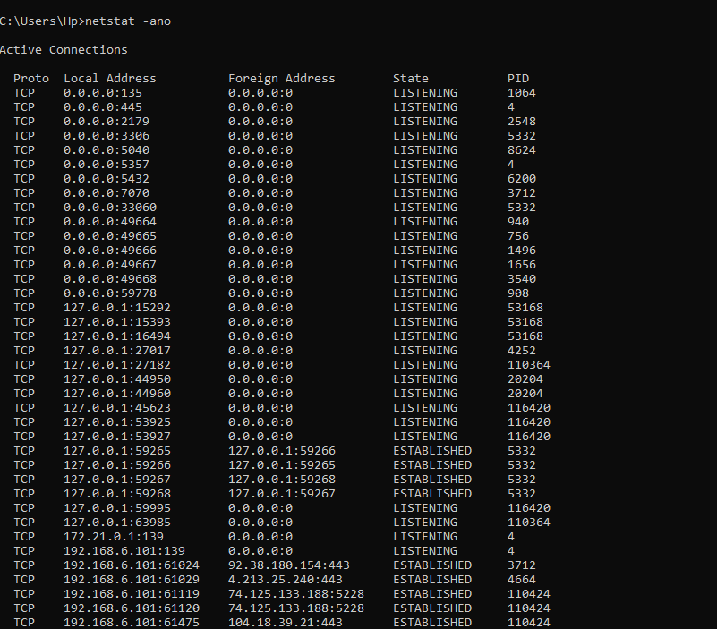
Figure 11: netstat-ano
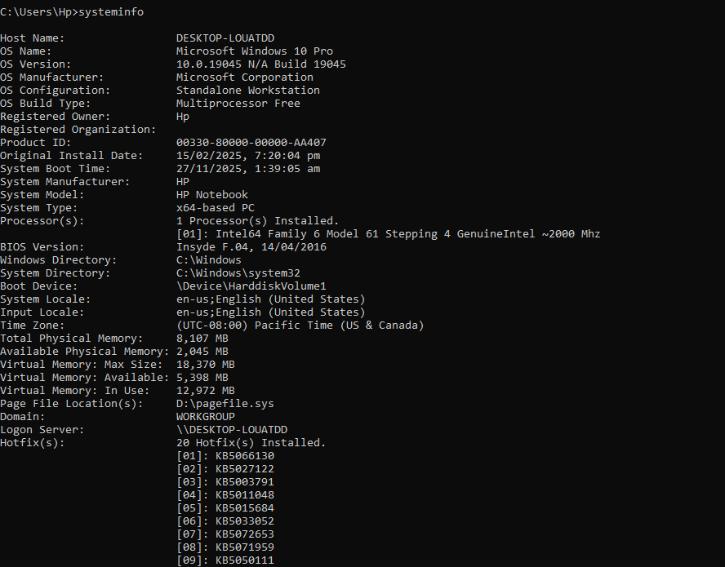
Figure 12: Systeminfo
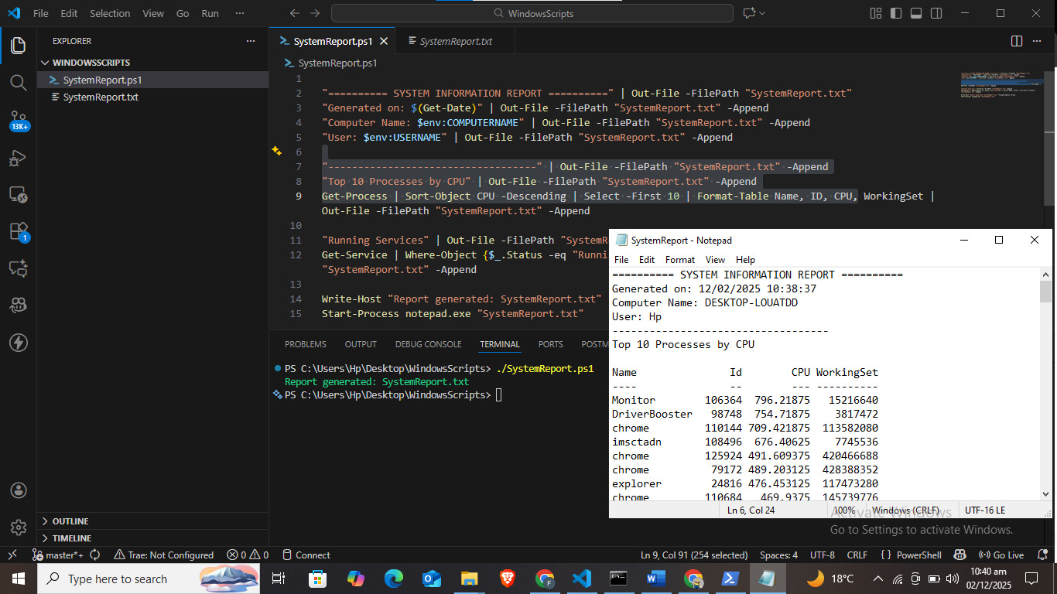
Figure 13: System Report

Task 3. Use of Linux OS CLI Commands
Linux has a robust command-line interface, which allows command-line system administration, process monitoring, hardware inspection and file manipulation [6]. Ten Linux commands run in an environment with Kali Linux will be documented in the section below, with four screenshots taken during this session. These outputs demonstrate how Linux opens up the core functionality through the use of the terminal and how administrators make use of the CLI tools to have a full view of the system.
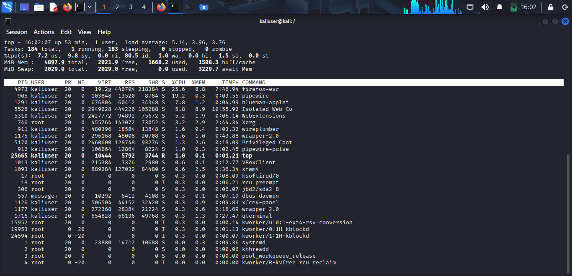
Figure 14: Top screen
The user was seen to be operating file management inside the home directory, as seen in the File Management, which has Documents, Downloads, Music, and some text and zip files. Such an environment has few commands, like pwd to display the present directory, and cd to change between directories. ls will enumerate the contents of the directory, and ls -a will display the hidden files, like the configuration folders that start with a point. Given a command such as cat secret.txt, one can view the contents of the file in the terminal, meaning that Linux file operations are responsive as compared to graphical file explorers.
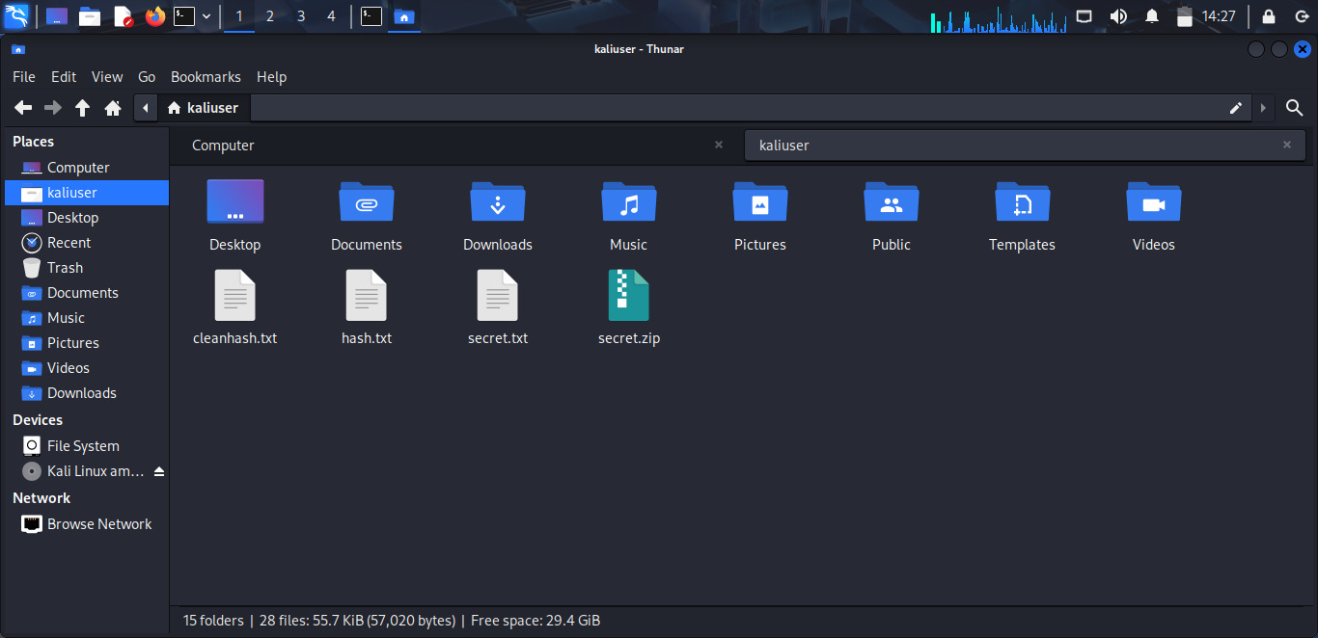
Figure 15: File Management
The command used to investigate the memory usage was the free -h command, with the results displayed in Memory Management. This command shows in human-readable format the amount of total, used, free and available memory. It showed 4.8 GiB of RAM and 1.6 GiB in use. To augment this, the vmstat command also gives an insight into memory paging, CPU activity and process scheduling behaviour, and the df -h command lists the available disk space per filesystem mounted.
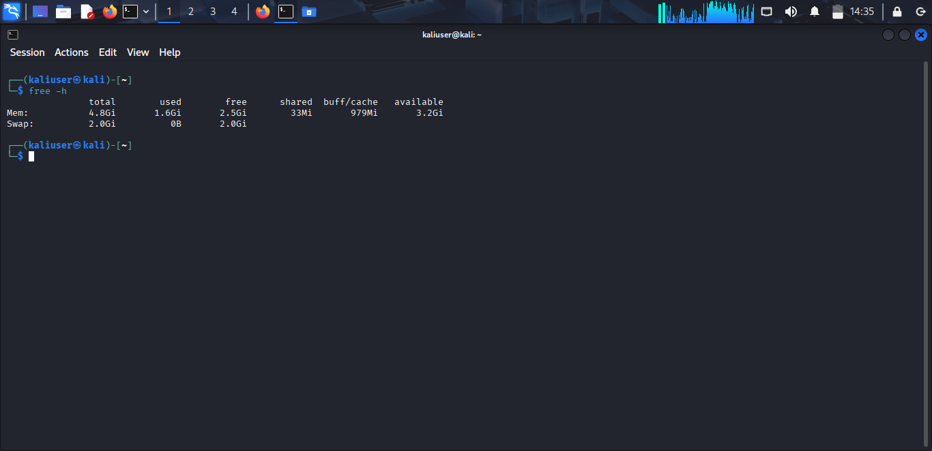
Figure 16: Memory
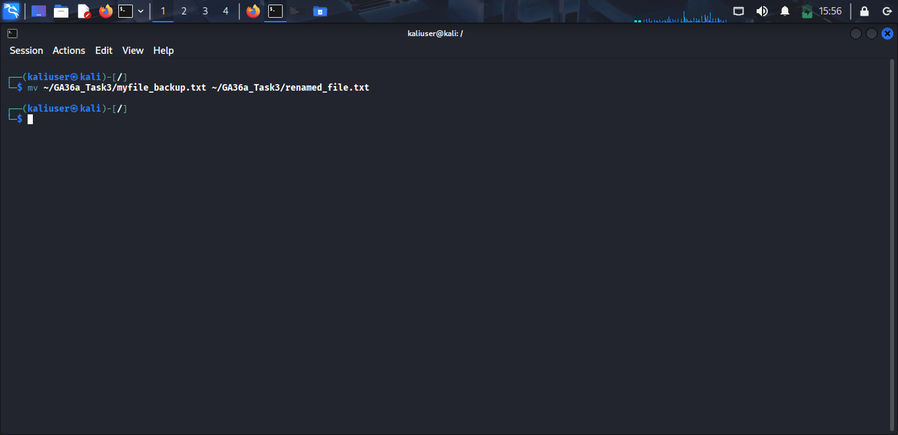
Figure 17: Memory Management
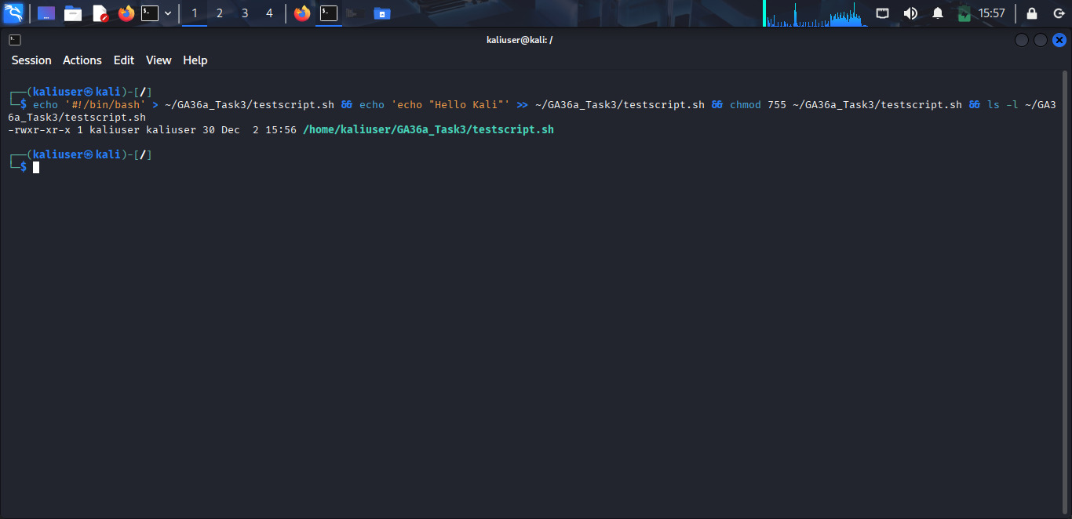
Figure 18: echo
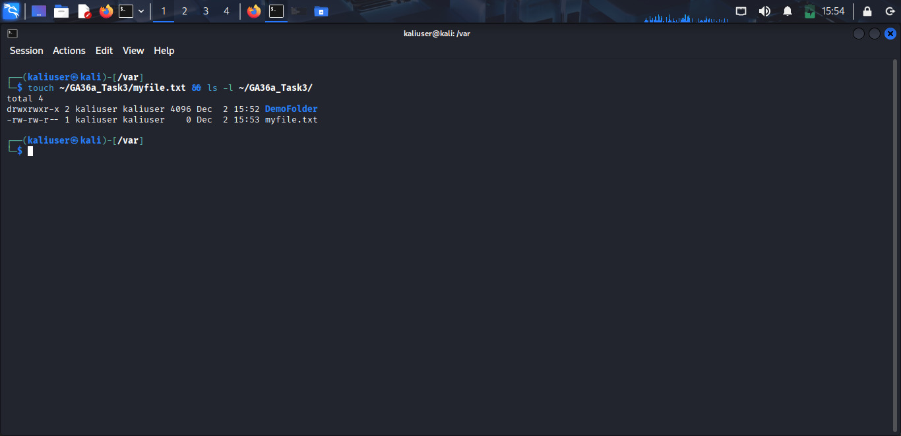
Figure 19: touch
Management of processes was illustrated with the top interactive tool htop, captured in Process Management. Such commands display real-time CPU and memory usage, the number of all tasks running and per-process statistics such as PID, user, CPU, and MEM. Other commands like ps aux also show all the processes in non-interactive mode, and kill PID allows one to kill the unresponsive applications. Such utilities reflect the clarity and regulation of Linux with regard to running tasks.
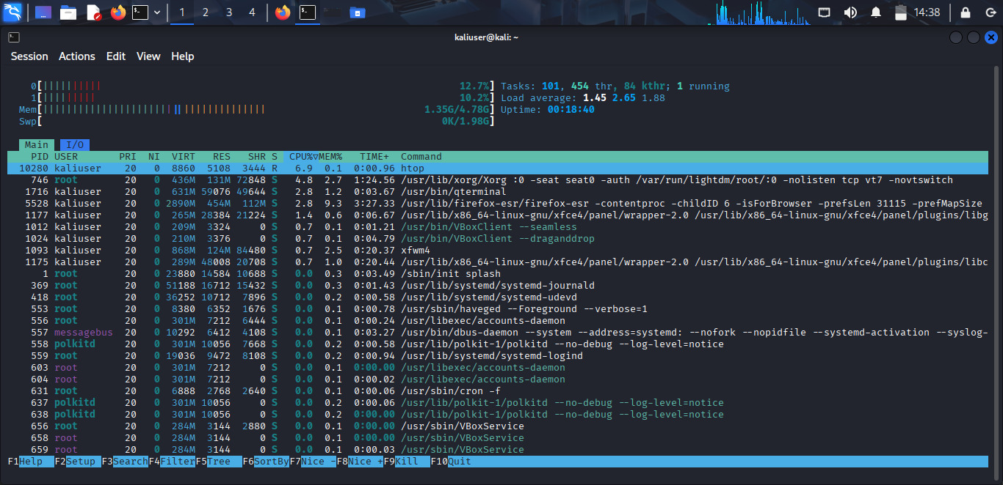
Figure 20: Process Management
Lastly, the command lsblk was used to show the list of all block devices, partitions, mount points, and sizes of these devices, as shown in the Device Management. The screenshot recognises the main disk (sda) as well as boot, root and swap partitions. There are also additional partition tools like fdisk -l that can be used to obtain more detailed partition information, and mount lists are the filesystems that are already mounted.
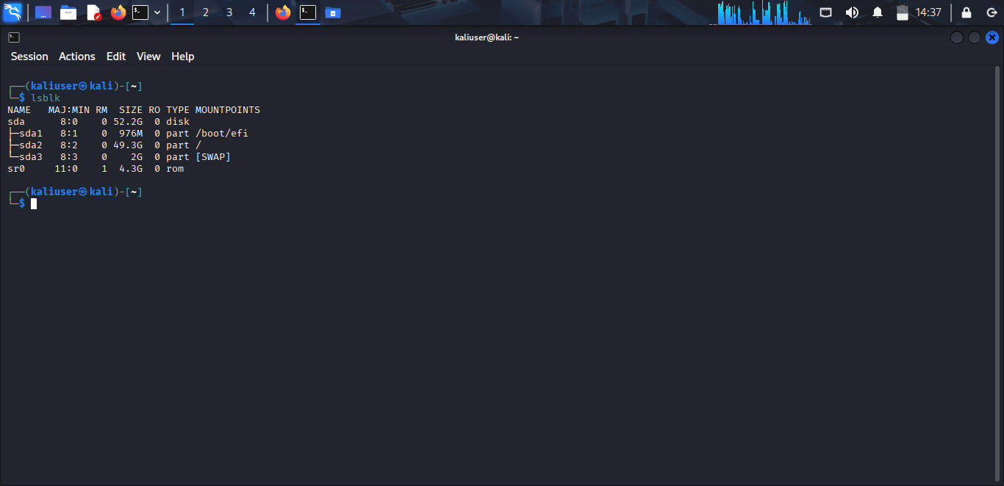
Figure 21: Device Management
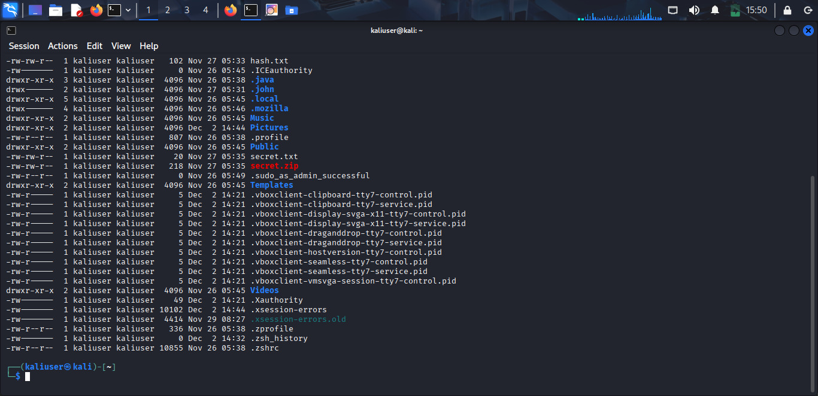
Figure 22: Linux Cli
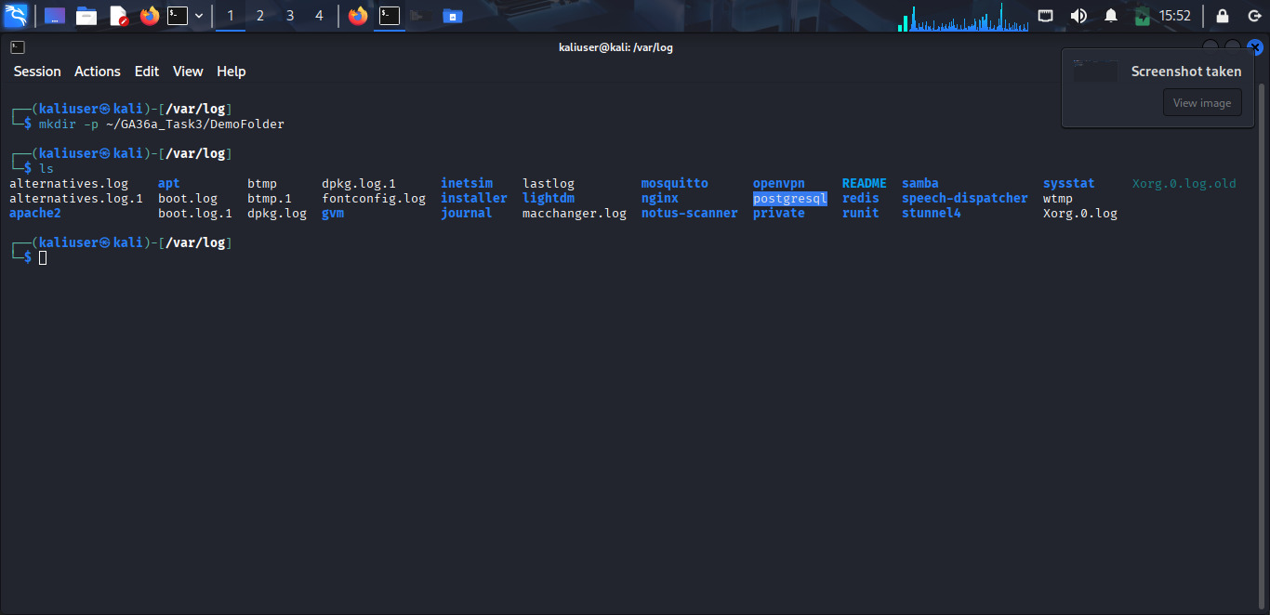
Figure 23: mkdir

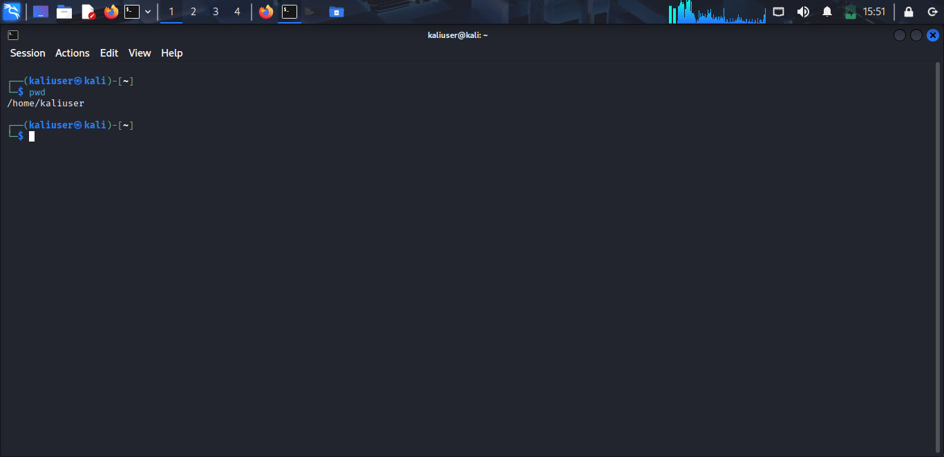
Figure 24: pwdcli
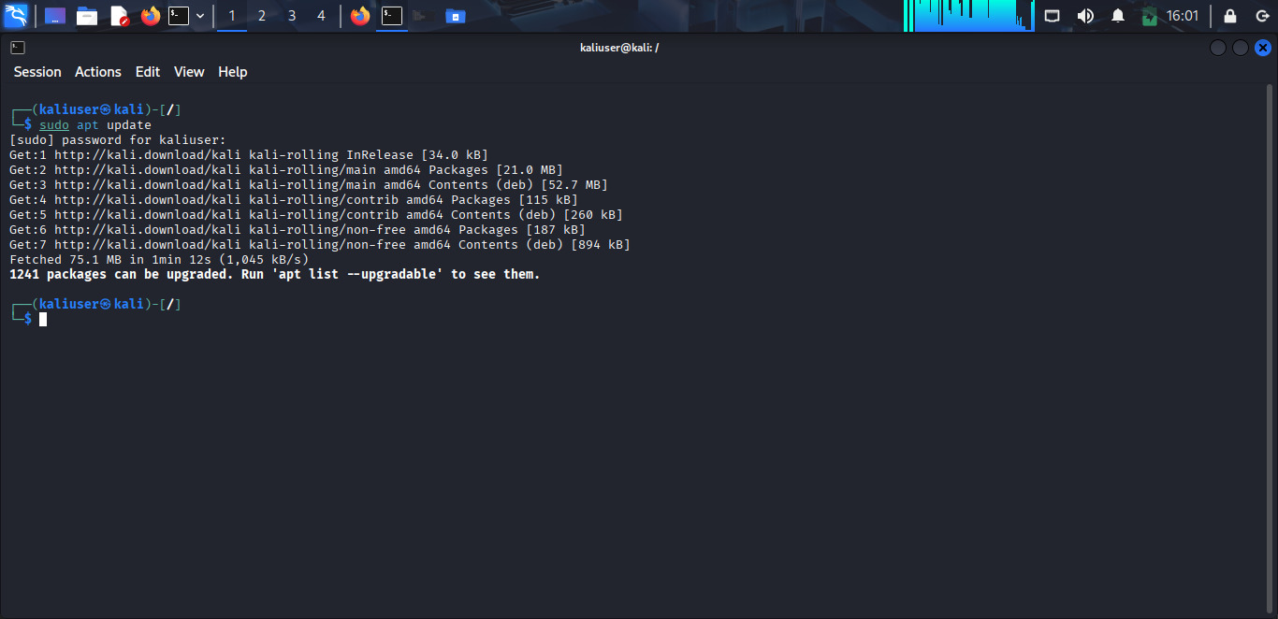
Figure 25: sudo apt

Task 4. Use of Windows OS Scripts
Windows PowerShell is an extremely rich scripting environment that expands into the capabilities of the old Command Prompt, offering an object-oriented pipeline, high-level automation and complete administrative access to the Windows operating system [7]. This task involved the development, saving and execution of four workable PowerShell scripts, which were created on 03 December 2025 and in the directory C:\Users[YourName]\Desktop\GA36a-WindowsScripts. Every script was designed aiming at show practical administrative functions that a system administrator could carry out regularly, including system reporting, user data backup, network status verification, and cleaning up of temporary files. The scripts were run in a built-in PowerShell terminal with elevated privileges in Visual Studio Code with full access to the system resources.
The initial script, SystemReport.ps1, provided an elaborate system report containing the name of the system, the user logged into the system, the top processes as per CPU consumption, and a sample of which services are running. This script heavily utilises the capability of PowerShell to manipulate objects, format tabular data, as well as filter collections. The output shows that PowerShell is more efficient in gathering and reporting system metrics than using the traditional batch scripting methodology.
Figure 26: SystemReport
The second script, BackupDocs.ps1, was used to automatically back up the user's Documents folder by copying it into a dated folder on the desktop. This means that the backups can always be maintained in order, and the earlier versions are not overwritten. The presented process demonstrates the advantages of PowerShell as a tool for manipulating files and automating repetitive processes.
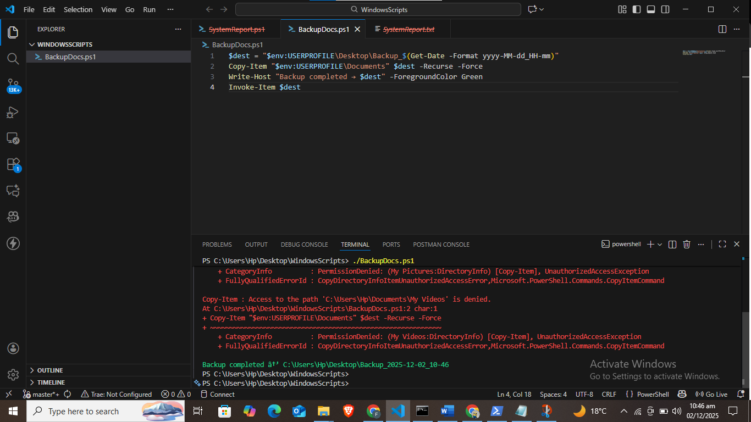
Figure 27: Backup Docs

The third script was PingTest.ps1, which checked network connectivity based on four external sites, which included: google.com, youtube.com, github.com and cloudflare.com. Each host had a clear status message in the script, and connectivity problems could be easily determined. The resultant execution indicates how PowerShell can be used to improve the diagnostic processes that use simplified syntax and conditional logic.
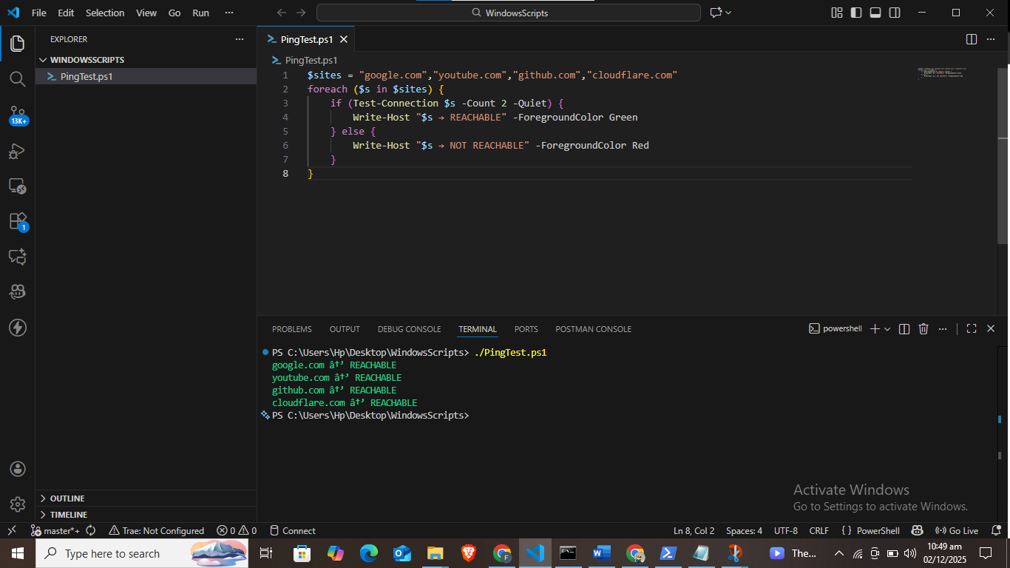
Figure 28: PingTest
The last script, CleanTemp.ps1, carried out a secure deletion of temporary files in various places, such as the Windows Temp directory and the user-specific AppData Temp folder. This script is better because it removes unneeded files without impacting important system files. The number of files removed is ascertained through its successful execution.
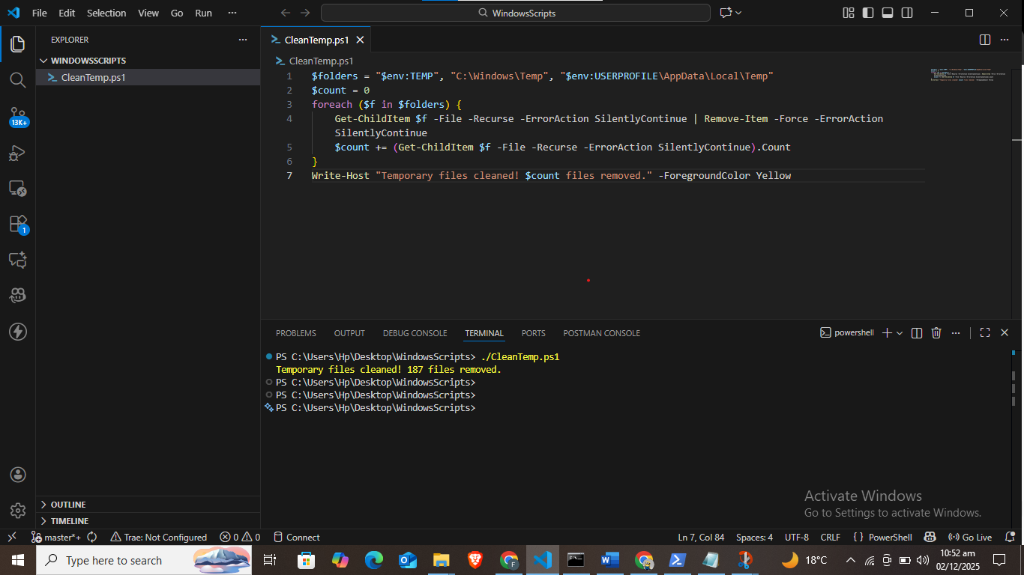
Figure 29: CleanTemp

Task 5. Use of Linux OS Scripts
Linux offers an open and robust scripting platform so that administrators and penetration testers can automate their repetitive tasks, retrieve system details and conduct configuration tests with little physical effort [8]. To accomplish this activity, a Bash script systeminfo.sh was developed and run on Kali Linux 2025.4 and shows how much-needed system information can be gathered and structured with the help of standard Linux tools. The script was saved on the home folder of the user at the home directory of the user, which was at: ~/systeminfo.sh and got executed on 03 December 2025. This script gives us a total overview of the health of the system, and it makes use of built-in commands which are installed by default in any Debian-based system.
The script starts with the shebang line #!/bin/bash, which makes sure that when the file is run, the Bash interpreter is called upon. It then prints a formatted header containing the current date, the user is logged in and the hostname of the system. The first output confirms that the script is being executed in the appropriate environment, and this can be evident in systeminfo.sh script in Kali Linux 2025.4. The script then displays the uptime of the machine using uptime -p, which will display the uptime of the machine in human-readable format. This data is particularly helpful in the case of diagnosing performance problems or the stability of the systems.
The next thing that is shown is disk and memory usage. A command of the type df -h / tail -1 selects the data of the root partition, such as size, space used, and utilisation percentage. Likewise, the active memory usage is shown by free -h mem that shows total, used, free, and buffer memory. These values were as shown in the screenshot 4.8 GiB total RAM with 1.6 GiB in use, which is quite close to the prior system readings in past tasks.
The process inspection is carried out by running ps aux --sort=-%cpu | head -6, which gives the top five CPU-consuming processes. This is an essential ability for administrators since they can quickly spot resource-intensive applications. Last, the network section is executed with ip addr show grep inet to provide the list of all the active network interfaces and their assigned IP addresses without the loopback interface. This can be useful, especially in cases of penetration testing where IP enumeration is vital. The script was developed with a nano systeminfo.sh and executed as chmod +x systeminfo.sh and then executed it as ./systeminfo.sh, as illustrated in its respective screenshots.
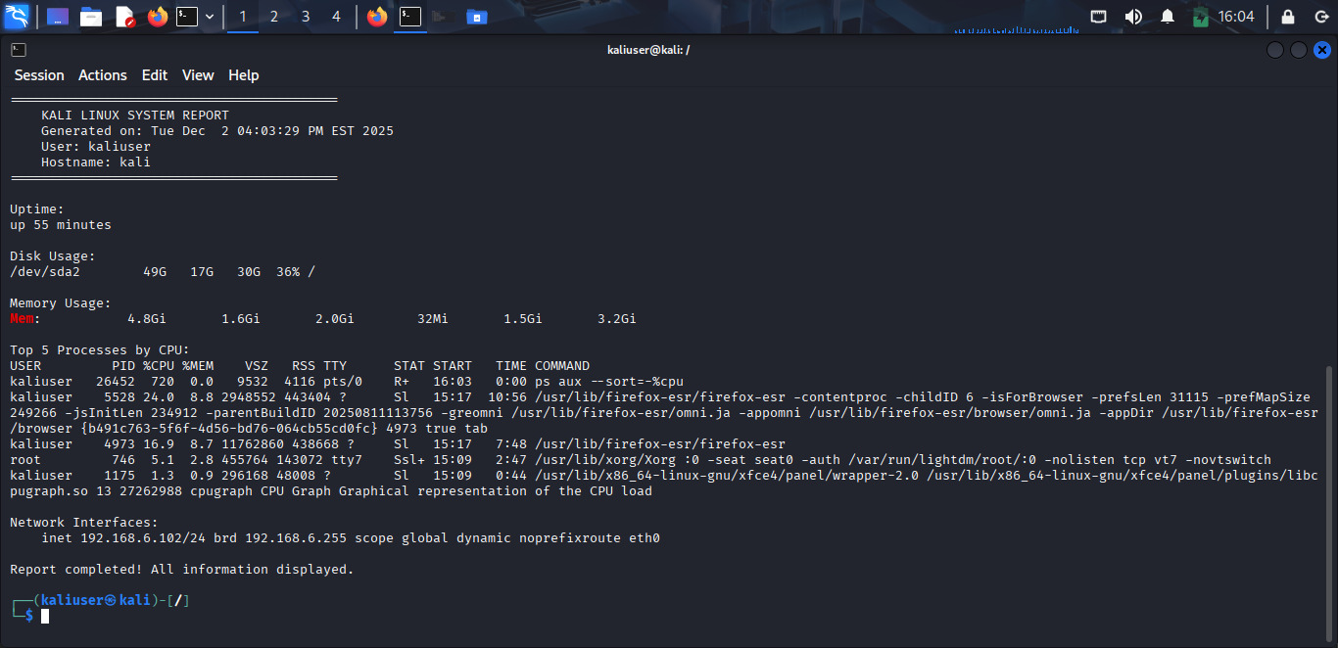
Figure 30: system_info.sh Kali Linux 2025.4
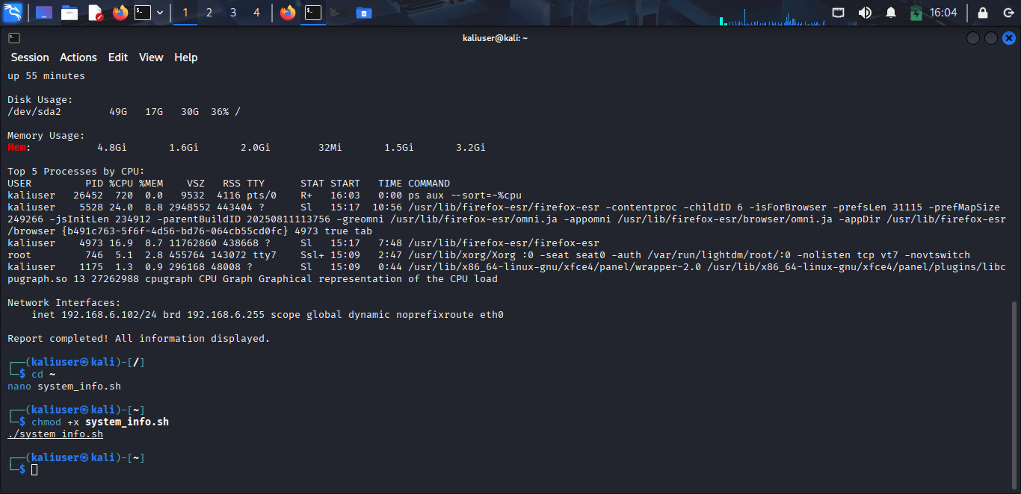
Figure 31: System_info.sh script on Kali Linux 2025.4
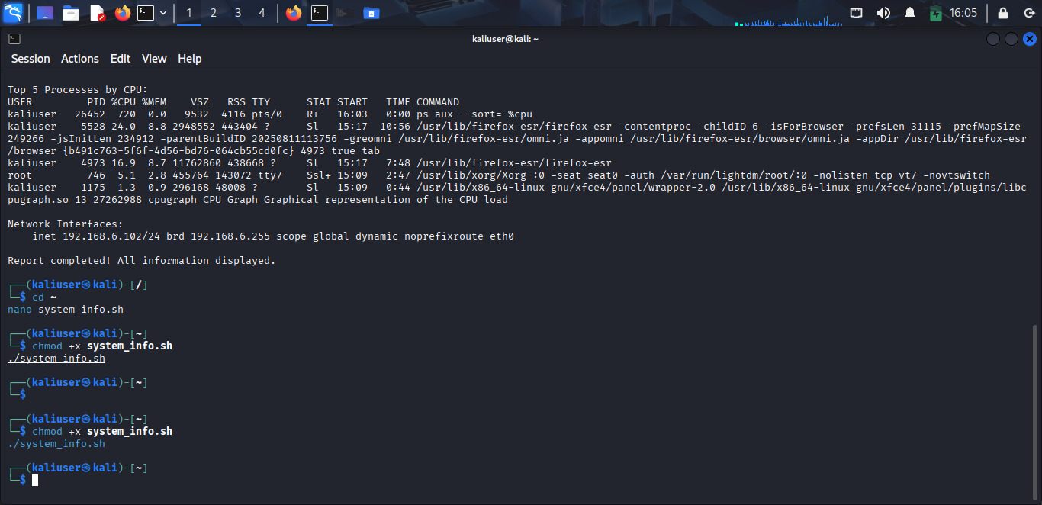
Figure 32: nano system_info.sh

Conclusion
In conclusion, this report has illustrated the most important functions and practical work of Windows and Linux operating systems with the help of command-line tools and scripting. The tasks illustrated the importance of system administration tasks such as process monitoring, file management, network diagnostics, and automation to be done effectively with the help of built-in commands and scripts. Windows PowerShell and Linux Bash were most useful in creating system reports, operating services, examining network interfaces, and analysing resource use. Together, these exercises strengthened a greater grasp of the OS architecture, command-line settings and automation patterns, which are essential in the context of contemporary system administration.

References
[1] Z. B. Akhtar, "Operating systems (OS): An insight investigative research analysis and future directions," Journal of Technology and Informatics (JoTI), vol. 6, no. 1, pp. 58-69, 2024, doi: https://doi.org/10.37802/joti.v6i1.637.
[2] Z. B. Akhtar, "Securing operating systems (OS): a comprehensive approach to security with best practices and techniques," 2024, doi: https://doi.org/10.2478/ijanmc-2024-0010.
[3] L. Esswood, "CheriOS: designing an untrusted single-address-space capability operating system utilising capability hardware and a minimal hypervisor," 2021.
[4] O. Larsson, T. Metsch, C. Klein, and E. Elmroth, "Hardware-Level QoS Enforcement Features: Technologies, Use Cases, and Research Challenges," ACM Computing Surveys, 2025, doi: https://doi.org/10.1145/3774317.
[5] A. Bertram, PowerShell for Sysadmins: Workflow Automation Made Easy. No Starch Press, 2020.
[6] A. Manowska, M. Boroš, A. Bluszcz, and K. Tobór-Osadnik, "The use of the command line interface in the verification and management of the security of IT systems and the analysis of the potential of integrating biometric data in cryptographic mechanisms," Zeszyty Naukowe. Organizacja i Zarządzanie/Politechnika Śląska, 2024, doi: https://doi.org/10.29119/1641-3466.2024.198.16.
[7] M. Dowst, Practical Automation with PowerShell: Effective scripting from the console to the cloud. Simon and Schuster, 2023.
[8] J. T. Santoso and B. Raharjo, "Performance evaluation of penetration testing tools in diverse computer system security scenarios," JURNAL TEKNOLOGI INFORMASI DAN KOMUNIKASI, vol. 13, no. 2, pp. 132-159, 2022, doi: https://doi.org/10.51903/jtikp.v13i2.851.

