Hristo Hristov
1.Pizza 4 U DFD
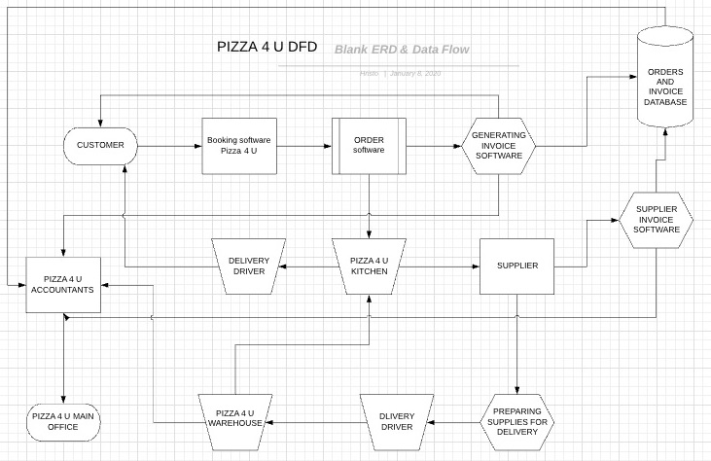
2.ERD
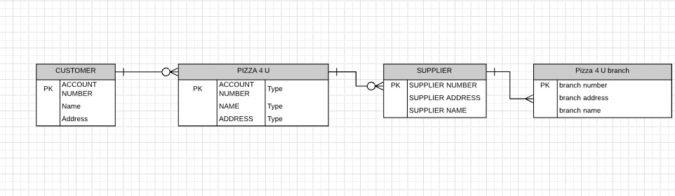

On the DFD diagram I made for Pizza 4 U I explain how the information travels trough the different levels. When customer makes an order, it is accepted from the booking software and is then sent to the order software. Order software sends a copy of the order to the kitchen and to the invoice software. Invoice software uses the information to fulfil the information in predesigned invoice and send it to the customer and to data storage. All orders and invoice are stored in the data storage and are accessible for a quarterly or yearly calculations.
Ordering software sends the order to the kitchen. Kitchen sends the needed quantities to the supplier who prepares them and sends them for delivery back to the kitchen. Supplier also send invoice and order description to Pizza 4 U data base storage and to the Pizza 4 U accountants. The accountants of Pizza 4 U have suppliers invoices and the invoice send to the customer.
In the ERD diagram I show the entityes between different actors and the relationship between them.

