Winter Christmas Fair at the Delta Hotel in Breadsall Priory

BMIH6007
International Meetings Management for the Hotel Industry
Assignment 1: Feasibility Plan for an International Meeting
2209341
Jasmin Begum
Kathryn Flynn

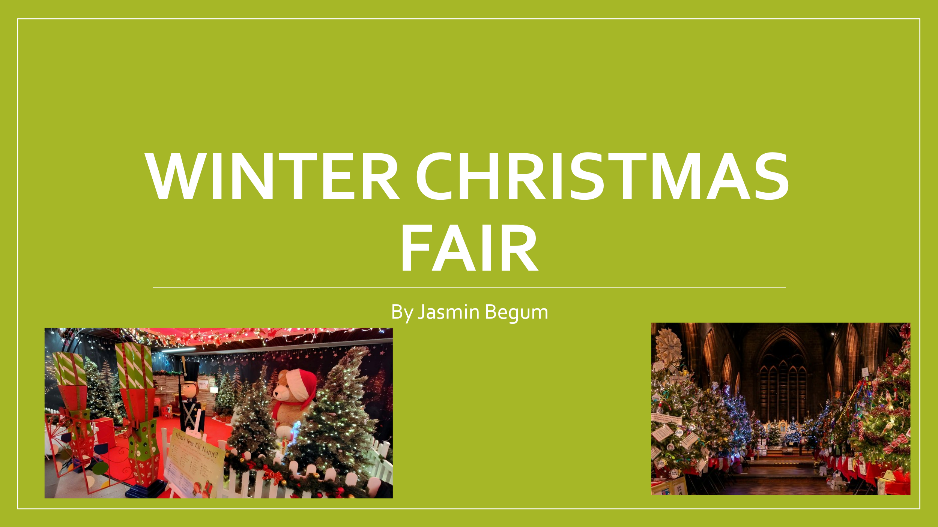
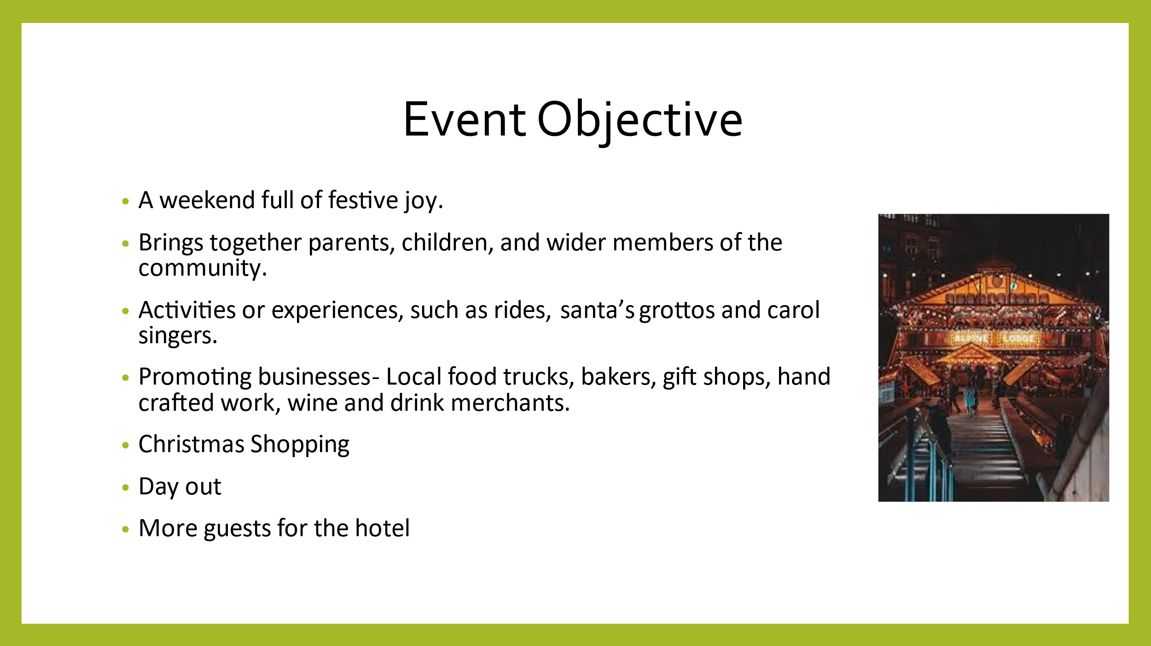
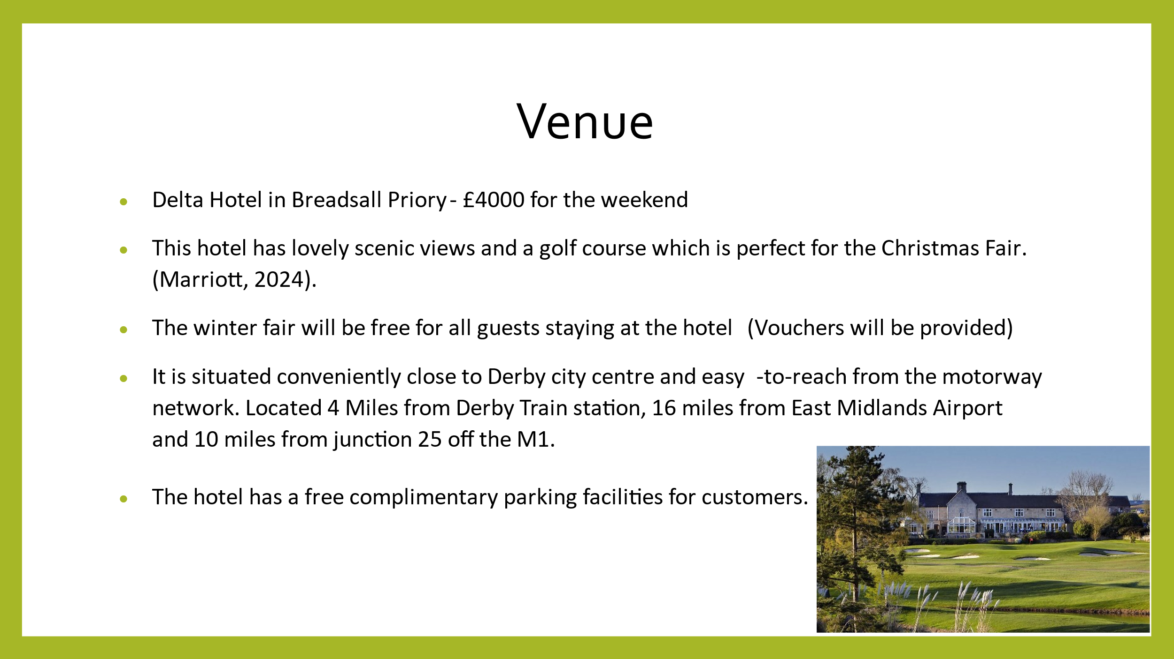
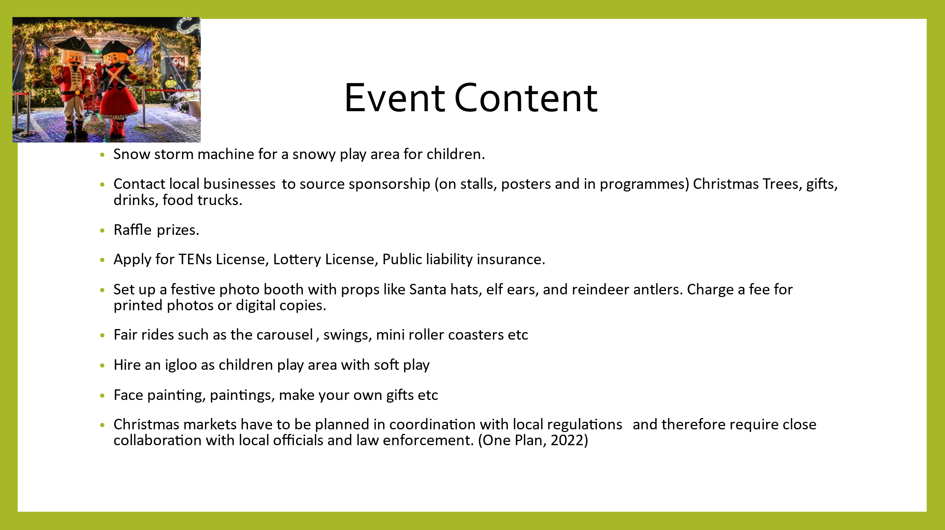
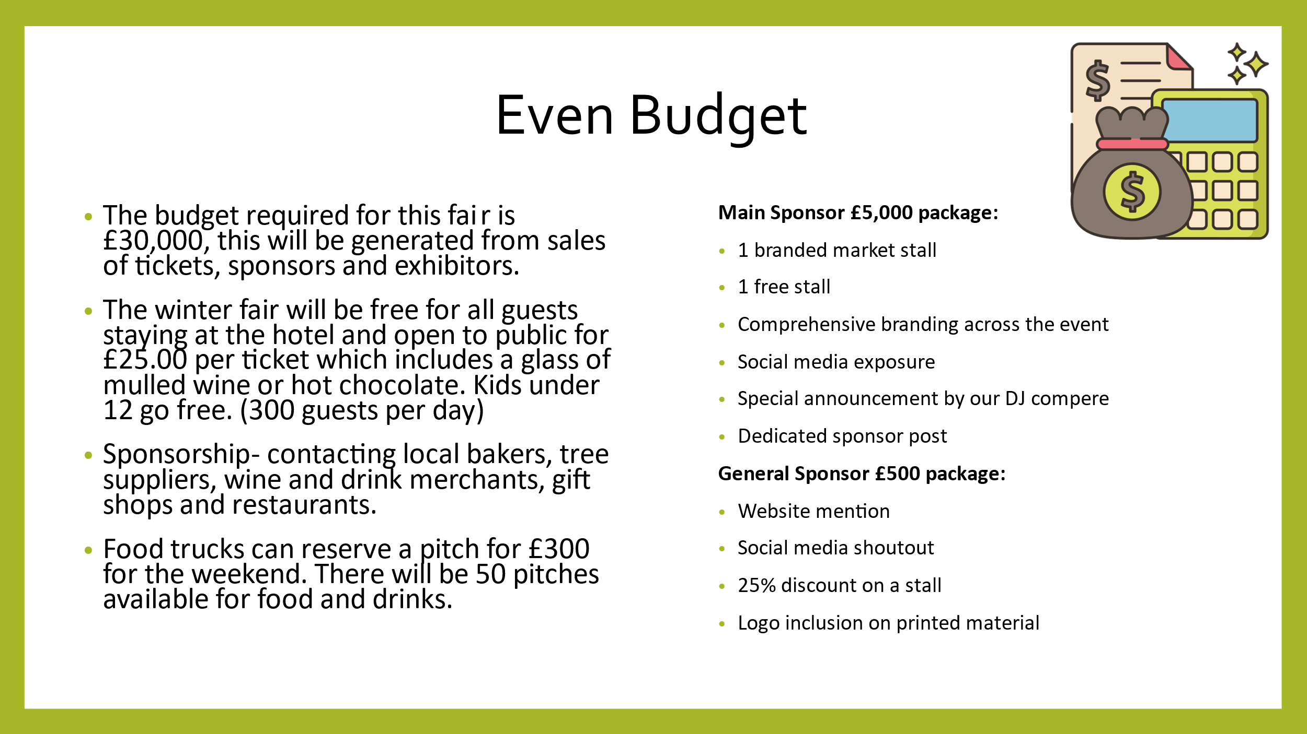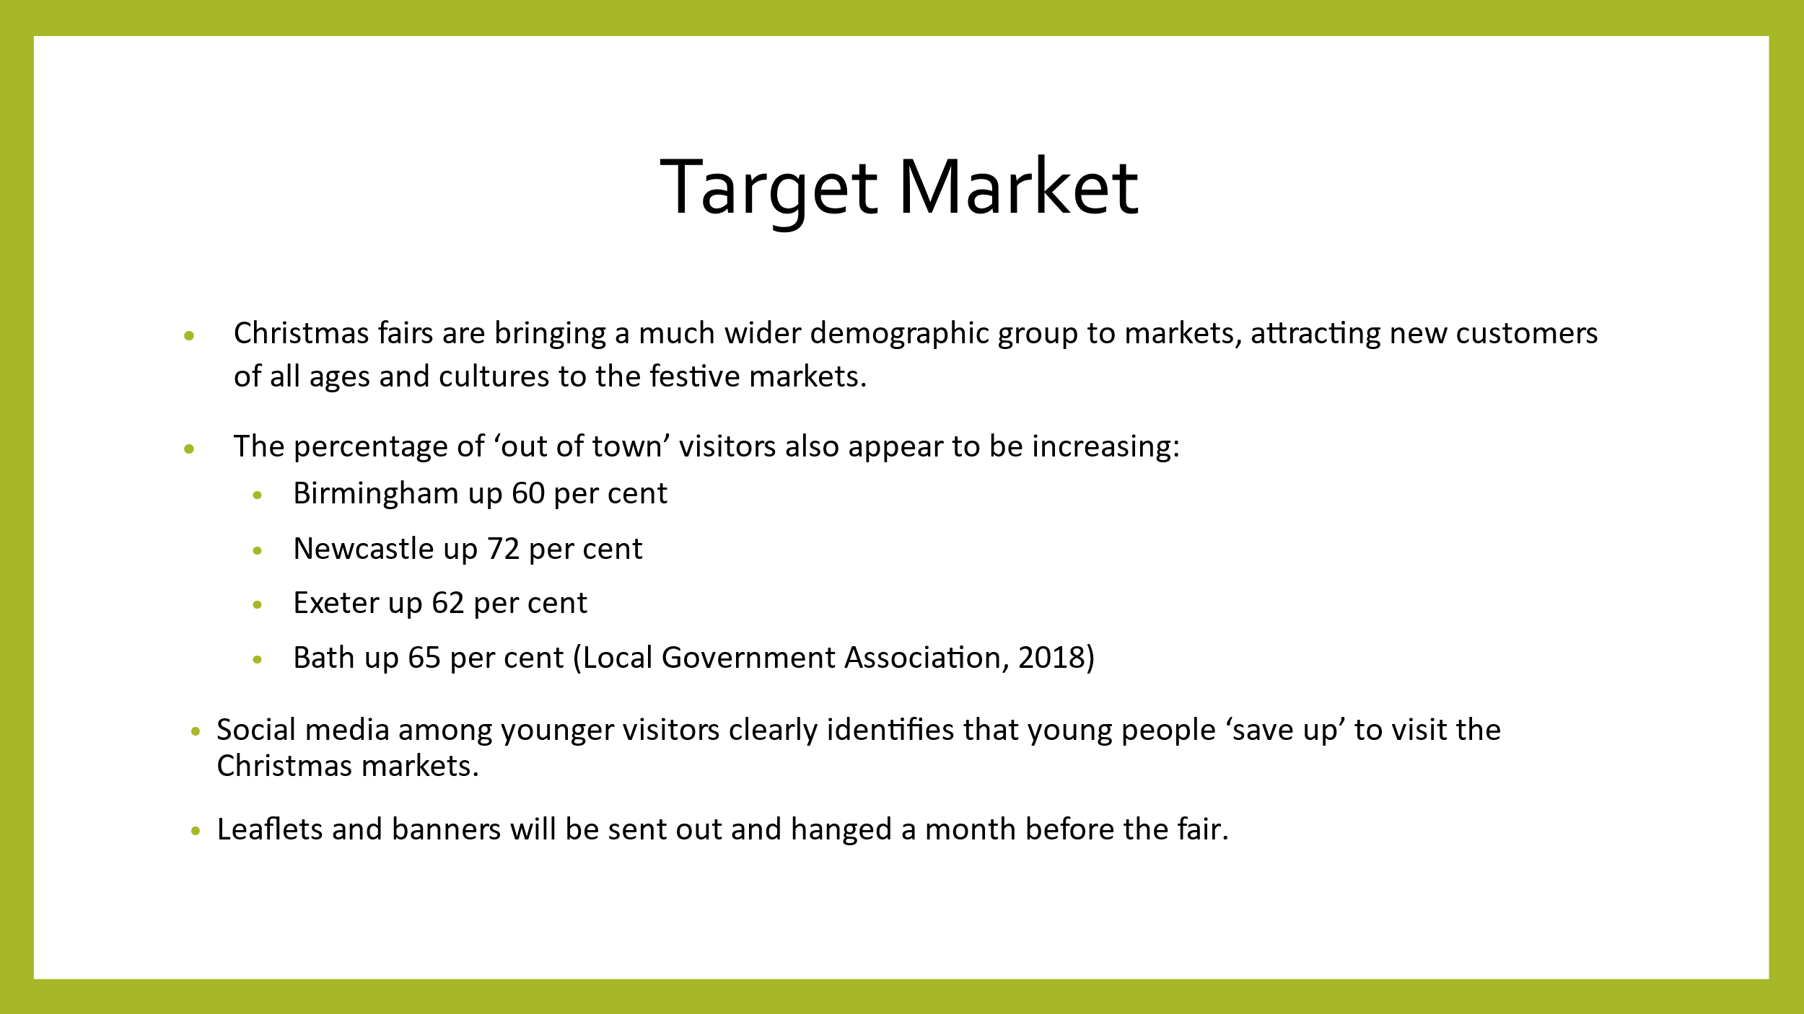
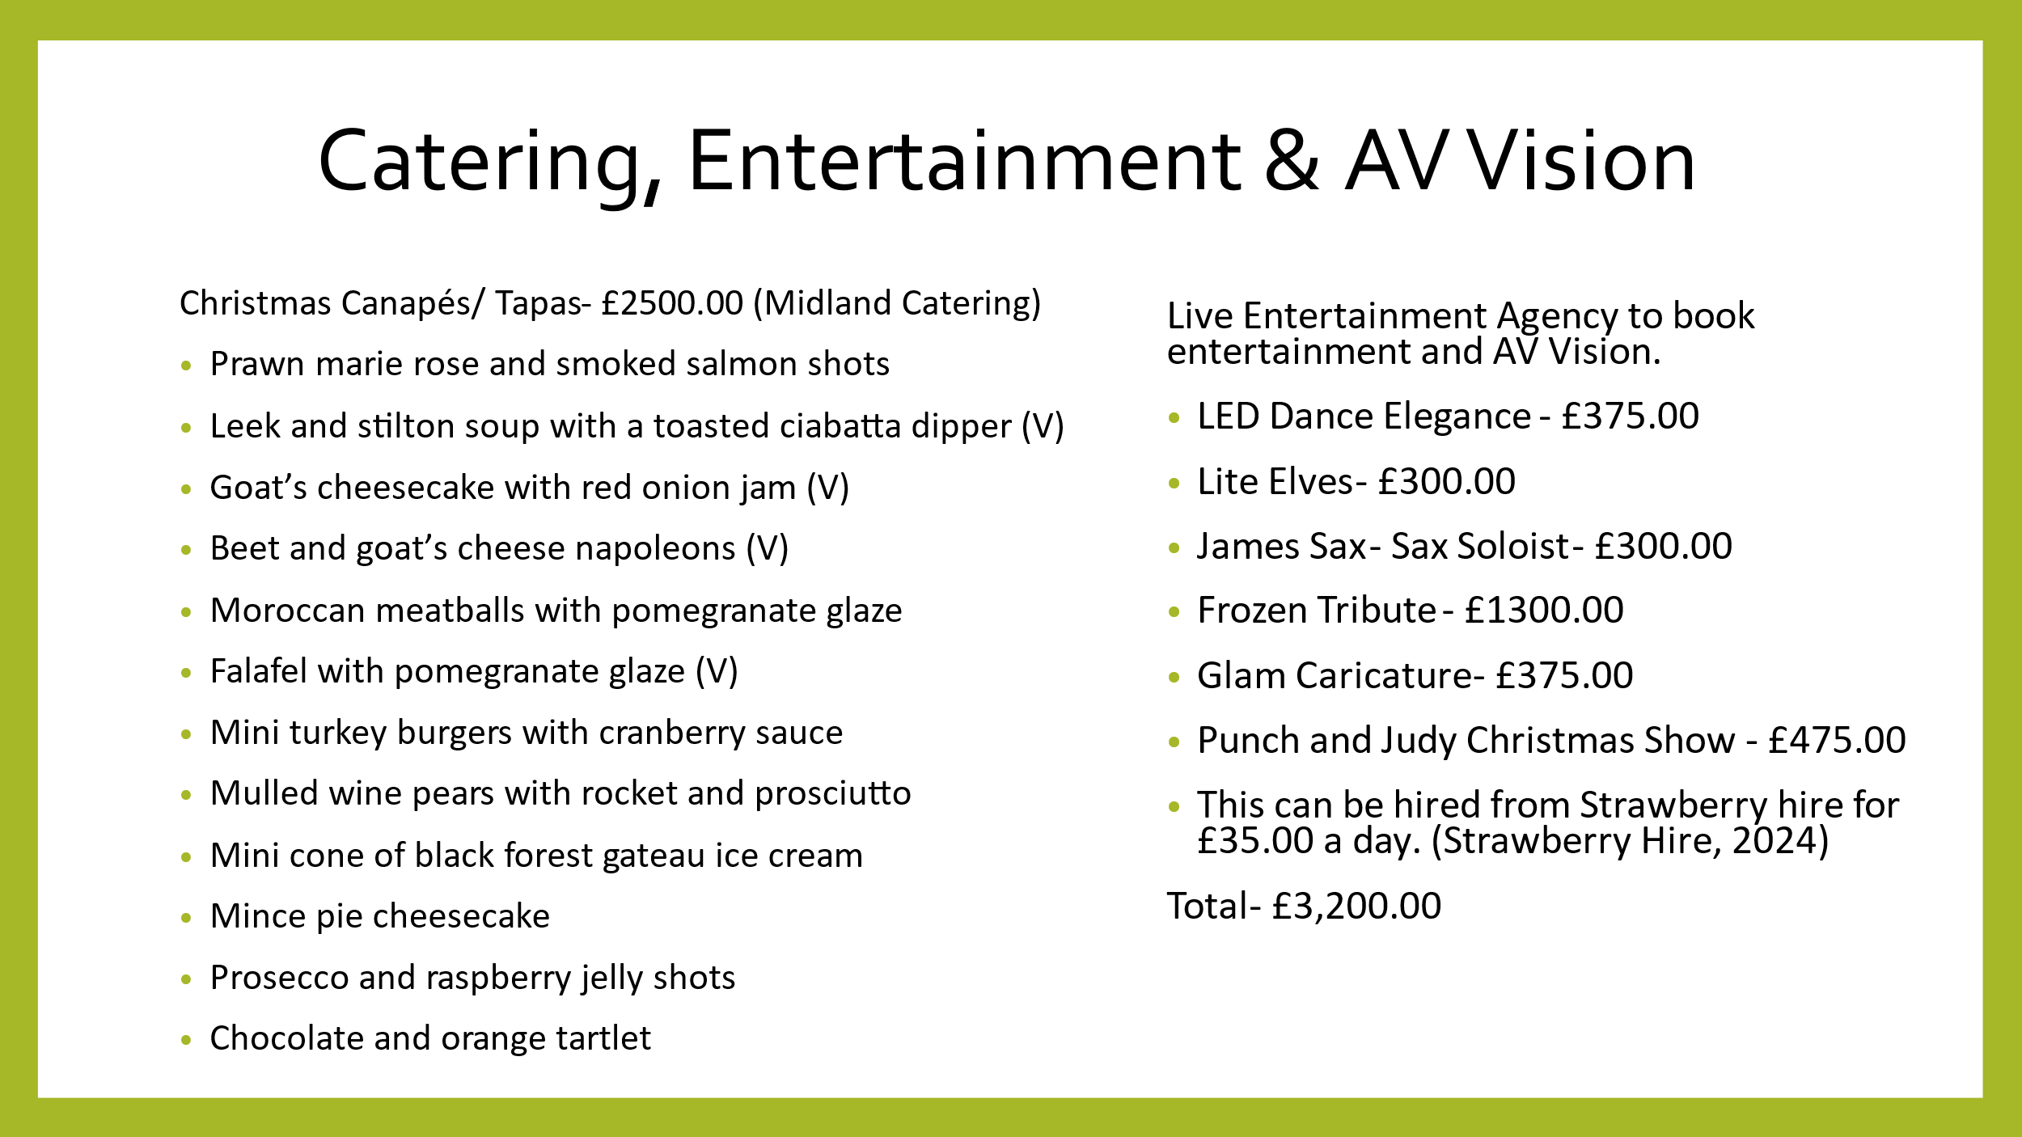
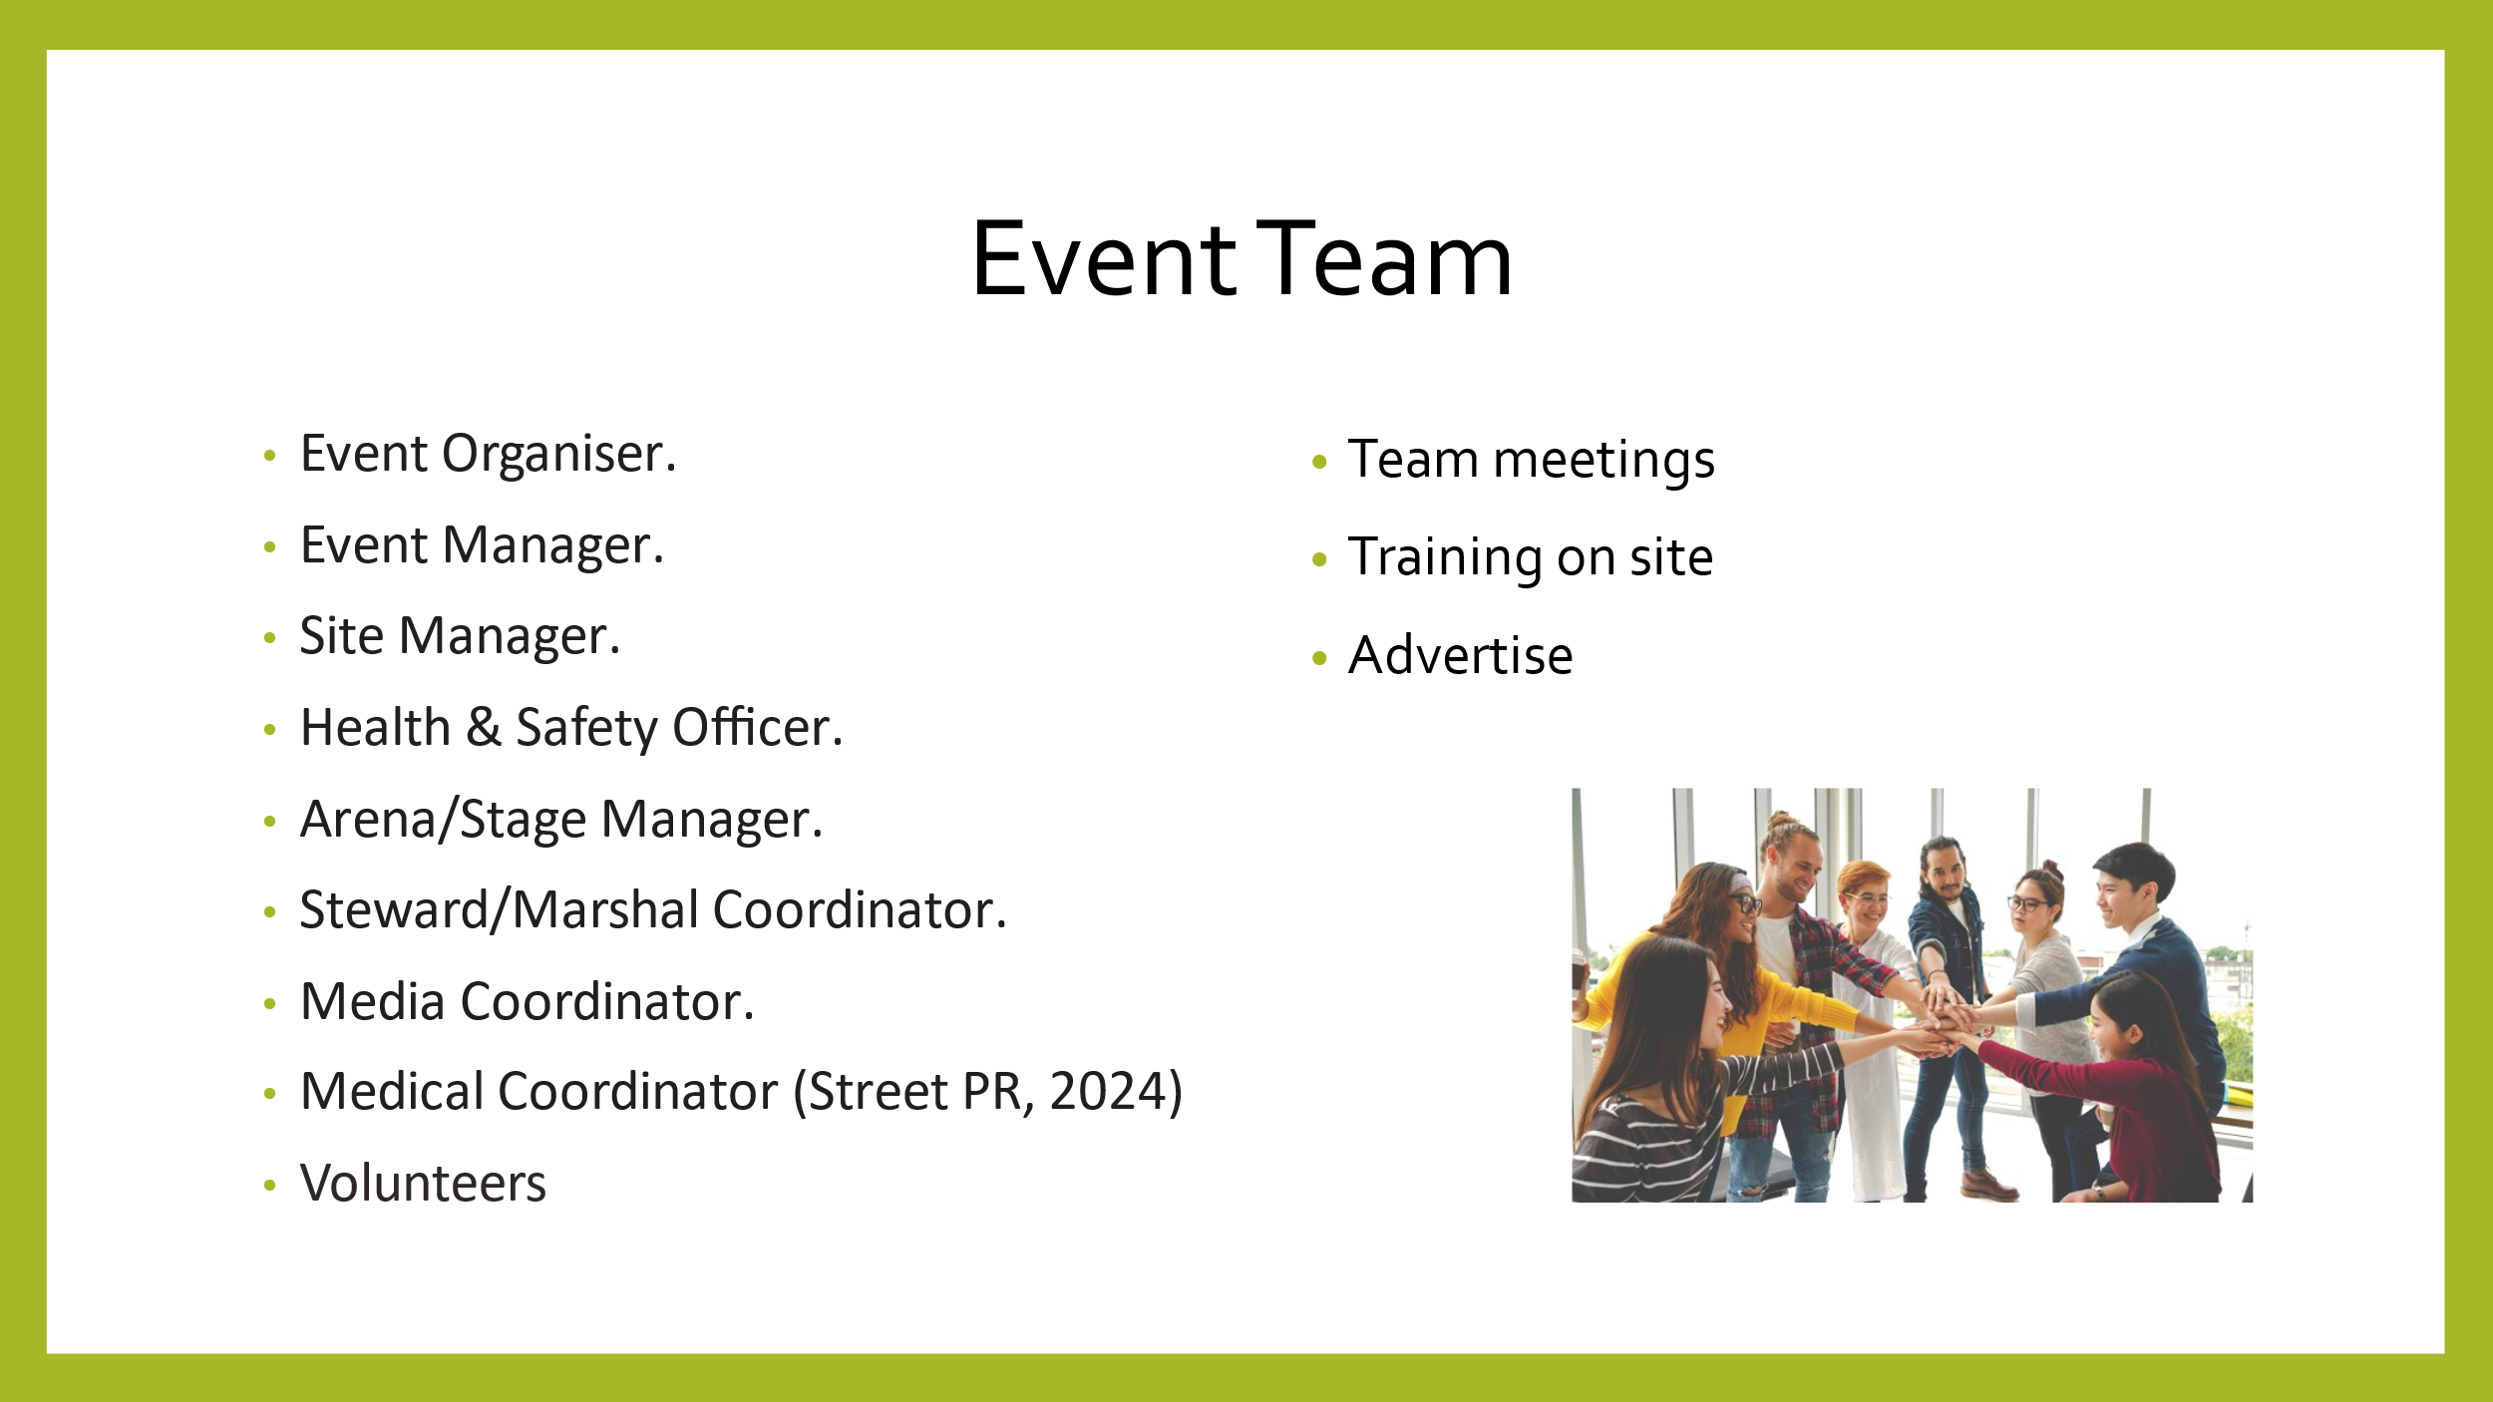
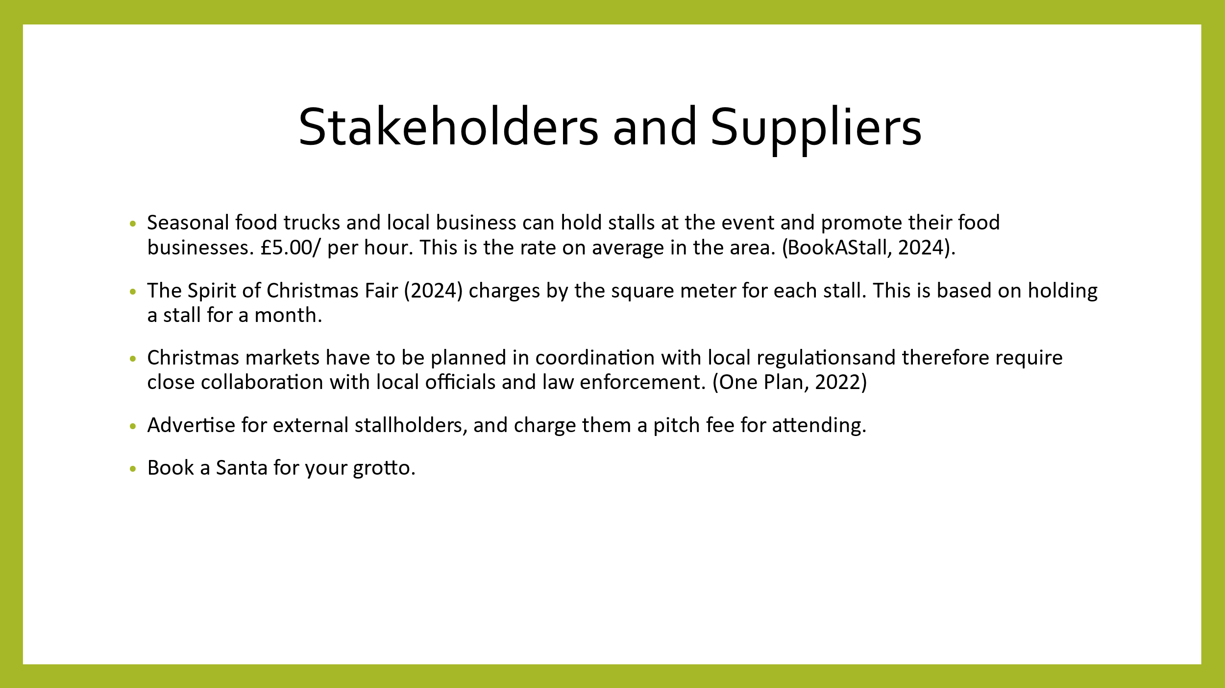
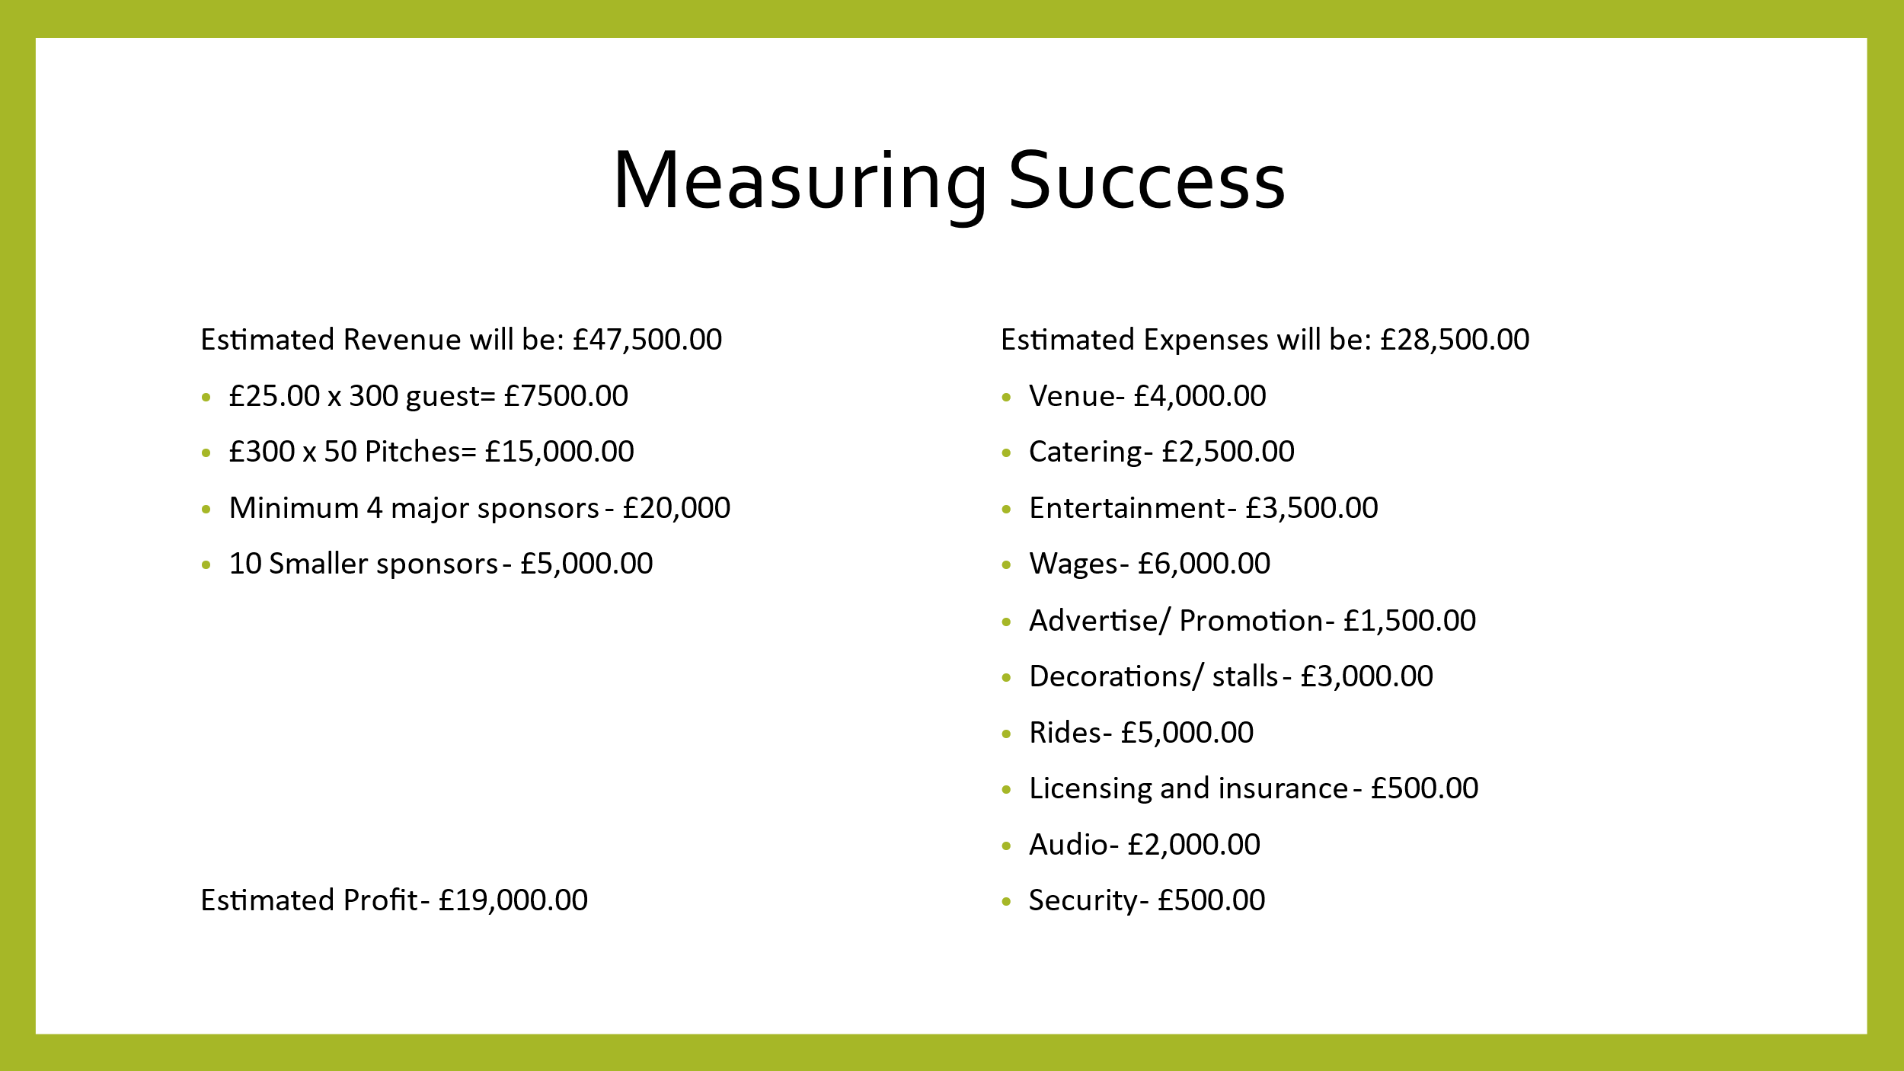

Reference
Atkin, V. (2022) Sharesy: How To Organise A Successful Winter Fair. Available at: How to Organise a Successful Winter Fair (sharesy.com) [Accessed on 05.10.2024]

Bingham Town Council (2020) Draft Budget For Christmas Fair. Available at: 7.-Appendix-B-Draft-Christmas-Fair-Budgets-2020.pdf (bingham-tc.gov.uk) [Accessed on 05.10.2024]

Book A Stall (2024) Bookastall Online Craft Destash. Available at: Bookastall Online Craft Destash - Book A Stall [Accessed on 05.10.2024]

Eventologists (2024) Lets Create Amazing Events. Available at: Event Management Company & Event Hire, Midlands and London (eventologists.co.uk) [Accessed on 08.10.2024]

IBTM World (2022) MICE Tourism Examples. Available at: MICE Tourism Examples: 14 Top Destinations | IBTM World [Accessed on 08.10.2024]

Live Entertainment (2024) Christmas entertainment. Available at: Hire Christmas Entertainment | Book Festive Entertainers (live-entertainment.co.uk) [Accessed on 05.10.2024]

Local Government Association (2018) Festive Cheer The local impact of Christmas Markets. Available at: 10.13 Christmas Markets.pdf (local.gov.uk) [Accessed on 05.10.2024]

LSD Promotions (2024) Sponsorship. Available at: Sponsorship (lsdpromotions.com) [Accessed on 08.10.2024]

Marriott (2024) Explore Derbyshire from our golf and spa Manor Hotel. Available at: Golf Hotel Derbyshire | Delta Hotels by Marriott Breadsall Priory Country Club [Accessed on 08.10.2024]

Mice Magazine (2024) List of Mice Events. Available at: MICE Events - List of MICE Events by MICE Magazine | MICE Magazine [Accessed on 05.10.2024]

Midlands Catering (2024) Christmas Canapes. Available at: Christmas Menus - Midlands Catering Company (midland-catering-company.co.uk) [Accessed on 05.10.2024]

Midlands Premier Events (2024) Igloo Dome Hire. Available at: Igloo Dome Hire Birmingham, Coventry Leicester - Midlands Premier Events | Event Hire In Birmingham And Surrounding Areas [Accessed on 05.10.2024]

One Plan (2022) Unique Challenges of Planning a Christmas Market (and how to get ahead of them) Available at: Unique Challenges of Planning a Christmas Market - OnePlan [Accessed on 08.10.2024]

Santa’s Grotto Hire (2024) Christmas Party Hire. Available at: SANTAS GROTTO HIRE [Accessed on 07.10.2024]

Sparta Security Services (2024) Event Security Specialists. Available at: Event Security Services - Security Companies For Events (spartasecurityuk.co.uk) [Accessed on 07.10.2024]

Spirit Of Chirstmas Fair (2024) Select The Package That's Right For You. Available at: Stand Packages & Guidelines - Spirit of Christmas (spiritofchristmasfair.co.uk) [Accessed on 14.10.2024]

Strawberry Hire (2024) Snow Storm Maxi. Available at: Snow Storm Maxi Snow Machine Hire - Strawberry Hire [Accessed on 14.10.2024]

Street PR (2024) Promotional Staffing. Available at: Promotional Staffing Services | StreetPR [Accessed on 14.10.2024]

The Fun Experts (2024) Festive Traditional Wooden Cart Hires. Available at: Festive Carts Hire | Perfect For Mulled Wine - The Fun Experts® [Accessed on 15.10.2024]

Togather (2024) Christmas Catering 2024. Available at: Christmas Catering - Find local caterers (togather.com) [Accessed on 15.10.2024]

We Are Tricycle (2024) Ideas For Christmas Funfair Hire. Available at: Christmas Funfair Ride Ideas | Fairground Help & Advice (wearetricycle.co.uk) [Accessed on 15.10.2024]

