University of Wales Trinity Saint David
London Campus

Component 1:
Website Redesign for Online Business Presence

Lecturer: Suneth Fernando Student: Virgil Stanciu ID number: 2411552 Modul code: ACCA5019 Business and Web Management
Contents
Prototype Link: https://www.figma.com/proto/tW9uUkkc6qVSIrRgq7QROP/Untitled?node-id=109-100&t=TRAdenUKJ5FtdDRY-1 2
Abstract Summary 2
1. Introduction 2
2. HealthyHarvest’s Website Redesign 2
3. Responsive Design Implementation 4
3.1 Project Methodology 4
3.1.1 The redesign follows a structured, user-centred approach: 4
3.1.2 User Personas 4
3.2 Visual Identity 5
3.2.1 Colour Palette 5
3.2.2 Typography and Imagery 6
3.3 Site Architecture 6
4. Implementation Key Page Features 6
4.1 Homepage, 6
4.2 Product Pages 8
4.3 Product Listing Pages 9
4.4 Subscription Pages 10
4.5 Basket and Checkout 11
4.6 User Interaction 11
4.7 Home page for iPhone 12
4.8 Accessibility and Compatibility 13
4.9 Success Metrics 13
Conclusion 14

Prototype Link: https://www.figma.com/proto/tW9uUkkc6qVSIrRgq7QROP/Untitled?node-id=109-100&t=TRAdenUKJ5FtdDRY-1

Abstract Summary
HealthyHarvest is an online retailer of organic food products, offering pantry staples, ready-prepared meals, and curated selection boxes, available via one-off purchase or customisable monthly subscription. While the brand has built a loyal customer base, the existing website no longer meets user expectations, limits business growth, and fails to fully reflect core values of sustainability, transparency, and authenticity.
This report outlines proposals for a complete user-centred redesign, developed following research into user needs, market trends, and competitor activity. The project will deliver an intuitive, accessible, and visually consistent digital platform, aligned with brand identity and designed to improve commercial performance. Measurable targets have been set for conversion, user engagement, subscription uptake, and technical performance, with final validation via user testing prior to launch.

1. Introduction
HealthyHarvest operates as an online retailer specialising in organic food products, including essential pantry items, ready-prepared meals, and specially curated selection boxes. Customers may purchase goods on an ad-hoc basis, or select a flexible monthly subscription service tailored to their requirements.
Although the brand benefits from a loyal customer base that values product quality, the current website no longer satisfies user needs, limits attraction of new customers, and does not adequately represent the organisation’s core principles: sustainability, transparency, and authentic sourcing.
A full redesign is therefore proposed, with the aim of improving usability, enhancing visual presentation, and ensuring the platform accurately reflects the brand. All changes are informed by user requirements rather than internal preference, and have been developed through research, definition of functional and aesthetic requirements, and creation of a testable prototype ahead of implementation.

2. HealthyHarvest’s Website Redesign
The organic food sector is growing at an estimated rate of 12–15% annually. Modern customers seek more than high-quality produce; they require intuitive navigation, clear traceability information, and a seamless purchasing journey. Any obstacle or inconsistency during this process is likely to result in lost sales and reduced brand loyalty.
While HealthyHarvest products are well-regarded, the limitations of the current website are restricting business expansion. The key issues identified, their impact, and resolution priority are set out below:
Table 1
Issue | Business Impact | Priority for Resolution
Unclear navigation and inefficient product search | High user bounce rate | Critical
Outdated visual identity inconsistent with brand values | Reduced customer confidence and trust | Critical
Poor functionality across mobile devices | Estimated loss of 60% of potential visitors | Critical
Insufficient product information provided | Low visitor-to-customer conversion rate | High
Limited visibility of ingredient origin and provenance | Reduced confidence in product authenticity | High
Low-quality product imagery | Perceived reduction in product value | High
Overly long and complex checkout process | High rate of abandonment prior to payment | Critical
Absence of personalised product recommendations | Lower average transaction value | Medium
Inadequate accessibility compliance | Exclusion of users with additional needs | High
Limited social proof and quality assurance indicators | Increased customer hesitation to purchase | High
Unclear user journey and call-to-action placement | Failure to meet core business objectives | Critical
Excessively slow page loading speeds | User exit before content is accessed | High

Business Implications
These identified shortcomings contribute to:
- Deterioration in user experience, resulting in reduced repeat custom
- Lower completion rates for customer orders
- Reduced average order value per transaction
- Higher churn among prospective long-term subscribers

3. Responsive Design Implementation
The redesigned platform will be developed to achieve the following strategic objectives:
- Simplify the end-to-end user journey, such that all products and information are accessible within a maximum of three clicks
- Establish a visual identity aligned with brand values, using natural colour palettes, considered layout structure, and high-quality, accurate imagery
- Present information clearly to support informed purchasing decisions
- Communicate the benefits of the subscription model and streamline the sign-up process
- Provide full visibility of the supply chain for each product, including origin, producer details, and distribution process
- Ensure full accessibility and consistent performance across all devices and user requirements

3.1 Project Methodology

3.1.1 The redesign follows a structured, user-centred approach:
- Research and Analysis: Comprehensive review of existing site performance, competitor benchmarking, and consultation with users to identify requirements
- Strategy and Definition: Development of representative user personas, alongside specification of desired aesthetic, functionality, and overall user experience
- Design and Prototyping: Production of detailed page wireframes and a functional prototype for validation and user testing

3.1.2 User Personas
- Anna, 34: A working parent seeking reliable, efficient grocery purchasing and clear delivery scheduling. Prioritises speed and simplicity, and is deterred by unnecessarily complex processes.
- Radu, 28: Environmentally conscious, with a strong focus on ethical sourcing and sustainability. Prefers a transparent, modern, and uncluttered digital experience.

3.2 Visual Identity
The proposed design employs a clean, natural, and welcoming aesthetic aligned with the brand’s market positioning.

3.2.1 Colour Palette
- Dark green: Primary brand colour, associated with nature and freshness; deployed for key interactive elements and primary actions
- Light green: Used for secondary details and subtle visual highlights
- Warm beige: Selected as the primary background colour for visual comfort and alignment with an organic brand identity
- Earthy orange: Applied for priority information, notifications, and promotional content to provide clear visual contrast
- Dark charcoal: Used for subscription-related sections to denote priority and exclusivity

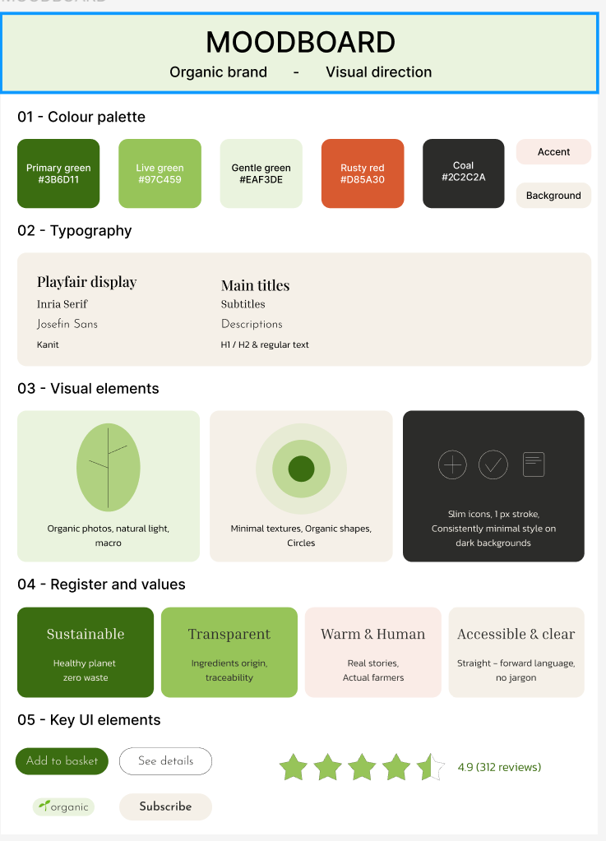

3.2.2 Typography and Imagery
- Headings will use an elegant typeface reflecting quality and tradition
- Body text will use a highly legible, accessible font optimised for all screen sizes
- All product photography will be captured in natural light to provide an accurate representation of items
- Icons will be consistent, minimal, and free of unnecessary decorative detail



3.3 Site Architecture
The structure has been designed to facilitate intuitive navigation:
- Main navigation menu: Shop – Subscriptions - About Us - Blog
- Product categories: Pantry Staples - Ready Meals - Curated Boxes - Drinks & Snacks
- Filter functionality: Users may refine listings by price, accreditation, country of origin, and customer rating
Breadcrumb navigation will be implemented across all pages to indicate current location and simplify return to previous sections.

4. Implementation Key Page Features

4.1 Homepage,
- Clear brand introduction and primary call-to-action positioned prominently
- Direct access to core product categories
- Showcase of best-selling and highest-rated items
- Dedicated section outlining subscription benefits
- Visual overview of the end-to-end supply chain
- Customer testimonials and independent quality assurance indicators

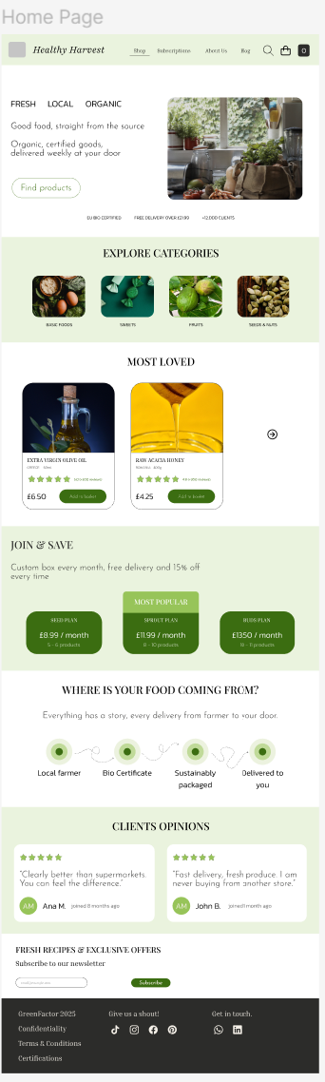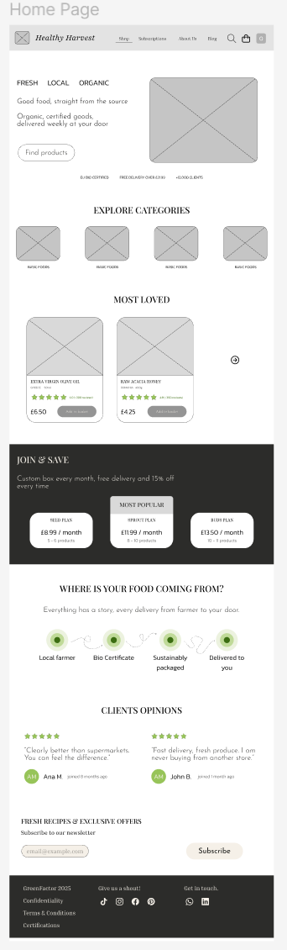

Both screens wireframe and mood board (high fidelity)

4.2 Product Pages
- Multiple high-resolution images from varied perspectives
- Core specifications: product name, origin, customer rating, price, and purchase option
- Producer and supply chain information
- Nutritional details and verified customer feedback
- Clear indication of available subscription discounts (15% saving)

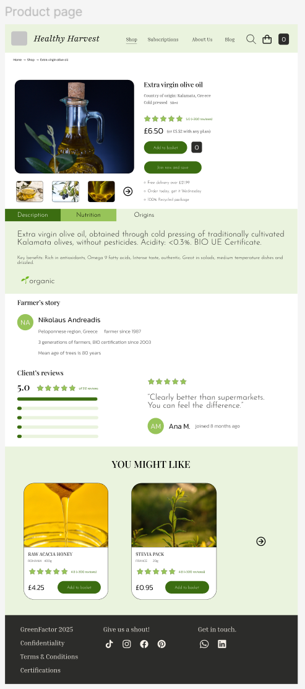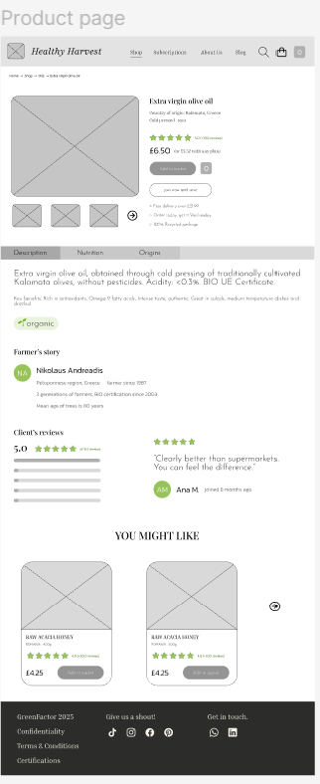
Both screens wireframe and mood board (high fidelity)

4.3 Product Listing Pages
- Advanced filtering to refine search results efficiently
- Clean, uncluttered layout with clear information hierarchy
- Seamless browsing via pagination or infinite scroll functionality

Both screens wireframe and mood board (high fidelity)

4.4 Subscription Pages
- Dynamic pricing display for monthly and annual billing, highlighting cost savings for annual payment options
- Clear identification of the most popular plan
- Step-by-step explanation of subscription terms and management
- Comprehensive frequently asked questions, including flexibility of cancellation and order modification

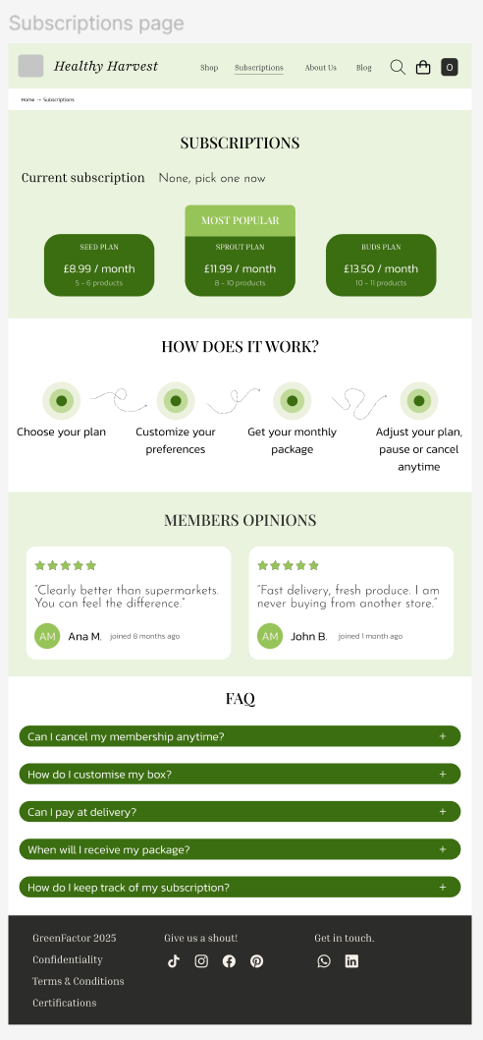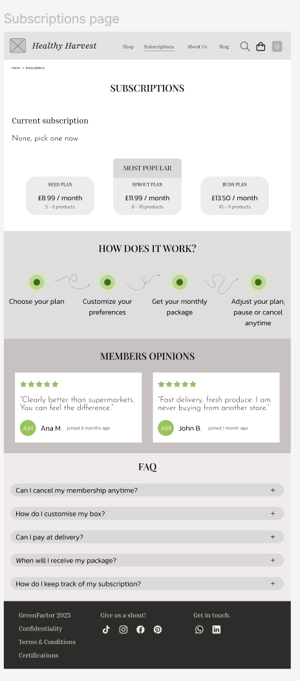

Both screens wireframe and mood board (high fidelity)

4.5 Basket and Checkout
- Simplified three-stage process: Review Order - Delivery Details - Payment
- Visible progress indicator throughout
- Continuous display of order value breakdown
- Reminder of applicable subscription savings
- Prominent confirmation of secure payment processing

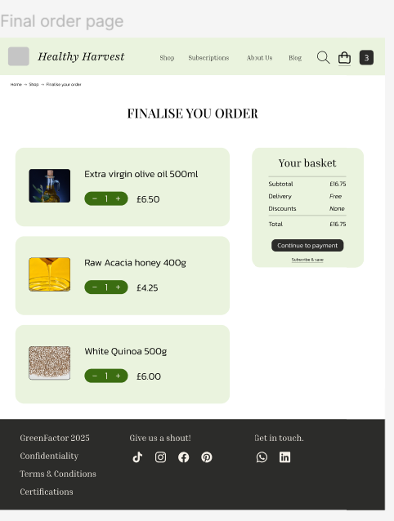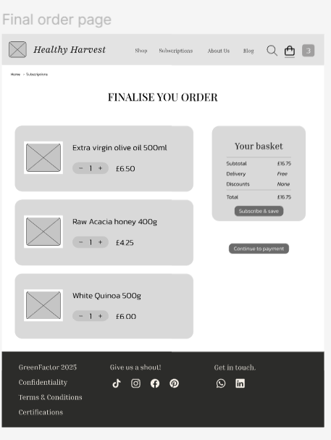

Both screens wireframe and mood board (high fidelity)

4.6 User Interaction
- Real-time updates to basket contents upon addition or removal of items
- Direct adjustment of order quantities within the basket view
- Collapsible sections for supplementary information to minimise visual clutter
- Flexible selection of preferred delivery date during checkout

4.7 Home page for iPhone

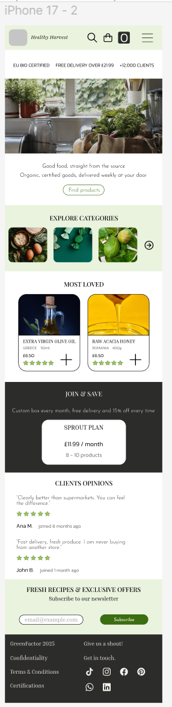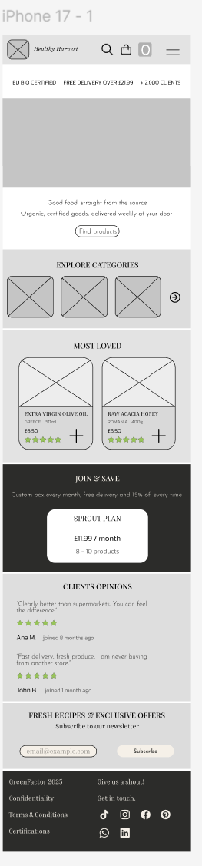
Both screens wireframe and mood board (high fidelity)

4.8 Accessibility and Compatibility
- Full compliance with recognised accessibility standards, including support for screen readers and assistive technologies
- Fully responsive design, developed using a mobile-first approach to ensure consistent performance across all devices
- Optimised page loading speeds for all connection types

4.9 Success Metrics
Performance will be monitored against the following key performance indicators:
Table 2
Category | Metric | Current Performance | Target Performance Post-Launch
Sales | Conversion rate | 1.2–1.8% | 2.8–3.5%
Sales | Checkout abandonment rate | Approximately 70% | Less than 45%
Subscriptions | New subscription sign-up rate | 0.3% | 1.2%
Subscriptions | Retention rate at 3 months | 60% | 80%
Sales | Average order value | Approximately £15 | Approximately £23
User Experience | Homepage bounce rate | Approximately 55% | Less than 30%
User Experience | Average session duration | 1 minute 45 seconds | 3 minutes 20 seconds
Technical Performance | Average page load time | Exceeding 4.5 seconds | Less than 2.5 seconds

Prior to public launch, the prototype will be tested with a representative sample of existing and prospective users to identify and resolve any remaining usability issues.

Conclusion
This project constitutes a complete strategic overhaul of VerdeMas’ digital presence, rather than a cosmetic update. The redesign is centred on user requirements and is intended to highlight the quality and ethical principles that define the brand.
Key deliverables include:
- A visual identity fully aligned with HealthyHarvest core values of authenticity, quality, and ethical practice
- Intuitive navigation allowing efficient location of content and products
- Full transparency across sourcing, production, and delivery processes
- A streamlined, reliable purchasing journey
- A clear, accessible subscription offering
Following launch, ongoing performance monitoring and iterative improvement will be undertaken to maintain optimal user experience and support sustained business growth.

