INE Compu-Fix Repair System Diagrams
BORISLAV DIMITROV 1921770 CC UWTSD

1. Context Diagram:

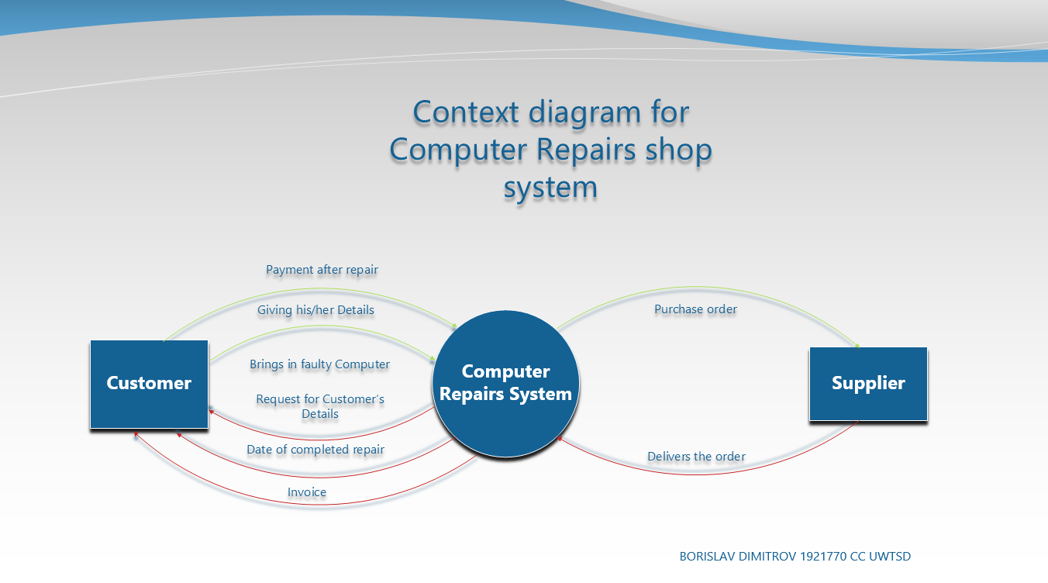

Customer is giving the faulty Computer, the system is taking the details, gives the customer data to collect. If item is out of stock, the system can order new one from the Suppliers. After repair, the customer collects the PC followed by invoice, followed be immediate payment.

2. Level 0 Diagram:

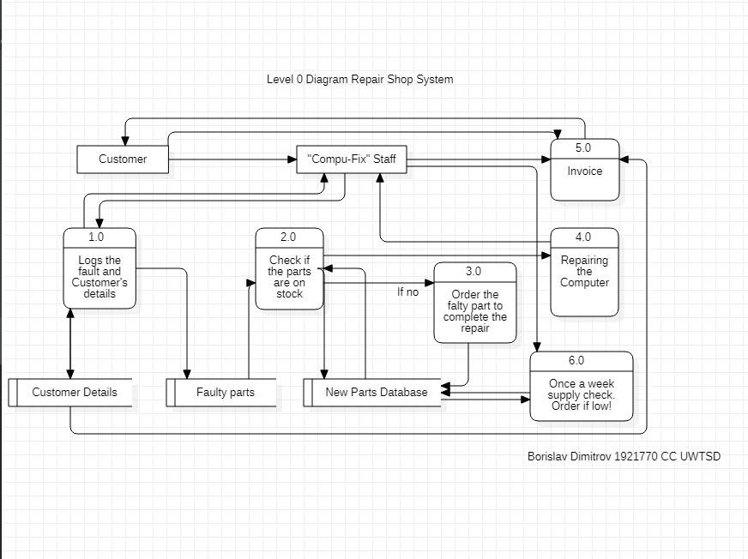

Customer brings the PC to the shop. Compu-fix Staff logs the fault and Customer’s details. Checks if the parts are on stock and continue to Repairing the Computer. If the part is out of stock the system is making an order from the supplier. After repair, the customers receives and Invoice. In order to collect he must pay immediately.

3.UseCase Diagram:

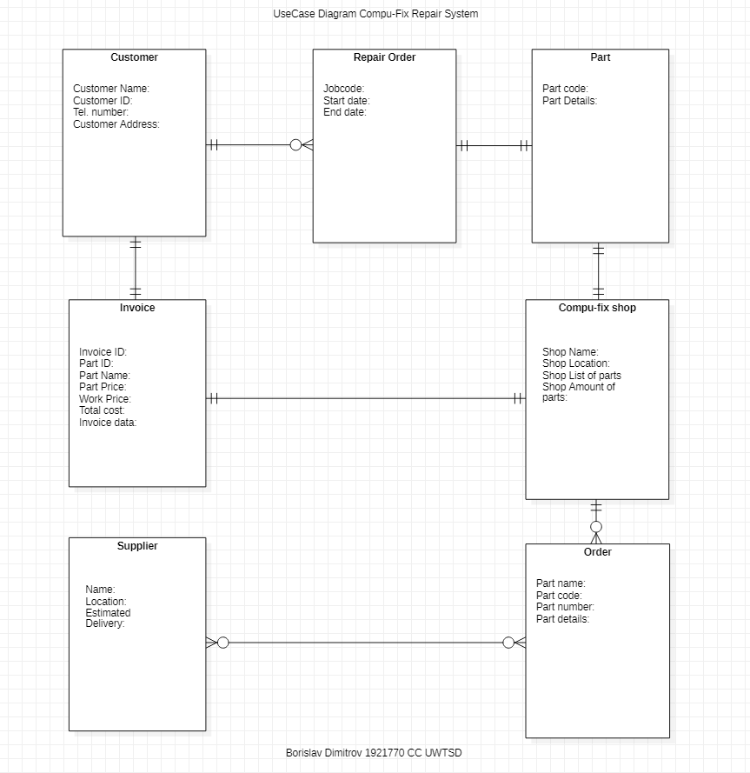

Customer making repair order. Order for damaged part provided from the shop followed by invoice, ment for the customer. If the part is not available, the shop is making order from the Supplier.

4. ER Diagram:

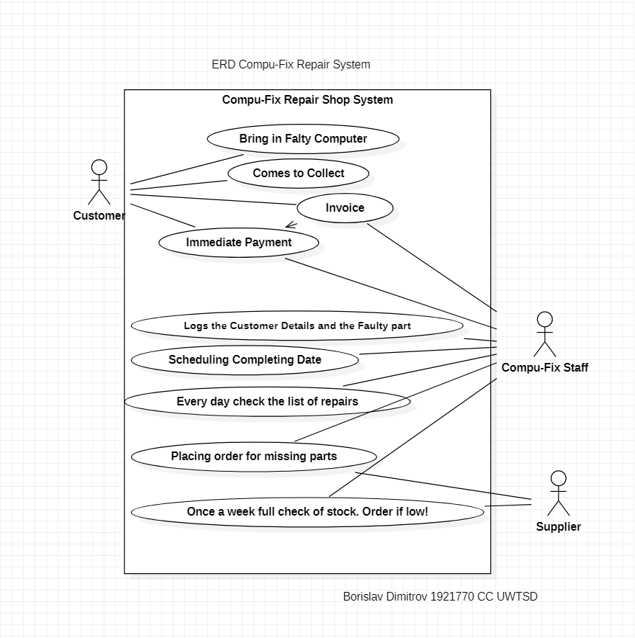

Customer brings falty computer, comes to collect, takes the invoice, makes the payment.
Compu-Fix Staff logs the Customer Details and Fault problem. Schedules the job. Keeps the inventory full and making invoices.
Supplier receives the list of orders and delivers.

