ACCA5019

Business and Web Management

Website Redesign for Online Business Presence

Name:
Radu Cristian Boros

ID:
2319948

Module Tutor: Dr Mobolanle Bello

Table of content

1.0 Introduction 3
2.0 Healthy Harvest Website Redesign 3
Current Issues 3
Proposed Solutions 5
3.0 RESPONSIVE DESIGN IMPLEMENTATION 6
4.0 IMPLEMENTATION SECTION 7
4.1 MOODBOARD AND WIREFRAME DESIGN 15
5.0 CONCLUSION 17
References 18

Introduction

This report presents a UI/UX website redesign proposal for HealthyHarvest, an online organic grocery business that sells organic produce, pantry staples, prepared meals and curated grocery boxes through one-time purchases and subscription plans. The purpose of this report is to explain how the redesigned website can improve usability, support the brand’s sustainable values, increase customer trust and encourage online orders and subscription sign-ups.

The scope of the report covers the main issues affecting the current HealthyHarvest website, including confusing navigation, outdated visual design, poor mobile optimisation, limited product information, lack of sourcing transparency, weak calls-to-action and accessibility concerns. It also discusses proposed design solutions, responsive design implementation and the importance of moodboards, wireframes and prototypes in the UI/UX design process.

The methodology followed a user-centred design approach[10]. A moodboard was created to define the visual direction of the brand, using natural green tones, white space, fresh produce imagery and a small orange accent colour. Wireframes were then developed to plan the structure and functionality of five key pages: Home, About, Products, Order and Contact. Finally, an interactive prototype was produced in Inkscape to demonstrate the proposed design.

This report is significant because a clear, responsive and visually consistent e-commerce website can improve customer experience, support business growth and help HealthyHarvest communicate freshness, sustainability and trust more effectively.

2.0 Healthy Harvest Website Redesign

Current Issues

The current HealthyHarvest website has several issues that affect user experience, customer trust and business performance. One of the main problems is confusing navigation and poor information architecture. As an online organic grocery business, HealthyHarvest needs a website structure that allows users to quickly find products, delivery information, subscriptions, brand details and contact support. If the navigation is unclear, customers may become frustrated and leave the website before completing a purchase.

Another issue is the outdated visual design. HealthyHarvest focuses on organic produce, pantry staples, prepared meals and grocery boxes, so the website should visually communicate freshness, health, sustainability and trust. If the website uses an old layout, inconsistent colours, poor spacing or low-quality images, it may not reflect the brand’s sustainable values. A weak visual identity can make the company appear less professional and reduce customer confidence.

The website also has a non-responsive and poorly optimised mobile experience. Many customers now browse and shop using mobile phones, so an e-commerce website must work effectively across different screen sizes. If text is difficult to read, product cards do not fit properly, or buttons are too small to tap, users may abandon the website. This can negatively affect mobile sales and subscription sign-ups.

Limited product information is another important problem. Customers buying organic groceries usually want to know what is included in each product box, how many items are provided, whether the produce is seasonal, and whether the ingredients are responsibly sourced. If product descriptions are too short or unclear, users may not feel confident enough to order.

The lack of ingredient sourcing transparency is also a major issue. Organic grocery customers often care about where their food comes from, how it is grown and whether suppliers follow sustainable practices. Without clear information about farmers, suppliers, seasonal produce and packaging, HealthyHarvest may fail to communicate one of its strongest brand values.
The website also has limited trust signals and social proof. In e-commerce, trust is important because customers are expected to share personal details, delivery information and payment information. Customer reviews, testimonials, clear contact details, delivery information and visible policies help reassure users. Research suggests that website design, usability and trust are closely connected to customer satisfaction and loyalty [1].

Other issues include ineffective calls-to-action, accessibility barriers and slow loading times. Calls-to-action such as “Shop Now,” “Add,” “Order Now” and “Start Subscription” should be clear and easy to identify. Accessibility problems such as poor colour contrast, unclear form labels and small text can make the website difficult to use for some customers [3]. Slow loading times caused by large files or unoptimised images can also reduce user satisfaction and increase abandonment [4].

Proposed Solutions

The redesigned HealthyHarvest website should use a clearer and more consistent structure. The proposed prototype uses five key pages: Home, About, Products, Order and Contact. This structure supports the main customer journey by helping users discover the brand, learn about its values, browse products, place orders and contact the business.
The Home page should introduce the brand clearly through a strong banner, simple headline, product highlights, reviews and clear calls-to-action. This helps users understand the purpose of the website immediately. The About page should explain HealthyHarvest’s story, sourcing values and commitment to fresh organic produce. This improves trust and supports the brand’s sustainable identity [5].
The Products page should use category buttons and product cards. Categories such as Vegetables, Fruits, Boxes, Pantry and Meals make browsing easier. Product cards should include clear images, product names, item counts, prices and “Add” buttons. This makes the shopping process more direct and helps customers compare products quickly [1].
The Order page should support both one-time orders and subscription options. It should explain delivery options, weekly subscription orders and special order details in a simple layout. This helps customers understand how to order fresh organic groceries and encourages repeat purchasing.
The Contact page should provide customer service information and a simple contact form. Clear form labels such as Name, Email, Phone Number and Message make the page easy to use. This also helps customers ask questions about orders, delivery, products or subscriptions.
The visual redesign should reflect the HealthyHarvest brand identity. The prototype uses a light green, white and organic green colour palette. The light green header and footer create a soft natural appearance, while darker green headings and buttons communicate freshness, health and sustainability. White card backgrounds keep the layout clean and readable. Orange is used only as a small accent colour for selected buttons and calls-to-action, helping important actions stand out without overpowering the organic theme.
Responsive design should also be applied to improve usability across devices. Responsive design is a web design approach where the layout adapts to different screen sizes and devices, allowing users to access the same content effectively on desktops, tablets and mobile phones [2]. In the proposed HealthyHarvest design, product cards, content sections and forms should be able to stack vertically on smaller screens. This would make the mobile version easier to read and use.
Accessibility should be improved by using readable fonts, clear labels, strong colour contrast and visible buttons [3], [6]. Images should also be optimised so the website loads faster without losing visual quality [4]. These solutions help create a website that is more professional, trustworthy and suitable for an organic grocery e-commerce business.

3.0 RESPONSIVE DESIGN IMPLEMENTATION

Responsive design is an important part of modern e-commerce website design because users access websites through different devices, including desktop computers, tablets and mobile phones. It allows the layout, images, text, navigation and interactive elements of a website to adjust to different screen sizes so that the content remains usable and readable [2].

For HealthyHarvest, responsive design is necessary because customers may browse products, compare grocery boxes, read delivery information and place orders from mobile devices. If the website is not responsive, users may experience problems such as small text, crowded product cards, broken layouts and buttons that are difficult to tap. These issues can create frustration and reduce the chance of users completing an order.

Responsive design improves user experience by making the website easier to navigate across devices. On a desktop screen, the Products page can display several product cards in a row. However, on a mobile screen, these product cards should stack vertically so that each product image, name, price and “Add” button remains clear. This makes browsing easier and reduces visual clutter [2].

The navigation menu should also adapt to smaller screens. A full horizontal menu may work well on desktop, but mobile users need a simpler layout that allows them to access Home, About, Products, Order and Contact without difficulty. This helps users move through the website more efficiently and supports a smoother customer journey.

Forms also benefit from responsive design. The Contact page includes input fields for Name, Email, Phone Number and Message. On mobile devices, these fields should become full-width so users can type easily. Buttons such as “Send”, “Order Now” and “Start Subscription” should also be large enough for touch interaction [6].

Responsive design can also increase mobile sales. If customers can browse products quickly, read information clearly and complete actions without technical problems, they are more likely to continue shopping. A poor mobile experience can lead to abandonment, while a responsive and well-structured layout can support higher conversion rates and repeat purchases [2].

For HealthyHarvest, this is especially important because grocery shopping is often a quick and convenience-based activity. Customers may want to order fresh produce, pantry staples or weekly grocery boxes while using their phone. A responsive website supports this behaviour by making the shopping process simple, accessible and reliable.

Overall, responsive design improves both user experience and business performance. It helps HealthyHarvest provide a consistent experience across devices, supports mobile customers and encourages online orders and subscription sign-ups.

4.0 IMPLEMENTATION SECTION

Moodboard
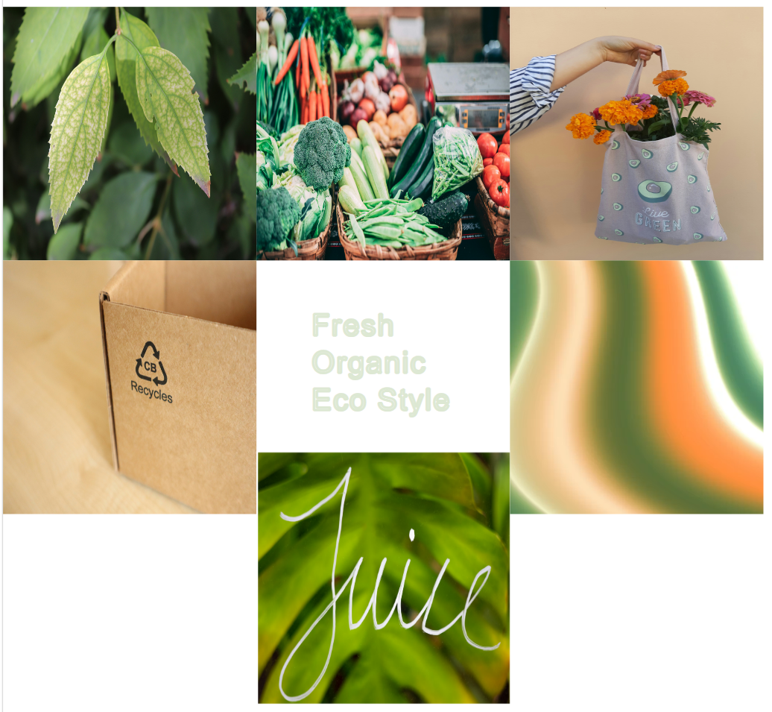
Figure 1: HealthyHarvest Moodboard

The moodboard shows the visual direction of the HealthyHarvest redesign, including natural green colours, fresh produce imagery, eco-friendly inspiration, typography ideas and a small orange accent colour.

Wireframe

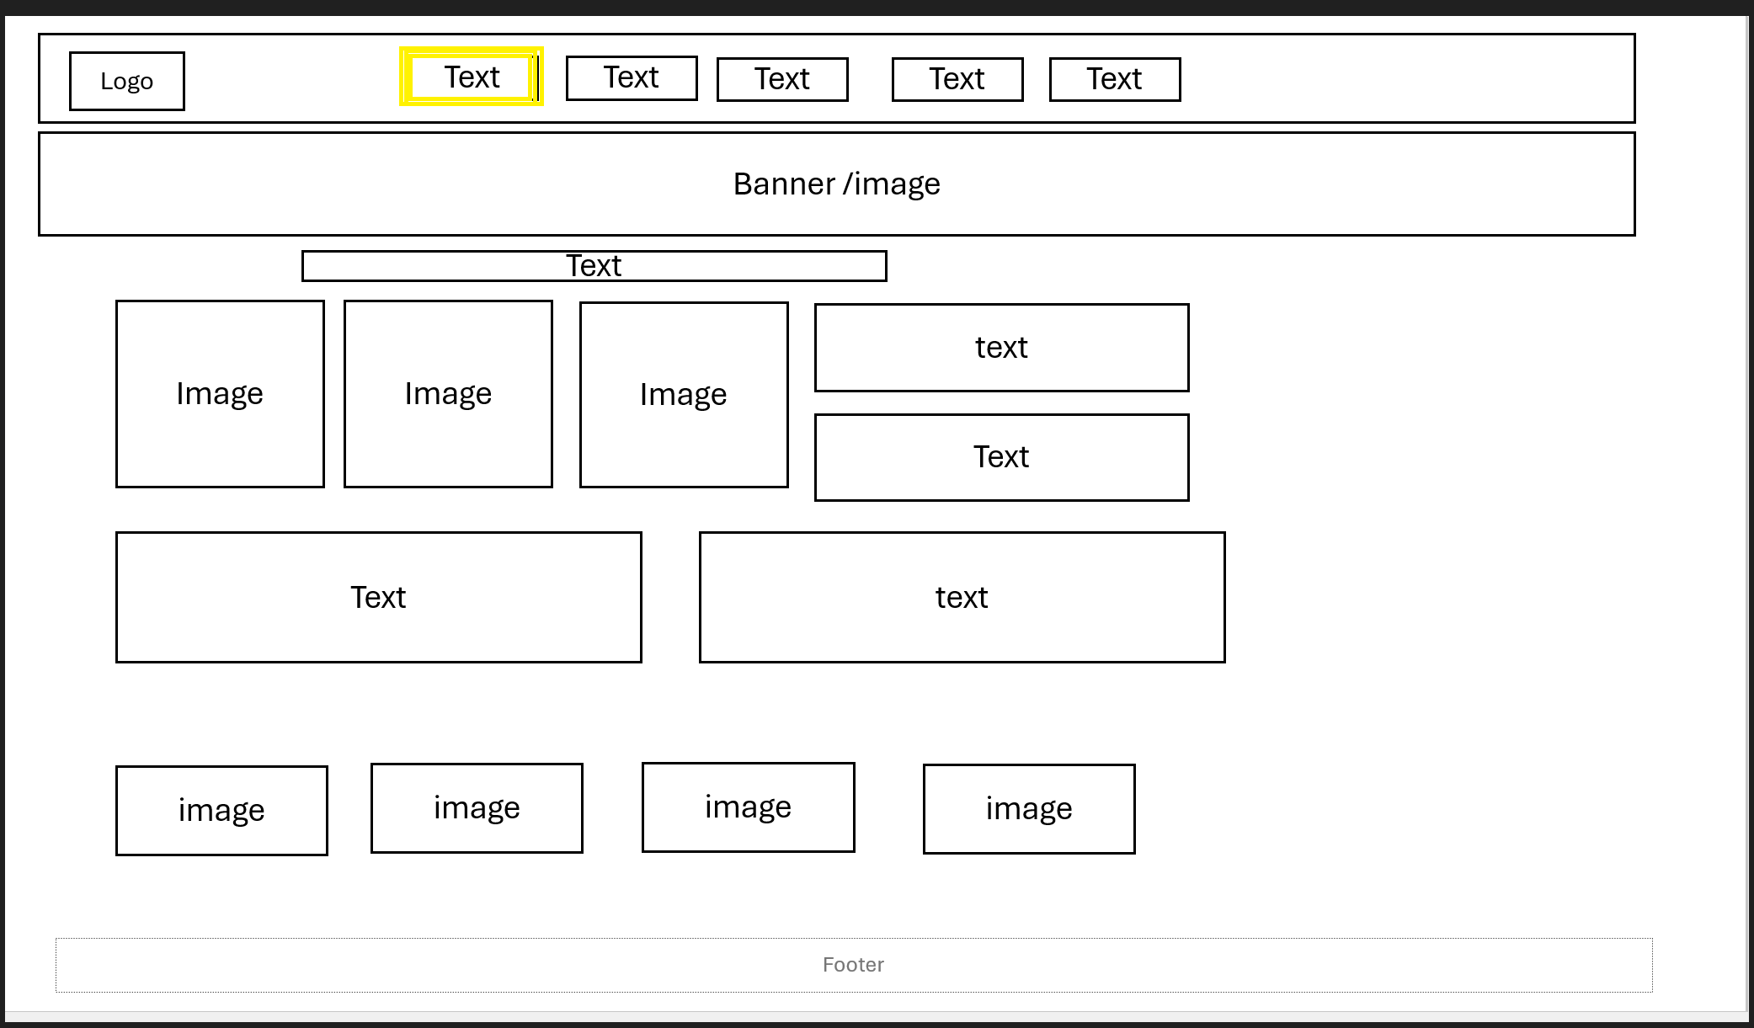
Figure 2: Homepage Wireframe

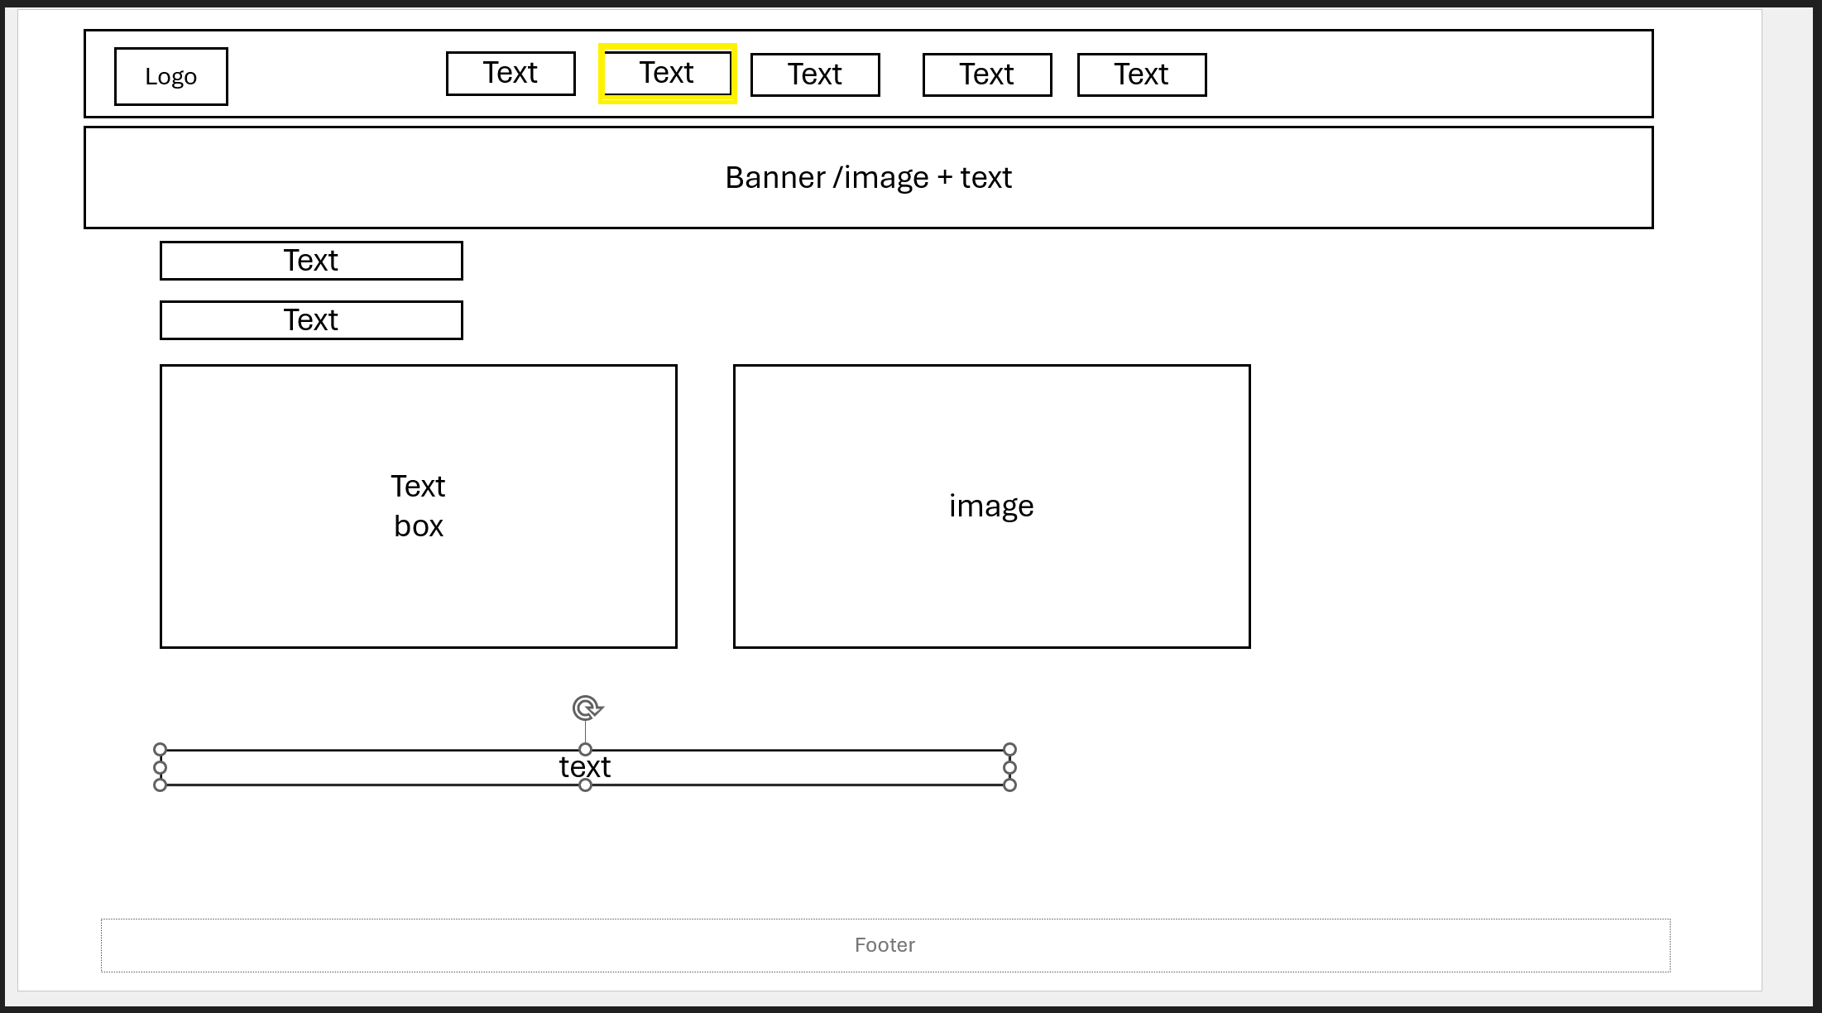
Figure 3: About Page Wireframe

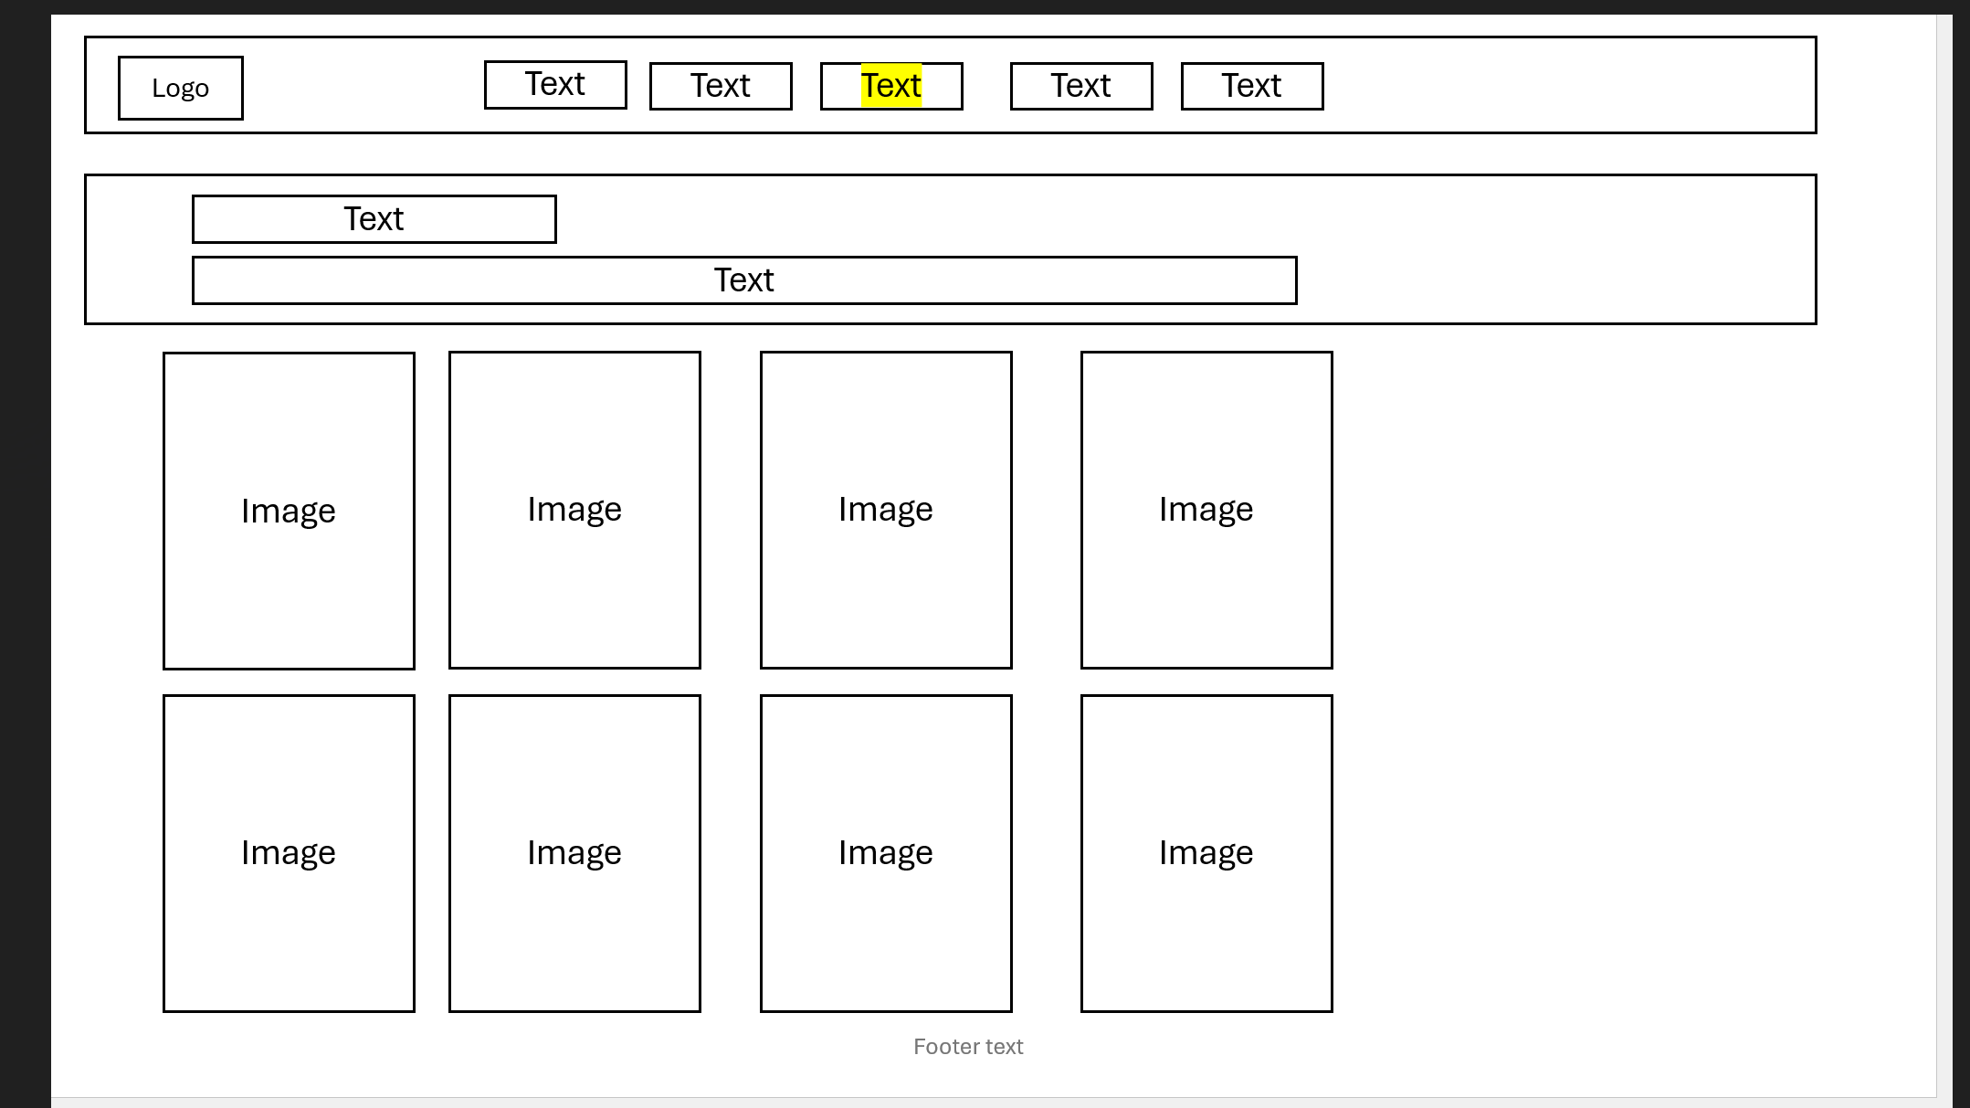
Figure 4: Products Page Wireframe

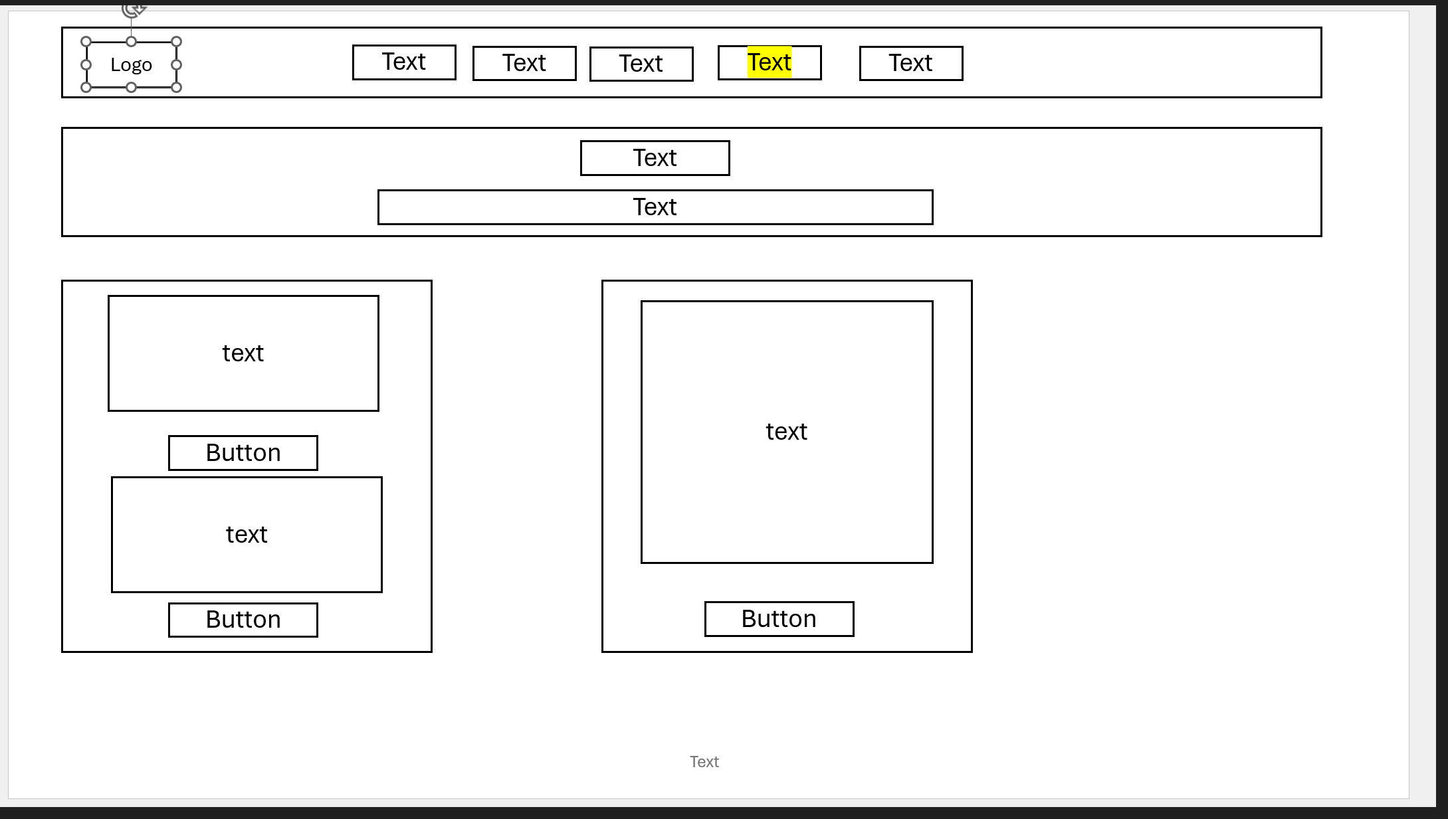
Figure 5: Order Page Wireframe

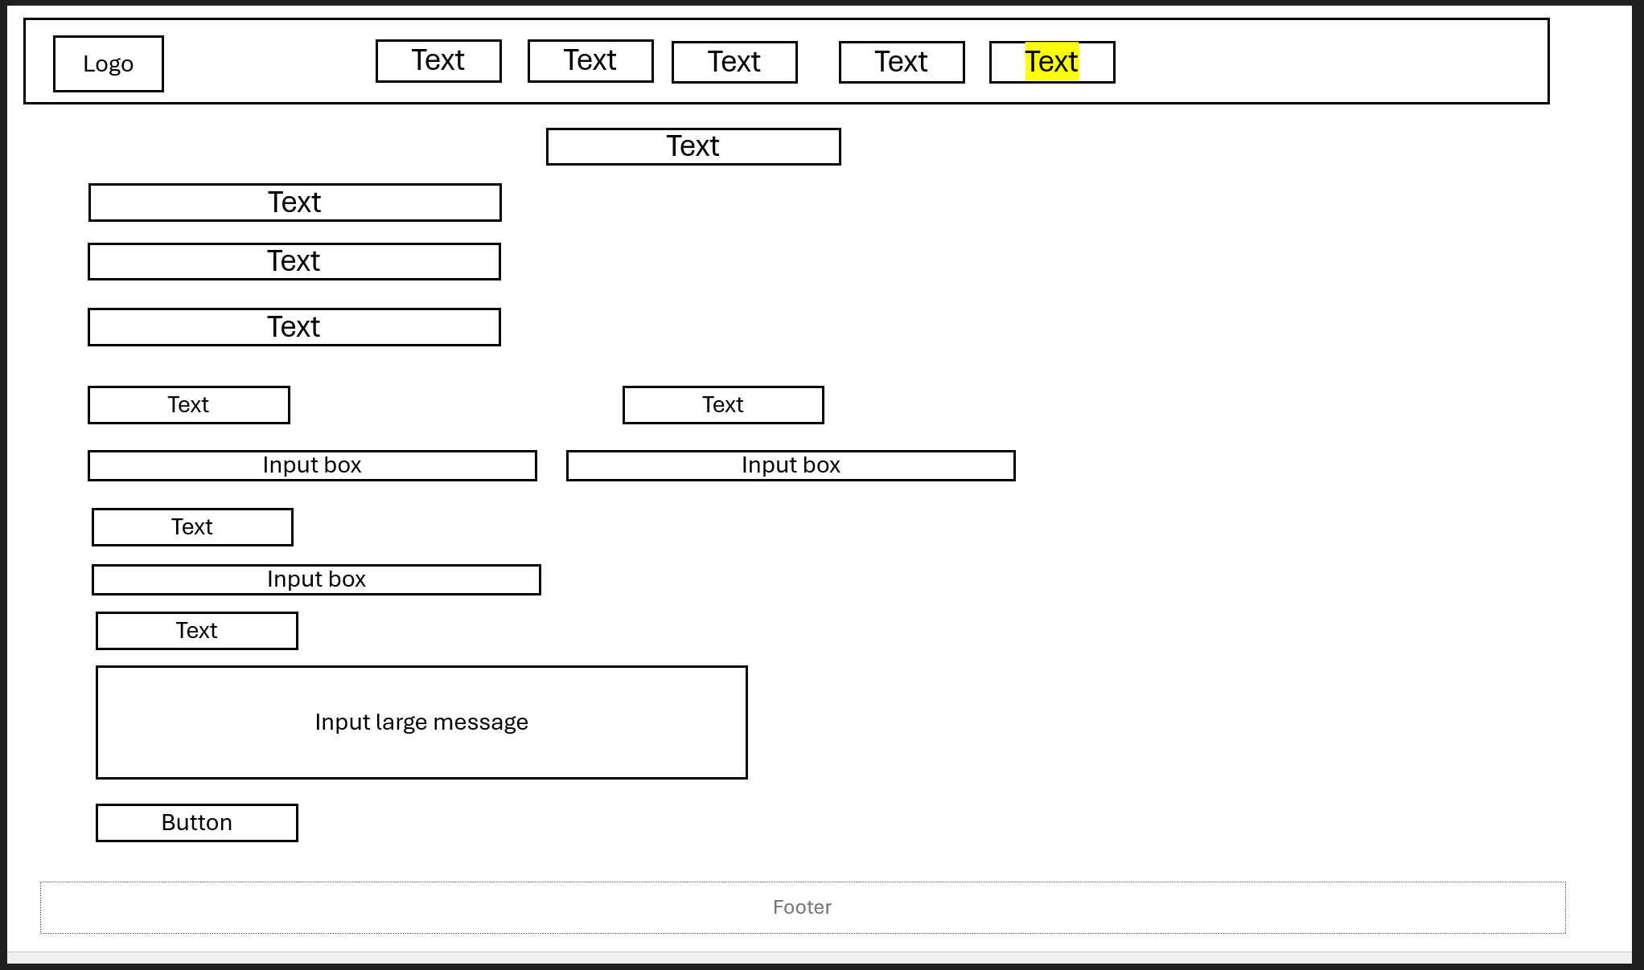
Figure 6: Contact Page Wireframe

Web Design

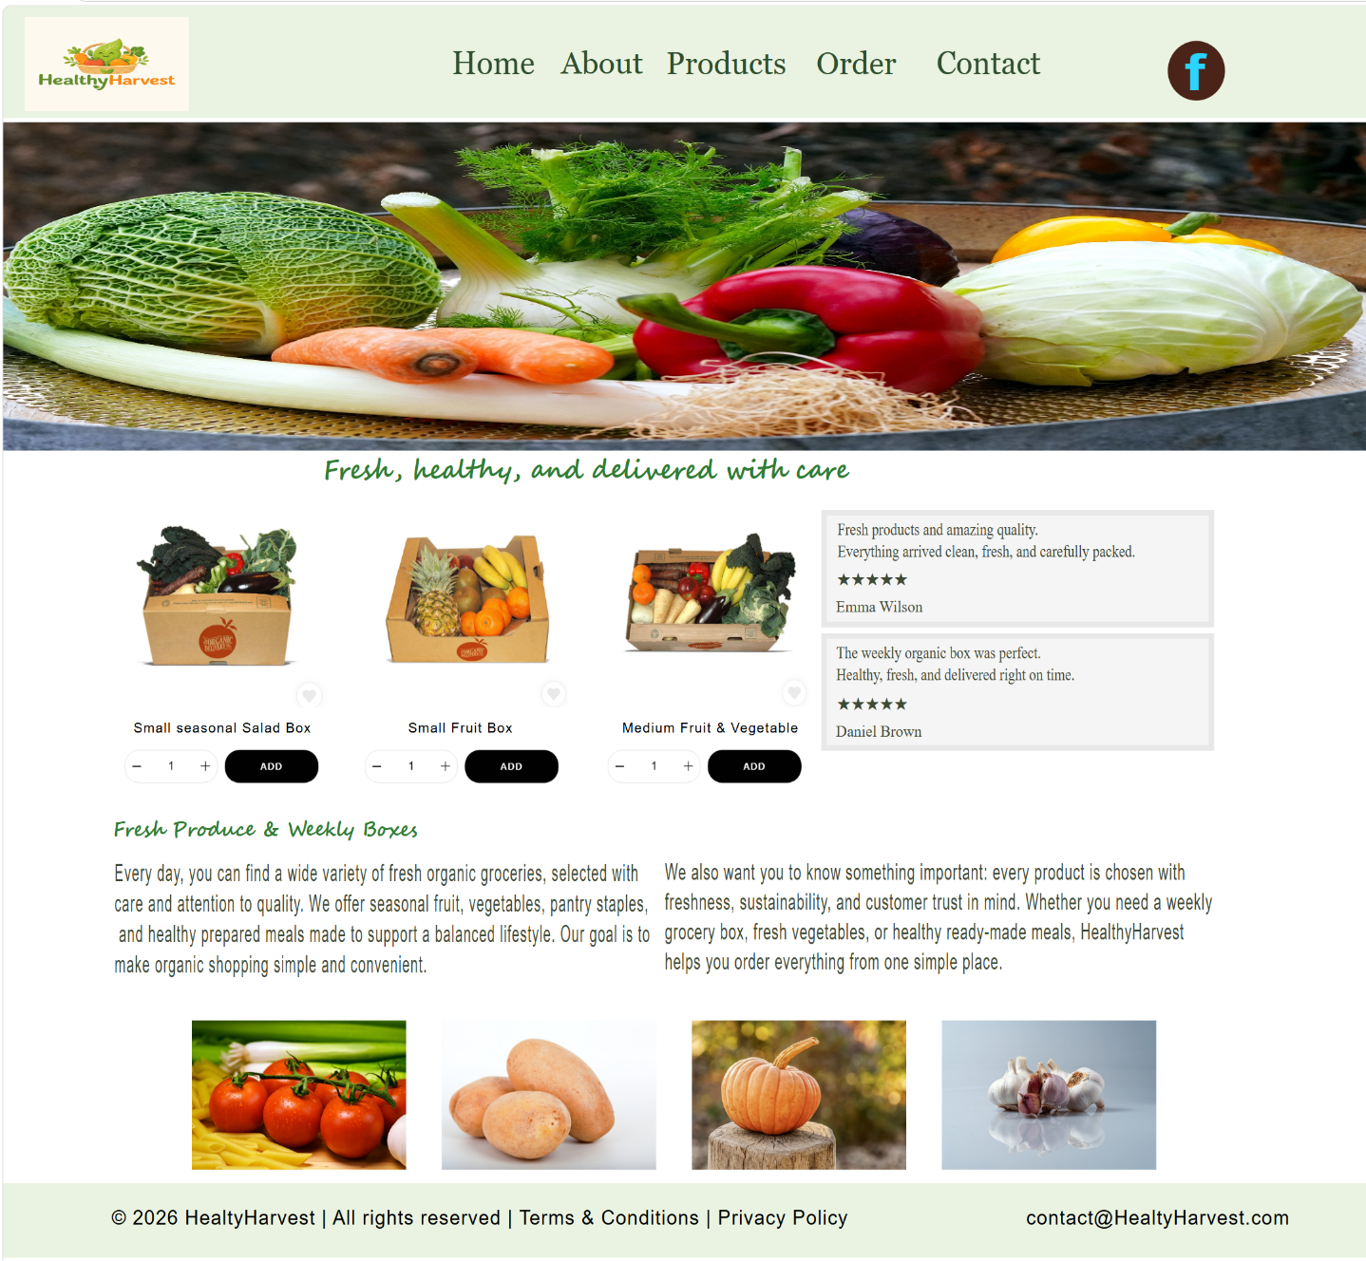
Figure 7: Homepage Web Design

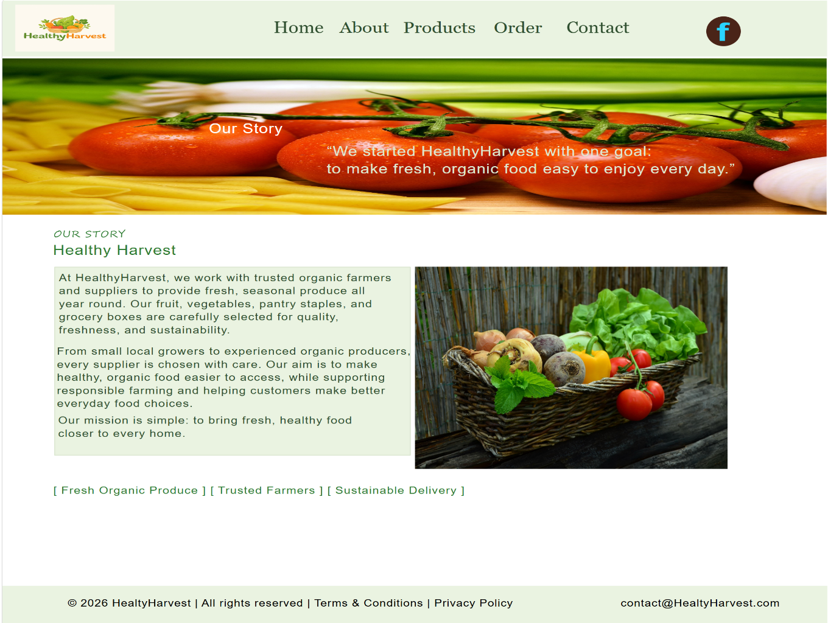
Figure 8: About Page Web Design
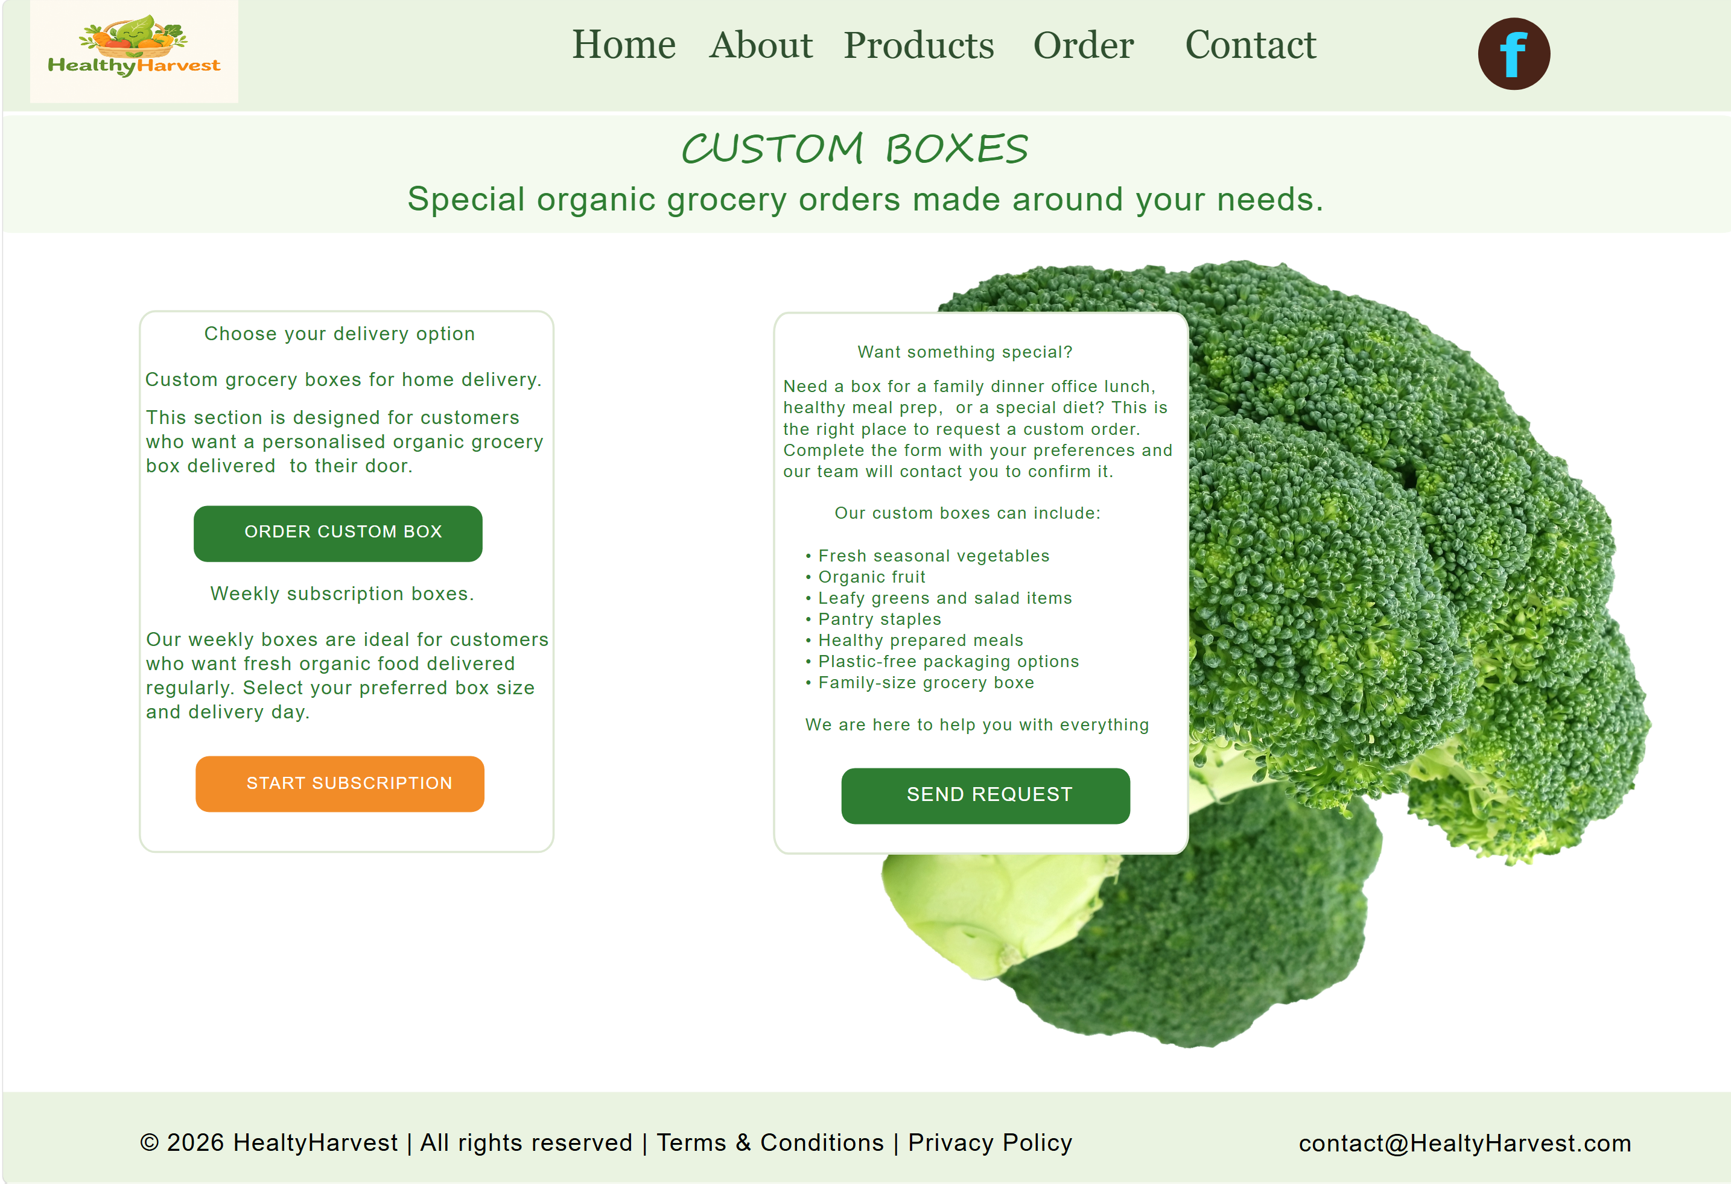
Figure 9: Order Page Web Design
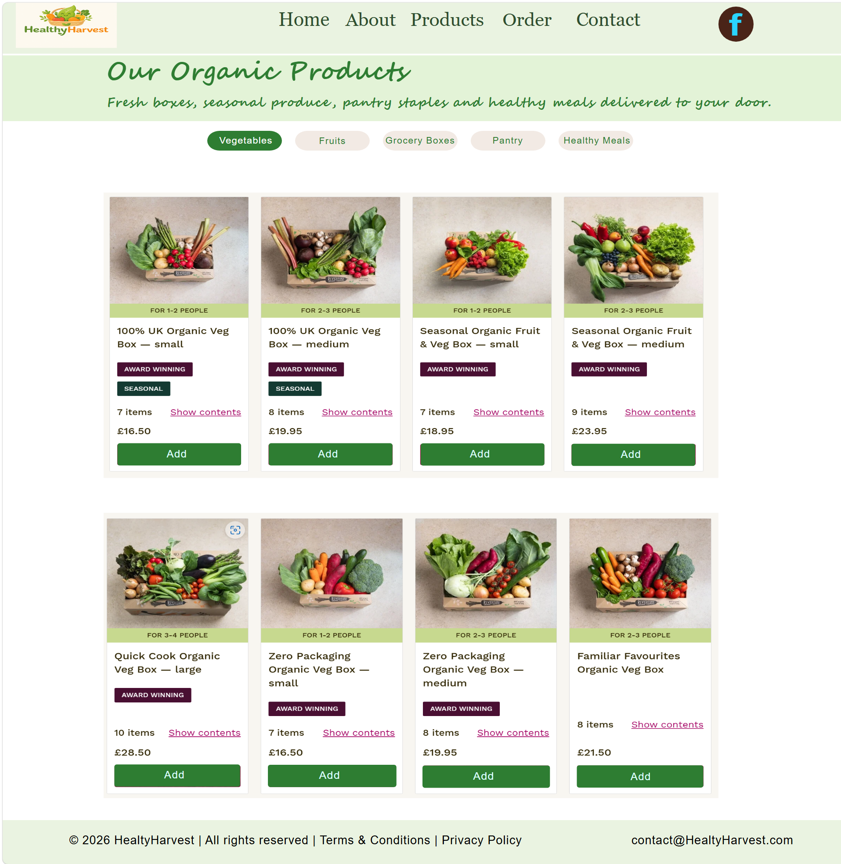
Figure 10: Products Page Web Design
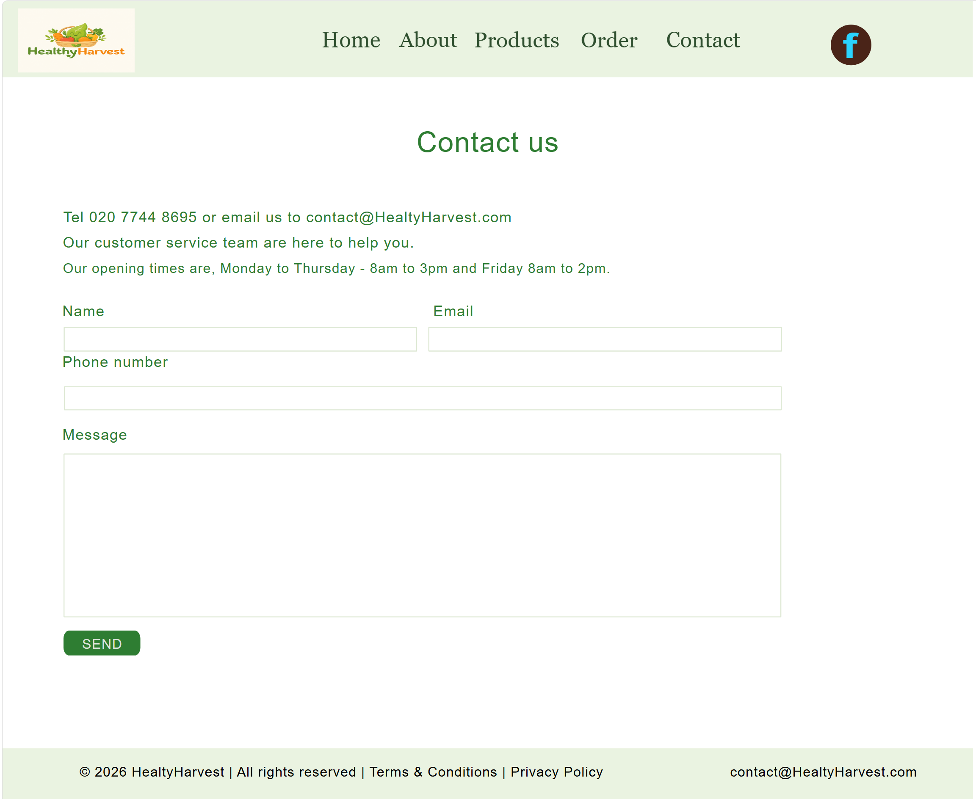
Figure 11: Contact Page Web Design

4.1 MOODBOARD AND WIREFRAME DESIGN

A moodboard is a visual collection of design inspiration used to establish the creative direction of a project [8]. It can include colours, images, typography, icons, textures and layout ideas. For the HealthyHarvest redesign, the moodboard was used to define a natural, fresh and sustainable brand direction before creating the final prototype.

The moodboard influenced the design by supporting the use of a light green, white and organic green colour palette. The light green colour was used for the header and footer to create a soft natural appearance, while darker green was used for headings and main buttons to represent health, freshness and sustainability. White space was also important because it helped the layout feel clean, modern and easy to read. A small orange accent colour was used for selected buttons and call-to-action elements, helping important actions stand out without making the design look too bright or distracting.

The moodboard also influenced the type of imagery used in the prototype. Images of fresh fruit, vegetables, organic produce and eco-friendly packaging were used to communicate HealthyHarvest’s identity as an organic grocery business. This supports the brand values of freshness, responsible sourcing and healthy living. The typography inspiration also encouraged the use of readable fonts with a friendly and approachable style, suitable for a modern grocery website.

A wireframe is a low-fidelity layout that shows the structure and placement of website elements before final colours, images and detailed styling are added [9]. It helps designers plan the position of navigation, headings, content sections, images, buttons, cards, forms and footer areas. Wireframes are useful because they focus on usability and functionality before visual decoration.

For HealthyHarvest, the wireframes influenced the final prototype by organising the five key pages: Home, About, Products, Order and Contact. The homepage wireframe planned the hero banner, product highlights, reviews and footer. The About page wireframe arranged the brand story and sourcing information. The Products page wireframe helped organise category buttons and product cards. The Order page wireframe structured delivery options, subscription information and order details. The Contact page wireframe positioned customer service information and the contact form.

Overall, the moodboard and wireframes helped create a consistent and user-friendly design. The moodboard guided the visual identity, while the wireframes guided the layout and user journey. Together, they supported the creation of a clear, professional and suitable website prototype for HealthyHarvest, following a user-centred design approach [10].

5.0 CONCLUSION

This report has presented a UI/UX website redesign proposal for HealthyHarvest, focusing on improving usability, visual identity, responsive design, accessibility and customer trust. The project was based on the needs of an online organic grocery business that sells fresh produce, pantry staples, prepared meals and curated grocery boxes. The final prototype included five key pages: Home, About, Products, Order and Contact.
The design process was important because it helped transform the problems of the existing website into clear design solutions. The moodboard supported the visual direction by establishing a natural green, white and orange colour palette, supported by fresh produce imagery and eco-friendly design inspiration. The wireframes helped organise the structure of each page before the final prototype was created, making the design more consistent and easier to follow.
The redesigned prototype supports HealthyHarvest’s business needs by improving navigation, making product browsing clearer, strengthening trust through brand information and reviews, and providing a simple order and contact process. These design decisions are important because website usability, design quality and trust can influence customer satisfaction and loyalty in online shopping environments [1]. Responsive design was also considered so the website could provide a better experience across desktop, tablet and mobile devices [2].
Overall, the project shows that a structured UI/UX design process is essential for creating a high-quality e-commerce website. A clear, consistent and user-focused design can help HealthyHarvest communicate its organic values, improve customer satisfaction and encourage online orders and subscriptions.

References

[1] J. Guo, B. Zhang, and X. Zhang, “Impact of shopping website design on customer satisfaction and loyalty: The mediating role of usability and the moderating role of trust,” Sustainability, vol. 15, no. 8, p. 6347, 2023.

[2] F. Nawir and S. A. Hendrawan, “The impact of website usability and mobile optimization on customer satisfaction and sales conversion rates in e-commerce businesses,” The Eastasouth Journal of Information System and Computer Science, vol. 2, no. 1, pp. 15–30, 2024.

[3] P. Acosta-Vargas, B. Salvador-Acosta, L. Salvador-Ullauri, and J. Jadán-Guerrero, “Accessibility challenges of e-commerce websites,” PeerJ Computer Science, vol. 8, p. e891, 2022.

[4] B. Kumar, S. Roy, K. U. Singh, S. Pande, A. Kumar, A. Sinha, S. Shukla, M. A. Shah, and A. Rasool, “A static machine learning based evaluation method for usability and security analysis in e-commerce website,” IEEE Access, vol. 11, pp. 40488–40510, 2023.

[5] V. Zieglmeier and A. M. Lehene, “Designing trustworthy user interfaces,” in Proceedings of the 34th Australian Conference on Human-Computer Interaction, 2022.

[6] World Wide Web Consortium, Web Content Accessibility Guidelines (WCAG) 2.2, W3C Recommendation, 2024.

[7] K. Boyalakuntla, A. S. M. Venigalla, and S. Chimalakonda, “WAccess: A web accessibility tool based on WCAG 2.2, 2.1 and 2.0 guidelines,” 2021.

[8] S. Sano and S. Yamada, “Composing Mood Board with User Feedback in Concept Space,” 2023.

[9] S. Feng, M. Yuan, J. Chen, Z. Xing, and C. Chen, “Designing with language: Wireframing UI design intent with generative large language models,” 2023.

[10] H. Sharp, Y. Rogers, and J. Preece, Interaction Design: Beyond Human-Computer Interaction, 6th ed. Wiley, 2023.

