
Changemakers: Creativity and Value Creation
Assignment 2
Luke Davies – Student Number: 2315714 | 8/18/25 | ACCA5033

Contents

Introduction 2
Task 1: Project Management 3
Task 2: Enterprise 7
Task 3: Project Reflection 10
Conclusion 11
References 12
Appendix – Supplementary Information 14

Introduction
This report details several key considerations for developing the bias and accuracy Artificial Intelligence model outlined in Assignment 1 of this module.
The report begins with an outline of project management scope, technologies, and a timeline for completion of the project set out in the form of a Gantt chart. A wireframe website design is provided to demonstrate how the AI model would produce results to end users, alongside a flow chart demonstrating a potential logic flow of the underlying data analysis that the model may carry out.
The report then documents how the project idea could be incorporated into a limited company and PEST and SWOT analysis is provided. A potential business strategy is discussed alongside ideas for corporate identity and company logos.
The report continues with a project reflection section which details the utility of the project for the writer’s own development and that of society. Finally, a conclusion draws together the contents of the report. An appendix is included to provide supplemental material.

Task 1: Project Management

  - Q1 – Project Management & Planning
  - Project Scope
The project scope includes creating an Artificial Intelligence model called ‘MAITE’ – a type of search engine which queries multiple Natural Language Processing (‘NLP’) models based on user input, assesses the accuracy and bias of the model outputs, and displays the model outputs ranked by transparency, neutrality, and accuracy – with MAITE providing the user with the response which best meets those criteria.
  - Proposed Solution
Given the scope of the project outlined above, the problem that the project is resolving is one of transparency in the emerging field of NLP models. As aptly put by Afroogh et al:
“In the absence of transparency and explainability of the AI, the human does not have enough information to form a judgment regarding the chosen decision.” [1]
The creation of ‘MAITE’ as an NLP bias and accuracy ranking system solves this problem by breaking down any barriers between the end user and the ‘intelligence’ behind the NLP models queried. This is achieved not only through the ranking system, but by clearly explaining the sources of information, and any bias, in the model output. The project solution is therefore to solve the issue of transparency but also perception of NLP models through creating transparency of output.
  - Project Timeline
The project timeline is established as follows:
Research Stage – This will form the first stage of the project, where research into data ranking methods, bias, and accuracy is conducted. This beginning stage is expected to take 2 weeks to complete.
Design Stage – In this stage, the bias and accuracy ranking methods will be designed alongside designs for an app/website to display the results to end users. 1 month is allocated for this stage, given the time required for design and programming of the model.
Implementation and Testing Stage – Here real world testing of the methodology crafted in design can be caried out and refinements made if required. Approximately 1 month is allocated to this stage to allow for effective refinement.
Deployment Stage – The project’s final stage will involve creating a demonstration for potential advertising and/or investment partners, and hosting the app or website once finalised. Approximately 1.5 months are allocated to this stage given external parties are involved in progressing to deployment, assuming potential delays in replies and time to create demonstration.
  - Schedule of constraints
Several constraints may hinder the progress of this project, including:
- The availability of NLP models, including cost of purchase for paid-for models or where usage quotas exist
- Technical ability of the project designer in developing the technology required to query and rank NLP models
- Time of project completion, which could overrun beyond the suggested timeline if models become unavailable or user feedback is slow
- Limit of respondents providing user feedback, which would delay any testing stages of the project
- Cost of hosting a website and/or application to provide the model to end users
  - Gantt Chart
The below Gantt chart presents an estimate for key project stages. As noted in the following section, an Agile approach is preferred and as such the stages may be subject to overlap and/or rearrangement according to project need.
Link to Gantt Chart: Gantt.xlsx
Figure 1: Gantt Chart phases 1 and 2 [16]
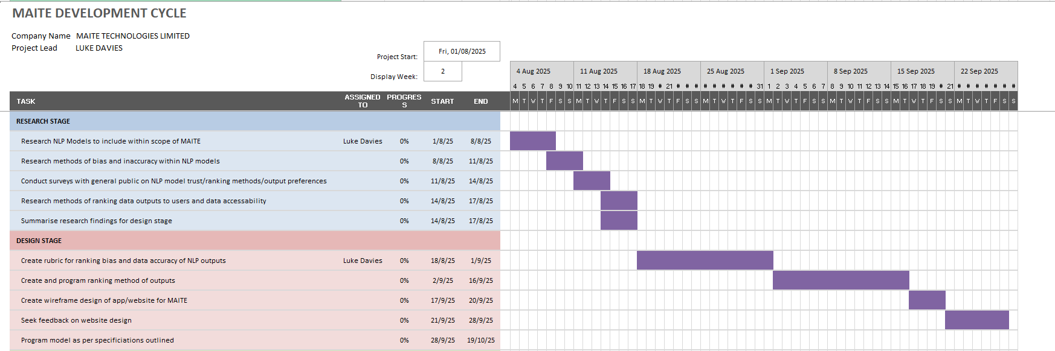

Figure 2: Gantt Chart phases 3 and 4 [16]
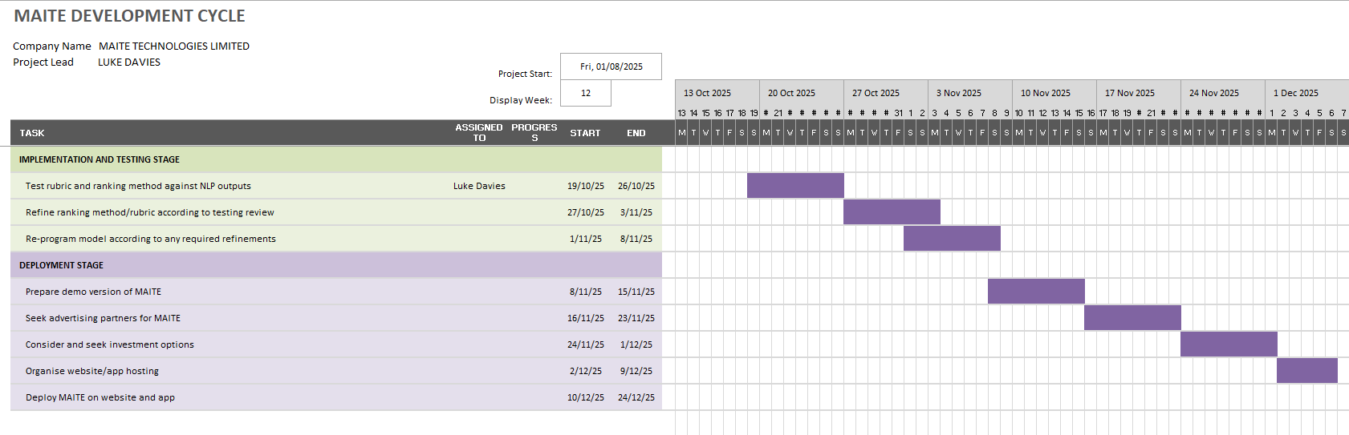

  - Development Methodology
Of the various methodologies available, this project favours a flexible approach given that the stages of the project may adapt depending on roadblocks in model development or user feedback. For example, ideas given in later surveys or feedback may warrant changes in the site/app design or ranking methods.

  - Development Method
Several development methodologies exist, each of which serve to progress a project from inception through to completion. These include, for example, a waterfall methodology where one project phase is completed before the next is started, or a Kanban methodology where visual boards are used to manage progress.
For the MAITE project, it is likely that several stages of the project may overlap or require revisiting, given, for example, that feedback provided by users later in the project stage, or during later testing of the model, could require amendment to the model coding completed earlier on in the product lifecycle.
As such, an Agile approach to project management best suits this project. An Agile approach allows for an “evolving and collaborative” [2] approach to project development where the ebb and flow of the project can change according to specific needs, rather than adopting a traditional ‘waterfall’ model where stages of the project are completed in sequence and in isolation. Using this model, the project plan can develop according to project needs, and this level of flexibility suits the project well.
  - Q2 – Project Design
  - Wireframe Website Design
The below documents a potential design of MAITE’s front website search page, and also a search results page. Attention has been given to providing the most trusted/least biased result (according to the algorithm created), and to providing a clear list of sources.

Figure 3: Wireframe design for front page of website and search results page [17]
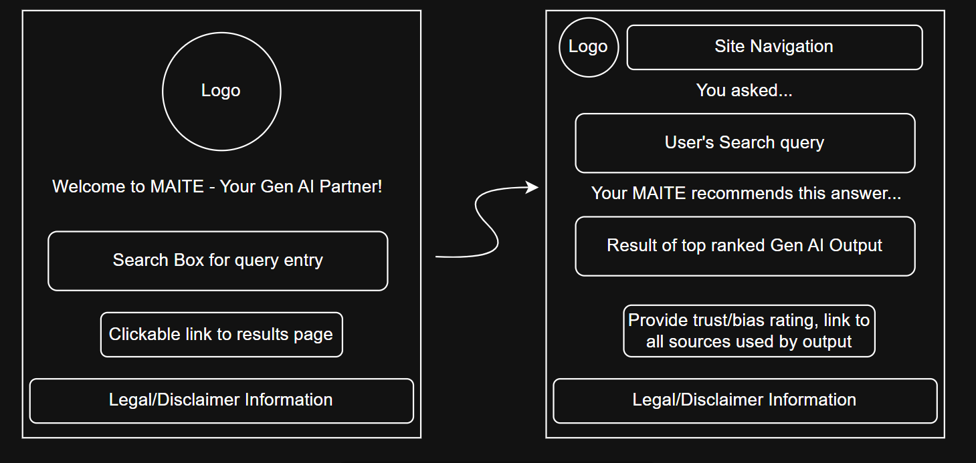
  - Data Model Flowchart
The below provides a data model flowchart for MAITE. Here, the process of query to result is described whereby the user’s query is run through MAITE’s bias/accuracy model, with the outputs ranked and sources listed.
Figure 4: Data Model Flowchart for MAITE project [17]
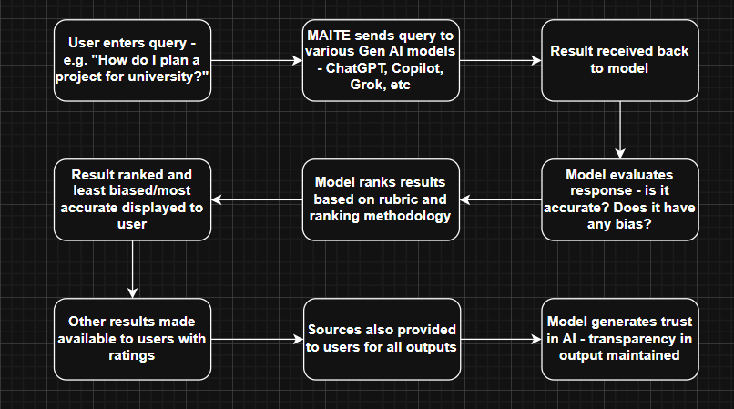

Task 2: Enterprise
  - Q1 – PEST & SWOT Analysis
The planning stages of the project can be further progressed via a PEST AND SWOT analysis. SWOT has been described as “a vital tool for strategic business planning” [3] insofar that it allows for the assessment of a potential enterprise’s strengths, weaknesses, opportunities and threats. The PEST analysis allows for consideration of an enterprise’s political, economic, social and technological aspects in society. Taken together and as outlined by Yu, a PEST-SWOT analysis allows one to “identify actionable insights and strategic directions” [4].
With the above in mind, the following PEST-SWOT considerations are given for this project:
PEST Analysis
Political – Consideration of GPDR requirements if data is stored by MAITE, or wider legal factors such as the recently enforced EU AI Act [5]. MAITE must ensure compliance with such legislation.
Economic – The creation of MAITE as a concept could revolutionize transparency within the emerging generative AI field, and as such could generate significant revenue through, for example, advertising partnerships. MAITE could generate employment opportunities within society. A challenge may be securing funds for MAITE as a start up company.
Social – MAITE could improve digital literacy if trust in Generative AI models increase – conversely, too much reliance may be placed on models if they become too effective, posing an ethical issue - and as such the site may want to promote seeking alternative sources of information.
Technological – A large barrier to the creation of MAITE will include technical expertise in querying multiple AI models. Furthermore, as AI models evolve they may include bias and accuracy checking models within their own software, and so MAITE requires a unique voice and brand to maintain trust and relevancy in the market.
SWOT analysis
Strengths – The main focal point of MAITE lies in its ability to reduce fear and distrust in AI models, and so its strength is in transparency and reliability in the way it produces results to users.
Weaknesses – Early funding may be needed for the technology required to make MAITE a success. There may be initial distrust in a new, unknown AI system which MIATE would need to overcome, possibly with advertising campaigns.
Opportunities – There is an opportunity to create a trustworthy AI brand with MAITE, and if successful, the brand could be developed into other revenue streams such as price comparison (e.g. insurance) or comparison of holidays or hotels, for example.
Threats – A major threat to the company is pre-existing AI models incorporating trust and bias checking into their own models, negating the use of MAITE, or other companies creating a similar idea and competing with MAITE.
  - Q2 – Business Proposals
As noted elsewhere in this report, the project in question has been named ‘MAITE’ – an amalgamation of the terms ‘AI’ and ‘Mate’. The name is a creative play on words, intended to project ideas of the guidance of a trusted friend which aids the user in navigating the world of generative AI.
A sample logo for the project is provided below:
Figure X – Project logo [6]


Given the company is a new startup requiring funding and public trust in order to be successful, a limited company may be the most suitable corporate entity for MAITE to adopt. In this format, funders and investors can safely inject capital into the venture and have their legal liability limited by share value. This approach to incorporating MAITE could, as outlined by banking advice [7], enhance public trust in MAITE as a regulated corporate entity which naturally would benefit a trust-oriented startup company. This approach is preferred over, for example, sole tradership, which would result in “unlimited liability” [8] for debts or legal claims.
Regarding a business strategy, MIATE could operate on a ‘freemium’ basis, whereby “users can pay for premium content and features after adopting the base product” [9]. In the case of MAITE, users could be limited to a number of search enquiries per day, and a paid subscription could be created for additional searches. Using this model could generate significant traffic to the site if public trust is gained in the model, which would encourage investment opportunities.
In consideration of investment, the following initiatives could be utilised to fund the creation of MAITE:
- Government initiatives such as the UK Innovation Fund [10] provide funding for companies which ‘drive societal benefit’.
- Advertising agencies could be approached to fund the start up.
- Crowdfunding sites – such as Kickstarter [11] – could be utilised for public funding.
- University funding, such as the Enterprise Start Up Grant offered by University of Wales Trinity Saint David [12].

Task 3: Project Reflection
Project MAITE’s aim is to generate a trustworthy, source-citing AI companion – and in doing so will present many benefits, challenges, and areas for personal growth.
A major benefit of the project for its designer will be developing skills in data analysis and coding, which will assist in progressing the writer in their goal of becoming a data analysist or data scientist. Studies have shown that project-based learning is beneficial to a student’s academic success [13], particularly in problem solving, given that a project may reach certain roadblocks such as a lack of technical expertise. The writer may seek to utilise university resources to improve their coding and data science knowledge to overcome this, such as the universities libraries or E-resources such as LinkedIn Learning, which has been shown to “boost… industry-relevant technical skills which would enhance… employability” [14].
Further, the MAITE project has a clear societal benefit in improving the public perception of generative AI models. If trust is improved and an uptake is seen in the use of transparent AI models such as MAITE, the general public could be better informed on a variety of topics with the aid of AI – this creates a dual benefit of improving computer literacy (where a fear of IT systems being inaccurate is a barrier to better understanding of computing) and improving general knowledge gained through user friendly AI generation.
The project is however not without its challenges. As described elsewhere, the idea behind MAITE could be copied by existing AI models and utilised within their own proprietary software. A method for overcoming this lies in creating a strong branding for MAITE – brand reputation alone, as discussed by Açikgöz et al, can create a “sustainable competitive advantage” [15] over other similar ideas – this advantage will be key for MAITE and could be achieved by, for example, aggressive marketing campaigns, social media interaction, and strength of the algorithms created to rank outputs to increase brand awareness and generate trust in the MAITE brand.
Another potential challenge within the MAITE project is one of AI ethics – should an AI model decide what is ‘accurate’ or ‘unbiased’? The risk to MAITE is that, whilst the model itself promotes transparency, it itself is not trusted by the public. Possible methods of mitigating this include providing the model’s rubric for scoring accuracy and bias publicly so that users can view ‘under the hood’ of the methods MIATE uses to judge AI outputs. Alternatively, users could be encouraged to provide feedback on the system to foster a sense of community development in MAITE, which would have the dual benefit of improving trust and the model itself via feedback.

Conclusion
This paper outlines the methods via which a university project, entitled ‘MAITE’, could be developed using several well-known project and enterprise reflection techniques.
Despite several discussed challenges, MAITE presents an opportunity to create a strong AI brand within the emerging sector which promotes clear, ethical AI outputs to users through a robust accuracy and bias ranking model.

References

[1] S. Afroogh, A. Akbari, E. Malone, M. Kargar, and H. Alambeigi, “Trust in AI: progress, challenges, and future directions,” Humanities & social sciences communications, vol. 11, no. 1, Art. no. 1568, 2024, doi: 10.1057/s41599-024-04044-8.
[2] C. Tristancho, “Top 15 Project Management Methodologies: An Overview,” Project Manager, Sep. 10, 2024. https://www.projectmanager.com/blog/project-management-methodology [Accessed July 29, 2025]
‌[3] L. Jiagui and J. F. I. Lam, “Macao’s academic book publishing industry: A SWOT and PEST analysis,” Learned publishing, vol. 37, no. 2, pp. 98–108, 2024, doi: 10.1002/leap.1598.
[4] Y. Yu, “The Study of the Development Path of the Ice and Snow Sports Tourism Industry in Hohhot, Inner Mongolia, Based on SWOT-PEST Matrix Analysis,” SHS web of conferences, vol. 193, p. 1042, 2024, doi: 10.1051/shsconf/202419301042.
[5] European Commission, “AI Act enters into force,” European Commission, Aug. 2024. https://commission.europa.eu/news-and-media/news/ai-act-enters-force-2024-08-01_en
‌ [6] OpenAI, “Logo image generated for MAITE using DALL·E in ChatGPT,” Aug. 2025. [Online]. Available: https://chat.openai.com
[7] Natwest, “Setting up a limited company: the pros and cons | NatWest Business,” www.natwest.com, Feb. 21, 2022. https://www.natwest.com/business/insights/finances/accounting-and-tax/setting-up-a-limited-company-pros-and-cons.html
‌[8] Littlefoot, “5 Advantages And Disadvantages Of Being A Sole Trader,” Business Accounting Basics, Dec. 17, 2021. https://www.businessaccountingbasics.co.uk/sole-trader-advantages/
‌ [9] Y. Shang, J. Jiang, Y. Zhang, R. Zhang, and P. Liu, “When does a freemium business model lead to high performance? — A qualitative comparative analysis based on fuzzy Sets,” Heliyon, vol. 10, no. 3, Art. no. e25149, 2024, doi: 10.1016/j.heliyon.2024.e25149.
[10] UK Research and Innovation, “Funding finder,” UKRI, 2025. [Online]. Available: https://www.ukri.org/opportunity/?filter_council%5B%5D=822
[11] Kickstarter, “Kickstarter,” Kickstarter, 2025. https://www.kickstarter.com/
‌[12] “Entrepreneurship Start Up Grant - INSPIRE,” Uwtsd.ac.uk, 2024. https://inspire.uwtsd.ac.uk/future-funds
[13] C.-H. Chen and Y.-C. Yang, “Revisiting the effects of project-based learning on students’ academic achievement: A meta-analysis investigating moderators,” Educational research review, vol. 26, pp. 71–81, 2019, doi: 10.1016/j.edurev.2018.11.001.
[14] X. Du, "Embedding LinkedIn Learning MOOCs to Enhance Students' Educational Experience and Employability," European Conference on e-Learning, pp. 163-172,XIV, 2020. Available: https://www.proquest.com/conference-papers-proceedings/embedding-linkedin-learning-moocs-enhance/docview/2473445215/se-2. DOI: https://doi.org/10.34190/EEL.20.082.
[15] F. Y. Açikgöz, M. Kayakuş, B.-Ștefania Zăbavă, and O. Kabas, “Brand Reputation and Trust: The Impact on Customer Satisfaction and Loyalty for the Hewlett-Packard Brand,” Sustainability, vol. 16, no. 22, p. 9681, 2024, doi: 10.3390/su16229681.
[16] Chart created using Microsoft Corporation, Microsoft Excel. [Software]. Available: https://www.microsoft.com/excel
[17] Images created using JGraph Ltd., diagrams.net (formerly draw.io). [Online]. Available: https://www.diagrams.net

Appendix – Supplementary Information
Figure 1 – Engagement with Module Units
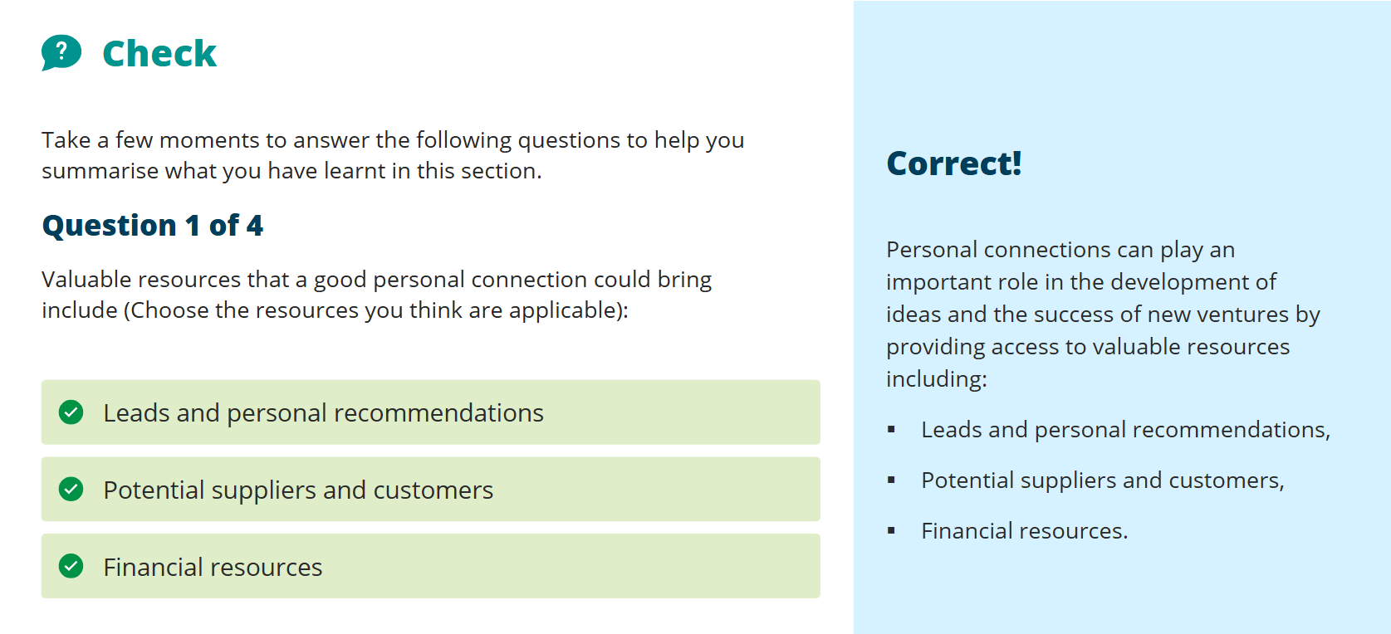
Figure 2 – Engagement with Module Units
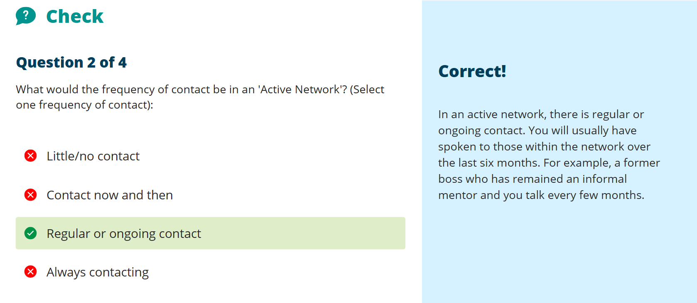

Figure 3 – Engagement with Module Units
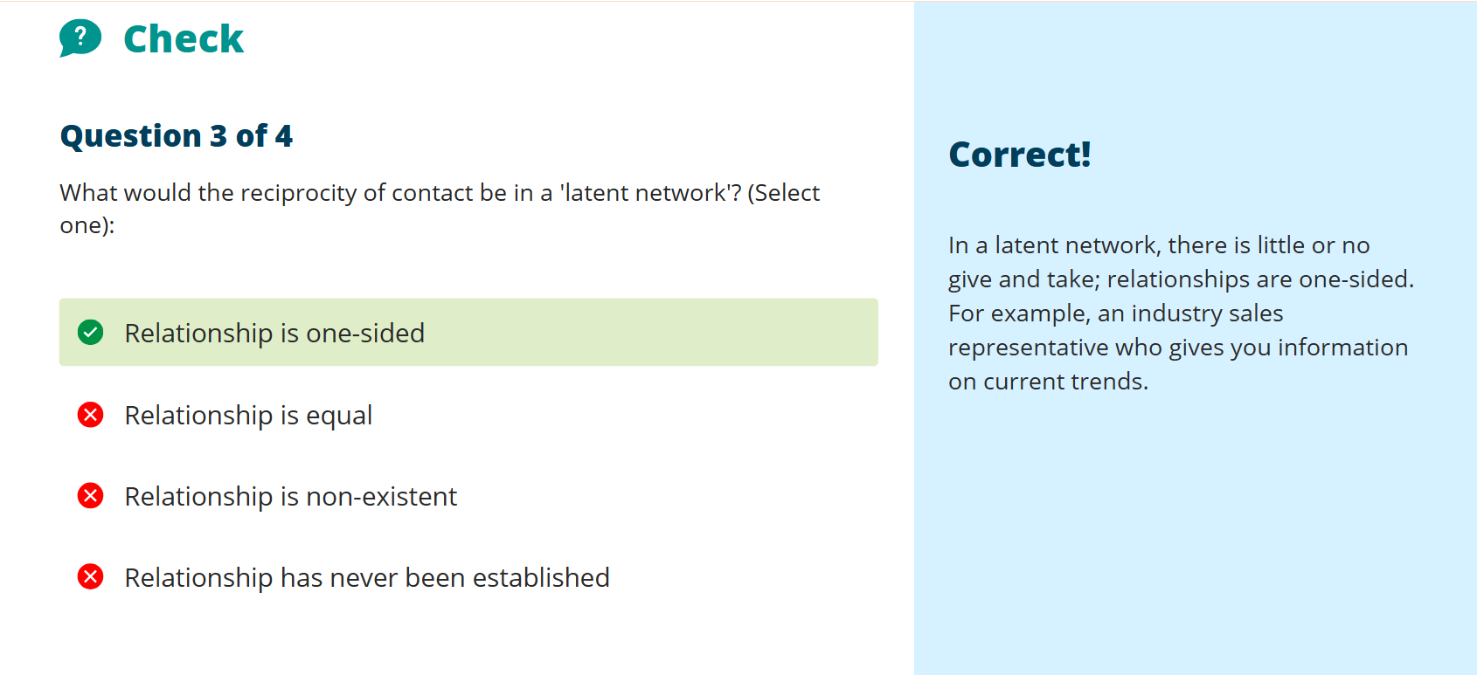

Figure 4 – Engagement with Module Units
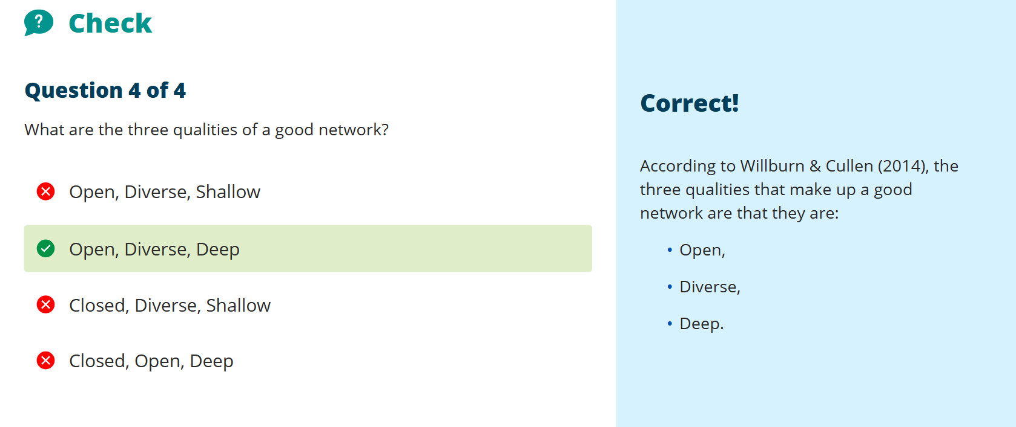

Figure 5 – Engagement with Module Units

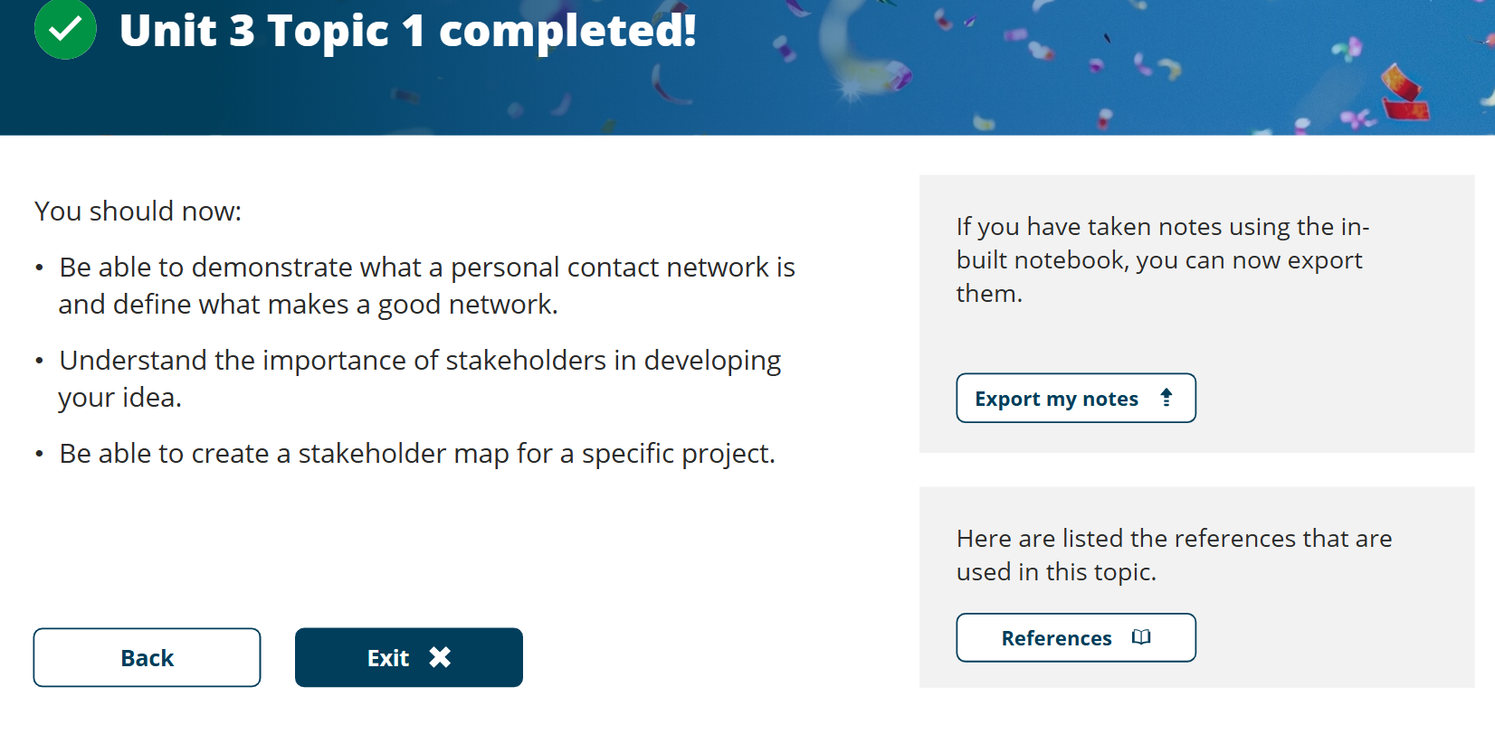

Figure 6 – Engagement with Module Units
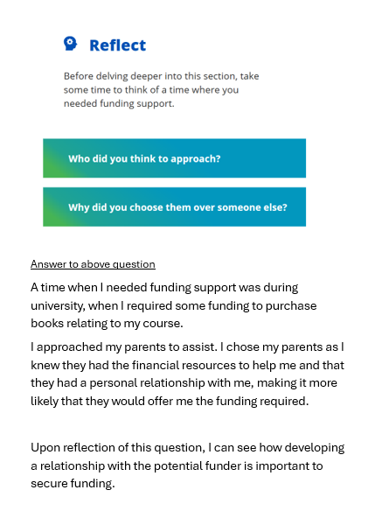

Figure 7 – Engagement with Module Units
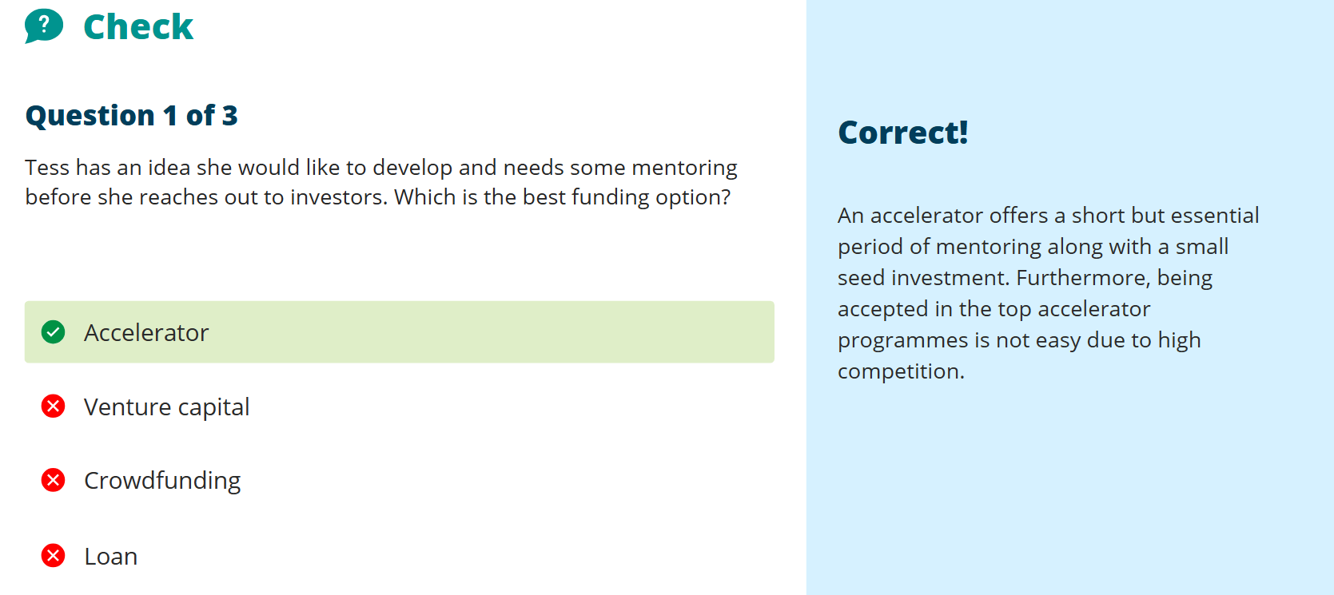

Figure 8 – Engagement with Module Units

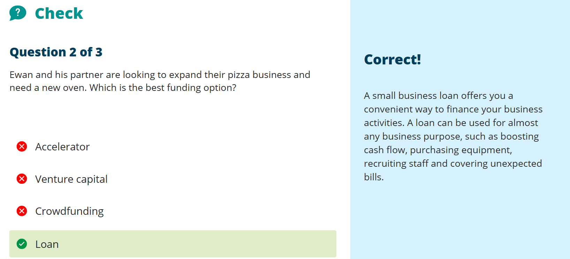

Figure 9 – Engagement with Module Units
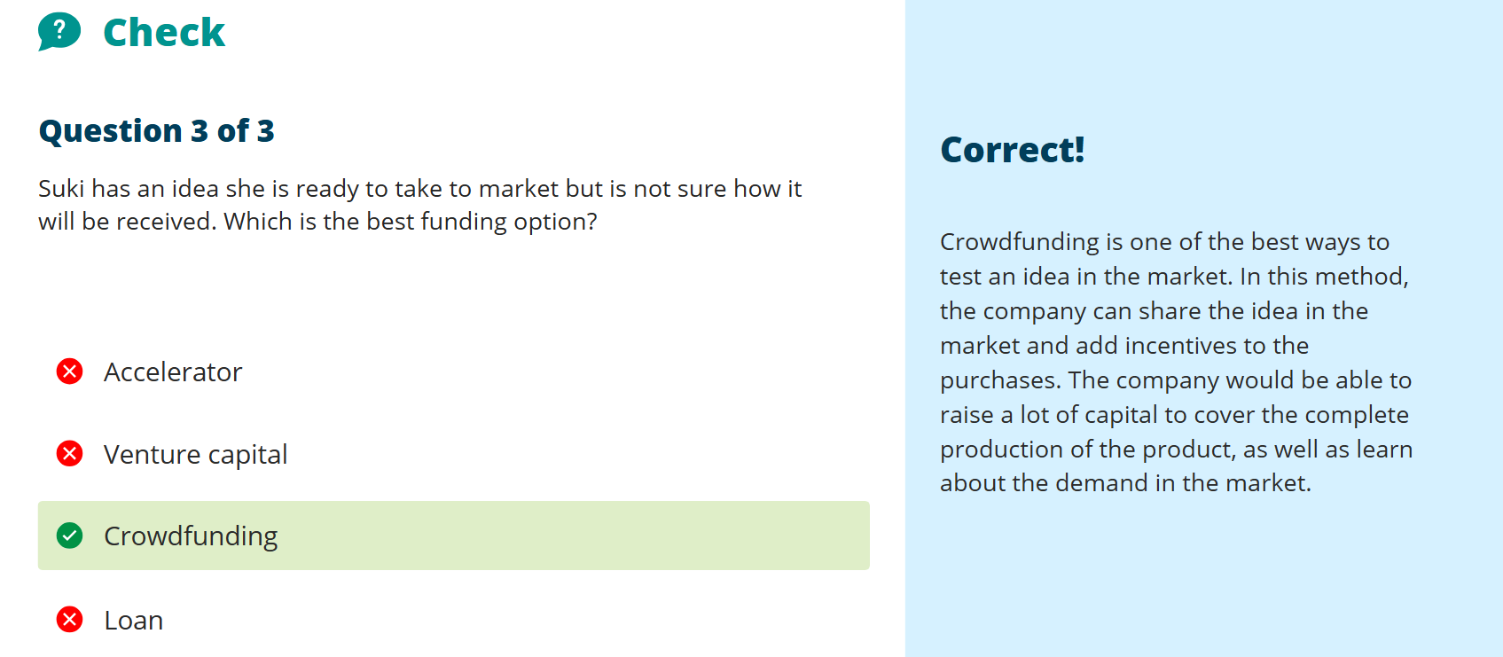

Figure 10 – Engagement with Module Units
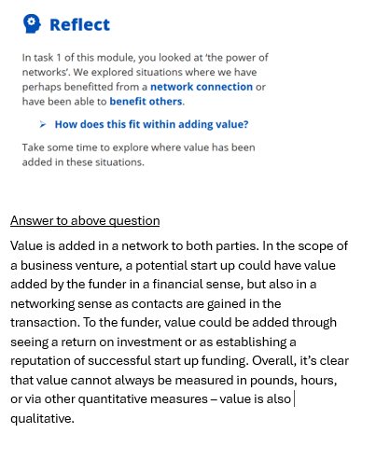

Figure 11 – Engagement with Module Units
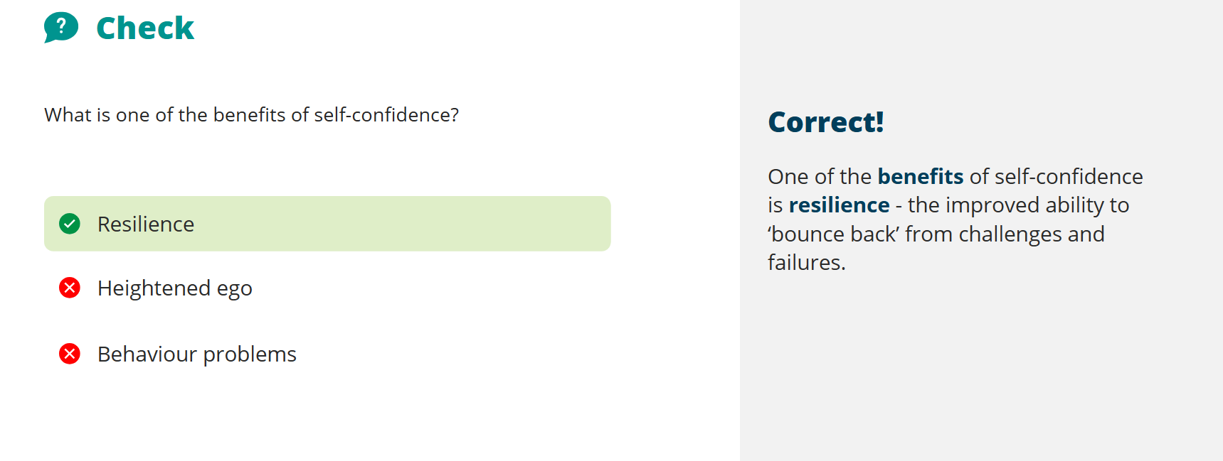

Figure 12 – Engagement with Module Units
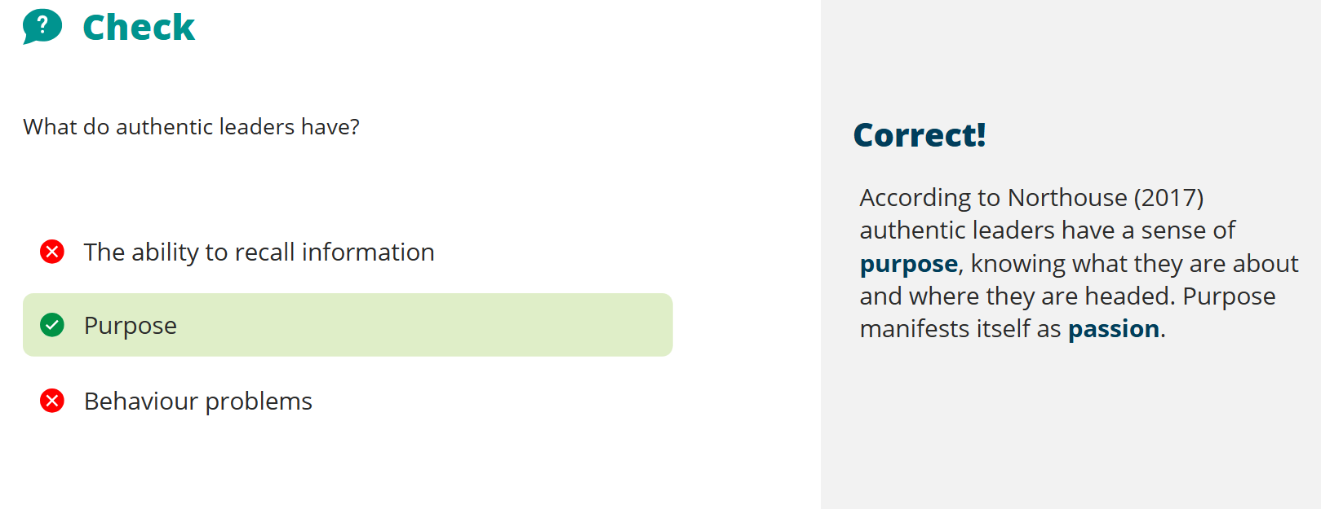

Figure 13 – Engagement with Module Units
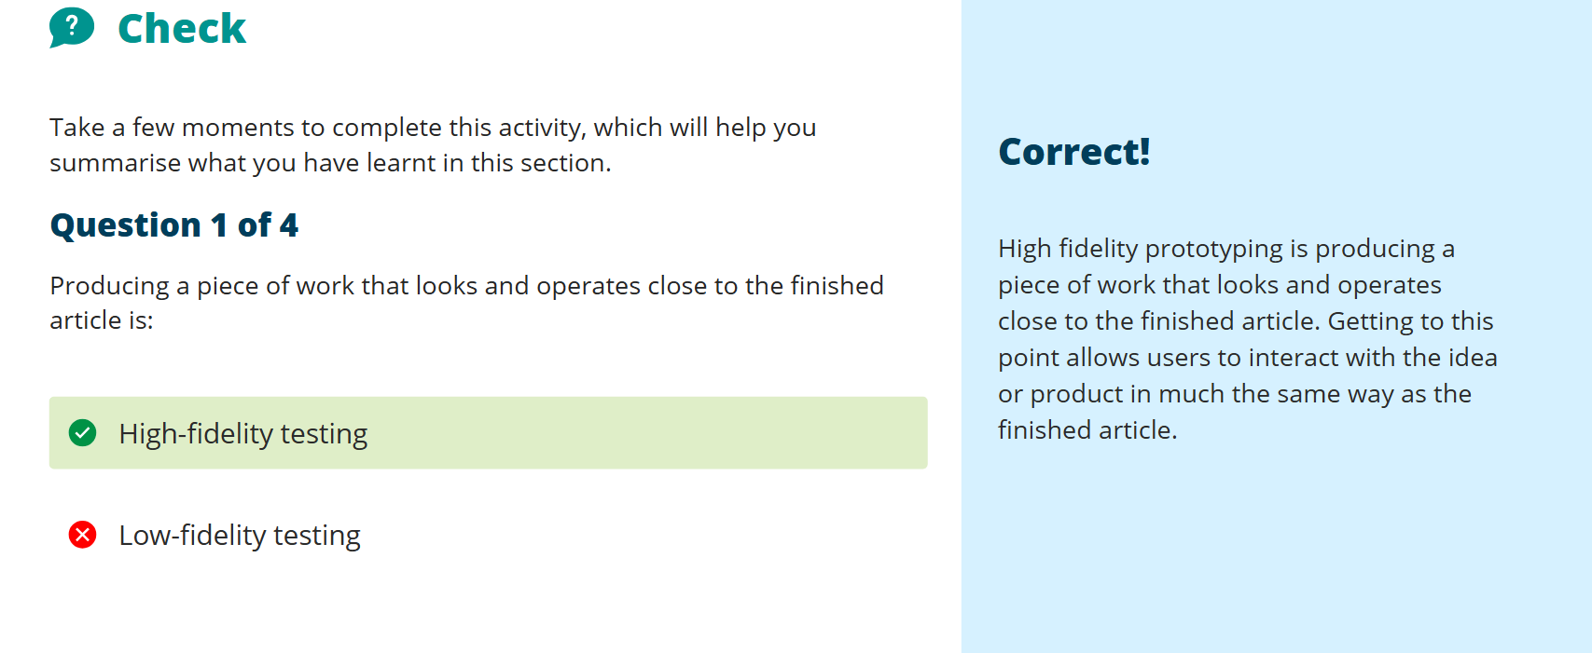

Figure 14 – Engagement with Module Units
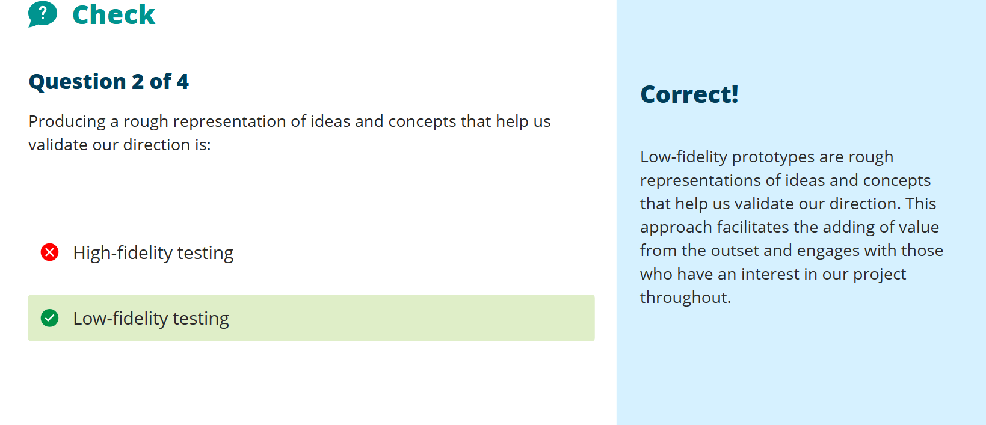

Figure 15 – Engagement with Module Units


