RESEARCH PROPOSAL

STUDENT: MIRCEA CATALIN DOCIU (2019337)
MODULE TITLE: DIGITAL SKILLS AND RESEARCH METHODS
MODULE COD: BMSW4003
LECTURER NAME: ABDI RAHMAN

Abstract
The study focuses on the percentage of the usability of the internet during the pandemic situation which has resulted in the dependency on the technological tools and systems in spectral reference to the staff and the students. The larger part of the online environment has provided a challenging situation regarding the adaptability issues which has been a major concern. The research proposal through the survey method, by the primary quantitative data, has managed to portray the current usage of the internet in comparison to the use of the internet post-pandemic, based on the set of questionnaires.
Table of Contents

Introduction 4
Research Design 4
Research Question 4
Methods Used in the Research 4
Ethical Considerations 6
Results 6
Details of the Questionnaire results 6
Question 1 6
Question 2 7
Question 3 8
Question 4 9
Question 5 10
Discussion 10
Showcase of the Results 10
Fitting with the Literature 11
Conclusion 12
Reference List 13
Appendix 14

Introduction
Technology plays an important aspect in the lives of people throughout the world. The applicability of the technology by the students has a different approach based on the daily foundation through web surfing, texting, and social networking. Similarly, the staff has been using technology as part and parcel of life in the professional aspect. However, the pandemic has affected the applicability and the usage of the technology for both the staff and the students, through the development of the quantitative methods that have changed the technology. The students have employed technology in the educational sector, whereas the staff has also made the usage for the necessity of the work from home. The ethical considerations during the pandemic for the promotion of precision have shown the usage of privacy through the voluntary participation of nature. The applicability of the technology has been the priority as the educational sector has moved on to the online sector forming a large part, based on the challenges which have cost the evolution of the Techno stress in the computer revolution. The research design focuses on the adaptability of the usage of the technology by the staff and the students, keeping on par with the usage of the techniques and the teaching process of the students in the parity of the teaching and the learning essentiality, for offering better opportunities for the students.

Research Design

Research Question
In the execution of any kind of research, the methodology used by the researcher requires to have a clear understanding of the main research questions that he or she wants to address. Taking this into consideration for this research study as well, the researcher has also adapted a particular research question. This ensures that the researcher can follow a guided pathway. The main research question for this study is as follows:
RQ 1. Are Staff and Students Confident in Using Technology to Collaborate?

Methods Used in the Research
Descriptive research design
The descriptive research design has been used in this report. The usage of the research design provides an in-depth view of the topic provided with details in the descriptive research which proves extremely valuable through the qualitative collection of the data, instead, it utilizes the elements of both (Sahin and Mete, 2021). The conduction of the descriptive research design has been allowed for it provides a cost-effective and quick analysis of the data gathering, as this can be applied for different purposes, for being a versatile method. This research design helps in the better performance of the research, in a less amount of time experienced by students (Afiani et al. 2021).
Primary Quantitative data collection
The Primary Quantitative data collection method has been applied in this report. This type of data collection has been applied as it focuses on the concrete numbers and devalues fewer valuables. The proposed method that has been applied is the usage of the survey, through the usage of the online and the email address survey system through an adequate number of observations (Lowe et al. 2018). This helps in the review of the large data sets, the usage of the structured interviews, and the observations of the participants are also usually adopted for the conduction of the primary data.
Sample size and sampling
In this research study, a sample size of fifteen students was selected. By the help of the random sampling method, the concerned sample size has been selected. The reason behind the selection of the random selection method is that it provides the researcher with an opportunity to carry out unbiased research in an effective manner (Zhang, 2022). The performance of the data analysis offers a chance that provides less risk in carrying out an error for justifying a sample size (Lakens, 2022). The selection of the equalization provides a chance in the development of the sample size and the sampling. This helps in the formation of the simplest form of data collection.
Quantitative Data Analysis
This research project has applied the system of quantitative data analysis, under which the collected survey data from the close-ended questionnaires would be evaluated with the help of statistical and graphical representations. The quantitative data analysis helps in the collection of the data, through the type of the results by the application of the statistical tests. This results in the proper interpretation of the data, through the presentation of the findings based on the error and the subjectivity of the straightforwardness. This helps in the renovation of the biases from the conduction of the research which results in the making of the research a more authentic one, for the accessibility of the accurate data.

Ethical Considerations
The usage of the ethical considerations, through the usage of the integrity, fairness, and the open-mindedness for the meaning of the operation. This has been helpful in the consideration of the research through truthful living manners, by the avoidance of the methods of deception, dishonesty, partiality, and the rise in the conflict of interests. The ethical consideration includes the respect for others, the avoidance of the conflict of harm, the consideration of privacy as the prime key, through the voluntary nature of participation that has ensured the level of confidentiality and the maintenance of anonymity adoption of digital technologies for teaching and learning (Lekgothoane, 2021).

Results

Details of the Questionnaire results

Question 1
Options | Frequency of response | Percentage of response (%) | Number of respondents
Yes | 9 | 60 | 15
No | 5 | 33 | 15
Cannot Say | 1 | 7 | 15
Table 1: Internet Usage before Pandemic
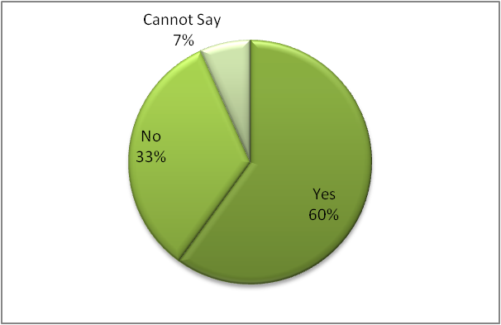
Figure 1: Internet Usage before Pandemic

Question 2

Options | Frequency of response | Percentage of response (%) | Number of respondents
Yes | 9 | 67 | 15
No | 5 | 27 | 15
Cannot Say | 1 | 6 | 15

Table 2: Current Internet Usage

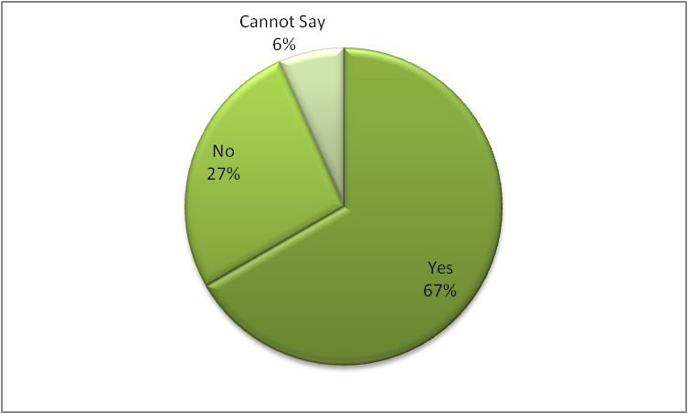
Figure 2: Usage of the Internet at Present

Question 3

Options | Frequency of response | Percentage of response (%) | Number of respondents
Strongly disagree | 1 | 7 | 15
Disagree | 1 | 7 | 15
Neutral | 1 | 7 | 15
Agree | 7 | 46 | 15
Strongly Agree | 5 | 33 | 15
Table 3: Usefulness of the Internet during a pandemic
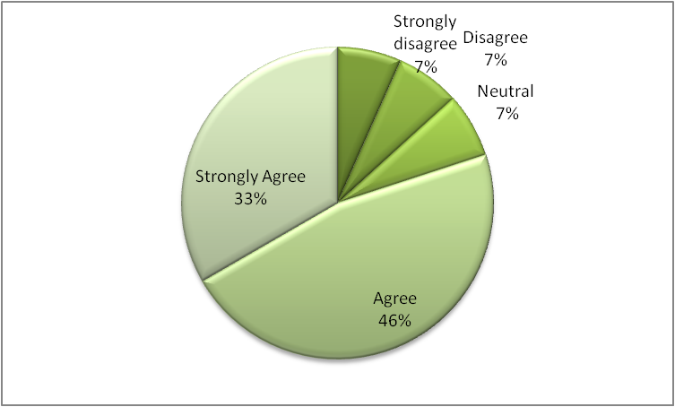
Figure 3: Usage of the Internet during the Pandemic

Question 4
Options | Frequency of response | Percentage of response (%) | Number of respondents
Excited | 9 | 60 | 15
Nervous | 5 | 33 | 15
Cannot Say | 1 | 7 | 15
Table 4: Feeling about Technology
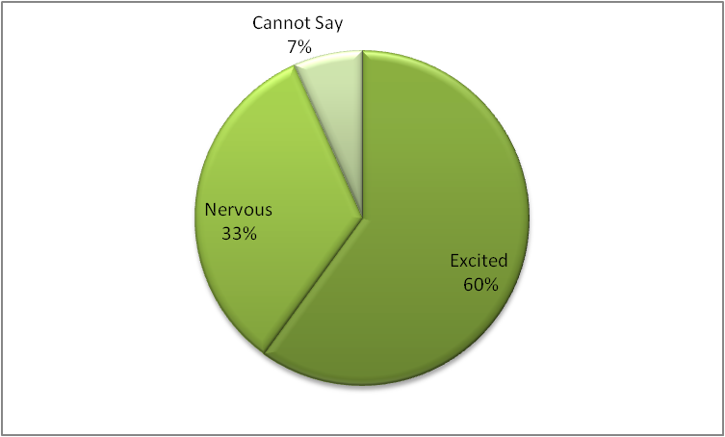
Figure 4: Feeling about the usage of the Technology

Question 5

Options | Frequency of response | Percentage of response (%) | Number of respondents
Excited | 5 | 33 | 15
Nervous | 9 | 60 | 15
Cannot Say | 1 | 7 | 15
Table 5: Usage of Video Cameras during online activities
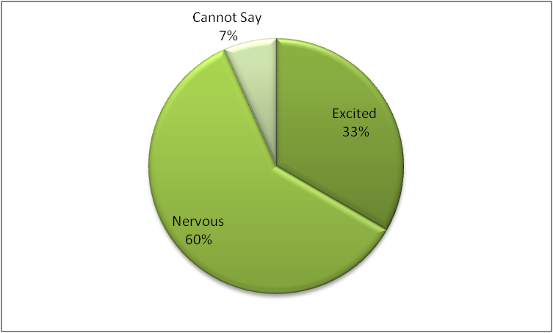
Figure 5: Using Videos Cameras during Online classes

Discussion

Showcase of the Results
Question 1
From the provided statistical and graphical representation it could be observed that the maximum number of respondents have signified that they have used the internet before the pandemic. About 60% of the respondents have said yes, the 33% of the respondents have replied with negative connotations and 1% of respondents have not provided any proper answer to the question.
Question 2
The graphical analysis presents the statistical data that the maximum number of respondents, about the value of 67% on the current usage of the internet has respondent in yes, the 27% of the respondents have answered in a negative connotation, whereas only 6% of the respondents have responded in the average framework, which states that the usage of the internet is still being prevailing among the students and the staffs.
Question 3
The provided data through the graphical analysis of the research conducted shows that the usefulness of the internet during a pandemic has shown 46% the agreeable, the 33% of respondents strongly agree, and the other respondents have equally responded in neutral, disagree, and strongly disagree. This shows that the usefulness of the internet has been a priority during the time of the pandemic.
Question 4
The estimated value of the percentage on behalf of the feeling of the usage of the technology has resulted in the positive output through the maximum percentile of the respondents, with 60% voting for being excited, 33% of the respondents have resulted in being nervous and 7% of respondents have declared that they cannot say. This shows that usage of technology is being considered a priority in the present time.
Question 5
According to the provided data and the analytical tools through the usage of the graphic representations have used focuses the usage of the camera during the online activities has been considered a negative connotation, with the 60 % of many of the respondents being nervous about the usage of the camera, the 33% of the respondents being excited and only one percent have responded in absurdity.

Fitting with the Literature
The analysis of the results from the questionnaires concerning the technical issues has resulted in the development of the quantitative methods that have resulted in the consideration of the usage of the technology by the staff and the students. The proportionate value presents the development of the requirements under ethical considerations. The questionnaires and the literature review showed some parallel similarities that have resulted in the summation of the usability of the technology among the staff and the students. This helps in showing that the technology in high technical performance in a better understanding of its implementation and adaptation (Rahman et al. 2021).

Conclusion
The overall analysis of the research project shows that the proper usage of the quantitative method in tracking the data of the usage and the adaptability of the technological advancement regarding the staff members and the students, in special accordance with the post-pandemic situation, has made all of them dependent on the technology. The analysis of the survey proves the fact that the applicability of the technology has been more, regarding the educational system where the ethical considerations in the technological advancement have been considered under the guidelines of the online environment for the better adaptation of the technologically inclined world.

Reference List
Afiani, D.A., An Investigation of Students' Difficulties in Writing Descriptive Text. (A Qualitative Descriptive Research of VIII-3 Class Students of Junior Private School Jakarta in the Academic year 2021/2022) (Bachelor's thesis, Jakarta: FITK UIN Syarif Hidayatullah Jakarta).
Lakens, D., 2022. Sample size justification. Collabra: Psychology, 8(1), p.33267.
Lekgothoane, R.L.C., 2021. Investigating levels of digital classroom technologies and teacher's usage of technology in selected schools in Limpopo Province (Doctoral dissertation).
Lowe, A., Norris, A.C., Farris, A.J. and Babbage, D.R., 2018. Quantifying thematic saturation in qualitative data analysis. Field methods, 30(3), pp.191-207.
Rahman, F.B.A., Hanafiah, M.H.M., Salehuddin, M., Zahari, M. and Jipiu, L.B., 2021. Systematic Literature Review on The Evolution of Technology Acceptance and Usage Model used in Consumer Behavioural Study. International Journal of Academic Research in Business & Social Sciences, 11(13), pp.272-298.
Sahin, S. and Mete, J., 2021. A Brief Study on Descriptive Research: Its Nature and Application in Social Science. International Journal of Research and Analysis in Humanities, 1(1), pp.11-11.
Zhang, W., Mei, Y. and Cummings, R., 2022. Private Sequential Hypothesis Testing for Statisticians: Privacy, Error Rates, and Sample Size. arXiv preprint arXiv:2204.04597.

Appendix
Q1: Did you use the Internet before the pandemic?
OPTIONS
- YES
- NO
- Cannot Say
Q2: Do you use the Internet now?
OPTIONS
- YES
- NO
- Cannot Say
Q3: How far do you agree that the Internet was useful during the pandemic?
OPTIONS
- Strongly disagree
- Disagree
- Neutral
- Agree
- Strongly agree
Q4: How do you feel about technology?
OPTIONS
- Excited
- Nervous
- Cannot Say
Q5: How do you feel about using video cameras during online activities?
OPTIONS
- Excited
- Nervous
- Cannot Say

