Social Media and Children in Wales

Social Media in the 21st Century is becoming more concerning, as the cause of many deaths, bullying, conflicts and a click away from finding out a huge amount of information about anything and anyone. Social Media was introduced for the concept of keeping in touch with friends and family, near and far. Most Social Media sites have an age restriction of 16 years and over. However, this has dropped over the years, hence the issues arising of children struggling with bullying and upset. Social media platforms have become an integral part of online lives. Social networks are a wonderful way to stay connected with others, but you should be wary about how much personal information you post.
The Welsh mid year population Figure currently stands at 3,113,200. The NSPCC presents the findings from an online self-completion survey of 1,024 11-16 year olds in the UK, 28% of which were aged 11-12 years. Their research found 23% of 11 and 12 year olds with a social networking site profile had been upset by something on it over the last year.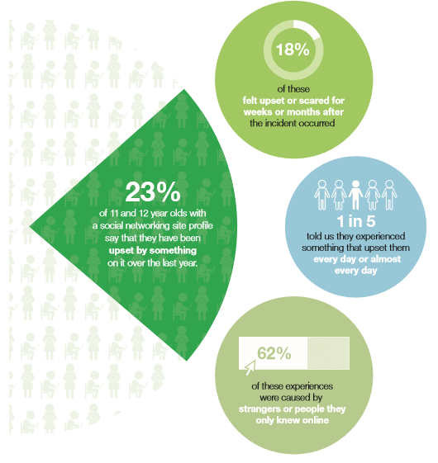
Figure 1.1 Sourced NSPCC Website (2013)

According to the NSPCC, most negative internet experiences are caused by strangers, or in fact people that they know online. Social Media is used to hide behind usually by children or adults that are not confident to upset others face to face “Now, of course, a free and open internet is vital. But in no other market and with no other industry do we have such an extraordinarily light touch when it comes to protecting our children. Children can’t go into the shops or the cinema and buy things meant for adults or have adult experiences; we rightly regulate to protect them. But when it comes to the internet, in the balance between freedom and responsibility we’ve neglected our responsibility to children… So we’ve got to be more active, more aware, more responsible about what happens online. And when I say we I mean we collectively: governments, parents, internet providers and platforms, educators and charities.” (David Cameron, speech on 24 July 2013). More evidence and research found that age restrictions are not as secure and safe as we presume they would be “Many providers ban users under 13 and apply particular technical protection mechanisms and moderated services for minors under 18. However, age restrictions are only partially effective. Fewer younger than older children use social networking sites, but many ‘underage’ children are still using these services. It seems clear that measures to ensure that under-aged users are rejected or deleted from the service are not successful on the top social networking site services used by children in Europe.” (UKCCIS Evidence Group).
New research from the NSPCC has found that almost a quarter (23 per cent) of 11 and 12 year olds who have a profile on a social networking site say that they have been upset by something on it over the last year. These experiences range from trolling to online stalking to being asked to send a sexual message. While most of these children were able to recover from what they encountered quickly, around one fifth felt upset or scared for weeks or months after the incident occurred. A fifth of those who experienced something that upset them told us that they experienced this every day or almost every day.

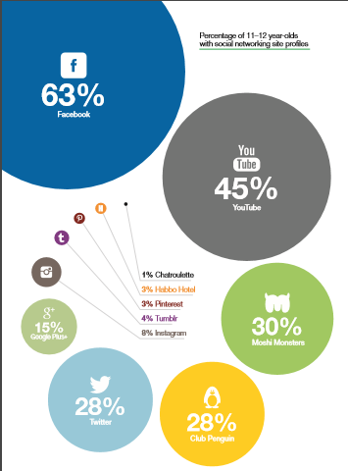
Source: NSPCC research. Base: All 11–12 year olds who had a social networking account: Facebook: 171; YouTube: 119; Twitter: 60; Moshi Monsters: 70; Club Penguin: 64.

Some of the most popular sites, such as Facebook, Twitter and YouTube, require users to be over the age of 13 to have a profile. There is reliable evidence from a variety of sources that large numbers of children under the age of 13 are active users of these sites. We estimate that around half of all the UK’s 11 and 12 year olds (666,000 children) have a profile on a social networking site for which the minimum age is at least 135. In many cases parents are aware that their child has a profile, and may have helped them to set it up. Some of the providers of social networking sites with a minimum age of 13 say that they do not provide bespoke advice for children under the age of 13, because they are not supposed to have a profile on their sites. There is a lack of robust age verification tools and children lie about their age to obtain profiles. It is very difficult for providers to ascertain which profiles are underage 12 year old users and which are legitimate 13 year old users. Other providers are concerned that providing bespoke advice to underage users would put them in breach of the American legal and regulatory framework by which they are governed – a framework primarily designed to protect children under 13 years old from inappropriate advertising. In this respect the American regulation which is designed to protect children under 13 is a false friend, and may be doing more harm than good by discouraging sites from providing adequate protection to their younger users. The NSPCC challenges these providers to take a more pragmatic approach to protecting children, and rise to the challenge of the substantial number of children under the age of 13 who are on their sites. These sites may not be directly targeting younger children, but sites which appeal to teenage users will inevitably attract tweens, who imitate older peers.

There are many advice columns for young children and parents with basic safety rules of the internet. Privacy and security settings exist for a reason: Learn about and use the privacy and security settings on social networks. They are there to help you control who sees what you post and manage your online experience in a positive way. Once posted, always posted: Protect your reputation on social networks. What you post online stays online. Think twice before posting pictures you wouldn’t want your parents or future employers to see. Recent research found that 70 percent of job recruiters rejected candidates based on information they found online. Your online reputation can be a good thing: Recent research also found that recruiters respond to a strong, positive personal brand online. So, show your smarts, thoughtfulness and mastery of the environment. Keep personal info personal: Be cautious about how much personal information you provide on social networking sites. The more information you post, the easier it may be for a hacker or someone else to use that information to steal your identity, access your data or commit other crimes such as stalking. Know and manage your friends: Social networks can be used for a variety of purposes. Some of the fun is creating a large pool of friends from many aspects of your life. That doesn’t mean all friends are created equal. Use tools to manage the information you share with friends in diverse groups or even have multiple online pages. Use your personal profile to keep your real friends (the ones you know and trust) up to date with your daily life. Know what action to take: If someone is harassing or threatening you, remove them from your friends list, block them and report them to the site administrator.
Below, the NSPCC has included an ‘agreement’ draft that could be used between parents and children. It is to ensure that all parties are aware of what is happening in their social media lives.

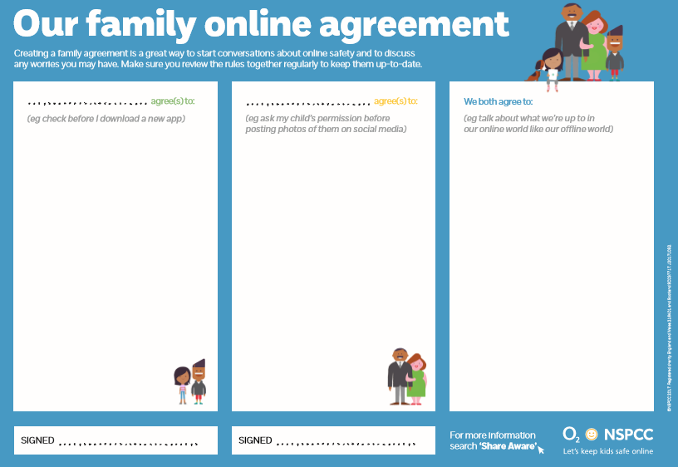
Figure 1.3 Sourced from NSPCC (2013)

In addition to these experiences, a small number of 11 and 12 year old children in our survey had experienced even more serious risks via social networking sites, such as online stalking, being asked to send a sexual message and being encouraged to hurt themselves. The numbers who did so were too small to draw any conclusions, and further research is needed. Nevertheless, this deeply concerning result is consistent with other trends that we are seeing. ChildLine has received a marked increase in the number of contacts relating to online stalking in the last few years. During 2012–13, ChildLine dealt with over 100 counselling sessions where young people specifically mentioned online stalking11. Additionally, contacts to ChildLine about self-harm have risen dramatically in recent years and self-harm is the fourth most common reason for children to contact ChildLine.
In December 2012, the NSPCC conducted an online self-completion survey of 1024 11 to 16 year olds in the UK. Interviewees were recruited by a market research agency, Researchers, who had a pre-existing panel of over 45,000 children. Interviewees received a written explanation of the research aims before signing a consent form. Their parents had previously given their consent for their child(ren) to be part of the online panel, and were given the opportunity to opt-out of this survey due to its sensitive nature. Each interviewee received a modest honorarium. Questionnaire completion lasted an average of seven minutes, and comprised of a series of questions presented online.
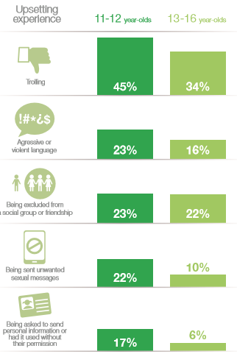
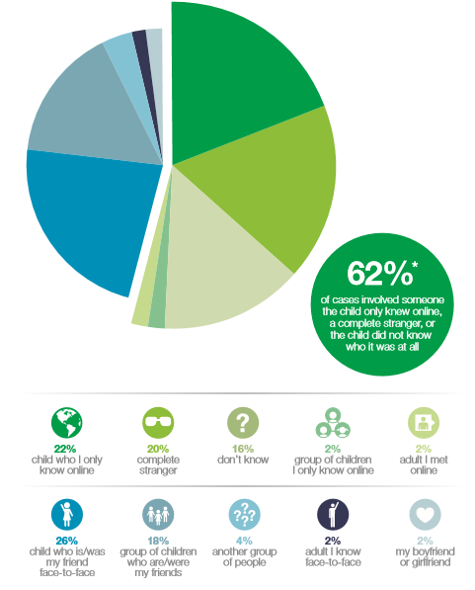
Figure 1.4 and 1.5 Sourced from NSPCC (2013)

In conclusion, I would add from my own personal experience that social media is an addictive and powerful tool, for adults, let alone children. From the statistics that have been listed, we can see that Social Media is having a growing affect on children and young people. The current issues continue to grow, and children are facing issues that they are not yet old enough to know how to deal with. Younger children are using social media, rather than a couple of years ago when technology was not such a hit with children. Almost every child that I am in contact with, has a technology device that enables them to connect with others via social media. The awareness of who they may be interacting with needs to be common knowledge, not just within homes, but within education and schools.

References

NSPCC. (2013) Younger children networking sites report.
https://www.nspcc.org.uk/globalassets/documents/research-reports/younger-children-social-networking-sites-report.pdf

