

STATISTICAL ANALYSIS AND VISUALISATION OF AIR POLLUTION DATA USING R: AN EXPLORATORY STUDY OF THE AIRQUALITYUCI DATASET

Module Title: Advanced Statistical Programming
Module Code: ACCA7022
Name :- Vishal S Bapodara
Student Id: 2514482
Course: MSc Data and AI
Submission Date: 20 March 2026

Table of Contents
1. Introduction 3
1.1 Background of Air Quality Analysis 3
1.2 Aim and Objectives of the Study 3
1.3 Structure of the Report 3
2. Dataset Description and Data Preparation 4
2.1 Overview of the AirQualityUCI Dataset 4
2.2 Data Import and Structure Examination 4
2.3 Data Preparation and Variable Creation 4
3. Exploratory Data Analysis and Visualisation 5
3.1 Importance of Exploratory Data Analysis 5
3.2 Time Series Analysis of Pollutants 5
3.3 Relationship Between Pollutants and Meteorological Variables 6
4. Correlation Analysis Between Pollutants 7
4.1 Purpose of Correlation Analysis 7
4.2 Correlation Matrix and Heatmap Visualisation 8
4.3 Interpretation of Correlation Results 9
5. Hypothesis Testing: Pollutant Levels Under Different Conditions 9
5.1 Research Question and Hypothesis 9
5.2 Selection of Statistical Test 10
5.3 Results and Interpretation 10
6. Seasonal Comparison of Pollutant Levels 11
6.1 Seasonal Analysis Approach 11
6.2 Statistical Method: ANOVA 12
6.3 Results and Visualisation 12
7. Discussion and Conclusion 13

1. Introduction

1.1 Background of Air Quality Analysis
Air pollution is a serious environmental and health concern in the world. Monitoring air quality helps researchers to be aware of the effect of pollutants on the ecosystem, climate, and human health. High levels of pollution, especially in high traffic and industrialized cities are linked to respiratory diseases, cardiovascular and reduced life expectancy. Carbon monoxide (CO), nitrogen dioxide (NO₂) and nitrogen oxides (NOx) are the common air pollutants found mostly due to the burning of fuels and vehicle-emitted emissions. Atmospheric dispersion and chemical reactions also influence the behaviour of pollutants due to such meteoral factors as temperature and humidity. Therefore, it is noteworthy that both weather and pollutant variables should be examined to learn patterns of air quality.

1.2 Aim and Objectives of the Study
The main aim of this report is to perform the analysis of the air pollution data using the R statistical programming environment. The study uses the AirQuality data to discuss trends and relationships between different pollutants and weather conditions.
The specific objectives of the study are to perform the exploratory data analysis to understand the pattern of pollution over a period, to investigate the relationship between different types of pollutants and assess the impact of meteorological conditions on the concentration of pollutants using the statistical methods of hypothesis testing, to compare the concentration of the pollutants by the seasons and define the potential seasonal variations in the air quality.

1.3 Structure of the Report
This report is divided into several sections. The second part provides an overview of the dataset and the preprocessing operations used in the analysis. This is subsequently accompanied by visualisation of trends in pollutants and variables relationships. The report then gives correlation analysis, hypothesis testing and comparisons between seasons groups. Finally, a concluding discussion and conclusion summary are given in which the key outcomes of the research are summarized.

2. Dataset Description and Data Preparation

2.1 Overview of the AirQualityUCI Dataset
The data (AirQualityUCI) used in the present study will be found in the UCI Machine Learning Repository. It contains the hourly readings of air pollutants and environmental parameters obtained by air quality monitoring sensors. The primary pollutants that will be considered in this project include carbon monoxide (CO), nitrogen dioxide (NO₂), nitrogen oxides (NOx), and benzene (C6H6), which are generally associated with automobiles and industrial operations. In addition to the pollutants data, the dataset comprises the meteorological variables as the temperature (T), the relative humidity (RH), and the absolute humidity (AH). It is also a date and time-based dataset which could be analyzed using time series analysis to establish the trends of pollution as time goes.

2.2 Data Import and Structure Examination
The data of AirQualityUCI was imported in R programming language using readxl package in read_excel () function. Upon importing the dataset into the system it was stored in a dataframe named AirQuality which will form the primary dataset in the analysis process.
To explore the data structure and quality and do the analysis, a few operations were performed. Firstly, the column names of the dataset were seen to get an idea about the variables included in the dataset. This was then followed by the str() method to examine the data structure and identify the type of data of each variable. This was to determine the kind of variables (numeric, date or character) that were stored.
Further, variables dimensions were checked to ascertain the total number of observations and variables in the data. The head() function also viewed the first few rows of the data. The first steps are required because they will allow the researcher to verify that the dataset has been imported properly and that the variables are in the proper form before subjecting the dataset to statistical analysis.

2.3 Data Preparation and Variable Creation
To prepare the data, several data preprocessing steps were undertaken prior to the analysis. The initial procedure was to combine the date and time variables to come up with one date time variable. This allowed examining the data in time order and allowed generating time-series visualisations of trends of pollutants.
In addition, a new categorical variable was developed (Season) based on the month that the date variable received. There was a classification into Winter, Spring, Summer and Autumn seasons.
Database screening on missing values was also done. The missing values were replaced by the value -200 in the original data and turned into NA values in R to ensure the data could be adequately treated statistically. Finally, variables were converted to the desired format such as factors in instances where necessary. These pre-processing measures improve the accuracy of the analysis, make meaningful visualisations, and make effective seasonal comparisons of air pollutant levels.

3. Exploratory Data Analysis and Visualisation

3.1 Importance of Exploratory Data Analysis
Exploratory Data Analysis (EDA) is an essential activity in any data analysis process because it helps researchers to understand their dataset structure and properties before proceeding to statistical models. EDA allows analysts to identify patterns, detect anomalies, and explore relationships between variables. The descriptive statistics and visualisation would assist the researchers to have data on how the variables behave and interact.
Exploratory analysis is of particular concern in environmental data, such as air quality monitoring data, in which pollutant concentrations often vary with time, and are influenced by several environmental variables. Analytical tools such as line charts and scatter plot assist in highlighting and identifying patterns, trends and peculiarities over time which otherwise could have been obscured by the number summaries. This study utilised various visualisation techniques to explore the behaviour of pollutants and their association with meteorological variables.

3.2 Time Series Analysis of Pollutants
The temporal change of the pollutant’s concentration was plotted to examine the correlation between the pollutant and time-series. Line plots were developed using R to study the time dynamics of carbon monoxide (CO) and nitrogen dioxide (NO₂). Figure 1 introduces a time series of the CO concentration, and Figure 2 illustrates the dynamics of the NO₂ concentration during the monitoring period. Line plots can be used to represent time-dependent data as it is easy to observe variations and patterns. The visualisations demonstrate certain apparent alterations in the concentrations of pollutants, and these can be linked to daily traffic flow and industrial emissions. These changes also have their share with the weather conditions such as the temperature and the atmospheric dispersion as well as the seasonal issues may also have their part in the difference between the levels of pollution.
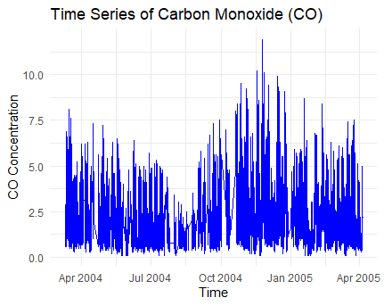  Figure 1: Time Series of Carbon Monoxide (CO)  (Source: R Studio) | 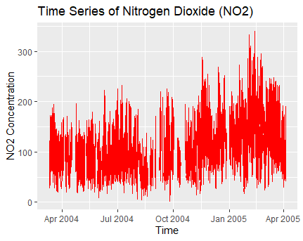  Figure 2: Time Series of Nitrogen Dioxide (NO₂)  (Source: R Studio)

3.3 Relationship Between Pollutants and Meteorological Variables
In addition to analyzing the patterns over time, the study also analyzed how the levels of the pollutants were correlated with the meteorological variables using scatterplots. The R analysis gave two scatter plotting, one of carbon monoxide (CO) and temperature and another one of nitrogen dioxide (NO₂) and relative humidity. These visualisations are provided in Figure 3 and Figure 4 respectively.
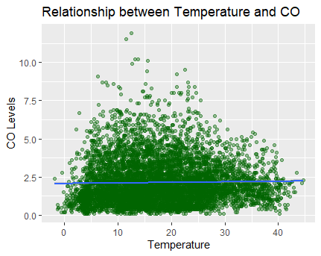  Figure 3: Temperature vs CO Scatterplot  (Source: R Studio) | 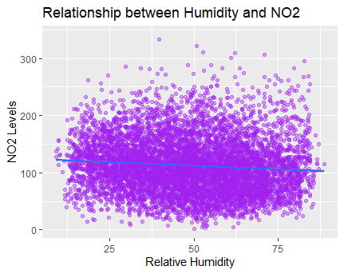  Figure 4: Humidity vs NO₂ Scatterplot  (Source: R Studio)

Scatterplots were chosen based on their use in finding potential relationships among variables. Scatter plots help the researcher to visually establish the presence of a linear or nonlinear relationship between two variables, by plotting one variable on the other. The methodology helps in determining trends that could be applied to the levels of environmental condition to influence the levels of pollutants.
Figure 3 illustrates the relationship between temperature and concentration of CO. The scatterplot shows that the concentration of pollutants may vary due to the temperature conditions, possibly due to the change in atmospheric chemistry or the distribution of emissions. Figure 4 indicates that there is a relationship between the concentration of NO₂ and humidity that may influence the dispersion of pollutants and chemical reactions of pollutants in the atmosphere.
The meteorological variables play an important role in determining the concentration of the pollutants or the way the pollutants spread in the atmosphere. Rises in temperature can also accelerate chemical reactions amongst the pollutants, and humidity can affect the transport of pollutants and the stability of the atmosphere. During the examination of the relations, the researchers will be capable of knowing more about the environmental factors that influence the level of air pollution.

4. Correlation Analysis Between Pollutants

4.1 Purpose of Correlation Analysis
Correlation analysis is used to measure the strength and direction of correlation between variables in a dataset. In the examination of air pollution, correlation will help in tracing whether diverse pollutants tend to increase or decrease together. These correlations are important because closely related pollutants may be induced by the same source of emissions like vehicle emissions, industrial activities, or fuel burning.
The Pearson correlation coefficient was used in this study to test the interrelations between the selected pollutants. Pearson coefficient measures the linear relationship between two variables and gives a value ranging between -1 and +1. A value close to +1 illustrates a highly positive relationship i.e. both variables are likely to increase in a similar direction. Closer to 0 value suggests a low or no linear relationship among the variables. A close to -1 value instead indicates that there is a very strong negative correlation, with one variable increasing and the other decreasing.

4.2 Correlation Matrix and Heatmap Visualisation
In R environment, correlation matrix was prepared to examine the correlations between the pollutants. These pollutants were carbon monoxide (CO), nitrogen oxides (NOx), nitrogen dioxide (NO₂) and benzene (C6H6). The choice of these variables was since they are general indicators of air pollution and that they are in most cases associated with the combustion processes.
The correlation matrix was made by utilizing the cor() R function that calculates the Pearson coefficients of correlation between two variables of interest. This matrix will provide numerical data of strength of relationships of any two pollutants.
The correlation matrix was visualised with the help of a heatmap, and it is provided in Figure 5 to make the interpretation of the results easier. The heatmap shows the scale and orientation of the correlation between the variables in form of colour scales. Strong positive relationships are often represented in a darker or warmer colour, whereas weaker ones are seen in light.
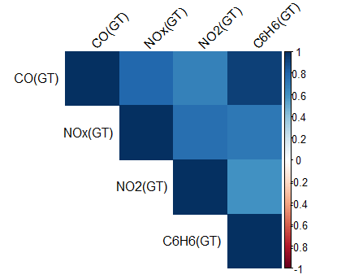
Figure 5: Pollutant Correlation Heatmap
(Source: R Studio)
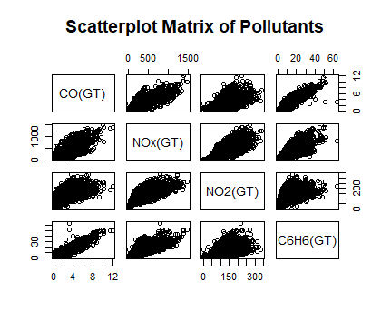
Figure 6: Scatterplot Matrix of Pollutants
(Source: R Studio)
In addition to the heatmap, a scatterplot matrix was plotted to represent the pair-wise relationships among the pollutants as in Figure 6. The plot allows correlations graphically because it shows where a single piece of data falls regarding two pairs of pollutants.

4.3 Interpretation of Correlation Results
The correlation indicated that several correlations exist between the pollutants. Nitrogen oxides (NOx) and nitrogen dioxide (NO₂) were likewise found to be strongly positively related as NOx contains NO₂, and they can be formed in a similar way by burning. It was also discovered that moderate correlations exist between carbon monoxide (CO) and other pollutants such as benzene (C6H6). These trends show that the sources of different pollutants may include different sources of emission including vehicle emissions and industries.

5. Hypothesis Testing: Pollutant Levels Under Different Conditions

5.1 Research Question and Hypothesis
The impact of environmental conditions on the level of air pollution was also undertaken to test the hypothesis that carbon monoxide (CO) levels vary depending on the level of humidity. The research question that will be applied in the analysis of this is: Do CO levels vary under low and high humidity conditions? Meteorological conditions, such as humidity, may influence the dispersion of air pollutants and their accumulation in the atmosphere.
To answer this question, two statistical hypotheses were developed. The null hypothesis (H₀) is that the difference between the CO concentration in the high and low humidity conditions is not significant. On the other hand, the alternative hypothesis (H₁) is that the CO concentrations in these two humidity levels are dissimilar. Through testing these hypotheses, the researchers will be able to draw conclusions on the effects of humidity in influencing levels of carbon monoxide.

5.2 Selection of Statistical Test
An independent tests t-test was applied in testing the hypotheses. It is a statistical test, which is appropriate in the case of comparing the means of a continuous variable in 2 independent groups. In this analysis, the groups were created by categorizing the humidity into high and low humidity conditions using the median of humidity in the data.
To test whether CO concentration of these two groups of people is significantly different in mean, the independent samples t-test will be applied. It has several assumptions that must be included when utilizing this test. First, the observations must be independent of each other, i.e., each measurement is a distinct observation. Second, the dependent variable should reasonably follow a normal distribution within each group. Third, the variance of the two oughts to be reasonably equal a hypothesis which is referred to as homogeneity of variance. The t -test can be used as a valid way of group comparison of means under reasonable assumptions.

5.3 Results and Interpretation
The results of the t -test indicate that the test value is t = 4.49 and the p-value = approximately 7.4 × 10⁻⁶. The null hypothesis is rejected since the p-value is significantly lower than the standard level of significance of 0.05. The implication of this finding is that the concentration of CO in high and low humidity is statistically significant.
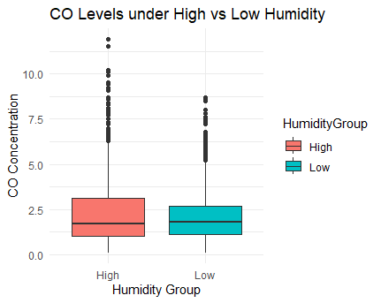
Figure 7: CO Levels under High vs Low Humidity
(Source: R Studio)
Figure 7 represents a boxplot of the CO level with the presence of humid and dry conditions. The graphical representation supplements the statistical findings showing the difference in the distribution of CO levels between the two groups. This discovery in the environmental perspective means that the quantity of pollutants can be influenced by the existence of meteorological conditions.

6. Seasonal Comparison of Pollutant Levels

6.1 Seasonal Analysis Approach
The suitability of the seasonal approach in the analysis of air pollution is that the weather patterns vary significantly over the years. The changes in temperature, humidity and atmospheric circulation can influence the pollutant dispersion and reaction in the atmosphere. In addition to this, other causes of pollution such as heating systems, transportation activity, and industrial emissions can differ depending on the seasons. The data was categorized into four seasons, namely Winter, Spring, Summer and Autumn to analyse seasonal change in pollutant concentrations.

6.2 Statistical Method: ANOVA
A test of Analysis of Variance (ANOVA) was used to draw the comparison of the level of pollutants of the four seasonal groups. ANOVA is a statistical value used to determine the existence of significant differences among means of three different groups and beyond because the groups are independent. This analysis used ANOVA to identify the average levels of nitrogen dioxide (NO₂) in the four seasons.
The following were the hypotheses of the ANOVA test. The null hypothesis(H₀) is the same means of the pollutants in all seasons. The other hypothesis (H₁) is that the level of pollutants mean is not equal in one of the seasonal groups. The type of analysis that will be used in this analysis is ANOVA as it will assist in comparing multiple groups simultaneously with considering the overall variation of the data.

6.3 Results and Visualisation
The ANOVA results indicate that there is a change in the concentration of the NO₂ between the seasonal groups. To supplement statistical analysis, a boxplot was drawn to depict seasonal variation in pollutants levels as shown in Figure 8. The visualisation demonstrates the variation in the concentration of pollutants in the different seasons. The higher concentrations of pollution are possible during colder weather days because of the lesser dispersal of the pollutants in the air and the lesser during hot weather with more dispersion of the pollutants.
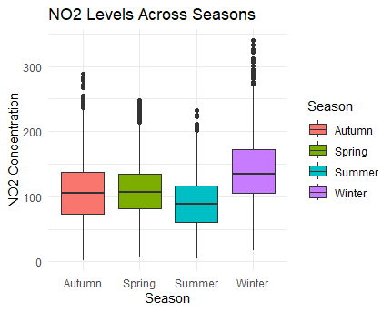
Figure 8: NO₂ Levels Across Seasons
(Source: R Studio)

7. Discussion and Conclusion
The analysis indicated that the data on air quality represented several significant trends. Time-series visualisations revealed changes in the level of pollutants over time, and correlation analysis revealed strong correlations between such pollutants as NOx and NO₂, which can indicate common sources of emissions. The experiment provided by the hypothesis testing showed that the meteorological factors, especially humidity, might influence the level of the CO concentration. The seasonal analysis also showed that the degree of pollutants seasonally varied and this is due to the atmospheric conditions in which the pollutants were dispersed. These findings depict the importance of environmental surveillance when it comes to controlling pollution in urban areas.

