Student Name: Daniel Newman
Student Number: 1702330
Lecturer Name: Kemi Ademoye
Module: Application Development
Module Code: ACCA5012

Contents
Table of Figures 3
Introduction 4
Abstract 4
Application Development Concepts 4
Security Vulnerabilities in Web Development 4
History of Security Vulnerabilities and previous security measures 4
Common methods of security attacks 4
Notorious Attacks 5
The need to create Secure Websites 5
Design Patterns 5
Requirements 5
The Application 5
Software Requirements 5
Design 6
Bootstrap 6
Design Diagrams 6
Implementation 7
Featured Scripts 7
Screenshots of Project 9
Evaluation 15
Testing 15
UI and design evaluation 17
Reflection of Project 17
References 18
Images and information used in Application References 19

Table of Figures
Figure 1 Diagram of Home Page 6
Figure 2 Diagram of Artist Details Page 6
Figure 3 Screenshot of Sorting By Artist Name 7
Figure 4 Screenshot of sorting by Artist Search 8
Figure 5 Screenshot of sorting by group members 8
Figure 6 Screenshot of sorting by concert date 8
Figure 7 Screenshot of Concert Page 1 9
Figure 8 Screenshot of Concert Page 2 9
Figure 9 Screenshot of Concert Page Pages search 9
Figure 10 Screenshot of Artist Details 1.1 10
Figure 11 Screenshot of Artist Page 1.2 10
Figure 12 Screenshot of Artist Page 2.1 11
Figure 13 Screenshot of Artist Page 2.2 11
Figure 14 Screenshot of Registration Page 12
Figure 15 Screenshot of Log In page 12
Figure 16 Screenshot of Forgotten Password Page 13
Figure 17 Screenshot of Create new Concert Page 13
Figure 18 Screenshot of Edit Concert Page 14
Figure 19 Screenshot of Concerts Showing Page 14
Figure 20 Screenshot of Testing Password 14
Figure 21 Screenshot of Testing log in 15
Figure 22 Screenshot of Testing Microsoft log in 15
Figure 23 Screenshot of Testing Google log in 15
Figure 24 Screenshot of Testing Incorrect log in 16
Figure 25 Screenshot of Testing Admin rights 16
Figure 26 Screenshot of Testing Booking Page 17

Introduction
In this report the author will discuss application development concepts including a review of application security vulnerabilities and methods of preventing them. As well as this the author will identify a design pattern and the uses of the pattern. Finally the author will provide documentation for an application created to demonstrate Application Development Techniques.

Abstract
The overall purpose of this report was to show an understanding of the importance of web security and how to prevent security issues from occurring. Design Patterns have been looked at to assess the different types of design patterns website developers could choose to develop their sites. A website called ConcertUK has been created to demonstrate these Application Development Concepts.

Application Development Concepts
In this section the author will discuss Application Security Concepts, The history, methods and countermeasures.

Security Vulnerabilities in Web Development

History of Security Vulnerabilities and previous security measures
One of the first instances of security vulnerabilities came in the form of a harmless worm virus in 1971 that would make itself known to the user calling itself the “Creeper” and then moving on to the next system to do the same thing. Another user then created a new system called “The Reaper” which would travel system to system just as the creeper had to remove all traces of the Creeper. The Creeper was one of the first viruses and The Reaper was one of the first anti-viruses. [1] The point being that once a potential of a threat is realised then any security system should make itself safer from being effected by that threat and in many cases, predict possible risks and set up a countermeasure for that potential risk.

Common methods of security attacks
Some of the most common security attacks websites face can often be very dangerous. One of the most famous examples is with DDOS attacks, a DDOS attack is a method of flooding a website with fake views. Due to the overwhelming amount of views the website is experiencing at once it often leads with the website crashing. [2]
A second security attack which could occur is a man in the middle attack, in this attack someone could be sent a message or an email which looks official and requests the user to log into their account and provides a link to a website which is meant to imitate that of another website. If the user does comply with this email then they could potentially be giving their log in details to someone else. [3]
There are also attacks designed to attack the user’s password. One of these is a dictionary attack which enters a username as well as a guess at a password based on some of the most popular passwords such as “Password123”, a website could create a validation technique to prevent the user from creating a password that is too simple. There are also Brute force attacks in which a program is used to enter password after password changing slightly every time until it guesses the right one, most websites will use a captcha verification after so many password attempts in the hopes to prevent non-human users from gaining access to any account. [4] [5]

Notorious Attacks
A notorious example of a security attack would be the attack on the NHS by a malware known as “WannaCry”. This malware was accidentally downloaded from an unsecure website and then spread throughout the NHS. As a result of this the NHS lost £20 million due to the cancellation of appointments and a further £72 million as a result of having to clean up and to establish better security systems. Attacks like these are not uncommon, and do not only happen to large businesses, this is why it is especially important to take website security into consideration so that attacks like these are less likely to strike. [6] [7]

The need to create Secure Websites
Websites must be designed to be secure, failing to do so can be detrimental to a website as it makes them prone to attacks such as data breaches, DDoS or SQL Injection. If a website handles personal data then this data could be in risk of being misused or stolen by attacks, if a website is not secure and personal data is under risk then this could become a huge legal issue as the website does not have enough protection in place to prevent these types of data breaches as it should do under the Data Protection Act as organisations are responsible of the safety of data held by them. [8]

Design Patterns
A suitable design pattern for this project is the Factory Design Pattern. [9] In this pattern a set of types of data are defined, however more data sets are needed later on. For example a Concert could track music types and have pre-defined concepts of these music types in the code to be entered into the database. However if a new music genre were to appear and gain popularity future concerts would need to be able to implement this music genre. The Factory Design pattern allows freedom to continue adding to a pre-defined concept. An example of this comes in the enumerations of the project in which values are assigned to numbers which are entered into the database, these enumerations can be edited to add more options without having to edit the table fields. [10]

Requirements

The Application
The application created is called ConcertUK. ConcertUK will be a concert ticket selling service in which the user can search through a list of upcoming concerts and view details about them. The user can buy tickets to go to the concert. As well as this, Admin rights are given to admins in which they can create, edit and delete concerts.

Software Requirements
The Software Requirements Specification Technique chosen to specify the requirements of the ConcertUK app is the MoSCoW Requirements Prioritisation method. This method will define what the application must do to succeed, should do to succeed, what it could do to succeed and what it could do in the future. [11]
Firstly, the application must show all the available concerts and display information about them. The application must also allow the user to book tickets to go see a concert.
The application should allow users to register for an account and log into the website. The application should also provide the option to log in through Microsoft and Google and have information only viewable by admin accounts.
The application could provide the admins with an ability to edit and create new concert details. The application could allow the user to sort and search for particular concerts in the list.
The application will not allow the user to view the concert venue maps and choose a specific seat but this is a feature which could be implemented in the future.

Design

Bootstrap
ConcertUK’s main design elements involve the use of bootstrap to set the number of columns that each object should take up on the screen whilst also allowing it to change depending on the size of the screen that the website is being viewed on, this is known as responsive web design.

Design Diagrams
On the top left corner of the home page will be some navigation options to navigate the site, to the right of that will be the register and login buttons. The layer beneath that has the search options which will allow the user to search through the concerts. Then finally the user will be able to view the columns containing concert information below that.
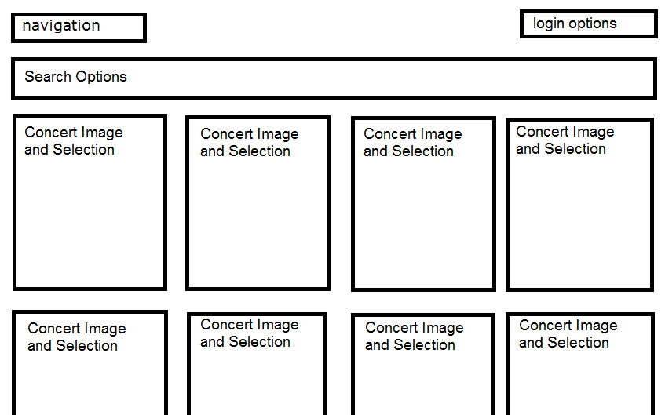
Figure 1 Diagram of Home Page
The Details of the tour page has a similar top and then has a large image of the artist’s promotional concert art and then information about the tour to the right.
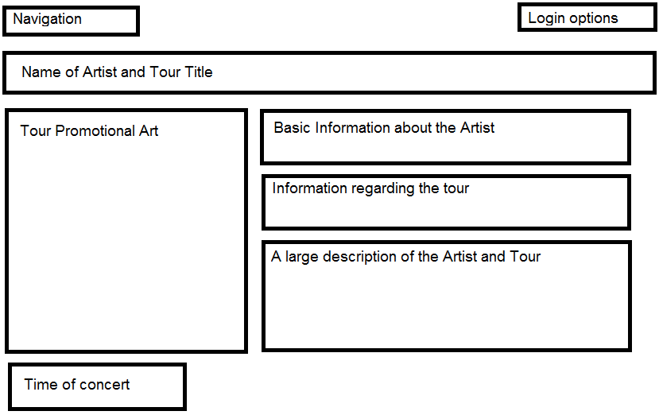
Figure 2 Diagram of Artist Details Page

Implementation

Featured Scripts
One of the most interesting scripts implemented is the ability to search for artist names in ascending and descending order and also search by group members in the case of there being a band with multiple members. The image below Demonstrates searching by artists in ascending order and so the artists appear in alphabetical order.
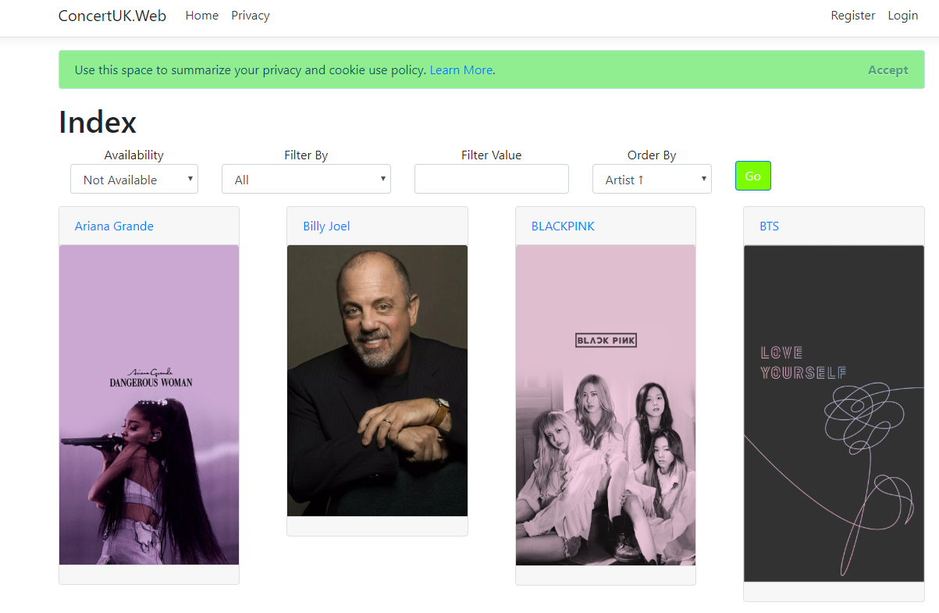
Figure 3 Screenshot of Sorting By Artist Name
In the image below, the search is filtered by Artists where the name is similar to the search, in this case a artist name was entered and the artist appeared from the search.

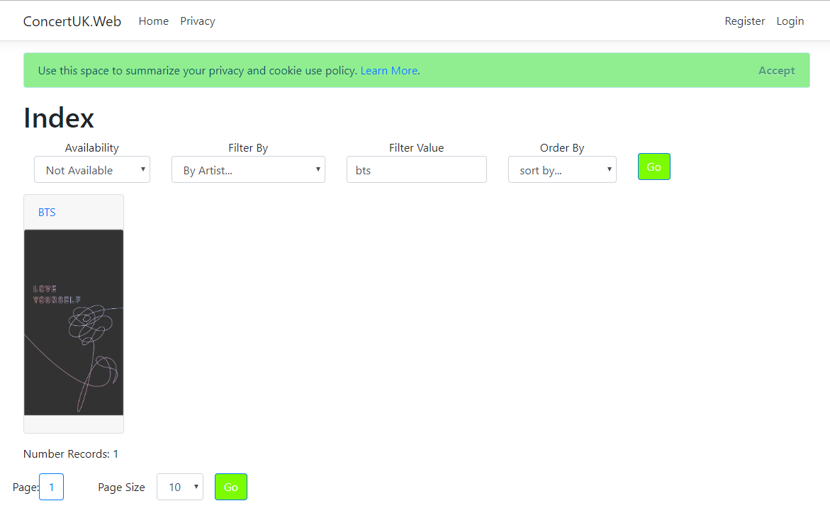
Figure 4 Screenshot of sorting by Artist Search
The below image demonstrates searching the artists by group members and searching for “Stevie Nicks”, a member of Fleetwood Mac. The search is successful and only displays the Fleetwood Mac tour as this was the only group which had a member of the searched name.
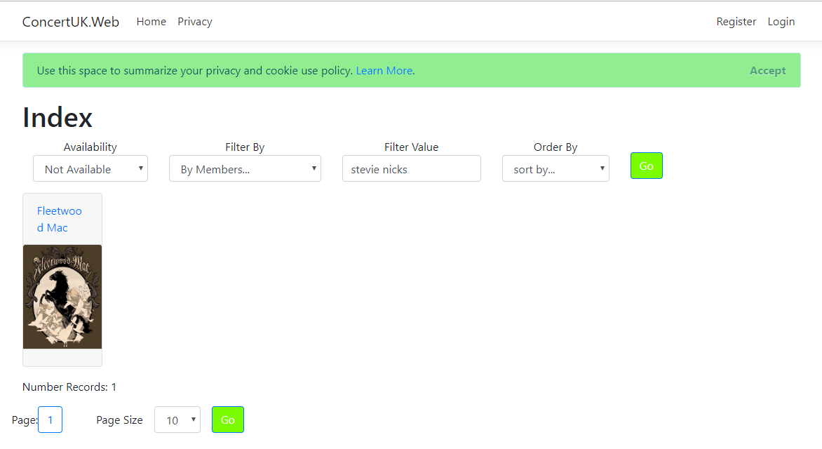
Figure 5 Screenshot of sorting by group members
The below Image demonstrates searching by the date of the concert from the closest to today’s date until the furthest from todays date.

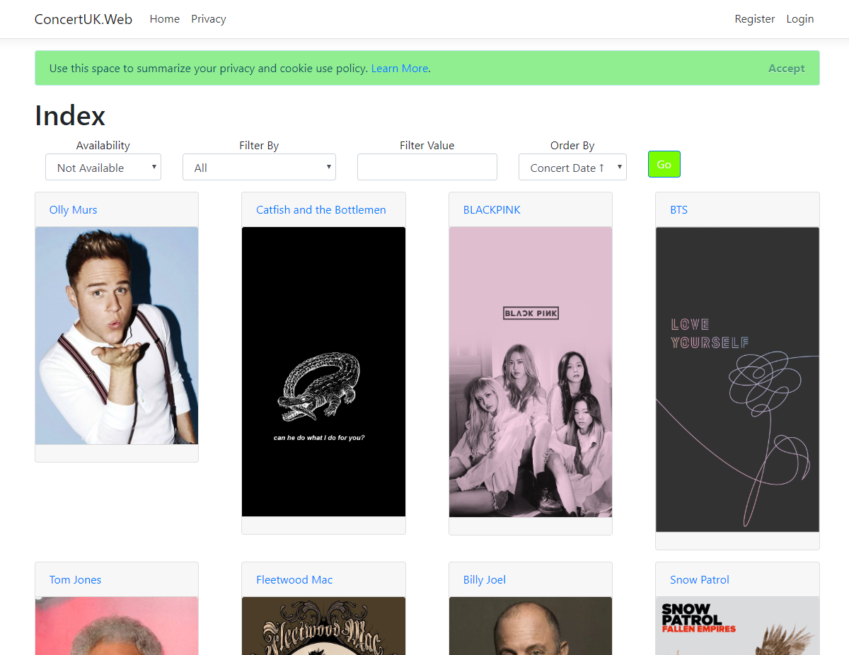
Figure 6 Screenshot of sorting by concert date

Screenshots of Project
Concerts Page
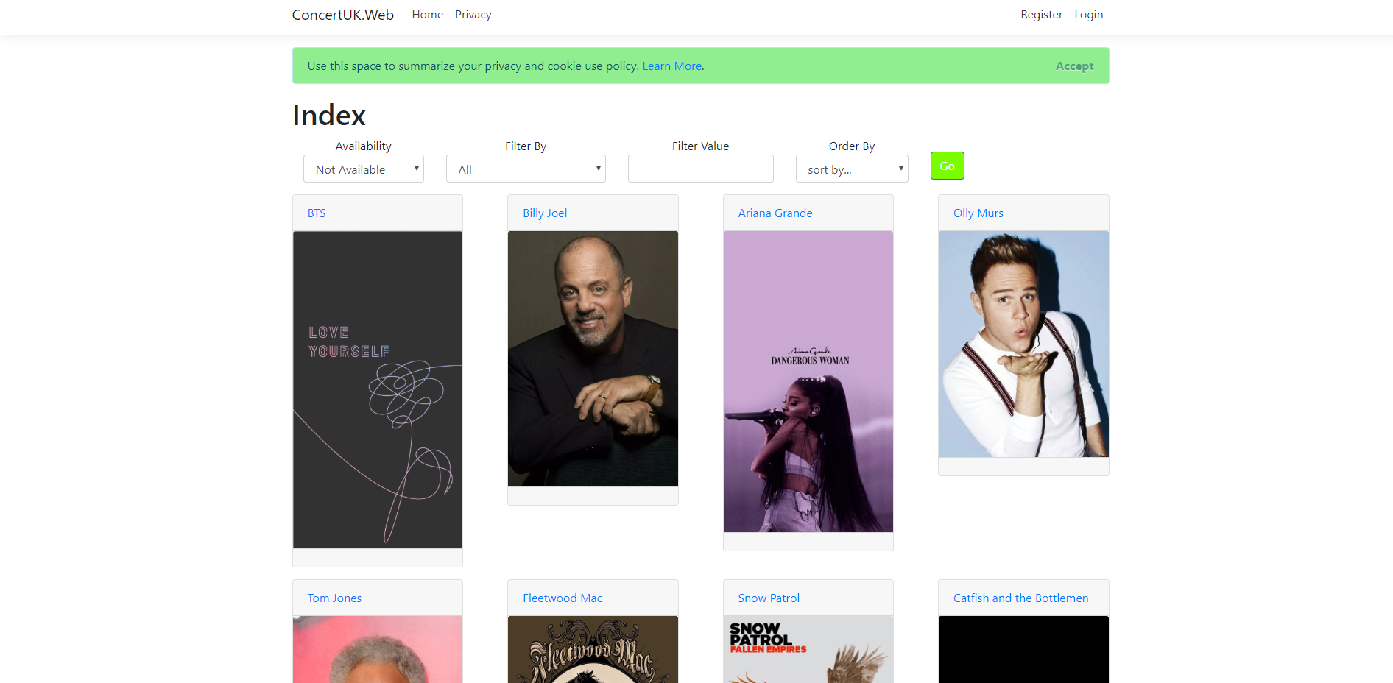
Figure 7 Screenshot of Concert Page 1

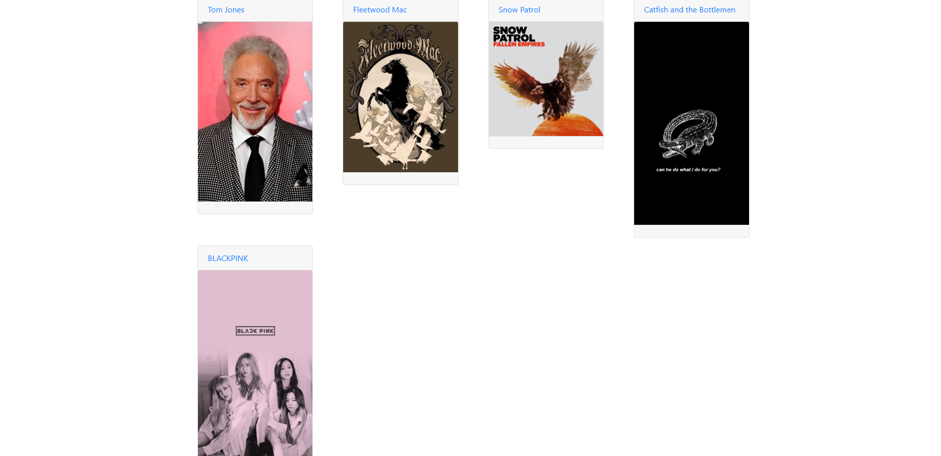
Figure 8 Screenshot of Concert Page 2
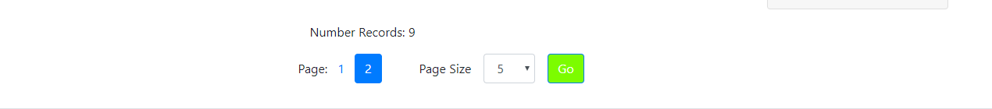
Figure 9 Screenshot of Concert Page Pages search

Concert Details Page
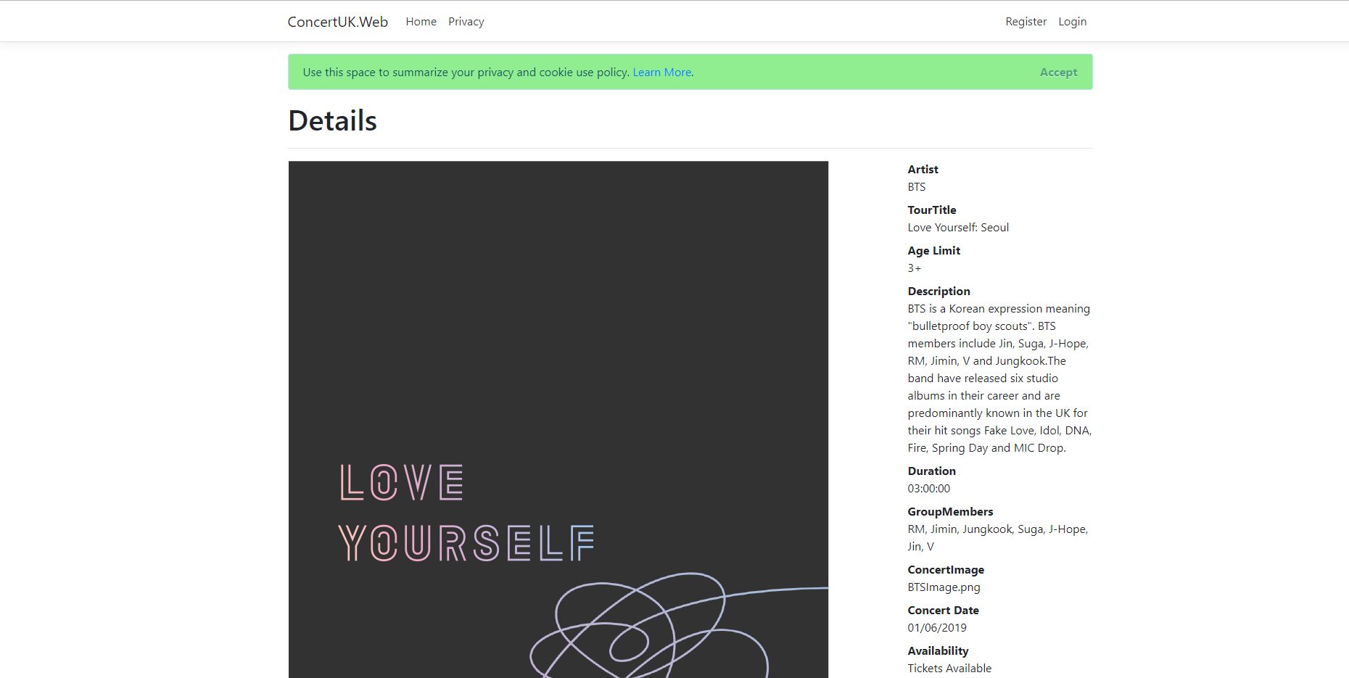
Figure 10 Screenshot of Artist Details 1.1
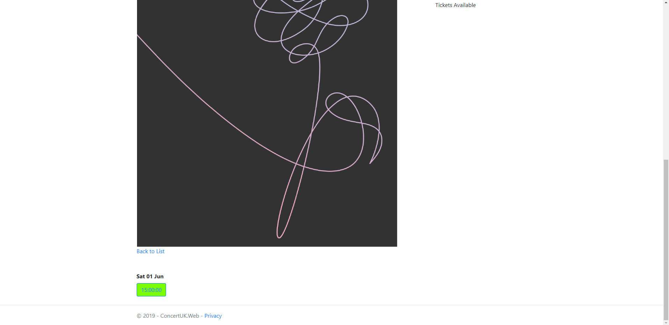
Figure 11 Screenshot of Artist Page 1.2

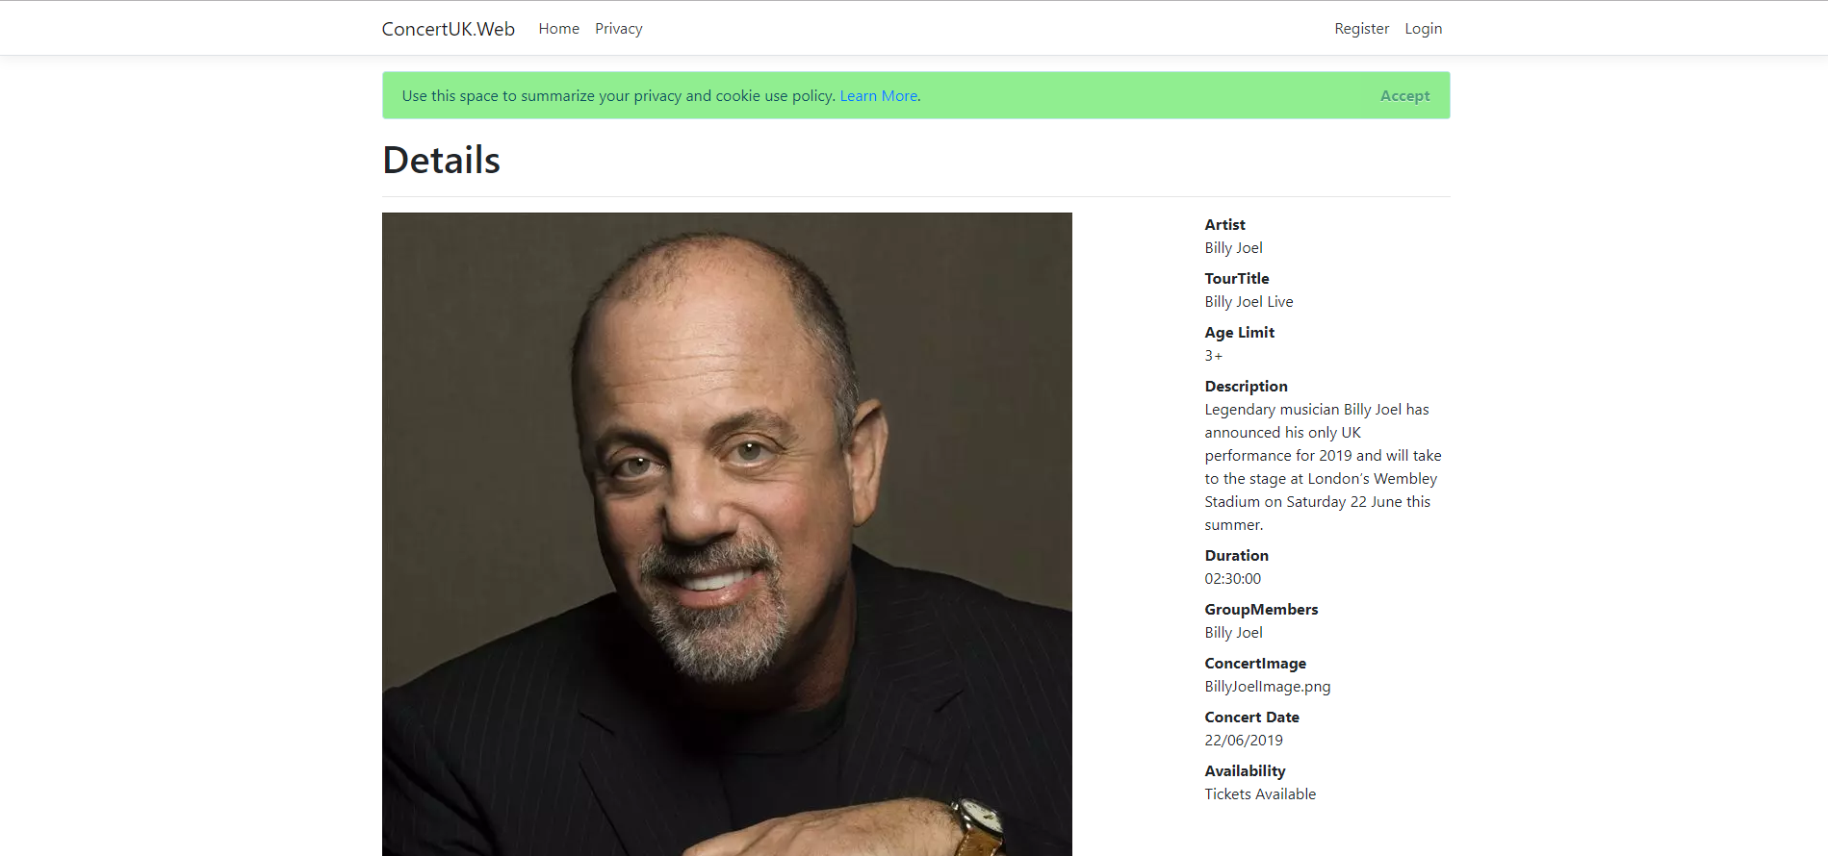
Figure 12 Screenshot of Artist Page 2.1

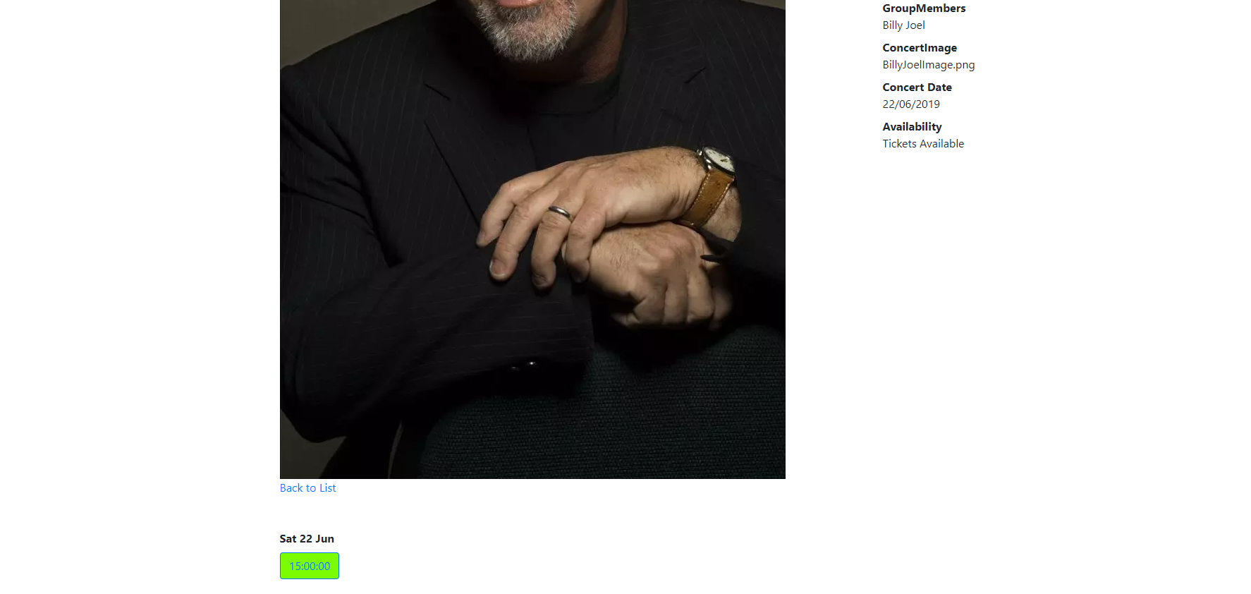
Figure 13 Screenshot of Artist Page 2.2

Register an Account Page
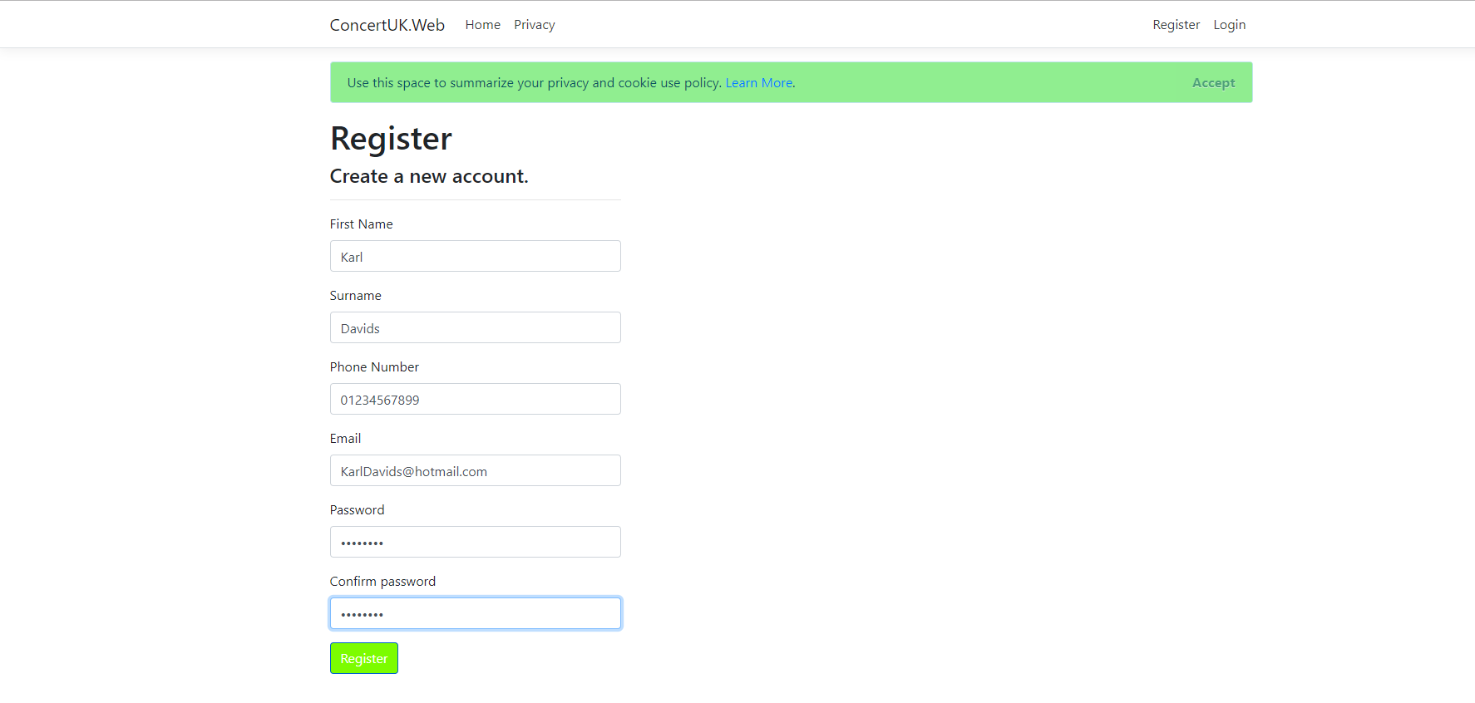
Figure 14 Screenshot of Registration Page

Log In Page
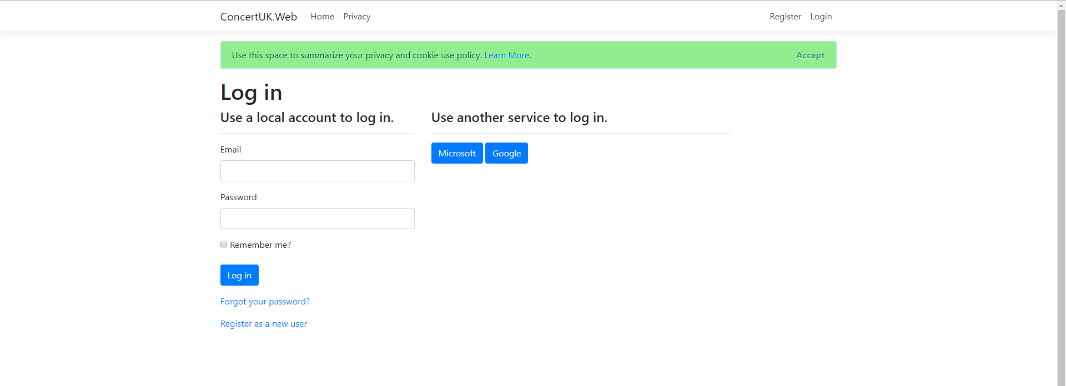
Figure 15 Screenshot of Log In page

Forgot Password Page
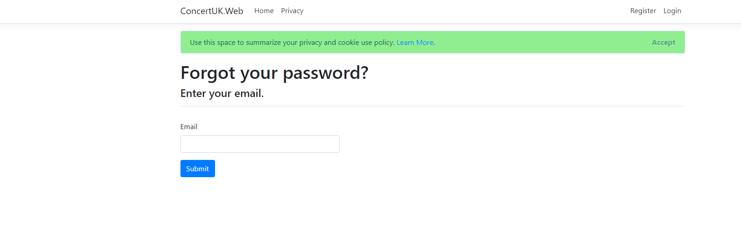
Figure 16 Screenshot of Forgotten Password Page
Create New Concert Page
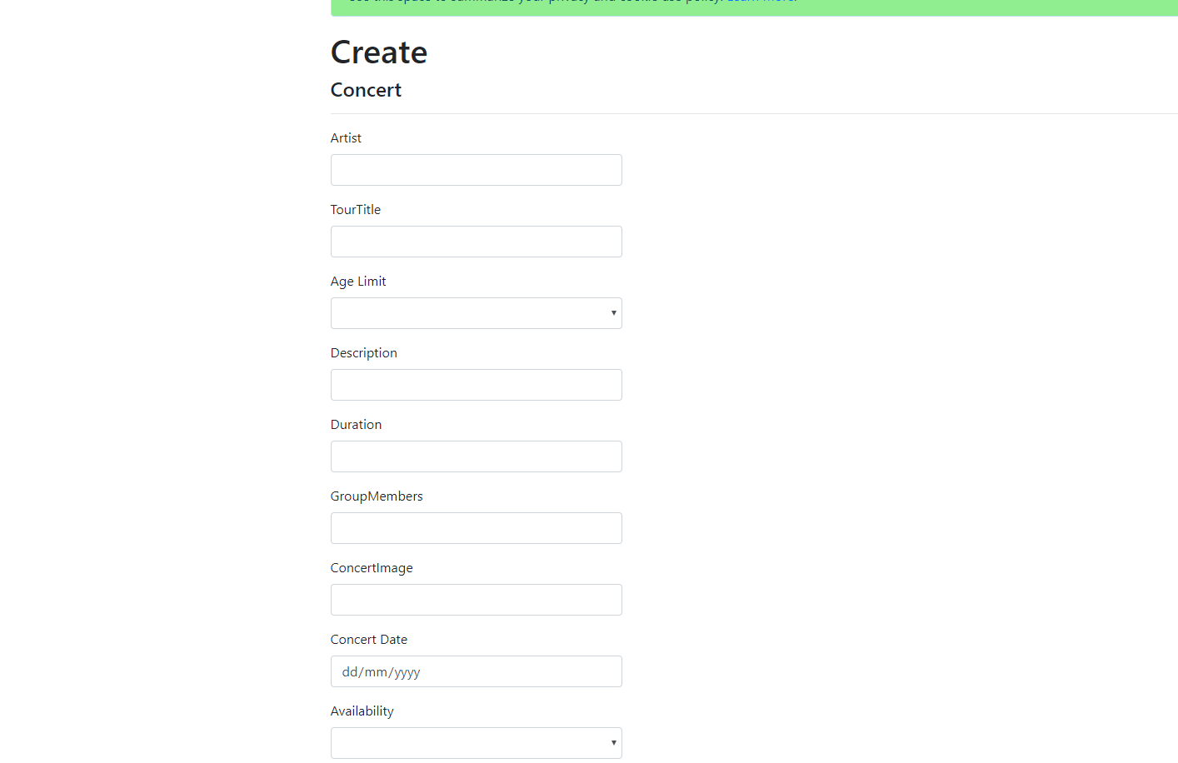
Figure 17 Screenshot of Create new Concert Page
Edit Concert Page
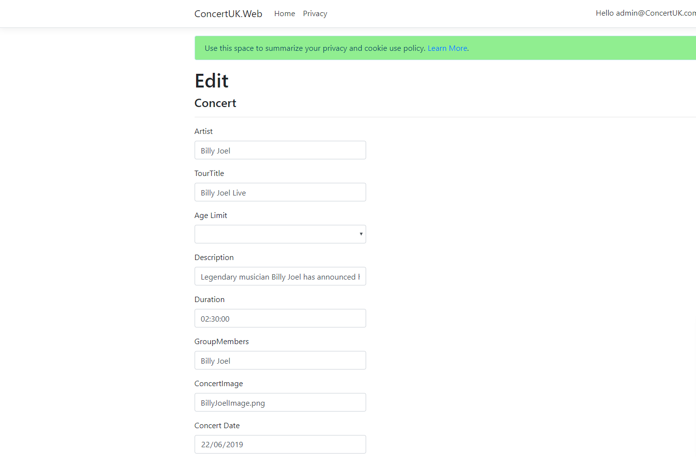
Figure 18 Screenshot of Edit Concert Page

Concerts Showing Page
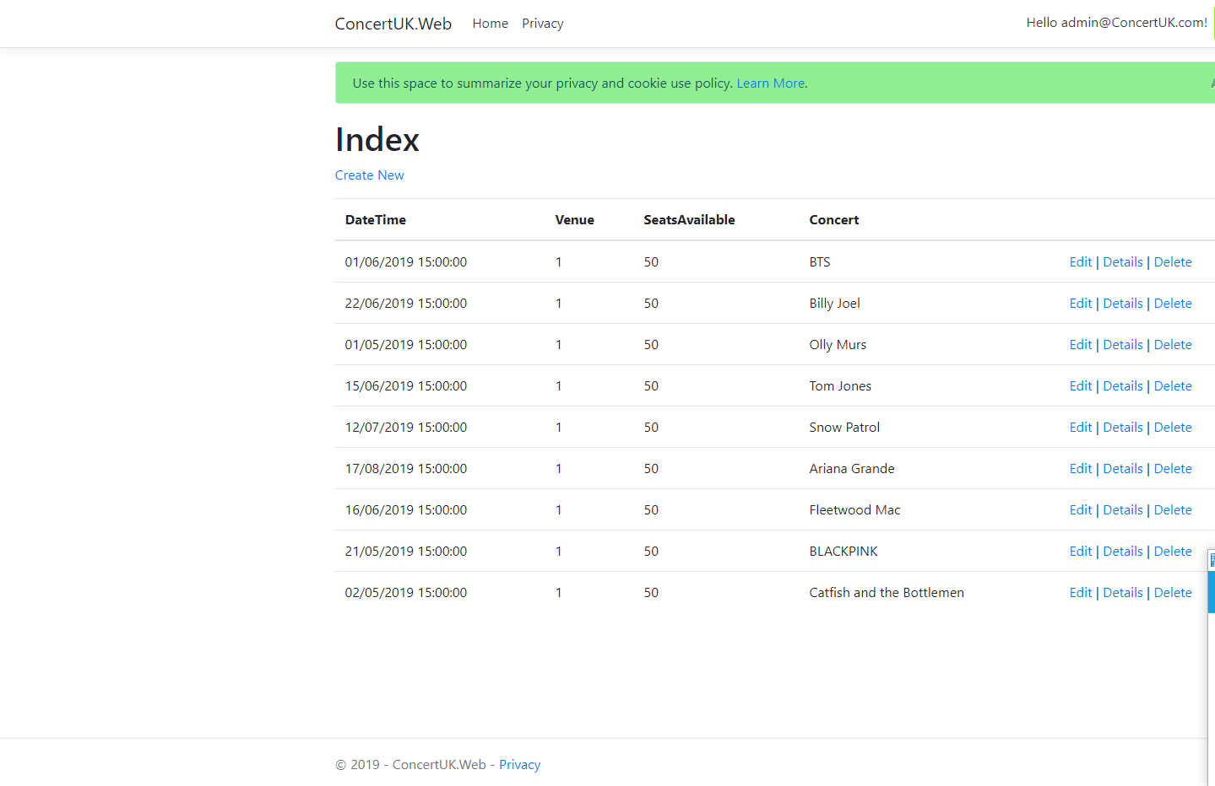
Figure 19 Screenshot of Concerts Showing Page

Evaluation

Testing
When creating any application it is important to test features to ensure everything works as intended. This section contains some tests conducted by the author.
Double Entry test on register page to prevent user from mistyping their password.
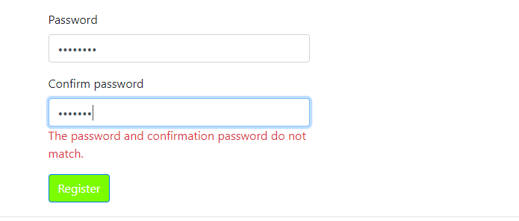
Figure 20 Screenshot of Testing Password
Test of logging into the website works and name is displayed.
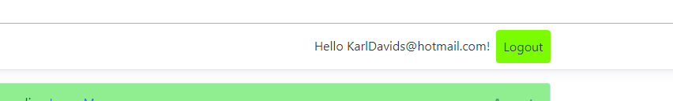
Figure 21 Screenshot of Testing log in
Test of using a microsoft log in goes through to microsoft
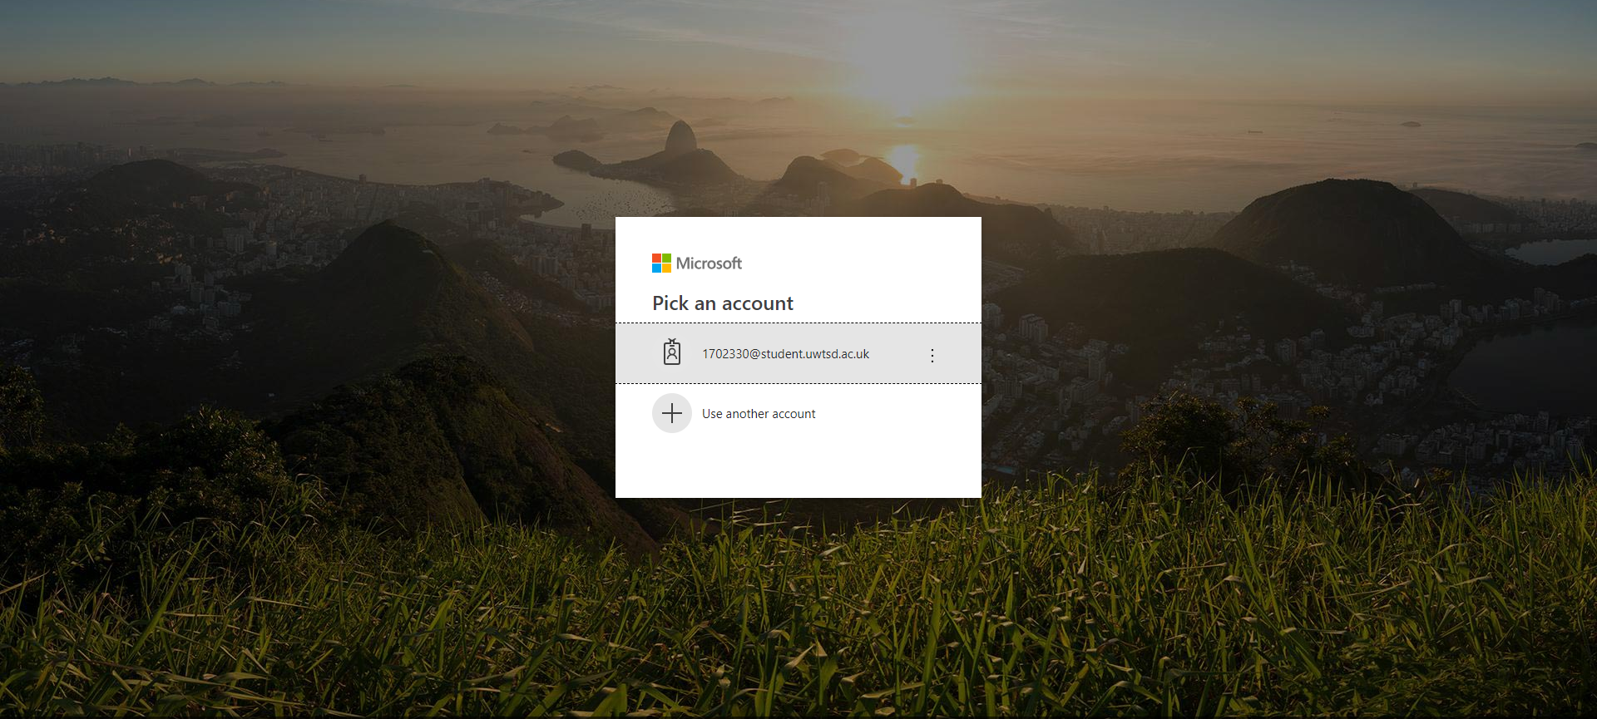
Figure 22 Screenshot of Testing Microsoft log in

Test of using a google log in does not direct to a google log in, in the future the author plans to ammend this.
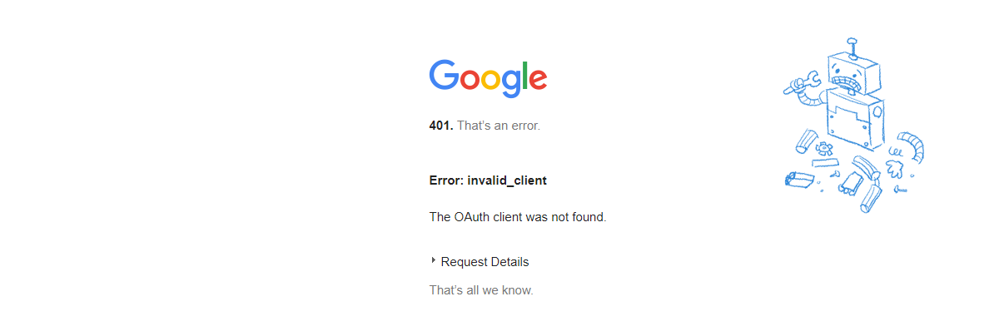
Figure 23 Screenshot of Testing Google log in
Trying to pass a user that does not exist into the log in page results in an error message and prevents the user continuing.
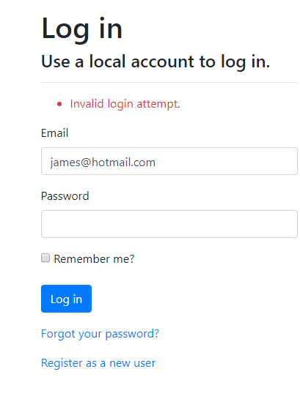
Figure 24 Screenshot of Testing Incorrect log in
Test to show new options when admin is logged in, these options aren’t present for regular accounts or anonymous accounts.
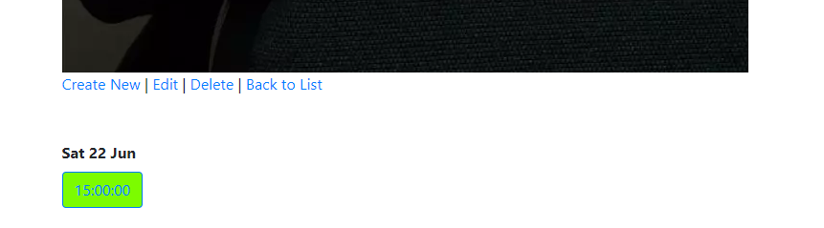
Figure 25 Screenshot of Testing Admin rights
Attempting to Access the Booking Form does not work. The author believes this returns an error because the form is inaccesible through its intended method, instead manually typing the URL does not work either. However after attempting to resolve this issue the author was unable to come to a solution, this feature was defined as a “Must Have” in the requirements, however this feature was not working as the author intended. Going forward with this application the author would like fix this error so that users can book tickets to concert shows.
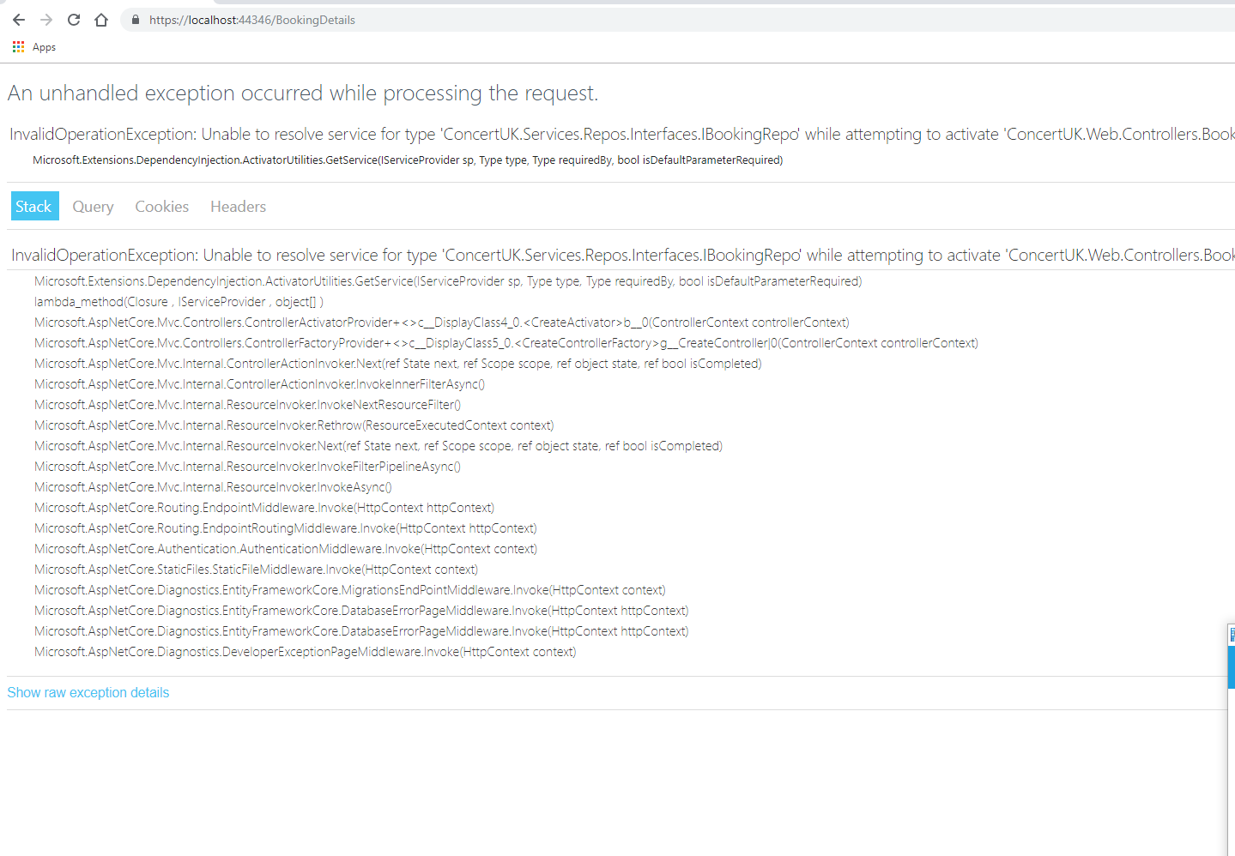
Figure 26 Screenshot of Testing Booking Page

UI and design evaluation
Overall the design is pleasing, there are however, a few issues with some image sizes not being consistent on the artist details page. The design is simple and is not overbearing for the user to understand. Looking at the website from a user perspective the website would appear intuitive and easy to use.

Reflection of Project
There were a few problems with the development of ConcertUK, the author’s PC would not run the application without throwing an error, after trying multiple computers since the original problem was spotted it turns out that the application would only load correctly in the classroom this module was conducted in. This meant that the author could only develop this application whilst in that particular classroom, as a result the author had more limitations on the timeframe to complete the development side of the application. The author also feels that this issue affected the quality of some features within the application as there was less room to experiment with more ideas. That being said, the author is happy overall with many of the features in the application and feels the application as a whole demonstrates an understanding of Application Development ideas and concepts.

References

[1] | Sentinel One, “THE HISTORY OF CYBER SECURITY — EVERYTHING YOU EVER WANTED TO KNOW,” Sentinel One, 10 February 2019. [Online]. Available: https://www.sentinelone.com/blog/history-of-cyber-security/. [Accessed 4 May 2019].
[2] | S. Weisman, “What is a distributed denial of service attack (DDoS) and what can you do about them?,” Norton, [Online]. Available: https://us.norton.com/internetsecurity-emerging-threats-what-is-a-ddos-attack-30sectech-by-norton.html. [Accessed 1 May 2019].
[3] | Symantec, “What is a man-in-the-middle attack?,” Norton, [Online]. Available: https://us.norton.com/internetsecurity-wifi-what-is-a-man-in-the-middle-attack.html. [Accessed 1 May 2019].
[4] | Rapid7, “What are brute-force and dictionary attacks?,” Rapid7, [Online]. Available: https://www.rapid7.com/fundamentals/brute-force-and-dictionary-attacks/. [Accessed 1 May 2019].
[5] | J. Melnick, “Top 10 Most Common Types of Cyber Attacks,” Netwrix Blog, 15 May 2018. [Online]. Available: https://blog.netwrix.com/2018/05/15/top-10-most-common-types-of-cyber-attacks/#Birthday%20attack. [Accessed 1 May 2019].
[6] | M. Field, “WannaCry cyber attack cost the NHS £92m as 19,000 appointments cancelled,” The Telegraph , 11 October 2018. [Online]. Available: https://www.telegraph.co.uk/technology/2018/10/11/wannacry-cyber-attack-cost-nhs-92m-19000-appointments-cancelled/. [Accessed 4 May 2019].
[7] | A. Allegretti, “Cost of WannaCry cyber attack to the NHS revealed,” Sky News, 11 October 2018. [Online]. Available: https://news.sky.com/story/cost-of-wannacry-cyber-attack-to-the-nhs-revealed-11523784. [Accessed 4 May 2019].
[8] | Experian Limited, “What is the Data Protection Act?,” Experian Limited, [Online]. Available: https://www.experian.co.uk/business/glossary/data-protection-act/. [Accessed 1 May 2019].
[9] | OODesign, “Design Patterns,” OODesign, [Online]. Available: https://www.oodesign.com/. [Accessed 5 May 2019].
[10] | GeeksForGeeks, “Design Patterns | Set 2 (Factory Method),” GeekForGeeks, [Online]. Available: https://www.geeksforgeeks.org/design-patterns-set-2-factory-method/. [Accessed 5 May 2019].
[11] | “MoSCoW Prioritisation,” Agile Business, [Online]. Available: https://www.agilebusiness.org/content/moscow-prioritisation. [Accessed 5 May 2019].

Images and information used in Application References

[12] | “BTS Image,” [Online]. Available: https://www.pinterest.co.uk/pin/539376492863312401/. [Accessed 30 April 2019].
[13] | “Billy Joel Image,” [Online]. Available: https://www.iheart.com/artist/billy-joel-4684/. [Accessed 30 April 2019].
[14] | “Ariana Grande Image,” [Online]. Available: https://www.pinterest.pt/pin/25825397848171038/. [Accessed 30 April 2019].
[15] | “Olly Murs Image,” [Online]. Available: https://www.pinterest.co.uk/pin/350858627194034187/. [Accessed 30 April 2019].
[16] | “Tom Jones Image,” [Online]. Available: https://www.pinterest.co.uk/annahendershot6/tom-jones/. [Accessed 30 April 2019].
[17] | “Fleetwood Mac Image,” [Online]. Available: https://www.pinterest.co.uk/pin/262756959483931589/. [Accessed 30 April 2019].
[18] | Amazon, “Snow Patrol Image,” [Online]. Available: https://www.amazon.com/Fallen-Empires-DVD-Combo-Deluxe/dp/B0065UJ1ZE. [Accessed 30 April 2019].
[19] | “Catfish and the Bottlemen Image,” [Online]. Available: https://www.pinterest.co.uk/pin/423971752411487398/. [Accessed 30 April 2019].
[20] | “Blackpink Image,” [Online]. Available: https://www.pinterest.co.uk/pin/473300242073862597/. [Accessed 30 April 2019].
[21] | Ticket Master, “Ticket Master,” [Online]. Available: https://www.ticketmaster.co.uk/. [Accessed 30 April 2019].

marking criteria and Student FEEDBACK

This section details the extent to which the assessment criteria are demonstrated by you, which in turn determines your mark. The marks available for each category of skill are shown. Lecturers will use the space provided to comment on the achievement of the task(s), including those areas in which you have performed well and areas that would benefit from development/improvement.

Common Assessment Criteria Applied (Assignment 2) | Marks available | Marks  awarded
1. Engagement with Literature Skills

Although there is good evidence of engagement with literature skills and supports the written research work for security, the written research does not fully address the questions asked in the brief - please see comment below. (Grade mark: 70.00%) | 5 | 3.5
2. Knowledge and Understanding Skills

A good discussion of security in general, but the brief has asked for web application security issues - see OWASP. The section on design patterns is requires a clearer explanation of the chosen design pattern and how it works and its relevance in web applications and you also need to explain what software design patterns are. (Grade mark: 44.00%) | 25 | 11
3. Cognitive and Intellectual Skills

A fair evaluation of the application has been provided identifying its limitations. Your testing approach is generally good, but needs to be improved to further demonstrate different test cases of the application's functionality. Most of your test cases are for default functionality provided with the VS application template which works straight out of the box. I am more interested in functionality that you have created. (Grade mark: 50.00%) | 20 | 10
4. Practical Application Skills

A good attempt featuring a simple application based on the class tutorial but there is room for improvement. Requirements and the intended design have been well thought out. Good attempt at changing the default views, but there is still some room for improvement. Generally, the application is incomplete and requires more functionality as the functionality is currently limited to displaying data. The edit and create views are the defaults, which require some added functionality to make them work. (Grade mark: 57.78%) | 45 | 26
5. Transferable Skills for Life and Professional Practice

The report is generally well written and presented. (Grade mark: 70.00%) | 5 | 3.5

Assignment Mark (Assessment marks are subject to ratification at the Exam Board. These comments and marks are to give feedback on module work and are for guidance only until they are confirmed. ) | Late Submission Penalties (tick if appropriate) |  | 54%
 | Up to 1 week late (40% Max) |  | 54%
 | Over 1 week late (0%) |  | 54%

