Bateman, Elliot
1809092

L4 – QUALITY AND BUSNESS IMPROVEMENT TECHNIQUES

Introduction
This report offers a prioritised corrective action plan to improve the manufacturing process of the base for a free-standing pillar drill. This has been done through analysis of the defect data and employment of appropriate quality tools with the support of relevant reading. To gain the conclusions in this report, many assumptions of the process and day to day running of the company had to be made. It was assumed that each worker worked at the same rate as their colleague and worked the same hours, Monday – Saturday. It was also assumed that all of the workers use different methods to complete their operations and that defected products from the sandcasting operation are not screened out before they get the to milling machines. This report focuses on three main areas. The defects created by day will be analysed along with the effect that the current shift pattern has on production. The individual defects created by each worker will also be a focus and recommendations will be made to the company on how individual errors can be reduced to improve the production process. The final area of focus is on the most common defects and how these can be reduced.

Defects by Day
After analysing the data, it was noticed that both workers A and B as well as workers C and D, work 6-day weeks. This is noteworthy as it is not now common in the workplace. This is largely down to Henry Ford, the founder of Ford Motor Company. Henry Ford introduced the 5-day working week with 2 consecutive rest days in 1914. ‘Ford argued that a shorter week was no less productive, as workers came back to work fresher after a two-day holiday. Moreover, Ford believed that an increase in leisure time was necessary to drive an increase in the demand for consumer goods’ (Bryson et al, 2007). The increased pressure of production in a shorter period, refined and standardised processes so that there was no loss in production due to the shorter working week.
The Sandcasting defects show employees working a 6-day week, with defects reaching a peak for both workers on a Wednesday. Bryson et al (2007) suggests that the defects increased on a Wednesday because overall production also increases on this day. ‘One possibility is that productivity may be at its peak in the middle of the working week, say on a Tuesday or Wednesday,’ this would mean that the number of defective items would increase, however, the proportion of defective items compared to the items of adequate quality will stay the same.

0
2
4
6
8
10
12
14
16
18
20
Monday
Tuesday
Wednesday
Thursday
Friday
Saturday
Sandcasting Defects By Day
Worker A
Worker B

The Vertical Milling data supports this view as Wednesday is also the day in which they produce the most defective products. This could be due to several reasons. It could be due to a high number of orders scheduled to be despatched on Thursdays, in which case workers could be working quickly to produce enough to fulfil these orders, which, in turn creates a greater number of defective products.

0
2
4
6
8
10
12
Monday
Tuesday
Wednesday
Thursday
Friday
Saturday
Vertical Milling Defects
Worker C
Worker D

Worker Defects
After analysing the data, it can be deduced that the two workers carrying out the Sandcasting process are operating at vastly different levels of competence. This is evident in the number of defective products that each worker is producing. Worker B has produced 25 more products with defects than Worker A, with most of the defects for both workers coming on the surface finish.

0
10
20
30
40
50
60
Surface Finish
Blow Hole
Defective
Finishing
Improper
Shape
Others
Sandcasting Defect Data
Worker A
Worker B

The difference in competence between the two workers could be due to several reasons. The difference in performance could point to a difference in experience, with Worker A possibly having a great deal more experience than Worker B. The Human Capital Theory would support the view that the employee with the most experience would have greater performance because ‘Human Capital Theory studies assume that experiences are translated into knowledge and skills’ (Frese et al, 2001).
Following on from the length of experience each employee has, another explanation to the difference in performance between Worker A and Worker B could be the different training programmes that they undertook. Worker A May have had extensive training ensuring that they are competent to complete the tasks before being allowed to operate alone. Worker B on the other hand, may not have had as much of a rigorous training programme which may have had an adverse effect on their performance. Bianca (no date) highlights the employer’s role in handling training to ensure that staff are performing at the right level, ‘most employees do not come to their jobs with the total knowledge and experience required to perform perfectly. They need a manager to select appropriate training options so that they may advance to a desired level of performance’.

0
5
10
15
20
25
30
Surface Finish
Defective
Finishing
Blow Hole
Improper
Shape
Others
Vertical Milling Defects Data
Worker C
Worker D
Analysis of the defects created by Worker C and Worker D operating the vertical milling machine also show a gap in their competence which, along with the Sandcasting defects can be explained by difference in experience and training. However, as this is a theme in both the sandcasting and the vertical milling, it would seem that the improvements can be made in the hiring process to ensure that suitable candidates are employed. Employers can use many different tools and practices to ensure that they hire the correct candidates. Selection tests are a useful tool adopted by organisations to ensure that they employ the correct people. Selection tests rate applicants ‘on aptitude, personality, abilities, honesty and motivation. Properly designed selection tests are standardized, reliable and valid in predicting an applicant’s success on the job’ (Gusdorf, 2008). The use of a comprehensive selection test could have narrowed down the possibility of employing candidates who are not suited to the job, thus improving production performance. The skills examined during the selection tests, should mirror those required to complete the job successfully. If the skills tested in the selection process are different to the skills required to carry out the role, then the test would be redundant.
As there are differences in performance between Worker A and Worker B as well as Worker C and Worker D, it could point to the lack of a Standard Operating Procedure (SOP). Standard Operating Procedures offer detailed instructions on the safest and most efficient method of carrying out a task. Castro (2015) identifies the benefits that a Standard Operating Procedure can offer.
SOPs ensure that no matter what day it is or who is working, the tasks that keep your organization running effectively will be done the way you want them done. They don’t hamstring employees or turn them into robots. Rather they provide security because each employee knows what’s expected of him or her, rather than guessing what needs to be done daily.
This suggests that the differences in performance between the employees would not be there if the company had an effective Standard Operating Procedure in place.

Common Defects
Defect | Frequency of Occurrence | Cumulative Number | Cumulative Percentage
Surface Finish | 124 | 124 | 62.94%
Blow Hole | 43 | 167 | 84.77%
Improper Shape | 20 | 187 | 94.92%
Defective Finishing | 6 | 193 | 97.97%
Others | 4 | 197 | 100%
Total | 197

%
0.00
%
20.00
40.00
%
60.00
%
%
80.00
100.00
%
%
120.00
0
20
40
60
80
100
120
140
Surface Finish
Blow Hole
Improper Shape
Defective Finishing
Others
Frequency of Occurrence
Cumulative Percentage

The above table and accompanying Pareto Diagram show that surface finish issues account for over 62% of the defects created in the production process. When combined with the defective blow holes, the percentage is increased to 84.77%. This suggests that if the company address the surface finish as well as the blow hole issues, it would mean 84.77% of the issues will have been eradicated. To address the issues, the origin of the issues must be identified.

Sandcasting Defects | Worker A | Worker B | Total
Surface Finish | 26 | 48 | 74
Blow Hole | 17 | 17 | 34
Defective Finishing | 0 | 0 | 0
Improper Shape | 5 | 8 | 13
Others | 0 | 0 | 0
Total | 48 | 73 | 121

The above table shows that 74 surface finish and 34 blow hole defects were caused by the sandcasting process. The below table shows that only 50 surface finish issues were caused in the vertical milling process and only 9 blow hole issues were caused during this process. Blow hole defects are common in sandcasting whereas they are not a known defect in the milling process. However, vertical milling can reveal blow holes that were hidden beneath the surface, these can be discovered through the use of non-destructive testing such as X-Ray and Ultrasound. This could suggest that the company does not have an effective quality checking system and it can be assumed that all issues with blow holes originated in the sandcasting process. Assuming that no surface finish issues were passed from the sand casters to the vertical milling process, this would mean that 59.39% of all defects are surface finish or blow hole issues originating from sandcasting.
Vertical Milling Defects | Worker C | Worker D | Total
Surface Finish | 24 | 26 | 50
Blow Hole | 3 | 6 | 9
Defective Finishing | 2 | 4 | 6
Improper Shape | 2 | 5 | 7
Others | 2 | 2 | 4
Total | 33 | 43 | 76

As a large proportion of defects involve surface finish and blow hole issues originating from the sandcasting process, it would make sense to address these issues first.

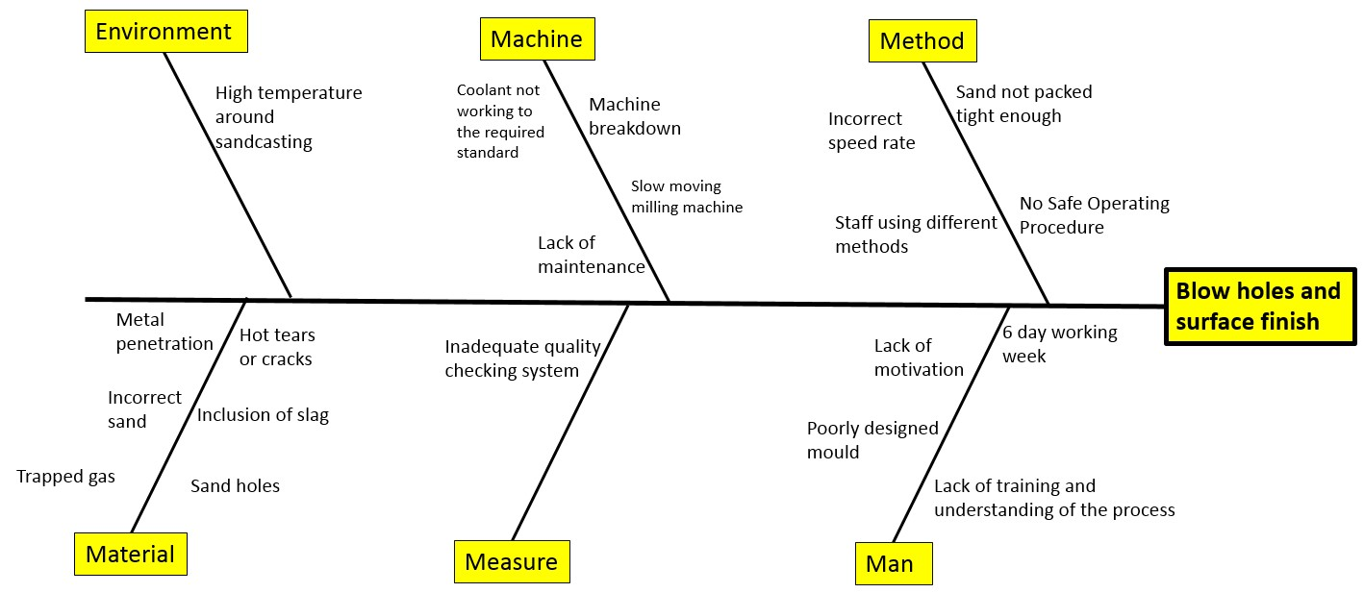
Three main surface finish issues are responsible for the defects, metal penetration, hot tears or cracks, and sand holes. The majority of these issues can be traced down to operators receiving insufficient training. See figure below:

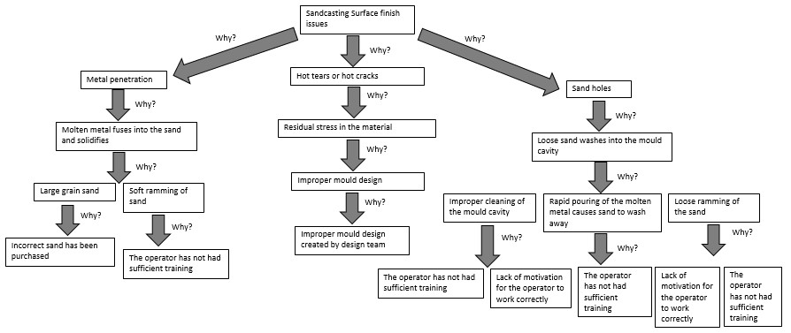
The excessive amount of blow holes is caused by trapped gas on the surface of the casting which is there because some of the metal has started to solidify. There are 5 reasons why the metal starts to solidify: excessive moisture in the sand, low permeability of the sand, sand grains that are too fine, sand that has been rammed too hard and insufficient venting. Many of these issues can also be rectified by training individuals to a higher standard and offering employees further motivation to carry out their roles to an acceptable level. See figure below:

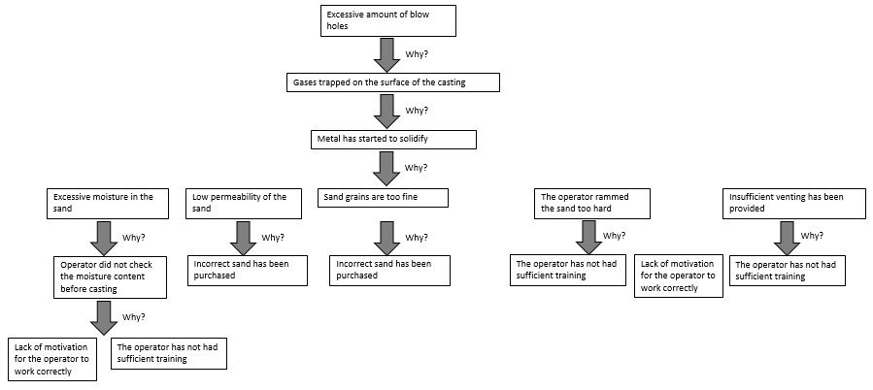

There are three main issues which cause defects in the vertical milling process. The spindle speed, ineffective coolant and the feed rate. Spindle speed changes as the cutting forces applied to the spindle fluctuate, this can cause an uneven cut. Cutting fluids are used to lubricate the material and remove heat from the area. Ineffective coolant leads to problems with the accuracy of the cut. Providing effective coolant should be part of the regular maintenance carried out on the machine as ineffective coolant can hinder the performance and life expectancy of the machine. Feed rate directly impacts the surface finish of a product. If material is fed as a high speed, the cut will be rough and not as accurate, however, if the material is fed through at a slower speed, it allows the spindle to accurately cut everything that it should and leave a smooth finish.
Using the causes of the defects, recommendations can be made to eradicate the defects and improve the production of the base for a free-standing pillar drill.

Recommendation | Reason
Alter Shift pattern from 6 working days to 2 days, 2 nights and 4 days off. | Less shift handovers per day leads to fewer opportunities for miscommunications and disruptions, this can result in increased productivity.  12-hour shifts can reduce stress and improve quality of life which leads to improved morale.  12-hour shifts can create more dedicated employees as in the 4 days, employees are focused on work as there is more time off during the 4 rest days. (Circadian.com, no date)
Create a more rigorous hiring process. Make use of psychometric testing, practical test centres and group interviews as well as individual interviews. | A rigorous selection process can predict a candidates’ chance of succeeding in a role. This increases the probability that the company will employ suitable people who will cause less defects, thus increasing productivity.
Create a training plan for each role with competencies for operators to pass before they can operate alone. | The training plan will ensure that employees can operate the equipment and carry out their roles to the required standard. This will ensure that employees are able to carry out the tasks which will reduce defected products and increase production.
Produce Standard Operating Procedures (SOPs) for each task. | Standard Operating Procedures ensure that the safest and most efficient way of carrying out the task is followed. SOPs can reduce defects as they offer instructions for operators to follow on how to complete the tasks, thus minimising errors.
Improve quality checking by investing in X-Ray and Ultrasound machines. | Quality checking systems are essential. Using non-destructive quality checking systems like X-Ray and Ultrasound can spot defects beneath the surface. These prevent defected items moving to the next stage of the process. Quality checking after each stage of a process is essential for fault finding. A fault can be stopped at source if it is instantly known where it was created. As well as quality checking, all defected items should be filtered out and not allowed to move to the next stage of the process. Quality checking ensures that customers receive a quality product, ‘no business can survive long term without satisfying customers, this needs to be a managed intention.’ (Brown, 2014)

References

Bianca, Audra, (No date). Relationship Between Training and Employee Performance. Work - Chron.com. Available at: https://work.chron.com/relationship-between-training-employeeperformance-4257.html [Accessed: : 04/04/2019, 13:50pm]

Brown, C. (2014). Why Have A Quality Management System? What is Quality Assurance Anyway? - ISO Consultants and Products. [online] ISO Consultants and Products. Available at: https://www.independentqualityservice.com/quality-management-system-qualityassurance-anyway/ [Accessed 19 Apr. 2019].

Bryson, Alex and Forth, John (2007) Productivity and days of the week. Discussion Paper.
Royal Society for the encouragement of Arts, Manufactures & Commerce. Available at: https://eprints.lse.ac.uk/4963/1/daysoftheweek%28LSEROversion%29.pdf [accessed: 01/04/2019, 11:20am]

Circadian.com. (n.d.). 8 Major Advantages of 12-Hour Shifts: A Manager’s Perspective. [online] Available at: https://www.circadian.com/blog/item/14-8-major-advantages-of-12hour-shifts-a-manager-s-perspective.html [Accessed 19 Apr. 2019, 11:00am].

Castro, A (2015) 8 Reasons Your Organization Needs Standard Operating Procedures. Available at: http://www.amy-castro.com/8-reasons-organization-needs-standard-operatingprocedures/ [accessed: 15/04/2019, 08:00am]

Gusdorf, Myrna (2008) Recruitment and Selection: Hiring the Right Person. Alexandria, USA: SHRM Academic Initiatives. Available at: https://swsu.ru/sbornik-
statey/pdf/Recruitment%20and%20Selection%20IM.pdf [Accessed: 09/04/2019, 10:00am]

M. Frese, A. Rauch, (2001) International Encyclopedia of the Social & Behavioral Sciences.
Available at: https://www.sciencedirect.com/topics/social-sciences/human-capital-theory [accessed: 04/04/2019, 13:10pm]

