BMSW4004 - Problem Solving and Decision Making

STUDENT NAME:MARIAN SERBU-1907362

LECTURER: YAJESH KUMAR

COURSE: PROBLEM SOLVING AND DECISION MAKING

UNIVERSITY OF WALES TRINITY SAINT-DAVID’S
Table of Contents
Task 2 3
Introduction 3
Define a complex problem in the workplace including its scope and impact 3
Analyse information on the identified problem, to help inform the decision-making process 4
Propose a range of alternative solutions to the problem 5
Use a decision-making technique to evaluate a range of solutions to identify the most appropriate option 6
Develop a plan for implementing the solution 8
Communicate the plan to stakeholders 9
Assess appropriate monitoring and review techniques to ensure the successful implementation of the solution. 9
Conclusion 10
References 11

Task 2

Introduction
The purpose of the report is to identify the techniques related to the problem solving along with the workplace issues. In the following report, the problems related to managing the bar from the job role of a Bar manager will be evaluated. Moreover, the report will derive the possible workplace solutions to mitigate the problem by integrating the monitoring functions to resist workplace problems.

Define a complex problem in the workplace including its scope and impact
The workplace defines the place of employment that supports the coordination and cooperation of the teams to achieve the organisational goal (McLaughlin, 2018). The complexities in the workplace arise due to the different cultural backgrounds of the team members, unstructured communication, lack of clarity in direction, inappropriate workplace policies, etc. However, external factors like the rise in the demand of the customers, shift in the taste and preferences of the customers, changing government norms, etc.
In regards to the job role of a Bar Manager, one has to manage the day-to-day operations of the bar by integrating the resources. The pub manager has to create an environment that ensure safety and security for the employees and also need to focus on the fast-paced environment (Poulston, 2017). The responsibilities of the Bar Manager are to promote and grow the business by hiring and retaining the talent and also support the customer value proposition. The manager has to ensure that the patrons must receive excellent drinks, foods and services promised the organisation. Moreover, as a Bar Manager, an individual has to execute the planning for the promotional events by prioritising the quality service and safety practices. The Bar Manager has to check the licenses and accordingly update the vendor about the contracts, delivery schedules, order update, etc. with a motive to increase the level of profit and customer satisfaction (De Castro, 2017) . Therefore, it can be reckoned that the Bar Manager has to ensure the stock is updated and smooth operation of the bar by hiring, training, and retaining the staff. Moreover, as a part of legal responsibilities, the Bar Manager has to check the current license of the liquor, contract agreements, inventory management, and managing the budgets.
Therefore, the common challenges that can be perceived by job responsibilities are as follows:
- The development of the menu to attract customers is a critical part of the job role. The reason for such a challenge is due to the rapid changes in the taste and preferences of the customers. Moreover, the bar has to stock up with the right products an varieties that the customers are preferring. It needs to be checked that the bar menu must not be complicated as it can create confusion for the customers.
- The matching of the industry trends with the bar operation is a challenge to the bar manager due to the rising cost of the procurement activities (Brownell, 2017).
- The staff’s rotation and creating the duty roster is a common problem that the Bar Manager used to encounter from the staff. It has been observed that fixing the time as per the requirement of the staffs are not possible which create conflicts.
- The awareness among the customers regarding the closing time or last order is less. The Bar Manager encounter challenges to make the customer understand the last order or happy hours closing time.

Analyse information on the identified problem, to help inform the decision-making process
The decision making process is an attempt to undertake a decision after analysing the collected information related to the identified problem. Moreover, evaluation of the alternatives and other perspectives related to the identified problem is also focused on the decision-making process. Therefore, one of the important aspects of decision making is “information analysis”.
The workplace problem related to the role of a Bar Manager can be categorised into two dimensions that are as follows:
External Factors:
- Customer Demand: The frequent change in the customer’s taste and preferences is increasing the operational cost of the bar counters. Moreover, maintaining the updated stocks as per the demand of the customers’ needs to be focused.
- Government regulations: The legal compliances of maintaining the license of the bar can be observed. Moreover, the renewal of such licenses on time is required to sell the liquor. Therefore, the administrative activities are complex in case of the job role of a Bar Manager.
- Industry Trends: The recent trend of the industry related to pubs and counters has influenced the day-to-day operations. Therefore, maintaining the requirements as per the trends of the industry is imperative.

Internal Factors:
- Staff Rotation: The shifts of the staff based on the flexibility of the team members are focused on fixing the staff rotation. However, the difference in the personal priorities of the staff and non-cooperation used to create issues in preparing the duty rosters.
- Staff Hiring and Development: The retention of the staff is difficult in the pubs as the staff after gathering experience like to switch to different organisations. Therefore, retaining such staff is challenging in the bars.
- Negotiation with the suppliers: The failure to meet the delivery schedules are common in the bar operations (Law, 2016). Therefore, the incompetency in the delivery schedules influence the bar operation and reduces the customer satisfaction level.
- Unsound behaviour of customer: The abnormal behaviour of the customer after consuming the drink sometimes creates unnecessary violence in the bar. The Bar Manager encounters problems in addressing the requirement of the customers at that time. Therefore, a high patience level and problem-solving skills are imperative for the Bar manager.

Propose a range of alternative solutions to the problem
From the job role of a Bar Manager, it can be ascertained that the identified problems are related to both the internal and external factors. Therefore, the range of alternative solutions that can resist the identified workplace problem is as follows:
- Employee Motivation helps to retain the staff for the long-term period and accordingly reduces the operational cost. Motivation specifies the willingness of the individual towards undertaking an action (Huber, 2017). In accordance with Herzberg’s Two Factor Theory, the Bar manager has to give priority both on the hygiene and motivational factors. For instance, to ensure the hygiene factors, the pay scale, employment policies, and fringe benefits should be given to the staff. Moreover, the opportunities for promotion, development programs, etc. must be introduced to retain the staff.
- Learning Organisation Culture will help to stimulate the behaviour of the staff towards flexibility and eagerness to learn and develop. Moreover, organisation culture signifies the shared beliefs that help to increase cooperation and coordination among the staff (Umassd, 2019).
- The integrated communication process helps to fix the staff rotation issues. The role of the integration is to increase the real-time access of the team members. For example, the integrated unit will help to understand the priorities of the staff and accordingly fixes the schedule based on the flexibility. With the integrated system, the staff can get the updates and accordingly plan their schedules to control the conflicts with each other. Moreover, the supplier’s issue can be controlled with the integrated operating system through the real-time status update and inventory control. Therefore, the bar manager can share the status report with the operation manager as per the requirement.

Use a decision-making technique to evaluate a range of solutions to identify the most appropriate option
Cause and Effect analysis underlines the technique that helps to address the causes of the identified problem (Simon, 2013). The key phases that require to implement the “cause and effect analysis” are as follows:
- The identification of the workplace problem (Bar operations)
- The involvement of the factors related to the workplace problems (internal and external factors influencing the bar operation)
- The identification of the genuine causes for such identified problem
- The last phase is to draw a diagram to support the visualisation process.
Fishbone or Ishikawa diagram is mainly used to address the cause and effect analysis. Moreover, such a diagram is useful to track the causes of variations and failures in the operational process (Ishizaka, 2014). The diagram manifests the skeleton of the fish with a problem at the top and spines of the finesse are the possible causes. For example, the workplace problem is related to the Bar Operation that includes supplier’s negotiation process, staff rotation, the unsound mind of the customers to understand the offers, etc. The Bar manager has to ensure the presence of the current stock of the liquor and availability of the services to the customers by managing the staff. Moreover, the legal requirement is also attached to the responsibility of the Bar Manager like license renewal and taxation to sell the wine. The following diagram will help to analyse the range of solutions by identifying the possible causes of the identified problem.

Methods
Environment

Complex Bar Operations
Equipment
People

Fishbone or Ishikawa diagram Source: Author
From the diagram, it can be observed that the possible causes can be categorised under the environment, methods, people, and equipment. The possible reason under the heads identified in the diagram are as follows:
- Environment: The changing Government norms in updating and maintaining the alcohol selling license is increasing the administrative duties of the Bar Manager (De Castro, 2017).
- Methods: The lack of coordinated methods showcases the requirement of the integrated system and operation process to ensure real-time information access.
- Equipment: The need for the utensils to create an impression among the customers is required.
- People: The insufficient training and inadequate development plan of the staff increasing the conflict and high employee turnover.

Develop a plan for implementing the solution
A Continuous Improvement Plan signifies the range of activities that helps to review and measure the development based on realistic performance (Udechukwu, 2016). Therefore, the Plan-Do-Check-Act (PDCA) cycle denotes the four-phases problem-solving technique that helps to bring improvement in the business.
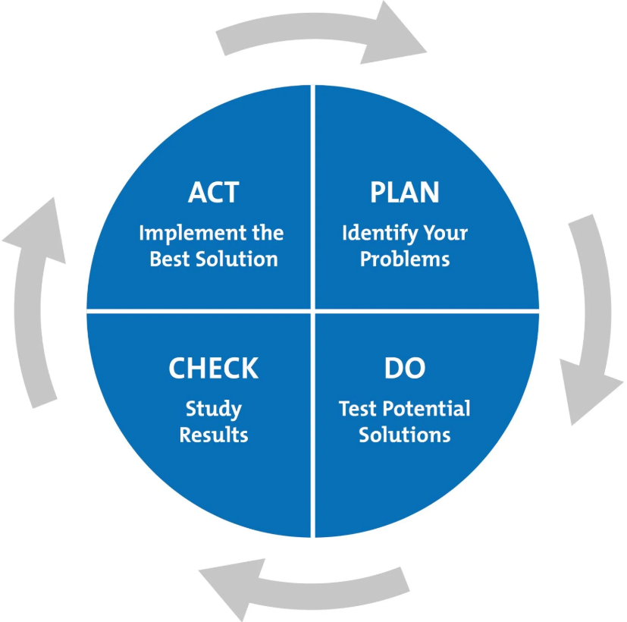
PDCA Cycle, Source: https://www.mindtools.com/
Moreover, recurring mistakes can be prevented from the PDCA cycle. The following phases of the Plan are as follows:
- Plan: The identification of the opportunity and implementing the change while developing the solution is the first phase. Therefore, the Bar manager has to focus on the integrated communication process to ensure operational efficiency. The problem related to the supplier’s transactions and staff rotation can be reduced with such a new process.
- Do: The post-implementation of the new system and training methods should be tested to understand the drawbacks and other requirements. The Bar Manager has to analyse the consequence in applying such a new system in the establishment.
- Check: The third phase will allow the Bar manager to review the new operating system and also to learn about the new process. The checking phase will help to determine the benefits of the new system and process that can reduce the complexities in maintaining the supplier’s contract and staff rotation.
- Act: the last phase is the moment for action that is required to overcome the gap if exists in the new process and system. For example, the staff may feel uncomfortable with the new process and likely to resist the change. Therefore, implementing the new methods of training is required to meet the deficiency.

Communicate the plan to stakeholders
The stakeholders are an important part of the business who are involved directly or indirectly (CoastAdapt, 2019). Therefore, interaction with the stakeholders needs to be clear to resist the workplace problem. For example, the new process in the establishment will influence the activity of the suppliers, Government agencies, staff, and managers related to the Bar Operation. The below table will support to communicate the development of the plan to the identified stakeholders.
Audience  (Who) | Message  (What) | Medium  (How) | Schedule  (When)
Staffs | Accessing the new integrated system | New operating process | Customer Arrival and departure
Suppliers | Status report of the delivery schedule in the mentioned dates of the new system | New Operating software that will be cloud-based | Order received and delivery
Operation manager | Monitoring the status and shared with the developments with other functional units | New Integrated Operating software | At the end of the day

Assess appropriate monitoring and review techniques to ensure the successful implementation of the solution.
The monitoring ensures the accountability of the process to overcome the deficiency after the implementation of the new process. For example, the 360-degree feedback system is effective monitoring and review techniques that help to fetch meaningful information across the levels of the organisation. The positive side of such a technique is the gathering of feedbacks irrespective of the different levels of the organisation without any biased technique (Brownell, 2017). However, collecting the information from such a technique is time consumable due to the higher involvement

Conclusion
The report has demonstrated the decision-making process by focusing on the solution related to the workplace. The techniques like cause and effect analysis have been presented with a fishbone diagram to support the visualisation of the causes related to the problem.

References
Brownell, J., 2017. Striking a balance: The future of work and family issues in the hospitality industry. International Journal of Human Resources Development and Management, 28(5), pp. 109-123.
CoastAdapt, 2019. [Online]
Available at: https://coastadapt.com.au/C-CADS/c-cads-step-6-monitor-evaluate-and-review
[Accessed 08 06 2020].
De Castro, A. F. K. S. E. a. O. J., 2017. How immigrant workers experience workplace problems: a qualitative study. Archives of Environmental & Occupational Health, 64(3), pp. 249-258.
Huber, G. a. M. R., 2017. The decision-making paradigm of organizational design. Management science, 34(5), pp. 572-589.
Ishizaka, A. a. S. S., 2014. Are multi-criteria decision-making tools useful? An experimental comparative study of three methods. European Journal of Operational Research, 264(5), pp. 462-471.
Law, R. B. B. D. M. M. R. a. B. S., 2016. Hospitality HRM: past, present and the future. International Journal of Contemporary Hospitality Management, 34(5), pp. 22-229.
McLaughlin, P. B. J. a. S. P., 2018. Developing an organisation culture to facilitate radical innovation. International Journal of Technology Management, 44(5), pp. 298-323.
Poulston, J., 2017. Hospitality workplace problems and poor training: a close relationship. International Journal of Contemporary Hospitality Management, 22(4), pp. 223-227.
Simon, H., 2013. Rational decision making in business organizations. The American economic review, 69(6), pp. 493-513.
Udechukwu, I., 2016. Correctional officer turnover: Of Maslow's needs hierarchy and Herzberg's motivation theory. Public Personnel Management, 39(6), pp. 69-82.
Umassd, 2019. [Online]
Available at: https://www.umassd.edu/fycm/decision-making/process/#:~:text=Decision%20making%20is%20the%20process,relevant%20information%20and%20defining%20alternatives.
[Accessed 06 08 2020].

