DS 1 Template

My Screenshots/Photos
- Please add 4–6 screenshots or photos of your digital life.
- You can use your phone or laptop.
- For each screenshot, write one or two sentences explaining what it shows.

Screenshot/Photo 1

[This shows the main email app I use to receive and send emails.]

Screenshot/Photo 2
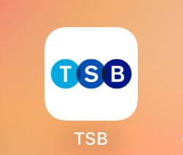
[This shows my online banking app which I use to manage my finances.]

Screenshot/Photo 3

[This shows how I plan and navigate my journeys.]

Screenshot/Photo 4
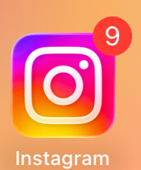
[This shows that I use instagram to socialise and connect with friends]

Screenshot/Photo 5

[This shows the main app I use to manage Crypto.]

Screenshot/Photo 6

[This shows I am a student at UWTSD and use the hub to access various tools.]

My Short Reflection
- Write 5–8 simple sentences about your digital life.
- You can use the sentence starters below if helpful.
I use digital tools each day of my life. I feel confident in using all the different apps seem in my screenshots. I want to improve at using at using Microsoft Excel. I hope this module will help me pinpoint the most effective and efficient ways to use digital tools in a business environment. Digital Skills are important for me because in a world that is ever evolving, having a solid foundation is very handy.

Sentence starters
- I use digital tools to …
- I feel confident when I …
- I want to improve …
- I often use these tools: …
- I sometimes feel nervous about …
- I hope this module will help me …
- Digital skills are important for me because …
You can write more if you want.

Submission Checklist
Before you submit, please check:
​​​ ☐ I added 4–6 screenshots
☐ I wrote short sentences for each screenshot
☐ I wrote my short reflection
☐ My work is my own
☐ My file opens correctly
​​☐ My file opens correctly

