Developing Relationships and Workplace Achievement

CONSULTANCY PROJECT FOR HOSPITALITY MANAGEMENT

-
Gregorio Bernardo
Student Number: 1913504

Table of Contents
Slide 1- Introduction 4
Slide 2- a) Determine Appropriate Knowledge, Skills and Behaviours (KSB) that are required by HR Professionals across The Department 4
Required Knowledge for HR Professionals 4
Slide 3- Cont. 6
Required Skills for HR Professionals 6
Slide 4- Cont. 7
Required Behaviours for HR Professionals 7
Slide 5- b) Training and Development Needs 8
Slide 6- C) Benefits to the Organisation of Developing an HR Officer through Effective Training and Development 9
Slide 7- Conclusion 10
Slide 8- References 11
Appendix 12
Personal Skills Audit 12

Slide 1- Introduction
- Present the aim of the study
- Introduce importance of HR officer in an organization
- Introduce discussion sections of the study
The study aims to evaluate the necessity of the training and development process for an HR officer to sustain organizational growth. HR officer of an organization helps to bridge the communication gap between the performance of the workers and the organizational goals (Pham et al., 2019). This study will focus on appropriate knowledge skills and behaviours that are required for HR professionals. The study will also present a personal skills audit and will identify training and development needs considering the audit plan. The study will essay the benefits to the organization and developing HR officer responsibilities through effective training and development.

Slide 2- a) Determine Appropriate Knowledge, Skills and Behaviours (KSB) that are required by HR Professionals across The Department

Required Knowledge for HR Professionals
- The knowledge of principles and procedures of the company
- The administration and management knowledge
- The knowledge of laws and legal codes
- The knowledge of customer service and quality management
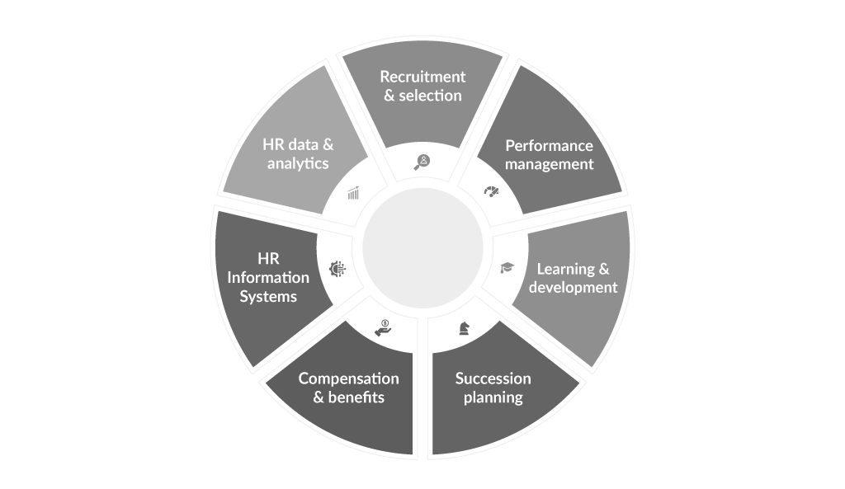
HR officers manage the strategic marketing planning of an organization to meet the organizational goals. HR officers need to achieve appropriate knowledge that can help them to gain success in the professional field as well as help the organization to maintain its organizational growth (Chyhryn et al., 2019). The HR officers should know the principles and procedures of a company that can ensure recruitment, training, benefits, employees’ relationship, the information system of the company. The HR officer is also responsible for the administration and management of a company that involved strategic planning, resource management, leadership quality, manufacturing process, and coordination with employees, suppliers, and stakeholders. HR officers also have the knowledge of laws, government regulation, democratic rules, and legal codes. HR officers should know the procedures of customer service including customers demand assessment, maintaining the quality of services, and fulfilling customers’ satisfaction (Villajos et al., 2019). The major knowledge that is required for an HR officer is the knowledge of effective communication and media production including information and technological knowledge. The HR officer should know about the economic and accounting practices of the organization including financial markets, financial data, and competitive market analysis.

Slide 3- Cont.

Required Skills for HR Professionals
- Active listening skill
- Decision-making and judgment skill
- Workforce management skill
- Coordination skill
- Critical thinking skill
- Time management skill
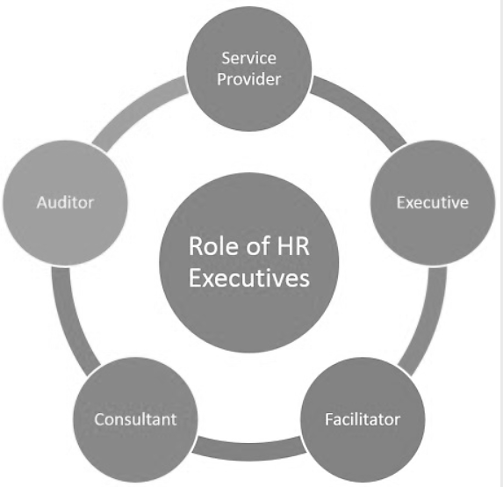
Figure: Role of HR Executives
(Source: Saeed et al., 2019)
The most important skill required for an HR officer is an active listening skill that can help to understand employees’ opinions and problems in the organization. Another important skill of an HR officer is the decision-making and judgment skill that help to manage organizational economic development as well as help to mitigate problems and risks (O’riordan, 2017). The HR officers should have workforce management skill where they can motivate, direct and monitor employees’ performances. Coordination skill is another important skill of an HR officer that helps to maintain a positive work environment in the organization and establish an effective communication system. Another major skill of an HR officer is the critical thinking skill where he/she can use logic and reasoning skills to develop effective solutions to mitigate organizational problems. Time management skill is the most important skill for an HR officer that helps to maintain the time frame and meet the deadlines of the projects (Saeed et al., 2019).

Slide 4- Cont.

Required Behaviours for HR Professionals
- Transparency and trustworthiness
- Purpose oriented
- Technological expertise
- Versatility and adaptability
- Solution-oriented
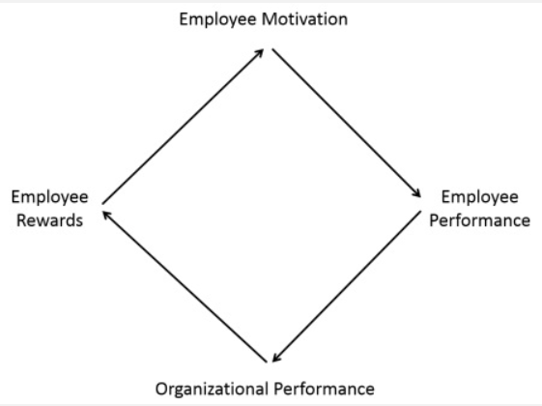
Figure: HR Behaviour Approach
(Source: Marr, 2018)

The most important behaviour of an HR officer is transparency and trustworthiness that help to establish a viable communication system in the organization. The major officers have to adopt purpose orientation where we can focus on organizational purpose and make strategies to achieve organizational goals (Roberts, 2018). The major officers also have to be technology experts, especially in the modern era, that can help them to incorporate technological advancement in the organization. Versatility and adaptability are important behaviours of HR officers that enhance their multitasking skills as well as they can adopt new skills to achieve success in the professional field. Another major important behaviour of an HR officer is the solution-oriented attitude that enhances their critical thinking skill and they can give effective solutions to mitigate any kind of problems and risks (Marr, 2018).

Slide 5- b) Training and Development Needs
- Incorporate In-Basket Training (IBT) to enhance problem-solving skills
- Incorporate Computer-Based Training (CBT) to enhance the information technology skill
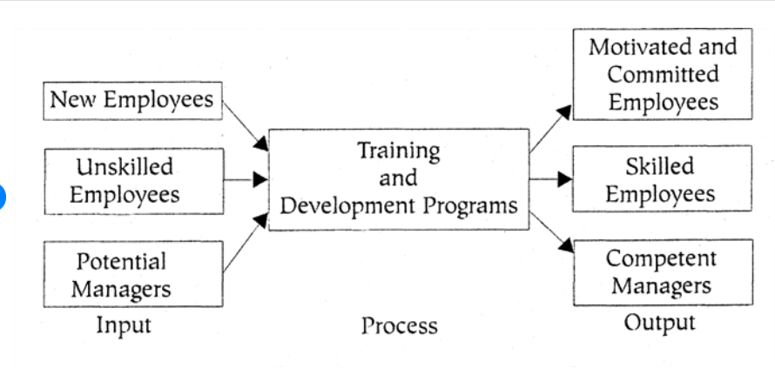
Figure: Training and Development in HR
(Source: Mishra, 2017)
Training and development enhance HR officers’ productivity rate and performance level that can help to gain professional success. Communication skills, information technology, and problem-solving skills are very important for HR officers that can help them to manage managerial activities as well as Organisational Management programs effectively (Canedo et al., 2017). To enhance problem-solving skills In-Basket Training method can be considered that provide training to improve managerial ability by improving decision making and problem-solving skills. This method has two stages where the major offices fast have to understand the case study within a specific time frame and then they have to analyze additions by questioning the analysis. This method allows developing flexibility, time management, realism, and work-pressure management simultaneously. To enhance the information technology skill, Computer-Based Training can be considered that allows developing presentation skills including computer-managed instruction system (Mishra, 2017). This training allows HR officers to increase their work speed and they can easily track employees’ performance by using technological devices. For better understanding a personal skill audit (Appendix) has been considered in this study.

Slide 6- C) Benefits to the Organisation of Developing an HR Officer through Effective Training and Development
- Maintain Quality Management
- Increase Productivity
- Maintain Resource Management
- Maintain Risk Management
- Reduce Turnover Risk
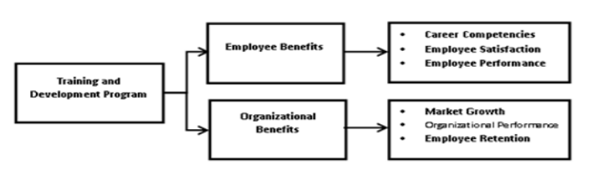
Figure: Benefit of HR Training and Development
(Source: Lau et al., 2019)

HR officers play a very important role in the organization, especially in workforce management. HR officers have multiple responsibilities that affect organizational growth and maintain economic sustainability. By providing effective training and development to the HR officers the organization can game prophets because and effective HR management is the pillar of a company (Lau et al., 2019). By providing training to HR officers, the organization can ensure quality management as well as increase organizational stability and sustainability in the market. It also helps to increase the productivity rate of the company that it holds the competition in the market. The training and development help to reduce risks and turnover problems of the company.

Slide 7- Conclusion
- Analyse the role of HR Professionals
- Analyse the responsibilities of HR Professionals
- Overview of the study
From the above discussion, it can be concluded that HR officers play a vital role in the organization and are responsible for multiple tasks in a company. HR officers are responsible for human resource management, quality management as well as maintaining economic sustainability in a company. The study has discussed the required knowledge, skills, and behaviour of HR professionals to ensure organizational growth. The study has also identified the necessity of training and development in evaluating HR responsibilities. The study has also shown that the training and development process is also beneficial for the organization to achieve its goals.

Slide 8- References
Chyhryn, O.Y., Karintseva, O.I., Kozlova, D.D. and Kovaleva, A.V., 2019. HR management in the digital age: the main trends assessment and stakeholders.
Villajos, E., Tordera, N., Peiro, J.M. and van Veldhoven, M., 2019. Refinement and validation of a comprehensive scale for measuring HR practices aimed at performance-enhancement and employee-support. European Management Journal, 37(3), pp.387-397.
O’riordan, J., 2017. The practice of human resource management. Research paper, 20.
Saeed, B.B., Afsar, B., Hafeez, S., Khan, I., Tahir, M. and Afridi, M.A., 2019. Promoting employee's proenvironmental behavior through green human resource management practices. Corporate Social Responsibility and Environmental Management, 26(2), pp.424-438.
Roberts, J., 2018. Future and changing roles of staff in distance education: a study to identify training and professional development needs. Distance Education, 39(1), pp.37-53.
Marr, B., 2018. Data-driven HR: how to use analytics and metrics to drive performance. Kogan Page Publishers.
Canedo, J.C., Graen, G., Grace, M. and Johnson, R.D., 2017. Navigating the new workplace: Technology, millennials, and accelerating HR innovation. AIS Transactions on Human-Computer Interaction, 9(3), pp.243-260.
Mishra, P., 2017. Green human resource management: A framework for sustainable organizational development in an emerging economy. International Journal of Organizational Analysis.
Lau, K.W., Lee, P.Y. and Chung, Y.Y., 2019. A collective organizational learning model for organizational development. Leadership & Organization Development Journal.
Pham, N.T., Tučková, Z. and Jabbour, C.J.C., 2019. Greening the hospitality industry: How do green human resource management practices influence organizational citizenship behavior in hotels? A mixed-methods study. Tourism Management, 72, pp.386-399.

Appendix

Personal Skills Audit

Name
Job role: Human Resource Officer

 | Very good | Good | Adequate | Little or no experience
Information Technology
Microsoft Office Word |  | √
Excel spreadsheet |  |  | √
a Database |  |  |  | √
specialist HR software
the internet | √
e-mail | √
PowerPoint |  | √

 | Very good | Good | Adequate | Little or no experience
Communication Skills
Drafting contracts of employment | √
Taking notes of disciplinary | √
Write reports |  | √
Produce material to support presentations |  | √
Delivering a training session | √
Resolving disputes/complaints |  | √
Interviewing |  | √
Advising on HR issues |  | √

 | Very good | Good | Adequate | Little or no experience
Problem solving skills
Make good use of verbal reasoning skills, able to handle complex data and make selective use of information |  | √
Explore more than one solution in order to solve a problem |  |  | √
Consider the ideas of others to help solve problems |  |  | √

Supervisory Management
How much experience have you had in your role? |  |  | < 1 month | 1-3 months | > 3 months
How many people have you managed at any one time? |  |  | None | 1-5 | Above 5

