Research Methods
Project Proposal
Investigation into User Experiences on Websites Using Eye Tracking Technology
by Paige Harris
MSc Applied Computing
Supervisor – Dr Nik Whitehead

Contents
1.0. Introduction 3
1.1. Background 3
1.2. Aim of Study 5
1.3. Expected Outcomes 5
2.0. Research and Development Methods 6
2.1. Research Methods 6
1.1.1. Philosophies 6
1.1.2. Approaches 6
1.1.3. Final Philosophy and Approach 6
2.2. Meetings with Supervisor 7
2.3. Strategies 7
2.3.1. Experiment - Eye Tracking 7
2.3.2. Questionnaire 7
2.3.3. Possible Questions 8
2.4. Analysing Data 8
2.5. Risks 10
2.5.1. Limitations 10
2.5.2. Legal and Ethical Issues 10
3.0. Resources and Planning 12
3.1. Resources 12
3.2. Planning 13
4.0. References 16

Figure 1- F shaped pattern [11] 4
Figure 2 - Glance Distribution [12] 4
Figure 3- Ogama Screenshot [6] 9
Figure 4- User in front of an eye tracker [7] 9
Figure 5 - Gantt Chart (image 1) 13
Figure 6- Gantt Chart (image 2) 14
Figure 7- Gantt Chart (image 3) 15

Introduction
The title of this project is ‘Investigation into Website User Experiences Using Eye Tracking Technology’. It will investigate the user’s experiences on websites, looking into how they use the websites and the main techniques which are used to attract users to certain areas of a website as well as the usability. To investigate this, the Eye Tribe tracker along with Ogama software will be used and the data collected will be examined using data mining techniques. The investigation will also be evaluating the users experience by having questionnaires and getting feedback from the user on how user friendly the website was.

Background
The World Wide Web was first created in the year 1989 and the very first webpage was launched live on the 6th of August 1991 and included information about the Word Wide Web. It included details on how people could create their own webpages and explained hypertext. The webpage was extremely simple and used links to access different areas of the website. A good web design now expects the website to be clean and user friendly, to do this the website must be;
- Simple
- Consistent
- Readable (typography)
- Mobile Compatible
- Suitable colour scheme
- Easy Loading
- Easy to Navigate
- Ability to communicate with the user
All these points can ultimately cover accessibility and usability in little depth. These are areas which will be looked further into during the literacy review.
Eye tracking technology was first introduced in 1908 by Edmund Huey. He “…built a device which could track eye movement during the reading process. This first eye tracker was very intrusive as readers had to wear a type of contact lens with a small opening for the pupil. The lens was attached to a pointer which changed its position following the movements of the eye.” [1]. Years later, in 1937, the first recording of eye movements were taken by and educational psychologist called Guy Thomas Buswell. The technology he used was “light beams which were reflected on reader’s eyes and recorded them on film.” [1] From conducting this research Buswell should that there “is a significant difference between oral and silent reading and that one person reads in two different ways at two different moments in times.” [1]. During the 1950s and 1960s, a Russian psychologist called, Alfred Lukyanovich Yarbus, conducted several studies based around eye tracking and fixations. An example of one of the studies conducted is “if the reader was asked several questions about the shown images, their eyes would focus on those parts which are relevant to the questions.” Then, during the 1970s and 1980s, research in eye tracking and eye movement was thriving, the technology was able to separate a person’s head movements to their eye movements to make eye tracking more accurate. In 1980s computers had developed enough so that they were able to complete eye tracking in real time, beginning the implement of using eye trackers during videos and human interaction with computers. By the end of the 1990s, eye tracking was beginning to be used for advertising and analysing how people observe internet content such as animated graphics, buttons and advertisements etc. From the 2000s to today eye tracking is being used for the following reasons;
- “As a means of communication for disabled people who can use only their eyes for input;
- In ophthalmology, for a better understanding of eye movements and for development of means to prevent, diagnose and treat abnormalities ["Ophthalmology is a branch of medicine dealing with the diagnosis, treatment and prevention of diseases of the eye and visual system” [2]];
- For testing usability of websites, software, computer games, mobile devices, etc.
- In explaining growth and transformation in perceptual, cognitive, and social abilities from infancy through young adulthood. ” [1]
It is being used for market research, helping business to understand the main elements of a website, packaging, items on a shelf, and advertisements on papers or billboards etc. which customer’s sees and what they don’t see. “…testing materials before launching is becoming an important part of marketing communication process of world’s leading companies.” [1] Eye tracking technology has become readily available, and can be as easy to access as downloading a piece of software, using a webcam and running it from a home or business computer.
Many different studies have been completed for eye tracking for websites already. By looking into previous studies, it makes it easier to identify the trends which are likely to occur and any new information which has not yet been identified. From researching a little into the previous studies, some findings are;
- F-shaped Pattern for Reading Web Content
- Eye Gaze Patterns while Searching vs Browsing a Website
- An Eye Tracking Study of How Font Size, Font Type, and Pictures Influence Online Reading
- Effects of Hyperlink Density on News Web Page Reading: An Eye tracking Study
- The Determinants of Web Page Viewing Behaviour: An Eye-Tracking Study
- Could I have the Menu Please? An Eye Tracking Study of Design Conventions
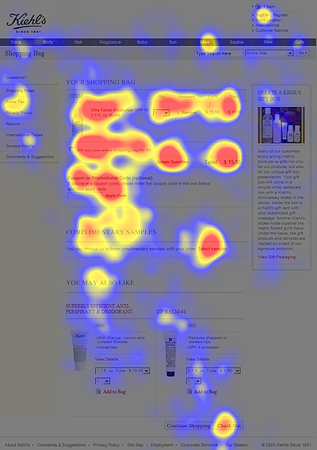
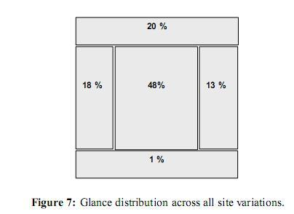
These studies were found to be interesting, some of which will be looked into in further depth during the Literature review.
Figure 1- F shaped pattern [11]
Figure 2 - Glance Distribution [12]

Aim of Study
The aim of this study is to identify any possible patterns in the ways people experience websites and how user friendly they feel the websites are.
  - To conduct a literature review on;
    - The technology which has previous been used and current technology which is used for eye tracking.
    - The standards which are being followed to ensure websites are user friendly.
  - Conduct a research test with multiple participants, tracking their eye movements during the use of several websites.
  - Conduct a questionnaire on usability for each participant and each website they use.
  - Record and analyse the results from the eye tracking software and questionnaires.
The above objectives have been created using the SMART guide to goal setting. SMART is an acronym used that help to create goals that are clear and achievable.
“
- Specific (simple, sensible, significant).
- Measurable (meaningful, motivating).
- Achievable (agreed, attainable).
- Relevant (reasonable, realistic and resourced, results-based).
- Time bound (time-based, time limited, time/cost limited, timely, time-sensitive).” [3]

Expected Outcomes
The research experiments will be taken by a number of participants and the characteristics of the group will be diverse. It is expected to find from the research that the majority of participants will identify different positives and negatives throughout each website when answering the questionnaires as some of the participants will have a background knowledge of computers and websites, where as some will not. Some of the users might have eye problems, therefore might need the website to be more accessible such as enlarging text and colour changes for those who are colour blind. Accessibility also requires the website to be readable by screen readers for those who are blind.
When conducting the eye tracking experiment the results for each participant will be different, however there will be patterns in what they identify first as well as the elements of the website they never looked at. This can be used to identify the way in which people read websites and whether or not they are reading the website in depth, looking at advertisements and using the website to the maximum potential ease.
From this experiment, it is wanted to prove whether a website is or is not user friendly by using the eye tracking technology as well as the questionnaires filled in by each participant.

Research and Development Methods
This section of the report will explain the research methods including the philosophies and approach which will be used in order to complete the project as well as the strategies which will be used to collect the data and the main techniques to analyse it.

Research Methods
The research method which will be used to complete this project will be Phenomenology. This research method involves collecting data to be analysed. The process is split into 3 stages, planning, collecting the data, and then implementation or analysis.
When planning the project, the research questions must be identified first, without knowing these then the correct ways for collect the data cannot be identified. Then the means of research must be designed, in this case using the eye tracking technology and the use of questionnaires.
The data then will get collected ready to be analysed and come to an overall conclusion from the research. The research purpose in this case is Exploratory research which means collecting preliminary data to identify problems or positives within a websites usability. Primary research will be done, collecting new data by using new participants and new websites which will be analysed using the questionnaires and eye tracking technology. It will be qualitative data from the eye tracking analysis as the review of the data will be done by someone other than the participant, therefore even though the data is true, it will be open to interpretation by the analyser. The hardware which will be used for the eye tracking experiment is the Eye Tribe eye tracker and the software which will interpret the data is Ogama.
The analysis of the data can be seen in Analysing Data.

Philosophies
The report will include both types of philosophies as there are two type of analysis which needs to be completed. It will include the use of Positivism and Phenomenology. Positivism will be used when conducting the eye tracking experiment, using a deductive approach. “As a philosophy, positivism adheres to the view that only “factual” knowledge gained through observation (the senses), including measurement, is trustworthy. In positivism studies the role of the researcher is limited to data collection and interpretation in an objective way. In these types of studies research findings are usually observable and quantifiable.” [4] Phenomenography will be used during the questionnaires using and Inductive approach. “Phenomenography is a qualitative research methodology… that investigates the qualitatively different ways in which people experience something or think about something.” [5]

Approaches
As mentioned in Philosophy, there will be two types of approaches used, Deductive and Inductive. Deductive will be used for the eye tracking experiment and Inductive will be used to gather data from the questionnaires.

Final Philosophy and Approach
After selecting the initial Philosophy and Approach, as only one can be named as the type of project, it will overall be a positivism philosophy with a deductive approach for the three strategies, experiment, Document Review and Survey.

Meetings with Supervisor
Meetings will take place with the project supervisor, who will be Dr Nik Whitehead. Meetings will be used to ensure that the project is kept on track and all the requirements are being met. The meetings will help to generate new ideas and help solve any problems.

Strategies
The strategies which will take place during this project in order to complete the study will be, firstly to complete the literature review to gain background knowledge on the subject. Then an experiment will take place where each participant will use a number of website and review them using a designated questionnaire along with an eye tracker being used to identify the main areas of a website the participant focuses on and doesn’t recognise.

Experiment - Eye Tracking
Eye tracking will be used to follow the participant’s eye movements when they are using a website. Websites will be chosen specifically for this project, some of the websites chosen will be websites with bad usability and others will have good usability and then these will be compared using the eye tracking software results. A total of 3 websites will be chosen, one to be the University of Wales Trinity Saint David, the remaining two are yet to be selected. The participant will be given a set of instructions to follow when using the websites, instructions could include;
- Access the Contact Details.
- Search for …
- Reduce the website to half screen.
- Navigate through to the … page
- Find delivery details
- Find Returns Details
- Zoom in 200%
- Go to Create an Account
Questions can then be asked based on the instructions how easy it was to complete each task.
The eye tracker which will be used is an Eye-tribe tracker, and the software which will be used is called Ogama.
“The main goals in designing OGAMA were the following:
- Recording and analysing of gaze and mouse movement data together
- Open source publishing to provide extensibility to the research community
- Implementation of state-of-the-art eye tracking analysis functions like replay, areas of interest (AOI) definition, attention maps in an up-to-date user module
- Visual-guided data mining through the use of different visual representations
- Database-driven software layout to handle highly sampled eye- and mouse tracking data” [6]

Questionnaire
Questionnaires will be created to show the positives and negatives which the test participants have identified when using the websites. Two questionnaires will be created overall, the first being a test questionnaire and the second will be in final questionnaire which will be used in conjunction with the eye tracking test.

Test Questionnaire
A test questionnaire will be created to see if the correct questions are being asked as well as the directions for the participant to follow on top of the questionnaire are easy to understand. This questionnaire will be tested when the user is using a website different from the ones which will be used for the final testing. It will be completed using only the website and not the eye tracking technology as it is only to test the questionnaire.

Final Questionnaire
The final questionnaire will be created to be completed for the final testing stage. It will be used when the participants are using the website and when using the eye tracking technology. The questions will be in line with the instructions used for the website.

Possible Questions
The questions below are some possible questions which will be asked to the participant after completing the tasks for the website are;
- Was the website working?
- Was the website slow at responding?
- Have you ever seen this website before?
- Did you complete all the tasks?
  - How did you find them?
  - Was it easy to find the contact details?
- Was the navigation easy to use?
- How was the colour scheme?
- Is the text easy to read?
- Were Product Descriptions easy to identify?
- Were Product images easy to see?
  - Could the images be made bigger?
  - Was there enough images?
- When you zoom in, did the website adapt?
- If you could change the website, what would you do?
The majority of questions will be closed questions, only allowing the participant to select yes, no or N/A to make the analysis easier. There will also be a section for any notes they would like to add.

Analysing Data
To be able to analyses the data and generate a conclusion, the eye tracking software will record the participant’s eye movements when on the screen, comparisons will be done for each participant to identify the patterns within the data. The software which will be used for this analysis is called Ogama, once the data has been collected, data mining techniques will be used to identify the patterns within the data. The questionnaire will also be used to identify patterns when using the websites, the data will be transferred into an excel file where it can then be analysed. The information collected from the questionnaires will be answers to closed questions.
The following image is a screenshot found online of the Ogama recording module. “The Recording module is designed to capture subjects’ gaze and/or mouse movements during the presentation of the experiments slideshow.” [6]

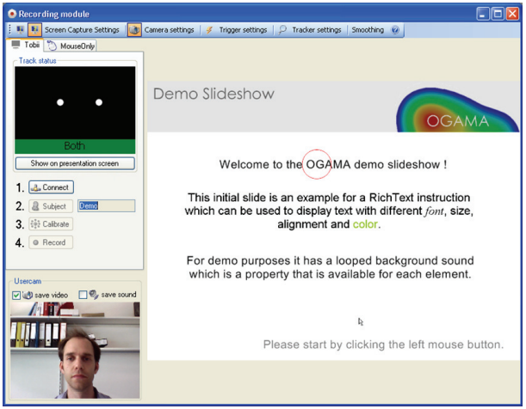
Figure 3- Ogama Screenshot [6]
A replay model is used after the experiment has been conducted to visualise the “Its intended use is to easily visualize and record single subject gaze and mouse tracking segments.” [6]
The fixation module is “designed to recalculate, store and display the gaze and mouse fixations made by the subjects” [6] meaning the fixations can be visually represented via five display modes including, dots, circles, spotlights, attention map (heat map), and only if they have been selected they will show.
These models will be used to identify the main fixations, gazes and mouse tracking when the participants are using the websites.
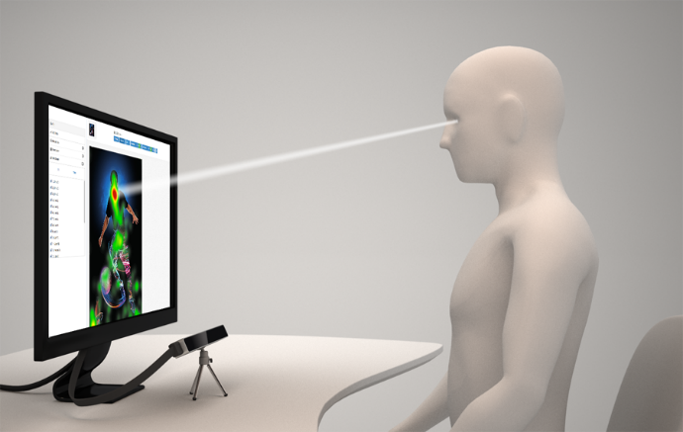
The eye tribe tracker is one of the commercial eye trackers that are supported by Ogama. “The Eye Tribe Tracker is an eye tracking system that can calculate the location where a person is looking by means of information extracted from person’s face and eyes. The eye gaze coordinates are calculated with respect to a screen the person is looking at, and are represented by a pair of (x, y) coordinates given on the screen coordinate system.” [7]
Figure 4- User in front of an eye tracker [7]

Once the data has fully been analysed a conclusion can be made based on the results found.

Risks
The main risks for this project will include any limitations which could prevent this project from completion, and the legal and ethical issues which can affect the data being collected. An ethics form has been completed in a separate document.

Limitations
Limitations within this project could potentially mean the project does not get completed within the designated timeframe or at all. There are several reasons why the project might not go to plan, these include;
- Poor time management
- No access to the hardware needed to complete the experiment (eye tracker)
- No access to the software needed to complete the experiment (Ogama)
- Unsure how to use the Ogama software
- Not finding enough or any participants
- Project scope is too large
- Not being able to access the university computers e.g. network failure, closed
- Not meeting the requirements of the study
This project must be well managed to ensure that it becomes completed on time and to the highest standard possible will all experiments completed and data analysed to a conclusion. The key components to good project management are;
- “Time – the intended duration of the work
- Cost – the budget allocated for the work
- Scope – what innovations or changes will be delivered by the project
- Quality – the standard of the outcome of the project.
Increasing or decreasing any one of these components will affect the others.
For example, reducing the time allocated to complete the project will also reduce the amount of work that can be done (scope), which may then affect the quality and the cost of the project.” [8]
If these limitations do cause any effect on the timescale, time will have to be taken from other tasks in order to keep the project on time for completion. The Gantt chart in Planning can be seen to finish the project by the 02/08/2019, this still gives time before the official deadline on the 31/08/2019, for anything that might need extra time to complete.

Legal and Ethical Issues
Legal and Ethical issues must be considered within this project as some data from the participants will be taken and they will need to fully understand what the data is going to be used for.
The Data Protection Act (2018) includes 6 principles which need to be considered, these are:
- “Used fairly, lawfully and transparently
- Used for specified, explicit purposes
- Used in a way that is adequate, relevant and limited to only what is necessary
- Accurate and, where necessary, kept up to date
- Kept for no longer than is necessary
- Handled in a way that ensures appropriate security, including protection against unlawful or unauthorised processing, access, loss, destruction or damage” [9]
This act gives people who have data stored on them, also known as data subjects, the right to view data which is being stored on them by the government or other organisations. The Data Protect Act (2018) also gives the data subject the right to;
- “Be informed about how your data is being used
- Access personal data
- Have incorrect data updated
- Have data erased
- Stop or restrict the processing of your data
- Data portability (allowing you to get and reuse your data for different services)
- Object to how your data is processed in certain circumstances” [9]
In this project, the participants must be aware of what the data which will be taken from them will be used for, in this case, a final year Dissertation. They should be informed that the data will be taken from questionnaires and an eye tracking experiment using websites before agreeing to participate with the experiment.
The data which will be taken from the participant is their age and gender, this will aid in analysing whether or not a certain age group finds it easier to use websites that another.
Potential participants will be fully informed, before providing consent, of what is involved in participating this research project. Participants will provide consent by signing the questionnaires that will be made electronic, as well as signing an electronic consent form for the eye tracker.
All participants of the project will be informed the project will be completed by end of September, if they want to see the results, the researcher can be contacted on their university e-mail address.

Resources and Planning
This section will explain the main resources which will be used to conduct the research and complete the project. It will also show the project plan which has been put together using Microsoft Project which, if followed, will allow the project to be completed on time.

Resources
The resources which will be used to complete the research and literature review are key in order to gain the most reliable information. Research papers and previous projects around similar topics will help to gain more knowledge and understanding of the eye tracking technology and the best ways it can be used to gain the most effective data, along with searching the standards for complete user friendliness in websites. This type of information can be found using the internet where websites can be access, Google Scholar, which will allow to access scholarly literature, the Library at UWTSD and using the Online Library can be used to access journals and books. In order to place the report together, access to Microsoft word will be needed as well as Microsoft PowerPoint to create the viva. When creating the questionnaires, Microsoft Word will be used and once ready they will be printed onto A4 paper. Microsoft Project will be used to create a Gantt chart which can be seen in Planning in this document. Eye tracking technology will be needed to conduct the testing of use of websites for each participant, this technology will be borrowed from UWTSD and tests will be conducted within the campus using the universities computers.
Resources, Concluded;
- Library and Online Library – To be used for research
- Computer– To be used for research and documentation
- Internet connection – To access resourced online
- Microsoft Word – To document the project
- Eye Tracking hardware - Eye Tribe
- Eye tracking software – Ogama
- Microsoft Word - to Create the questionnaires
- A4 Paper
- A2 Paper
- Printer – To print off the questionnaires
- Microsoft Project – To generate a Gantt chart showing the time of events.
- Questionnaire and Tests Participants
- Microsoft PowerPoint - to create and present viva’s

Planning
In order to allow for good time keeping within this project, Microsoft Project has been used to create a Gantt chart which will allow to plan ahead each task within the project and the time frame thought to be required for each stage. The Gantt chart shows the main task in bold and then the subtasks below. The duration is shown with a start and finish date for each task and subtask along with the predecessors which state which tasks need to be completed before the task can begin. From this project plan, it has been estimated the end date for the project is the 02/08/2019, however the deadline for the project is 31/08/2019.
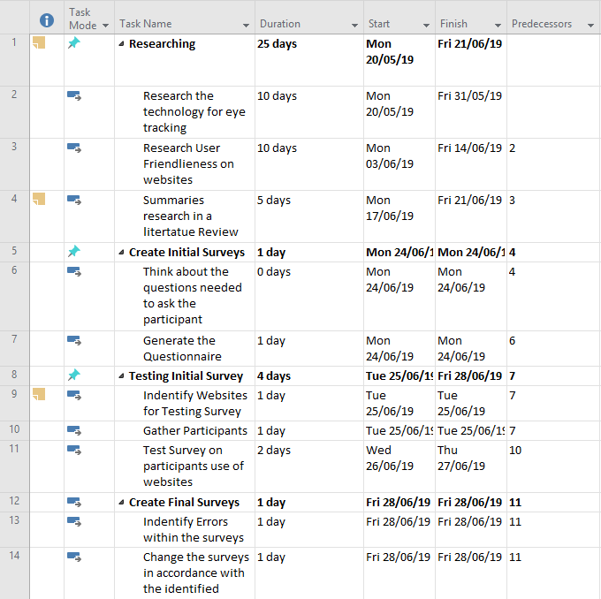
Figure 5 - Gantt Chart (image 1)

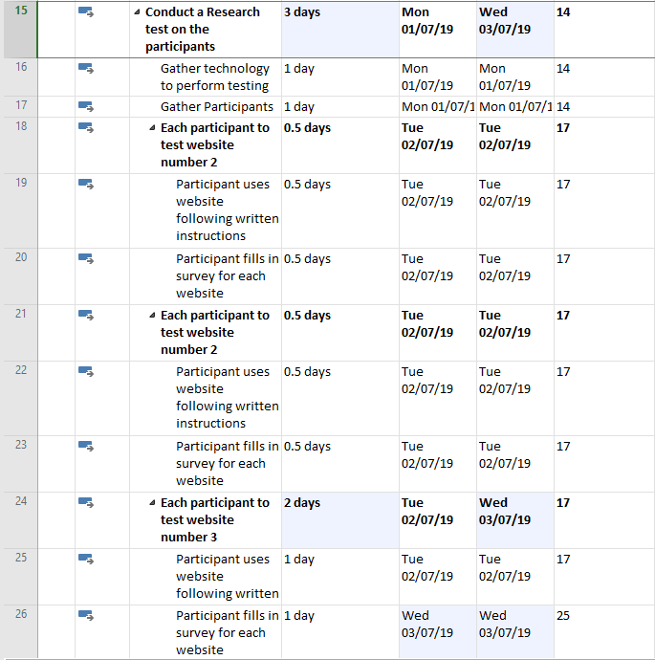
Figure 6- Gantt Chart (image 2)

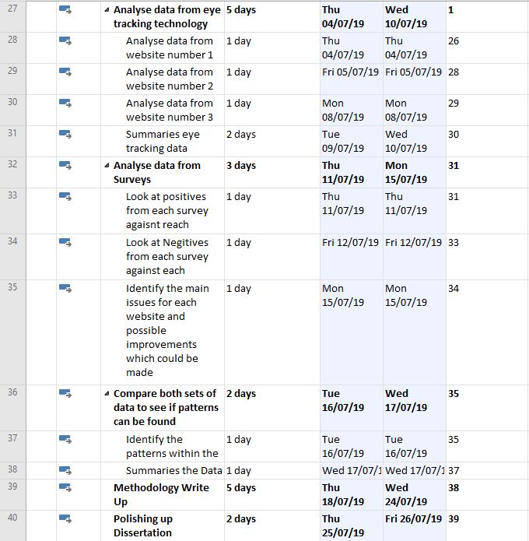
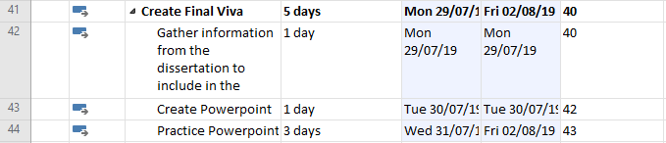
Figure 7- Gantt Chart (image 3)

References

[1] | “eye-tracking-history,” eyesee-research, [Online]. Available: http://eyesee-research.com/blog/eye-tracking-history/. [Accessed 20 03 2019].
[2] | “what-is-ophthalmology/,” rcophth, [Online]. Available: https://www.rcophth.ac.uk/about/what-is-ophthalmology/. [Accessed 02 05 2019].
[3] | “SMART Goals,” mindtools, [Online]. Available: https://www.mindtools.com/pages/article/smart-goals.htm.. [Accessed 04 05 2019].
[4] | “Positivism Research Philosophy,” Research Methodology, [Online]. Available: https://research-methodology.net/research-philosophy/positivism/. [Accessed 10 04 2019].
[5] | “Phenomenography - A research approach investigating different understandings of reality,” 1986.
[6] | A. Voßkühler, “ogama,” [Online]. Available: http://www.ogama.net/sites/default/files/pdf/OGAMA-DescriptionV25.pdf. [Accessed 08 05 2019].
[7] | “Eye Tracking 101,” theeyetribe, [Online]. Available: http://theeyetribe.com/dev.theeyetribe.com/dev.theeyetribe.com/general/index.html. [Accessed 08 05 2019].
[8] | “what-is-project-management,” axelos, [Online]. Available: https://www.axelos.com/best-practice-solutions/prince2/what-is-project-management. [Accessed 11 04 2019].
[9] | “data-protection,” gov, [Online]. Available: https://www.gov.uk/data-protection. [Accessed 11 04 2019].
[10] | “Smart Goals,” mindtools, [Online]. Available: https://www.mindtools.com/pages/article/smart-goals.htm. [Accessed 04 05 2017].
[11] | “the-f-pattern,” ericmay, [Online]. Available: http://ericmay.info/home/experience/online-news/the-f-pattern. [Accessed 08 05 2019].
[12] | “6 Eye Tracking Studies and What they say about Website Conversion Optimization,” VWO, [Online]. Available: https://vwo.com/blog/6-eye-tracking-studies-and-what-do-they-say-about-website-conversion-optimization/. [Accessed 08 05 2019].

