  Component One:  What are the key skills required when working in the housekeeping team? 750 words (+/- 10%)  Contribution to Overall Module Assessment: 25% | Student No: | 2207618
 | Module Title: | OPERATING HOTEL FACILITIES
 | Module Code: | BMIH4006
 | Lecturer: | Lola Villard  Chris Wilkin  Lisa Bassler Muhammad Cassamo  Lisa Knight
A person should have a diverse set of skills while working in a housekeeping team. Given below are some of the important skills needed to be successful in the housekeeping job.
Cleaning Techniques
Housekeepers are responsible for keeping a hotel clean, upkeep the décor, and maintaining cleanliness (Bhatnagar and Dheeraj, 2019). One should know that different cleaning techniques are needed for different surfaces and products. Housekeepers should also know a proper procedure for cleaning to ensure that the work is done in a short time without compromising cleanliness and hygiene. Apart from this, it is important to have knowledge about safety precautions and the utilization of products to ensure the safety of both the team members and the guests. It is important to have different skills while working as a housekeeper. It is important for the hotels to have a clean and hygienic environment. Not having properly cleaned rooms and other areas of the hotel can transmit various diseases and can also impact the reputation of the hotel.

Attention to Details
The cleaning crew needs members with strong attention to detail. Housekeepers need to be skilled in identifying filth, stains, and debris that could be simple to miss. They provide an inviting atmosphere by upholding high standards of cleanliness and hygiene. Addressing problems right away stops them from getting worse and guarantees a secure and enjoyable environment for residents or visitors. productive space organization also enables productive processes and a methodical approach to upholding cleanliness and order.
Time Management
To sustain productivity and fulfil deadlines, cleaning staff must have strong time management abilities. Housekeepers must be masters in task management, making sure that each duty is finished in the allowed time (bbc.co.uk, 2023). Prioritise places like common spaces or guest rooms that need rapid maintenance. Following set deadlines ensures seamless production and avoids delays. Additionally, housekeepers must make sure that every area is thoroughly cleaned, leaving no area unattended. Housekeeping staff can offer consistent, high-quality outcomes with effective time management, delivering a tidy and welcoming atmosphere for residents or visitors.
Communication Skills
Members of the housekeeping staff must possess effective communication skills in order to complete their responsibilities. To ensure efficient coordination and teamwork, housekeepers should participate in clear and succinct communication with the other members of their team to ensure the flow of information is proper (Tra, 2020). To satisfy requirements and uphold consistency in their job, they must comprehend and adhere to directions precisely. Quickly reporting maintenance problems or supply requirements aids in problem resolution effectively and ensures a productive workplace. Housekeepers should also engage with residents and visitors in a professional manner by being courteous, watchful, and respectful. Strong communication abilities improve cooperation, promote efficient operations, and make everyone's experience positive.

Physical Endurance and Stamina
Members of the housekeeping staff must possess physical stamina and endurance to fulfil the requirements of their positions. They must be able to handle physically taxing jobs like cleaning, carrying big things, and operating machinery. Housekeepers frequently spend long periods of time standing, bending, and lifting things, which calls for endurance and strength. To guarantee completeness and efficiency in their job, it is imperative that they retain their energy and attention throughout the shift. Additionally, because every site could have a distinct set of requirements and work settings, housekeepers must learn to adapt. Professional housekeepers need to be physically strong and resilient to provide dependable, high-quality services.
Problem-Solving Skills
Problem-solving skills are very important skills needed for being a part of housekeeping as there are various challenges that may arrive during the work (Espellita and Maravilla, 2019). These challenges can be related to regular duties like cleaning or can be related to guests. It is important to think critically and come up with a solution within very less time. A person should be able to analyse issues and resolve them creatively. There may be times when guests will have unexpected demands. The housekeeping team should be able to analyze the demand and act accordingly.

Teamwork and Collaboration
Teamwork and collaboration are necessary skills that are needed by housekeeping professionals. It is important to work collaboratively with the team in order to complete the work properly and on time. It fosters a sense of unity and shared responsibility. One should assist and support the other team members whenever the help is needed. Helping each other creates a positive work environment which enhances the morale and productivity of the team (Işık et al., 2021). Collaboration also ensures that the workflow is smooth, especially during the peak season.

Word Count | 753

References
bbc.co.uk, (2023) BBC [Online] Careers in hospitality Available at: https://www.bbc.co.uk/bitesize/guides/zb6njhv/revision/2 [Accessed on 08 June 2023.
Bhatnagar, E. and Dheeraj, N., (2019). Impact of housekeeping services and practices on customer satisfaction and repeat business. Prabandhan: Indian Journal of Management, 12(8), pp.46-57.
Espellita, S. and Maravilla Jr, V.S., (2019). Employable Skills for Hospitality Graduates as Perceived Among Hotel Supervisors in Cebu City. Journal of Economics and Business, 2(2).
Işık, C., Aydın, E., Dogru, T., Rehman, A., Alvarado, R., Ahmad, M. and Irfan, M., (2021). The nexus between team culture, innovative work behaviour and tacit knowledge sharing: Theory and evidence. Sustainability, 13(8), p.4333.
Tra, T., (2020). Action plan for training new Housekeeping Employee: case: Hotel Indigo Helsinki.

Component Two:
Contribution to Overall Module Assessment: 25%
In this scenario – You have just been promoted to the team leader for a floor within the hotel. A guest complains that on their arrival, their room had not been properly cleaned. Create an action plan and answer the following questions.

Problem | Why did it happen? | What are you going to do? | How will you prevent this from happening in the future? | What measures would you introduce to improve team effectiveness?
When the guest arrived in their hotel room, they found that the room was not cleaned properly. Various problems in management can be analyzed due to this complaint. | The housekeeping team is not working properly and there is no one to monitor them can be one reason. In absence of | First and foremost, I am going to apologize to the guest for the inconvenience caused. I will communicate will the guest and take down notes of all the complaints made. I will assure them that the feedback is taken seriously (Zinko et al., 2021). | Clear communication is needed to prevent such incidences in the future. A communication system can be established between all the teams to ensure that real-time information is delivered. Regular staff meetings and briefings are also needed to address the potential issues. | Clear roles and responsibilities will be allocated to each team member. As specific tasks will be allotted to the team members, they can work hard and improve their skills in that particular task. This will reduce confusion, and team members will be will know their designated tasks. Everyone will understand their tasks and expectations. It will improve accountability and enhance efficiency. Proper communication channels will be developed to ensure that all the details are provided to the staff members and vice-versa.
 | There can be miscommunication between the housekeeping team and the front desk due to which the guest’s arrival time or specific requirements must have been missed. | An investigation will be conducted to check the severity of the issue. I will personally assist the guest to check the issues. | A training program can be developed for the housekeeping team. The program will cover cleaning techniques, attention to detail, following hotel standards, and time management skills. It will improve staff skills and organizational performance (Hussain et al., 2023). | Team-building activities will be conducted for better communication, collaboration, and the creation of better bonds. Team outings, skill-building workshops, game activities, and lunches will be done to increase interaction and build strong working relationships. It will ensure that the members help each other whenever needed.
 | Improper training can be another reason why proper cleaning procedures were not followed. | The housekeeping team will be immediately called to discuss the situation and gather information regarding the cleaning issue. | Standard Operating Procedures should be followed for cleaning rooms and their inspections. The SOP will help to develop standards and quality control measures. SOP will have regular updates and reviews to ensure its effectiveness | A track of the tasks, good and bad reviews will be kept. Constructive feedback on performance will be given every month. Based on the feedback, training will be provided to improve the skills.
 | The high workload can be a reason leading to improper cleaning. Due to the high workload, housekeepers tend to miss details while cleaning. | A thorough cleaning will be done to meet the expectations of the guest. Compensation or alternative solutions will be provided to the guest if necessary. | Quality control checks will be conducted after the housekeeping procedure for enhancing guest satisfaction (Yasa, 2019). Supervisors or team leaders will check whether the cleaning standards are followed properly or not. | A rewards and recognition program will be implemented to appreciate the hard work of the staff. It will include bonuses, gift vouchers, and other form of incentives. This will motivate the team members leading to enhanced work performance (Lee and Rhee, 2023).
 | Human error is one of the common reasons for not following proper cleaning procedures. | A follow-up will be taken to ensure the guest is satisfied with the services and ask for any issue that needs to be resolved. | Feedback and reviews from the guests will be taken. The guest reviews will be useful to improve the cleaning standards and avoid such consequences in the future | Team members will be encouraged to provide feedback, suggestions, ideas, and innovations (Hayat Bhatti et al., 2020). These suggestions will be utilized to improve the quality of the work.
 |  |  |  | It is important that the staff members take full responsibility for their actions hence autonomy will be encouraged. Necessary resources and authority will be given to the staff members so that they will be able to take necessary actions even if the higher authorities will not be around to instruct them.

References
Hayat Bhatti, M., Akram, U., Hasnat Bhatti, M., Rasool, H. and Su, X., (2020). Unraveling the effects of ethical leadership on knowledge sharing: the mediating roles of subjective well-being and social media in the hotel industry. Sustainability, 12(20), p.8333.
Hussain, A., Khan, M., Rakhmonov, D.A., Mamadiyarov, Z.T., Kurbonbekova, M.T. and Mahmudova, M.Q.K., (2023). Nexus of Training and Development, Organizational Learning Capability, and Organizational Performance in the Service Sector. Sustainability, 15(4), p.3246.
Lee, H.W. and Rhee, D.Y., (2023). Effects of Organizational Justice on Employee Satisfaction: Integrating the Exchange and the Value-Based Perspectives. Sustainability, 15(7), p.5993.
Yasa, I.K., (2019). The Implementation of Total Quality Management (TQM) in Housekeeping Department of W Bali-Seminyak. International Research Journal of Management, IT and Social Sciences, 6(2), pp.22-30.
Zinko, R., Patrick, A., Furner, C.P., Gaines, S., Kim, M.D., Negri, M., Orellana, E., Torres, S. and Villarreal, C., (2021). Responding to negative electronic word of mouth to improve purchase intention. Journal of Theoretical and Applied Electronic Commerce Research, 16(6), pp.1945-1959.

Component Three:
Contribution to Overall Module Assessment: 50%
Your task is to create and prepare a presentation following the detailed scenario provided below.

As the floor housekeeping manager and given the recent guest complaints you need to put together a basic training presentation for your colleagues within the housekeeping team to get the best out of them, ensure that brand standard is being achieved, and that Health and Safety procedures are also being followed.

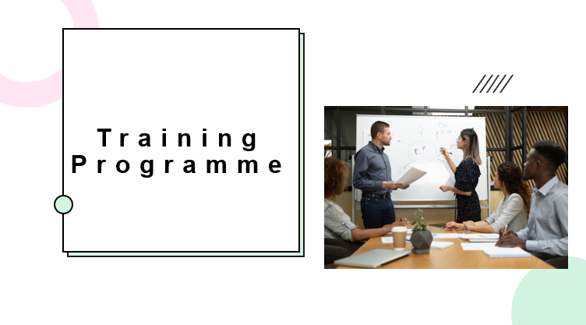

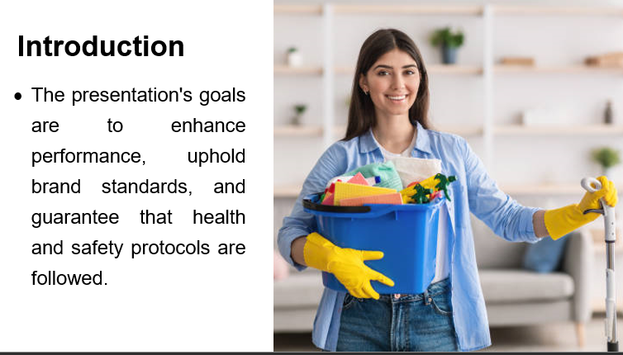
Training Notes: Emphasis on the value of adhering to brand standards and health and safety protocols in this presentation will be discussed. How these components impact our general achievement and customer happiness at the finish of this presentation will be achieved. Pay close attention to the examples and recommended practices that will be given. With this information, the staff will be able to carry out their responsibilities successfully and make the visitors feel secure and welcome.

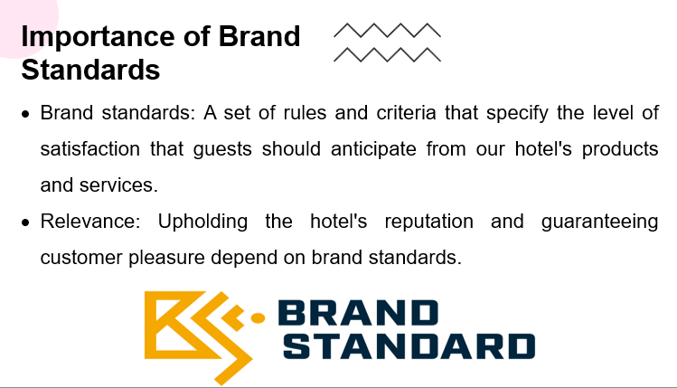
Training Notes: The performance of the hotel is measured against brand criteria, which also influence the total visitor experience. They guarantee uniformity in all areas, including interactions, facilities, cleanliness, and service. The staff will build a reputation, gain the trust of customers, and encourage loyalty by adhering to and surpassing brand standards. The exact brand criteria that relate to the hotel will be covered in detail throughout this session, along with their significance in providing outstanding guest experiences.

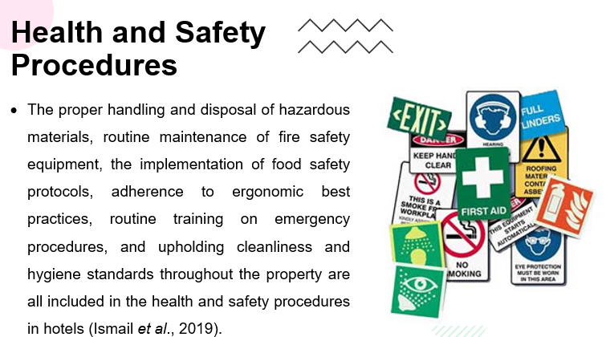
Training Notes: For a workplace to be safe for both employees and visitors, health and safety standards must be implemented. Consistently following these practices has a direct impact on employee engagement and work satisfaction in addition to fostering a sense of security. Employees may actively contribute to maintaining a safe workplace and establishing a healthy work environment by being aware of and following these measures. Participants will learn about particular Health and Safety practices, their significance, and how they affect employee engagement and well-being during the program.

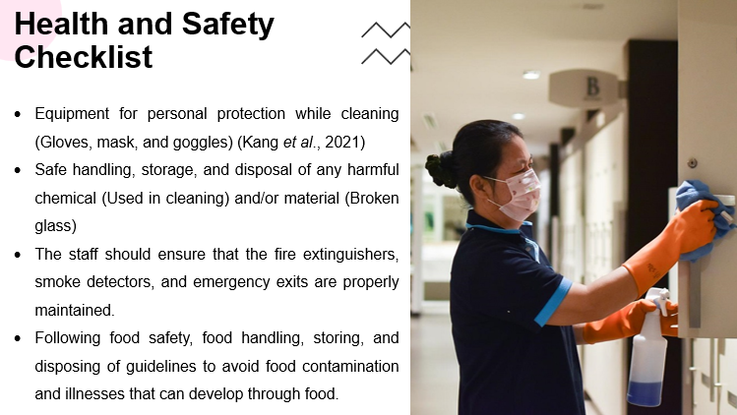
Training Notes: We can guarantee a secure working environment by adhering to these protocols. Participants should be familiar with the required Health and Safety procedures and appreciate their significance in keeping a secure workplace by the end of this program.
Assessment: A quiz at the conclusion of the training session will be used to gauge how well participants understood the checklist by asking them to name the necessary steps and show that they were aware of how to carry them out. This will assist to confirm their comprehension and guarantee adherence to the rules for health and safety.
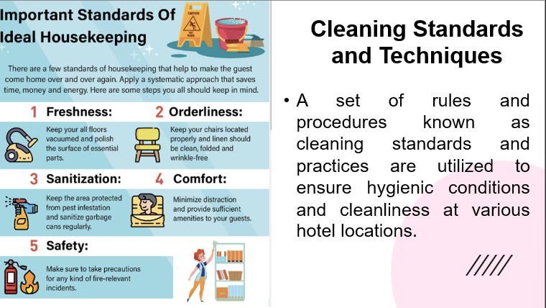
It has extensive instructions for cleaning a variety of areas, such as guest rooms, common areas, and kitchens. In order to create an immaculate and welcoming atmosphere, cleaning standards include things like paying attention to detail, using the correct cleaning chemicals and disinfection processes, and successfully removing dirt and stains. Maintaining a great visitor experience, stopping the spread of germs and diseases, and upholding the hotel's reputation for cleanliness and hygiene all depend on observing these rules.

Training Notes: To maintain a high level of cleanliness and customer happiness, this presentation emphasizes the significance of cleaning standards and procedures. Participants will gain knowledge about appropriate cleaning methods for various spaces, efficient cleaning product usage, and meticulousness.

Learning Objectives: Participants should be able to utilize correct cleaning methods in their everyday duties and comprehend the importance of cleanliness by the end of this program.

Assessment: Through practical demonstrations where they show proper cleaning techniques, the use of suitable cleaning chemicals, and attention to detail in maintaining cleanliness standards, participants' comprehension will be evaluated.

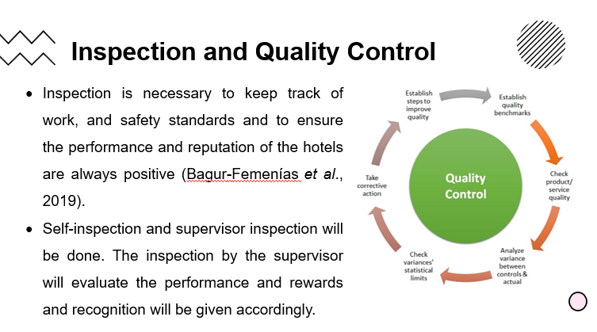
Training Notes: There are two different kinds of inspections throughout the process: supervisor inspections and self-inspections. Employees evaluate their own work as part of self-inspections to make sure it meets quality standards and pinpoint areas for improvement. Managers, on the other hand, carry out supervisor inspections to examine and rate the work done by employees. Inspections are conducted to maintain quality control, spot any deviations from brand requirements, and implement corrective measures as needed. Participants will be better able to evaluate their own performance, get feedback from superiors, and contribute to the hotel's overall quality and brand compliance by comprehending the inspection process.
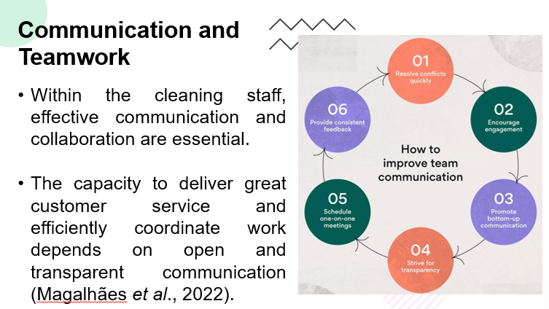
It encourages a cooperative atmosphere where team members may exchange information, ask for help when necessary, and cooperate to achieve shared objectives. Participants will get an understanding of how communication leads to a seamless operation, improved problem-solving skills, and ultimately a pleasant visitor experience by emphasizing its importance (Kipkosgei et al., 2020). To build a strong and effective team dynamic, promote active engagement as well as open communication, careful listening, and support of one another (Meng and Berger, 2019).

Training Notes: Promoting open and direct lines of communication, encouraging active listening, creating a positive team atmosphere, and offering chances for collaboration and criticism are all ways to improve communication and cooperation.

Learning Objective: Participants should leave this program knowing the value of cooperation and communication in attaining operational success and guest happiness. They should be able to participate fully in team activities, exhibit strong communication skills, and add to a supportive environment.

Evaluation: Group activities, role-playing situations, and feedback assessments from peers and supervisors can all be used to gauge how well participants comprehend and use good communication and collaboration.
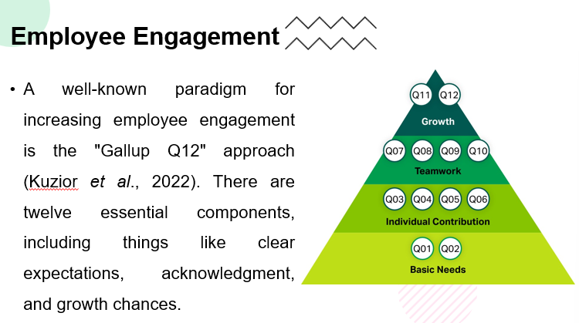
The Park Lane Four Seasons Hotel in London (fourseasons.com, 2023) by putting into practice initiatives like frequent performance feedback, customized recognition programs, and professional development possibilities, this hotel is an excellent example of the Q12 aspects. The Four Seasons Hotel's performance serves as an example of the value of staff involvement in accomplishing organizational objectives and providing outstanding customer service. It is possible to find applications for the Q12 model within the team by comprehending this best practice.

Training Notes: The Q12 concept for employee engagement is put into practice through a variety of procedures (Kuzior et al., 2022). Clear performance expectations are one of these, as are frequent feedback and acknowledgement, the facilitation of growth opportunities, the promotion of constructive team dynamics, and the instillation of a sense of purpose. Understanding the importance of each Q12 component and coming up with workable solutions to incorporate them into the team are the participants’ learning objectives. Group discussions that allow participants to express their perspectives and action plans for putting the Q12 aspects into practice can be used to perform assessments. Additionally, advances in employee engagement brought about by the use of the Q12 model may be evaluated via individual performance reviews.
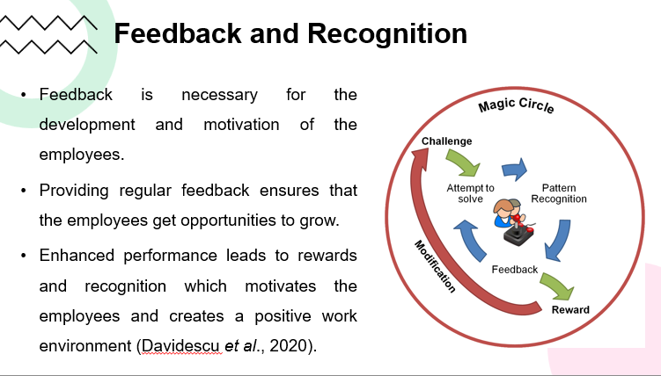
Training Notes: There are various steps involved in putting reward and recognition practices into practice. Establishing a systematic recognition program that includes both informal and formal acknowledgement techniques is advised. These can include verbal expressions of gratitude as well as material prizes like certificates or gift cards. Building a peer-recognition culture helps create a positive work environment. Recognizing the importance of routine incentives and recognition and comprehending their effect on employee motivation and job satisfaction (Pham Thi Phoung and Ahn, 2021) are among the learning objectives for participants. The capacity to recognize and use efficient reward and recognition systems in their various jobs should also be demonstrated by the participants. A post-training survey can be used to gauge participants' comprehension of the material and their familiarity with reward and recognition procedures.
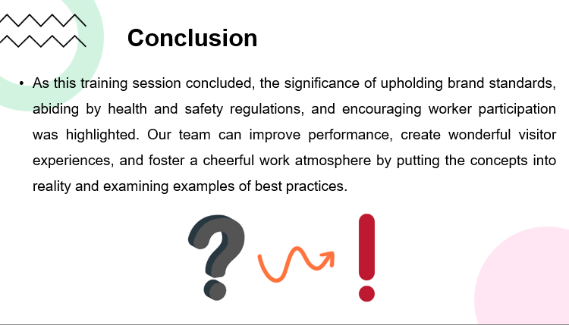
Training Notes:

What will be done during the presentation?
I'll begin by sincerely thanking everyone for arriving and introducing myself as the floor housekeeping manager in order to conduct this presentation efficiently. I will be very clear about the presentation's aim and emphasize how we want to raise performance, uphold brand values, and make sure that health and safety regulations are followed. I'll give a general description of the presentation's layout, including the number of slides and the anticipated length. I will use simple language and visual aids to convey each slide during the talk in order to increase comprehension and participation. By asking questions, offering time for thinking, and fostering dialogues, I will actively promote involvement. In order to show practical applications and highlight the key learnings, I will use examples from real life. I'll summarise the main ideas discussed in the presentation's conclusion and emphasize how crucial it is to apply the training to our regular job. By responding to inquiries and issues, as well as making sure the team feels encouraged and inspired to put the information acquired to use, I will foster a pleasant learning environment.

References
Bagur-Femenías, L., Perramon, J. and Oliveras-Villanueva, M., (2019). Effects of service quality policies in the tourism sector performance: An empirical analysis of Spanish hotels and restaurants. Sustainability, 11(3), p.872.
Davidescu, A.A., Apostu, S.A., Paul, A. and Casuneanu, I., (2020). Work flexibility, job satisfaction, and job performance among Romanian employees—Implications for sustainable human resource management. Sustainability, 12(15), p.6086.
Fourseasons.com, (2023), Four Season [Online] Location Available at: https://www.fourseasons.com/london/getting-here/?_s_icmp=ja_lon_hero_no_state_found [Accessed on 12 June 2023].
Ismail, S., Samsudin, S.Z. and Pusiran, A.K., (2019). Influence of occupational safety and health training toward staff practices at fast food restaurant in Malaysia. Indian Journal of Public Health Research and Development, 10(6), pp.1285-1289.
Kang, S.E., Park, C., Lee, C.K. and Lee, S., (2021). The stress-induced impact of COVID-19 on tourism and hospitality workers. Sustainability, 13(3), p.1327.
Kipkosgei, F., Kang, S.W. and Choi, S.B., (2020). A team-level study of the relationship between knowledge sharing and trust in Kenya: Moderating role of collaborative technology. Sustainability, 12(4), p.1615.
Kuzior, A., Kettler, K. and Rąb, Ł., (2022). Great Resignation—Ethical, Cultural, Relational, and Personal Dimensions of Generation Y and Z Employees’ Engagement. Sustainability, 14(11), p.6764.
Magalhães, C., Araújo, A. and Andrés-Marques, M.I., (2022). How Do Hospitality Workers Perceive Their Work Skills before and after the Lockdown Imposed by the COVID-19 Pandemic?. Social Sciences, 11(12), p.588.
Meng, J. and Berger, B.K., (2019). The impact of organizational culture and leadership performance on PR professionals’ job satisfaction: Testing the joint mediating effects of engagement and trust. Public Relations Review, 45, pp.64-75.
Pham Thi Phuong, L. and Ahn, Y.J., (2021). Service climate and empowerment for customer service quality among Vietnamese employees at restaurants. Sustainability, 13(3), p.1172.

