Decisions in Python

Sometimes we want to make a decision in a program, and go one way or the other (or several different ways!)

For example:

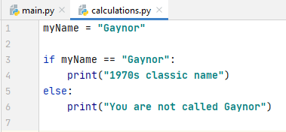

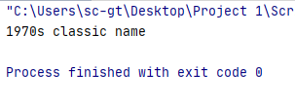

As you can see, Python ran the if part of the statement

Let's change myName to "Bob":

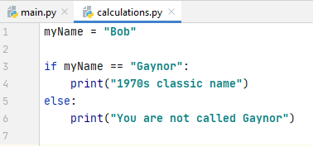

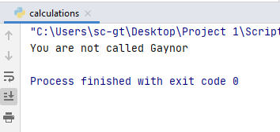

This time the program ran the else part of the statement (ie myName was not Gaynor)

The syntax in Python is important. Python does not use { } separate if and else statements, as many other languages do. Instead, it uses a colon : on the end of the if/else statements and the contents are tabbed in:

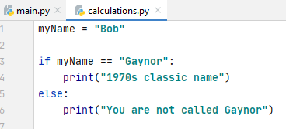

The tab is important. You should use it no matter how many lines of code you have in your if statement.

For example:

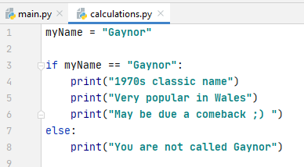

Once you have broken with the tabbing, the normal flow of the program resumes

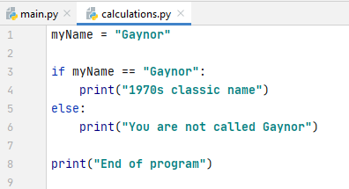
Back to normal flow of program (if/else finished)

As your programs become more complex, it is very easy to miss a tab. This is a very common error when programming in Python – keep an eye on your tabs

Operators
We have already seen the "equal to" operator ==

Other operators are:

== equal to
> greater than
>= greater than or equal to
< less than
<= less than or equal to

Some examples of greater than:

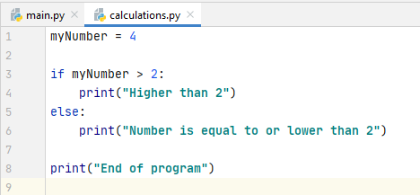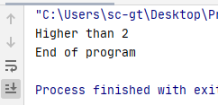

Note: myNumber will trigger the if statement if it is higher than 2, ie 3 or more. To include 2 itself, use >=

You can even use operators with strings, for example:



