New Build Dwelling:
Technical Report with Drawings
ACBA4001

Prepared for:

G. Traylor

Created by:

J. Langstone

Date Completed:

January 22nd, 2021

Table of Contents
Contents
1.0 Executive Summary 3
2.0 Terms of Reference 3
3.0 Procedure 3
4.0 Introduction 3
5.0 Ground Floor Detailed Section 6
6.0 First Floor detailed Section 8
7.0 Eaves Section Detail 10

Figure 1 SIPS Panel diagram (Kingspan, 2020) 5
Figure 2 CLT diagram (Federation, 2016) 5
Figure 3 Ground floor Detailed Section 6
Figure 4 First Floor Detailed Section 8

1.0 Executive Summary

To prepare a technical report for a client that will address the timber frame construction details required, as the client is unfamiliar with Timber frame construction. The Technical Report will be graphical and contain the relevant information to support the chosen frame of construction for the client’s proposed house extension.

2.0 Terms of Reference

2.1.1 To show neatly drawn, proportionate and suitably annotated sections and sketches of the proposed house structure.
2.1.2 To inform the client of the advantages, disadvantages, and associated building regulations of the timber frame construction.
2.2 To show the Technical Report was constrained by the information given and researched and the need to complete it by 22nd January 2021.

3.0 Procedure

This section identifies the research sources used.
3.1 The research included secondary sources on the and climate from websites and textbooks set out in the references and bibliography.

4.0 Introduction

Timber Frame construction is a proven modern construction method, it is not a system of building.
Here is a quote is taken from the TRADA website that simply describes what forms Timber frame construction:
“Timber frame construction uses timber studs and rails, together with a structural sheathing board, to form a structural frame that transmits all vertical and horizontal loads to the foundations.”
(TRADA, 2020)
What is Timber?
Trees naturally absorb Carbon which is stored when the wood is transformed into timber for construction. The timber naturally absorbs more carbon than It can emit. It is stored when used construction material. When the timber is removed from the building, the Timber can then be used as fuel or naturally be absorbed into the earth, where it came from. This allows timber frame construction to be a sustainable way of building structures.
Types of Timber Frame Construction
The majority of today’s Timber Frame construction is produced through a modern method of Construction (MMC), which consists of prefabricated timber panels and floors. These timber panels are typically made up of a mixture of different materials such as:
- Structural Timber.
- Plasterboard.
- Polyethylene Vapour control layer.
- Breather membrane.
- 50mm clear cavity.
- External Cladding (e.g., Brick or siding).
- Wall ties.
- Additional added insulation where applicable.
All these material components come together to make the typical timber frame envelope of a domestic building.
Benefits
Timber frame has many benefits over other conventional techniques of building. Here are some examples of the general benefits for a client choosing Timber frame for their building asset:
- Offsite Construction
- Ease of project plan
- Reduced site storage for materials
- Use of sustainable building materials.
- A high score for a BREEAM rating
- Reduced project waste
- Fast erection speed
- Higher thermal performance

Currently, Timber frame construction consists of high levels of insulation within its make-up. In short, modern Insulation allows walls to be built with smaller widths, thus allowing more space inside the building. Older buildings would require much thicker walls, which could hold more warmth and keep out moisture.
There are different two forms of Timber frame construction methods which are older and not as popular as the MMC alternative in the UK. These two methods are ‘balloon Framing’ and ‘Platform framing’. Both are dated and do not hold as many benefits as the Modern method of construction.
Although the most common timber frame method to be found in the UK is platform framing, the MMC is newly developed in recent years and is more popular.
Here are two Commonly known timber Frame construction methods explained:
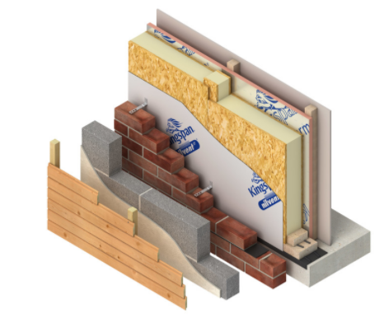
SIPS
Structurally insulated panels can be up to 7.5m long and can provide a vast continuous layer of insulation. They are bonded on to OSB on each side of an insulating centre. SIPs can be used as a structural load-bearing element. Here is an example of a Sips panel taken from Kingspan timber solutions:
Figure 1 SIPS Panel diagram (Kingspan, 2020)

CLT
Cross-laminated Timber is a grouping of different layers of lamella (pine or Spruce) which are glued tightly together which correspond to the previous layer with a right angle in alternate directions. They tend to be cut and manufactured off-site in a factory.
Here is an example showing CLT timber material:
Figure 2 CLT diagram (Federation, 2016)
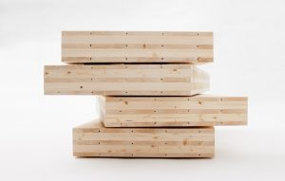

Acoustics
Timber frame famously has good acoustic values compared to traditionally built domestic dwellings. Sound finds it harder to travel through the densely packed timber, insulation, plasterboard and cladding materials because they are fitted so tightly together. A quote from TRADA states how insulation helps to stop high-frequency sounds from travelling through an envelope wall:
“Within Timber frame, these are partially stopped with the insulation in the wall, which not only acts to avoid heat loss but absorbs higher frequency sound that resonates within the cavity by turning the sound energy into heat energy.”
(TRADA, 2020)

5.0 Ground Floor Detailed Section
Figure 3 Ground floor Detailed Section
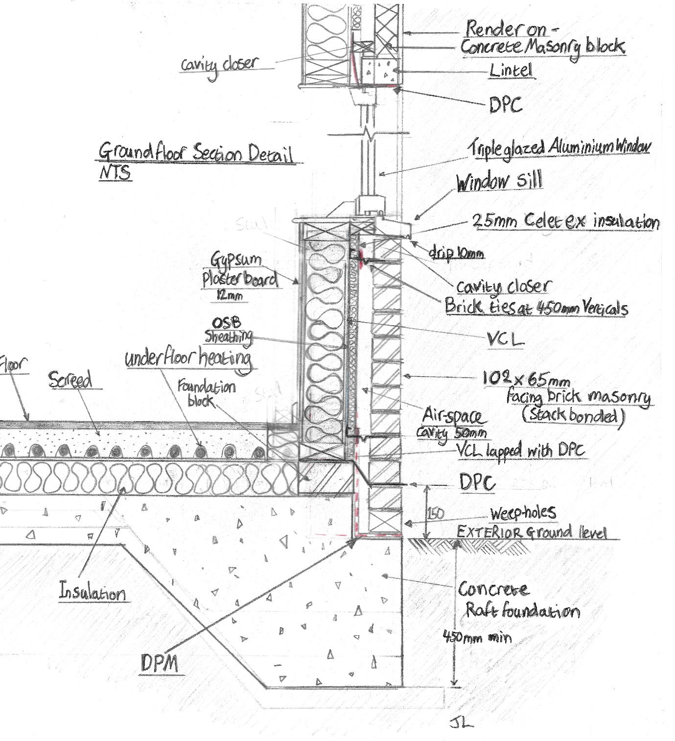
Figure 3 of the Ground floor shows that the wall envelope consists of:
- Brickwork (102mm).
- 50mm Air Cavity.
- Celotex 25mm TB4000 PIR Insulation Board.
- Breather membrane.
- Timber studs.
- 140mm Mineral insulation.
- Vapour control layer
- 12.5mm gypsum plasterboard
Giving us a calculated U-Value = 0.20 for the wall construction on the ground floor.
Ground floor:
1.Raft foundation concrete
2. 100mm PIR insulation
3. 100mm screed with underfloor heating installed.
4. 20mm Tile floor
U-Value = 0.18
As you can see in the diagram above, there is a SIPS panel used for the timber frame construction, and It has an external face of masonry brick cladding with an additional 25mm of PIR Celotex insulation in the cavity.
Masonry Brick cladding
The cavity is bridged with ‘Slotted Frame Cramps with Drips’. With the risk of thermal bridging, these brick ties are appropriate for stopping any thermal bridges from occurring. The brick ties are required by the building regulations of approved document part A (Government, Approved Document A, 2017) to be fixed into the studs of the SIP panels at 600mm, meaning the vertical centres must be designated at 376mm at a maximum. This will allow the brickwork to be supported by the frame and structurally sound.
Here is a quote from Riley and Cotgrave explaining an advantage of brick masonry cladding on timber frame construction:
“It protects the inner frame from the elements and prevents moisture from entering the building by the creation of a capillary break, in the form of a drained cavity.”
(Cotgrave, 2018)
Ground level and DPC
The ground level is at a required minimum height from the bottom of the wall (450 minimum) and the DPC (150mm up) is found at the appropriate height to the ground, as is stated by the building regulations Approved documents, part C (Government, 2017)
Cavity
The cavity must be 50mm in residual width, which is the minimum distance required under Part C of the building regulations approved documents (Government, 2017).
The ground floor is constructed on a concrete Raft foundation which is for this building as it sits on a greenfield site.
Greenfield land
The greenfield site that the domestic dwelling sits on land that has not been previously developed but has been used as agricultural land. The chosen Raft foundation is a good match for this type of ground as the raft allows for movement and the 2-storey domestic building will not have an extremely heavy overall weight bearing down on the raft foundation.

VCL
Vapour control layer. This is a membrane material which has the purpose of substantially reducing the transfer of water vapour through any building In which it is incorporated.
A VCL should be fixed at 250mm centres to the top and bottom of a timber frame and at any laps in the envelope of the building. There should never be any holes in the VCL.
Raft Foundation
Raft foundations are quite frequently used in conjunction with Timber frame domestic dwellings. A quote by Riley and Cotgrave very briefly explains one reason why a raft can be used for this type of building: “Timber frame construction is lighter than traditional masonry construction” (Cotgrave, 2018).

6.0 First Floor detailed Section

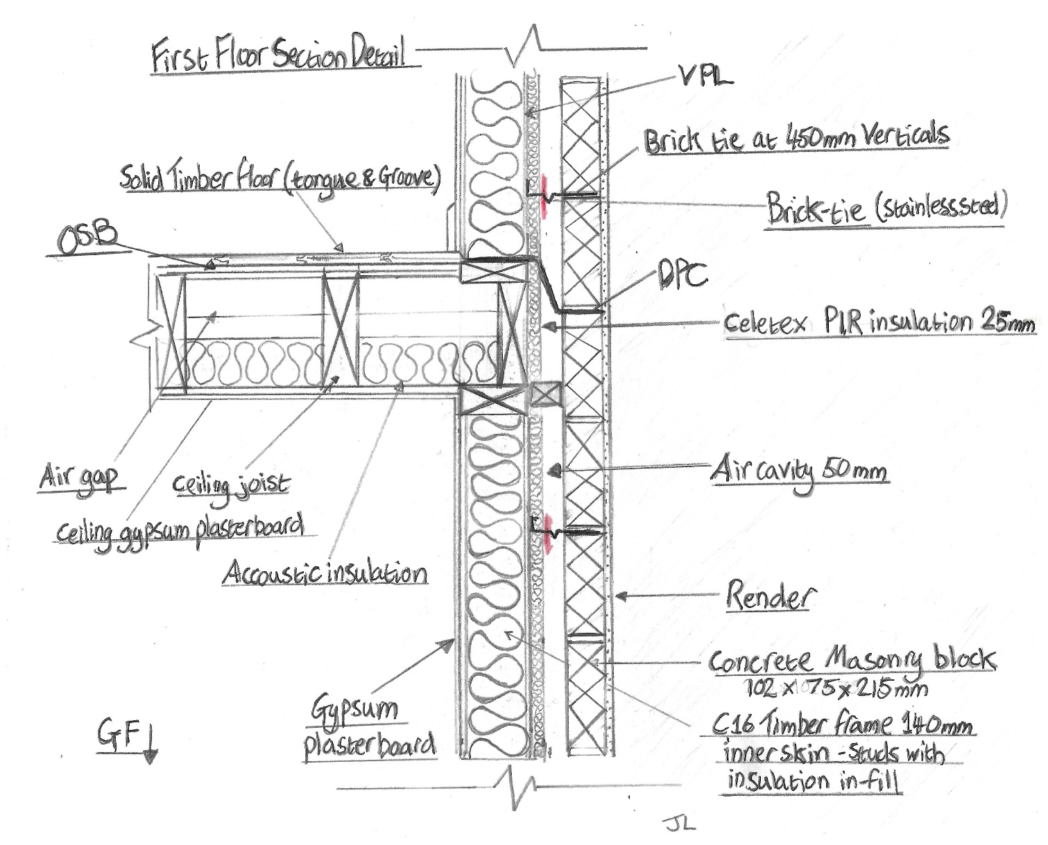
Figure 4 First Floor Detailed Section

Figure 4 of the First-Floor wall construction shows that the wall envelope consists of:
- 15mm sand and cement Render - Ivory
- Concrete masonry block
- 50mm Air cavity
- Celotex 25mm TB4000 PIR Insulation Board
- Breather membrane.
- Timber studs.
- 140mm Mineral insulation.
- Vapour control layer
- 12.5mm gypsum plasterboard
This gives a calculated U-Value = 0.19 for the wall construction on the First floor.

Noggins
Noggins are put into the timber frame panels to help straighten out wall studs and the floor joists. They are also there to give a strong fixing for additional utilities that maybe later fixed to the inside.
The first-floor junctions
The first floor is built into the external wall envelope, which then transfers loads to the Ground. The appropriate methods of over-lapping materials in the panels mustn't disturb the cavity as this may inflict thermal bridging.
Upper floors are covered with oriented strand board and provide an interim working platform for construction of the upper sections of the dwelling.
As you can see another Damp proof course (DPC) is added to prevent any damp coming through the first floor.

Floor joists
Floor joists must be installed at a maximum distance of 600mm. Joists must also have a clear gap of 25-75mm between the first joist and the wall face to aid the installation of services and the fixing of floor decking. This is following the part A of the approved documents under the building regulations (Government, Approved Document A, 2017).

7.0 Eaves Section Detail
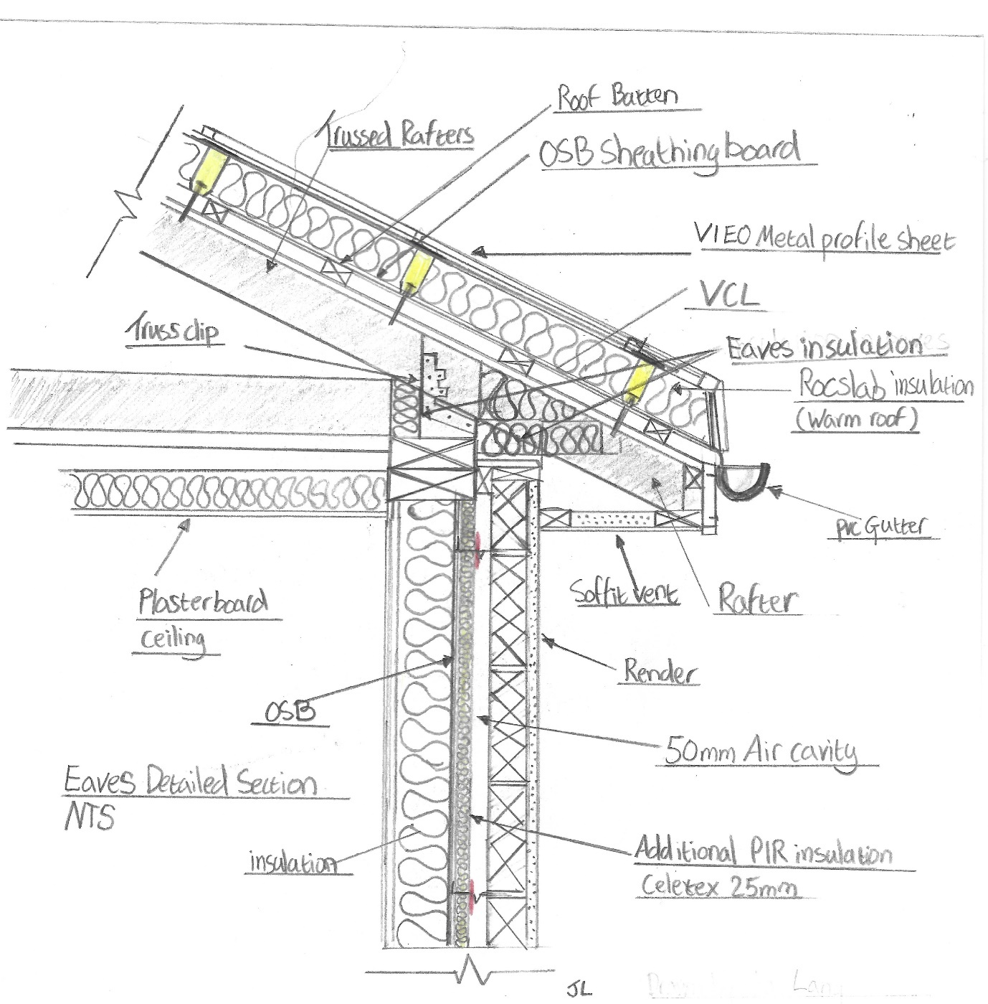
Figure 5 Eaves Detailed Section
As you can see in the sketch, a cavity barrier has been installed (not labelled) at the top of the external wall which meets the roof. This will ensure no heat loss in the cavity through the roof. The cavity barrier will also aim to give a thirty-minute fire resistance time window.
The external Wall meets the pitched 30degree trussed rafter roof angle, which is ventilated using a soffit vent. Ventilation will help reduce the amount of any moisture trapped in the eave’s junction. Ventilation gap equivalent to 10mm minimum continuous opening is required where the roof pitch is above 15 degrees.

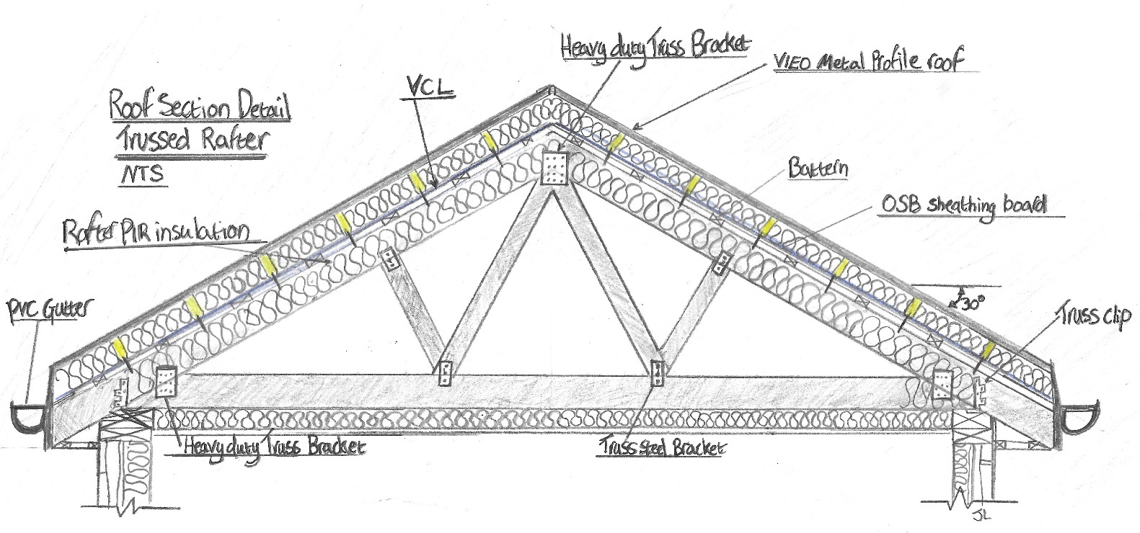
Roof Detailed section

Figure 6 Roof Detailed Section
The Trussed Rafter design of this roof can be identified as ‘Fink’.
The worst acceptable fabric performance value for a roof is 0.20
A typical U-value for a trussed rafter roof would be 0.21.
This roof as you can see in figure 6 has additional insulation in the VIEO Metal profile sheeting system, which installed on top of the OSB board above the rafters.
The roof consists of the following components:
- VIEO Metal profile sheet roof (Warm Roof)
- 90mm RocSlab insulation
- VCL
- OSB
- Battened with small 30mm air-gap
- Rafter with 150mm PIR insulation Celotex XR4000
- Ceiling PIR insulation Celotex 100mm GA4000
With this additional insulation contained in the roof, the calculated U-value came to 0.12.
A typical trussed rafter roof would not have the added insulation underneath the metal profile sheet. This helps bring down the overall U-value because it has added thermal performance to the roof structure.
Roof restraints
The trussed Rafters are held together by heavy duty truss brackets and truss clips which will give it stability against wind resistance.

Types of Roof materials
The VIEO metal profile sheet roof was chosen for the roof, here is quote taken from EuroClad stating the advantages of this roof design:
“It can offer significant cost savings versus traditional materials like zinc and lead and is a manufactured sheet product, which is faster and less onerous to install correctly than traditional materials.”
(EuroClad, 2020)
Traditional roof tiles on the other hand have a disadvantage because they impose a considerable amount of weight onto a roof structure.

References
Cotgrave, M. R. (2018). Construction technology 1: house construction. Palgrave.
EuroClad. (2020). Vieo Metal sheet roof. Retrieved from https://www.euroclad.com: https://www.euroclad.com/roofs/vieo-roof-profile/
Federation, T. T. (2016). cross-laminated-timber. Retrieved from www.ttf.co.uk: https://ttf.co.uk/timber-trade-topics/cross-laminated-timber/#jump_to_facts
Government, W. (2017). Approved Document A. Retrieved from https://gov.wales: https://gov.wales/building-regulations-guidance-part-structural-safety
Government, W. (2017). Building Regulations, Approved documents Part C. Retrieved from https://gov.wales/building-regulations-guidance-part-c-resistance-contaminants-and-moisture
Kingspan. (2020). Timber frame. Retrieved from https://www.kingspantimbersolutions.co.uk/en-gb/products-en/kingspan-tek
TRADA. (2020). Timber frame construction. Retrieved from https://www.trada.co.uk: https://www.trada.co.uk/start-here/timber-frame-construction

