Scott Jones
1803767@student.uwtsd.ac.uk
Ideation [1] and Development [2]

enterprise and innovation group project
J&J Fitness

Table of Contents
Table of Contents 1
Introduction 2
Ideation 2
The Idea 2
Illustration 3
Original 3
Second Design 4
Design 5
Requirements 5
Minimum Viable Product 5
Design Documentation 6
Differentiation 8
Development 9
Conclusion 13
Appendix 14
Reflection 14
Networking Event 18
Progress Sheets 19
References 20

Introduction
This report talks about the ideation and the development of J&J Fitness. Firstly, the idea; this is what the product is, how it will work, what it will look like, and what makes it different from its competitors. It will showcase an in-depth description on the application, along with what needs to be included within, and why.
Within this report will be a section covering the actual development of the application. This section will cover how the application is made, including screenshots of the code used for all parts. In addition, the key features will be highlighted.

Ideation

The Idea
The idea is an application for mobile devices, mainly smartphones. The application will be in the Health and Fitness category. This will include multiple features, such as; diet plans, workout routines, a point-based leader board system with friends to compete with, fitness news and other similar.
Applications are becoming more and more popular as technology gets more advanced, and it is important to get as many users to use the application. Anyone who has a smartphone uses it daily, and this is to quickly access data. This is where mobile applications are perfect. [1] It is imperative to get as many users using the application as possible. “To get popular: keep it simple, engaging and be ready for changes” [1]
According to Statista, applications are projected to generate over 9935 billion US dollars by the year 2023. [2] This shows that there is still plenty opportunity to grow within the mobile application market within the next few years.

Illustration

Original
A very important part of application development is how it looks. “The design of an app enhances the user experiences which is the biggest factor that ensures success of an app” [3]
The application was originally created on Adobe Photoshop since this software was most familiar to the developers. Yet after a little more time and research, it was quickly discovered that the best software to use would be Adobe XD. This software is specifically designed to create applications, and has an abundance of advantages over Adobe Photoshop in application design. One of these features is the ability to transfer to design over to a phone screen to see first-hand how-to application would run/ work.
The application consists of 3 colours, keeping a constant theme throughout the brand, maintaining professionality. Each screen contains of 2 navigation bars; one on top, and one on bottom. The centre of each screen contains a scrolling page to fit more information on.
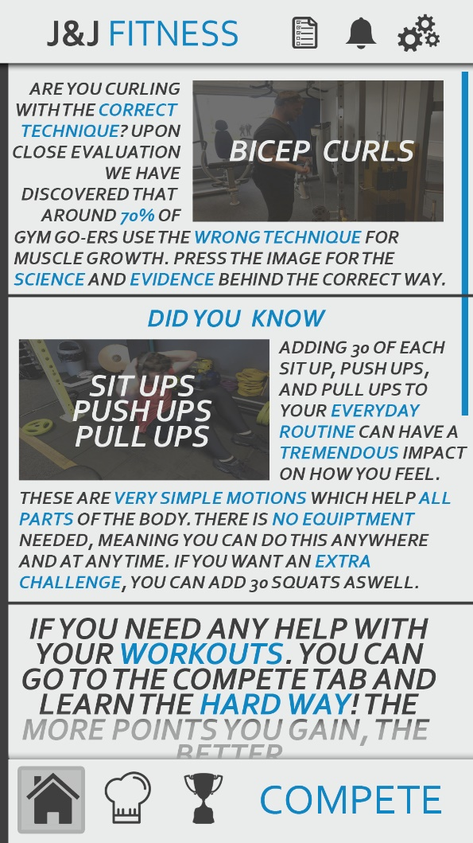
This is a screenshot ofc the original base design for the home screen. This design has some pros and cons to it, the biggest con being that the writing is rather small and may be hard to read on a mobile phone screen. This could be fixed within the settings where the user could change font size. As previously mentioned, you can see the two navigation bars on the screen, as-well as the scroll bar on the far-right side.
Whatever screen the user is currently on is highlighted on the corresponding symbol. The screenshot shows the user on the Home Screen, and in the bottom left bar you can see the ‘Home Screen’ icon is highlighted. The user will also be able to access the Home Screen by clicking the logo in the top left corner.

Second Design
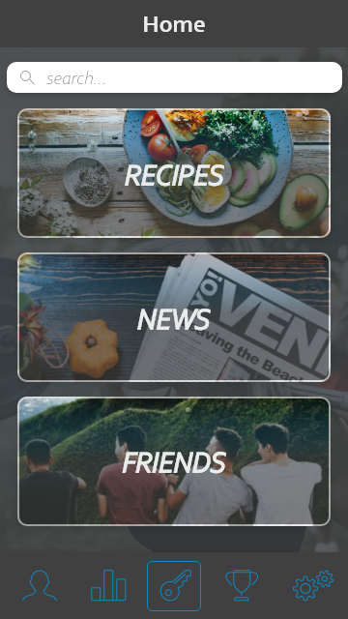
When it came to develop the application, there was a big design change. This is the new design, as seen, there is a massive change. There is a couple of features which have been taken out, the top navigation bar has been completely removed. Those features are implemented somewhere else within the application.
This design looks sop much more professional than the previous. The use of images through the application elevates it to a different level, reducing the boring/bland effect it had before.

Design

Requirements
The application will need multiple features in order to function correctly, below are a few of these features;
- Login In / Sign Up pages
- Password Encryption
- Encrypted Database for User Details
- Internet Connection for Live Competing
- User Add / Delete function (friends feature)
- Easy Navigation
- Linked to a Database and Website
- Seamless page transitions
- Regular Updates

Minimum Viable Product
The minimum viable product will contain only the basic features of the application to ensure that everything runs as it should. This way it would be easier to find any potential bugs and get them fixed whilst in the early stages of development.

Design Documentation

Original
The below screenshot shows the basic structure of the application. The grey links show what the buttons are connected to what pages. All the pages are labelled above the corresponding page. As you can see, the ‘Compete’ logo (bottom right of each page) is linked to the ‘Compete Main’ page. This will be where the users compete against their friends. More screenshots in the appendix…
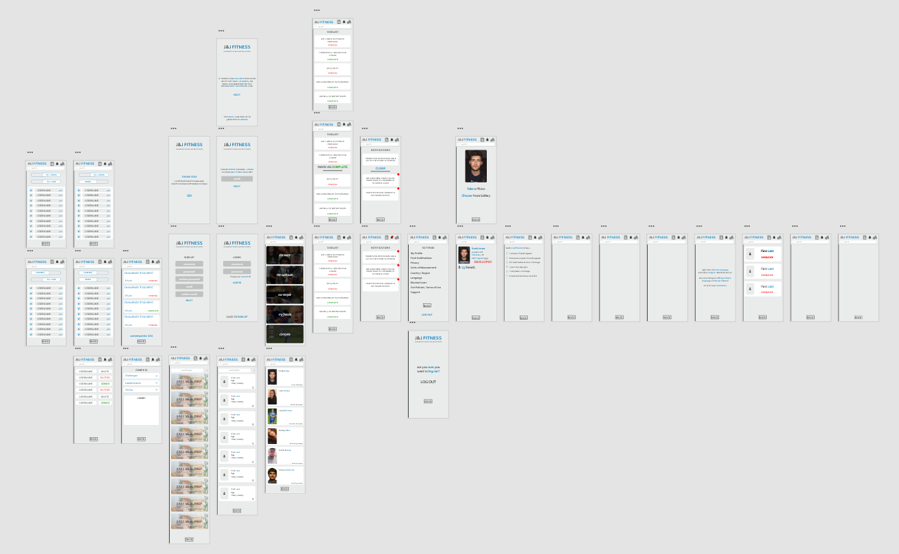
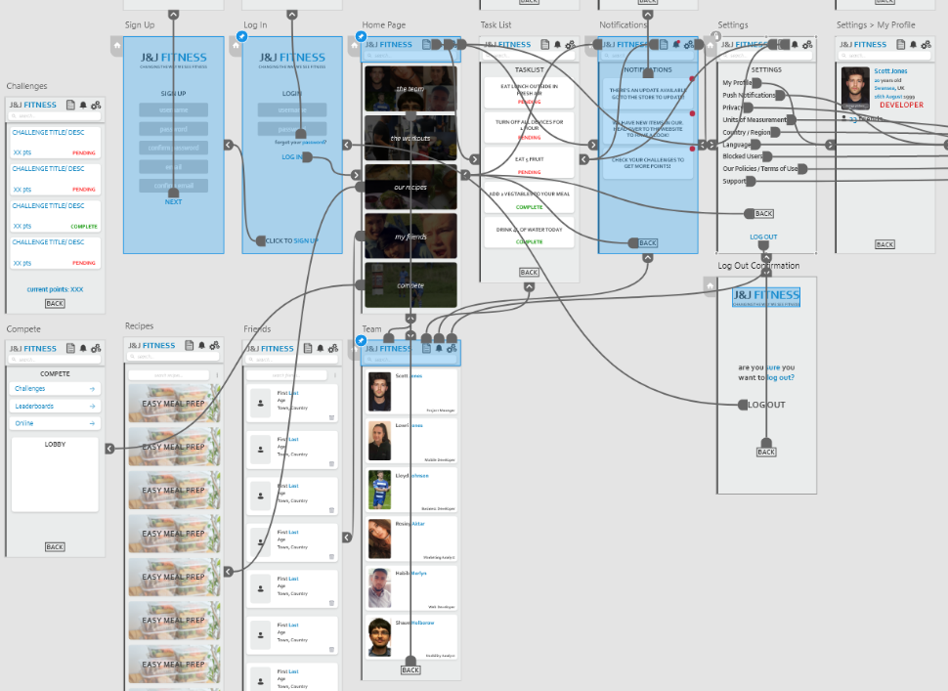
The below screenshots show how the some of the pages are linked. This prototyping tool doesn’t create an code, this is purely for prototypes

Second
After playing around with different styles and concepts, the design was completely revamped. This did dig into the time significantly, but overall the result makes it worth it. This isn’t every single page, since it was known what each page was linked to from previous design, there would be no time to waste on creating every single screen.
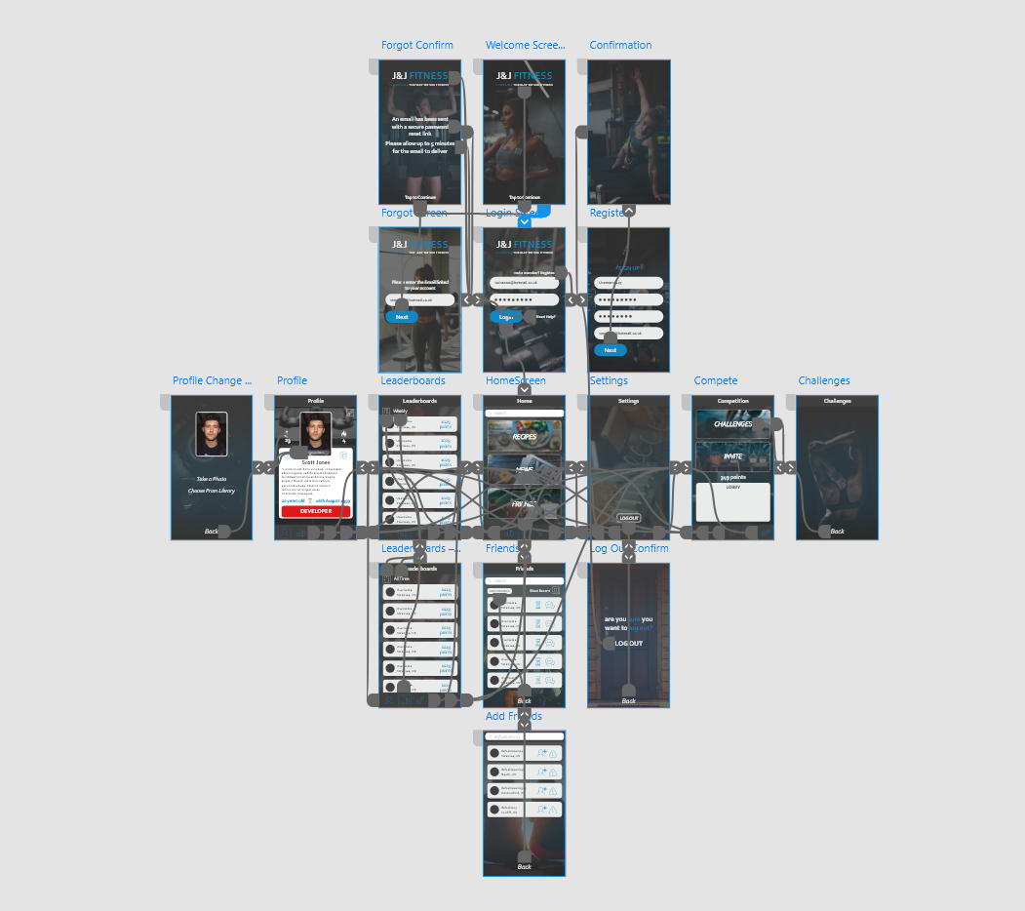

Differentiation
Since there is such a dense market in health and fitness application, there needs to be a feature that makes the project unique and different from its competitors. This means the application needs a Unique Stand Point (USP). “a USP is a summary of features that makes your business unique and valuable to your target market” [4]
The differencing factor within the application is granting the user the ability to compete against their friends in real time to gain points towards a leader board. There will be prizes implemented with coming first within a certain time period to motivate the users to compete.

Development
Android Studio and Adobe XD were used for the development of the application.
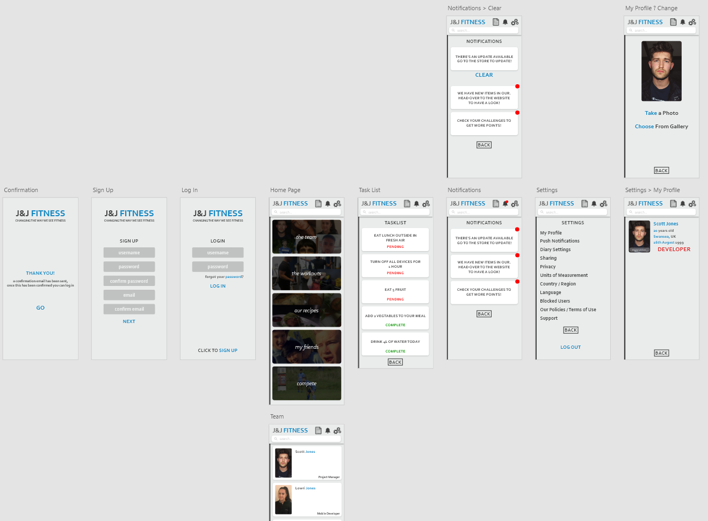
After playing around with the design, a last-minute decision was made to use the original design to show the entire structure, and to change the design to a more homely/professional design.
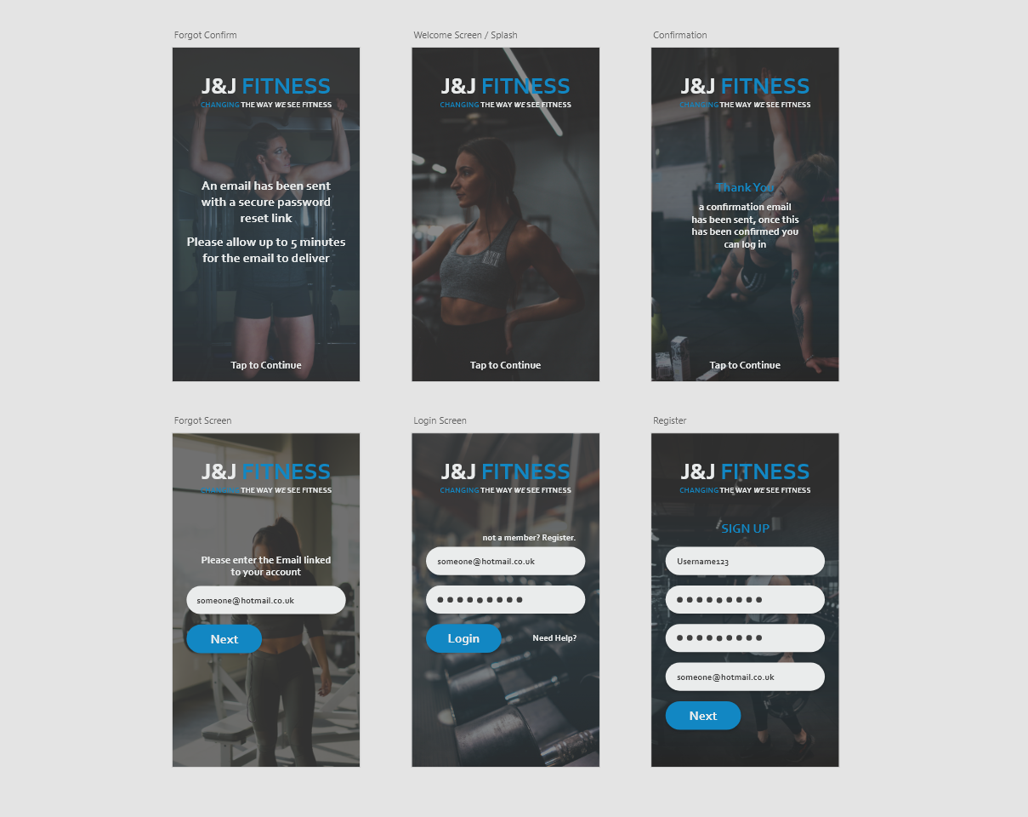
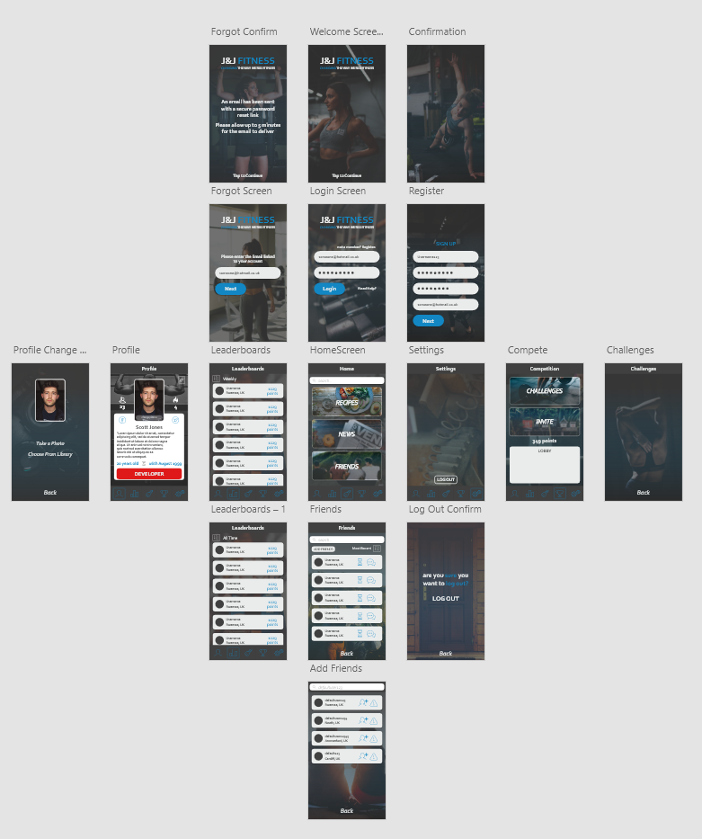
Here is a close look at the home page design, consisting of image buttons, a bottom navigation bar and a search bar up top.
This is shows most of the pages in the new design.
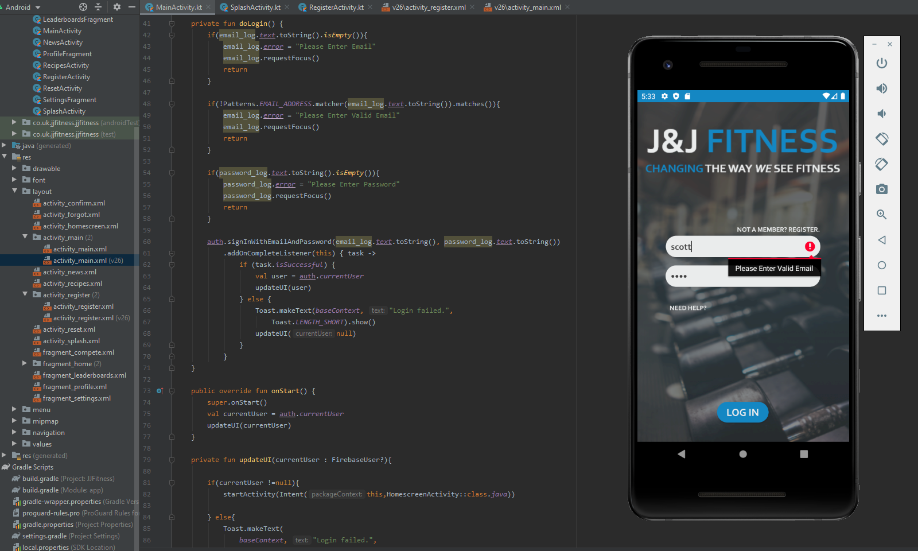
Above is a screenshot and an emulator to show (the majority of) the log in page code. There are multiple IF statements to prevent the user from entering insufficient details. An example shown in the screenshot, the code providing this error is also highlighted above.
Below shows the sign-up page, this is where users create and account using an email and password if they haven’t previously registered.
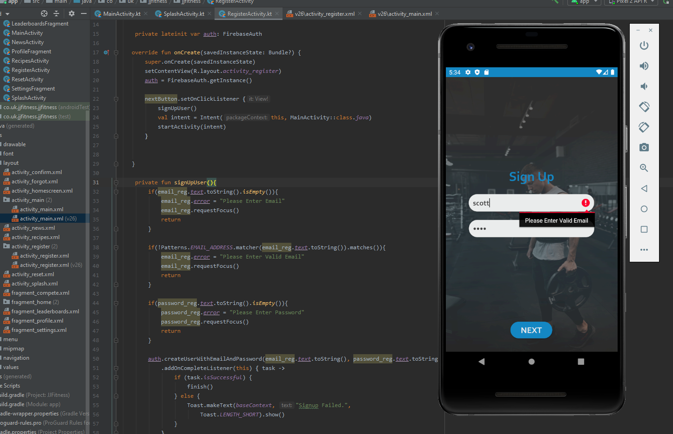
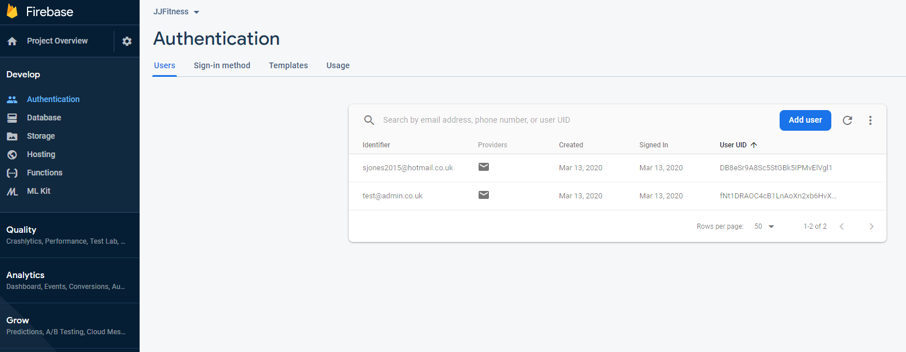
Android Studio has a built-in database software to make it moderately easy for developers to allow user email/password authentication. The above screenshot shows where the developer’s mange the users. Here you can change the user’s password by sending them a password reset link manually straight to their email.

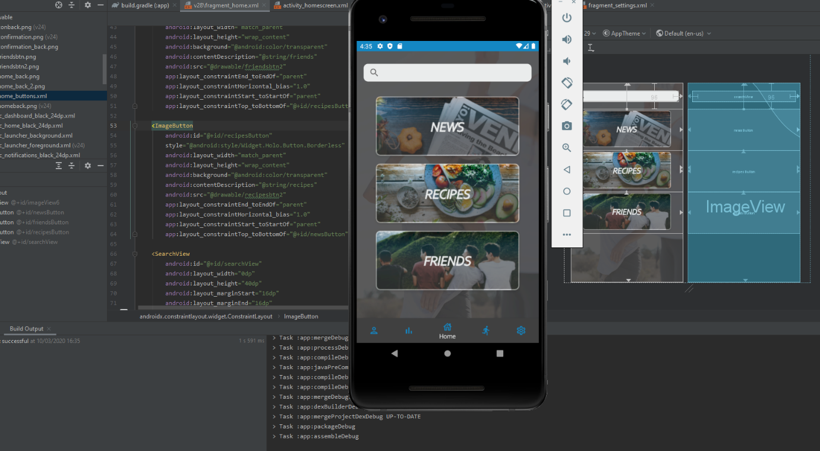
Below is a screenshot of the home page working inside the application. The code in the background is the design and layout of the homepage. Relation back to the design. You can see that this is very near the close screenshot of the home page screen. The leading difference being the navigation bar at the bottom. This different navigation bar was much easier to code, plus it looks a lot better, and the screen name comes below the icon when the page is selected. This saves a lot of space since there is no need for the top bar.

Conclusion
The whole project rests on how the application looks and functions. Therefore, a lot of time and research went into the design and structure. Like previously mentioned, there was a complete design change halfway through the project. This did halt the development process significantly since we could not start that without having the design.
The second design makes a substantial difference in the appearance, if the design is bad it would ruin the user experience. If the user experience is bad, then it is very unlikely that the users will return to the app or recommend it to other people.
Developing the app was also a lengthy project, it took multiple days and many hours of debugging just to get basic functions working. It also took a long time to learn the layout and navigation settings within both software used. It was also difficult to try and replicate the design from Adobe XD over to Android Studio, and to make it look as similar as possible.

Appendix

Reflection
I have greatly developed my technical skills whilst doing this project. In the original pitch, I was using Adobe Photoshop to create the prototype since I was familiar with the software. When it came to the actual design and development, I went outside of my comfort zone to try and develop new skills and learn new software’s. I decided to use Adobe XD for the design. This is a software that is made exclusively for design prototype User Interfaces on Mobile and Web sites/applications. This program has a fantastic range of tools and features to make this process much simpler. The protype feature allows you to link each of the pages together by individual components (buttons) of each page. This portrays a very accurate representation to what the application will look like and function when it came to code it.

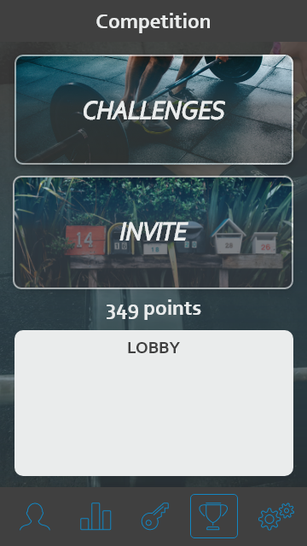
This is the competion page that I exported straight out of Adobe XD. The software allows for perfect spacing and a clean professional look.
I can say after desinging this entire project, I am more than comfortable with every single feature on this software. I enjoyed it so much that I have also started working on a completely separate project in my own time.
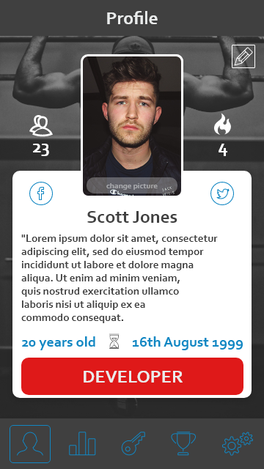

This is the profile page designed on Adobe XD. As you can see, the navigation bar at the bottom shows the user which page they are currently on by surrounding that button with an outline.
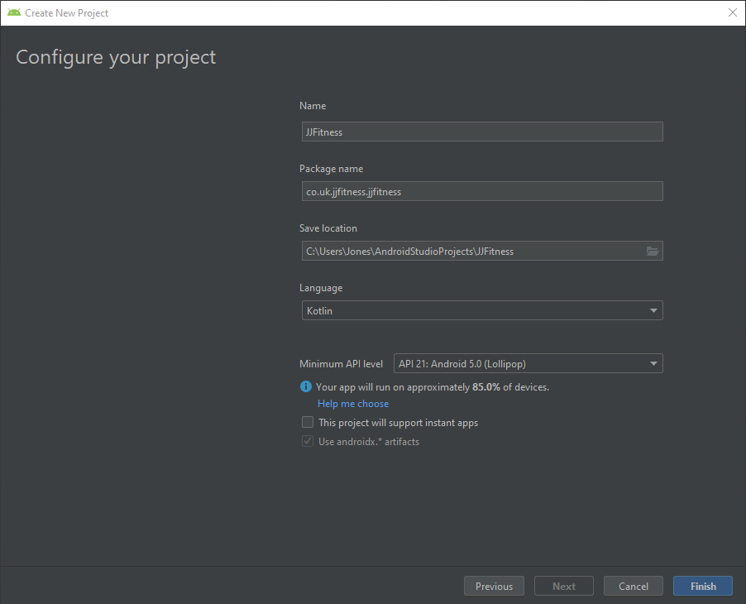
Also massively out of my comfort zone was Android Studio. Like Adobe XD, prior to this project I had never heard of Android Studio, had never seen the interface and had never seen a video / tutorial about it. It was completely alien to me.
I had zero experience in any type of application desing or development before this. Now I have a very good understadning of Adobe XD, and can also create a basic application with working log in / sign up features.

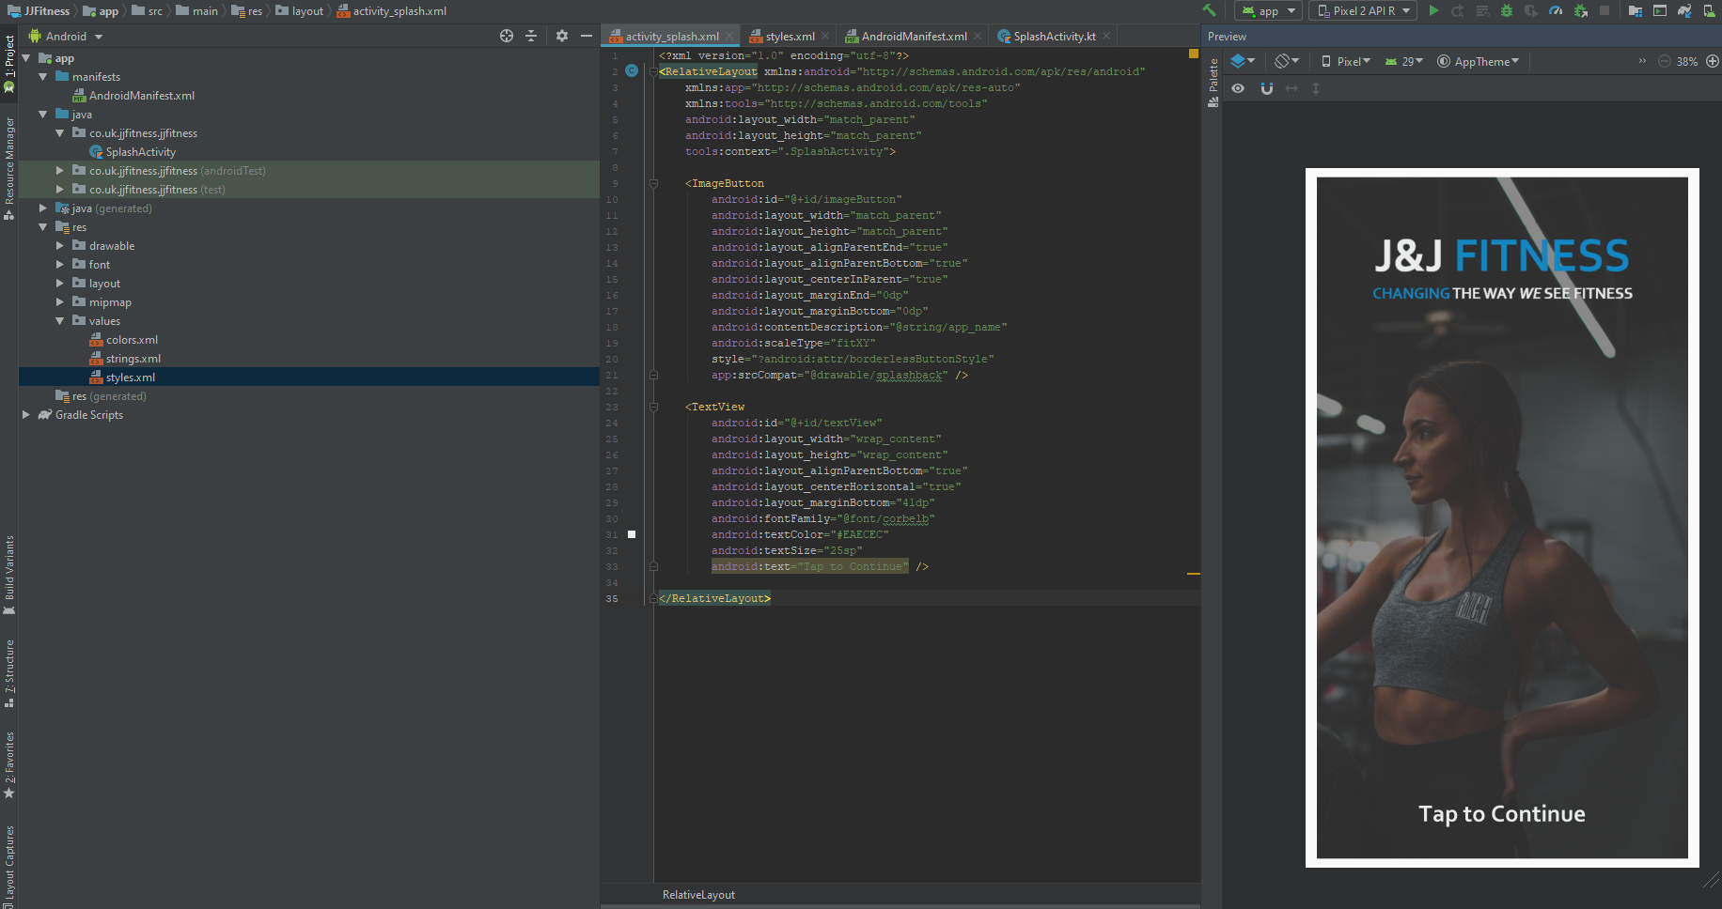

I decided to write the code in Kotlin as opposed to Java. I never really had any experience in either language, so I had to choose one to learn. The reason I chose Kotlin is because it is a new language, and too my understanding, a lot more can be done using less code than in Java. A downside to the language being newer is that there are not many guides that can be used to help build the project.

Above is a screenshot of the sign-up page, which is prompting the user to enter an email address. This is created using an IF statement to check if the edit text field contains the same layout as a standard email address. When the user enters the details, the details are saved to a database which is linked to the application, they can then use these credentials to log in. They will not be able to log in without the credentials.

Networking Event
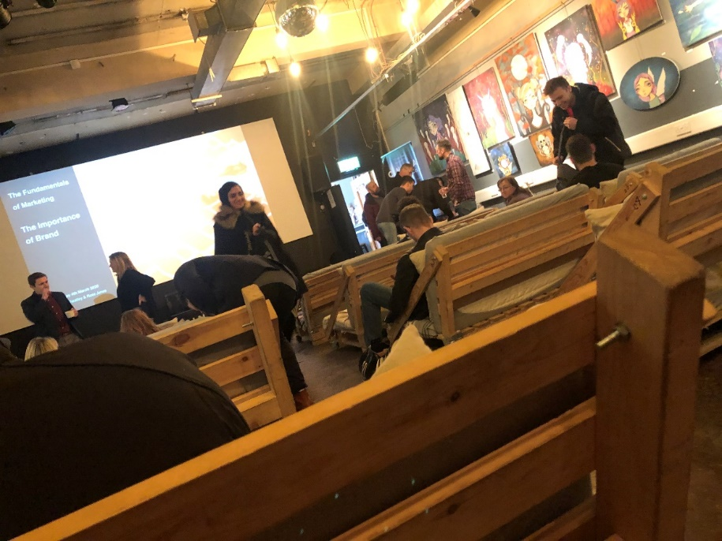

Our team attended an event in Swansea’s ‘Cinema & Co’, this event focused on the fundamentals of marketing.

This talk gave us a great in depth understanding on marketing as a whole and the importance of having a great brand identity.
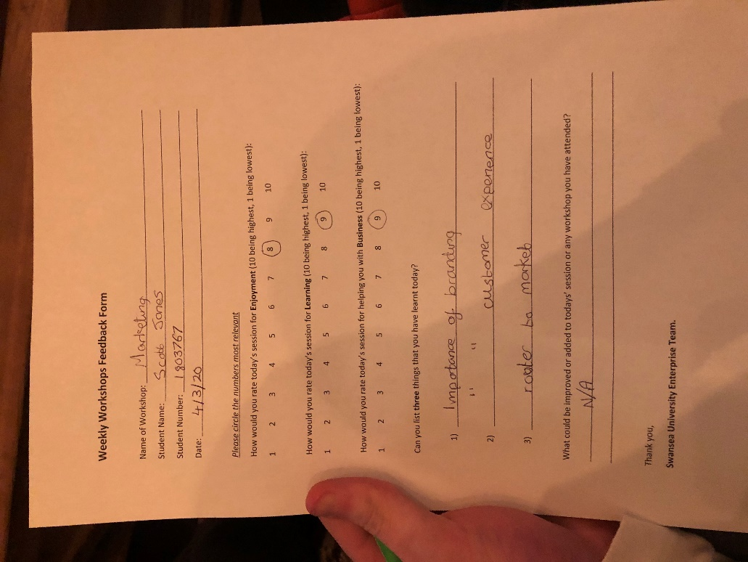

Progress Sheets
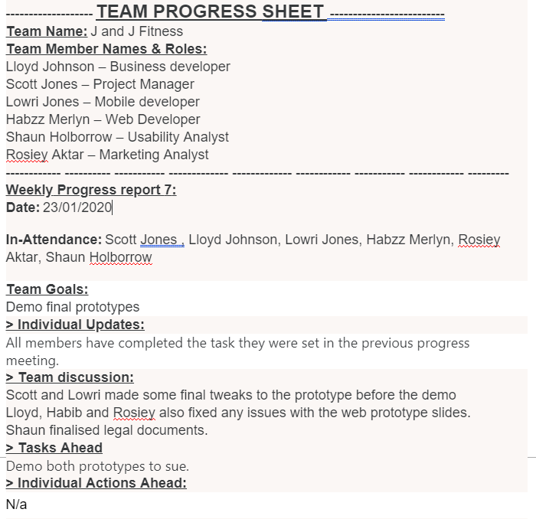
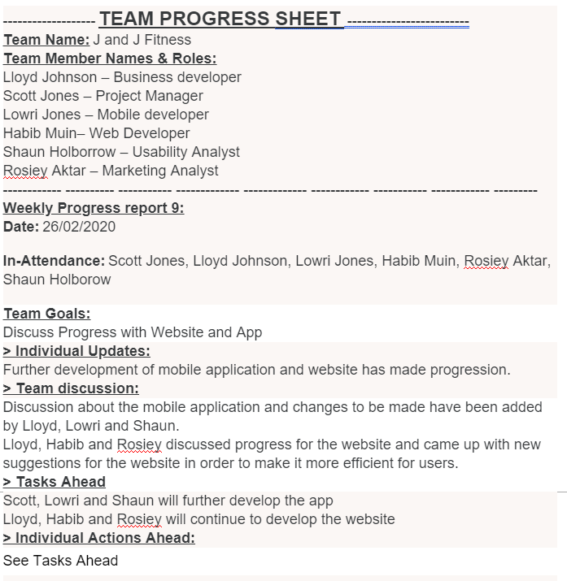

References

[1] | F. Aloé, “Why mobile apps are so popular?,” TapPublisher, 04 December 2013. [Online]. Available: https://tappublisher.com/blog/why-mobile-apps-are-so-popular/26.
[2] | J. Clement, “Mobile app usage - Statistics & Facts,” Statista, 01 August 2019. [Online]. Available: https://www.statista.com/topics/1002/mobile-app-usage/.
[3] | S. Srivastav, “How Important is UI UX Design in an App Development Process?,” AppInventiv, 13 February 2019. [Online]. Available: https://appinventiv.com/blog/importance-of-ui-ux-design-during-your-mobile-app-development/.
[4] | O. Gough, “The importance of creating a USP in today’s global market,” GrowthBusiness, 22 August 2017. [Online]. Available: https://www.growthbusiness.co.uk/importance-usp-global-market-2551905/.

