

A Study of the Blast Furnace 4 Cyclone Semi-Auto Sequence

by
Daniel Richards

Supervisor: Dr Gary Jones
Second Marker: Mrs Jenifer Prince Devaraj

The project was submitted as part of the requirements for the award of
BEng (Hons) Electrical and Electronics Engineering

April 2024

DECLARATION

I, Daniel Richards declare that I am the sole author of this Project; that all references cited have been consulted; that I have conducted all work of which this is a record, and that the finished work lies within the prescribed word limits.

This work has not previously been accepted as part of any other degree submission.

Date : .......25.04.2024........................................

FORM OF CONSENT

I Daniel Richards hereby consent that my Project, submitted in candidature for the B.Sc.(Hons) Computing (stream) degree, if successful, may be made available for inter-library loan or photocopying (subject to the law of copyright), and the title and abstract may be made available to outside organisations.

Date : .......25.04.2024........................................

Abstract

Objective
The objective of this project is to investigate, design, and implement an alternative system to the current trace heating circuit installed in Blast Furnace 4 at Port Talbot Steel Works in South Wales that will avoid the hardening of flue dust within the cyclone chamber of Blast Furnace number 4. The concept of the cyclone is to remove the majority of large dust particles from the dirty gas exiting the blast furnace, A strong vortex, like that in a Dyson vacuum cleaner, throws particles in the flow, heavier than the carrier gas to the walls of the Cyclone

Solutions to the issue
A brainstorming session was held at the Ironworks headquarters to address the cyclone clogging with flue dust, following this, three alternatives were offered, which are detailed in this report to discover the best answer to the problem at Blast Furnace 4. These are, Option 1 – Do nothing, Option 2 – Reinstate and upgrade the existing trace heating system. Option 3 – Installation of Laser measurement devices.

Methods Used and Findings
Investigate the market for other similar systems to the proposed idea.
Investigate various sensors to discover the best fit for the application.
A breakdown of the costs to implement the project.
The breakdown rate of the cyclone is monitored.

Results
Following the execution of one of the three options, the data obtained can be evaluated to determine whether the approach chosen and applied was successful. A general conclusion and a section for personal reflection also follow.

Acknowledgments

Firstly, I would like to express my gratitude towards my partner, Sara, for supporting and motivating me throughout my six-year journey, starting with HNC in 2018, and concluding with the BEng in 2024.

I would also like to thank Dr. Gary Jones, my project supervisor, for guiding me and providing valuable assistance on this project. I am immensely grateful to Mr. Gareth Symons, the Work Package Leader at Tata Steel, who allowed me to work on the Cyclone project and taught me the importance of striving for perfection. Gareth's dedication and enthusiasm are admirable and infectious.

Additionally, I extend my thanks to Mr. Marcus Burbidge, the Business Electrical Engineering Manager at Tata Steel, who allowed me to pursue my studies at the University on a part-time basis for the past 18 months. I appreciate the opportunity that Tata Steel UK has given me during these challenging times for the UK steel industry.

Table of Contents
Chapter 1 Introduction 9
1.1 A brief history of steelmaking at Port Talbot. 9
1.2 The need for change 9
1.3 Blast Furnace 4 10
Chapter 2 – The Options Available 11
2.1 Options map 11
2.1.1 Option 1 - Do Nothing 12
2.1.2 Option 2 - Reinstate and upgrade the existing Trace Heating system 13
2.1.3 Option 3 - Installation of Measurement Devices. 13
2.2 Main Objectives 14
2.3 Environmental Issues faced by Tata 15
2.3.1 Reputation 15
2.3.2 Dust Pollution 16
2.3.3 Introduction to Fugitive Dust 16
2.3.4 How does Tata Steel monitor PM10 & Dust? 17
2.3.5 How does Tata Steel UK mitigate our environmental impact? 17
Chapter 3 – Background Research 18
3.1 Port Talbot site classification 18
3.1.1 DSEAR 18
3.1.2 ATEX 18
3.2 DSEAR 18
3.2.1 When does DSEAR apply? 18
3.2.2 The Fire Triangle 19
3.2.3 Where does DSEAR apply? 19
3.2.4 What are dangerous substances? 19
3.2.5 Gases and Port Talbot and Llanwern 19
3.2.6 Overview of Area Classification 20
3.2.7 Equipment in Hazardous Areas 21
3.3 Protection Concepts 23
3.3.1 What is a protection concept? 23
3.3.2 Protection Concepts Briefs. 23
3.3.2.1 Flameproof – Ex d 23
3.3.2.2 Increased Safety – Ex e 23
3.3.2.3 Pressurisation and Purge – Ex p 24
3.3.2.4 Oil Immersion – Exo 24
3.3.2.5 Powder Filling – Ex q 24
3.3.2.6 Encapsulation – Ex m 24
3.3.2.7 Non-Incendive – Ex n 24
3.3.2.8 Optical Radiation – Ex op 24
3.3.2.9 Special – Ex s 25
3.3.2.10 Protection by Enclosure – Ext 25
3.3.2.11 Protection ‘I’ Intrinsic Safety 25
3.4 Past and Present Standards 26
3.5 TYPES OF DUST CATCHER 27
3.5.1 Dust catcher principles of operation – Used at Blast Furnace 5 27
3.5.2 Cyclone Principles of Operation – Used at Blast Furnace 4 27
3.5.3 Which method is better? 27
Chapter 4 – Design 28
4.1 Design Overview 28
4.2 Indications of the existing Switches 29
4.3 OEM Recommendations 30
4.4 Market Research 30
4.5 Comparison Table 30
4.6 Sensor Set-Up Pre-Installation on Site 31
4.7 Wiring System 32
4.8 Comparison Table of Common Wiring Systems 33
4.9 PLC System Requirements 34
4.9.1 Process Steps 34
4.9.2 Parking Arrangements of the Lorry 35
4.10 Speed of sound for various gasses 36
4.10.1 Atmospheric Pressure 37
4.11 Typical Composition of Blast Furnace Gas 37
4.12 LiDAR – Workings 39
4.12.1 LiDAR distance measurements 39
4.12.2 How do LiDAR’s work? 39
4.12.3 Types of LiDAR’s sensors? 39
4.12.4 Time of Flight Phase-measurement 40
4.12.5 Advantages of LiDAR: 40
4.12.6 Disadvantages of LiDAR: 41
4.13 Planning 42
4.14 Original Plan 42
4.14.1 Key Landmarks & unfinished work 43
4.15 New plan. 43
4.16 Chance Encounter 45
4.17 Simulation 46
4.17.1 HMI screen 46
4.18 Process flow of the simulation and PLC requirements 47
4.19 Main PLC Network 47
4.20 Simulation Components 49
4.20.1 Simulation Set up 50
4.20.2 Vega Tools App Used to Simulate Sensor 51
4.20.3 Overview of the Simulation 52
4.21 Gantt chart of the simulation 53
CHAPTER 5 – EVALUATION 54
5.1 Analysis of the findings 55
5.2 Reflection 56
References 57
5.3 Appendices 58
5.3.1 Cyclone Drawing Showing Positions of New Sensors 58
5.3.2 Quote for Hardware Used for the Project 59
5.3.3 Vega Specification Sheet 63
5.3.4 Main Program Black 65
5.3.5 YouTube Link to Video of Simulation. 70

Figure 1 – Brainstorming Map 11
Figure 2 - Steelmaking Process 11
Figure 3 - Priorty Table 12
Figure 4 - Objectives Table 14
Figure 5 - Dust Particles 16
Figure 6 - Emissions Examples 16
Figure 7 - Dust Monitoring 17
Figure 8 - Fire Triangle 19
Figure 9 - DSEAR Marking Examples 21
Figure 10 - Cyclone Discharge System 28
Figure 11 - Existing Level Switches 29
Figure 12 - Sensor Comparison Table 30
Figure 13 - Pre Installation Set-up 31
Figure 14 - Wiring Systems Caraison Table 33
Figure 15 - Speed of Sound for Various Gases Table 36
Figure 16 - Blast Furnace Gas Composition Table 38
Figure 17 - Time of Flight of a Lidar 40
Figure 18 - Shutdown Schedule of Blast Furance 4&5 42
Figure 19 - Gantt Chart 42
Figure 20 - Article of Tata Steel Future 44
Figure 21 - Potenial Plan of Tata Steel 45
Figure 22 - HMI Screen of Simualtion 46
Figure 23 - Components Used for the Simulation 49
Figure 24 - Simualtion Set-up 50
Figure 25 - Connection of Vega Tools App to the Sensor 50
Figure 26 - Screenshot of the Vega Tools App 51
Figure 27 - Overview of the Simulation 52
Figure 28 - Gantt Chart of the New Plan 53
Figure 29 - Scematic Drawing Showing Sensor Positions With the Cyclone 58
Figure 30 - Vega Quote 1/4 59
Figure 31 – Vega Quote 2/4 60
Figure 32 – Vega Quote 3/4 61
Figure 33 - Vega Quote 4/4 62
Figure 34 - Vegapuls 6X Spec Sheet 1/2 63
Figure 35 Vegapuls 6X Spec Sheet 2/2 64
Figure 36 - PLC Program Block 1/10 65
Figure 37 - PLC Program Block 2/10 65
Figure 38 - PLC Program Block 3/10 66
Figure 39 - PLC Program Block 4/10 66
Figure 40 - PLC Program Block 5/10 67
Figure 41 PLC Program Block 6/10 67
Figure 42 - PLC Program Block 7/10 67
Figure 43 - PLC Program Block 8/10 68
Figure 44 - PLC Program Block 9/10 68
Figure 45 - PLC Program Block 10/10 69

Chapter 1 Introduction

1.1 A brief history of steelmaking at Port Talbot.

Port Talbot has been synonymous with Iron and Steelmaking, with the monks of Margam abbey known to have made iron on-site in the 1200s, part of the abbey wall is still in place to this day, situated at the end of the Hot Mill finishing line.
In the early 1900s, the Port Talbot steelworks started to be built into the recognisable works we see today, this was helped to no end by the main railway line of South Wales which reached Port Talbot in 1850. By 1947 it was being developed into an integrated steelworks of international importance. The population of the town soared, and the early nineteen fifties saw the building of the vast Sandfields estate, intended to house the influx of Workers and their families. [1]
In March 1967, saw The ‘Iron and Steel Act’ which brought into public ownership about 90% of British Steelmaking.
The 1970s saw the closures program being put into place, with significant closures taking place by the end of this decade.
The start of the 1980s was heralded by a 13-week national steel strike. The strike was the result of the Corporation's pressure for change and a pay dispute. By the end of 1980, BSC had completed the closure of several outdated and lossmaking plants and reduced its workforce to 130,000 - compared with a total of 268,500 employees at the time of nationalisation. [1]
The early 1990's saw reduced demand and it was not until 1993 that growth in the UK economy gradually gathered pace and was reflected in a partial recovery in steel demand and price levels. The trend continued into 1994 and helped by continuing efficiency and productivity gains, British Steel returned to profit. On October 6, 1999 the merger with Koninklijke Hoogovens to form Corus came into effect.
Corus was acquired by Tata Steel in April 2007 in a transaction that created one of the world’s largest steelmakers, with a major presence in Europe as well as Asia, and renamed Tata Steel Europe in 2010. [2]

1.2 The need for change

On November 11, 2022, two people were exposed to Blast Furnace gas while reintroducing clean gas into the gas main. During regular operation, there was a cyclone blockage that caused output to be suspended; this blockage was caused by the hardening of flue dust, which is now a common occurrence at Blast Furnace 4. After the blockage was discovered, the furnace was put on hold until the blockage was cleared. The water U-Seal was put in place, effectively blocking any gas travelling from the furnace to the gas plant, and the slip plate was removed, preventing any gas from the gas plant from entering the gas main.
After this isolation operation, the cyclone blockage could be worked on, and once cleared, the isolations could be removed. Following a period of purging, the clean gas water U-Seal was released in order to reintroduce clean gas via the gas main; additionally, during this activity, there was a localised release of gas near the gas main slip plate near to two individuals who were performing gas sampling as part of the regassing procedure. As a result of the gas inhalation, both individuals became unconscious at the slip plate platform.
An emergency response was launched, and the plant and surrounding region were immediately made safe. The injured were given oxygen before being returned to ground level and then brought to the hospital for further examination.
Following this occurrence, an HSE intervention was carried out at Port Talbot Steelworks, and the incident was categorised as fatal. The HSE recommendation was that Tata Steel reassess the system that led to the cyclone blocking.

1.3 Blast Furnace 4

Blast Furnace 4 operates 24 hours a day, 7 days a week, the blast furnace is a crucial part of the steelmaking operation at Port Talbot, having the Blast Furnace off for any length of time has a huge effect on the downstream operations of the steelworks.
The main purpose of the Blast Furnace is to produce molten iron by heating fuel, ore, and flux, together in the Blast Furnace vessel. The resultant molten iron is tapped off at the Blast Furnace into railed ‘torpedo’ shaped vessels, and transported to the Basic Oxygen Steel (BOS) plant for the later conversion into steel.
The Blast Furnace function as a whole, comprises three main functioning sections, the actual Blast Furnace, the Stoves, and the Gas Cleaning Plant.
Blast Furnace Gas gets generated as part of the process and is used by multiple departments throughout the site, including Morfa Coke Ovens and Energy. With no Blast Furnace Gas, the works areas would be forced to depend on alternative gases, including Natural Gas, which is significantly more expensive than Blast Furnace Gas.

This project takes place in the Gas Cleaning Plant where the gas leaving the furnace is cleaned by the cyclone and the wet scrubbers in the Gas Cleaning Plant.

Chapter 2 – The options available

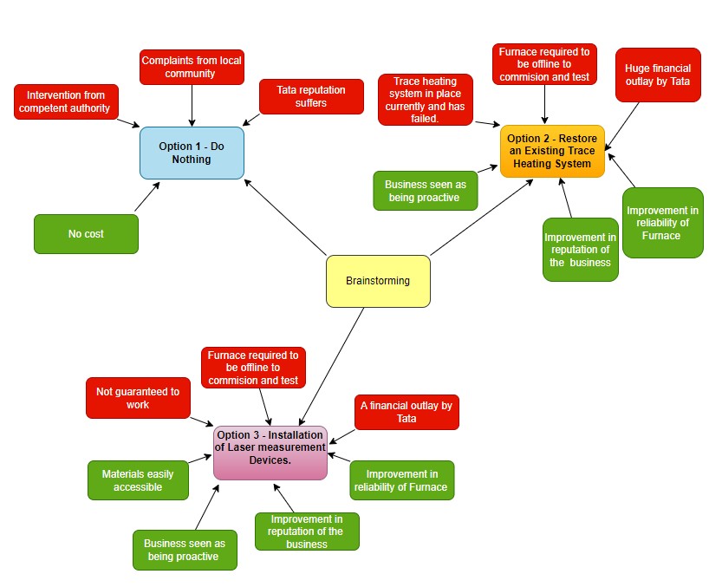
2.1 Options map

Figure 1 – Brainstorming Map
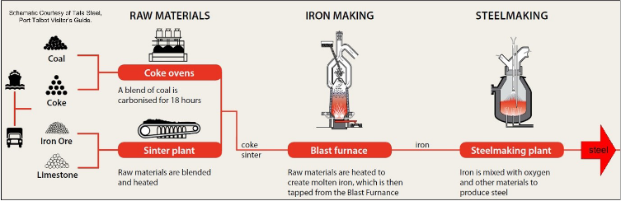

Figure 2 - Steelmaking Process

Solution Priority Table

 | Rating 1 = Good 10 = Bad
 | 1: Estimated Cost | 2: Risks | 3: External Impact | 4: Business Impact | 5: Suitability | 6: Time | 7: Easy to maintain
Solutions | 1 | 2 | 3 | 4 | 5 | 6 | 7 | Total
Option 1 - Do Nothing | 1 | 8 | 8 | 8 | 10 | 1 | 9 | 45
Option 2 - Reinstate and upgrade the existing Trace heating system | 8 | 5 | 4 | 2 | 4 | 5 | 3 | 31
Option 3 - Installation of Laser measurement devices. | 3 | 3 | 4 | 2 | 4 | 3 | 3 | 22

Figure 3 - Priorty Table

2.1.1 Option 1 - Do Nothing

1: Estimated Cost, This approach has no cost implications, hence it received a low score.
2: Risks, It received a high grade because there is a likelihood that the relevant authorities will intervene if the furnace continues to stop/start.
3: External Impact, Because of multiple complaints from local people about the noise caused by the re-starting of the Furnace, as well as dust becoming airborne, Tata's reputation has been harmed, it scored high on this basis.
4: Business Impact, Tata’s reputation will suffer as a result of doing nothing, as shown in this score assigned.
5: Suitability, Because this choice is deemed unsuitable, the maximum score has been awarded.
6: Time, There will be no time restrictions if the business continues with this approach.
7: Easy to maintain, This received a high rating since the furnaces are proving tough to maintain due to the cyclone clogging at regular intervals.

2.1.2 Option 2 - Reinstate and upgrade the existing Trace Heating system

1: Estimated Cost, This approach obtained high marks due to a budget quote of half a million pounds received.
2: Risks, This strategy was assessed to be of medium risk since, despite being part of the original design during the 2013 upgrade, the Trace Heating system failed and is not guaranteed to function the second time around.
3: External Impact, Even if successful, the issue of dumping flue dust will need to be addressed, therefore this ranked slightly below average.
4: Business Impact, As a result of resolving this issue, Tata's reputation with the local community will improve, thus the low score.
5: Suitability, A slightly below-average score was assigned due to the unknown element of the trace heating system's performance if installed.
6: Time, Because adopting this system would take a substantial amount of time, a midrange score has been allocated.
7: Easy to maintain, If the Trace Heating system is effective, component Tata Technicians will have experience with previous Trace Heating systems on-site, making maintenance achievable, justifying the low score.

2.1.3 Option 3 - Installation of Measurement Devices.

1: Estimated Cost, This scored low due to an estimated cost of approximately £30,000
2: Risks, Though there is no assurance of success, the major risk is not considering this alternative in terms of price and probable ease of being implemented, which explains the low score.
3: External Impact, Again, even if successful, the issue of discharging flue dust must be addressed, resulting in this being scored somewhat below average.
4: Business Impact, As with Option 2, as a result of resolving this issue, Tata's reputation with the local community will improve, thus the low score.
5: Suitability, As with Option 2, a slightly below-average score was allocated due to the uncertain component of this being effective.
6: Time, Proceeding using this system could be completed in a reasonably short length of time; a score under the halfway point has been given.
7: Easy to maintain, If Option 3 is put into effect, maintenance will be managed by Tata employees who have experience with similar systems throughout the plant, which is why the low score was given.

2.2 Main Objectives

The following table (Figure 4) outlines the main goals of the project, which are divided into subcategories based on the order in which they were completed. The table provides information on significant milestones and indicates whether they have been achieved or not. Additionally, it lists two tasks that are currently being worked on and will be completed after the report has been submitted.

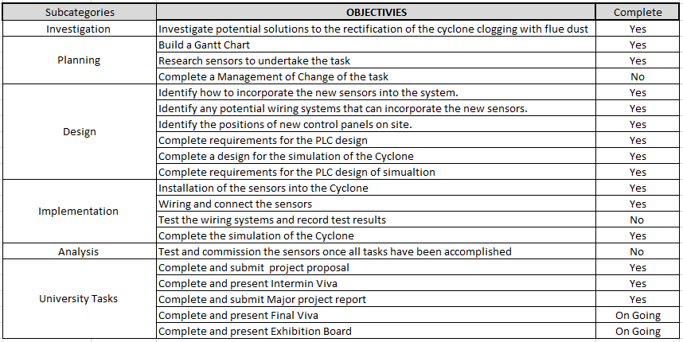

Figure 4 - Objectives Table

2.3 Environmental Issues faced by Tata

Tata steel must meet the requirements of the Environmental Management System – ISO14001, which is an Internationally recognised standard audited by SGS. The ISO 14001 outlines the overall intentions and direction of how the company will relate to its effect on the environment.

Over the years Tata Steel UK has had several permit breaches, in which NRW (Natural Resources Wales) can take various actions, each with specific implications. Accountability for breaches extends from top leadership to employees and may result in:
▪ Warranted Officers – powers under legislation.
▪ Evidence gathering capability.
▪ For permitted sites generally coupled with higher level non-compliances.

▪ Consideration to be given to public interest factors and outcome sought:
1. Stop offending – notices (prohibition, suspension)
2. To restore/remediate - notices, civil sanctions.
3. To punish/deter - civil sanctions, formal enforcement response – cautions, prosecutions.
4. Bring into compliance – notices.

Tata Steel UK has faced multiple fines due to dust pollution caused by the generation of dust at the base of Blast Furnace no. 4's Pug Mill floor. The dust accumulates on the floor and is often exposed to the wind, resulting in it being dispersed across the site and reaching the homes of the local residents. To address this issue, a proposed solution is to position a lorry with a skip within its trailer directly beneath the Pug Mill. This arrangement will enable the dust to be collected without it settling on the floor and being blown around by the wind.
[3]

2.3.1 Reputation

Over the years, Tata Steel UK's reputation has been affected by concerns raised by local residents regarding the red dust clouds that frequently hover over Port Talbot. This issue is largely attributed to the plating pits at the BOS Plant. However, it is important to note that the dust generated from the activities beneath the Pug Mill may have also contributed to this problem, and not in a positive way. [4]

2.3.2 Dust Pollution

During 2013, there was even an enforcement notice for dust pollution actioned against Tata Steel UK,
So, what does the dust at Port Talbot look like and what do Tata Steel UK do to prevent it.
Introduction to PM10 [3]

▪ PM10 is particulate matter of less than 10 microns in diameter which are very small dust particles
▪ Welsh Government Objective: not to exceed a daily mean average of 50µg/m3 more than 35 times in a calendar year
▪ The daily mean PM10 objective is set at the AURN (Automatic Urban Rural Network) monitor located in Port Talbot (Fire Station in Taibach)

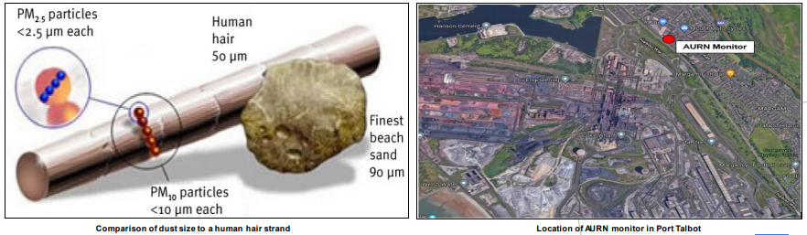
Figure 5 - Dust Particles

2.3.3 Introduction to Fugitive Dust

▪ Fugitive dust is a particulate matter which is not emitted from a point source (e.g. stack) that can become airborne.
Examples of fugitive dust sources include:
– Process emissions
– Lift-off from roads or stockpiles
– Material movements
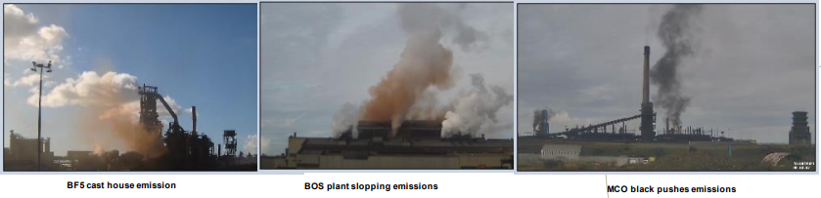
▪ Fugitive dust sources are taken into consideration when investigating complaints of fallout and visual emissions from the community with the use of a dust library to compare known to unknown dust samples

Figure 6 - Emissions Examples

2.3.4 How does Tata Steel monitor PM10 & Dust?

Tata Steel maintains a network of over 25x on-site monitors and many can record Particulate Matter (PM10 and PM100), deposition gauges, weather and noise. Including liaising with local community samples to pinpoint the dust source.
• Over 11x cameras (with 9x back up cameras) that automatically capture process emissions from known emission sources and are categorised by severity 1–3 (3 having the highest severity).
• Continuous Emission Monitoring Systems (CEMS) are installed on stack emission points (39 stacks in Port Talbot). In cases where CEMS are not in place, the emissions monitoring team conducts spot sampling to verify compliance with the specified emission limit values (ELV) as outlined in the environmental permit.
• We also have an extensive CCTV network to aid in further monitoring of site emissions.
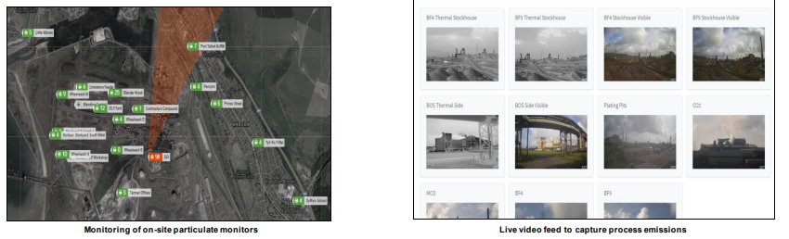

Figure 7 - Dust Monitoring

2.3.5 How does Tata Steel UK mitigate our environmental impact?

Stability of operation – Stability prevents fluctuations and equipment malfunctions that can lead to increased pollution and greenhouse gas emissions
• Dust Extraction System – These capture and contain dust particles, preserving air quality.
• Dust suppression systems - are used on product conveyors and in key process areas are visible within the control rooms across the site.
• Latexing of raw material stockpiles - which is the application of chemicals to form a protective layer, to minimise dust lift-off from stockpiles.
• Water bowsers and road sweepers - Online real-time GPS tracking systems are installed, and these are used to review performance and in turn minimise dust on site.

None of these are employed at the Blast Furnace no4 Pug Mill floor, hence the decision of a proposed solution to position a lorry with a skip within its trailer directly beneath the Pug Mill.

Chapter 3 – Background Research

Tata Steel Port Talbot site is classified as a Tier 1 COMAR. Control of Major Accident Hazards Sites (COMAH) [5]

3.1 Port Talbot site classification

The Port Talbot site is an upper tier COMAH site in part due to the generation, storage, distribution and use of CO bearing gases (COG, BFG, BOSG, Mixed Gas). Anyone on site is potentially at risk of toxic inhalation in the event of a major gas release.
As part of the COMAH regulations, employers must comply with the (DSEAR) Dangerous Substances and Explosive Atmospheres Regulations 2002, which is the primary legislation applying to the control of substances that can cause fires and explosions in the workplace. [5]

3.1.1 DSEAR
The Dangerous Substances and Explosive Atmospheres Regulations 2002 are abbreviated as DSEAR. Dangerous substances can endanger people's lives through fire and explosion. DSEAR enforces duties on employers and self-employed persons to safeguard people from hazards in the workplace such as fires, explosions, and similar catastrophes. This includes members of the public who may be endangered by work activities. [5]

3.1.2 ATEX
The EU Directives ATEX 95 (94/9/EC) and ATEX 137 (1999/92/EC) govern the sale and use of equipment in potentially explosive atmospheres, respectively. The name 'ATEX' is an abbreviation formed from the French title of the 94/9/EC Directive.
The term ATEX also refers to the regulatory criteria for managing explosive atmospheres and the suitability of the equipment and protective systems employed in them. HSE implements the user Directive, ATEX 137, under the Dangerous Substances and Explosive Atmospheres Regulations 2002 (DSEAR). ATEX 137 is concerned with worker health and safety in workplaces where potentially explosive atmospheres exist. [5]

3.2 DSEAR

3.2.1 When does DSEAR apply?
Apart from certain activities involving ships, DSEAR applies whenever:
- There is work being carried out by an employer (or self employed person)
- A dangerous substance is present (or is liable to be present) at the workplace
- The dangerous substance could be a risk to the safety of people as a result of fires, explosions or similar energetic events or through corrosion to metal
Fires and explosions create harmful physical effects - thermal radiation, overpressure effects, and oxygen depletion. These effects can also be caused by other energetic events such as runaway exothermic reactions involving chemicals or the decomposition of unstable substances such as peroxides. These events are also covered by DSEAR. Gases under pressure can also cause explosions creating harmful effects. Substances that are corrosive to metal may cause damage to metal or metal-containing structures which could result in reduced structural integrity. [6]

3.2.2 The Fire Triangle
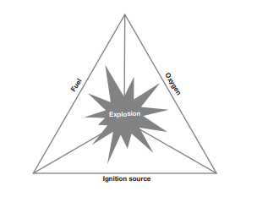

Figure 8 - Fire Triangle
[6]

3.2.3 Where does DSEAR apply?

DSEAR applies to workplaces where dangerous substances are present, used, or produced.
Workplaces are any premises or parts of premises used for work. This includes places such as industrial and commercial premises, land-based and offshore installations, mines and quarries, construction sites, vehicles and vessels, etc. Places such as the common parts of shared buildings, private roads and paths on industrial estates and road works on public roads are also premises - as are houses and other domestic premises if people are at work there. [6]

3.2.4 What are dangerous substances?

Dangerous substances are substances or mixtures of substances (called 'preparations' in DSEAR) that could create risks to people's safety from fires and explosions or similar events, such as 'thermal runaway' from chemical reactions or are corrosive to metal. Liquids, gases, vapours and dust that may be found in a workplace can all be dangerous substances. [6]

3.2.5 Gases and Port Talbot and Llanwern

Across Port Talbot, there are a variety of dangerous gases and dust, the gases include but are not limited to, Blast Furnace Gas, BOS Gas, Coke Oven Gas, Coke Dust, and Coal Dust.

Blast Furnace Gas is generated as fuel such as coke, iron ore, and limestone are continuously fed by a conveyor into the top of the furnace, whilst hot air is blown into the lower section of the furnace, through a series of pipes, resulting in a reaction taking place as the material descends under gravity. The downward-end products are molten iron, and the upward-end product is Blast Furnace Gas (Top Gas).

During the basic oxygen steelmaking (BOS) process carbon-rich pig-iron is made into steel via oxygen injection, through lances, oxidizes undesirable impurities contained in the metallic feedstock, oxidation reduces the carbon content of the steel and in turn, creates BOS Gas.

Coke Oven Gas is generated from the coke-making process, the coke oven is designed for the pyrolysis of coking coal in order to produce metallurgical coke, which is then useable ‘by-products’ including, Ammonia, Coal tar, Benzole, Naphthalene, Ammonium, and Coke Oven Gas.

Coke Dust is generated from bituminous coking coal, which is in large lumps as it reaches the ‘crusher house’ where it is crushed into lumps no larger the 3mm, during this process, coal dust escapes from all parts of the plant in turn creating a hazardous area.

Coal Dust is generated as coal is distributed from the stockyard via a conveyor and into the Screen House in the Carbon department where it is crushed into smaller more manageable sizes and then stored in silos before being fed into the Blast Furnace.

3.2.6 Overview of Area Classification

The control of sources of ignition by the use of specially protected equipment in areas where flammable gases or vapours may arise has been a fundamental safety measure for many years. Thus hazardous areas are classified into zones based on the frequency of the occurrence and the duration of an explosive gas atmosphere. The zones for gases, vapours or mists are defined in Schedule 2 of DSEAR. [6]

Zone 0 – A place in which an explosive atmosphere consisting of a mixture with air of dangerous substances in the form of gas, vapour or mist is present continuously or for long periods or frequently.
Zone 1 – A place in which an explosive atmosphere consisting of a mixture with air of dangerous substances in the form of gas, vapour or mist is likely to occur in normal operation occasionally.
Zone 2 – A place in which an explosive atmosphere consisting of a mixture with air of dangerous substances in the form of gas, vapour or mist is not likely to occur in normal operation but, if it does occur, will persist for a short period only. [6]

There are three defined grades of flammable gas, vapour or liquid release. These are defined in terms of their frequency and duration and are:
Continuous grade release: A release that is continuous or nearly so, or that occurs frequently and for short periods.
Primary: A release that is likely to occur periodically or occasionally in normal operation i.e. a release which, in operating procedures, is anticipated to occur.
Secondary: A release that is unlikely to occur in normal operation and, in any event, will do so only infrequently and for short periods i.e. a release which, in operating procedures, is not anticipated to occur. Such releases may be of known size e.g. fracture of a drain, or unknown size e.g. corrosion hole. These generally give rise to areas classified as Zones 0, 1, and 2 respectively. [6]

3.2.7 Equipment in Hazardous Areas

All equipment manufactured for use in explosive atmospheres must be suitably marked to indicate in what hazardous area (zone) the equipment can be used. Equipment marking can be found in BSEN60079-0.

From BSEN60079-0, the marking according to this standard is to be supplemented by the marking according to directive 94/9/EC. [6]
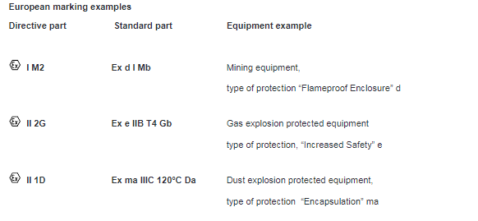

Figure 9 - DSEAR Marking Examples

The Ex marking for explosive gas atmospheres and explosive dust atmospheres shall be separate and not combined. Such as the example below.
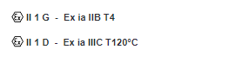

BSEN60079-0 Point 6.6.3 – Electromagnetic and Radar energy radiating equipment, Radar sources.

The output parameters from Radar sources of electrical equipment of EPL, Ma, Mb, Ga, Gb, Gc, Da, Db, or Dc shall not exceed the following values:

- 0,1 W/cm2 and 10MHZ for continuous sources,
- Average power density 0,1 W/cm2 and 2mJ/cm for pulse sources.
These parameters were checked with the manufacturer of the units before purchasing.

BSEN1127 6.4.12 Radar Waves

For the identification of hazards arising from Sensors, see 5.11.
The information in this subclause refers only to ignition hazards caused by acoustic power. 6.4.5 shall be taken into consideration for the associated electrical systems. [7]

NOTE 1 For specific applications see EN IEC 60079-0. If hazards due to Radarwaves have been identified, dependent on the category the following specific requirements for equipment, protective systems and components shall be complied with:

All categories: Radarwaves with a frequency of more than 10 MHz shall not be permitted, unless the absence of an ignition risk is proved for the case in poiThe following table outlines the main goals of the project, which are divided into subcategories based on the order in which they were completed. The table provides information on significant milestones and indicates whether they have been achieved or not. Additionally, it lists two tasks that are currently being worked on and will be completed after the report has been submitted.hich can easily catch fire (such as cotton i.e. at kHz frequencies) shall always be avoided in strong ultrasound fields, independent of the kind of hazardous explosive atmosphere, because the burning absorber could ignite a hazardous explosive atmosphere. [7]

The sound pressure level at any point in the whole sound field shall not exceed 170 dB (re. 20 µPa), unless it is proved for the case in point that ignition is not possible. The threshold is applicable to hazardous explosive atmospheres of gases, vapours, and dusts because critical temperatures for these atmospheres are not reached below this threshold.
NOTE 2 This is because even in solids with 100 % sound absorptivities (at 5 kHz), no critical temperature is attained. This threshold comprises a safety margin of 6 dB and takes into account a measurement uncertainty of 2 dB (k = 1). [7]

For Radarwaves with a frequency of up to 10 MHz in liquids in contact with hazardous explosive atmospheres, the following is required:

All categories: The acoustic intensity at the liquid surface shall not exceed 400 mW/mm2 unless it is proved for the case in point that ignition is not possible. Critical temperatures cannot be induced in sound-absorbing solids that penetrate the liquid surface below this threshold.

In applications that do not comply with this threshold, ignition shall be excluded by other means.

Exclusion of acoustically absorbing bodies that penetrate the liquid surface and have an acoustic impedance similar to liquid, i.e. one order of magnitude different to the acoustic impedance of the liquid; or
Exclusion of acoustically absorbing bodies that are spatially fixed and penetrate the liquid surface; or

The period of acoustically absorbing bodies that penetrate the liquid surface is limited to less than 3 seconds. [7]

EEMUA 186 3.1.11 – Selection of RadarEquipment
When Sensors are applied, significant proportions of the energy released by the sound transducer are absorbed by solid or liquid materials. Heating can occur in the material affected and, in extreme cases, may heat the material beyond the minimum ignition temperature. Radar equipment which is installed in hazardous areas, or installed outside, but radiating into the hazardous area, shall meet the requirements of IEC 60079-14:2013 Clause 5.8 [7]

3.3 Protection Concepts

3.3.1 What is a protection concept?

There are a total of 11 electrical protection concepts defined in the standards, arguably only 1 of them is a truly electrical concept where the energy delivered to the device is limited by design (Ex i)

The others rely on:-
- Exclusion of the flammable substance (e.g. Ex p, Ex o)
- Quenching (Ex d, Ex q)
- Prevention of sparks or hot surfaces (Ex e)

3.3.2 Protection Concepts Briefs.

3.3.2.1 Flameproof – Ex d

The letter ’d’ comes from the German word ‘Druckfest’

The idea is straightforward: place equipment in an extremely strong enclosure that will contain an internal explosion and cool the hot gas that departs immediately after an explosion, preventing the ignition of gases outside the enclosure.

Gases must be able to exit 'freely' through the flamepath; any limitation on gas escaping would affect the internal pressure within the enclosure as well as the temperature of the gas escaping. [6]

3.3.2.2 Increased Safety – Ex e

The letter ’e’ comes from the German word ‘Erhohte Sicherheit’

The concept is to minimise risks from arcs, sparks, and hot surfaces.
Enclosures to meet an impact rating of a minimum of Joules, IP54 Minimum, be solvent-resistant, terminals designed to maintain contact pressure on the wire. [6]

3.3.2.3 Pressurisation and Purge – Ex p

The underlying concept is one of exclusion; the technique of pressurising and purging enclosures prohibits any flammables from entering the enclosure. Fresh air (or an inert gas) is drawn from a non-hazardous area absent of flammable gases.

There are 3 sub-concepts of Ex p, which are, Type pxb, Type pyb, Type pzc. [6]

3.3.2.4 Oil Immersion – Exo

The idea is to protect by immersing equipment such as Heavy current switchgear, Transformers, and Resistance starters in oil. [6]

3.3.2.5 Powder Filling – Ex q

The basic concept is to protect by powder or quartz filling, applications include starters for Ex e Lighting, Capacitors, etc. [6]

3.3.2.6 Encapsulation – Ex m

Encapsulating components in an 'encapsulant', such as a compound or resin, provide protection. Applications include Solenoid Valves, Power supplies, etc. [6]

3.3.2.7 Non-Incendive – Ex n
The protection is a relaxed version of other methods as this concept is suitable for zone 2 use only, and includes various sub-concepts.
Such as,
Ex nA – Non-Sparking
Ex nR – Restricted Breathing
Ex nC – Simplified Pressurisation
Ex nL – Energy Limiting Apparatus
Ex nC – Enclosure Break. [6]

3.3.2.8 Optical Radiation – Ex op
There are 3 types of sub-concept

OP IS – Inherently Safe Optical Radiation
OP PR – Protected Optical Radiation
OP SH – Optical System with Interlock
Can be used in all Gas zones. [6]

3.3.2.9 Special – Ex s

This concept is reserved for special cases and has no specific rules.
There are 3 types of sub-concept

Sa – Zone 0
Sb – Zone 1
Sc – Zone 2. [6]

3.3.2.10 Protection by Enclosure – Ext

Type of protection whereby all electrical equipment is protected by an enclosure to avoid ignition of a dust layer of cloud.

The concept applies only to dust environments and is not a recognised concept in gas/vapour areas.
There are 3 types of sub-concept

ta – Zone 0
tb – Zone 1
tc – Zone 2. [6]

3.3.2.11 Protection ‘I’ Intrinsic Safety

Type of protection ‘I’ is one in which the energy available in the hazardous area is limited to a level below that which could ignite a flammable atmosphere.

There are 3 types of sub-concept

ia – Zone 0
ib – Zone 1
ic – Zone 2. [6]

3.4 Past and Present Standards

BS229: 1957 – 1971 Specification: Flameproof Enclosures of Electrical Apparatus, the logo for this standard was FLP in a crown.

BS1259: 1958 Specification: Intrinsically Safe Electrical Apparatus and Circuits for use in Explosive Atmospheres. This was replaced by BSEN 50020 in 2002 which was in turn replaced by En60079-11 in 2007.

BS4683-1: 1958 Specification: Electrical Apparatus for Explosive Atmospheres. Replaced by BS229 in 1979

BS5501-1: 1077 – 1993 Specification: Electrical Apparatus for potentially Explosive Atmospheres. Atmospheres general requirements. Replaced by BS EN50014 in 1993

BS5345: 1989 Specification: For Zones, Gas, Gas Groups and Protection Concepts, etc. Replaced by BS EN60079 in 2006

ES60079 – 2003 Specification: European standard which is ATEX, EN stands for ‘Euro-norm’ (European Standard)

IEC 60079 Specification: International standard that we work to. European and International standards run in parallel to each other.
The four most used sections of 60079 are as follows:

BSEN 60079-10 - Classification of Hazardous Areas
BSEN 60079-14 – Electrical Installation / Design
BSEN 60079-17 – Inspection & Maintenance
BSEN 60079-19 - Electrical Equipment Repair & Overhaul

EN61241: 1999 – 2006 - ATEX Dusts Replaced by BSEN 80079 in 2006

EN13463/ISO80079 – 2009 – Mechanical (Non-Electrical)

3.5 TYPES OF DUST CATCHER

Tata Steel UK at Port Talbot has two traditional operational Blast Furnaces, Blast Furnace 4 (BF4) & Blast Furnace 5 (BF5), both furnaces are operational with different methods of capturing dust. At Blast Furnace 4 a newer method of capturing dust is used, this is via a Cyclone, and, at Blast Furnace 5, dust is captured using the traditional method of a dust catcher.
Below is a brief explanation of the principles of each method.

3.5.1 Dust catcher principles of operation – Used at Blast Furnace 5

A gravity dust-catcher consists of four main parts; the inlet section, an internal trumpet, the main body and hopper, and the gas outlet pipe. The dust-catcher trumpet is the main feature that affects flow performance and the consequent particle separation efficiency. A dust-catcher relies solely on gravity to separate dust particles from the blast furnace top gas flow. These particles, carried by the free flowing gas pass out the top of the furnace and through a down-comer section where they enter another section which reduces the incoming velocity of the top gas through its diverging expansion profile (known as a trumpet). The flow then passes into the main body of the dust-catcher. The flow is then forced to turn 180˚ in the bottom third of the dust-catcher causing the heavier particles to deposit themselves in the dust-catcher hopper where they are removed periodically. [8]

3.5.2 Cyclone Principles of Operation – Used at Blast Furnace 4

The principle of a cyclone is to separate dust and particulates from a free moving gas stream without the use of filters. The shape of the cyclone generates an internal gas vortex aiding the separation of the solid particles from the gas stream. Rotational effects and gravity are used to separate mixtures of solids. The inlet to the cyclone brings in the blast furnace top gas, establishing a high speed rotating spiralled flow within the cylindrical confines of the cyclone body. The spiral begins at the cyclone’s top end (widest point), and ends up at the bottom end (narrowest point), before exiting vertically upwards, in a straight stream along its central axis. [8]

3.5.3 Which method is better?

It is found that a gravity dust-catcher and a gas separation cyclone both have extremely good benefits, but some drawbacks as well. First of all, if space constraints are not problematic, it may be possible to incorporate a medium-sized dust-catcher to remove the bulky particles, in conjunction with a smaller, more efficient cyclone, removing the smallest particles.
In terms of the efficiency of dust removal from the top gas, the only logical choice is the gas separation cyclone. [8]

As a result, retrofitting a remedy to the existing cyclone is a reasonable decision and one that Tata Steel has taken.

Chapter 4 – Design

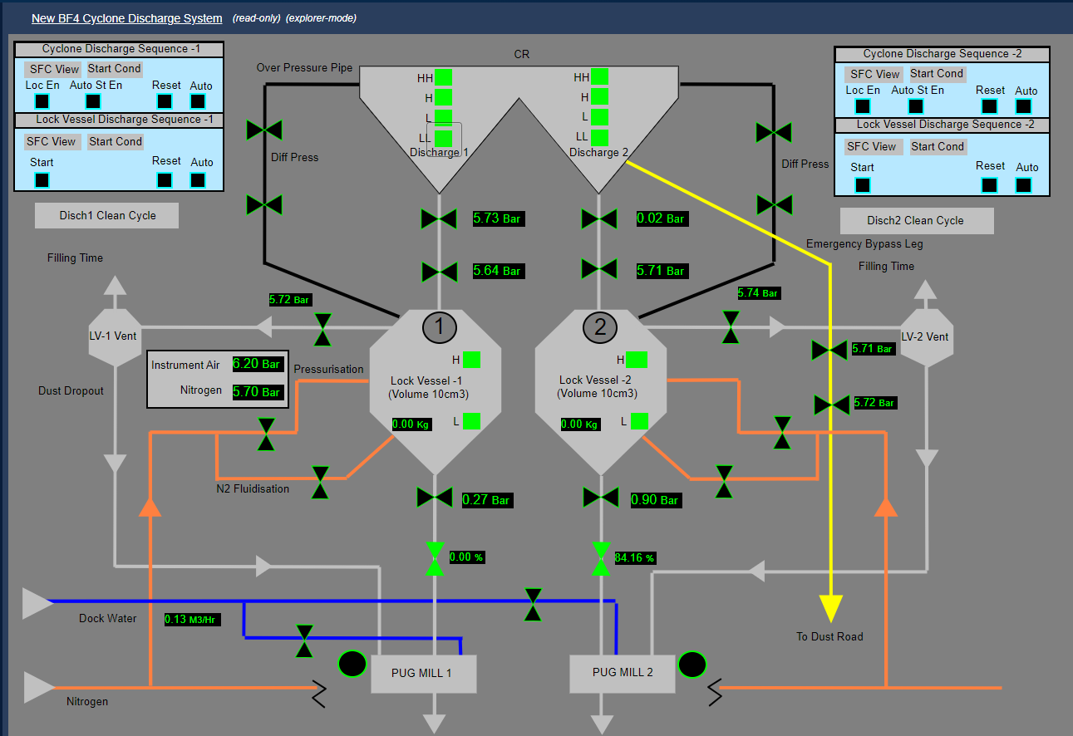

Figure 10 - Cyclone Discharge System

4.1 Design Overview

Figure 10 depicts the Blast Furnace 4, Cyclone discharge system, discharge 1, and discharge 2 of the cyclone as the two down legs (often referred to as trouser legs among Tata employees).
The movement of dust is then controlled by two inlet dome valves located between the trouser legs and the lock vessel.
The lock vessel is controlled by one of two level switches, which allow dust to enter the Pug Mill through an outlet dome valve.

There are currently eight level switches mounted in two groups of four on either side of the vessel.

4.2 Indications of the existing Switches

These switches provide the following indications:-

High-High – Alarm to the operator that the vessel is full, and initiate discharge should the local selector switch be in auto. If manual is selected the discharge sequence can only be initiated via the computer workstation or start discharge button at the LCP (Local control panel).

High – Message to the operator that the vessel requires emptying, and initiate discharge should the local selector switch be in auto. If manual is selected then the discharge sequence can only be initiated via the computer workstation or start discharge button at the LCP (Local control panel).

Low – Enables vessel discharge.

Low-Low – Disables/stops the vessel discharge.

The following control and alarm levels are allocated to each level switch

- Interlock
- Control
- Alarm & Control
- Alarm.

The readings taken from the levels are as follows

- High-High – 38M
- High – 36M
- Low – 30M
- Low-Low – 28M

There is currently suspicion that the level switches are either not reading at all or are not reading accurately, as they do not display readings on the BF SCADA system (see appendices for screenshot).
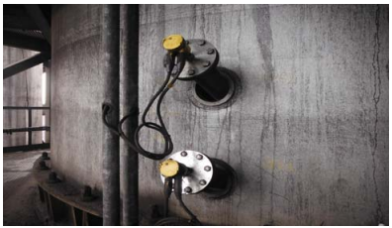

Figure 11 - Existing Level Switches
Figure 11 shows the existing level switches.

4.3 OEM Recommendations

The current predicted daily tonnages for cyclones range from 150t over 24 hours 365 days a year to a peak of 200t /24hr.
The OEM suggests dumping the cyclone every 8 hours; however, Tata currently operates this task every 24 hours.

4.4 Market Research

Different types of sensors on the market with comparison table 4.5

4.5 Comparison Table
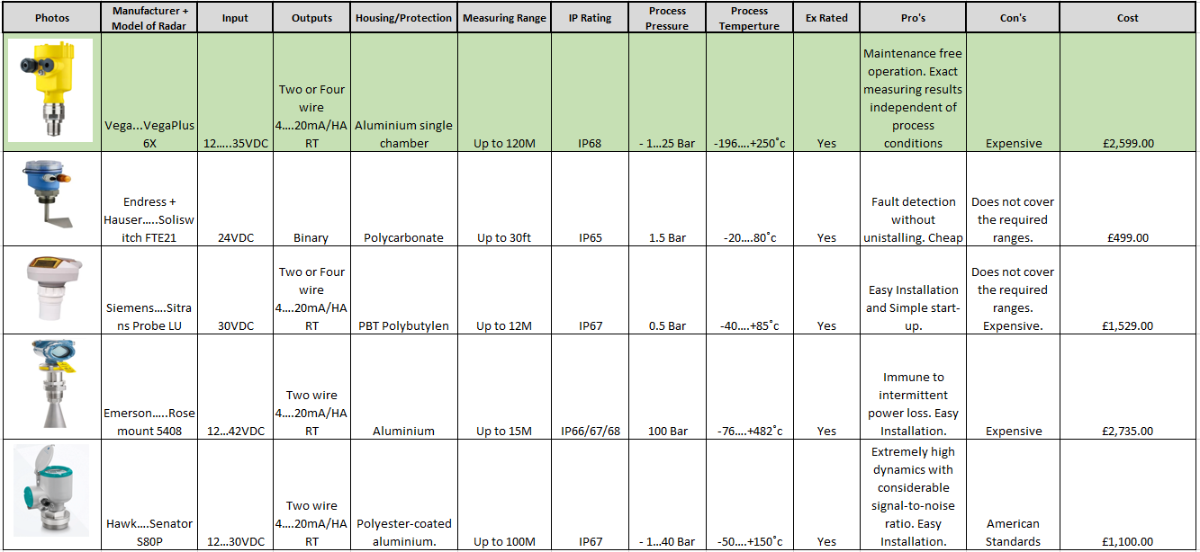

Figure 12 - Sensor Comparison Table
Five different sensors have been researched and their parameters are presented in the table above.

The Vega, Vegaplus 6X was chosen, simply because Vega is an approved supplier with Tata Steel, and their products are used throughout the site, allowing for familiarity with their products alongside providing Tata with access to the Vega helpdesk 24 hours a day, 365 days a year, should technical support be required.

4.6 Sensor Set-Up Pre-Installation on Site
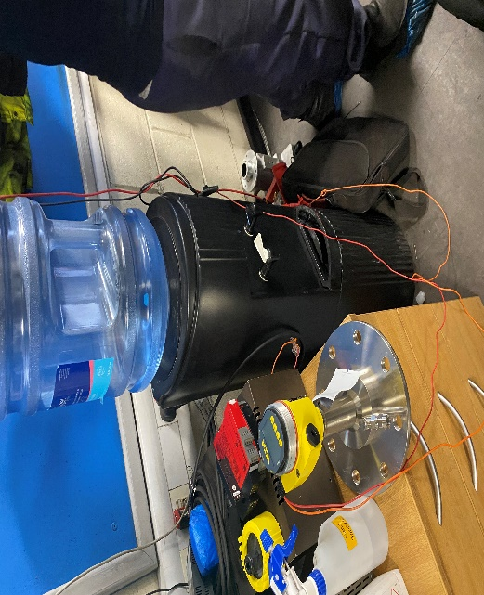
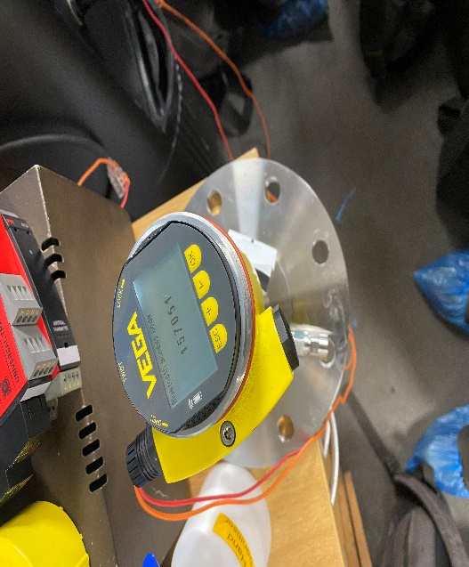

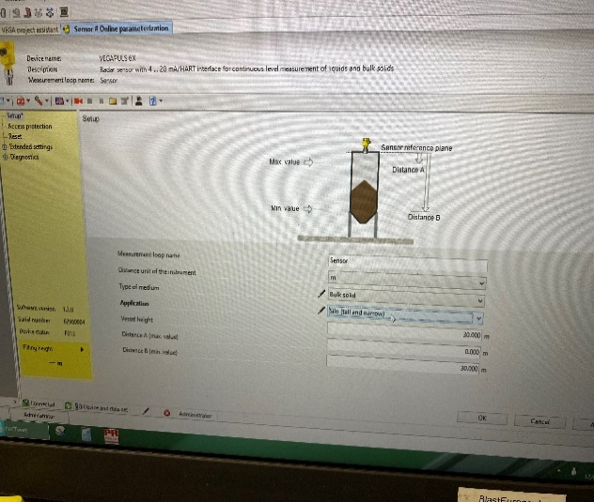
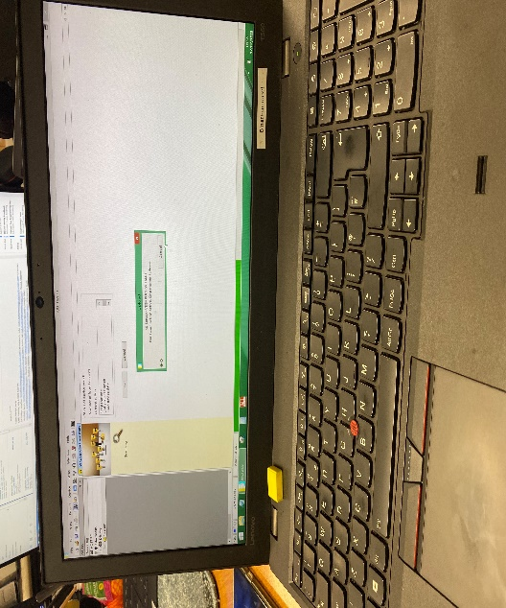

Figure 13 - Pre Installation Set-up
The sensors were tested in the Blast Furnace offices before being installed on-site, using temporary testing equipment. Bluetooth connectivity is an important feature of the VegaPlus 6X. This enables the sensors to be remotely connected and configured using a laptop or smartphone.

A distance of 2 meters was measured and marked out in the office, the sensor was then connected to the laptop, and the radar was placed at the pre-set measurements.

The radar read the distance and returned a reading of 1.95 meters, allowing the team to decide that the radar was reading accurately and was suitable for installation on site. This was then performed for the second radar, which returned a measurement of 1.96 meters, demonstrating that the radar was reading correctly.

4.7 Wiring System

The wiring method used to operate the sensors is a 4-20mA system, this is a commonly used control system method in industry.
The antenna of the radar level instrument transmits a very narrow microwave pulse which propagates at the speed of light in space.
When meeting the dielectric surface to be measured, part of its energy is reflected and received by the same antenna. The time interval of transmitting and receiving pulses is proportional to the distance between antenna and dielectric surface to be measured, and therefore the distance between antenna and dielectric surface to be measured can be calculated. [9]

In the industrial field, using an instrumentation amplifier to complete the signal conditioning and transmit it over a long line will cause the following problems: firstly, since the transmitted signal is a voltage signal, the transmission line will be interfered with by noise; secondly, the distribution resistance of the transmission line will generate voltage drop; thirdly, how to provide the working voltage of the instrumentation amplifier in the field is also a problem. [9]

To solve the above problems and avoid the influence of related noise, we use current to transmit the signal, because the current is not sensitive to the noise. 4～20mA current loop uses 4mA to indicate the zero signal and 20mA to indicate the full scale of the signal, and the signal lower than 4mA and higher than 20mA is used for various kinds of fault alarms. [10]

4.8 Comparison Table of Common Wiring Systems

Wiring System | Advantages | Disadvantages
0-10V | 0-10 voltage readings are easier to take than current readings when troubleshooting. 0-10V devices tend to be more common to purchase. It can be transmitted over long distances without significant signal degradation or interference | A sensor fault (no signal) cannot be detected: A value of 0V can indicate either zero value or no signal. It’s possible to work around this by using a 2-10V instead, but this is uncommon. It is prone to electrical noise and interference. Over longer cable distances, voltage drop can cause an inaccurate signal. A separate power supply to the instrument is usually required, meaning the sensor requires at least three wires.
Profibus | Speed and Efficiency: Profibus can support up to 12 Mbps data transfer rates, ensuring quick and efficient communication. Interoperability: Profibus enables devices from different manufacturers to communicate seamlessly, thanks to its standardized communication protocol. Flexibility: The protocol can be used in a variety of network topologies, including tree, star, and ring structures. Cost-Effective: By reducing the need for extensive cabling and allowing for easier system expansion, Profibus provides a cost-effective solution for industrial automation. | Limited Speed: While Profibus is suitable for most industrial applications, its maximum speed of 12 Mbps may not be enough for some high-speed or large data volume applications. High consumption in the transmission of short messages, the lack of power on the bus, and the higher cost as opposed to other buses. Expensive ASIC Required, No Power over the Bus, Expensive Connector
4-20mA | A no-signal fault can easily be detected: 0mA indicates no signal, while 4mA indicates a zero value. An instrument can be ‘loop-powered (often 24VDC) – meaning it can be powered by the same cable that it transmits on, meaning only two wires are required. It is much less prone to electrical noise, interference, and voltage drop. | High power consumption compared to other analogue signal types. Elevated output at zero reading. Supply is not isolated from output. Increasing circuit load resistance will reduce the supply voltage available to power the transmitter that is generating the 4-20mA signal

Figure 14 - Wiring Systems Caraison Table

[11] [12] [13] [14] [15]

4.9 PLC System Requirements

The system will require an HMI for operator interaction. The HMI must have the following controls and displays available on the home screen:-
- Buttons for starting and stopping the sequence.
- Signal failure alarm
- Current dust levels of each trouser leg.
- Indication of which Trouser leg requires dumping when not in auto mode.

A fault and warning screen which displays alarm warning.
Warning and alarm must include:-

- If the skip is in place before the sequence can start
- If the levels have exceeded 10M.
- Which of the existing level switches have been triggered.

A diagnostics screen to indicate which warning and/or fault are showing in real-time.

Incorporate a Toggle switch on the screen to switch between existing level probes and new radars

4.9.1 Process Steps

Step 1. When a reading of 7M (High Level) is obtained, once the lock vessel has been suitably pressurised, then, open the fluidisation line.

Step 2. Close the pressurization line. The 2 inlet dome valves between the trouser legs and the lock vessel will open for a duration of 2 seconds, allowing dust to enter the lock vessel; Note, that this should only be done for one trouser leg at a time.

Step 3. The 2 inlet dome valves from the trouser leg to the lock vessel will close once the dust has been transferred to the lock vessel.

Step 4. There are 2 existing levels within the lock vessel, L and H, once the H level switch has been triggered, Run the motor on the pug mill, water is to be introduced to the pug mill before the start of the sequence, 5 seconds, the outlet dome valve and dust control valve into the pug mill is opened, the lock vessel depressurisation valve (LV-1 &/OR LV-2) must also be opened during the phase, and dust leaves the lock vessel to transfer into the pug mill.

Slide valve/dust control valve, remove from the sequence, MOC.

Step 5. add a counter that will count the total weight dumped throughout the sequence.

Step 6. The outlet dome and dust control valves between the lock vessel and the pug mill are closed.

Step 7. When this procedure is completed, the material is ready to be transported into the skip beneath the pug mill.

Step 8. Once the pug mill has emptied, the valves are closed, and the sequence restarts to step 1 and onto the alternate trouser leg.
Step 9. There is an existing load cell located within each lock vessel, this allows the weight of the dust to be measured before leaving the lock vessel.

Step 10. When the dust enters the pug mill, water is added to it to increase the diameter of the fine dust and, as a result, reduce emissions.

Step 11. Existing flow control valves that deliver dock water to each pug mill will be incorporated into the new system to capture the flow and volume of water added to the material for final weight comparisons.

Note:- If the Radars fail and the levels are reading over 10M, the level switches are to be used as a backup measurement.

The skip that will transport the finished product will be weighed when empty and full allowing for a value of the finished product to be gained, and the load cells positioned within each lock vessel will allow the weight of the dust to be taken and compared to that located within the skip before it is transferred to the Sinter Plant.

To ensure safety and efficiency, we plan to integrate a sensor into the system that will detect the presence of a skip before initiating step 1. This precautionary measure will help prevent any accidents or malfunctions during the operation. We have listed below the available options that we can use for this purpose.

- Inductive loop sensor (mat in the ground)
- Magnetometer
- Radar Sensor

4.9.2 Parking Arrangements of the Lorry

Parking bays will be required (painted lines on the floor or a bunded wall) to allow the lorry/skip to park in the correct position and trigger the sensor.

Installation of a new Pedestrian Crossing in front of the Pug Mill floor, using Fhoss walkways, this is a new site standard at the Port Talbot Works.
Link to website - Illuminated Safety Walkways - FHOSS

4.10 Speed of sound for various gasses

The speed of sound varies greatly depending on the medium it is traveling through. The speed of sound in a medium is determined by a combination of the medium’s rigidity (or compressibility in gases) and its density. The more rigid (or less compressible) the medium, the faster the speed of sound. The greater the density of a medium, the slower the speed of sound. The speed of sound in air is low because air is compressible. Because liquids and solids are relatively rigid and very difficult to compress, the speed of sound in such media is generally greater than in gases. [16]

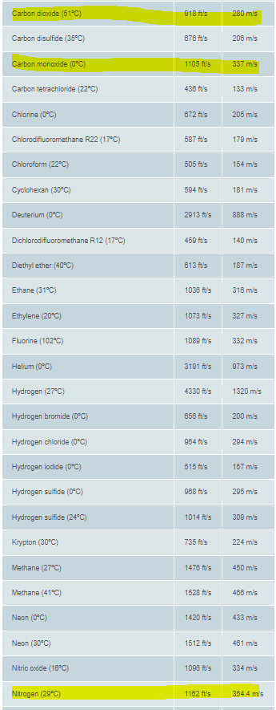

Figure 15 - Speed of Sound for Various Gases Table

Figure 15 above shows a list of common gases at atmospheric pressure.

4.10.1 Atmospheric Pressure

Air molecules colliding with a surface cause atmospheric pressure. Atmospheric pressure at sea level is about 101,000 Pa (101 kPa) but just 27,000 Pa (27 kPa) at the cruising altitude of a passenger plane.
Atmospheric pressure decreases as the height of a surface above ground level increases. This is because, as the altitude increases:
- the number of air molecules decreases
- the weight of the air decreases
- there is less air above a surface
This is why aircraft that fly at high altitudes must be pressurised. If the air pressure is too low, humans cannot take in oxygen quickly enough to meet their bodies’ needs. [17]
Atmospheric pressure drops as altitude increases. [18]

To compare the pressure of the cyclone against the atmospheric pressure at sea level, the following has been calculated.
1 bar = 100,000 pascals (Pa)
Therefore, with the cyclone pressure being at 5.71 Bar pressure (at the time of calculation, pressure can vary and is not a constant pressure), 5.7 bar = 570,000 pascals (Pa)
With atmosphere pressure at sea level being, 101,000 Pa, to obtain the atmospheric pressure of the cyclone the conversion factor '0.98692326671579’ is applied.
Therefore, 5.7 bars = 5.7 × 0.98692326671579 = 5.62546262028 atm. [18]

4.11 Typical Composition of Blast Furnace Gas

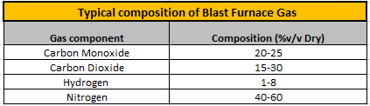

Figure 16 - Blast Furnace Gas Composition Table
Blast furnace gas is mostly composed of Carbon Monoxide, Carbon Dioxide, and Nitrogen, with a trace of Hydrogen included.

Details about the gases were supplied to Vega during the first consultation phase, and this was taken into account when selecting the Radars, and communication with Vega, the Radars' manufacturer, was established to evaluate whether the gases would alter the Radars' results. Tata was informed that the VegaPlus 6X had been tested and that gases and the internal pressure of the cyclone had no effect on the final values (Sensors would be housed outside of the cyclone and thus would not be subjected to any internal pressure).

The sensor works by emitting a continuous signal through the antenna. The emitted signal is reflected by the medium and received as an echo by the antenna. The frequency difference between the emitted and received signal is proportional to the distance and depends on the filling height. The determined filling height is converted into a respective output signal and output as a measured value. [19]

4.12 LiDAR – Workings

4.12.1 LiDAR distance measurements

LiDAR stands for light detection and ranging and it is a technology that appeared in the 1960s, shortly after the invention of the laser. In this post, we will explain its working principle, the main types of LiDARs, and the most important applications.

LiDAR technology consists of sending a laser beam to the target and measuring the reflected light with a photodetector to determine the distance to the target and this way generate a precise map of the surrounding environment. The main advantages of LiDAR are that it can provide precise position over large areas and that it is fast, making it possible to collect information with a speed and a degree of detail that would not be possible otherwise. [19]

4.12.2 How do LiDAR’s work?

LiDAR works based on two sets of measurements. The first piece of information is the position (the scanning system can be fixed or moving) and the pointing direction of the laser for each measurement. The second one is the distance, which can be measured through different approaches.

One of them consists of employing a pulsed laser and measuring the time of flight, that is, the time it takes the light to reach a surface and return to the source, therefore:

D = c · ΔT/2

Where D is the distance to the object, c is the speed of light and ΔT is the time of flight. This system is only limited by the requirement of a return signal, meaning powerful lasers have to be employed when distances of several kilometres have to be measured. [19]

4.12.3 Types of LiDAR’s sensors?

There are two main types of LiDAR: airborne and terrestrial. Airborne LiDARs are usually installed in an aircraft or a helicopter pointing downwards towards the ground and normally they measure an angular range of 180º. Among airborne LiDARs there are two subtypes: topographic and bathymetric. Topographic LiDARs are employed in forestry, urban planning or landscape ecology to examine the surface while bathymetric LiDARs are used for measuring the elevation and depth of water in coastlines, shores or banks.
On the other hand, terrestrial LiDARs can be 1-D or 2-D, covering 180º or 360º in this last case. They are utilized to characterize in great detail facilities and infrastructures and for creating 3D models of places. There are two basic subtypes: mobile or static, depending if the scanning system is mounted on a moving vehicle or on a fixed tripod. Mobile LiDARs are used in roads, highways, railways; while static LiDARs are utilized in engineering, archaeology or mining. [19]

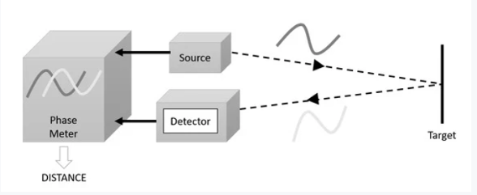
4.12.4 Time of Flight Phase-measurement

Figure 17 - Time of Flight of a Lidar
Time of flight phase-measurement principle [19]

4.12.5 Advantages of LiDAR:

Accuracy
Above all, LiDAR technology offers incredibly accurate, consistent results. The short wavelength can even detect small objects and create exact 3D models, making it possible to determine what the objects are, whether it’s a tree, person, or wall.
Speed
The sensor sends out laser pulses and receives them back in nanoseconds, making it possible to scan large areas in a fairly short period of time and still get a high volume of data.
Can Collect From a Variety of Locations
Places that are inaccessible, such as high mountains, dense forests and hard to reach areas can be easily mapped with LiDAR technology.
Automated Functionality
LiDAR technology consists of primarily automated processes, and while experienced pilots are necessary to operate the equipment, it’s more efficient than other methods of surveying that require more hands-on involvement.
Low Cost
Given the speed and large area that can be scanned coupled with the highly accurate results, LiDAR is significantly less expensive than other methods of land surveying and mapping. It is an affordable way to produce complex topographical surveys. [20]

4.12.6 Disadvantages of LiDAR:

Efficiency
Speed, cost, and the sheer volume of highly accurate data tend to make LiDAR the right option, but it’s important to know the disadvantages as you plan its use.
Requires Experience to Operate
It takes previous surveying experience to take check shots, run base stations, and check-in to benchmarks. The LiDAR is complex in nature and requires a deep understanding of the sensor.
Purchasing High-End LiDAR Sensors Are Costly
If you are trying to set up your own LiDAR shop it requires heavy investment into the LiDAR sensor and the personnel. [20]

4.13 Planning

Blast Furnace 4 shutdown was originally scheduled on W29, the original plan was to install sensors during the W29 BF4 shutdown, but the stop was cut short to 48 hours from the original planned 72 hours, which did not allow enough time to install the sensors.

The work has now been planned to be undertaken during W46, 14th November. This stop has once again been cancelled.
The stop work has been re-arranged for the 22nd & 23rd of November.

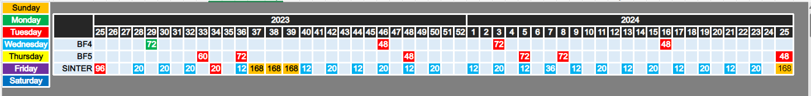

Figure 18 - Shutdown Schedule of Blast Furnace 4&5

4.14 Original Plan
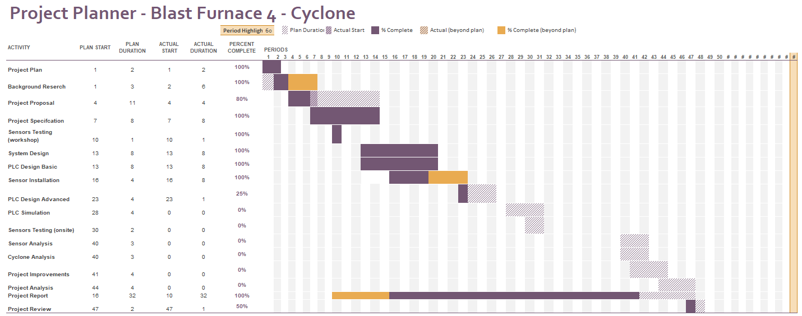
Figure 19 - Gantt Chart

4.14.1 Key Landmarks & unfinished work

The Gantt chart illustrates the key milestones that were set as KPIs for the project. As discussed further in this report, the project gained momentum during the summer of 2023, and most of the KPIs were achieved within their designated timeframe. Notably, the project plan, background research, and the project proposal were all completed before I returned to university in late September 2023.

Furthermore, the system was designed and agreed upon, and the basic PLC requirements were completed within the allotted timeframe, which indicates that the planning was given sufficient time and that the work was proceeding on schedule.

The sensors were tested in the workshop to ensure that they were fully operational and working accurately before being installed on-site. Despite some challenges, such as the Blast Furnace stops being cut short or cancelled due to production demands, the sensors were eventually installed and cabled on-site.

Unfortunately, the project's progress stopped at this point. Several tasks remain unfinished, such as finalising the full PLC requirements, creating a PLC program for the work, testing and commissioning the project, and performing an analysis of the cyclone and the sensors to determine if they achieved their goal of reducing the number of blockages the cyclone was previously experiencing.

4.15 New plan.

My project experienced a major setback towards the end of 2023 following Tata Steel UK's decision to cease all steel-making operations at their Port Talbot site. As a result, the company has shifted its focus solely to essential maintenance, and all ongoing projects have been either halted or postponed. Unfortunately, the project I have been working on was also affected and put on hold. This was a significant disappointment, especially since I had made excellent progress, with the hardware installed on the cyclone, cabling to the sensors installed, terminated, and tested, leaving only the PLC element unfinished.

As of the time of composing this report, I am uncertain if I will retain my position at Tata Steel by the time this report is due. My current position as part of the process safety team and the DSEAR compliance team is nearing its conclusion, resulting in a state of ambiguity and uncertainty for me.
After consulting with my project supervisor, Gary, it was mutually decided that I would simulate the process of the cyclone gathering dust and transferring it to the lock vessel using Factory I/O, a simulation tool available at the University. Additionally, a Siemens PLC would be employed to enable control of the simulation.

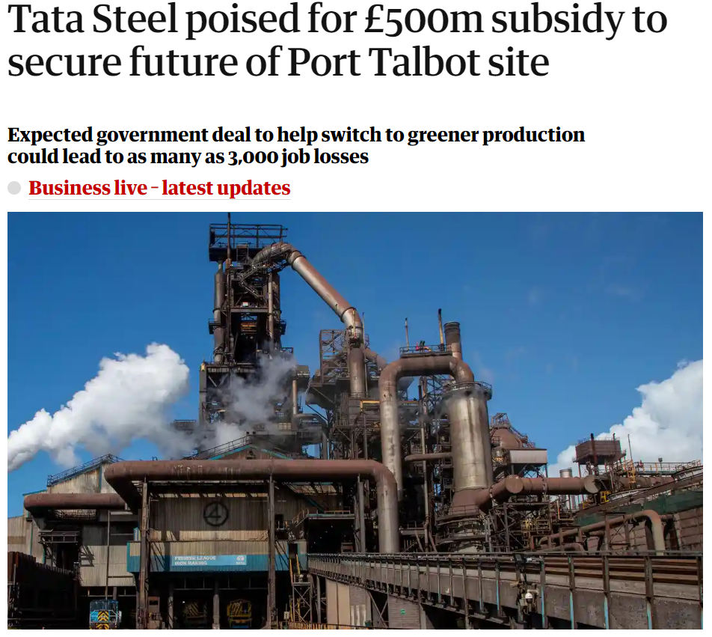
Figure 20 - Article of Tata Steel Future
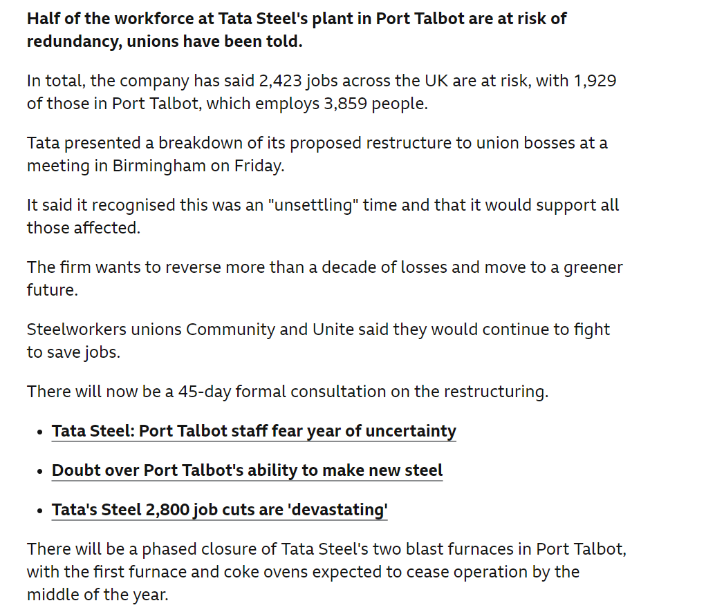
Figure 21 - Potenial Plan of Tata Steel

4.16 Chance Encounter

During a chance encounter with Ashleigh, an engineer working at the Cold Mill in Port Talbot, I was informed that there was an unused programming laptop available which had the Siemens TIA portal program installed on it. This laptop was generously given to me, allowing me to work on my project from the comfort of my home. Furthermore, Ashleigh mentioned that resources were available, including a sensor, a PLC, and an HMI screen, which I could use to simulate my project. This news was like music to my ears, as it meant that I could complete my project without having to drive to Swansea University and risk not finding an available computer to work on.

4.17 Simulation

The simulation is as follows, there are two tanks within the scene, the tank on the right represents the ‘Cyclone’ and the tank and the left represents the ‘Lock Vessel’.
This can be seen in the screenshot below.
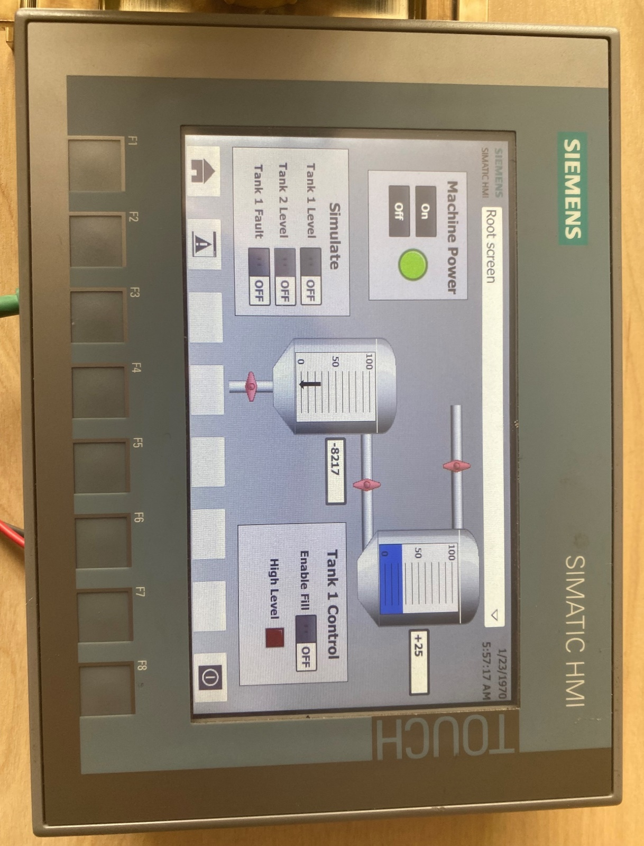

4.17.1 HMI screen

Shows the levels of the Cyclone and Lock Vessel.
High level alarm shows if the Cyclone has overflowed its intended target.
Enables the simulation process to start, once the button is in the on position.
Allows the operator the transfer between simulation mode of Tank 1 and 2, and use of the sensor.
Allows the operator to put the system in fault mode to test the overflow alarm function.
Cyclone
Lock Vessel
Machine Power, starts and stops the system.
Figure 22 - HMI Screen of Simulation

4.18 Process flow of the simulation and PLC requirements

When the fill valve on the right-hand tank is opened, the cyclone will begin to fill up with ‘dust.’ The filling process continues until the cyclone reaches a predetermined level of 7.5 meters. Once this level is reached, the discharge valve in the cyclone is triggered, opening the fill valve in the lock vessel. This, in turn, releases the "dust" from the cyclone and directs it into the lock vessel.

Once the cyclone has emptied to a predetermined level of 2.5 meters, the emptying process stops and the cyclone starts to refill. During the emptying process, the lock vessel begins to fill, reaching a predetermined level of 7.5 meters. Once this level is reached, the lock vessel then begins to empty until it reaches a predetermined level of zero.

The process is then repeated.

When the dust level in the Cyclone tank reaches 8 meters (80%), an overflow alarm is triggered. This activates a red button on the HMI screen.

The simulation process is not as advanced as the real-life scenario at Blast Furnace no4, as multiple steps of the process are missing, but this is making the best of a bad situation.

The system will require an HMI for operator interaction. The HMI must have the following controls and displays available on the home screen:-

- Buttons for starting and stopping the sequence.
- Signal failure alarm (Overflow of Tanks)
- Current dust levels of each tank are shown.

4.19 Main PLC Network

The proposed system will be designed and constructed with the aid of the Siemens TIA software and the Siemens S7-1500 PLC. An overview of each network block, along with a description of its operation, has been included to provide an understanding of the system's structure.

Main OB1 - Is the main communication block used to control the project

Network 1 – Switches the machine on or off and enables the outputs.

Network 2 – The block is used to simulate the level of Tank 1 when the external PLC, HMI, and sensor are being used. However, as I only had access to one sensor for the simulation process, I had to put the opposite tank into simulation mode to make the process work.

Network 3 – The block is used to simulate the level of Tank 2 when the external PLC, HMI, and sensor are being used. As per network 1, I only had access to one sensor for the simulation process, I had to put the opposite tank into simulation mode to make the process work.

Network 4 – The norm x block is used to scale the input of Tank 1 into a computing term to normalise the output, whereas empty is equal to 0 and full is equal to 27,648, so the tank is 10 meters in height, so, for a reading of 5 meters, a value of 13,824 would be obtained, these figures are then scaled via the scale x block into a more workable figure of between 0.0 – 1.0, and finally the output is given in terms of a more recognisable terms 4-20mA.

Network 5 – As per network 4, this block provides the same function, but for Tank 2.

Network 6 – Detects when Tank 1 has reached its intended target of 75%.

Network 7 – Detects when Tank 1 has reached its intended target of 0%, and the tank has discharged and is empty.

Network 8 – The system is designed to constantly monitor the level of Tank 1 and trigger a fault if it exceeds its maximum intended value of 75%. if the level reaches 80%, a fault is automatically generated and displayed on the HMI. This feature ensures that any potential overflows or safety hazards are detected and addressed promptly.

Network 9 – Detects when Tank 2 reaches the specified target of 75%.

Network 10 – Detects when Tank 2 has reached its expected level of 0% and has discharged and is empty.

Network 11 – As per network 8, the same fault detection block is in place for Tank 2, allowing an alarm to be triggered if an unexpected overflow has been activated.

Network 12 – Is used to drain Tank 1, when Tank 1 has reached its intended setpoint of 75%, the valve is opened allowing the Tank to be emptied, by energising Q16.0.

Network 13 – This is in place for an operator to fill the system and has a latching function if one of the tanks has inadvertently passed its intended setpoint of 75%.

Network 14 – Is used to drain Tank 2, when Tank 1 has reached its intended setpoint of 75%, the valve is opened allowing the Tank to be emptied.

4.20 Simulation Components

For the simulation, the following components were used.

- Vega Bar 83
- Siemens Simatic KTP700 Basic HMI
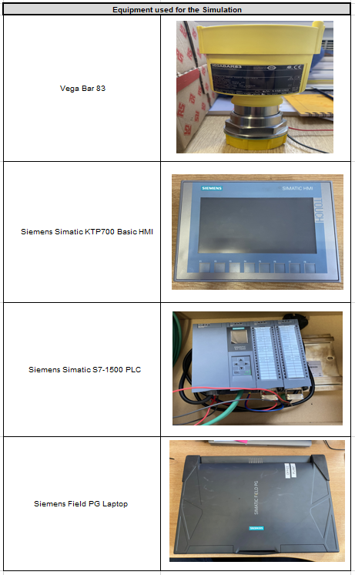
- Siemens Simatic S7-1500 PLC
Figure 23 - Components Used for the Simulation

4.20.1 Simulation Set up
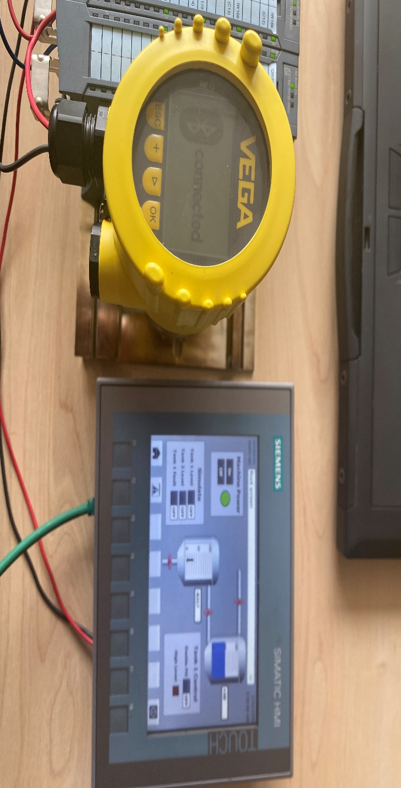
Figure 24 - Simualtion Set-up
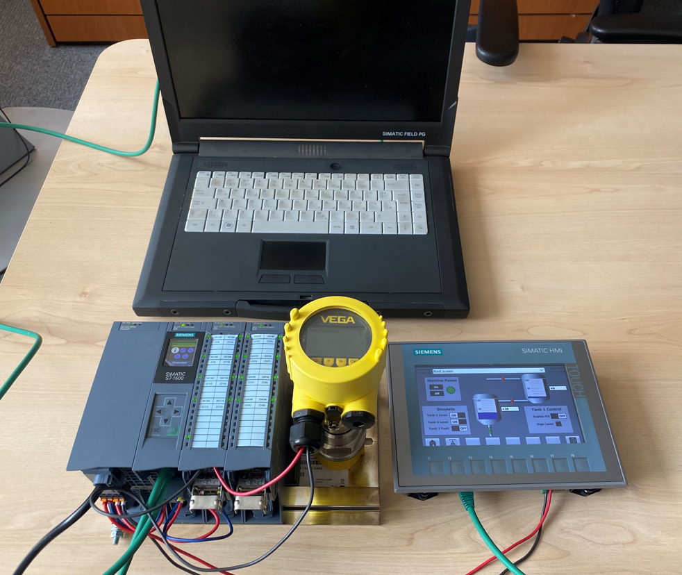
Set up of simulation in the office

Figure 25 - Connection of Vega Tools App to the Sensor

4.20.2 Vega Tools App Used to Simulate Sensor

The Vega Tools app was used to configure the Vega sensor, this allowed settings to be programmed into the sensor via the app.

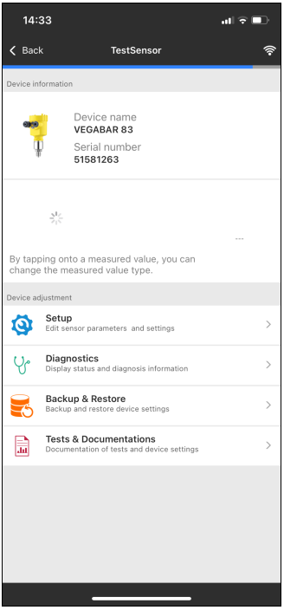
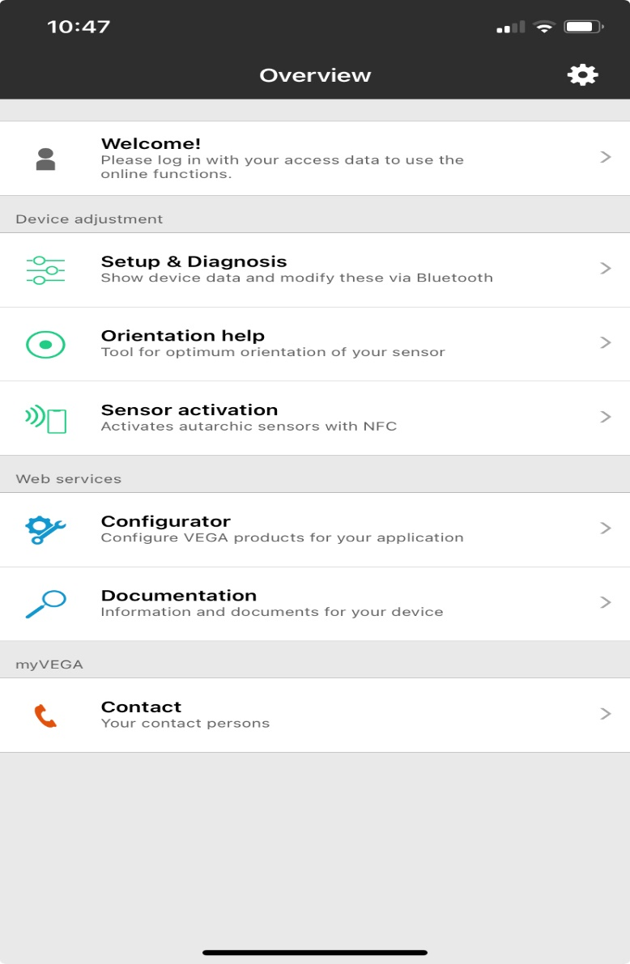
Figure 26 - Screenshot of the Vega Tools App

Figure 26 shows the sensor connected to the Vega Tools app.

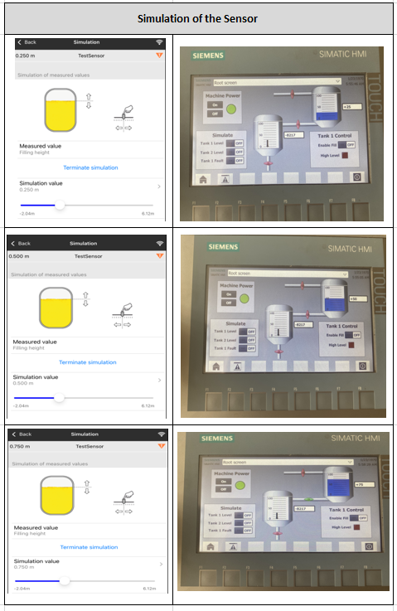
4.20.3 Overview of the Simulation
Figure 27 - Overview of the Simulation

The diagram presented in Figure 27 demonstrates the simulation of the sensor via the Vega tools app and the PLC program. The simulation is limited to readings between 0 and 1. Therefore, the settings were entered as 0.25, 0.50, and 0.75, which correspond to 25%, 50%, and 75%, respectively.

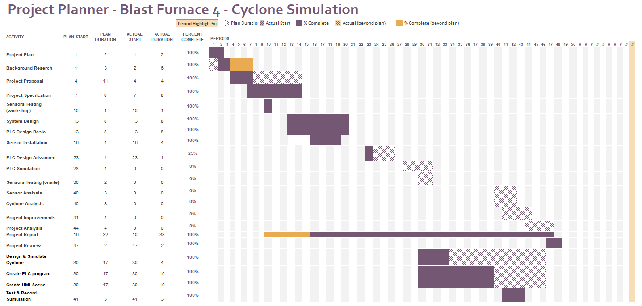
4.21 Gantt chart of the simulation

Figure 28 - Gantt Chart of the New Plan

The project plan has undergone significant changes, primarily concerning the development of a new simulation. The most notable changes involve designing a simulation of the Cyclone process and creating the necessary PLC requirements.

To accomplish this, I had a conversation with Gary, and together, we agreed on what the overall simulation would look like, and then I completed the PLC requirements. As reflected in the Gantt chart, the Design and simulation of the Cyclone stage was allotted 17 weeks to complete. However, in reality, it was finished much earlier than anticipated.

The other two major milestones included creating the PLC program once the full requirements were completed and designing an HMI scene to operate the simulation. Although I allowed 17 weeks for each stage to give myself ample time, I was able to complete both much earlier than expected. It's worth mentioning that PLC programming is not my strongest suit, but once I had access to a laptop with the Siemens program, my progress accelerated.

After completing the simulation aspect, I recorded myself performing the simulation, which will be included in the report and serve as evidence for the overall project.

A link for the video of the simulation can be found in the Appendice 5.3.5

CHAPTER 5 – EVALUATION

As previously stated, the project, unfortunately, could not be completed, and thus we were unable to gather any data to draw conclusions. The project had five main objectives, out of which three were successfully achieved. The first objective was to investigate a solution that would permit the Cyclone to dump dust more frequently. The second objective was to create a project plan, which was executed as planned until Tata Steel halted all non-essential work. This was completely out of our control. Despite this, we were able to achieve the third objective, which was the design stage. The sensors were bought, installed, and wired up, and the PLC requirements were agreed upon and signed off.

However, we were unable to complete the fourth and fifth objectives, which were the testing and commissioning aspects of the project, and the analysis of the dust dumping process. This was due to the cancellation of the project, making it impossible to move forward.

The main objective of the project was to have a significant role in a work-based project and develop skills and confidence as a result. I am happy to report that I believe I was able to achieve this goal. I have received positive feedback for the role I played in the project and have been entrusted with supporting other projects.

After some careful consideration, I have concluded that if I were to embark on the same project once again, I would not make any changes to the approach I took. As I previously mentioned, the project was progressing well and gaining momentum until there was news of the plant closures, which unfortunately impacted the pace of the project. Before that, there was a positive response from the works area, which allowed us to move forward swiftly and make significant progress.

5.1 Analysis of the findings

The project that was planned has unfortunately remained incomplete, which meant that the results could not be analysed in detail. It is extremely frustrating and disappointing as the project was so close to being implemented following a lot of hard work by the team involved.
Despite this, I strongly believe that the proposal was based on a solid premise, and had a high likelihood of success in a real-life scenario. It is unfortunate that the proposal was not brought to fruition, and it is unlikely that it ever will be.

As previously mentioned, the simulation used to test the cyclone's functionality was a limited version of the real-life Blast Furnace process. It lacked several insights into the cyclone's workings and was only designed to operate as a basic proof of concept. The simulation had limited functions available, which made it difficult to determine whether the final project would have been a success or not.

In the event that the project had taken place, my analysis would have focused on several key data points. Firstly, I would have looked at the number of dumping cycles per day to ascertain whether this had increased from the current rate of one dump per day. Additionally, I would have examined the average time it takes for each dump to be executed, as well as the overall average time for all dumps. These metrics would have provided valuable insights into the efficiency and effectiveness of the current system.

Another crucial aspect of my analysis would have been to investigate the number of blockages recorded since the implementation of the new system. By comparing this data with the number of blockages recorded prior to the new system, I would have been able to determine whether the new system had improved the overall performance in this area.

Lastly, I would have endeavored to gather feedback from the Blast Furnace team regarding the transition to the new system. This would have included their opinions on the process of the transition, any challenges they encountered, and suggestions for potential improvements. By collecting this feedback, I could have identified any areas of the transition process that could be optimised, thereby ensuring a smoother and more efficient implementation of future projects/changes.

The primary purpose of the simulation was to provide some control aspect within my project. It was not intended to be a replica of the actual cyclone process. Therefore, it cannot be considered a like-for-like copy of the cyclone's workings. Although the simulation was a useful tool to test the functionality of the cyclone, it could not provide any indication of the real-life results.

To conclude, the simulation had certain limitations due to the features available within the application that restricted its ability to offer insights into the workings of the cyclone. Nonetheless, it was a valuable tool that provided some degree of control in the project, though, again it didn’t offer any help in identifying any areas of improvement and any potential problems that might have needed to be addressed if the real-life project were to ever be completed.

It is noteworthy that traditional steelmaking in the United Kingdom is gradually fading away, making it difficult to observe the processes of other steelworks and how they control their operation within their Gas Plants.
As of the time of writing this report, the steelworks at Scunthorpe have also declared their intention to stop all traditional steel-making operations, and instead, transition to a more environmentally friendly way of producing steel, similar to the route taken by Port Talbot.

5.2 Reflection

As a student pursuing a degree, I was tasked with completing a project that would showcase my skills and knowledge. Naturally, I looked for a project that I could work on within my workplace, assuming that this would give me an edge and help me complete the project efficiently. However, I was soon to learn that things don't always go according to plan, and sometimes, even the best-laid plans can go awry.

Luckily for me, I found a project that was related to my day-to-day role - the project on the cyclone. With this project, I could undertake work for my university project during the day while still carrying out my regular duties at work. I hit the ground running and made great progress over the summer, completing my project proposal and interim viva ahead of schedule. The project on-site was also making excellent progress, with sensors being ordered, installed, and wired up before summer ended.

But as we moved on to the next phase of the project, which involved designing a Programmable Logic Controller (PLC) for controlling the cyclone's sensor and creating an HMI interface, I quickly realized that I had underestimated the extent of the work involved. Even though I had recently completed a PLC module in university and believed I had the knowledge and skills required to execute the task, it became apparent that I had nowhere near the expertise needed to complete the project's objectives.

I struggled with the simulation model and soon realized that a vast amount of work would have to be carried out in the background to complete the Cyclone project successfully. Looking back, I now realize that it was a good thing that I couldn't complete the PLC program for the cyclone work, as I lacked the necessary skillset to execute it, and would have had to pass it on to someone else for completion.
After I managed to gain access to a work laptop, this allowed me to work on the program at home, to avoid commuting to Swansea every week, which was a huge benefit in allowing me to chip away at the program in my own time.

Throughout my Electrical and Electronic Engineering degree course, I have encountered numerous challenges that have tested my adaptability and resilience. Despite facing setbacks such as the news of the Steelworks closure and the impact it had on my motivation, I managed to overcome them by effectively managing my time and creating a balance between my personal life, training for Triathlon, and work responsibilities.

One of the key indicators of being a good engineer is the ability to pivot between real-life projects and simulations, and I strongly believe that I have demonstrated this skill. It required me to be flexible and open-minded, enabling me to learn and adapt quickly to new situations.

My journey toward obtaining a degree qualification has been a significant achievement for me. Initially, I doubted my capabilities and thought it was beyond my reach. However, this experience has taught me to believe in myself more, and not limit myself before even starting something. I am proud of what I have accomplished so far and excited about future opportunities to continue growing as an engineer

References

[1] | “histroricalporttalbot.com,” [Online]. Available: Home (historicalporttalbot.com). [Accessed 10 June 2023].
[2] | “Tatasteeleurope.com,” [Online]. Available: Port Talbot | Tata Steel in Europe (tatasteeleurope.com). [Accessed 09 June 2023].
[3] | BBC, “BBC,” 30 July 2013. [Online]. Available: Tata Steel Port Talbot issued with notice over pollution - BBC News. [Accessed 13 Nov 2023].
[4] | “Wales Online,” 20 April 2022. [Online]. Available: The red dust clouds which hover over Port Talbot covering cars and window sills and even making pets ill claim residents - Wales Online. [Accessed 13 Nov 2023].
[5] | HSE, “HSE,” 27 Nov 2023. [Online]. Available: COMAH 2015: Public Information Record (hse.gov.uk). [Accessed 16 Dec 2023].
[6] | HSE, “Fire and Explosion,” 26 April 2022. [Online]. Available: DSEAR in detail - Fire and explosion (hse.gov.uk). [Accessed 13 Nov 2023].
[7] | B. S. Publication, “BS EN 1127 1:2019,” 2019.
[8] | “Sciencedirect.com,” [Online]. Available: https://www.sciencedirect.com/science/article/abs/pii/S1383586613002591. [Accessed 13 Aug 2023].
[9] | “Made in China,” [Online]. Available: 4-20mA Radar Level Transmitter Meter Gauge for Liquid Gas - China Radar Hygienic Level Meter and Radar Level Transmitter Price (made-in-china.com). [Accessed 10 Dec 2023].
[10] | “Kaidi86,” [Online]. Available: Why should transmitters and sensors use 4～20mA as transmission signal? (kaidi86.com). [Accessed 05 Jan 2024].
[11] | “Veris,” [Online]. Available: Different Types of Analog Sensors & How To Choose One | Veris. [Accessed 17 Aug 2023].
[12] | “dwyer-inst.com,” [Online]. Available: Understanding Sensor Output Signals – Dwyer Instruments Blog (dwyer-inst.com). [Accessed 17 Aug 2023].
[13] | “Metroid Electical Engineering,” [Online]. Available: Analog signal types: 0-10V versus 4-20mA - Metroid Electrical Engineering. [Accessed 17 Aug 2023].
[14] | “rtautomation.com,” [Online]. Available: PROFIBUS Protocol Overview - Real Time Automation, Inc. (rtautomation.com). [Accessed 17 Aug 2023].
[15] | “sensorsone.com,” [Online]. Available: Advantages and Disadvantages of using a 4 to 20 mA Signal (sensorsone.com). [Accessed 17 Aug 2023].
[16] | “Openstax.Org,” [Online]. Available: 14.1 Speed of Sound, Frequency, and Wavelength - Physics | OpenStax. [Accessed 22 July 2023].
[17] | “BBC Bitesize,” [Online]. Available: Atmospheric pressure - Pressure in fluids - AQA - GCSE Physics (Single Science) Revision - AQA - BBC Bitesize. [Accessed 03 Sept 2023].
[18] | “Nationalgeographic.org,” [Online]. Available: Atmospheric Pressure (nationalgeographic.org). [Accessed 17 Aug 2023].
[19] | “Pyroistech,” [Online]. Available: LiDAR: working principle and main applications - Pyroistech. [Accessed 04 Jan 2024].
[20] | “FlyGuys,” [Online]. Available: Advantages and Disadvantages of LiDAR Technology - FlyGuys. [Accessed 03 Jan 2024].

5.3 Appendices

5.3.1 Cyclone Drawing Showing Positions of New Sensors
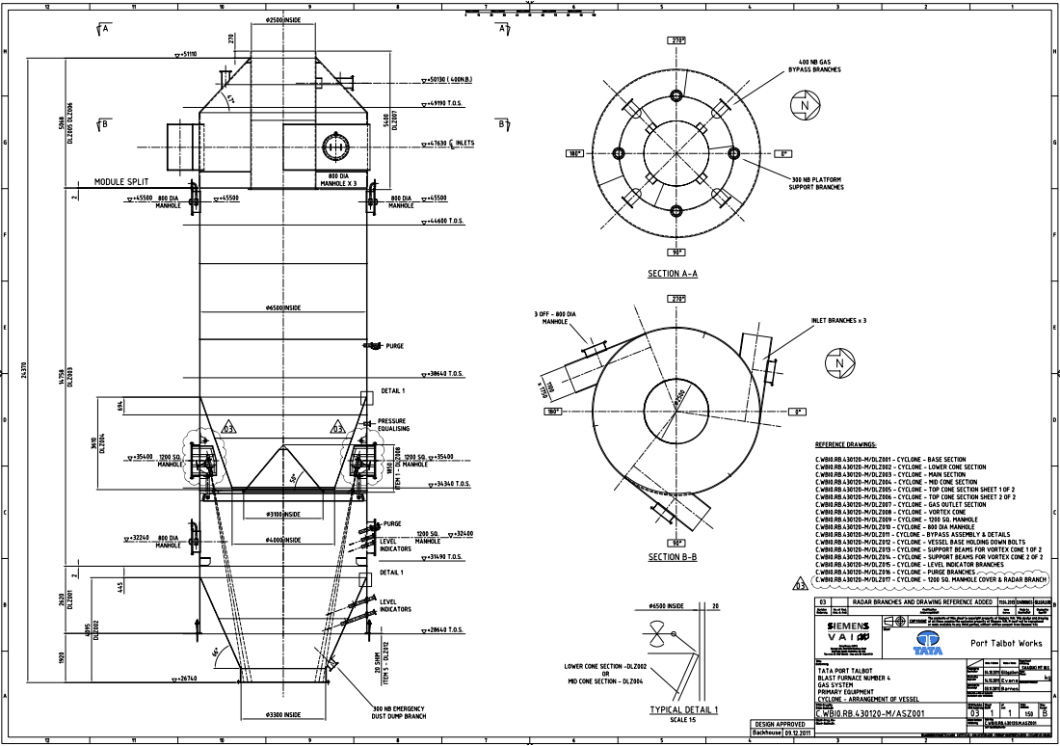

Figure 29 - Scematic Drawing Showing Sensor Positions With the Cyclone

5.3.2 Quote for Hardware Used for the Project

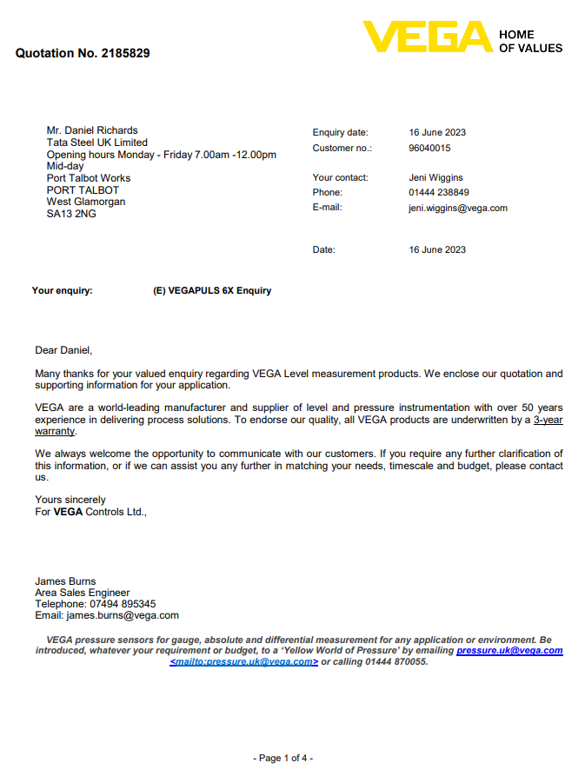

Figure 30 - Vega Quote 1/4

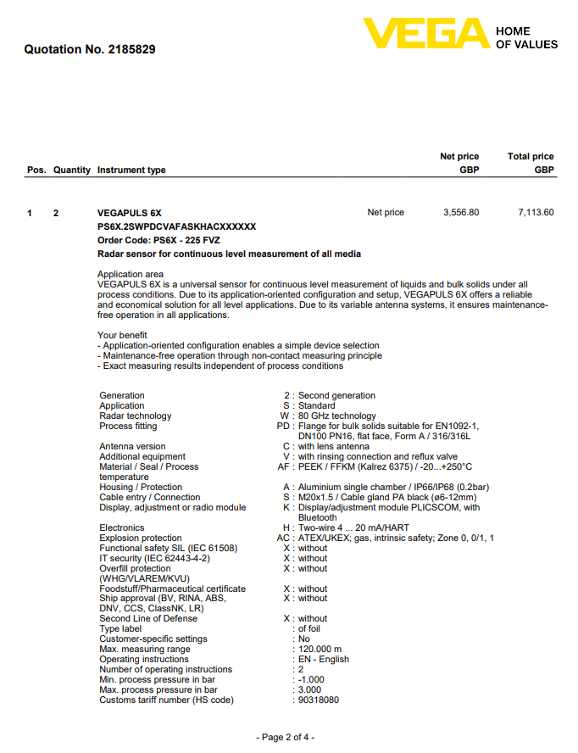

Figure 31 – Vega Quote 2/4

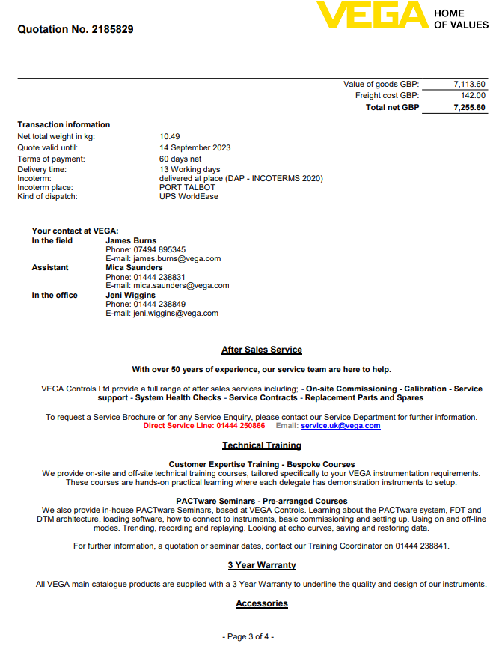

Figure 32 – Vega Quote 3/4

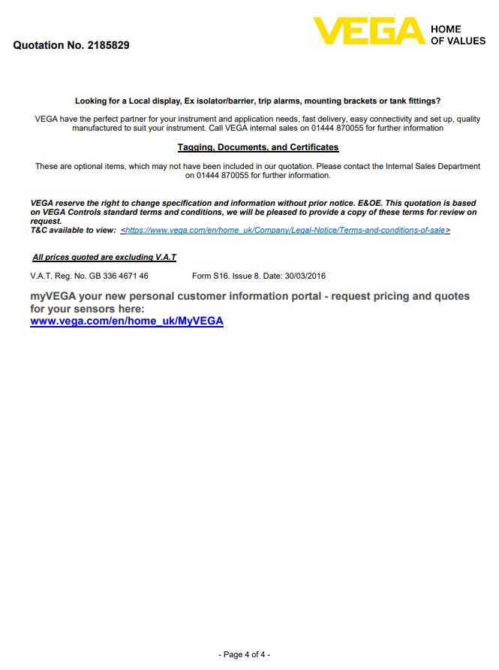

Figure 33 - Vega Quote 4/4

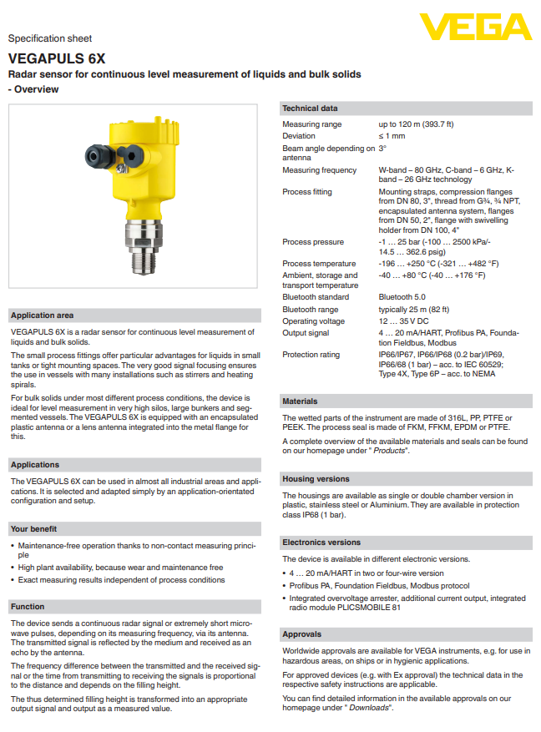
5.3.3 Vega Specification Sheet

Figure 34 - Vegapuls 6X Spec Sheet 1/2
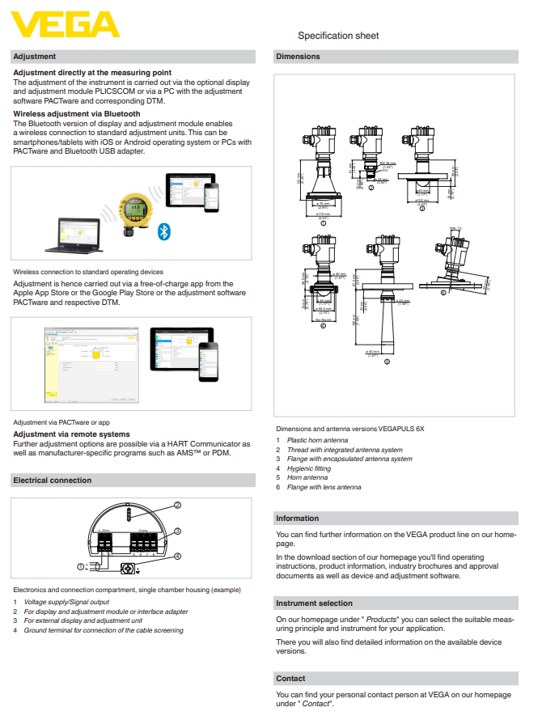
Figure 35 Vegapuls 6X Spec Sheet 2/2

5.3.4 Main Program Black

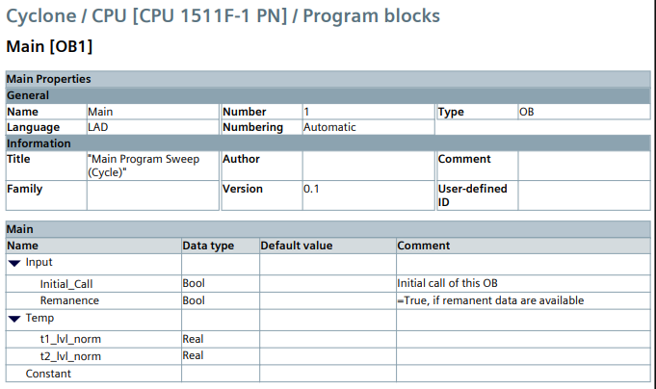
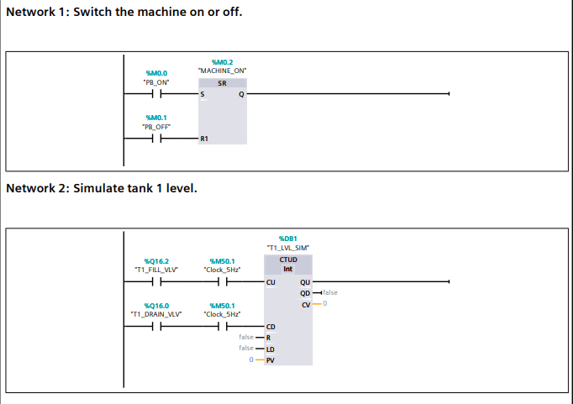
Figure 36 - PLC Program Block 1/10
Figure 37 - PLC Program Block 2/10

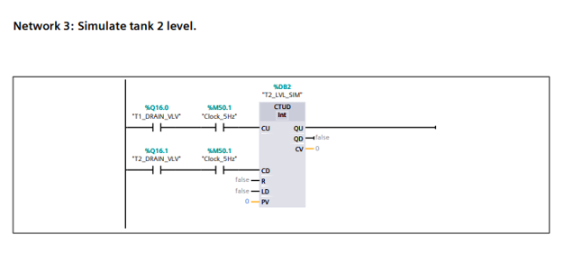
Figure 38 - PLC Program Block 3/10
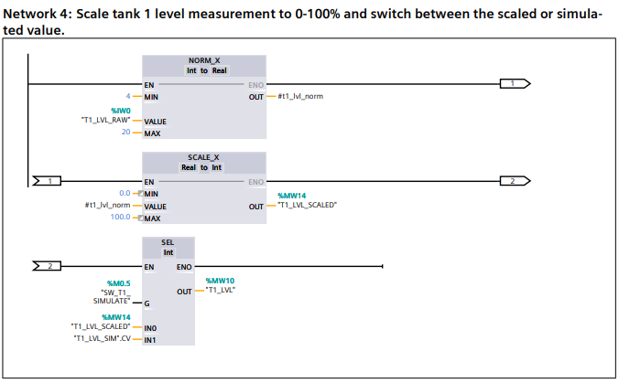

Figure 39 - PLC Program Block 4/10

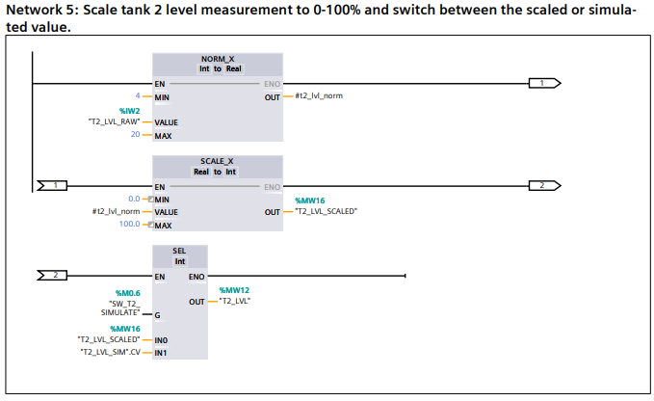
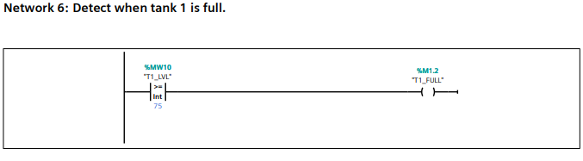
Figure 40 - PLC Program Block 5/10

Figure 41 PLC Program Block 6/10
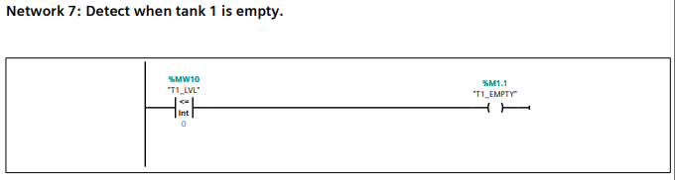

Figure 42 - PLC Program Block 7/10

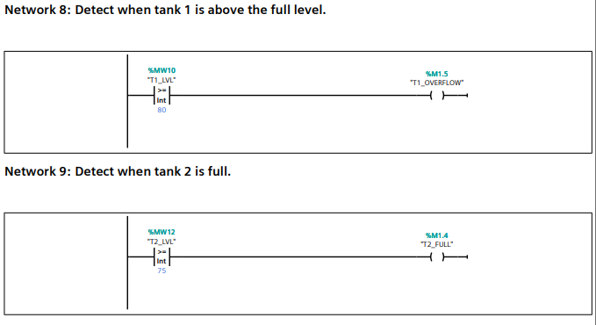
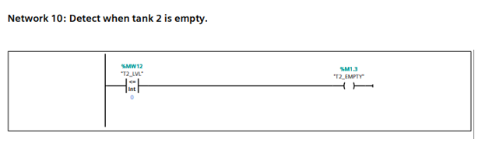
Figure 43 - PLC Program Block 8/10

Figure 44 - PLC Program Block 9/10

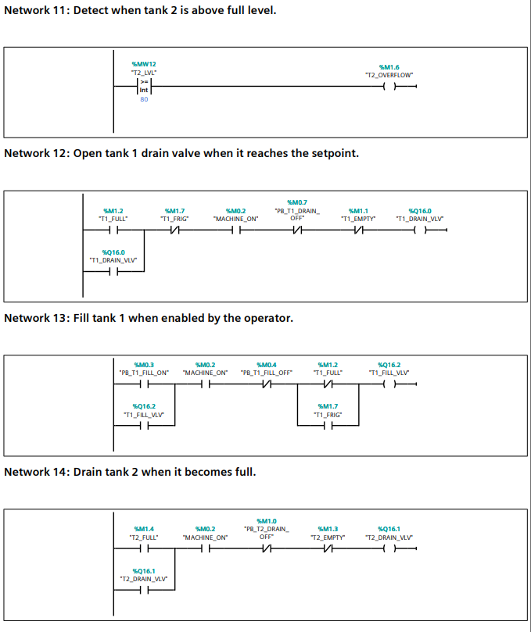
Figure 45 - PLC Program Block 10/10

5.3.5 YouTube Link to Video of Simulation.

https://youtu.be/Y717gpmzbX8?feature=shared

