Internet Technology & Security
ACCA4018

Networking and Cyber Security BSc

Timothy Ferfers
1903054

Synthesize a solution to a potential real life scenario

Recommendations on CoffeeCapulus Network Security Policy Regarding All Aspects of the Enterprise Resources

I. Introduction
The company CoffeeCapulus are renowned for their very popular Blue Mountain Peak blend and are looking to introduce BYOT (Bring Your Own Technology) elements into their current network. The aim of this is to allow both customers and staff bring their personal devices and use appropriate network resources through these devices.
The current network which CoffeeCapulus uses is primarily cloud based; therefore the majority of the companies resources are all off-site and securely accessed through the internet in their establishments. Due to the fact the company is already so familiar with cloud technology supporting the business devices and systems, it makes sense that they would want to look into BYOD possibilities.
II. Related Work
Throughout this Project one thing has been the focus: mobile devices and how they can be used in the workplace. Although the ‘what’s’ and ‘why’s’ for implementing BYOD will be discussed, the first question to ask is ‘how?’. Indeed how will these devices be integrated into the companies systems, the answer is; through a Mobile Device Management software or MDM for short. This useful software will provide the bridge between a network and the mobile devices brought onto it [1]. Researching how different MDM software works and which is the best choice was the first step to meeting the company’s desires. After much deliberation, the chosen MDM software was ManageEngine’s Mobile Device Manager Plus. This software comes with a huge array of features provide many tools to manage the devices on the network. One of the best features includes a seamless App management tool. The tool allows for the installation of desired apps to connected devices, useful for allowing company regulated apps to be easily installed. In additions certain apps can be blacklisted and restrict desired apps network connectivity. The software also supports profile management; this allows very easy integration of existing employees and customers accounts onto this new system.
When it comes to MDM software, there are some drawbacks to. MDM software can be over-costly for what they actually provide. Connected devices have to make use of locally installed software to handle the devices connection to the network [1] through the MDM; however these local software packages are limited in what they can control on a device. As there are so many mobile devices with different OS, it is near impossible for MDM to have a more intrusive impact on mobile devices through its local software as it requires too much input from mobile device vendors and developers.
In order to understand what is that CoffeeCapulus wanted in their network, it was important to research what BYOD is and how it can integrate mobile devices into a network. Bring Your Own Devices (often interchanged with Bring Your Own Technology) is term which refers to employees and sometimes customers being able to bring their personal devices into the workplace and use them on the company network for a specific purpose. In the Case of CoffeeCapulus, BYOT will be used to allow both employees and customers to use their mobile devices on the network. The aim is to use BYOT to enable employees to perform basic work functions such as taking orders from customers, relaying orders to the kitchen, pricing up orders, printing bills, etc. all through a personal device.
Productivity is key in a business environment and employees can often boost their productivity through familiar and comfortable working conditions [2]. Allowing the use of employees personal devices can increase their speed at working as they are familiar with the device they are operating. Also the Employees are generally more satisfied as they know to make full use of their personal devices. Using BYOT can theoretically reduce costs for a business as the employees make use of their own devices and have little need to use company hardware, which could also pave the way for more flexible working hours as they can work from any location, provided their connection and mobile device are secure. However there are drawbacks to the implementation of BYOD in a network, such as networks infrastructure being unable to handle the workload of so many new devices registering to it. There is also the big factor of security; these personal devices may have a virus unbeknownst to the user and BYOT could provide it a backdoor straight into the companies systems [1]. This issue is more avoidable with company owned devices as the content on them is regulated by IT staff from the moment they are installed into the workplace. To safeguard this, multiple precautions such as antivirus software and device scanning will have to take place on each device connecting to the network. In addition, there are many different devices in the world today which allow wireless connection and interactivity, all running on different hardware and software. In order to account for the diversity in devices, the network needs to account for different types of OS trying to connect to the network and prepare for compatibility.
In order to regulate issues such as the diversity of devices and their operating systems, plus the danger of devices containing malware and requiring adequate scanning, the BYOT should make use of MDM software to allow the best possible regulated connection. This ties back to the choice of MDM software: Mobile Device Manager Plus. This software is capable of initiating a scan on connected devise, designed to look for all known mobile device compatible malware, the account registrations system also helps keep track of users’ actions on their mobile device in the workplace.
III. Policy
To ensure that the company and the users of its network adhere to good practice, it is important they have a policy to refer to which outlines the companies procedures and rules in regard to the subject of the policy. In this case, the policy is specifically tied to the Security of the Network for CoffeeCapulus.
Any users of the CoffeeCapulus Network will only be granted access to network resources such as internet connection or company related actions after they are signed into an account. Any information handled by the CoffeeCapulus network is protected by the Data Protection Act. In addition, as an account is required to access the network, any activity which does not comply with what this policy standards or is otherwise illegal will be the blame of the owner of the account which committed such acts.
Users must create an account with an email address and password. This email address requires verification handled by a verification message sent to the given address. Users must choose a password which is suitably complex, including regular letters and at least one capital letter, one number, one symbol and must be between eight to sixteen characters in length. It is the users responsibility to remember this password, however to ensure the security of their account and this network they should no use a password re-used from another account they hold. Users should also refrain from writing down the password anywhere as this could also pose a security risk. For users who struggle to remember it is recommended they write down an obscure hint that only they would understand. Staff passwords will automatically expire every three months, prompting the user to choose a new password on their next login to the network.
The users of the CoffeeCapulus Network have a responsibility to their own accounts security and to adhere to good practice while on the network. Staff using the network must not use resources unless it is to aid them in carrying out their work. Customers using the network can use their devices at their own leisure so long as they use the company’s app to order CoffeeCapulus Product within thirty minutes of connecting. The company regulated the internet connection of the network, primarily for the customers benefit, this allows connection to selected search engines, social media sites and other websites, blocking connection to any unwanted web content. Any user, whether customer or staff who abuses the network to access content meant to be blocked or otherwise illegal will have their account terminated and the associated persons will be appropriately dealt with.
Bring Your Own Device / Technology (BYOD / T) is supported in this network for the benefit of staff and customers. Through the use of Mobile Device Management software: ManageEngine’s Mobile Device Manager Plus, the mobile devices which connect to the network will be assigned the proper permissions, restrictions and account tracking following a successful login through said device. For the Mobile Device Manager to operate properly, a local application needs to be installed to devices which connect to the network. This application serves to allow the most efficient communication between the device and the network and ensure the device is used as intended. Installation of this application is possible on a variety of known mobile device Operations Systems, the earliest versions supported of each type of vendor OS is listed as follows:
1. IOS 10.3.4 2. Windows Phone 8.1 3. Android 8.0 Oreo (API 26)
Attempting to connect to the network with a mobile device which does not support any of these listed Operating Systems will not be able to take full advantage of the ordering system or the networks resources.
All users of the network will have varying levels of access. In the average branch of CoffeeCapulus, the manager will have increased access to the account management of staff in order to update their details accordingly when appropriate. The manager will also be able to view all in-branch related detail related to finances and transactions made through the network. Staff will be able to receive order through their personal devices and send appropriate orders to other members of staff such as kitchen or cleaning staff. Managers are able to modify the permissions of staff’s mobile devices through their MDM account to a certain extent. However administrator privileges will be held by assigned network managers. In the event any member of staff wishes to alter their level of access, they must go through the process of contacting their appropriate superior and explain why they need such a change made and for how long.
IV. Implementation
The design of a cloud network differs from regular LANs in a few ways; in this case it also needs to be integrated with the BYOT system. The network to be used in CoffeeCapulus branches has been designed through packet tracer. This model showcases how the networks components will operate and how a BYOT device will connect to the cloud services. This following network model was created with Cisco Packet Tracer as the software can create reliable simulations of networks under Cisco standards. In this model there are 6 laptops which act as BYOD devices, they are wirelessly connected to the network across multiple routers acting as the access points within CoffeeCapulus buildings. Due to the amount of devices connecting to the network from different access points, Wireless LAN routers are used to handle the incoming traffic from the access point routers. The WLAN routers are connected to combination of distribution switches; these switches are interconnected in a mesh topology to manage high network traffic from the whole network. The distributions switches connect the controllers to the networks core routers, these devices go through the internet to forma a direct connection to the companies cloud based services. The company uses Microsoft Azure for it cloud computing services in this model.
The following Data Flow Diagram depicts the process of a device connecting to CoffeeCapulus’ network under the pretence of being a wireless mobile device with appropriate hardware and OS.
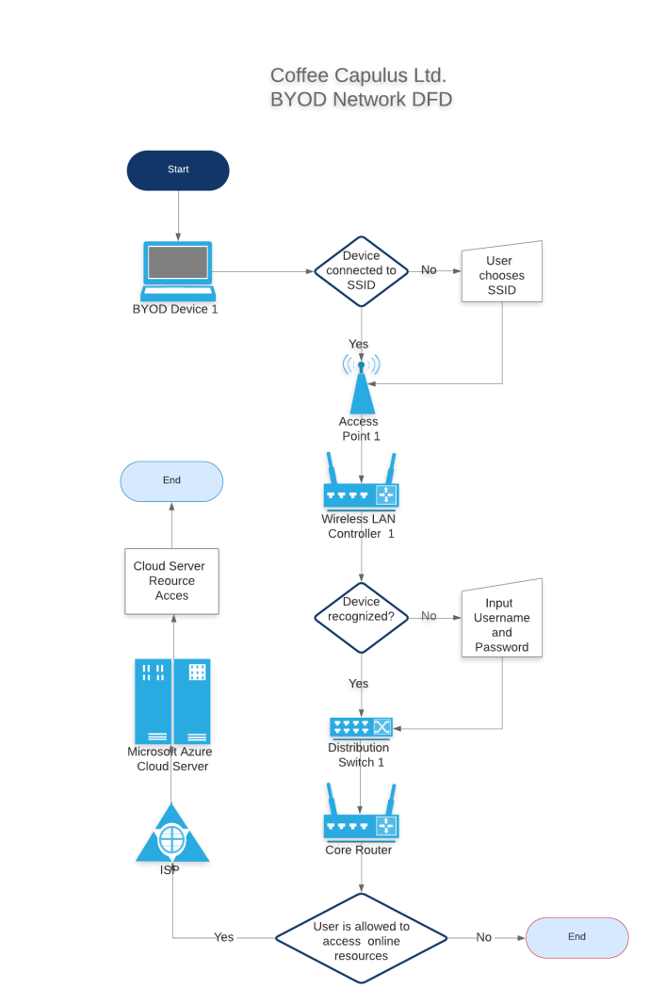
From this Data Flow Diagram, the process of how devices connect to the network and are allocated appropriate permissions is outlined. As shown in one particular decision box, the decision is made to whether or not the registered user has permission to access the cloud based resources.
V. Conclusion
The network model created for CoffeeCapulus took a lot of consideration and planning. Each device featured in the Packet tracer example was specifically selected and the topologies connecting the devices were also not chosen lightly. To conclude, the network is viable in its current state and will perform to the required standard set out by the client; CoffeeCapulus. Although after review, there are some areas which the client may wish to observe and could possibly be changed for the better in future.
It could be argued that the current network is too reliant on cloud services for its operations. In fact, the majority of the company’s business relies on cloud based computing for daily business transactions. It may be in the CoffeeCapulus best interest to move some operations from the cloud network to some owned servers. Investing in private servers comes with a lot of benefits such as not paying a premium to a cloud service and removing the need to trust this external company with CoffeeCapulus’ data. Cloud based services could still be a part of the network, however it would be beneficial and faster to have more important data such as financial transactions data and any high capacity data holdings kept at locally owned servers. In addition, moving some operations over to owned servers could result in lower business costs and improved transactions speeds in-store as the internet is not used as a medium if the particular operation is run through own servers.
Implementing BYOD comes with many advantages as previously covered; however the biggest consideration should always be security. Whilst the use of personal devices through BYOD can mean less company money spent on devices, increased familiarity etc. It still bears the danger of users picking up malware or illicit software in their personal lives due to lack of precaution or ignorance. Despite company standard protection from Antivirus software, device scanning and the MDM built in safety measures, the ideal situation is prevent employees from being exposed at all. Only around 50% of employees use their own security measures on personal devices [4]. This begs the thought what if they have important information such as their copies of login details or notes of workplace transactions on their devices leftover from work. Therefore it may be in CoffeeCapulus’ best interest to fund and/or enforce employees to take preventive measures on the personal devices they choose to bring to work. Through the use of information packs and simple instructions, staff can be instructed to install their own protective software on their personal devices. The choice of protective software should be recommended by CoffeeCapulus to point the less IT literate staff in the right direction. For example Kaspersky Mobile Antivirus is frequently updated and sports the latest consumer grade scanning.
VI. Appendix
References:
[1] P. Redman, J. Girard and L-O. Wallin, Magic Quadrant for Mobile Device Management Software. 2011
[2] <National Cyber Security Centre>, Mobile Device Guidance. gov.uk, 2020.
[3] K. Downer and M. Bhattacharya, BYOD Security: A New Business Challenge. China: Chengdu, 2015.

Cisco Packet Tracer Model: CoffeeCapulus Network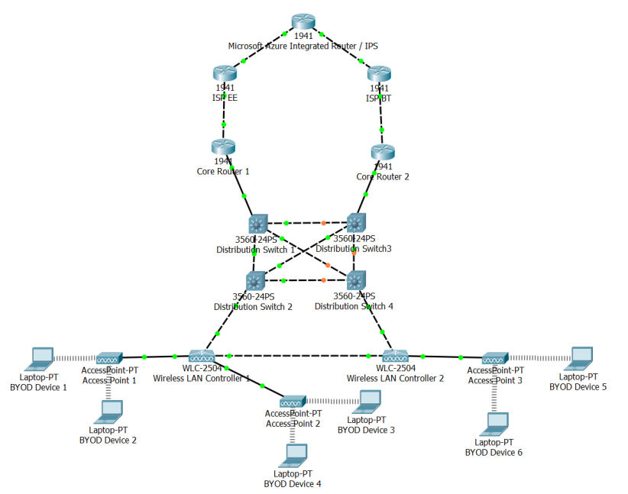
(Note: This image of the model was captured before D.Switch 4 and D.Switch 3 had finished connecting some adjacent switches)

marking criteria and Student FEEDBACK

This section details the assessment criteria. The extent to which these are demonstrated by you determines your mark. The marks available for each criterion are shown. Lecturers will use the space provided to comment on the achievement of the task(s), including those areas in which you have performed well and areas that would benefit from development/improvement.

Common Assessment Criteria Applied (Assignment 1) | Marks available | Marks  awarded
1. Engagement with Literature Skills
Extent of research and/or own reading, selection of credible sources, application of appropriate referencing conventions.
You have covered key concepts. However, your work lacks appropriate range of sources such as academic journal articles. This demonstrated lack of engagement with literature skills. (Grade mark: 46.67%) | 15 | 7
2. Knowledge and Understanding Skills
Extent of knowledge and understanding of concepts and underlying principles associated with the discipline.
You have demonstrated knowledge and understanding. However, see comment above which is lacking in this report. You have used the IEEE report formatting; very good. (Grade mark: 53.33%) | 15 | 8
3. Cognitive and Intellectual Skills
Analysis, evaluation and synthesis; logic, argument and judgement; analytical reflection; organisation of ideas and evidence
Your report discuss all the relevant areas for this assignment; policy, DFD, network design, etc. Very good conclusion, try to avoid new augment in your conclusion, it should sum up relevant aspect from your entire report. Very good DFD diagram. (Grade mark: 70.00%) | 40 | 28
4. Practical Application Skills
Deployment of methods, materials, tools and techniques; application of concepts; formulation of innovative and creative solutions to solve problems.
Your practical design works when pinging end devices. However lack of security measures implemented on core devices such as the switches. Passwords implemented on router. (Grade mark: 50.00%) | 20 | 10
5. Transferable Skills for Life and Professional Practice
Attributes in professional practice: individual and collaborative working; deployment of appropriate media; presentation and organisation.
Your report written and flow well. It could be justify align to make it looks very professional. (Grade mark: 70.00%) | 10 | 7

Assignment Mark (Assessment marks are subject to ratification at the Exam Board. These comments and marks are to give feedback on module work and are for guidance only until they are confirmed. ) | Late Submission Penalties (tick if appropriate) |  | 60%
 | Up to four weeks late |  | 60%
 | First Attempt? |  | 60%

