Crisis Management for Responsible Tourism & Events:
BMTP6020

Assignment Title: Crisis Management Case Study Review

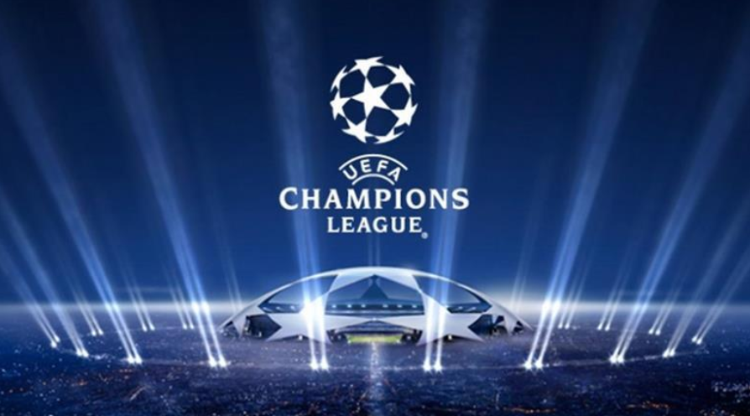
Image: Broadcast Sport, 2021

Presented by: Amanda Lewis (1909364)
05/05/2023

Introduction

This case study review will critically analyse and evaluate an academic training scenario that was undertaken by students on Tuesday 25th April. The scenario which was based on the UEFA Champions League and The London Bridge Attack which both took place in 2017, provided students with the opportunity to participate in a practical and interactive learning session in order to gain real life experience of how to effectively respond to crises. For the purpose of the training session, Bayern Munich and Liverpool were playing at the Principality Stadium in Cardiff with there being an audience of 60,000 people. This included four members of the royal family, the British Prime Minister, the German Prime Minister as well as the First Minister. In preparation for the event, the stadium had been on lockdown for five days prior to the event as well as the area within the ring of steel being on lockdown for 3 days. Students were presented with a series of scenarios relating to the event whereby they had to work collaboratively in order to identify the relevant actions that would need to be taken in response to the given crisis. Following on from the training session, a critical reflection of both how we responded to the crisis as a team as well as the authors personal role will be provided within the case study. By Reflecting on this learning experience, this provides students with the opportunity to analyse what was learnt in order to improve future performance (Learning Pool, 2023).

Preparation

In advance of the training session, students participated in an academic field trip to Cardiff in order to prepare for the learning scenario. The trip encompassed visits to key areas such as the Principality Stadium, Cardiff Arms Park as well as providing the opportunity for the team to familiarise themselves with the surrounding areas including the ring of steel. Students were assigned individual areas with them needing to undertake detailed research into their specific field in order to identify the key issues which would need to be considered as a result of the event taking place. The author was assigned Cardiff Castle and a number of key issues were identified relating to the venue being at an increased risk of a terrorist attack with these being presented at the start of the training session in the form of a PowerPoint presentation (See Appendix A and B). Within this was a series of preventable measures which were identified in order to mitigate the risk of an attack occurring at Cardiff Castle. Students were also allocated into command structures and required to divide roles and responsibilities ahead of the event. For the purpose of the task, the author was assigned to the silver command with five other team members and required to undertake detailed research in order to prepare for the scenario (See Appendix C).

Confidential Information

For the purpose of the scenario, all team members were confidentially informed that the London Bridge Attack in 2017 was originally intended for the UEFA Cardiff Champions League in Cardiff. However, as a result of the heightened security measures that were implemented in Cardiff in preparation for the event, this was instead carried out in London.

Cardiff Champions League

In June 2017, Cardiff hosted the UEFA Champions League which was to be the biggest ever sporting event held in the city (Mosalski, 2017). When hosting large sporting events such as the UEFA Champions League, this increases the risk of a terrorist attack and in order to mitigate these risks preventable measures need to be implemented (Bladen et al., 2018). At the time of the UEFA champions league, the security level in the UK was set as severe meaning ‘an attack is highly likely’ (GOV, 2023). Although vigilance was heightened due to the event being held in the wake of the Manchester Arena Bombings which had taken place just weeks earlier, it is suggested that unprecedented security measures were already in place with the Football Association of Wales stating that ‘The security operation for the four-day period covering June 1-4 will be the biggest ever seen for a sporting event in the UK’ (BeSoccer, 2017).

When planning major events which can be defined as ‘event’s which can be defined as ‘events that by their scale and interest are capable of attracting significant visitor numbers, media coverage and economic benefits’ (Bowdin et al, 2011:20), it is vital that protective security measures are carried out in co-operation with the police and other authorities (Wynn-Moylan, 2018). To ensure that the UEFA Champions league could be safely executed, 50 officers worked full time on the planning with there being 6,000 officers deployed to Cardiff during the week of the event (Mosalski, 2017). Protective security measures included searches being conducted on drains, road closures, restrictions on water travel within the area as well as the roof of the Principality Stadium being closed to reduce the risk of a drone attack (BBC, 2017) (FAW, 2017). As suggested by Wynn-Moylan (2018), by implementing heightened security measures, this can discourage terrorism related activities by acting as a deterrent which is believed to have been a key contributing factor in the safe delivery of the Cardiff UEFA Champions league.

London Bridge Attack

Whilst the 2017 UEFA Champions League was safely executed as a result of the enhanced protective security measures, as earlier stated this led to the planned attack for Cardiff being diverted to London where the ‘London Bridge Attack’ was carried out. This resulted in the death of eight people with forty-eight being injured when a van mounted the pavement on London Bridge driving into pedestrians before proceeding to Borough Market where they stabbed four people (Black, 2019). Vehicle-ramming attacks are considered to be one of the simplest and most effective methods for terrorists due to there being minimal resources and planning required with them still having the capacity to inflict widespread death and injury (Houser, 2022). The implementation of vehicle barriers is identified to be a key preventable measure in order to mitigate the risk of these types of attacks from occurring (Houser, 2022) which was effectively demonstrated when Cardiff blocked off roads to vehicles for the UEFA Champions League (Mosalski, 2017) which prevented them from being at risk of a terrorist attack which was unfortunately then carried out in London.

Training Session

On the day of the training session, all group members were firstly required to meet at the universities library in order to watch real life crisis footage in the immersive suite. This included emotional scenes of both Hillsborough and the Bradford Fire with its purpose being for students to consider the measures that could have been implemented which could have prevented the tragic outcomes that occurred from happening. By analysing the footage this enabled students to prepare for the crisis scenarios that would be presented to them later in the day.

Command Structures

As earlier stated, students were allocated into command structures with these being gold, silver, and bronze with this also being also referred to as the GBS structure (College of Policing, 2013). As stated by the College of Policing (2013) ‘This structure provides a framework for delivering a strategic, tactical, and operational response to an incident or operation. It also allows processes to be established that facilitate the flow of information and ensures that decisions are communicated effectively and documented as part of an audit trail’. The author was part of the silver command who are responsible for coordinating a tactical response with this being aligned to the strategy set by gold. Roles and Responsibilities were to be allocated within each command with these being assigned on the morning of the scenario whereby the author took on the role of the ‘Public Order Silver Commander’.

Scenarios

As the training scenarios commenced, students were separated into their command structures where they were required to work collaboratively in order to establish the measures that would be taken in response to the crisis. Whilst not all of the scenarios have been discussed within the review, this section will provide an overview of some of the issues that arose within the training session with these being discussed as follows.

At 12pm all commands were informed that there had been a 999-call reporting there was a bomb in Cardiff Castle which was due to go off in two hours. Whilst the commands identified measures which included bringing in sniffer dogs to locate the bomb and evacuating the premises, what we didn’t consider was that this could have been a hoax, and this should have been investigated prior to making any decisions in terms of evacuation. On reflection, the commands should have considered that may have been an attempt to cause panic particularly as it is stated that the vast majority of bomb threats are in fact hoaxes (GOV, 2020). Whilst the author did however question how a bomb had been placed in the castle due to there being increased security measures in place as outlined in the PowerPoint presentation, the fact that this could have been a hoax was not identified and this should have been a key consideration amongst all commands.

At 1pm it was reported that there was an issue regarding the circulation of counterfeit tickets. As highlighted in real life footage shown to students earlier that day, counterfeit tickets can cause huge levels of disruption with this being particularly evident during the Champions League Final in Paris when police used pepper spray to control the crowds (Spencer, 2022). At this stage, the commands were not communicating with one another with communication only taking place within each command. Whilst the measures identified by the silver command were focused around minimising the amount of disruption caused by deploying extra security to avoid crowd build ups, all of the commands overlooked the fact that the Principality Stadium was not the first ticket check point with this instead being upon entering the ring of steel. This was an oversight on all of our behalf’s which could have been identified had there been a greater understanding of the structural set up within Cardiff at the time of the UEFA Champions League taking place.

The final scenario presented was linked to the London Bridge Attack and the events that occurred as a result of this. At 9:58pm which was the time that the vehicle mounted into the pavement on London Bridge, the prize giving was due to take place at the Champions League in Cardiff. Following reports of a white van being seen on CCTV looping around the area, the vehicle is identified to be making its way back up towards Castle Bridge at 10:05 just minutes after Munich fans have started leaving the stadium. At 10:07 a 999 call is received informing that 6 people have been hit by the van with there being one person now in the river. This was followed by reports of stabbings and explosives within the city whereby the commands needed to effectively respond to the above incidents.

Whilst effective communication was demonstrated within each command during the earlier scenarios, at this stage it appeared that the silver command had lost motivation with there being less input given in terms of responding to the incidents that were occurring. During this time, the silver command pointed blame at the gold command for not relaying information over to them. However, on reflection this comment was unfair as the group recognised that errors were made on their part having not attempted to communicate with either gold or bronze commands.

It was later highlighted that gold command had provided the silver command with information relating to armed people needing to be deployed, cobra being escalated as well as road closures needing to be implemented which should have been relayed to bronze command, yet this wasn’t carried out and therefore identified as a further error on our part. Communication plays a central role in effective teamwork (Mullins, 2007), and it is evident that the task was not carried out as successfully as it should have been due to levels of miscommunication and unpreparedness amongst the command structures.

Reflection

Whilst reflecting on the overall effectiveness of this training scenario, it is in the opinion of the author that there were a number of errors made by the silver command structure both beforehand and on the day of the session itself. Although there were open discussions within the silver command with views and opinions being shared openly, communication was poor between each command structure in the final scenario which the author believes was due to unpreparedness and a lack of understanding with regards to the task. Had group members of adequately prepared ahead of the training session, there would have been a clearer structure within the command in terms of roles and responsibilities with these only being allocated earlier that morning. This led to a lack of understanding as to what each role entailed with there being no further mention of individual roles during the training session itself. Despite one member of the command setting up a communication channel at 9:30 pm on the night before the training session, this was not enough time to work collaboratively as a team with most members not even responding due to the short amount of notice. Whilst we had all undertaken individual research for our designated areas, we were not prepared enough as a group and with roles only being assigned on the day of the session, there was not enough time to gain a clear understanding of what was expected from us from both a group and individual perspective.

On a more positive note, all members of team participated to group discussions within the silver command structure and whilst there were occasions where some contributed less than others, we were able to work collaboratively as a team with each member of the group taking it in turns to share the findings with the other commands at the end of each scenario. As stated by Cottrell, (2019), effective teamwork requires both good listening skills and participation in group discussions which the author feels that were able to demonstrate despite there being a lack of communication prior to the session. Furthermore, there was a sense of cohesiveness within the command in terms of open discussions and all members being treated in a respect manner which is vital for promoting a positive working environment (Mullins, 2007).

Upon reflecting on the authors individual performance, it is believed that by carrying out a personal site visit to Cardiff Caste on the 15^{th of} April in order to observe the grounds and surrounding areas, this assisted in the planning process whereby risk factors were able to be successfully identified as well as mitigating actions in order to present these to fellow students on the day of the training scenario. The author further believes that excellent two-way communication skills were demonstrated by oneself in terms of contributing views and opinions whilst actively listening to the contributions of others with these being identified by Cottrell (2019) as a core element of successful teamwork. However, on reflection, greater initiative could have been taken beforehand to set up a communication channel in advance with there also being failings in terms of the level of research and familiarisation that was undertaken in order to gain a clearer understanding of the roles and responsibilities of the silver command. Furthermore, as earlier stated blame was pointed at the gold command which again was a result of both the group and the authors unpreparedness.

Conclusion and Recommendations

In conclusion, it is evident that the training session was not performed effectively due to a series of errors that were made in the lead up to the exercise in terms of a lack of communication and preparedness. In order to successfully execute this task, the silver command should have set up a channel of communication in advance whereby roles and responsibilities were divided prior to the day of the session. This would have enabled the team to have undertaken detailed research with regards to tactically responding to the scenario-based crisis. Due to a lack of preparation from the Silver Command, this then resulted in a lack of understanding of the structural framework with this being a vital part of effectively responding to the crisis. Had the framework been adequality researched and roles and responsibilities assigned beforehand rather than on the day of the exercise, group members would have been able to follow processes and make decisions effectively whilst communicating with one another as well as other commands.

Bibliography

BeSoccer. (2017). Cardiff on Champions League final alert after Manchester attack. [Online]. BeSoccer. Available at: https://www.besoccer.com/new/cardiff-on-champions-league-final-alert-after-manchester-attack [Accessed 3 May 2023].

BBC. (2017). Champions League final roof closed for safety reasons. [Online]. BBC. Available at: https://www.bbc.co.uk/news/uk-wales-40059676 [Accessed 3 May 2023].

Black, J. (2019) ‘The subjective and objective violence of terrorism: analysing “British values” in newspaper coverage of the 2017 London Bridge attack’, Critical studies on terrorism, 12(2), pp. 228–249. Available at: https://doi.org/10.1080/17539153.2018.1498191.

Bladen, C., Kennell, J., Abson, E. & Wilde, N. (2018). Events Management An Introduction. 2nd ed. Oxon: Routledge. p232, 264.
Bowdin, G., Allen, J., O'Toole, W., Harris, R. & McDonnell, I, (2011). Events Management. 3rd ed. Oxon: Routledge. p20

Broadcast Sport. (2021). LiveScore makes every Champions League game FTA in Ireland. [Online]. Broadcast Sport [Image]. Available at: https://www.broadcastnow.co.uk/broadcasting/livescore-makes-every-champions-league-game-fta-in-irela [Accessed 3 May 2023].
College of Policing. (2013). Command structures. [Online]. College of Policing. Available at: https://www.college.police.uk/app/operations/command-and-control/command-structures [Accessed 4 May 2023].

Cottrell, S. (2019). The Study Skills Handbook. 5th ed. London: Red Globe Press. pp.178-9.

FAW. (2017). Security. [Online]. FAW. Available at: https://www.faw.cymru/cardiff2017/local-knowhow/security/ [Accessed 3 May 2023].

GOV UK. (2020). Bomb Threats. [Online]. GOV UK. Available at: https://www.gov.uk/government/publications/crowded-places-guidance/bomb-threats [Accessed 4 May 2023].

GOV.UK. (2023). Terrorism and national emergencies. [Online]. GOV.UK. Available at: https://www.gov.uk/terrorism-national-emergency [Accessed 3 May 2023].

Home Office. (2021). Critical incident management. [Online]. Home Office. Available at: https://assets.publishing.service.gov.uk/government/uploads/system/uploads/attachment_data/file/1013 [Accessed 3 May 2023].

Houser, R.S. (2022) ‘Democratization of terrorism: an analysis of vehicle-based terrorist events’, Trauma surgery & acute care open, 7(1), pp. e000964–e000964. Available at: https://doi.org/10.1136/tsaco-2022-000964.

Learning Pool. (2023). Why Reflection Encourages a Better Learning Experience. [Online]. Learning Pool. Available at: https://learningpool.com/why-reflection-encourages-a-better-learning-experience/ [Accessed 4 May 2023].

Mosalski, R. (2017). The full extraordinary details of the Champions League final in Cardiff have been revealed. [Online]. Wales Online. Available at: https://www.walesonline.co.uk/news/local-news/full-extraordinary-details-champions-league-12861364 [Accessed 3 May 2023].

Mosalski, R. (2017). This is everything we know about security at the Champions League final in Cardiff. [Online]. Wales Online. Available at: https://www.walesonline.co.uk/news/local-news/everything-know-security-champions-league-13078397 [Accessed 3 May 2023].

Mullins, L. J (2007). Management and Organisational Behaviour. 8th ed. Harlow: Pearson Education Limited. p351, 456.

Spencer, P. (2022). furious UEFA blame thousands of fake tickets for fan disruption as Liverpool call for investigation and describe securi. [Online]. Talk Sport. Available at: https://talksport.com/football/1119897/liverpool-fake-tickets-real-madrid-paris-champions-league-fi [Accessed 4 May 2023].

Wynn-Moylan, R. (2018). Risk and Hazard Management for Festivals and Events. Oxon: Routledge. p230, 233.

Appendices

Appendix A

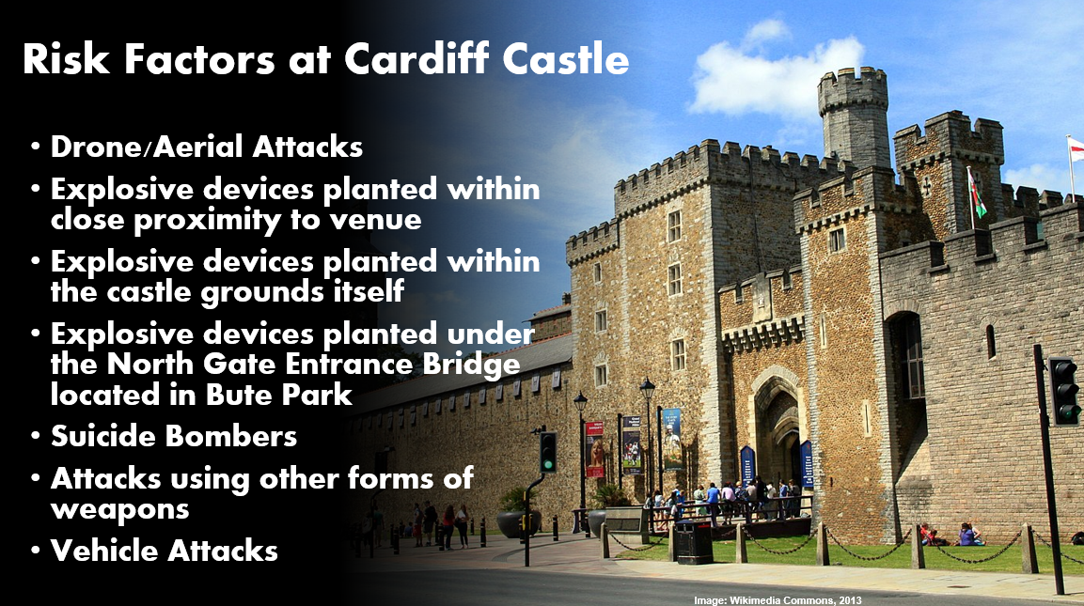

Appendix B

During the UEFA champions league which is due to take place on the 25th of April 2023 it has been identified that venues within the city of Cardiff are at an increased risk of terrorism related activities which could pose a threat to any persons present within the area at the time. The management team of Cardiff Castle have identified there to be specific areas which may be at risk and will need to implement a series of precautionary measures that will be undertaken to minimise these risks. These are as follows:

- As an open aired venue, Cardiff Castle is at an increased risk of a drone attack and there are security concerns that drones may be used to carry out an air strike. To mitigate this risk, there will be a drone detection and monitoring system in place to ensure that any unauthorised drones are detected prior to reaching the target.
- There is an increased risk of explosive devices being planted both within the castle itself as well as the surrounding areas. Heightened searches will need to be performed on all drains, bins and bushes within the area as well as carrying out searches on any skips that might be in use.

- Within the castle itself, searches on drains, bins and bushes will also be performed with there also being extra security checks made on toilets and unattended areas.

- There is also a greater risk of explosive devices being planted both within and around the venue and any suspicious looking items as well as unattended bags will need to be monitored. The entire site will undergo regular inspections to ensure no suspicious items have been planted 'out of sight'.
- There is also a risk of explosive devices being planted under the North Gate Entrance Bridge located in Bute Park as this is currently the entry and exit point due to the South Gate Entrance being closed.

- The planting of such devices could also be in the days prior to the event and the area will therefore require continuous CCTV monitoring so that any acts of crime can be detected.

- An attack could also be carried out using other forms of weapons such as the use of knives and guns and there will need to be an increased presence of sniffer dogs in the area as well as bag searches being undertaken before anyone enters the castle grounds.

- Any type of attack could be carried out by a suicide bomber and there will need to be an increased focus on anyone acting suspiciously as well as on any persons carrying suspicious looking back packs both upon attempting to enter and around the venue itself. All persons attending the castle will be informed of increased security measures via tannoid announcements with them being encouraged to be vigilant as well as to report anything suspicious to nearby security.

- Whilst previous attacks have been in the form of vehicle ramming, this is considered by the management team to be low risk due to there being restricted access and a number of road closures in place at the time of the event. Instead, there will be a greater focus on any abandoned vehicles which may contain explosive devices parked near the target area.

Appendix C

Silver Commander
Below is a list of suggested actions for Silver commanders handling critical incidents.
It is not intended to be exhaustive and is not listed in any defined order:
• establish the instigation of critical incident management procedures
• open decision log and record all decisions taken
• if decision made to instigate CI procedures, brief Gold Commander and take
their strategic instructions
• appoint a loggist (if necessary)
• appoint officers to undertake business as usual while you are a Silver
Commander.
• if appropriate appoint silver support staff and tactical advisors
• obtain and agree Gold Commander’s strategy.
• develop and co-ordinate the tactical plan considering:
• gold Commander’s strategy
• legal considerations
• human rights considerations
Page 30 of 41 Published for Home Office staff on 25 August 2021
• community Impact considerations
• health and safety
• if multi agency establish and maintain contact with other partner Silver
Commanders
• inform NCC(U) and liaise for further support.
• if appropriate appoint Bronze Commanders to deal with specific aspects of the
incident for example the media, business area.
• if necessary, seek authority for additional staff or resources from Gold
Commander
• if the incident continues over a long period, co-ordinate the change-over of
staff and commanders including your own.
• liaise closely with Bronze Commander and obtain regular updates
• brief staff and keep them updated
• ensure the Bronze Commander operations meet with the strategic and tactical
plan
• provide regular updates to Gold Commander and take their further instruction
on the strategic handling of the incident
• continually review tactical plan to support the strategic overview and relay any
new instructions to Bronze Commander
• when advised of stand down by Gold Commander, advise Bronze
Commander
• attend formal de- brief
• collate all records of the incident including decision logs
• if appropriate arrange relief of staff
• ensure staff health and welfare is considered (for example refreshments)
Considering tactical deployments – aide memoire
Tactical deployment aide memoire
When considering tactical deployments as Silver Commander. It may be useful to
bear some of the below questions in mind:
What - what are the aims and objectives to be achieved?
Who - who by, police, emergency services and partner agencies, what resources are
available?
When - timescales, deadlines and milestones in delivery of tasks.
Where – locations?
Why - what is the rationale within the overall aims and objectives set by the Gold
Commander?
How - how are these tasks going to be achieved, what barriers to achieving them
may be encountered?

Source: Home Office, 2021

