COMMUNITY ENGAGEMENT

LCBB4002
BA Business Management

Lecturer Name: Gregory Cowan
Student Name: Cornel Valentin Gabriel Bondor
ID Number: 1813451
Executive summary
Community engagement offers organisations opportunity for improving skills of employees for better productivity. This report has considered Toyota Motors Corporation, in UK to analyse community engagement perspectives. Organisational information has shed light on sector, size, structure, values, mission and goals of Toyota. Customer identification and SWOT analysis have been performed. Furthermore, roles of employees working in this company have been discussed. In a particular role selection, role of innovative designing expert has been chosen that plays significant responsibilities to promote company’s green technology. Additionally, development and training requirements of staff have been analysed.

Table of Contents
Introduction 4
Organisational information 4
Sector 4
Size 4
Structure 4
Values 5
Mission 6
Goals 7
Customer identification 7
SWOT analysis 7
Roles of employees 8
Importance of development and training 9
Role selection and importance of role 12
Development and training requirements 13
Conclusion 14
Reference List 15

Introduction
Involvement of employees with corporate programs offers organisations to foster positive work-culture in a company. This report is based on community engagement that is discussed in context of Toyota Motors, UK. This report has focused on organisational information, customer identification and SWOT analysis. Furthermore, roles of employees and importance of development and training have been discussed. A particular role in this company has been selected with highlighting its importance. Additionally, development and training requirements of this role have been analysed.

Organisational information

Sector
Toyota Motors refers to a multinational manufacturer in automotive industry, and its headquarter is located at Toyota City in Japan. This brand represents to be a market leader in a global perspective to sell hybrid electric vehicles.

Size
In UK, Toyota operates a large number of dealerships in car manufacturing through franchise networks; in financial year 2017, this figure was 182. This brand has two plants of manufacturing in UK, representing £2.75 billion investment and employing around 3000 staff (Annualreports.com, 2018). The plants of vehicle and engine manufacturing are located at Burnaston, Derbyshire along with Deeside of North Wales respectively. In financial year 2019, this organisation has become 10th largest automotive manufacturer in world on a revenue basis.

Structure
Toyota Corporation used to maintain a centralised global hierarchical structure that seemed to be “spoke-and-wheel” model. However, from fiscal year 2013, this company started to follow structure of divisional organisation. As stated by Iglesias, Markovic and Rialp (2019), in multinational corporations, individual business unit cannot control all operations. Hence, from 2013, new structure follows three vital characteristics-

Characteristics | Descriptions
- Geographical divisions | This company possesses eight divisions regionally (North America, Japan, Europe, Asia, China, Caribbean, Latin America, Africa, and Middle East). Each division’s regional head has been instructed to report to headquarters.
- Global hierarchy | Management has enhanced decision-making responsibilities of head regarding business unit and region.
- Product-dependent divisions | Four product-dependent divisions are-  - Lexus International  - Unit centre  - Toyota number 1 for business operations in Japan, Europe and North America  - Toyota number 2 for business operations in remaining regions

Table 1: Characteristics of Toyota organisational structure
(Source: Toyotaaruba.com, 2020)

Values
Values of this multinational corporation involve-
- Honouring spirit and language of law in every region and country in purpose of fair business
- Respecting customs and culture and contributing to social and economic development by corporate activities
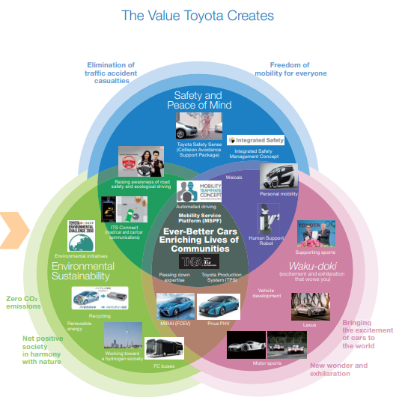
Figure 1: Values created by Toyota
(Source: Slideshare.net, 2016)
- Dedicating business to provide safe and clean products as well as enhancing life quality
- Development and creation of advanced technologies to provide outstanding services and products and fulfil customers’ needs worldwide
- Fostering an efficient corporate culture to enhance teamwork value and individual creativity, while honouring mutual respect and trust between management and labour

Mission
Mission of this company is making maximum profits on a long-term basis for stakeholders and representing to be a good citizen in corporate world.

Goals
Goals of this automotive corporation include becoming most respected and successful car manufacturer in every market around world. Furthermore, this company has set a goal to offer best ownership and purchasing experience.

Customer identification
Customers range from age groups between 30 and 50 years, and this company considers people in middle, especially upper-middle groups to produce automotive vehicle's money value (Annualreports.com, 2018). This brand applies an amalgamation of psychographic, geographic and demographic segmentation strategies in purpose of customer profiling. Furthermore, new customer target of this company includes young buyers. According to statement of Don Esmond (general manager and senior vice-president), the new division of Scion has been designed to attract generation Y customers.

SWOT analysis

Strengths  - Efficient human resource (HR) - This organisation is blessed with around 348,877 skilled HR professionals in world.  - Innovative work culture- Advanced functional strategies, management system and operating system, are major strengths to gain competitive advantages.  - Strong brand position- Largest fleets along with 150 plug-in hybrid electric vehicle (PHEV) production has created a strong position in UK.  - Diversified portfolio- This brand operates a variety of cars from hybrid to electric cars.  - Advanced technology- Technology of “Green Vehicle” acts as an innovative step to handle petrol price and environmental concerns.  - Worldwide supply chain- This brand operates branch companies, outlets and manufacturing factories globally.  - Capabilities of high production-  This organisation can produce about 10 million cars per year. | Weaknesses  - Over-dependability on suppliers- Production has become sloth due to such dependence.  - Poor recognition of brand- Toyota operates four flagships, including Lexus, Daihatsu, and Hino. Among them, Daihatsu and Hino has failed to make sufficient recognition.  - Failure in product marketing- Due to inaccurate marketing, this brand has failed to popularise green technology in India and China.
Opportunities  - Growth in developing nations- With exuberating demands, this brand can increase its popularity in developing nations.  - Environment-friendly production- As environmental concerns are growing, Toyota can implement strategies to make environment-friendly production. | Threats  - High competition- Strong competition with Hyundai, Mitsubishi, Ford and Volkswagen is creating threats.  - Lower profits- Continuous rise in exchanging rates has become a significant concern.
Table 1: SWOT analysis of Toyota Motors

Roles of employees
Employees working in management teams are involved in reducing costs, operating global business and applying human intelligence for enhancing productivity. Didier Leroy (vice president at executive level) is engaged in bringing passion and energy to combat with fierce competitiveness. Koji Kobayashi (Vice president at executive level) works on cost-reduction and Production System of Toyota (TPS) that are backbones of Toyota (Toyota-industries.com, 2018). Besides, employees working in technological department perform to expand safety, excitement and freedom for smart mobility communities. In this regard, these employees work hard to decrease consumption of fossil fuels and cut carbon-dioxide emissions to decrease global warming.
Additionally, workers engaged in department of mobility services play vital roles to create automated services in driving. For this purpose, employees in strategic management team have facilitated an agreement with Uber for collaboration expansion in fiscal year 2018. As a result, these team members have played competent roles to bring advanced developmental strategies in market. Besides, contributions of these employees are significant to enrich ride-sharing services that leverage automated driving technology.
As propounded by Wang, Zhao, and Zhou (2018), employees of a company have been regarded as an essential internal stakeholder to meet objectives and goals.
On other hand, Noe and Kodwani (2018) have stated that employees’ efficiency and dedication in multinational corporations are important to gain competitive advantages. For instance, workers in strategic management have prioritised a “best in town" approach and highlighted business environment improvement, challenge identification and effective distribution. Concerned employees are abiding by responsibilities to provide services, carefully tailored for regional characteristics and customer lifestyles. In contrast, concerned employees have applied the approach of "home and away" to transcend borders of Group's operations.
Conversely, employees working in quality management team apply TPS and use Jidoka concept (automation with human touch) to reduce costs and eliminate waste. Additionally, these employees implement Just-In-Time or JIT approach to bridge production, engineering and administrative departments.

Importance of development and training
As propounded by Cocuľová (2017), development and training are integral segments to enhance employees’ skills, and competencies in a company so that company’s growth can be ensured. Toyota has applied HR development in purpose of sustainable growth by global training program, recognising application of Toyota Way. In this context, On-Job-Training or OJT is performing as training program’s foundation.
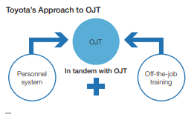
Figure 2: Approach of Toyota to OJT
(Source: Toyotaaruba.com, 2020)
Selected automotive brand has developed the Genchi Genbutsu concept, that has focused on onsite and in-hand experience for skill development. This concept has developed strategies for development and training purposes-
- Mentoring workers by senior colleagues and supervisors
- Mentoring junior colleagues and subordinates to make mutually beneficial relationships for learning in regular activities
- Providing necessary experiences to ensure professional growth by OJT
- Offering off-job training for new candidates

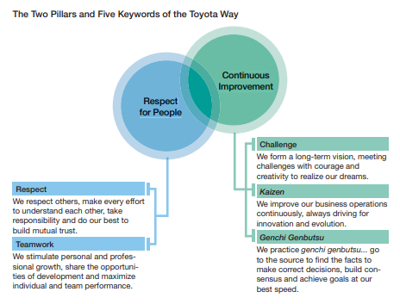
Figure 3: Two pillars of Toyota Way
(Source: Toyota-industries.com, 2018)
HR department has organised techniques and job skills in purpose of “Global Content” framework to help staff practice and understand Toyota Way. As stated by Krzywdzinski (2017), development and training programs are beneficial for improving current performance. Therefore, Global Content has been designed to prioritise both off and on-job training to enhance employee performance. In development process, this company has developed HR teams by following the specific philosophy- “manufacturing or monozukuri is developing people”. In order to ensure better engineering and administrative divisions, employees are trained to apply a cost-effective approach. This approach facilitates to bring staff at production locations and give staff in-hand experiences about standardised and consistent operations.
As propounded by Kasiri et al. (2017), customer satisfaction has to be a top-most priority to maintain market share for an organisation.
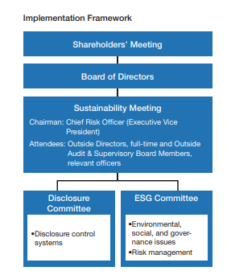
Figure 4: Sustainable framework
(Source: Annualreports.com, 2018)
Therefore, employees are engaged in sustainable growth of this company; for instance, staffs focus on applying positive manufacturing cycle to exceed expectations of customers and enrich community lives. Employees follow decisions taken in shareholders' meetings for sustainable development and risk management.

Role selection and importance of role
Role of an innovative designing expert in engineering department of Toyota has been selected. Being an expert in concerned department, responsibilities involve making organisational vision of CO2 emissions into reality within financial year 2050. For this purpose, roles include making innovative ideas of environmental technology. In fiscal year 2017, this brand announced plans for selling above 5.5 million electric vehicles in each year within year 2030 (Slideshare.net, 2016). This mission has prioritised Zero CO2 emissions in new vehicles and expanding vehicle sales up to 80% in UK and other nations within year 2023. Hence, concerned expert needs to make possible efforts to reduce CO2 emissions by 90%. Besides, specified expert plays important roles to maintain three values, such as peace along with safety, environmental sustainability and excitement to create a sustainable society of mobility. In this context, this expert possesses significant roles to improve electrification system to decrease CO2 emissions from vehicles, including both electric vehicles of fuel cell (FCEVs) and electric vehicles run by battery (BEVs).
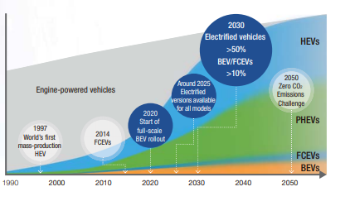
Figure 5: Milestones of vehicle electrification
(Source: Toyotaaruba.com, 2020)
From an energy-consumption perspective, specified expert performs component roles to design engines that can run by both hydrogen and electricity. In order to perform this role, pilot projects have been introduced to test vehicles that are low-carbon generating and fit with renewable energy. Through performing these roles, concerned expert contributes in planning of new power trains introduction with 37 variations in 19 models within fiscal year 2021.

Development and training requirements
In purpose of making low-carbon and renewable energy fit vehicles, training, as well as development, is necessary to utilise technological advancements in vehicle designing. As stated by Zablah et al. (2016), skill development in engine designing hybrid technology and transmissions is vital to achieving excellence in environmental performance.
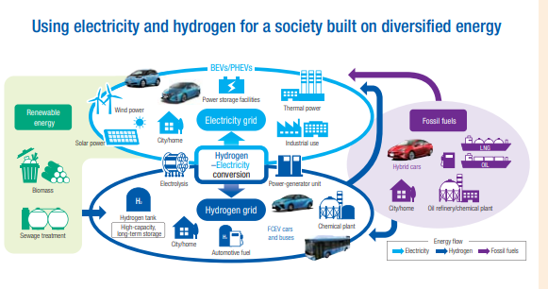
Figure 6: Diversified energy framework
(Source: Annualreports.com, 2018)
Hence, to increase employee competencies in hybrid technology, concerned company has developed New Global Architecture of Toyota (TNGA) for making environment-friendly cars. Through developmental factors of TNGA, management examines thoroughly fundamental performance aspects for improvement. According to this examination, training has been provided-
- Making designing and manufacturing components compact and lighter
- Creating cars with low-gravity centres
- Applying high-speed combustion techniques in engines
On other hand, Ochoa (2018) have argued that development cannot be achieved until proper evaluation of training effectiveness has been done. Hence, management has monitored whether effectiveness of fuel economy has been increased by decreasing CO2 emissions.

Conclusion
Hence, this report concludes that Toyota is serving as a promising manufacturer in UK market of automotive industry. Values of this company involve making every effort in purpose of customer satisfaction. SWOT analysis has revealed that global presence, brand position and worldwide supply chain are strengths of this company. This company has opportunities to grab customers' attention by applying green technology in car manufacturing. However, high competition and exchange rates are creating threats. Employees of this company play significant roles in manufacturing, cost reduction, sustainability maintenance and technological advancement. In role of innovative designing expert, low-carbon consuming vehicle production has been prioritised. In this regard, management has implemented TNGA approach to enrich development and training program.

Reference List
Books
Noe, R.A. and Kodwani, A.D., 2018. Employee Training and Development, 7e. New York: McGraw-Hill Education.
Journals
Cocuľová, J., 2017. The Analysis of the Selected Factors Influencing the Selection of Employee Training Methods. Journal of Human Resources, 5(2), pp.7-14.
Iglesias, O., Markovic, S. and Rialp, J., 2019. How does sensory brand experience influence brand equity? Considering the roles of customer satisfaction, customer affective commitment, and employee empathy. Journal of Business Research, 96, pp.343-354.
Kasiri, L.A., Cheng, K.T.G., Sambasivan, M. and Sidin, S.M., 2017. Integration of standardization and customization: Impact on service quality, customer satisfaction, and loyalty. Journal of Retailing and Consumer Services, 35, pp.91-97.
Krzywdzinski, M., 2017. Automation, skill requirements and labour‐use strategies: high‐wage and low‐wage approaches to high‐tech manufacturing in the automotive industry. New Technology, Work and Employment, 32(3), pp.247-267.
Ochoa, M.J.D.A.A., 2018. The Importance of Training in the Knowledge Era: a Comprehensive Vision. International Journal of Business and Social Science, 9(4).pp.4-5.
Wang, L., Zhao, J.Z. and Zhou, K.Z., 2018. How do incentives motivate absorptive capacity development? The mediating role of employee learning and relational contingencies. Journal of Business Research, 85, pp.226-237.
Zablah, A.R., Carlson, B.D., Donavan, D.T., Maxham III, J.G. and Brown, T.J., 2016. A cross-lagged test of the association between customer satisfaction and employee job satisfaction in a relational context. Journal of Applied Psychology, 101(5), p.743.
Websites
Annualreports.com, 2018. Annual Report 2018. Retrieved on: 9/5/2020<http://www.annualreports.com/HostedData/AnnualReports/PDF/NYSE_TM_2018.pdf>
Slideshare.net, 2016. Management Structure. Retrieved on: 9/5/2020<https://www.slideshare.net/masarali/toyota-12732700>
Toyotaaruba.com, 2020. About Toyota. Retrieved on: 9/5/2020<https://www.toyotaaruba.com/about-toyota/>
Toyota-industries.com, 2018. Responsibility to Our Employees. Retrieved on: 9/5/2020<https://www.toyota-industries.com/csr/reports/items/40-45e.pdf>

