BSc Health and Social Care
Module: BMHP5015 – Building Your Personal Brand for Sustainable Employment
Component 2 – Written Assignment (Report)
Student Name: Misba Mahmood
Student ID: 2413669
Module Tutor: Olufemi Oluranti
Submission Date: Sunday 19th July 2026

Contents Page
Introduction 3
- Analysis of the Job Description and Person Specification 3
- Analysis of the Employability Skills Required 4
Figure 1. NHS Jobs Vacancy Screenshot 5
Figure 2. Job Description and Person Specification 6
- Evaluation of My Skills, Qualifications and Experience 8
Table 1. Personal SWOT Analysis 9
- Building My Personal Brand, Professional Identity and Professional Network 10
- Five-Year SMART Action Plan 11
Table 2. Five-Year SMART Action Plan 11
- Conclusion 13
Appendix A- Curriculum Vitae 14
- References 16

Developing the Employability Skills Required for a Future Career as a Children's Palliative Nurse: A Professional Development Report

Introduction
Employability is a key aspect of professional development within health and social care because practitioners must demonstrate the knowledge, skills and behaviours required to provide safe, compassionate and person-centred care. In addition to academic qualifications, employers increasingly expect healthcare professionals to possess effective communication, teamwork, leadership and a commitment to lifelong learning in order to meet the changing demands of healthcare practice (NMC, 2018).
This report analyses a current Band 6 Children's Palliative Nurse vacancy advertised by Birmingham Community Healthcare NHS Foundation Trust (NHS Jobs, 2026) (see Appendix A). Although this is a senior role requiring post-registration experience, it reflects my long-term career aspiration of working within children's nursing. Analysing the vacancy provides an opportunity to identify the employability skills, professional behaviours and development required to achieve this career goal.
The report evaluates the skills and qualities required for the role, compares them with my current knowledge and experience, explores the importance of personal branding and professional identity, and presents a SMART action plan to support my future professional development.

1. Analysis of the Job Description and Person Specification
The chosen vacancy is for a Band 6 Children's Palliative Nurse within Birmingham Community Healthcare NHS Foundation Trust (NHS Jobs, 2026). The role focuses on providing specialist palliative and end-of-life care for children and young people with life-limiting conditions while working closely with families and multidisciplinary professionals.
Analysis of the job description demonstrates that employers expect candidates to possess advanced clinical knowledge alongside leadership, decision-making and effective communication skills. The successful applicant is responsible for coordinating care, supporting colleagues and contributing to service improvement, indicating that specialist nurses are expected to demonstrate both clinical competence and professional accountability. These expectations reflect the Nursing and Midwifery Council (2018), which requires nurses to practise safely, preserve professionalism and promote trust.
The person specification also highlights teamwork, emotional resilience and the ability to work independently. These qualities are particularly important within children's palliative care because nurses often support families during emotionally challenging situations. Consequently, practitioners must combine technical knowledge with empathy, compassion and professional judgement.
Although the vacancy is intended for an experienced practitioner, analysing its requirements provides a valuable benchmark for my own professional development. It has enabled me to identify the knowledge, transferable skills and professional behaviours I will need to develop throughout my future nursing career.
(see figures 1 and 2 for screenshots of the vacancy)

2. Analysis of the Employability Skills Required
The role of a Band 6 Children's Palliative Nurse requires a combination of specialist knowledge, transferable employability skills and professional behaviours. The vacancy demonstrates that employers expect nurses to provide high-quality care while leading practice, working collaboratively with multidisciplinary teams and supporting children and families (NHS Jobs, 2026). Therefore, employability extends beyond clinical competence and includes communication, leadership, emotional intelligence and continuous professional development. Yorke (2006) argues that employability involves developing the knowledge, skills and personal attributes that enable graduates to gain and sustain employment, reinforcing the importance of continuous professional development within healthcare.
Communication is one of the most important employability skills identified within the vacancy. Children's palliative nurses must communicate effectively with children at different developmental stages while also supporting parents and carers experiencing emotional distress. Consequently, communication involves empathy, active listening and the ability to adapt information according to individual needs. The NMC (2018) identifies effective communication as essential because it promotes safe, person-centred care and reduces the risk of misunderstandings that may compromise patient safety.
Leadership and teamwork are also fundamental to the role. Band 6 nurses are expected to coordinate care, contribute to service development and work collaboratively with other professionals (NHS Jobs, 2026). These responsibilities require practitioners to demonstrate sound clinical judgement while maintaining effective working relationships across multidisciplinary teams to ensure holistic, family-centred care.
Emotional intelligence is particularly important because children's palliative care involves supporting families during highly emotional situations. The CareerEDGE Employability Model identifies emotional intelligence, alongside subject knowledge, transferable skills, career development learning and experience, as an important component of graduate employability (Dacre Pool and Sewell, 2007). This suggests that employability is developed through continuous learning and reflective practice rather than academic achievement alone. Goleman (1998) argues that emotional intelligence enhances communication, leadership and relationship building, making it particularly important within children's palliative care where nurses must demonstrate empathy, compassion and emotional resilience while supporting children and their families.
Finally, reflective practice and lifelong learning are essential for maintaining professional competence. The NMC (2018) requires nurses to continually update their knowledge and skills to ensure safe and effective practice. Consequently, employers value practitioners who demonstrate self-awareness, adaptability and a commitment to continuous professional development.

Figure 1 NHS Jobs Vacancy Advertisement
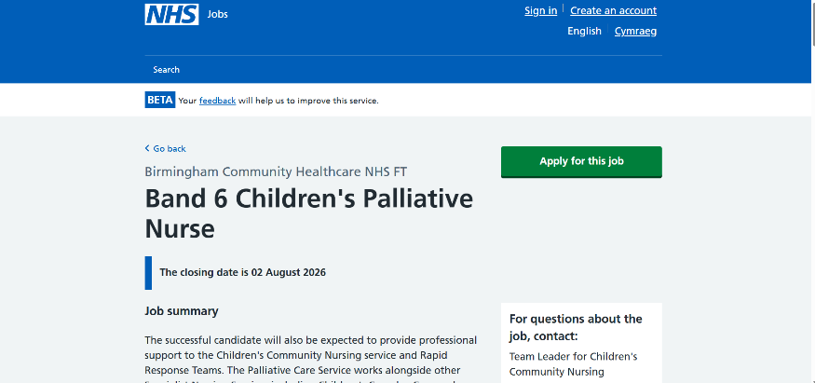
Source: NHS Jobs (2026).

Figure 2. Job Description and Person Specification for the Band 6 Children's Palliative Nurse Vacancy
Source: NHS Jobs (2026).
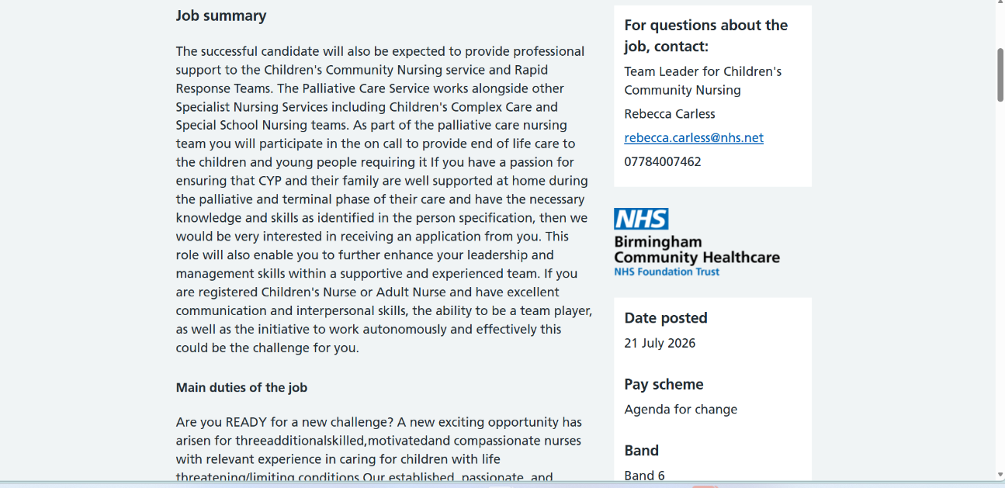
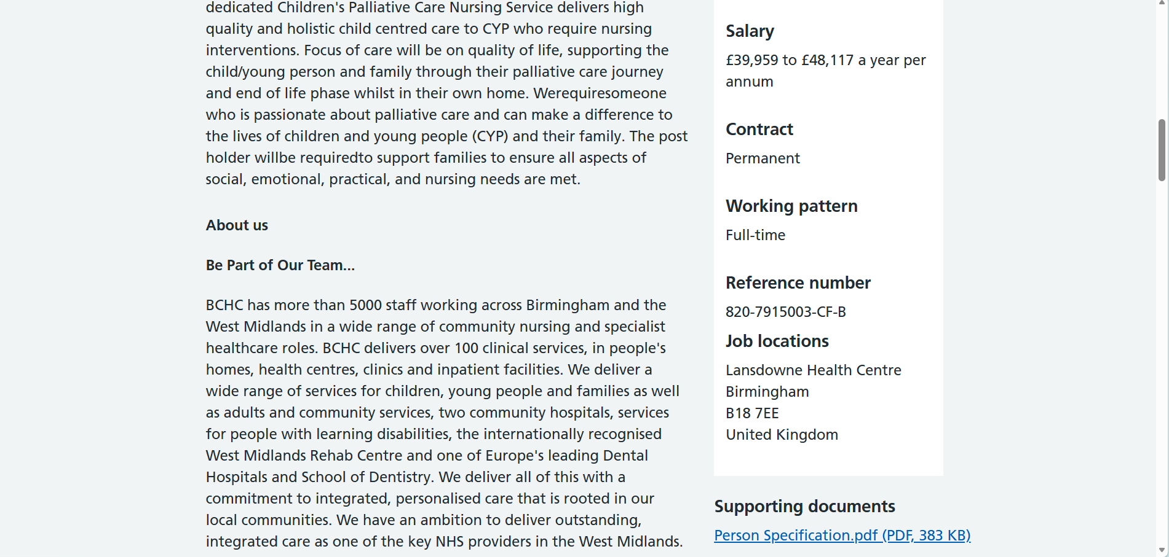
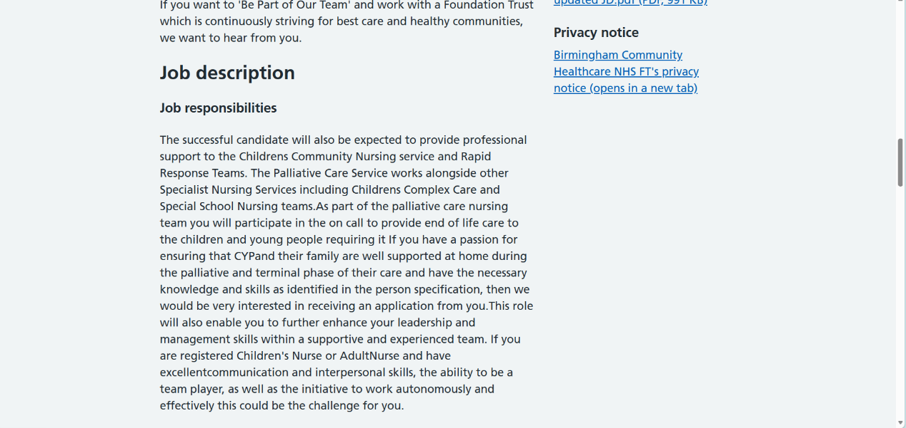
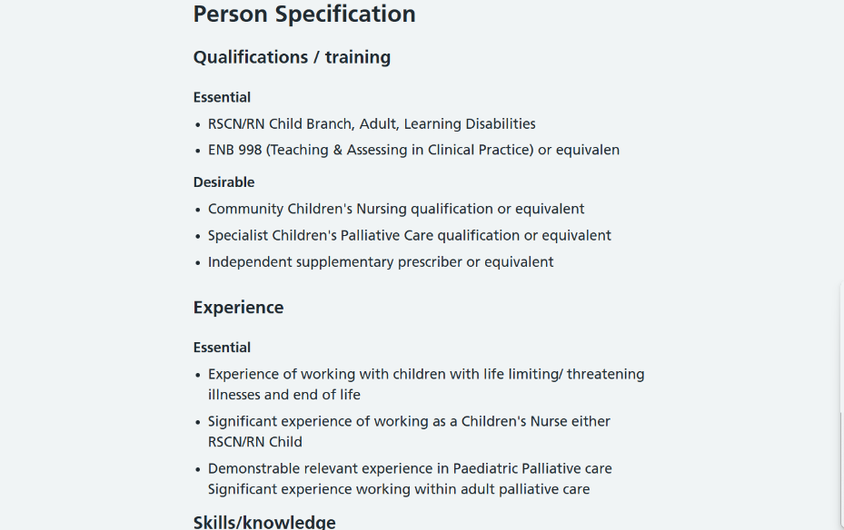
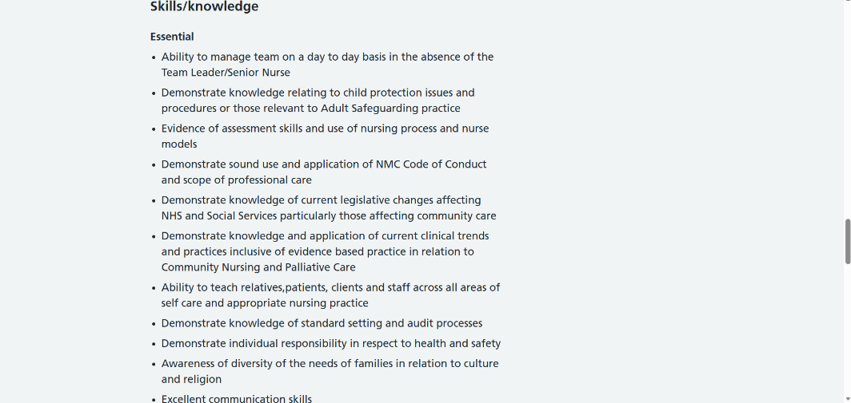
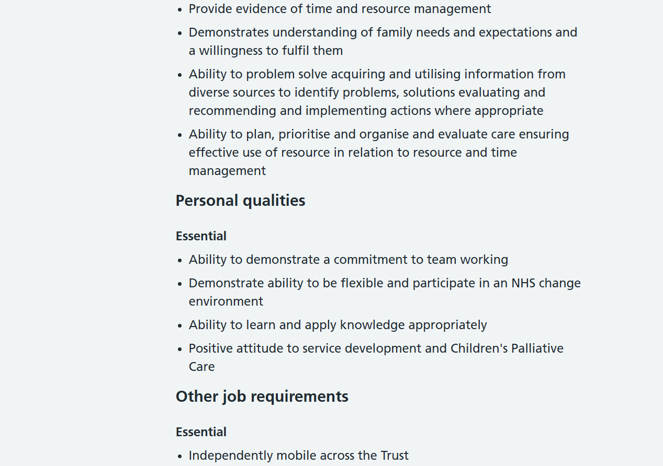



3. Evaluation of My Skills, Qualifications and Experience
Evaluating my current skills, qualifications and experience against the requirements of the Band 6 Children's Palliative Nurse role has enabled me to identify both my strengths and areas requiring further development. Although this position is intended for an experienced registered children's nurse, analysing the vacancy has provided a useful framework for assessing my employability and identifying the competencies I need to develop. The CareerEDGE Employability Model suggests that graduate employability is influenced by subject knowledge, generic skills, emotional intelligence, career development learning and practical experience (Dacre Pool and Sewell, 2007). This model provides an appropriate framework for evaluating my readiness for a future career in children's nursing.
To assess my current employability, I completed a personal SWOT analysis (Table 1). This self-assessment tool enabled me to identify my strengths, weaknesses, opportunities and threats in relation to my career aspirations. The findings have informed the professional development goals outlined later in this report.

Table 1. Personal SWOT Analysis
(Source: Author's own work, 2026)
Strengths | Weaknesses
Strong theoretical knowledge developed through studying the BSc Health and Social Care programme. | Limited practical experience within children's nursing and palliative care settings.
Good communication, teamwork and presentation skills developed through university group work and class activities. | Not yet a registered Children's Nurse and therefore unable to meet the professional requirements of a Band 6 role.
Good understanding of safeguarding, person-centred care, equality, diversity and ethical practice gained through academic study. | Leadership and advanced clinical decision-making skills require further development through future nursing education and clinical placements.
Motivated, compassionate and committed to pursuing a career caring for children and their families. | Limited exposure to caring for children with life-limiting or life-threatening conditions in a clinical environment.
Opportunities | Threats
Successfully complete my BSc Health and Social Care degree and progress to Level 6. | Competition for Children's Nursing programmes and future NHS posts.
Apply for a Children's Nursing degree to gain professional registration and clinical placements. | Limited practical experience compared with applicants who already have healthcare experience.
Gain experience through volunteering, placements or Healthcare Assistant opportunities in the future. | Balancing academic study with gaining additional experience and professional development.
Undertake CPD courses, attend NHS careers events and build a professional network through LinkedIn and university contacts. | The emotional demands of children's palliative care require resilience and continuous personal development.

The SWOT analysis indicates that I possess strong academic knowledge and transferable skills but require further clinical experience, leadership development and professional nursing education before progressing towards a Band 6 role.
My BSc Health and Social Care degree has provided a strong understanding of safeguarding, person-centred care, equality, diversity and evidence-based practice. In addition, university presentations, group work and independent research have strengthened my communication, teamwork, organisation and time-management skills. These transferable skills provide a solid foundation for children's nursing; however, I recognise that theoretical knowledge alone is insufficient and must be complemented by practical clinical experience before I can meet the expectations of a specialist practitioner (NMC, 2018). This reflects Benner's (1984) Novice to Expert model, which explains that nurses develop competence progressively through education and clinical experience.
Using Gibbs' Reflective Cycle (1988), I have reflected on my learning throughout this module and recognised that self-awareness is essential for professional development. Similarly, Schön (1983) argues that professionals improve their practice through reflecting on their experiences, enabling continuous learning and development. Reflection has helped me identify the need to develop greater confidence, leadership and clinical decision-making through future nursing education, placements and continuous professional development. Achieving these goals will strengthen my employability and support my progression towards a specialist career in children's palliative nursing.

4. Building My Personal Brand, Professional Identity and Professional Network
Developing a strong personal brand is an important aspect of employability because it enables individuals to communicate their values, skills and professional qualities to potential employers. Peters (1997) describes personal branding as presenting the qualities that distinguish an individual, while Shepherd (2005) argues that an effective personal brand should be based upon authentic skills and professional credibility. Within healthcare, this should reflect compassion, professionalism, integrity and person-centred care.
My personal brand is centred on becoming a compassionate, reflective and reliable healthcare professional committed to improving outcomes for children and their families. Throughout my Health and Social Care degree, I have strengthened my understanding of safeguarding, communication, ethical practice and person-centred care while recognising the importance of continuous learning. These experiences have contributed to the development of my professional identity and reinforced my commitment to a future nursing career.
Building a professional network is equally important for career progression. Developing relationships with university lecturers, healthcare professionals and fellow students can provide valuable opportunities for mentoring, learning and career development. I also intend to attend NHS careers events, maintain a professional LinkedIn profile and produce an up-to-date CV to communicate my knowledge, transferable skills and career aspirations effectively.
My unique selling point is my genuine commitment to working with children, willingness to learn and determination to continuously improve both personally and professionally. I believe these qualities, combined with my academic knowledge and reflective approach to learning, will enable me to contribute positively to children's nursing and align with the values expected of NHS employees.

5. Five-Year SMART Action Plan
The following SMART action plan outlines the steps I will take over the next five years to develop the knowledge, skills and experience required to achieve my long-term career goal of becoming a Children's Palliative Nurse. The plan reflects the importance of continuous professional development, practical experience and lifelong learning (NMC, 2018).

Table 2. Five-Year SMART Action Plan
Objective | Specific Actions | Timescale | Resources Required | Success Indicator
Complete my BSc Health and Social Care degree | Successfully complete all Level 5 and Level 6 modules | September 2026–June 2027 | University lectures, Moodle resources, academic support and independent study | Degree successfully completed
Gain practical healthcare experience | Apply for volunteering opportunities or Healthcare Assistant roles working with children | Within 12 months | NHS Jobs, local hospitals, children's hospices and volunteer organisations | Practical healthcare experience and professional references obtained
Progress into Children's Nursing | Apply for a Children's Nursing programme | 2027 | UCAS, university careers service, open days and academic guidance | Offer received for a Children's Nursing programme
Develop specialist clinical knowledge | Complete additional training in safeguarding, paediatric first aid and basic life support | Ongoing | NHS learning resources, accredited CPD courses and professional workshops | Certificates achieved and increased clinical confidence
Strengthen my professional profile | Maintain an up-to-date CV, develop a LinkedIn profile and attend NHS recruitment events | Ongoing | University Careers Service, LinkedIn, NHS Careers events and networking opportunities | Professional portfolio developed and increased employment opportunities
Achieve my long-term career goal | Successfully qualify as a registered Children's Nurse and gain experience to progress towards a specialist Children's Palliative Nurse role | Within five years | Nursing degree, clinical placements, NMC registration and mentorship | Employment within children's nursing and progression towards a specialist role

The SMART action plan provides realistic and achievable goals that will enable me to develop the knowledge, clinical experience and professional behaviours required for a future career in children's nursing. As I recognise that a Band 6 Children's Palliative Nurse role requires significant post-registration experience, the plan focuses on progressing through higher education, gaining practical experience and engaging in continuous professional development. Regularly reviewing these objectives will help me monitor my progress and prepare for future specialist practice (NMC, 2018).

6. Conclusion
This report has demonstrated that employability within children's nursing requires more than academic achievement and depends upon the development of professional knowledge, transferable skills and reflective practice. Analysis of the Band 6 Children's Palliative Nurse vacancy identified communication, leadership, teamwork and emotional intelligence as essential qualities for delivering safe, compassionate and family-centred care.
Evaluating my own skills and qualifications enabled me to recognise both my strengths and the areas requiring further development, particularly gaining clinical experience, leadership skills and professional nursing education. The SWOT analysis and SMART action plan have provided a realistic framework for achieving these goals.
Overall, this report has strengthened my understanding of the knowledge, behaviours and professional standards expected within children's nursing. By continuing to develop my skills, professional identity and practical experience, I will be better prepared to achieve my long-term ambition of becoming a Children's Palliative Nurse.

Appendix A- Curriculum Vitae
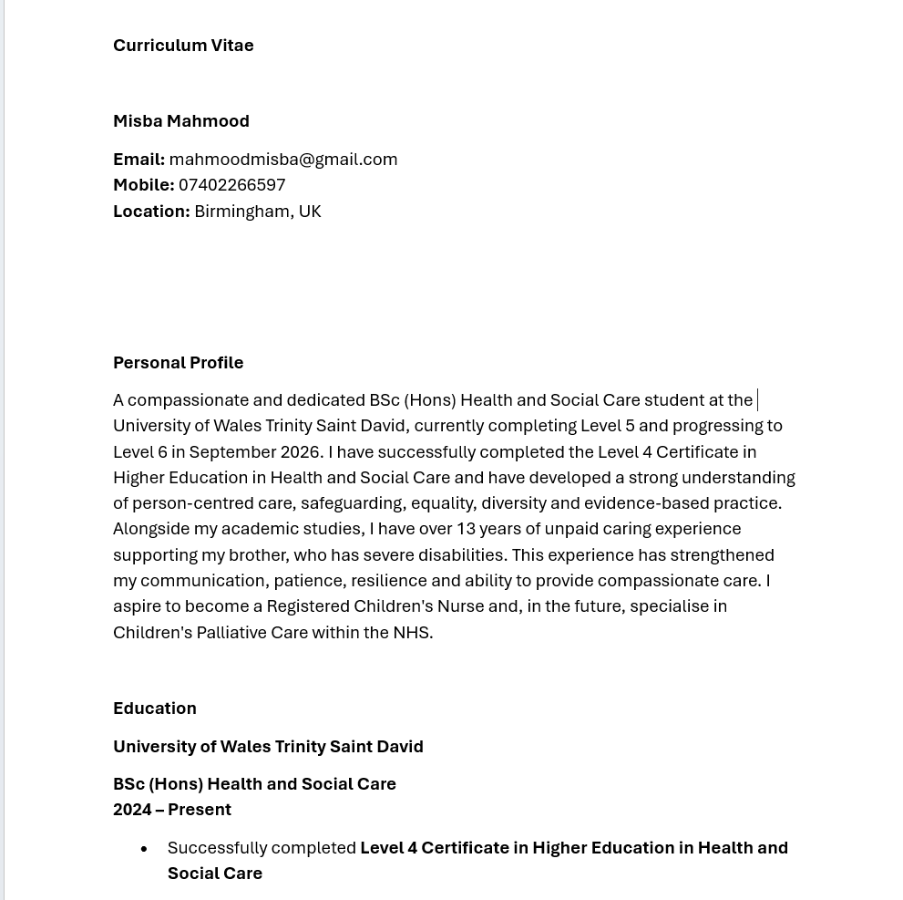
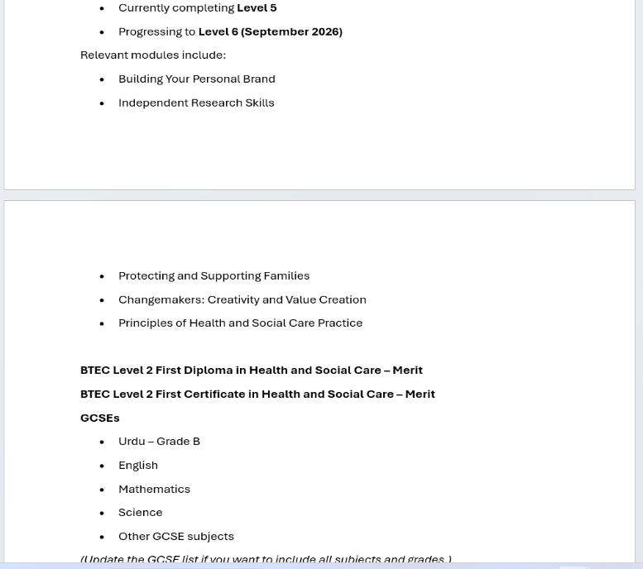
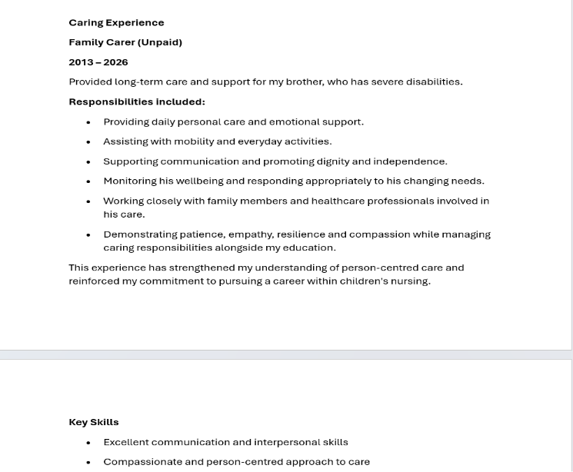
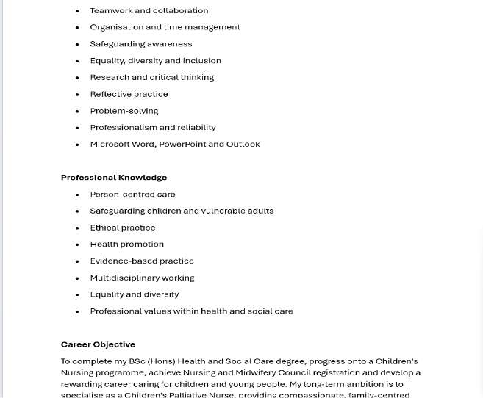
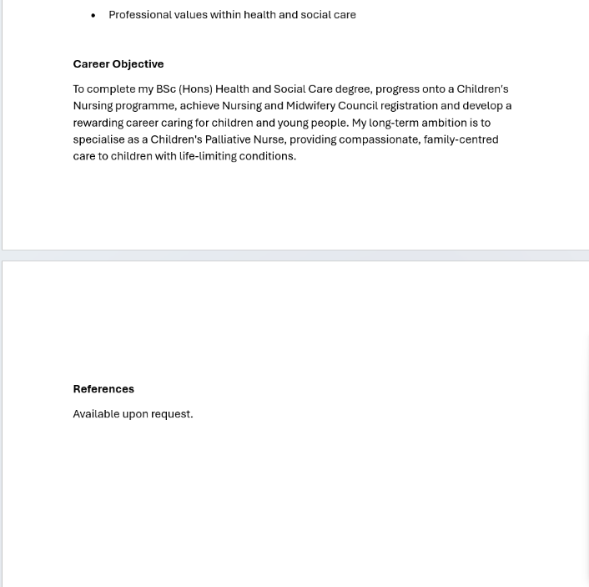

References
Benner, P. (1984) From Novice to Expert: Excellence and Power in Clinical Nursing Practice. Menlo Park, CA: Addison-Wesley.
Dacre Pool, L. and Sewell, P. (2007) ‘The key to employability: Developing a practical model of graduate employability’, Education + Training, 49(4), pp. 277–289.
Gibbs, G. (1988) Learning by Doing: A Guide to Teaching and Learning Methods. Oxford: Oxford Polytechnic.
Goleman, D. (1998) Working with Emotional Intelligence. London: Bloomsbury.
NHS Jobs (2026) Band 6 Children's Palliative Nurse, Birmingham Community Healthcare NHS Foundation Trust. Available at: https://www.jobs.nhs.uk/ (Accessed: 22 July 2026).
Nursing and Midwifery Council (2018) The Code: Professional Standards of Practice and Behaviour for Nurses, Midwives and Nursing Associates. London: NMC.
Peters, T. (1997) ‘The Brand Called You’, Fast Company, 10, pp. 83–90.
Schön, D.A. (1983) The Reflective Practitioner: How Professionals Think in Action. New York: Basic Books.
Shepherd, I.D.H. (2005) ‘From Cattle and Coke to Charlie: Meeting the Challenge of Self Marketing and Personal Branding’, Journal of Marketing Management, 21(5–6), pp. 589–606.
Yorke, M. (2006) Employability in Higher Education: What It Is – What It Is Not. York: Higher Education Academy.

