Research Method
Introduction 3
The previous chapter of this dissertation has achieved the first objective of this study which is to analyse key existing literature surrounding the topic of county lines and the impacts it has on children. This next chapter will seek to provide a further understanding into county lines and how Gwent Police respond to it. This will be done by using research methodology. This chapter will detail the justification of this research and what methods will be used to address the gap in literature. There are 2 main types of research, which are primary and secondary. Bryman (2016) has described primary research as information that has been personally collected by an individual and gathered for a specific purpose, whereas secondary research is the information obtained from previous studies which have been conducted by someone else. From this, as there is an academic gap within the specific area of county lines within Gwent Police, primary and secondary research will be used to answer this projects question.
Research Strategy 3.1
Saunders et al, (2016) had developed the ‘research onion’, this provides defined layers to guide a researcher through the process of conducting a research strategy. It allows for the researcher to identify different options and potential routes to go down when developing the research methodology.
The diagram shown in Figure 3.1 is the chosen research process for this study, with every layer showing a research technique.
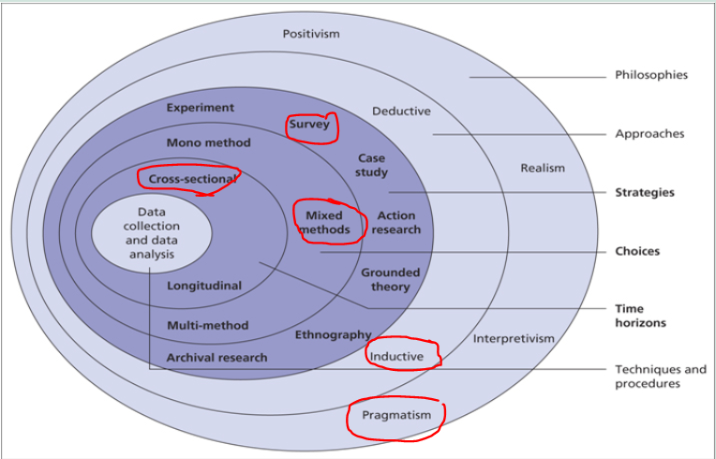
Figure 3.1

The outer layer of the onion is the ‘Philosophies’ which shows the angle a researcher could take when undertaking a project. The pragmatism view of the philosophy was chosen because it allows a more flexible view for the outcome of the research. It uses both qualitive and quantitative research. (Saunders et al, 2019) describes pragmatism as following the research problem and research question using a range of methods such as mixed, multiple, qualitive, quantitative with the emphasis on practical solutions and outcomes.
The next layer consists of two types of approaches to researched which are mainly used in academic literature, these are known as deductive and inductive. Bryman (2016) demonstrates the key differences between the approaches. He states that the deductive starts with a theory, the goal being to either prove or disprove their hypothesis. Whereby an inductive approach is basically the opposite, the researcher may develop findings and then collect data and will come to a conclusion from within that collected data. Therefore, an inductive research approach will be used in this research project to establish how Gwent Police respond to children involved with county lines.
A strategy through conducting ‘survey’ questionnaires and interviews with different individuals within the organisation will gather information and be obtained from different perspectives which will be anonymous. It will hope to gather information from officers within Gwent.
The study will be using a mixed method design, which is the analysing of both quantitative and qualitive methods. Gaps within information can be filled easily using both methods that show in depth exploration. With qualitive data showing the response of Gwent Police and quantitative data showing the impacts of children involved. This part of the study will mainly consist of qualitive data. Qualitive data is where you are not using numbers being counted or measured, but data that can gain insight from using language and descriptions.

The final aspect of the research onion is known as the ‘time horizon’. This illustrates how long research collection may take. This is a small project study, and ‘cross sectional’ is the appropriate choice of time horizon as it can also lead an opportunity for a further future study. Within the middle of the research onion is the data collection and analysis which will be discussed next.

Data Collection 3.2
Primary research is used for collecting data based on specific research question or topic. Qualitive methods will be used such as interviews and questionnaires. Questionnaires can provide many advantages and disadvantages. They offer the chance to be anonymous but are often time consuming in creating and disseminating, to then gathering the information received. The questionnaire will be presented to those currently employed by Gwent Police as police officers and above to those working in specialist departments. As well as this, surveys will also be used. Both anticipate that this can demonstrate the understanding of county lines to officers and their knowledge of the subject area. They have been disseminated through email and created by using Survey Monkey. The questionnaire has been designed using multiple choice and closed format questions.
Interviews consisted of 6-7 questions based on the topic area. The interviewees will be mixed from police officers to a police inspector who oversaw the modern slavery department for Gwent. A mixture of individuals was used to gather the different perspectives of the individuals through a range of ranks and departments to establish if their views are similar. The interviews were planned as a semi structured interview which were conducted in a small office of the police station. Qualitive data collected in natural settings are likely to be rich in contextual detail. (saunder et al 2019). A semi structured interview has been described as suiting well for exploring perceptions. (Barribal et al 1994)). To conduct these interviews, a formal email was drafted and sent to those willing to participate. All participants were asked the same open-ended questions. Participants were advised they did not have to participate any longer and that all information will be anonymous. Each lasted approximately 20 minutes long. Answers were recorded via recording device and note taking with consent.

Data Analysis 3.3
Data gathered and obtained from the primary research of questionnaires and the interviews will be analysed, the interviews being recorded and transcribed using a software known as NVIVO. This was used to be able to review and identify any patterns between the participants, to gain a deeper understanding of the perceptions and thoughts of those participating.

Limitations and Potential Problems 3.4
There may be some issues and limitations during the study. An ethics form had been completed and submitted to UWTSD to ensure every part of the project was approved before it was commenced. There are also time constraints due to working hours and shift work with other officers completing the interviews/questionnaires and having the free time within the working hours to conduct interviews. Within this, the participants were also informed of the sensitivity and nature of the study and how their answers would be utilised as well as their right to remain anonymous.
As well as this, the current pandemic has resulted in more people working from home and those taking parts availability may be minimal. The pandemic could have resulted in interviews being conducted online or through phone instead of a face to face interview.

Conclusion
This chapter has clarified the research methodology, it has justified the methods which will be used in this study. The next chapter will be the gathering, analysis and presenting of the findings from the data collected which was gathered by using the methods of this chapter.

References
- Saunders, M., Lewis, P. and Thornhill, A. (2009) Research methods for business students. England: Pearson Education Limited.

- Bryman, A. (2016) Social research methods: Oxford University Press

- Barriball, K. L., &While, A. (1994). Collecting data using a semi structured interview: A discussion paper. Journal of Advanced Nursing,

