REPORT ON THE IMPACT OF VLE (VALUE LEARNING ENVIRONMENT) MODEL ON THE STUDENTS LEARNING EXPERIENCE
Student Name : Iulian Ionut Panait
Student ID: 2112739
Name of Lecturer :Amitave Banik
Name of The University :University of Wales Trinity Saint David
CertHE T1GW3 (SH2)

Table of Contents
Introduction 3
Literature review 3
Research design and method 5
Data analysis and discussion 6
Conclusion 14
Reference List 15
Appendices 16

Introduction
The quality of the environment of the education system has been changed in recent times because the expectation of changing has increased highly which has improved the learning quality. Learning has evolved into a never-ending activity throughout an individual’s existence, requiring various methods of training should evolve through effort to satisfy rising demands as well as maintain educational continuation. Education, which had once conducted inside a facial expression setting, is now taking place within a setting controlled through technology as well as desktop technology. Any visual learner experience (VLE) seems to be a computer platform designed to help students educate as well as instruct inside a classroom setting. Any virtual learning environment (VLE) could be used inside any organization through a Limited Areas Connection (LAN) as well as across its Online like a Public Networks (WAN) for simplify projects, communications, material administration, as well as participation.
VLEs could be employed that language contributes face-to-face teaching practices as well as during distant education. This new website should be a public business connection which pupils and university employees use for access information; while rear ends might include datasets, file servers, and additional physical / logical resources.
The aim of this research is to properly investigate the impact of the VLE model on the learning process on the education system. Following the aim some objectives have been undertaken in this research that are
- To discuss the process or art of VLE Model and its equipments
- To examine the experience of the students through the use of VLE Model
- To explore the impact of the software VLE and exercise from the university of Wales Trinity

Literature review
Waheed, et al. (2020), has stated that, current digital school platforms inside this area of schooling effectively imitate reading ability throughout standard educational procedures. Educators usually anticipate a visual identification technology to be able to identify, evaluate, as well as integrate feelings throughout addition to have a positive educational impact, including observation, comprehending, including showing feelings, inside this sentient engagement procedure. Instructors could determine if learners grasp each educational topic based on learners' varied emotions throughout online education settings as well as change respective educational programmes unless educators display various reactions during recordings (Waheed, et al. 2020).
According to Yang, et al. (2018), learners' engagement within digital educational context prior to the start of such courses has minimal impact upon overall achievement. Accelerated advances with innovative instructional technologies have resulted with a massive growth throughout digital knowledge discovery, resulting in a plethora of instructional resources with a substantial influence upon universities. Such quick expansion of knowledge discovery therefore presents chances that improve students' involvement through technology networks in order to improve overall experiential teaching. Formative assessment, which predicts students' conduct as well as provides indications for improved strategic planning, have sparked the creation of various academic groups as a result of the accumulation of information extraction (Yang, et al. 2018).
As per Bogusevschi, et al. (2020), its Virtual Learning Environment (VLE) offers a variety of operations, resources, as well as recommended operations, and though its major characteristic is that it encourages cooperation and coordination among investigators as well as study respondents (educators, many experts, charitable teaching assistants, family members, and kids), who have been encouraged to contribute to such VLE's information and components creation. Founder that elements of such Virtual learning environment well with help of parents as well as societies' ethnic and language assets would be a core component, featuring four predicted outcomes: (1) improved stakeholders participation as well as participation; (2) a richer as well as authentically multicultural education (Bogusevschi, et al. 2020).
According to Aljohani, et al. (2020), colleges in today’s academia help to improve the overall content of the instruction process while also boosting undergraduate achievement. Various instructional methods, including facial expression (F2F) teaching, e-learning, collaborative teaching, including virtual schooling, was generally accessible. One is becoming increasingly common throughout modern schooling. Like a consequence of the worldwide epidemic created through COVID-19, universities have become impacted upon an international scale, both government as well as institution academics administrations deciding both classroom procedures will be conducted online throughout the ongoing duration of such 2019–2020 academics sessions (Aljohani, et al. 2020). As a result, mobile applications have become adopted as a tool towards institutional growth.
As per Romijn, et al. (2019), Despite such fact that academic instructional but also acquiring knowledge procedures have always just now throughout constant involvement throughout terms of its involvement of innovation upon a certain introduction of evolving techniques, the fact of the matter is whether due to the detainment imposed by covid-19, everything just appears that comprehensive usage Information and communication technologies in systematic adjustment had imposed as well as its integration might have boost, like an experiment of dynamic capabilities, and cultivated a procedure of change toward a virtual climate (Romijn, et al. 2019). As a result, every one of such changes has resulted in a better long-term educational approach.
Summary of the reviews:
Its Online Program of the United Kingdom has been a leader of contemporary correspondence courses throughout the mid-1960s, offering mixed education programs with face-to-face coaching as well as program offerings that include voice as well as video-based study content. Academic earnings technologies have evolved fast across institutions throughout its globe with the first introduction of online Web. Nevertheless, worldwide need for digital classrooms has grown towards this point that it is rare to encounter any learner as well as instructor who cannot utilize but rather understand many online educational tools along with applications accessible. Education systems have become the subject of several studies, as the results demonstrate that learners and even educational professionals have differing opinions about them.

Research design and method
The research method and process have played a significant role in evaluating the data and information in the study. For producing a proper investigation about the research context both primary data has been used in this research. For gathering the primary data a group of questions have been undertaken in the study which (in appendix one). Through the use of Google meeting the interview has been performed due to the current pandemic situation. The result of the survey will be presented through the graph generated through Excel. The result and outcomes in the example study are also helpful to present such arguments.

Data analysis and discussion
The result from findings has been discussed in this section. The results have been conducted through the quaternary survey and graph generated through excel. In the survey I have undertaken some questions. First I have introduces the participants from the survey. The below presented figure is show the amount of participant in the investigation. The below presented figure shows how many students are engaged with the use of the VLE module. In my survey a total of 40 participants have been conducted, in which 62.5% are the male participants and 37.5% are the female participants.
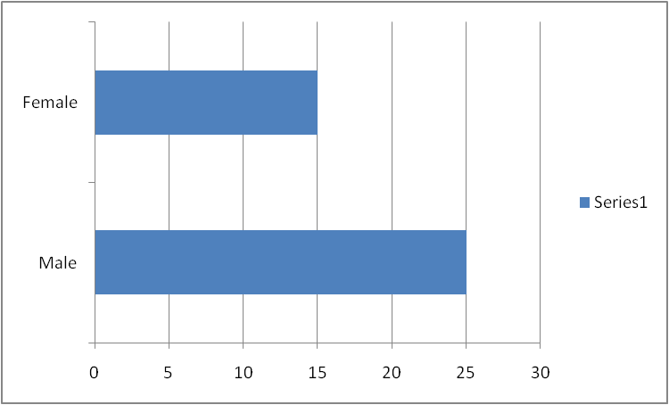
Figure 1: Participants using the module
(Source: Self-created in Excel)
Students have a chance to get interact through the VLE module, but some of them have not used it. In this survey this kind of situation has been found. Through the survey it has found many of the participants have been using this program in their home and do not have any kind of issues. Some participants have been using it but sometimes face some issues during learning and few of the participants have not properly used it. The below presented figure is showing the rate of agree of the students about the use of this model. Through this result it has found that 50% participants have used this program in their home who do not face any kind of issues, 37.5% participants has been used in their home but faces some issues and 12.5% participants have not used this feature yet.
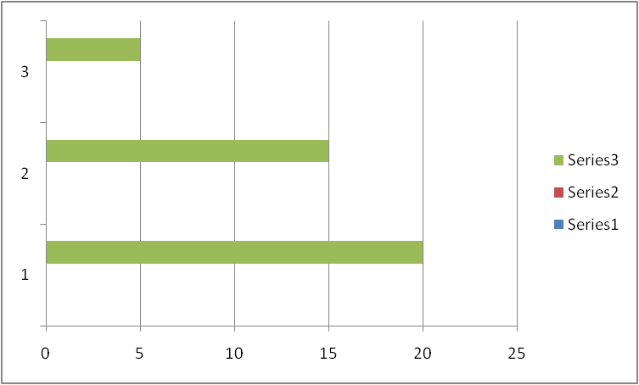
Figure 2: Showing how many student are using Tool
(Source: Self-created in Excel)
After following the usage rate of the feature, a question has been asked to the students that are this feature is helpful for them during learning. I think this is quite helpful for the students, from the result it has been found that 62.5% students have agreed with this statements, where 25% have has provided moderate answer and 12.5% student have disagree with the statement (fig 3).

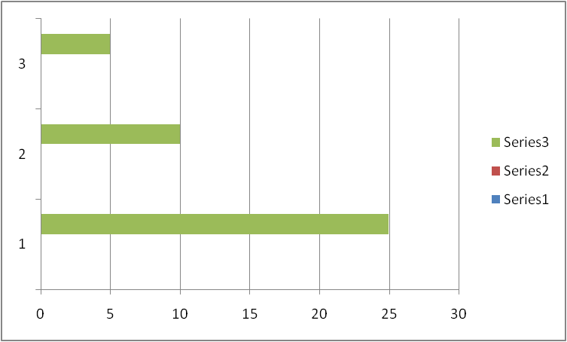
Figure 3: Experience of the students
(Source: Self-created in Excel)
After following the experience of the students it has asked them how many times they have used this feature in a month. From the survey it has been found that 50% students are required to use it daily in a month and 25% of students frequently use this in a month. Beside this it has also found that many of them around 25% are not required to use this outside of their classes (fig 4).
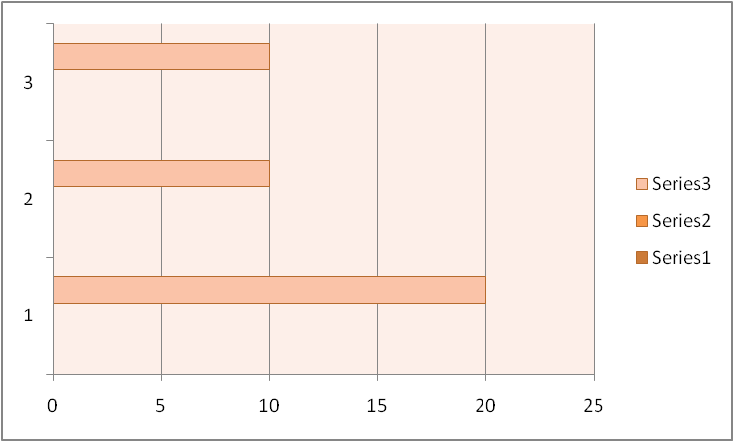
Figure 4: Importance of the module in learning
(Source: Self-created in Excel)
Following the experience or usage rate of the student any one will tell that this has improved the learning opportunity and encouraged them to learn independently. Based on these consequences I have asked the question to the students. From the result it has found that 37.5 % students or agrees with this statement. Where 50% students stated a neutral answer and 12.5% students disagreed with the statement (fig 5).
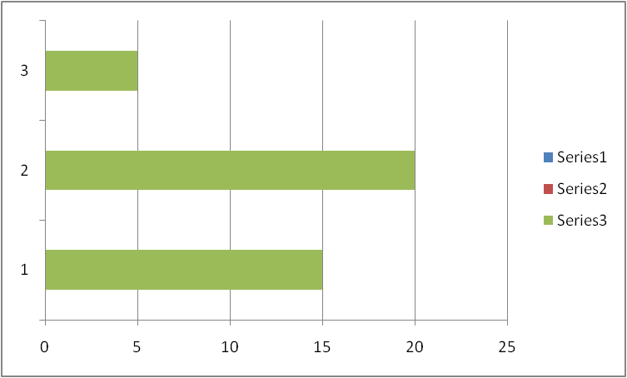
Figure 5: Role of the module in encouraging
(Source: Self-created in Excel)
As this has revealed that the use of this program is encouraging the confidence of the students, one more question has arrived in my mind that is this also encourages students to interact with each other. Through the result of the survey it can be stated that the 45% students agree that this can help them to encourage the other participants. 35% of students indicated moderate answers and 20% of students did not support this statement (fig 6).
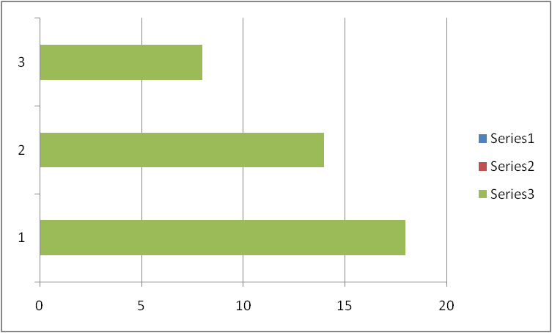
Figure 6: Encouraging student to interact each other
(Source: Self-created in Excel)
After these certain consequences one argument has arrived that is this motivating the learning behavior of the students. Following this, some agree that this has motivated them and some disagree with the statement. From the result, it has found that 50% of students agree, and 12.5% of students disagree (fig 7).
Figure 7: Role in motivating students
(Source: Self-created in Excel)
While asking the students about the tools under this program is this helpful or motivating during the learning so some of them 62.5% of students stated that the tools are helps fuel for them during learning and 12.5% students are disagree with the statements, many of the students around 25% has provided neutral answers (fig 8).
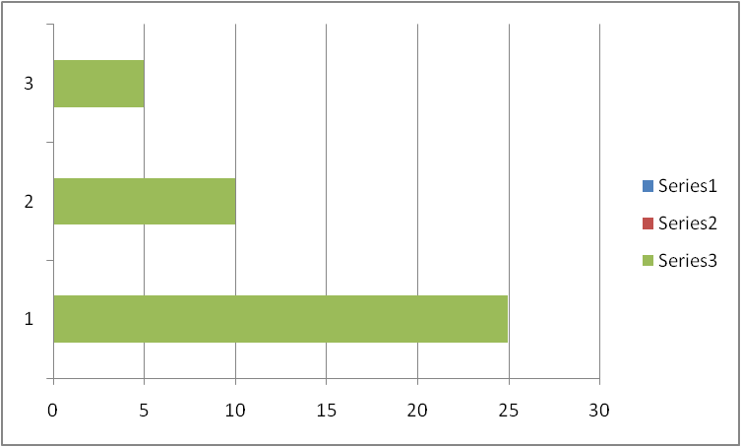
Figure 8: Tools of the module motivating students
(Source: Self-created in Excel)
At the end one question arrived: if this program has a positive impact. Through the survey result it has been found that sometimes it has a positive impact. Through the experience of students 62.5 % of them agree with the positive impact. Sometimes it has no positive impact that’s why many of them around 25% have stated neutral answers (fig 9).
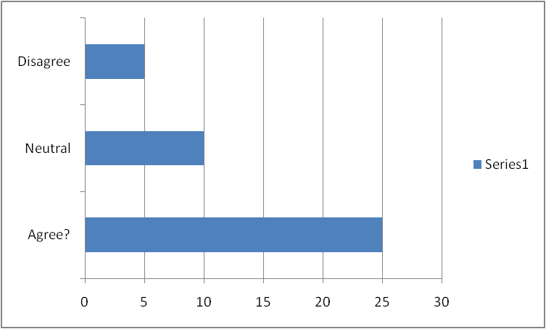
Figure 9: Experience of the students about the positive impact of this program
(Source: Self-created in Excel)

Conclusion
The all over report has been produced about the impact of the VLE model on the learning environments. To analyze the impact review of the literature has been gathered. Through the comments of the literature it has been identified that the VLE learning model is a quick expansion of knowledge discovery therefore presents chances that improve students involvement through technology networks through order to improve overall experiential teaching. For better understanding about the context a primary analysis has been performed. By performing a survey on the student experiences some information and data has been gathered and based on that information the discussion has been performed in the research. Through the descriptive analysis of the result it has found that more than 60% students believe that this module has a positive impact on the study.

Reference List
Journal
Al-Azawei, A. and Al-Masoudy, M., 2020. Predicting Learners' Performance in Virtual Learning Environment (VLE) based on Demographic, Behavioral and Engagement Antecedents. International Journal of Emerging Technologies in Learning (IJET), 15(9), pp.60-75.
Aljohani, N.R., Fayoumi, A. and Hassan, S.U., 2019. Predicting at-risk students using clickstream data in the virtual learning environment. Sustainability, 11(24), p.7238.
Bogusevschi, D., Muntean, C. and Muntean, G.M., 2020. Teaching and learning physics using 3D virtual learning environment: A case study of combined virtual reality and virtual laboratory in secondary school. Journal of Computers in Mathematics and Science Teaching, 39(1), pp.5-18.
Slot, P., Romijn, B. and Nata, G., 2019. A Virtual Learning Environment model of professional development aimed at enhancing diversity and inclusiveness.
Torres Martín, C., Acal, C., El Honrani, M. and Mingorance Estrada, Á.C., 2021. Impact on the virtual learning environment due to COVID-19. Sustainability, 13(2), p.582.
Waheed, H., Hassan, S.U., Aljohani, N.R., Hardman, J., Alelyani, S. and Nawaz, R., 2020. Predicting academic performance of students from VLE big data using deep learning models. Computers in Human behavior, 104, p.106189.
Yang, D., Alsadoon, A., Prasad, P.C., Singh, A.K. and Elchouemi, A., 2018. An emotion recognition model based on facial recognition in virtual learning environment. Procedia Computer Science, 125, pp.2-10.

Appendices
Appendix 1: Questionnaire
Q1: What is your Gender?
Male | Female
25 (62.5%) | 15 (37.5%)

Q2: Have you ever tried the model in home?
Yes – no problem | Yes-but have had problems | No
20 (50%) | 15 (37.5%) | 5 (12.5%)

Q3: Do you think this is really helpful for study?
Agree | Neutral | Disagree
25 (62.5%) | 10 (25%) | 5 (12.5%)

Q4: how many times you have required using this program outside the class?
More than one month | Less than one Month | Never
20 (50%) | 10 (25%) | 10 (25%)

Q5: Do you think this program has improved the learning opportunity and help you to learn independently?
Agree? | Neutral | Disagree
15 (37.5%) | 20 (50%) | 5 (12.5%)

Q 6: Is this program encourages you talk to the other students during activities?
Agree? | Neutral | Disagree
18 (45%) | 14 (35%) | 8 (20%)

Q7: Do you think the behavior of learning has been motivated through this module?
Agree? | Neutral | Disagree
20 (50%) | 15 (37.5%) | 5 (12.5%)

Q8: The varieties of tools, like excel, power point and other learning resources are available on this program, has motivating you during learning?
Agree? | Neutral | Disagree
25 (62.5%) | 10 (25%) | 5 (12.5%)

Q 9: What you think the module has a positive impact

Agree? | Neutral | Disagree
25 (62.5%) | 10 (25%) | 5 (12.5%)

Q 10: What you think can anybody learn more without this module?
Agree? | Neutral | Disagree
22 (55%) | 10 (25%) | 8 (20%)

