

Name Lindsay Dyble
Student Number 2405244
Module BMHP5014
Module Title Changemakers: Creativity and Value Creation
Lecturer Dani Dunne
Assignment Title Portfolio
Date Wednesday 25th March 2026

Task 1 – Concept Map

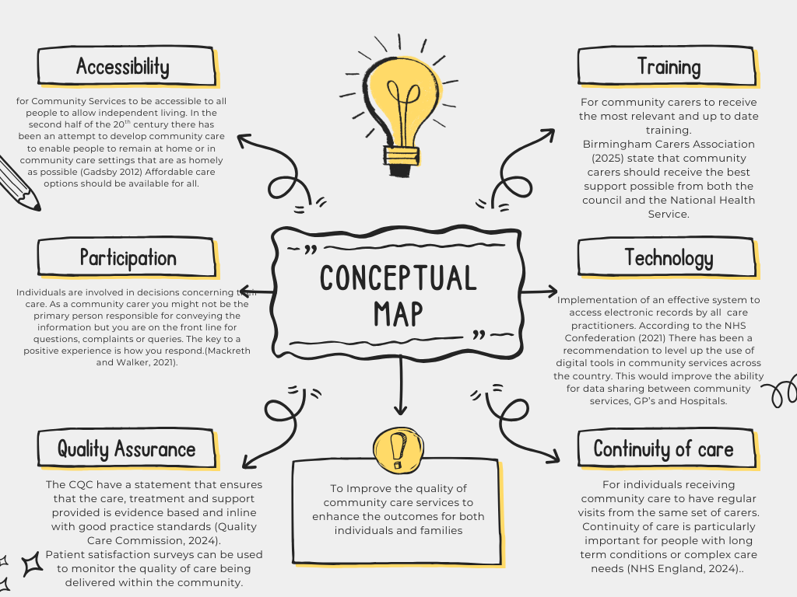

Task 2 - Self-Reflection of Group Activity
I was asked to join a group to take part in a challenge where you find as many uses as possible for a paperclip. I shared my own idea after listening to some of the suggestions from other group members. Each member of the group contributed ideas and then we discussed which ideas we thought would be the most practical.
I did not volunteer to share my idea first as I was not confident enough to go first. This was because I was unsure about how creative some of the other group members had been with their ideas. After a couple of the others had shared their ideas, I felt more comfortable sharing my own and contributing to the group discussion.
All members of the group were given the opportunity to speak one at a time as the rest of the group listened before discussing how practical we thought each idea was. Some ideas were discussed in more depth than others which has possibly limited opinions on the ideas that were given a shorter length of discussion time.
This challenge highlighted the importance of listening to others during a teamwork activity. Listening to the ideas and opinions of other members of the group, I was able to appreciate different problem-solving techniques. The group discussion allowed us to critically assess the practicality of the ideas rather than just focusing on the creativity.
The activity has helped me to recognise the importance of having confidence in my own ideas during group work. In future tasks, I will aim to share my own ideas more confidently and support others in the group to do the same.

Task 3 - Case Study of a UK innovation
The introduction of the NHS App represented digital innovation in the delivery of healthcare services. It introduced the opportunity for patients to be able to manage their own GP appointments, order repeat prescriptions, view test results, and access parts of their own medical records.
This was a transformation into accessing digitally accessible services and allowing people to book appointments digitally will save the NHS 200 million over 3 years. Parents will also be able to access their children's medical records, and the app will replace the need to carry the red book to appointments (Health, 2025).
Evidence indicates high levels of patient engagement with the app and the functions that are available to use, with features such as repeat prescription ordering and health record viewing experiencing rapid increases (NHS England, 2024).
As of December 2023, 33.6 million adults in England have downloaded the app. Between December 2022 and November 2025 monthly logins to the app rose by 53% and repeat prescription orders rose by 44%, demonstrating the effectiveness of the app for routine healthcare tasks (NHS England 2024).
Qualitative research shows (NHS England,2024) diverse user experiences and highlights digital technology in general practice through the NHS app. With some of its features described as being more useful than others, such as prescription ordering and COVID passes. Although the NHS app remains a complete innovation, ongoing work is needed to ensure that its potential can be sustained to meet patient needs.
The ability to use the app is however determined by the digital skills of the individual trying to gain access. People with limited IT skills could find it difficult to navigate, and this is proven by the evidence that points to inequalities in registrations across the different sociodemographic groups (NHS England,2024). Highlighting unequal trends with higher usage in the less deprived areas and less ethnically diverse practices, with a generally younger population (Sukriti et al.,2023).
Overall, the NHS app shows how digital health platforms can enhance accessibility, efficiency, and patient empowerment in modern day healthcare systems bringing services such as prescription ordering, appointment booking and being able to access medical records to once secure place. This will give the patients the ability to have better control over their own health as they have the facility to access the app anytime, anywhere.

Task 4 - Research Task
Children's mental health has become a growing concern in the United Kingdom over recent years and the number of children accessing treatment for mental health conditions in England has risen by 27% in three years from September 2021 to September 2024 (Royal College of Psychiatrists, 2024). The rise in children suffering from mental health issues puts a strain on their family, school, and health services. It is crucial that anyone who works or volunteers with children is able to recognise the signs that they may be struggling with their mental health (NSPCC, 2025). Understanding why there are so many children suffering from mental health issues is important to enable practitioners to develop prevention strategies to provide support for young people.
Evidence suggests that some children and young people's mental health and well-being has been substantially impacted due to the COVID-19 pandemic (GOV.UK, 2022), especially those who were vulnerable due to disrupted routines and social isolation when schools were closed and disadvantaged children had poorer outcomes than those with more advantage (GOV.UK, 2022). Studies show that the COVID 19 pandemic has affected the mental health of young people and they are disproportionally at risk of suicidal and self-harming behaviours. The study also indicates that females are more severely impacted than males (World Health Organisation, 2022).
Factors such as regular physical exercise, strong family support, and social connections were associated with better mental health outcomes (Adolescence Mental Health, 2021). These findings show the importance for improved Mental Health Services for children post pandemic to ensure that their mental health can be stabilised moving forward into adulthood.
The NHS study indicates that one in five children in England has a probable mental health disorder, and that eating disorders have risen in the 17 to 19-year-old age group. There has been a huge increase as the data shows that from 0.8% of the same age group in 2017 had risen to 12.5 % in 2023 (NHS, 2023)
NHS England now has Mental Health support teams in schools and colleges to provide early intervention with plans to expand to reach over half of the pupils in need nationwide.

Task 5 - Podcast
Children’s Oral Hygiene

Task 6 - NHS Leadership Framework Analysis
The NHS leadership framework (2013) has been developed by the NHS Leadership Academy (NHS Leadership Academy, 2013) as a guide for leadership behaviours and it outlines the behaviours required of individual members of staff for effective leadership across all levels of the NHS. On the 21st of July 2025, the government confirmed plans to regulate NHS managers through a disbarring system that will apply to board level leaders and their line reports within core NHS organisations (England, 2025). The leadership framework focuses on seven domains which include, demonstration of your personal qualities, how you work with colleagues and patients, service management, creating vision of what you would like to achieve and developing a strategy for delivery of the service.
Leadership is not limited to senior staff and managers, and it should be demonstrated by all staff to provide good quality patient care and to improve their own professional performance. When staff focus on how they work with others, they have a shared vision which focuses on patient-centered care which involves communicating clear goals and the development of strong teamwork.
Creating the vision involves engaging the team to ensure staff participation which includes involving individuals and demonstrating that their ideas and contributions are valued, this creates an atmosphere of staff engagement and mutual respect (NHS Leadership Academy, 2023). Delivering the strategy ensures staff capability and high standards of performance which support staff learning and personal growth.
The leadership framework promotes compassionate staff who can work collaboratively together to enhance the quality of healthcare and patient outcomes.
Working with others can be used as a leadership approach to encourage creativity and improve the quality of care. The NHS relies on collaboration between multi-disciplinary teams for essential service improvements.
Leaders can create an environment of open communication and mutual respect where staff feel comfortable expressing their thoughts on existing services and sharing ideas on areas that they would like to improve. Reflective practice can help when you are focusing on issues in your own practice, and reflection may show that you have gaps in your professional knowledge that can be easily rectified (Hargreaves and Page, 2018). Valuing staff contributions can strengthen team relationships and support creative problem solving. A collaborative approach can lead to improved service coordination and better patient outcomes and quality of care.

Task 7 - Self-Reflection Journal Entry
I have used the structure from Gibbs Reflective Cycle (McLeod, 2025) to structure my self reflection of this module. The Gibbs reflective model provides a structure to help reflect on your own experiences through stages.
When I first started the module, I initially thought that creativity involved producing new and original ideas. However, I quickly realised through classroom tasks especially the one which involved the use of a paperclip and lecture materials that creativity can be expanding on existing ideas and making, small changes and adaptations which are innovative so that they allow for continuous improvements.
At the beginning of the module, my lack of confidence in my own ideas limited my participation in class discussions and tasks. As my understanding of the module developed, I realised that creativity can be built on existing knowledge to develop ideas where small changes are implemented.
Evaluating this experience, this module has helped me to recognise that creative thinking can emerge through gradual changes and ongoing development of the original idea. This module has also highlighted the importance of self-belief in the creative prosses for me.
In conclusion, this module has demonstrated that personal confidence plays a crucial part in creativity. Moving forward, I need to believe more in myself when working on future modules. Especially when they involve creative tasks where I can share my ideas with greater confidence. I now recognise that even a small change can contribute to innovation.

Reference List
Care Quality Commission (2024). Delivering evidence-based care and treatment - Care Quality Commission. [online] www.cqc.org.uk. Available at: https://www.cqc.org.uk/guidance-regulation/providers/assessment/single-assessment-framework/effective/delivering-evidence-based-care. (Accessed 23rd January 2026)
England, N. (2024). NHS England» Integrated health and care. England.nhs.uk. Available at: NHS England » Integrated health and care
England, N. (2025). NHS England» Management and leadership development. England.nhs.uk. Available at: NHS England » Management and leadership development Accessed 7th March 2026.
Glasby, J. (2017). Understanding health and social care. Bristol: Policy Press.
GOV.UK (2022). Children and Young People.GOV.UK. Available at: 4. Children and young people - GOV.UK
Hargreaves, J. and Page, L. (2018). Reflective practice. Cambridge, Uk ; Malden, Ma: Polity.
Health (2025). Managing healthcare easy as online banking with revamped NHS App. GOV.UK. Available at: https://www.gov.uk/government/news/managing-healthcare-easy-as-online-banking-with-revamped-nhs-app. Accessed on 9th February 2026
NHS LEADERSHIP ACADEMY (2013). How was the Healthcare Leadership Model developed? – Leadership Academy. www.leadershipacademy.nhs.uk. Available at: https:How was the Healthcare Leadership Model developed? – Leadership Academy
NSPCC (2024). Child mental health: recognising and responding to issues. NSPCC Learning. Available at: Child mental health: recognising and responding to issues | NSPCC Learning
Royal College of Psychiatrists (2022). Children’s mental health crisis deepens: severe shortage of psychiatrists to meet growing demand. www.rcpsych.ac.uk. Available at: Children’s mental health crisis deepens: severe shortage of psychiatrists to meet growing demand
Sukriti, Kc., Tewolde, S., Laverty, A.A., Costelloe, C., Papoutsi, C., Reidy, C., Gudgin, B., Shenton, C., Majeed, A., Powell, J. and Greaves, F. (2023). Uptake and adoption of the NHS App in England: an observational study. British Journal of General Practice, 73(737). doi:https://doi.org/10.3399/BJGP.2022.0150. Accessed on 9th February 2026
Mackreth, P. and Walker, B. (2020). A handbook for support workers in health and social care. A person-centred approach. Andover: Routledge Ltd.
McLeod, S. (2025). Gibbs Reflective Cycle. Simply Psychology. Available at:Gibbs Reflective Cycle Accessed on 17th March 2026
NHS England (2024). Person-centred Care. NHS England. Available at: https://www.hee.nhs.uk/our-work/person-centred-care. Accessed on 25th January 2026
NHS England (2024). NHS England» Transformation and innovation delivery update. www.england.nhs.uk. Available at: https://www.england.nhs.uk/long-read/transformation-and-innovation-delivery-update/. Accessed 23rd January 2026
Samji, H., Wu, J., Ladak, A., Vossen, C., Stewart, E., Dove, N., Long, D. and Snell, G. (2021). Review: Mental Health Impacts of the COVID‐19 Pandemic on Children and Youth – a Systematic Review. Child and Adolescent Mental Health, 27(2), pp.173–189. doi:https://doi.org/10.1111/camh.12501. Accessed 10th February 2026
Www.nhs.uk. (2025). Birmingham Carers Association. [online] Available at: https://www.nhs.uk/services/service-directory/birmingham-carers-association/N10497037?gsdServiceId=377 (Accessed 23rd January 2026)
www.nhsconfed.org. (n.d.). How digital technology is benefiting community health services | NHS Confederation. [online] Available at: https://www.nhsconfed.org/articles/how-digital-technology-benefitting-community-health-services. Accessed Sunday 25th January 2026
www.england.nhs.uk. (n.d.). NHS England» Proactive care. Available at: https://www.england.nhs.uk/community-health-services/proactive-care/. Accessed on 25th January 2026
NHS England (2023). One in Five Children and Young People Had a Probable Mental Disorder in 2023. www.england.nhs.uk. Available at: NHS England » One in five children and young people had a probable mental disorder in 2023 Accessed 10th February 2026
World Health Organization (2022). COVID-19 pandemic triggers 25% increase in prevalence of anxiety and depression worldwide. World Health Organization. Available at: https:COVID-19 pandemic triggers 25% increase in prevalence of anxiety and depression worldwide

