Portfolio for ECEY4012.

Contents:
Part One – Study Timetable- page 2-4
Part Two – AI activity Page – Page 5,6,7
Part Three – Poster and reference list page 8,9
Part Four – Link to oral presentation

AI acknowledgment

I acknowledge the use of Microsoft 365 Copilot on 08/09/2026 to support my work for part 1 and 2 of the portfolio.
prompt(s):

- Hi I am a level 4 student studying in the UK, I am studying on a Monday evening I work full and have a family, can you please help me with my time management to study?

- Hi I’m a level 4 student studying in the Uk, can you help me with note taking during lectures please

- Help to create an academic poster for a level 4 module in academic skills. Two main headings. Time management and note taking

I confirm that I have not presented any AI generated text as my own work. I confirm I have copies of my drafts, notes, and other resources I used before, and after the use of AI tools which I may be asked to provide in evidence.

Rhan 1 Templed amserlen astudio / Study timetable template
Amser /Time | Llun  Monday | Mawrth  Tuesday | Mercher  Wednesday | Iau  Thursday | Gwener  Friday | Sadwrn  Saturday | Sul  Sunday
00:00 - 00:59 | Sleep | Sleep | Sleep | Sleep | Sleep | Sleep | sleep
01:00 - 01:59 | Sleep | Sleep | Sleep | Sleep | Sleep | Sleep | Sleep
02:00 - 02:59 | sleep | Sleep | Sleep | Sleep | Sleep | Sleep | Sleep
03:00 - 03:59 | Sleep | Sleep | Sleep | Sleep | Sleep | Sleep | Sleep
04:00 - 04:59 | Sleep | Sleep | Sleep | Sleep | Sleep | Sleep | Sleep
05:00 - 05:59 | Sleep | Sleep | Sleep | Sleep | Sleep | Sleep | Sleep
06:00 - 06:59 | Wake- prepare for work | Wake – Prepare for work | Wake- Prepare for work | Wake – Prapare for work | Wake – Prepare for work | Sleep | Sleep
07:00 - 07:59 | Get girls ready for school | Get Girls ready for school | Get girls ready for school | Get Girls ready for school | Get girls ready for school | Sleep | Sleep
08:00 - 08:59 | School run get to worki | School run , get to work | School run, get to work | School run, get to work | School run, Get to work | Sleep | Sleep
09:00 - 09:59 | Work | Work | Work | Work | Work | Breakfast with the girls | Breakfast family time
10:00 - 10:59 | Work | Work | Work | Work | Work | Family time | Cleaning sorting
11:00 - 11:59 | Work | Work | Work | Work | Work | Family time | Visiting family
12:00 - 12:59 | Lunch | Lunch | Lunch | Lunch | Lunch | Family time | Visiting family
13:00 - 13:59 | Work | Work | Work | Work | Work | Family time | Visiting family
14:00 - 14:59 | Work | Work | Work | Work | work | Family time | Family time
15:00 - 15:59 | work | work | work | Work | Work | Family time | Family time
16:00 - 16:59 | Make way to uni check emails | Pick girls up sort tea, housework | Pick girls up, sort tea , housework | Pick girls up- sort tea , housework | Pick girls up | Family time | Family time
17:00 - 17:59 | University | Family time- homework , talk to craig | Go see mam and dad , take mam shopping | Tea , and get ready for BSL lessons | Food shopping | Family time | Family time
18:00 - 18:59 | university | Reading/emails  Prepare any uni work | Home sort the girls out have my tea | BSL lessons | Houe work and make tea | Family time | Sorting school stuff
19:00 - 19:59 | University | Sort girls out for bed , and school next day | Watch Tv  Look at assessments | BSL lessons | Family time | Family time | Sorting girls for bed
20:00 - 20:59 | Drive home, see girls | Look through uni assignment | Watch tv  Look at assessments | See the girls , tv and chill | When girls in bed do some reading | Tv and chill  Check if assignments need doing | Reading checking if assignments need doing
21:00 - 21:59 | Shower and prepare next day | Look through uni assignments | Prepare for next day | Chill watch tv | Reading/ watch tv | Tv and chill  Check if assignments need doing | Tv and chill  Prepare for next day
22:00 - 22:59 | Sleep | Self care – bed | Self care- Bed | Self Care – Bed | Self Care – bed | Self care and bed | Self care and bed
23:00 - 23:59 | Sleep | sleep | Sleep | Sleep | Sleep | Sleep | Sleep

I used Microsoft Copilot to explore two different study techniques to support me through early years education and care degree.
First prompt
Hi I am a level 4 student studying in the UK, I am studying on a Monday evening I work full and have a family, can you please help me with my time management to study?
Copilot response
Absolutely, Laura — juggling full-time work, family life, and Level 4 study is a lot, but it’s also completely doable with the right structure. The key is building a rhythm that works with your real life, not against it. Here’s a plan designed specifically for someone studying one evening a week while working full-time.
Copilot also provided me with a tailored study plan:

Monday
- 7–10pm: Main study session
- End with a weekly plan + priorities

Wednesday
- 20–30 mins: Review Monday’s notes, highlight key ideas

Friday
- 30–40 mins: Work on an assignment paragraph or reading

Sunday
- 45–60 mins: Research, referencing, or finishing a task
Total weekly study time: 4–5 hours This is ideal for Level 4 while working full-time.

How to make this sustainable

Use the “3 Task Rule”
Each week, choose only three study tasks that must be done. This prevents overwhelm and keeps you moving.

Break assignments into tiny steps
Instead of “Write my essay”, break it into:
- Find 2 sources
- Read 1 article
- Write 150 words
- Add references
Small steps = less procrastination.

Use family-friendly study boundaries
Tell your family:
- “Monday nights are my study night.”
- “I just need 30 minutes on Wednesday and Friday.”
Clear expectations reduce guilt and interruptions.
I refined my prompt by asking copilot could it give me three bullet points to help me with my time management.
Refined response.
Here are three clear, powerful bullet points to keep your time management simple and effective:
- Plan your week in advance — choose three priority study tasks and schedule them into specific time slots so you always know what you’re doing and when.
- Use short, focused sessions — 20–40 minute blocks midweek plus your Monday evening study keep you moving without overwhelming your family or work life.
- Break every task into tiny steps — small actions like “read 2 pages” or “write 100 words” stop procrastination and make progress feel easy.
I checked what copilot told me with Stella Cottrell and she agreed that note taking during a lecture was good practise she also spoke about the importance of not writing down full sentences and using key words and abbreviations but still ensuring that the notes are legible and useable. Stella also wrote about using different coloured pens, styles of writing and the use of sticky notes to help organise notes.
AI spoke about leaving a blank space if the lecture moves on to fast and then go back to fill it later, but stella writes about planning for amendments, leaving spaces within your notes which you can go back and add new information in at a later time, this is quicker than re writing all your notes again. “Corttrell,2024, p.279”
McMillian and Weyers wrote about creating a study timetable and it gave advantages of being organsied and setting good daily habits to help towards studying. Using unproductive time like before going to sleep or commuting to work to read a article or write down notes “McMillian and Weyers 2021, pg.26” The book also spoke about organising family plans onto a wall Calander and checking this inline with my study timetable to unsure there is a flexible study and family time.
AI generated a tailored study plan for me and when I refined my search asking AI give me 3 clear bullet points to help me with my time management whilst studying. AI advised me to plan my week in advance, Honeybourne wrote about keeping family and studying at a good balance ‘‘it is important to set time aside for hobbies and socializing as this will help with overall stress and wellbeing ‘“Honeybourne 2025,chapter 4 “
Redefection.
For this part of the assessment Microsoft copilot was used to explore two different study skills that could be incorporated to support new students studying a degree. There were two prompts used to find out the information required. The first prompt gave a lot of information which was generic and some of it was not relevant it did give me a basic study timetable including time slots for studying which was useful. Therefore, a further prompt was used to refine the results to give a clearer response. The refined prompt was ‘can you give me three bullet points to help me with my time management whist studying’ The results were a lot clearer and easier to read giving specific results. Copilot was useful to help find information, but the prompt used needs to be clear and specific in order for copilot to give the best response
Copilot was also prompted to find academic resources to support these study skills, copilot returned information on one UK university and an academic skills website which could be accessed through the website that had been linked, some of the information on the links were generic and one of the links was invalid. I was able to access a reading list provided by the course lectures which the library offered books on study skills these were accessible online through the UWTSD library. These were easily accessible, easy to read and relevant to the module I am studying.
Using this process has shown that copilot is quick and easy to access, it saves time and gives you a lot of information, its easy to scan through to be able to pick out the main points but the information generated isn’t always reliable and can be a generic response, it also shows that using copilot can be affective when promoted to give a refined response. copilot can give you other possible questions that are related to the prompts asked.
I would think that if I was to use copilot In the future to help me with my studies, I would use it as a starting point to generate ideas and then refer back to the reading list for the module and books or articles recommended by the course lectures, I would also refine the prompts and unsure that the information has come from a reliable source.

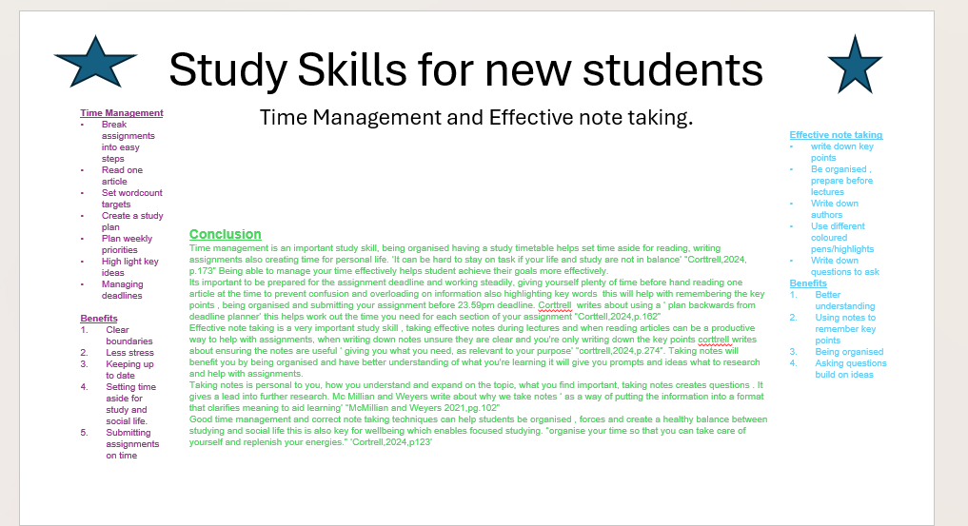

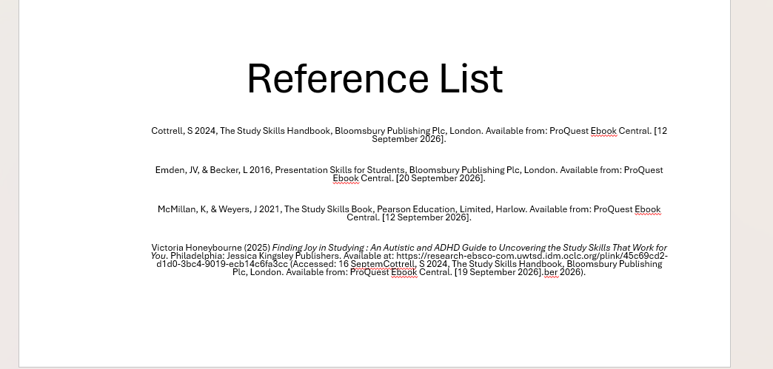

voice over.mp4 link to voiceover.

REFERENCE LIST

Cottrell, S 2024, The Study Skills Handbook, Bloomsbury Publishing Plc, London. Available from: ProQuest Ebook Central. [12 September 2026].
Emden, JV, & Becker, L 2016, Presentation Skills for Students, Bloomsbury Publishing Plc, London. Available from: ProQuest Ebook Central. [20 September 2026].
McMillan, K, & Weyers, J 2021, The Study Skills Book, Pearson Education, Limited, Harlow. Available from: ProQuest Ebook Central. [12 September 2026].

Victoria Honeybourne (2025) Finding Joy in Studying : An Autistic and ADHD Guide to Uncovering the Study Skills That Work for You. Philadelphia: Jessica Kingsley Publishers. Available at: https://research-ebsco-com.uwtsd.idm.oclc.org/plink/45c69cd2-d1d0-3bc4-9019-ecb14c6fa3cc (Accessed: 16 SeptemCottrell, S 2024, The Study Skills Handbook, Bloomsbury Publishing Plc, London. Available from: ProQuest Ebook Central. [19 September 2026].ber 2026).

