Building And Deploying a Type 2 hypervisor

[Draw your reader in with an engaging abstract. It is typically a short summary of the document. When you’re ready to add your content, just click here and start typing.]
  - David Julian Rapado

Table of Contents
Introduction 2
What are Hypervisors 3
Types of Hypervisors 3
Type1(Bare metal) 3
Type 2(Hosted) 3
Resource allocation 4
Isolation and security 4
Hardware Abstraction 5
Management and Orchestration 5
Setting Up the Noss network 5
Fig 1 topology of Noss 5
Fig 2 Dashboard for Server and WorkStation 6
Fig 3 Setting up Date time and UK keyboard 6
7
Fig 4 Set New Passwords 7
Fig 5 Check Connection between Server and WorkStation 8
Fig 6 changing the name of the work station and server 8
Conclusion 9
References 10

.

Introduction
Noss, a Multinational Corporation with operations in Swansea and London, requires the establishment of a robust network infrastructure to accommodate fast and effective communication, collaboration, and resource management across its locations. As the designated IT professional, the implementation of a virtualised environment leveraging hypervisors presents a strategic solution to address NOSS’s expanding and evolving business needs. This report explores the intricacies of hypervisors, their types, features, and their sustainability within the context of NOSS’s network.

What are Hypervisors
A hypervisor is sometimes called Virtual Machine Monitor (VMM) and there are two types Bare-metal (type1) and Hosted (type2) it is a critical component in virtualisation technology that enables the creation of Virtual Machines (VMs) operating within an isolated environment. Operating independently of the host system, the hypervisor takes and allocates physical hardware resources CPU scheduler, memory, and storage among many VM guests [1]. While the VMs are leveraging the computational, the physical hardware continues to execute essential tasks.

Types of Hypervisors
There are two types of Hypervisors type1 (bare-metal) and type 2 (hosted)

Type1(Bare metal)
Type 1 hypervisors are called bare-metal because the sit directly on metal servers and they have direct access to hardware and its resources. They do not have an operating system installed. [2]
Advantage of using a type 1 is that they are fast, efficient and stable as they don’t need to run through a operating system and also more secure, as the lack of an operating system reduces the risk of becoming unstable.
Disadvantage of using a type1 is that they are hard to maintain and not very user friendly.

Type 2(Hosted)
Type 2 hypervisors are called hosts because they run on top of a operating system. Share resources with the Operating system.
Advantage of a type 2 is that they are cheaper to run than a type 1 due to it being easier to instal and maintain also scalability is easier
Disadvantages of type 2 due to the shared resources with an operating system latency [2] can be a problem also it’s less secure.

Resource allocation
The hypervisor partitions off the physical resources like the CPU cores, memory modules and storage devices, the VM then distributes theses limited resources up between multiple applications. VM recourse allocation is basically determining how best to divide the resources between VMs present in your network. One thing to consider when VMs allocate the resources it often leads to optimization problems- the more VM processors you have the more connections within your network, which could lead to a higher chance of latency and bottlenecks, and other issues that could affect the performance of the machines and network. There are ways around this firstly, you can specify resource allocation preference what constraints the hypervisor has when allocating resources on VMs. And secondly you could limit how many VMs to its host core. As a general rule a ratio of 1:1 ratio one VM per host is consider good, but technically you could add as many as you liked, however this could lead to overload and a slowdown in performance, so if you do decide to add VMs maybe try going in small increments like 2:1 and work up to say 4:1 and so on. doing it this way you can keep a check on the performance, this is type of monitoring is what’s called establishing baselines [3]. Basically, you monitor the performance of you network and using the data collected you will be able to have better picture on how to avoid overloading the network and improving its performance.

Isolation and security
By encasing each VM in in its own virtualised environment, the hypervisor ensures that there is no unauthorised access on the host core systems and safeguarding sensitive data. For example, Intel VT-x and AMD-v [4] hardware enables direct extraction from the CPU to the VM this is called a “virtual machine entry”. When a VM tried to execute a privileged instructions are stopped temporarily and control of the CPU is given to the VMM. The instructions that caused the “virtual machine exit” are inspected along with hardware providing information in response to the exit. Then using the information gathered from the VME (virtual machine exit) the VMM emulates the privileged instructions with in the VM. Once this has been done the VMM carries out the extraction with another machine entry. The Intel VT-X and AMD -V are also designed to detect sensitive data events and instructions. This takes away the need for the VVM to monitor supervisory code like instructions. This allows the VVM to choose between hardware assisted virtualisation or binary translation depending on the workflow requirements, this offers the VMM more flexibility. Something to consider is the performance, if workloads are using binary, they might outperform the hardware assisted virtualization. Other security features such as access controls encryption and secure boot mechanics are also implemented at the hypervisor to mitigate and prevent security threats and vulnerabilities.

Hardware Abstraction
A hardware abstraction layer (HAL) [5] of software that allows the OS to interact with the Hardware devices and components at a general level presenting virtualised representations of the CPU, memory and storage and network interfaces to a guest VM. This abstracted layer shields the VM from the more complex hardware activities, allowing them to operate independently across a diverse hardware architectures and configurations.

Management and Orchestration
Orchestration allows the centralization of management interfaces automating and scaling applications monitoring configuration by the hypervisor. Tasks like live migration, snapshot management to optimise the resources and manage disaster recovery, [6] operational workflow.

Setting Up the Noss network
The IT team conducts an analysis of the Noss network topology to figure out and understand the infrastructure and identify areas for improvement. Things like the physical layout network devices and the options for connecting between Swansea and London. See fig 1

Fig 1 topology of Noss
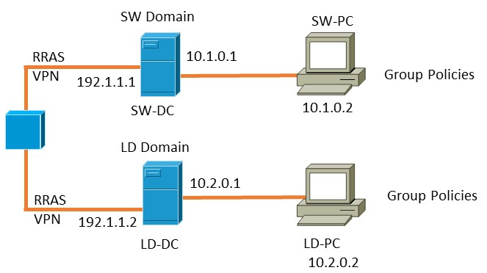

Fig 2 Dashboard for Server and WorkStation
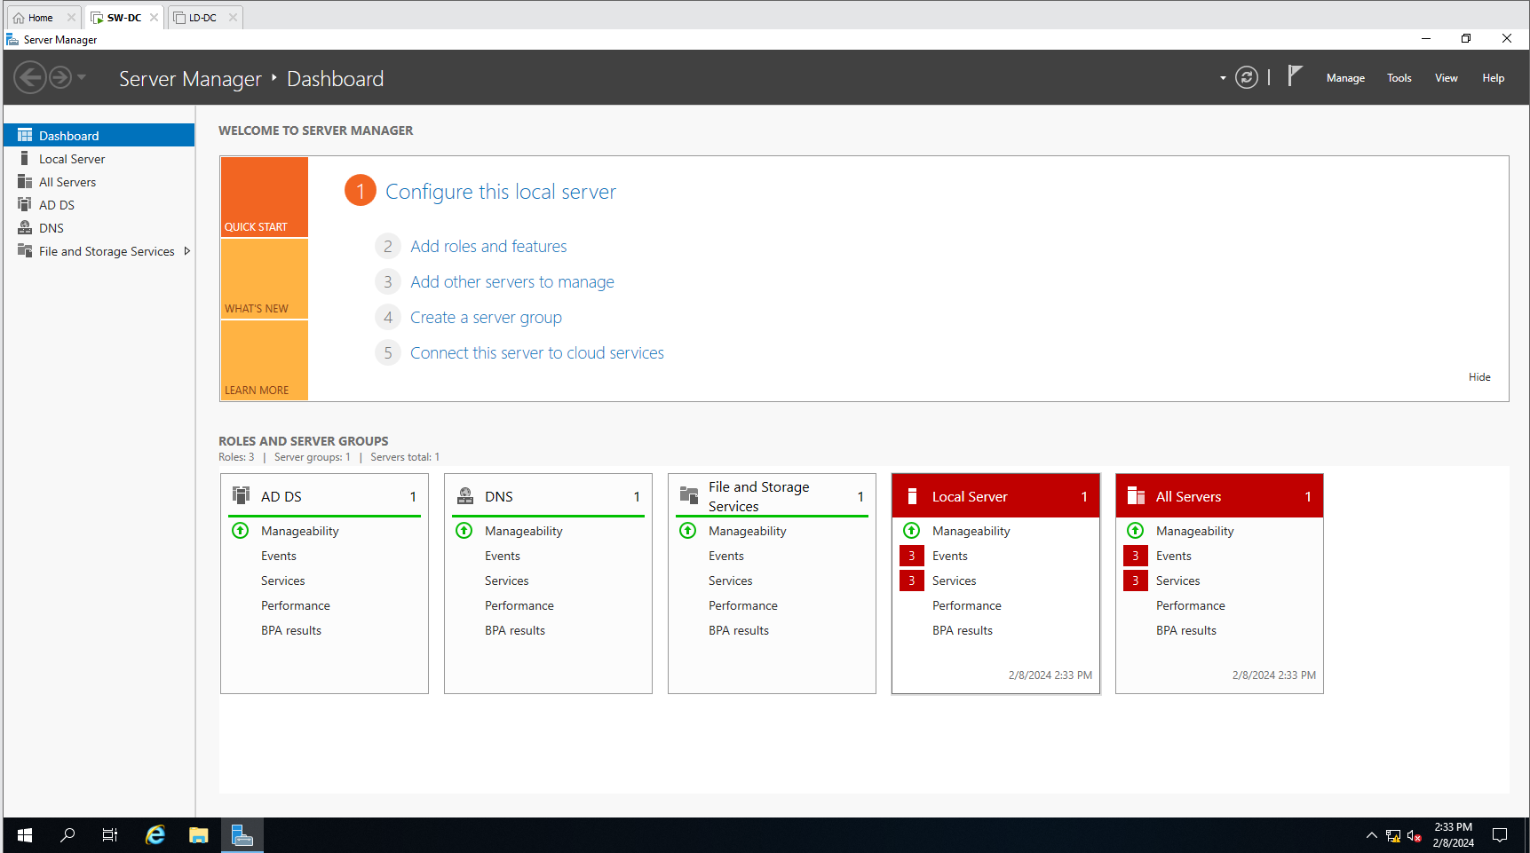
Here is a dashboard showing the Swansea workstation and Server and the London workstation and Server.

Fig 3 Setting up Date time and UK keyboard
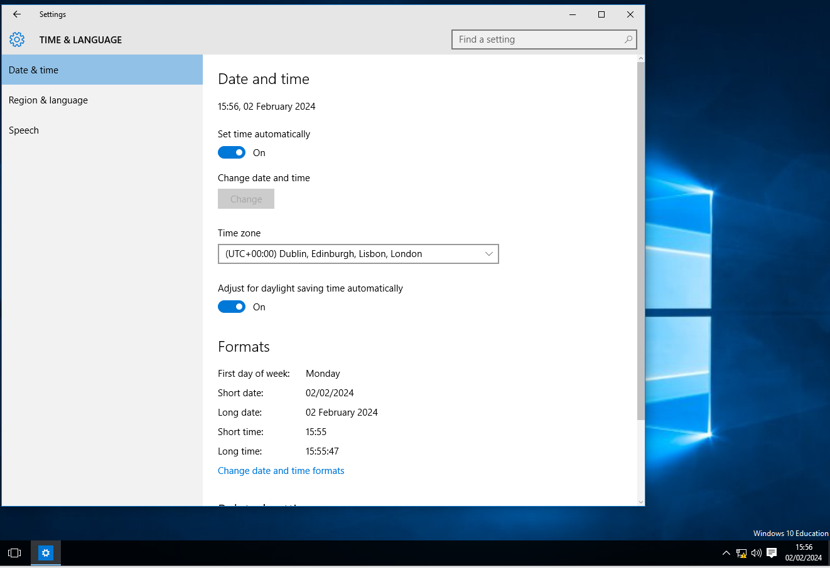
Once the initial set up the Workstations and Servers have been completed they need to be set UK date and time and UK keyboard settings.



Fig 4 Set New Passwords
Here is a screen Shot of the Password being changed for Both WorkStation and server
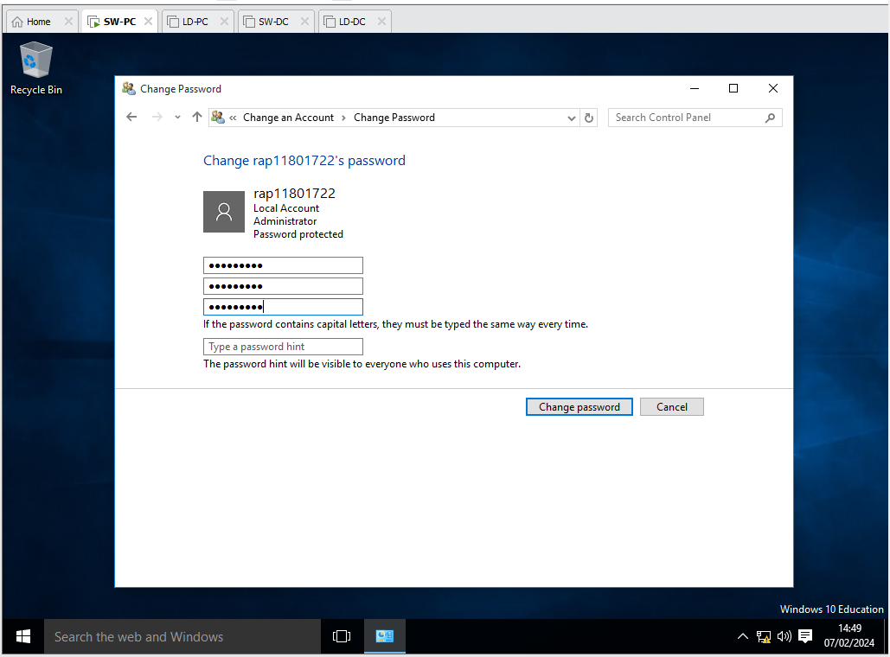

Fig 5 Check Connection between Server and WorkStation
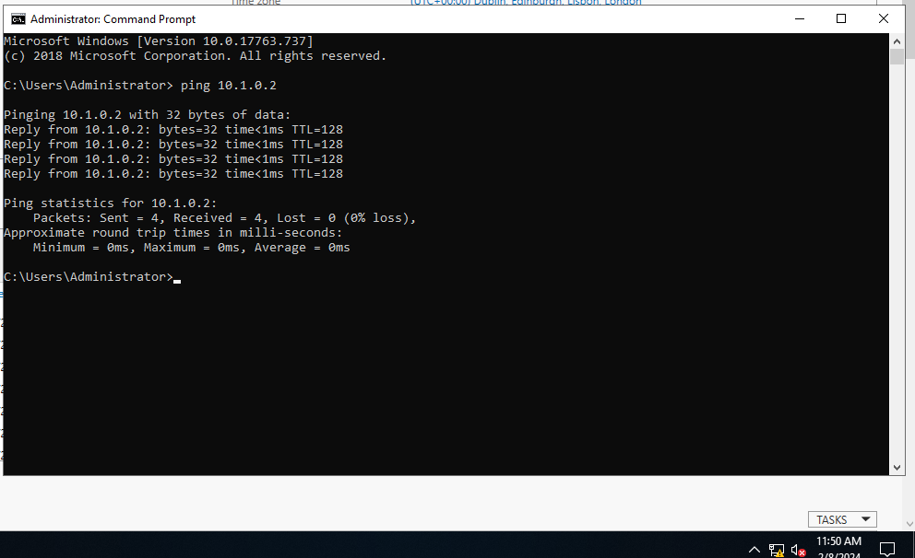
To check the connection between server and workstation and vice versa use the command ping! In the command line prompt.

Fig 6 changing the name of the work station and server
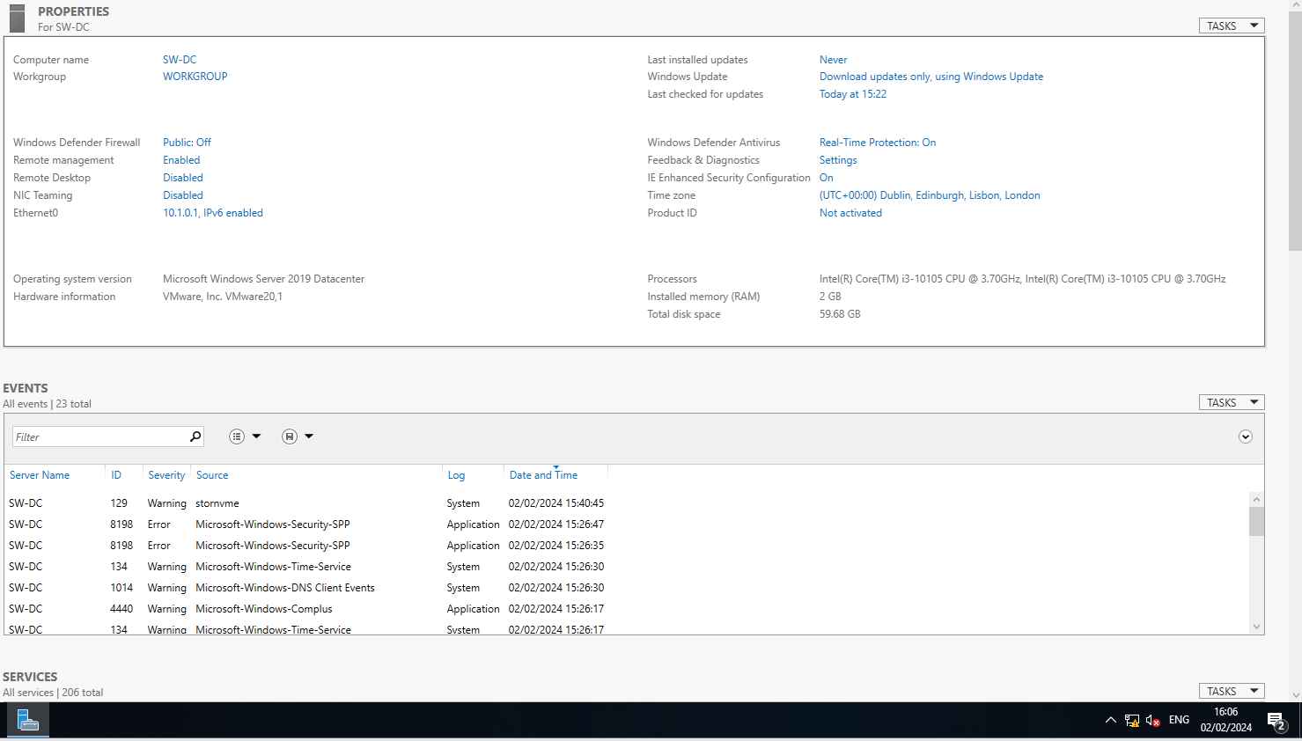
This screen shot shows the nave of the server and work station can be changed to reflect the topology.

Conclusion
Overall, Type 2 hypervisors offer a cost-effective solution for individuals, small businesses, and development teams looking to harness the benefits of virtualisation without the need for specialised hardware or a complex configuration. By following theses steps the Noss network will be successfully set up to facilitate communication, collaboration and resources sharing between the Swansea and London sites, giving the organisation the right tools to deliver a exceptional service to its stakeholders.

References

[1] | R. Hat, “https://www.redhat.com/en/topics/virtualization/what-is-a-hypervisor,” 3rd January 2023. [Online]. Available: https://www.redhat.com/en/topics/virtualization/what-is-a-hypervisor. [Accessed 29th January 2024].
[2] | https://aws.amazon.com/what-is/hypervisor/, “AWS,” 2024. [Online]. Available: https://aws.amazon.com/what-is/hypervisor/. [Accessed 29th January 2024].
[3] | “https://www.dnsstuff.com/virtual-machine-resource-allocation,” 22 July 2021. [Online]. Available: https://www.dnsstuff.com/virtual-machine-resource-allocation. [Accessed 29 January 2024].
[4] | M. Foley, “https://www.vmware.com/content/dam/digitalmarketing/vmware/en/pdf/whitepaper/techpaper/vmw-white-paper-secrty-vsphr-hy,” 2014. [Online]. Available: https://www.vmware.com/content/dam/digitalmarketing/vmware/en/pdf/whitepaper/techpaper/vmw-white-paper-secrty-vsphr-hy. [Accessed 30 January 2024].
[5] | H. w. Dijiang huang, “Science Direct,” 2018. [Online]. Available: https://www.sciencedirect.com/topics/computer-science/hardware-abstraction-layer. [Accessed 8 Febuary Febuary 2024].
[6] | Broadcom, “VMware,” [Online]. Available: https://www.vmware.com/topics/glossary/content/cloud-orchestration.html#:~:text=Orchestration%20enables%20automatic%20scaling%20of,clouds%2C%20both%20public%20and%20private.. [Accessed 8 Febuary 2024].

