

GROUP REPORT (3000 WORDS)

STUDENTS NAME: DELIA MARINA CIURARU (2226588)
MIHAI ANGELICA DROSU (2310056)

MARIAN LEBA (2313869)
This Photo by Unknown Author is licensed under CC BY-SA-NC
RALUCA SELENA STANCIU (2132773)
MODULE CODE: LCBB5015 PRINCIPLES MARKETING
LECTURE NAME: Md. ASHIKUL KHAN

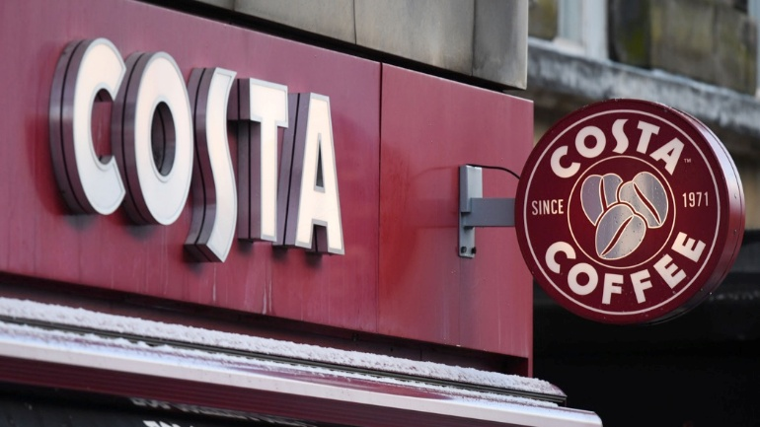

Table of Contents
Introduction to Costa Coffee 3
Purpose of the Report 3
Situational Analysis 4
PESTEL ANALISYS FOR COSTA COFFE 4
Competitive Rivalry – High: 5
STP Analysis for Costa Coffe 8
Integrated Marketing Communications (IMC) 9
Ansoff Matrix – Growth Strategy 9
Marketing Strategy Mix (7Ps) for Costa Coffee 10
Implementation and Control: KPIs and Balanced Scorecard for Costa Coffee 12
Key Performance Indicators (KPIs) 12
Conclusion 13
References (Harvard Style) 14

Introduction to Costa Coffee
Costa Coffee Costa coffee is the most famous and successful brand of coffeehouse in Britain it also operates in a very notorious food and beverage retail market. Established in 1971 as a wholesale coffee roaster in London by Bruno and Sergio Costa, the business has grown from being purely a wholesaler of specialty Italian roasted coffee to becoming an international retailer known for its premium quality coffee and customer focussed service proposition (Smith, 2023). The company has more than 2,800 stores in the UK and a network of international franchises as well as express machine retailer outlets (Costa Coff ee, 2024). Costa Coffee It has continued to grow since acquisition by Coca-Cola in 2019, benefiting from further distribution and innovation investment (Johnson 2022).
The company's core offerings are freshly brewed coffee, hot and iced beverages, sandwiches, pastries and Rasna: ready-to-drink options in the retail market (Mintel.2023). Costa Coffee is the leading coffee chain in the UK and outperforms rivals like Starbucks and Caffè Nero in terms of both market share and customer loyalty (Euromonitor, 2024). Its commitment to sustainability, quality and convenience has strengthened its brand image, now in line with new consumer views on ethical coffee experiences that are accessible (Williams, 2023).

Purpose of the Report
This report will aim at an attempt to strengthen the brand of Costa Coffee in UK, increase its market share and subsequently broaden the customer base. With changing consumer needs, increasing sustainability requirements and stiffer competition in-market, the case for Costa Coffee is ‘Define your marketing to drive brand growth’(Brown, 2023). This report will concentrate on the company’s current marketing activities, and pinpoint where there needs to change in strategy and/or tactics that will be ensured through reader's comprehension of market segmentation targeting/positioning (STP).
The segmentation phase requires the identification of different customer groups through demographic, behavioural, and psychographic variables; whereas targeting will decide which group are more likely to be profitable in future (Kotler et al., 2022). Segmentation will then be followed by the definition of how Costa Coffee will position itself with reference to competitors in terms of its image, quality and value proposition (Baines, Fill & Page 2023). The report will also examine the company’s marketing mix execution – product, price, place and promotion (4Ps), people, process and physical evidence to make sure strategic plan corresponds with operational plan (Jobber & Ellis-Chadwick, 2023). Finally, this plan is expected to provide feasible suggestions in order to improve market position and customer relationship of Costa Coffee in the UK.

Situational Analysis

A situational analysis provides a structured understanding of Costa Coffee’s internal and external environment, identifying the key factors influencing its market performance and strategic direction. This section applies the PESTEL framework, SWOT analysis, and Porter’s Five Forces model to evaluate Costa Coffee’s current market conditions and competitive position.

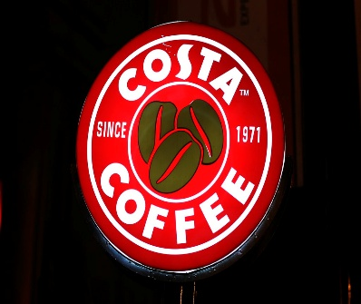
PESTEL ANALISYS FOR COSTA COFFE

POLITICAL | Costa Coffee operates within the UK’s highly regulated food and beverage industry, where policies on taxation, employment law, and sustainability significantly affect business operations (Taylor, 2023). The company must also adapt to post-Brexit trade regulations, which have increased supply chain complexity and import costs for raw materials such as coffee beans (Henderson, 2023).
ECONOMIC | Rising inflation and fluctuating consumer spending power have impacted the foodservice sector, influencing demand for premium coffee products (Office for National Statistics, 2024). However, the coffee shop market continues to show resilience, with consumers valuing affordable indulgences such as takeaway beverages during periods of economic uncertainty (Mintel, 2023).
SOCIAL | Changing lifestyles, the rise of remote working, and a growing preference for ethical and sustainable products have shaped consumer expectations (Williams, 2023). There is increased demand for plant-based and low-sugar options, as well as loyalty-driven digital engagement through mobile apps (KPMG, 2023).
TECHNOLOGICAL | Technological advancement underpins Costa Coffee’s operations through its Costa Club app, self-service Express machines, and digital ordering systems (Costa Coffee, 2024). These innovations improve convenience and data-driven customer insight.
ENVIROMENT | Costa Coffee’s commitment to sustainability includes initiatives to reduce waste, recycle coffee cups, and achieve carbon neutrality (DEFRA, 2023). Environmental concerns increasingly shape brand perception, compelling continuous investment in eco-friendly practices.
LEGAL | The company must comply with food safety, health, and environmental legislation, including UK Food Standards Agency guidelines and employment regulations (Johnson, 2023). Non-compliance risks reputational and financial consequences.

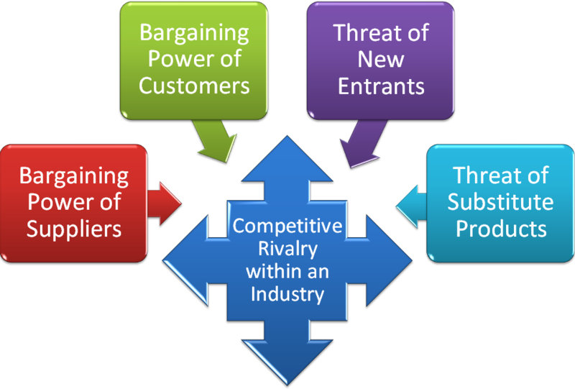
  - Porter’s Five Forces

Competitive Rivalry – High:
The UK coffee shop industry is relatively mature, with several competitors offering similar coffee and experiences such as Starbucks, Caffè Nero and Pret a Manger (Statista 2024). Quality and digital engagement are therefore key to differentiator.

Threat of New Entrants - Moderate: It is relatively easy to join, but achieving scale across the nation requires substantial resources in branding and supply chain infrastructure (Grant, 2023). Costa Coffee’s existing network creates a competitive moat.
While market entry barriers are relatively low, achieving national scale requires substantial investment in branding and supply chain infrastructure (Grant, 2023). Costa Coffee’s established network provides a competitive moat.
Bargaining Power of Suppliers – Moderate:
Costa sources coffee beans globally, making it sensitive to commodity price fluctuations. However, long-term supplier partnerships reduce vulnerability (Harrison, 2023).
Bargaining Power of Buyers – High:
Customers have choices and display low switching costs which enhance their negotiation power. Brand loyalty and product uniformity will serve to reduce the impact of this (Baines, Fill& Page, 2023).
Threat of Substitutes – High:
Alternatives are at-home coffee appliances, energy drinks and independent cafés that provide a more craft-led experience (Mintel, 2023). And so, Costa has to keep on reinventing itself to stay alive. In short, Costa Coffee is trading in a demanding but exciting space. Its effectiveness in doing so will be based on the extent to which brand equity, sustainability pledges and digital creativity can help offset competitor moves and evolving shopper targets.

SWOT Analysis


Costa Coffee’s primary strengths stem from its strong brand reputation, extensive store network, and commitment to product quality. Established in 1971, the company has built a trusted brand identity that resonates with consumers seeking consistency and convenience in premium coffee (Mintel, 2023). With its extensive UK network, over thousands of stores and Costa Express machines, it has a strong market presence and reach across the United Kingdom (Costa Coffee, 2024). This acquisition by the Coca-Cola has brought increased financial capability, greater global supply chain effectiveness and a broader number of markets to target for product diversification (Johnson 2022). In addition, the company is managing to improve customer loyalty and it’s working potential through digitalization initiatives such as the Costa Club app or contactless payment solutions (KPMG, 2023).

However, several weaknesses present ongoing challenges. Costa Coffee current premium pricing approach may lead to price-sensitive customers being priced out – especially in difficult economic times where inflation is high (Williams, 2023). Furthermore, the high reliance on UK market makes the brand vulnerable to domestic economic fluctuation as well as changes in consumer behaviours (Euromonitor 2024). Costa also lags behind some of its competitors in building a recognisable global brand (Grant, 2023).

Costa Coffee faces multiple opportunities for future growth. Increasing consumer demand for sustainable, ethically sourced, and plant-based products creates potential for innovation within its beverage and food portfolio (DEFRA, 2023). Expanding ready-to-drink product lines through Coca-Cola’s distribution network offers a route to reach new customers beyond coffee shops (Henderson, 2023). Furthermore, digital marketing and data-driven personalisation could strengthen customer engagement and retention (Baines, Fill & Page, 2023).

Nevertheless, the company encounters serious threats from rivalry with other companies including Starbucks, Pret A Manger and smaller specialist cafes that provide something special or unique (Statista, 2024). Increased raw material costs and greater competition from at-home coffee options also exert downward pressure on profit margins (Taylor 2023). In brief, Costa Coffee has strong brand equity, innovation and environmentally sustainability (adjustment) are situated in advantageous positions; however, to achieve long-term success the above three factors should perform better than other competitors[J1] in differentiating their product and adjust themselves with changes in the environment (Jobber & Ellis-Chadwick 23).

STP Analysis for Costa Coffe
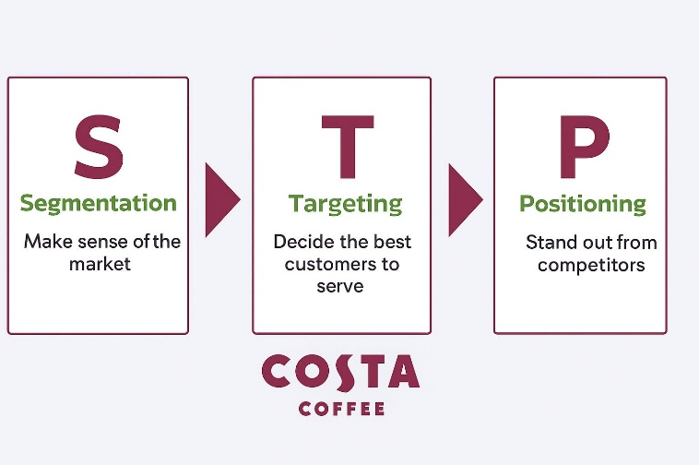
Segmentation: Costa Coffee uses a combination of demographic (age, income), geographic (urban locations, airports, shopping centres) and behavioural (coffee consumption level) segmentation. For instance, it focuses on the urban professional, the students and families who believe in café experience other than just a takeaway. Target customers: The company targets higher/ upper-middle and premium in high-foot traffic areas instead of cater the mass fast coffee (low price) market.
Position: Costa is a quality coffee shop chain that provides good, comfy surroundings and reliable service. Its proposition is “quality coffee for every day” rather than ultra-luxury or bargain. Therefore this “STP” strategy of Costa helps this being different from the low-cost chains and at the same time above the ultra-premium boutique cafes i.e. Costa Coffee can now position itself as a middle premium category and can have a large set pool of target market: an entire group whom they want to serve.

Integrated Marketing Communications (IMC)
Costa implements an IMC strategy, with an integration of its message, media and brand version over both traditional and digital contact points. Although it is not as dependent on mass ATL (above-the-line) advertising, it does exploit digital, social media, loyalty programmes and experiential campaigns. For example, the firm promotes itself through word-of-mouth and social promotions (e.g., photo contest, user-generated content) to reach younger customers. Offline, Costa upholds premium store feel and evidence (décor, packaging) to support its positioning. The distinctiveness of the IMC mix is to prove that the brand’s promise “quality coffee, done well” is continually accommodated. Furthermore, Costa’s loyalty scheme further serves to extend these customer relationships and retain them. Ultimately Costa’s IMC approach enhances its STP positioning by elevating brand salience and customer engagement in an integrated way.

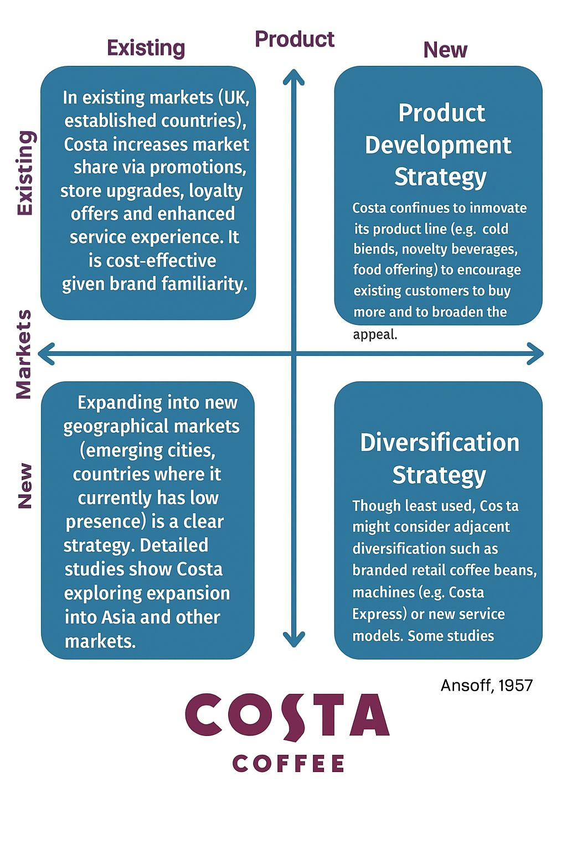
Ansoff Matrix – Growth Strategy

Applying the Ansoff Matrix, Costa can pursue four growth strategies:
Market Penetration: In the case of UK of established nations, Costa is increasing its market share through promotions, store refurbishments, loyalty product offerings and improved customer service. It's an economical choice for me since my brand is recognized.
Market Development: New geographical markets seem an obvious opportunity (so for example in emerging cities or countries where it has a low presence. Specific studies see Costa looking at growth in Asia and other markets.
Developing Products: Costa innovates their product range to persuade current clients to buy more and increase undeserved areas (say cold blends) or offer that are tasty but not selling as well (novelty drinks / food).
Diversification: Though less relevant, Costa could possibly look at related diversification in retail coffee beans branded machines (Costa Express) or new service models. Others point to opportunities for diversification to reduce risk. Applying the Ansoff matrix, then, provides a system to Costa’s growth strategy rather than simply selling more coffees from more outlets.
On the whole, Costa Coffee’s marketing mix combines well STP and IMC with Ansoff matrix. Its niche of quality-seeking urban customers, focus on selective premium and positioning as a dependable everyday premium coffeehouse provide it with a solid footing. The IMC build on that positioning from a consistent messaging and experience standpoint. Finally, the expansion strategy through the Ansoff matrix market penetration, development, product innovation and selective diversification help in strategic direction for future growth. These together will form a sensible and more academic marketing mix.

Marketing Strategy Mix (7Ps) for Costa Coffee

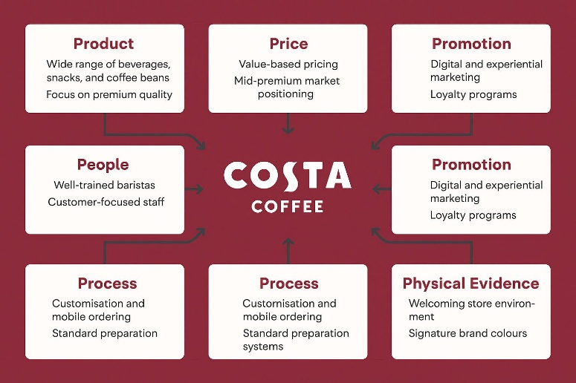
Product
Costa Coffee sells hot and cold drinks, pastries and cafetieres. Its menu offers espresso-based beverages, seasonal creations and better-for-you selections to meet changing consumer preferences. While the company also serves a range of high-quality coffee and proprietary Mocha Italia blend is still their focus. Product uniformity and standardisation of taste are its crucial factors (Marketing91, 2023).

Price
Costa Coffee Follows value-based pricing gaining share on 2 fronts Affordability meeting premium quality. It is in a mid-premium position which is above the mass-market while below the luxury boutique café.” Prices are also adjusted based on the purchasing power of local markets, keeping parity with competitors in global market (MBA Skoll, 2024).

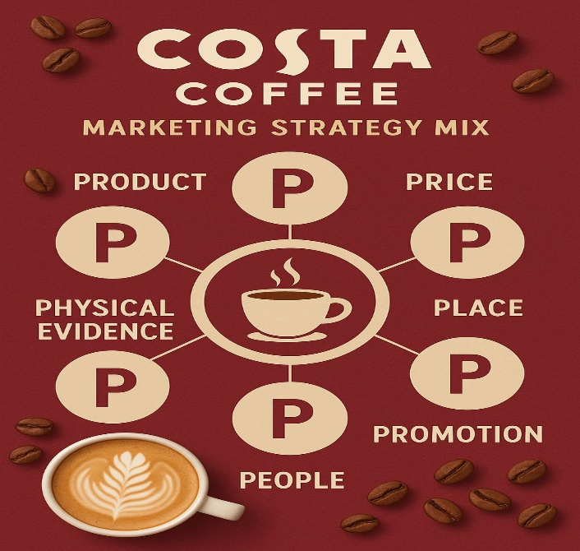
Place
Costa runs more than 4,000 stores around the world in and near cities, airports and major railway stations. The brand also operates Costa Express self-service machines, and its products can be bought in other retailers across the Spanish supermarkets and online market. This multi-channel distribution allows availability as well as brand reinforcement (Total Assignment Help, 2023).
Promotion Costa’s advertisement and marketing approach focuses on IMC which applies digital media alongside experiential marketing. Limited-edition drinks and sustainability initiatives are promoted on Instagram, TikTok and email newsletters. Loyalty programs, for example Costa Club App also encourages engagement through rewards and gamification (Desklib, 2023). Physical in-store experience and customer service are important touch points that reinforce the brand promise of comfort and quality (Marketing Week, 2024).

People
The employees are the heart of Costa when it comes to quality of service. The firm has been investing in training staff, particularly when it comes to barista skills, and does aiming for a consistent delivery of the brand. Its ethnically diverse work environment and customer experience mirrors its goal to “inspire the world to love great coffee” (Costa Coffee CSR Report, 2023).
Process Costa has combined speed with personalisation in the way it serves people. Visitors can personalize their drinks, opt for mobile orders and order via self-service kiosks for quick service. Efficiency is also achieved through homogenised preparation systems and machinery (such as for example in Costa Express machines) that are automated to produce consistent quality product materials (IBISWorld, 2024).
Physical Evidence The store environment – decor, scent and layout are also vital in reinforcing the brand’s premium but may to everyone band image. The unique design finish and the distinctive maroon-and-cream colour scheme make an enduring impression (Business Case Studies UK, 2023). (A) Marketing Mix Costa Coffee’s marketing mix as presented in 7Ps shows a well-rounded approach that considers quality, accessibility, innovation and sustainability. Costa maintains expertise and competitive edge in a crowded global market through a mix of premium positioning, operational efficiency and customer engagement.

Implementation and Control: KPIs and Balanced Scorecard for Costa Coffee

Efficiently overseeing and executing marketing activities is instrumental in translating Costa Coffee’s strategy into delivered results. Realisation is primarily an issue of getting the resources, people and operations to be in tune with corporate targets whereas control instruments especially KPIs (Key performance indicators) and Balanced Scorecard are used for monitoring and made efforts to improve continuously (Kaplan & Norton, 1992).
Implementation Strategy Cross-functional coordination is key to Costa Coffee's marketing delivery, with operations, marketing and customer experience teams working together. Tactics include explicit measures such as introducing new seasonal drinks which will contribute to order uplift through vegan and smoothies, extending the reach of Costa Express and driving digital loyalty participation. The time-line action plans are department-wise and store-wise which ensures accountability and real time responses (Kotler et al., 2023). For example, marketing wing is responsible for campaign launch, whereas operations departments look into uniformity of outlets and delivery of service (MBA Skoll, 2024).

Key Performance Indicators (KPIs)
Performance Evaluation: KPIs and the Balanced Scorecard
In Costa Coffee it has employed a mixed of financial and non-financial KPIs to access the performance of marketing strategy and its impact on organization overall. These measures are several and offer management a spotlight on how the organization is performing, areas that need to be improved, and compliance with long-term strategy direction. The Customer Retention Rate serves to be a vital non-financial KPI which illustrates the customer satisfaction, loyalty in obtaining business through repeat purchase levels, store visit frequency and usage of Costa Club application (IBISWorld 2024). By tracking this metric, Costa can measure the impact of its relationship marketing and customer experience efforts.
Simultaneously, Sales Growth and Revenue per Store are key financial KPIs that assess the quantifiable results of marketing initiatives, price strategies and new product introductions (Marketing Week, 2024). These numbers shed some light on how much of Costa's marketing efforts lead to margin expansion and market share gains. The Brand Awareness Index provides this added dimension, which measures Costa’s presence both online and offline are glimmers of how effective its communication is given a deeper context. Additionally, the Net Promoter Score (NPS) is employed to measure customer advocacy and satisfaction and represents rated perception of value or total service quality (Statista, 2024).
Productivity by Employee and Training Hours underscore Costa's operational excellence and continuing training and development efforts for our staff, underscoring the value of our employee base to producing consistently durable customer experiences that resonate in the marketplace. Costa Coffee has enhanced the direct impact of these KPIs by integrating them with the Balanced Scorecard (BSC) concept (Kaplan & Norton, 1996). It connects marketing objectives within the wider context of organisational goals from four different perspectives.
Financial Perspective: This is concerned with how profitable we are, how effectively we can control costs, return on marketing investment. The Customer Perspective evaluates satisfaction, loyalty and service consistency to ensure alignment with Costa’s brand promise “quality coffee made easy.” Internal Business Processes Perspective- Assesses the manner processes efficiently are operating, and how effectively a company is handling its digital services and supply chain. Lastly, in the Learning and Growth Perspective there are the highlighted innovative activities, digital transformation, staff training and sustainability operations (Costa CSR Report, 2023).
Together these KPIs allow Costa Coffee to bring data-driven intelligence right into the decision making process using the balanced scorecard approach. This allows for ongoing operations and strategic workings in the global coffee market where company can create long term competitive advantage. With KPIs baked into the Balanced Scorecard, Costa can monitor performance across the board and tweak its marketing strategy based on data. It promotes corporate learning and agility, sustaining competitive advantage and brand resilience within a volatile coffee sector (Harvard Business Review 2024).

Conclusion

Costa Coffee's approach to marketing appears based around an astute combination of careful planning, customer insight and delivery of brand personality. The company is the customer charter, can clearly know who my customers are, what are the best approaches to reach these people; The STP model used to do so majority. The emphasis on young professionals, students and “everyday coffee lovers” also helps Costa to create experience that is both premium and accessible. This transparent positioning towards high premium coffee on affordable prices makes it unique in this increasingly competitive world market (Marketing91, 2023).
This direction is further enhanced by the 7Ps of marketing. The strength of our brand is underlined by Costa’s product quality, good service and unique coffee varieties. Its pricing is fine for the quality, and with widespread locations spanning high streets to transport hubs, availability is good. Focusing on its people, processes and store design it conveys the same brand experience across all stores consistently and in a delightful manner (MBA Skoll, 2024).
Costa’s IMC means the message is consistent across all their touchpoints, from a social media as to loyalty app and in-store promotion – with that friendly, down-to-earth feel. This, along with high levels of innovation and responsible growth as per the Ansoff Matrix forces it to venture thoughtfully into new geographies and product forms (Costa CSR Report, 2023). Its execution and control systems in place, with appropriate KPIs and a match for these via the Balanced Scorecard guide strategy. By tracking sales, customer satisfaction and employee satisfaction, Costa can take fast action while still being true to its core purpose of serving great coffee in welcoming surroundings (Kaplan & Norton, 1996). In summary, Costa Coffee’s branding works as it fuses business objectives that resonate with real customer needs to forge an equilibrium between consistency, creativity and care - which is continually helping them to stay strong in the global coffee industry.

References (Harvard Style)

- Business Case Studies UK (2023) Costa Coffee: Delivering a consistent customer experience.
- Costa Coffee (2023) Corporate Social Responsibility Report. London: Costa Coffee.
- Desklib (2023) Marketing analysis of Costa Coffee.
- Essay48 (2024) Costa Coffee: Project Marlow – Ansoff Matrix analysis.
- Harvard Business Review (2024) How the Balanced Scorecard evolves in modern organisations. Harvard Business School Publishing.
- IBISWorld (2024) UK Coffee Shop Market Research Report. London: IBISWorld.
- Kaplan, R.S. and Norton, D.P. (1992) ‘The Balanced Scorecard – Measures that drive performance’, Harvard Business Review, 70(1), pp. 71–79.
- Kaplan, R.S. and Norton, D.P. (1996) The Balanced Scorecard: Translating Strategy into Action. Boston: Harvard Business School Press.
- Kotler, P., Keller, K.L. and Chernev, A. (2023) Marketing Management. 17th edn. Harlow: Pearson Education.
- MBA Skool (2024) Costa Coffee marketing mix (7Ps) and strategy.
- Marketing Week (2024) Costa Coffee: Building loyalty through digital experience.
- Marketing91 (2023) Marketing strategy of Costa Coffee.
- Marketer Club (2023) Why Costa Coffee remains popular among UK consumers.
- Statista (2024) Consumer satisfaction and brand ranking in UK coffee market.
- Total Assignment Help (2023) Business case analysis of Costa Coffee.

Group Contributions
Delia Marina Ciuraru contributed to the introduction, mission, and purpose of the report, ensuring clear objectives and contextual grounding. Mihai Angelica Drosu developed the situational analysis, including PESTEL, SWOT, and Porter’s Five Forces. Marian Leba focused on the marketing strategy, particularly the STP analysis, Integrated Marketing Communication, and Ansoff Matrix. Raluca Selena Stanciu prepared the 7Ps framework, implementation and control section using KPIs and the Balanced Scorecard and finalised the conclusion and references.

