Network Operating Systems and Services
Assignment One
By Timothy Day (1909697)

Name of the Team: KSPT
Team Members
Student Name | Student ID
Timothy Day | 1909697
Peter Holdstock | 2021952
Sam Jackson | 1802975
Kes sumner | 2015409
Team Evaluation
 | Kes Sumner | Sam Jackson |  | Pete Holdstock |  | Tim Day
Kes Sumner | 5 |  | 5 |  | 5 |  | 4
Sam Jackson | 5 |  | 5 |  | 5 |  | 4
Pete Holdstock | 5 |  | 5 |  | 5 |  | 4
Tim Day | 5 |  | 5 |  | 5 |  | 4
Timothy Day: As I came in late to the team, I watched Sam building the virtual network while also asking questions to my teammates to get a greater understanding of how a virtual network works.
Kes Sumner: Kes fixed a problem that aroused by rebuilding two client PCs with in the VM as when Sam was building the two clients PCs, he forgot to switch the windows 10 edition from home which is the default to Pro that allows certain Administration privileges.
Sam Jackson: Sam was the teams documentarian. He was the one in charge of taking the screenshots and building the virtual network.
Peter Holdstock: Peter was the leader of the team going through the instruction document point by point making sure everyone understood the task ahead.

Table of Contents
Table of figures 3
Abstract 3
Introduction 3
Part 1: 3
Part 2: 4
Conclusion 9
Reflection on collaborative work 9
References 9

Table of figures
Figure 1: Client virtual machine creation – worksheet page 5. 5
Figure 2: Optimising configuration for virtual machines. 6
Figure 3: All four operating systems installation in progress – worksheet page 7 7
Figure 4: SUGGESTED - configuring the different networks on the server – worksheet page 9 8
Figure 5: SUGGESTED - End of task 1 - successful ping from server to client – worksheet page 11 9
Figure 6: REQUESTED - Static IP and no DNS – Worksheet page 13 10
Figure 7: REQUESTED - Firewall turned off – Worksheet page 13 11
Figure 8: REQUESTED - Changed computer name - Worksheet page 13 12
Figure 9: SUGGESTED - Locations of the AD DS config files – worksheet page 15. 13
Figure 10: Server DMC1-NT is listed as the accatask.msft domain controller 14
Figure 11 - Management of AD Users 15
Figure 12: REQUESTED - New user accounts in Domain Users group - worksheet page 17 16
Figure 13: Unable to add client to the domain. 16
Figure 14: Incorrect IP address for DNS server. 17
Figure 15: Client successfully joined the domain. 18
Figure 16: User account unable to log on to domain controller - worksheet page 20 19
Figure 1 How a DHCP server works 21
Figure 2 Domain Tree in AD 21
Figure 3 User Object in AD 22
Figure 4 Password Policy in AD 22

Abstract
In this report it details the group work conducted with screenshots and brief descriptions of building a virtual LAN using Type 2 Hypervisor Management Software and deploying a network directory service and creating and understanding active directory network objects. Also within this report is some personal evaluation and learnings conducted alongside the group work.

Introduction
As part of a group we built an virtual LAN using Type 2 hypervisor management software, deployed a network directory service and created active directory network objects to grain a greater understanding of how a virtual LAN, network directory service and an active directory network objects work. Also, alongside the groupwork I conducted research on the different types of hypervisors and the benefits and drawbacks to each type, Explained what a DHCP is and how it works, justified Active Directory technology, gave descriptions on different terminologies I came across within the worksheet provided and gave a brief reflection on the tasks we completed.

Part 1:
Introduction:
Following the tasks assigned, a Type 2 Hypervisor platform based Virtualised network has been created, provided in the following report are the evidenced stages carried out to achieve this, with elaboration on partially important stages that can assist with the efficiency and security of creating a virtualised network. Also included are the issues faced while carrying out this process.
While the tasks were quite lengthy with regard to the steps that had to be carried out, and a few issues/misconfigurations were encountered, the process was completed within the time allowed within allocated the lab sessions.
The below screenshots and accompanying narrative provide an overview of some of the key stages of the end-to-end process from installation of the hypervisor platform to the creation of the new active directory domain including a domain joined client.

Worksheet task 1 (02/02/2023 - 09/02/2023):

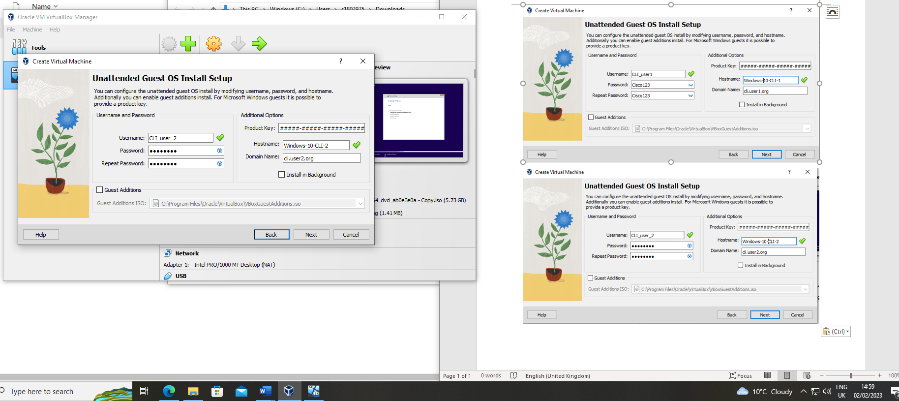
Figure 1: Client virtual machine creation – worksheet page 5.
Initial configuration on Client Virtual machine, the client will act as a traditional physical PC to a user, it will, have its own Operating system (OS), Network access, as configured in following stages, it will allow the user to access the network and other resources available on the virtualised network. Benefits of providing standard users with access to a client VM on a Virtual network include factors such as cost saving and an added layer of security.

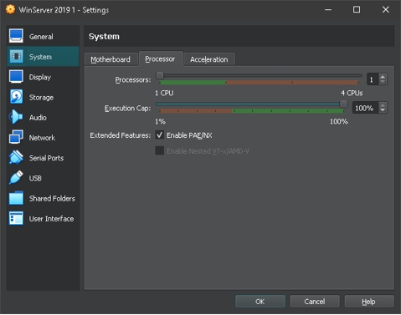
Figure 2: Optimising configuration for virtual machines.
Two features Virtual Box offers that can improve performance in a virtual environment are PAE/NX. PAE allows a 32-bit operating system to use more than 4GB of physical memory, while NX prevents the execution of potential malicious scripts from being run from data-only memory pages. Enabling these features can help improve the performance of the hypervisor and virtual machines.

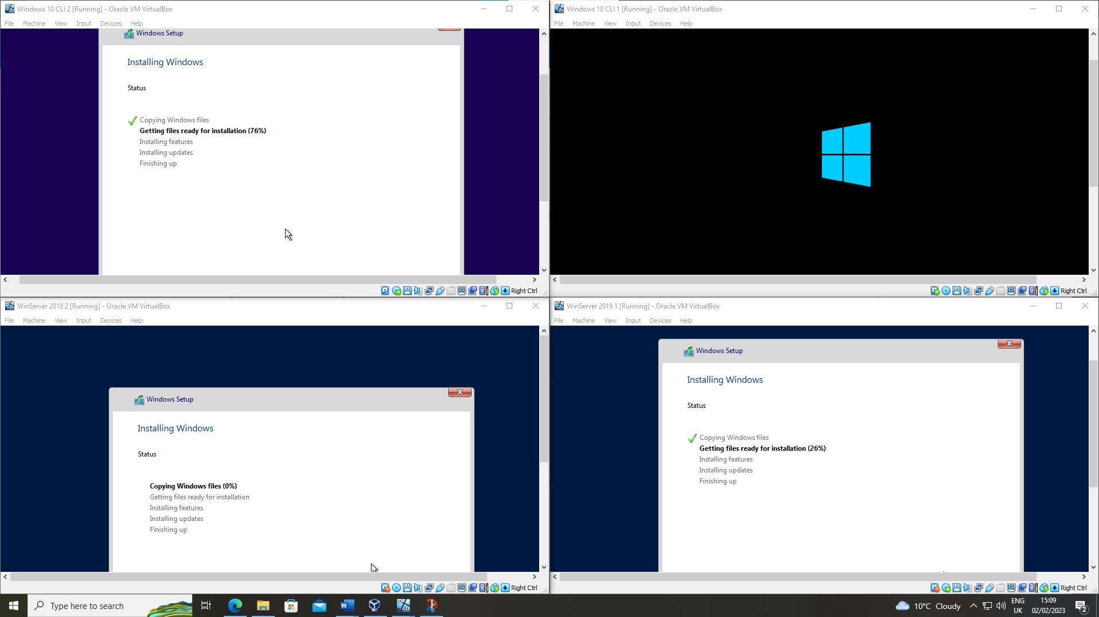
Figure 3: All four operating systems installation in progress – worksheet page 7
The installation process can be timely, essentially a new device is being setup in this stage, meaning the chosen OS being installed, drivers and updates. To make this phase as efficient as positive all available recourse of the host PC was being utilised at once to commence the setup of the 2 client and 2 server machines.

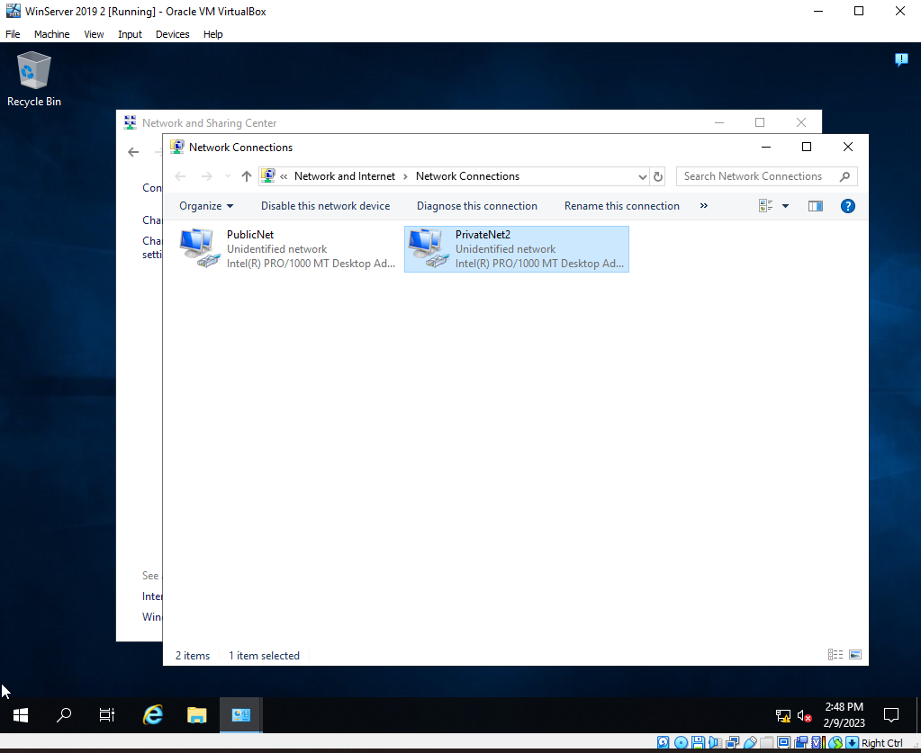
Figure 4: SUGGESTED - configuring the different networks on the server – worksheet page 9
Depicted above is the private network name change on the Windows server. The names were changed from the default ‘Ethernet’ names to more descriptive to make identifying the interfaces for the public and private networks easier.
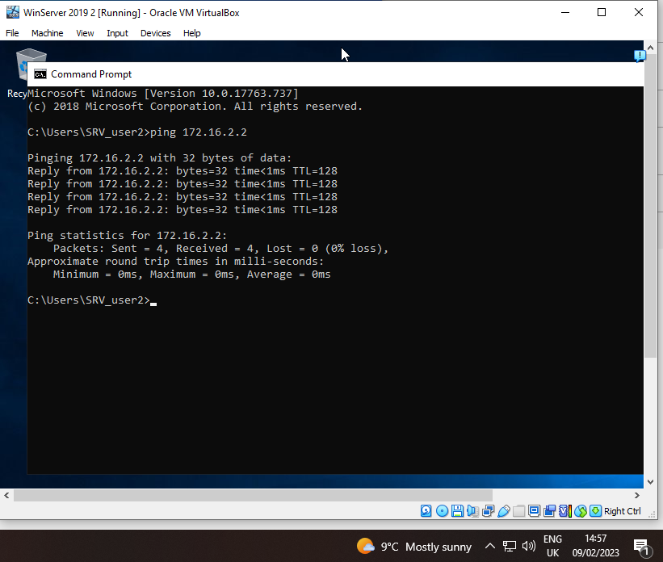
Figure 5: SUGGESTED - End of task 1 - successful ping from server to client – worksheet page 11
The figure above is showing four packets of data being sent across the network to client machine 2. This demonstrates that the network has been configured correctly to allow packets to travel across the network.

Worksheet task 2 (16/02/2023 – 23/02/2023):

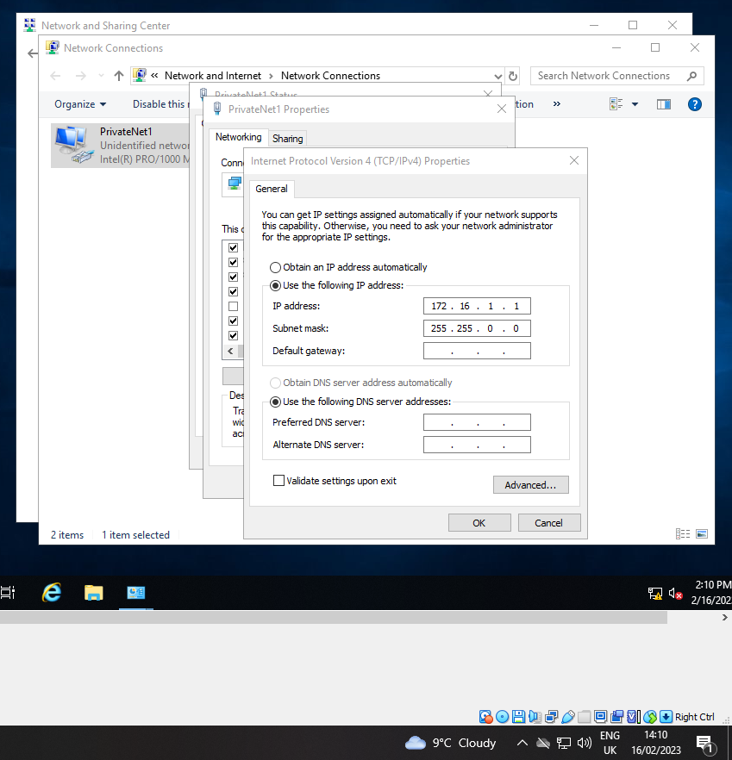
Figure 6: REQUESTED - Static IP and no DNS – Worksheet page 13
The above screenshot requested in the worksheet confirms the server is configured with a static IP address and no DNS server. Servers generally and domain controller specifically must have static IP addresses and not be configured by DHCP. When the server becomes the first domain controller it installs and configures DNS for the new domain, so no DNS entries should be present.
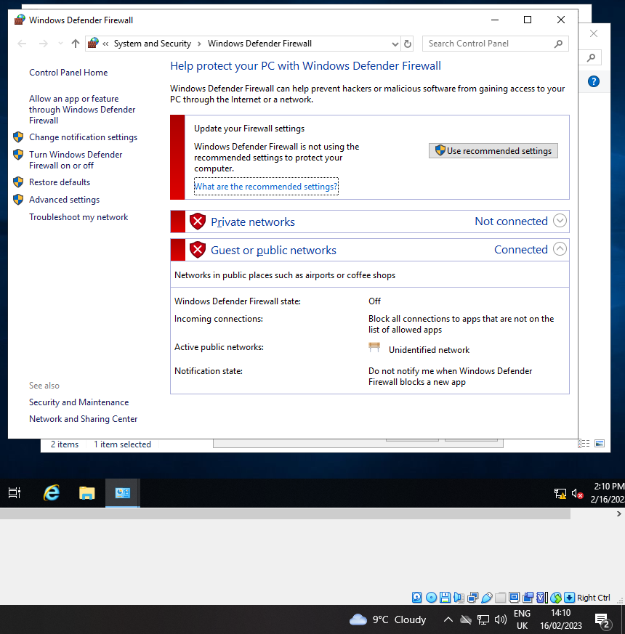
Figure 7: REQUESTED - Firewall turned off – Worksheet page 13
The figure above shows that the Windows firewall on the server has been disabled. The firewall was disabled during task 1 to allow the client to successfully ping the server and vice versa to prove network connectivity. As the firewall blocks ICMP (ping) protocol by default, similarly it can block some protocols/ports required for the client to communicate with the server required to join the domain.
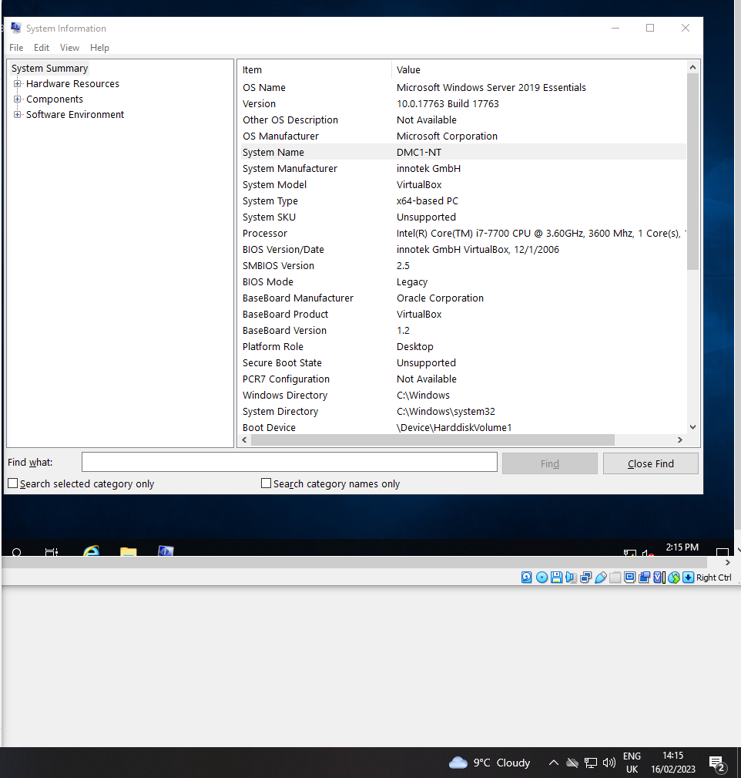
Figure 8: REQUESTED - Changed computer name - Worksheet page 13
In the figure above the client changes the computer name to DMC1-NT so that the client can be setup as the Domain Controller. It important since it is the most important Server/Service deployed in an enterprise network for managing network resources.
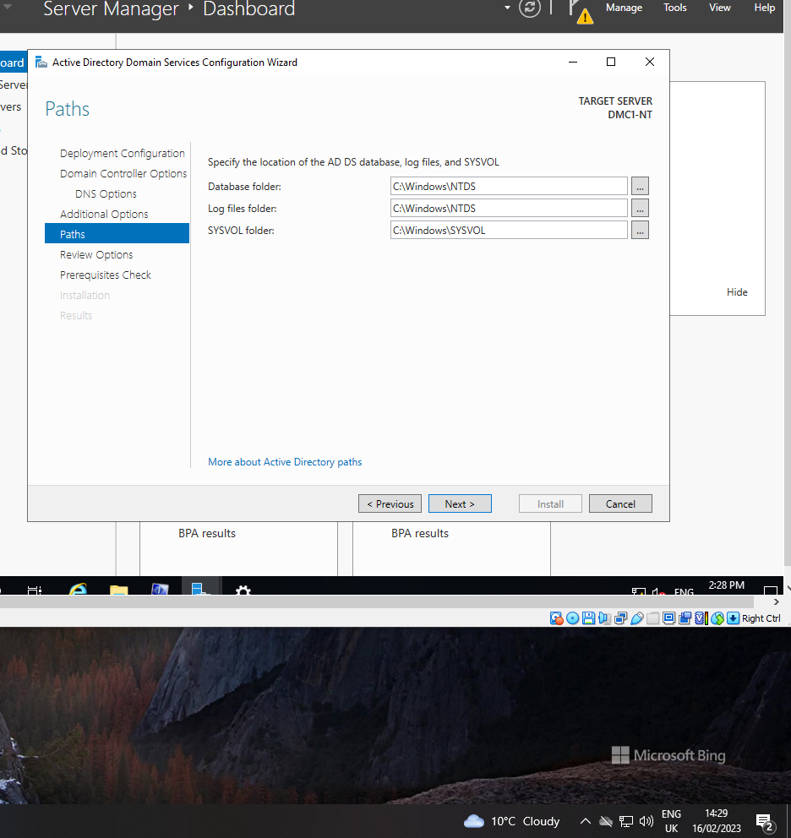
Figure 9: SUGGESTED - Locations of the AD DS config files – worksheet page 15.
The figure above shows the locations which have been selected to set up the Active Directory
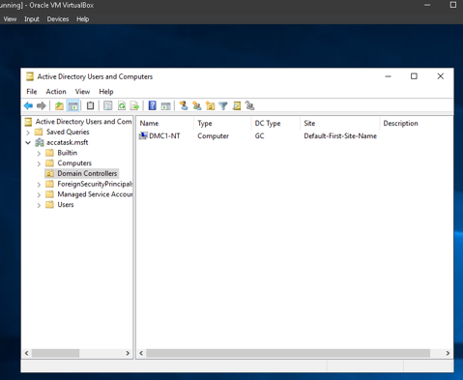
Figure 10: Server DMC1-NT is listed as the accatask.msft domain controller
The screenshot of the Active Directory Users and Computers console shows the renamed and promoted server DMC1-NT within the domain ‘accatask.msft’ located in the ‘domain controllers’ organisation unit in the active directory structure.
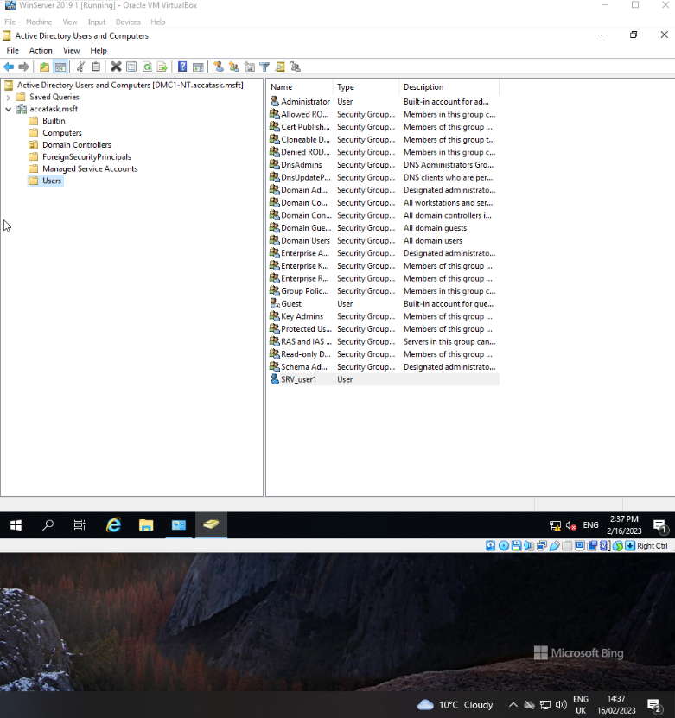
Figure 11 - Management of AD Users
When creating and managing Active Directory (AD) users, especially a domain/ Local admin accounts it is imperative that appropriate and strong passwords are used, as these accounts will have access to edit or delete other user accounts, domain access and make changes to network configuration such as security configurations. If a strong password is not use it can open the virtual network up to potential cyber threats.

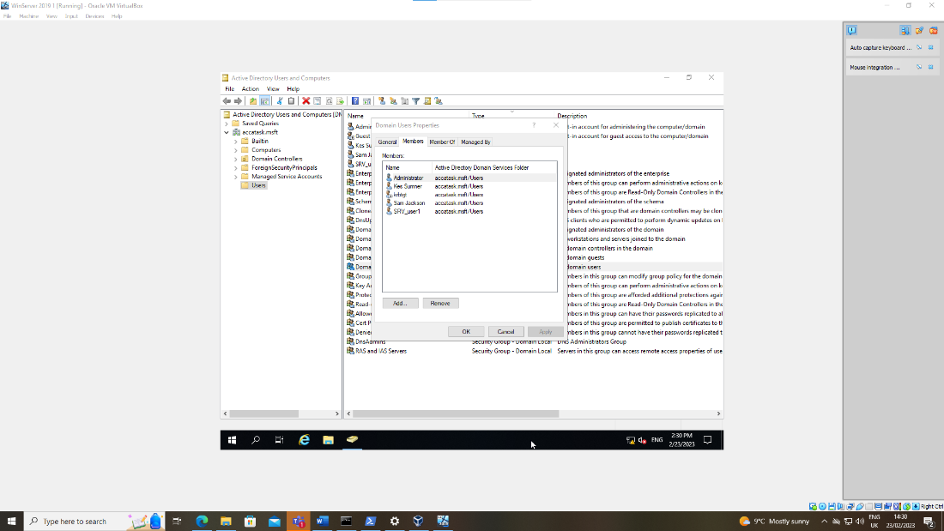
Figure 12: REQUESTED - New user accounts in Domain Users group - worksheet page 17
In the above figure requested in the worksheet, the properties of the newly created domain user are displayed including membership of the group ‘domain users’ within the ‘accatask.msft’ active directory domain.
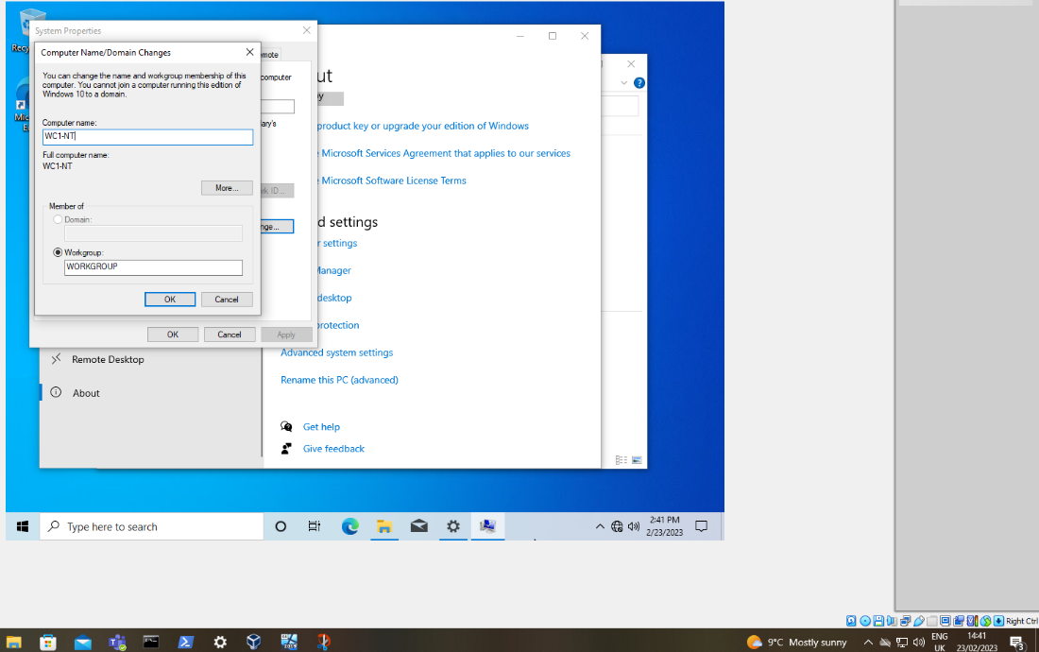
Figure 13: Unable to add client to the domain.
An issue was encountered during the task when it got to the stage where the client was to be joined to the new domain. The option to join a domain was greyed out. It transpired that the clients had been installed with Windows 10 Home edition (as a default during installation) instead of Windows 10 professional, which is for enterprise environments. The clients were rebuilt with the correct version and the client joined the domain successfully.

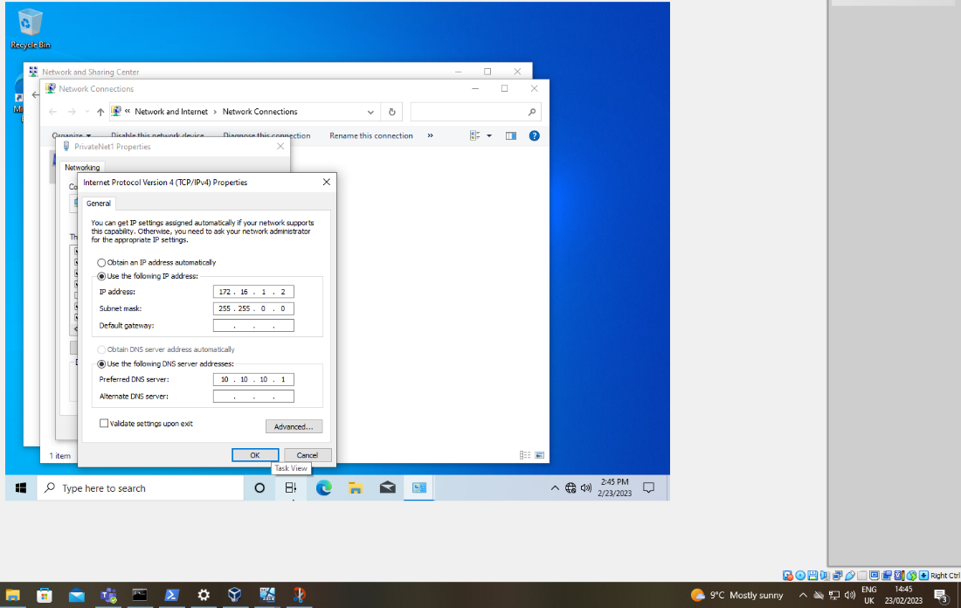
Figure 14: Incorrect IP address for DNS server.
In the above figure the incorrect IP address for the client’s DNS settings was documented in the worksheet tasks. This was quickly identified and remedied as the address given (10.10.10.1) was the external network address of the domain controller, on a different network to the client (172.16.1.0). This meant that the client could not use DNS services which are essential to joining a domain. The DNS server address was changed to the domain controller internal network address (172.16.1.1) and subsequent steps were a success.

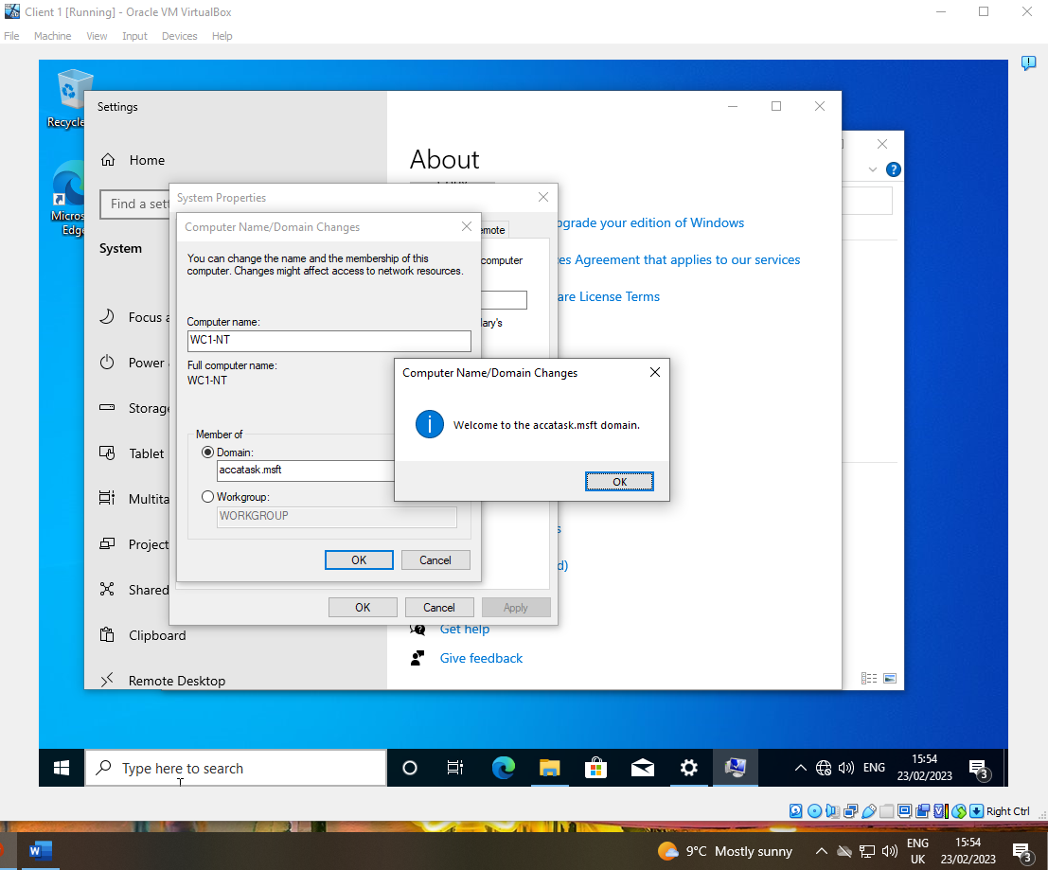
Figure 15: Client successfully joined the domain.
The above figure shows that the client has successfully joined the domain accatask.msft. In order for a Windows client to join a Windows domain both the domain controller and the new client need to be correctly configured and able to communicate over the network.

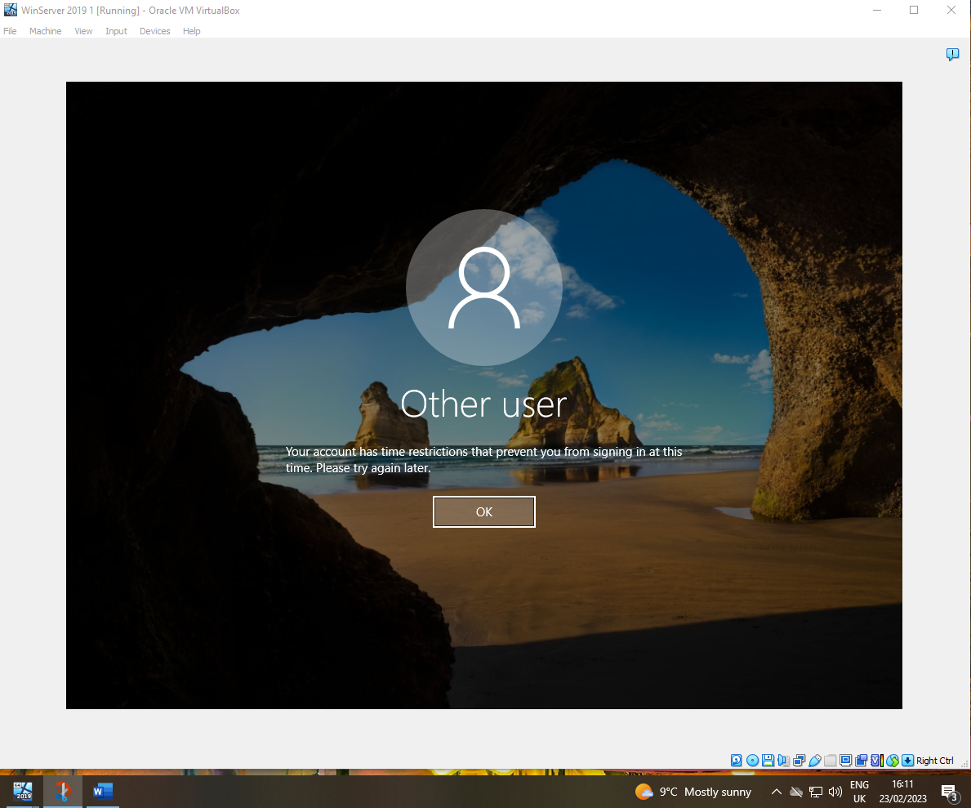
Figure 16: User account unable to log on to domain controller - worksheet page 20.
The above figure demonstrates that a standard domain user does not have permissions by default to allow them to log on to a domain member server or domain controller. A new domain user account from a previous step was used to try and log on to the domain controller. For domain controllers, only members of the domain administrators’ group can log on to them by default. For member servers members of the server administrators’ group can log on interactively.

Part 2:

Created in the 1960s A Hypervisor is a software layer that allows several operating systems to work alongside each other while sharing the same physical resources of the host machine. These operating systems function as virtual machines which mirror computing hardware in software layers.
Originally referred to as an virtual machine monitor a hypervisor allows a host to support several guests by sharing resources this includes power, memory, and storage. While in operation, the hypervisor separates each VM and assigns them their own dedicated portion of the resources available.
A type 1 hypervisor runs directly on the host computers physical hardware. A type 1 is typically faster and more efficient than type 2 as it interacts directly with the hosts CPU, RAM and hard drive. It also allocates all available processing power and resources to the VMs. Type 1s also provide higher security as there is no gap between the hypervisor and the host CPU.
A type 2 hypervisor runs as a software layer on top of the OS on the host computer instead on physical hardware. Type 2 provide an easy set up as it does not require separate management machines. Offers an streamlined access to a guest OS alongside the primary OS the host runs on which is ideal for end-user productivity.
The downside to using Type 2 over Type 1 as it is not as secure and efficient due to be on the software layer and not working off physical hardware which has issues such as latency, or a delay in processing request. Type 2 virtualisation is used by individuals who need access to multiple operating systems but are not concerned with higher latency.

A DHCP is a client/server protocol that provides an IP host with its IP address and other related configuration information such as the subnet mask and default gateway. RFCs 2131 and 2132 defines DHCP as an internet engineering task force ‘IETF’ standard based on Bootstrap protocol ‘BOOTP’. A protocol with which DHCP many implementation details. DHCP allows hosts to obtain required TCP/IP configuration information from a DHCP server.
According to Gary Kessler DHCP supports 3 different mechanisms for IP address allocation. Automatic which assigns a permanent IP address to a client. Dynamic which assigns an IP address for a limited time to a client which is call a lease. Manual which the server conveys an address to the client that been specifically assigned by the network admin.
Below is a diagram showing how a DHCP server works.
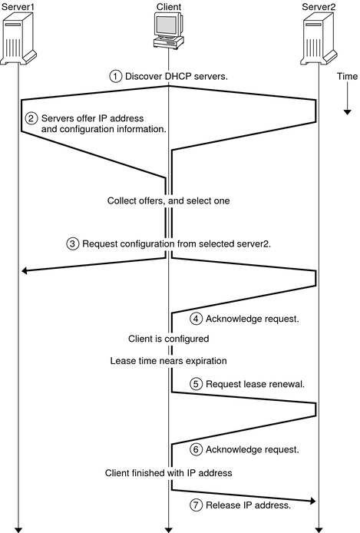
Figure 17 How a DHCP server works.

Active Directory abbreviated to AD is a technology used by windows to manage and organise network resources. AD serves as a central database that stores and manages information about the user, computers, and other network resources in a hierarchical and structured format.
AD uses a hierarchical structure to organise and store information about the network’s resources. The structure is based on the domain and domain tree concept. A domain is a logical grouping of resources such as users, computers, printers and other devices on the network. A domain tree is a structure of domains that share a common namespace and a trust relationship. Shown below is an example of a domain tree structure in AD.
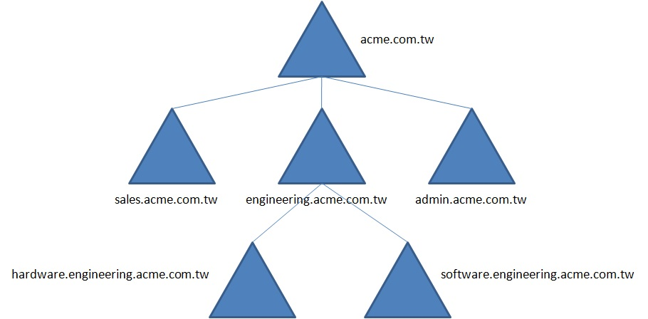
Figure 18 Domain Tree in AD

AD stores and manages network resources in a structured format using objects. An object is a collection of attributes that describe a network resource such as a user, computer, printer, or group. For example, a user object in AD will have attributes such as Name, username, password, email address and group membership. Shown below is a user object with multiple attributes such as First Name, Last Name, Initials, Full Name and User logon names.
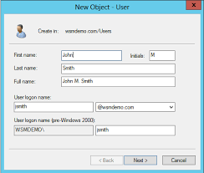
Figure 19 User Object in AD
AD provides a secure format to store and manage network resources. AD uses security identifier (SID) to uniquely identify each object in the AD database. The SID is used to control access to the network resources by allowing or denying permissions based on the user’s SID. AD also uses a password policy to enforce an strong password by how complex ,long and expiration for user accounts. Shown below is a password policy that is configured to require a minimum password length of 7 characters, complexity requirement disabled and a maximum password age of 365 days.
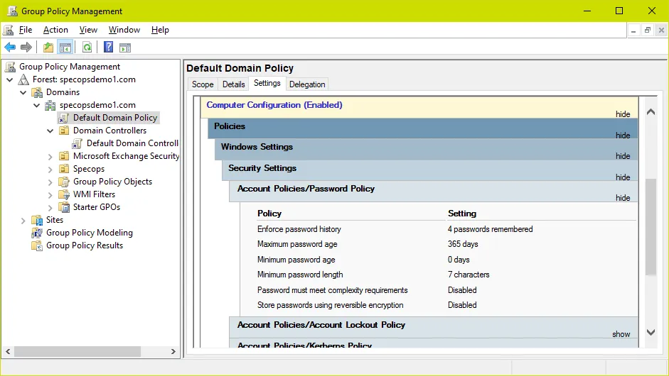
Figure 20 Password Policy in AD

List of terminologies found within the worksheet.
- Ping – To send an echo-request packet to an IP address and use the echo reply to determine whether another computer on the network is operational and the speed at which the data is transferred

- Server Management – is a process of monitoring and maintaining servers to operate at peak performance. Server management also includes management of hardware, software, security and server backups.

- Firewall – are tools that protect networks by deciding how and what information can come and go on the network. Firewalls are used to protect large networks and individual computers from malware and security threats. There are two different types of firewalls. A network firewall acts as a barrier to the entire network. This normally comes in the form of a separate piece of hardware that sits between the network and the internet. A host firewall is a software which is on each individual device such as Microsoft Firewall, McAfee Firewall for Mac and IPFire for Linux based systems. The downside to these software’s is that they only protect their individual device and not the entire network.

- PAE/NX – is an example of passing through virtualisation of the host CPU to the virtual machine. This needs to be done to run nested virtualisation.

- Network - A collection of interconnected devices that communicate with each other using a common set of protocols.

- Node - Any device that is connected to a network, such as a computer, printer, router, or switch.

- IP address - A unique numerical identifier assigned to each device on a network.

- Protocol - A set of rules and standards that govern how devices communicate with each other on a network.
- DNS (Domain Name System) - A system that translates human-readable domain names (like google.com) into IP addresses that can be used by network devices.

- DHCP (Dynamic Host Configuration Protocol) - A protocol that automatically assigns IP addresses to devices on a network.

As I joined my group late, I missed out on helping my group with task 1 of ‘building a virtual LAN using a Type 2 hypervisor management software’. But through research conducted above and in my own time away from my group I have more of an understanding of an virtual LAN and how a type 2 hypervisor works within a LAN. I asked questions to my group and conducted research on task 2 ‘deploying a network directory service and creating and understanding an active directory network objects’. Now I have an greater understanding of how to create an Active Directory and how useful it is as I have never created my own network in professional or a personal capacity before. By working with my group has also given me more experience with working as part of a group as I feel I would of struggled with these tasks on my own.

Conclusion
In conclusion I have learnt how to build an virtual LAN with a type 2 hypervisor management software, deploy a network directory service and create and understand an active directory network objects. Also, I have expanded my knowledge and understanding of these topics through research and displaying my findings in a report format.

Reflection on collaborative work
I have enjoyed working in a group as it has allowed me to further my understanding and learnings from previous group work conducted with new people as previously there was only about 10 – 15 people on my specific learning stream. It was nice to mix it up with other people from other learning streams to gain other perspectives and learning from their experiences.

References
M. Portnoy, Virtualization essentials. John Wiley & Sons, 2012.
D. Richards, “What is a hypervisor?” Liquid Web, 28-Jan-2022. [Online]. Available: https://www.liquidweb.com/blog/what-is-a-hypervisor/. [Accessed: 09-Mar-2023].
J. Gerend, “Dynamic Host Configuration Protocol (DHCP),” Microsoft Learn, 29-Jul-2021. [Online]. Available: https://learn.microsoft.com/en-us/windows-server/networking/technologies/dhcp/dhcp-top. [Accessed: 09-Mar-2023].
R. Droms and T. Lemon, The DHCP handbook. Indianapolis, IN: Sams, 2004.
G. Kessler, “The Dynamic Host Configuration Protocol (DHCP) and windows NT,” DHCP and Windows NT, Dec-1998. [Online]. Available: https://www.garykessler.net/library/dhcp.html. [Accessed: 09-Mar-2023].
S. Clines and M. Loughry, Active directory for dummies: Efficiently configure, manage, and update your network. Hoboken, NJ: Wiley, 2008.
Lithmee, “What is the difference between child domain and Tree domain,” Pediaa.Com, 05-Jun-2019. [Online]. Available: https://pediaa.com/what-is-the-difference-between-child-domain-and-tree-domain/. [Accessed: 09-Mar-2023].
“Active directory user object: An introduction,” Windows Active Directory, 02-Sep-2021. [Online]. Available: https://www.windows-active-directory.com/active-directory-user-objects-management.html. [Accessed: 09-Mar-2023].
D. Siegel, “How to check password complexity requirements in Active Directory,” Specops Software, 03-Jan-2023. [Online]. Available: https://specopssoft.com/blog/check-password-requirements-active-directory/. [Accessed: 09-Mar-2023].
S. Contributor, “What is server management? definition, best practices, and best software,” DNSstuff, 01-Dec-2022. [Online]. Available: https://www.dnsstuff.com/server-management. [Accessed: 09-Mar-2023].

