Daniel James (2218766)
2218766@student.uwtsd.ac.uk
University of Wales Trinity Saint David
BSc Computing (Computer Networks and Cyber Security)
The Use of RESTful WEb services with Cloud Computing
Network Programmability

Contents
1.0 Introduction 2
2.0 How the shift towards cloud computing has affected the industry. 3
2.1 What is Cloud Computing 3
2.2 The affect the recent shift back to Cloud Computing has had on the industry. 4
3.0 How the job of network professionals has evolved to meet the technical challenges of the cloud. 4
4.0 How RESTful web services have been used to facilitate these changes. 5
5.0 Why software defined networking has become so heavily adapted by industry, despite meaning an adaptation to the job role of network engineers. 6
5.1 What is software defined networking. 6
5.2 Why this has been so heavily adapted by the industry. 6
6.0 Why standards such as JSON and REST have been selected and utilised, specifically consider interoperability. 6
6.1 What is JSON 6
6.2 What is interoperability. 7
6.3 Why JSON and REST have been selected and heavily utilised. 7
7.0 Conclusion 7
8.0 References 8

1.0 Introduction
This report will aim to answer how the field of computing has moved towards a software-based networking model on the cloud rather than more traditional networking methods. The report is organised in the following structure: Section 2 analyses how the shift towards cloud computing has affected the industry. Section 3 shows how the job of network professionals has adapted to the technical changes of the cloud. Section 4 explains how RESTful web services have been used for the change to cloud computing. Section 5 answers the question as to why software defined networks have been so heavily adapted by the industry, despite the drastic changes to the job roles of network professionals. Section 6 analyses what are the JSON and REST standards and why the interoperability between them and other applications has made this approach so favourable. Finally, Section 7 concludes the report.

2.0 How the shift towards cloud computing has affected the industry.

2.1 What is Cloud Computing
The role and usage of cloud computing may be ever increasing over the last decade but the idea itself is not new, the idea of cloud computing can trace back to earlier than 1970. [1] Cloud computers fundamentally allow clients to access computers and processing power through the internet, though in more recent years with the rise of mobile devices has allowed for applications and services to be u wirelessly while also keeping storage low and reducing the need for high end processors. [2] With the constant technological advancements in hardware, software, and other factors such as major improvements to internet speeds and physical storage, and the reduction in power usage, it was obvious that cloud computing would make an everlasting impact on the industry.
There are three different models referred to when talking about cloud computing, shown in figure 1, which make up the three layers of the architecture. The first, Infrastructure as a Service (IaaS) provides hardware services that the client can access. The second, Project as a Service (PaaS) includes IaaS services while also including a complete service with development tools and software. Finally, Software as a Service (SaaS) allows for applications to be run on the cloud rather than on a client’s device, as a result this encapsulates all other layers. [1]
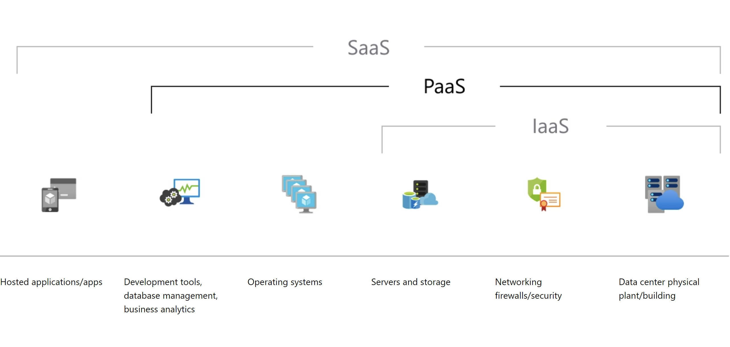
Figure 1 Demonstration of the overlapping roles within the cloud computing layers. [3]
In mobile cloud computing, to improve speed, the device will split up the processes of an application and offload these to the cloud to process at the same time. This is computational offloading, shown in figure 2, allowing the mobile device to decide how much workload is executed on the device and, if any, is offloaded to the cloud depending on the situation. [4]
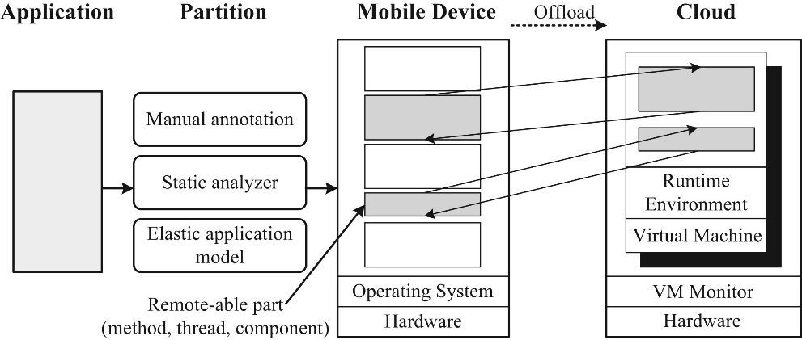
Figure 2 The process of offloading tasks to the cloud [4]

2.2 The affect the recent shift back to Cloud Computing has had on the industry.
Cloud Computing’s reliable hardware and software, and ability to deliver services to clients across the internet has firmly established it in current and future eras of computer systems. [2]
The lack of an upfront cost for physical hardware and software licences has allowed for many businesses, including small startups to begin using cloud computing. Many companies only require a large amount of computational power for a short amount of time to batch process a large amount of data to allow key business operations and discovering innovative marketing opportunities, cloud computing has made this possible for companies of any size to do this. This has made it even more affordable for businesses outside of IT to begin implementing cloud computing services into their everyday operations, leading to an ever-increasing rise of cloud computing use. [1]
The rise of ‘mobile cloud computing’ has brought with it a whole array of privacy and security issues that must be considered to protect the end users. When data is stored wirelessly onto the cloud, it can be intercepted by a third-party such as a hacker or malicious company to steal or sell your data. This has led to new security requirements made by institutes and government agencies such as the ITU or the National Security Agency in the US to protect client and companies’ data. [4]

3.0 How the job of network professionals has evolved to meet the technical challenges of the cloud.
Configuring physical network devices using a command line interface (CLI) is a slow and inefficient process and with the rise of cloud networks, it is obvious that a more user-friendly process is created. Software-based configuration tools have become more prominent allowing the end user to enter basic parameters for the network, then the program will fully install and configure the network. This has forced network professionals to switch from using the CLI to writing bespoke code and programs. [5]
The change has not been easy on the network engineers though, retraining has been necessary which is time consuming and expensive, and not all individuals or organisations will be willing or able to adapt to the new standards. Network professionals will be able to work with more speed due to this move towards programmable networks and will build closer ties with the organisations they work for as there will be more inclusion with the front-end operations. [5]
The biggest challenge and concern of the cloud is data processing and storage. For organisations to be able to use the substantial storage limits and powerful processing power, data is sent offsite to data centres through the internet, across the world. This outsourcing of data processing and storage has been the cause of a large amount of data breaches in recent years, which is obvious as the data is at its most vulnerable state while transferred offsite. Data encryption occurs while in this state, but this comes with downsides, the network engineer must carefully balance the security with the efficiency of the systems. Using more secure encryption techniques increases processing time; organisations that are constantly transferring data to the cloud would decrease in effectiveness in their systems, but this security may be worth it depending on the organisation. [6]
There are many different frameworks, such as ESPD (Efficient, Scalable, and Privacy-preserving Data) [6] and algorithms, such as SEAL (Secure and Efficient data perturbation Algorithm utilizing Local differential privacy) [7] that aim to solve this problem, although these usually come with limitations, normally sacrificing efficiency, scalability, or security to achieve whichever is the higher priority to the organisation. Algorithms such as SEAL use complex math and noisy methods to obscure and encrypt data, these methods are secure and provide incredible scalability allowing for use on large scale datasets. [7] Alternatively, the framework SEAL provides efficiency, scalability, and security, however the use of a secure key which can be intercepted and would provide instant access to the data by a malicious third party highlights a glaring vulnerability. [6]

4.0 How RESTful web services have been used to facilitate these changes.
REST uses already established internet standards such as HTTP, JSON, and XML to provide lightweight and scalable services. REST uses the GET, DELETE, PUT and POST methods from HTTP to access any Application Programming Interface (API). These APIs can give access to text, images, or any other service being provided on the web such as the weather forecast. The most common file type used to store data on an API is JSON, but other options are available such as plain text or comma-separated values (CSV). RESTful services are cheaper and lightweight to run due to HTTP services being available to all popular programming languages and compatibility with all major software and hardware providers. [8]
There are many different comparisons that can be made between JSON and XML, primarily though the key differences are readability and size of data transfer. XML is much more readable than JSON, however this comes with a cost as JSON has a lower amount of data to be transferred. For large APIs that are being called hundreds of times a second, transfer efficiency is key to reduce costs and maintain performance. Furthermore, most organisations will make use of a front-end page to organise and display the information from the API, negating the positives of XML. For these reasons, JSON is the more widely used standard for storing data on RESTful services. [9]
RESTful web services make up over 70% of cloud computing services, according to [10], showing the reliability and power of processing on the cloud using RESTful services. Any tool that can work with HTTP is able to use the RESTful services, which has helped facilitate changes to a more cloud-based web due to greater interoperability between tools and programming languages. Furthermore, less training would be required due to network professional’s ability to use prior knowledge to develop RESTful services rather than having to learn new protocols and functionality from scratch. [10]

5.0 Why software defined networking has become so heavily adapted by industry, despite meaning an adaptation to the job role of network engineers.

5.1 What is software defined networking.
Software Defined Networking (SDN) has been introduced to simplify network creation and management because of innovations in the cloud computing field. Software defined networking is a concept in cloud computing that provides performance and ease of use for network professionals and end users. Due to the nature of cloud computing, SDN must have high reliability and must not compromise on performance. [11]
SDN is the most common, and arguably best, network virtualisation practise in modern computing to move controlling network packets away from the physical hardware, which uses proprietary software which cannot be customised fully to the user’s requirements, to an approach that utilises software programming to control all network traffic without changing the existing network topology. [12]

5.2 Why this has been so heavily adapted by the industry.
Due to the simplicity, programmability, and ease of use of SDN, it is projected to replace traditional networking technologies in the coming years. There are many different reasons for the rise of SDN in the industry, this includes: Decoupling the hardware and software to allow them to work independently from each other has allowed for quicker deployment of network devices and development of new applications, the SDN also greatly simplified the networking model to allow for convenient access and management of the network, finally the move to software has allowed for a global view of the network, which allows the network professionals to troubleshoot and optimise the network more efficiently and provides much more information to allow for improvements to be made to the network much more effectively. [12]
For a smooth rollout across the industry, security must be considered. Authentication and authorisation techniques must be considered to prevent access and common attacks such as Distributed Denial of Service (DDoS) attacks must be mitigated to ensure reliability. An advantage of SDN over traditional networking technologies is the ability to update systems in a timely manner to deal with security vulnerabilities as they arise. Although for this to be affective the system must constantly monitor abnormal traffic to detect any of these vulnerabilities earlier. There are many different techniques to prevent and mitigate the effects of these attacks, but with the constant growth of popularity, it is obvious that security on cloud services will be under constant revue and effect the trajectory of software defined networks. [12]

6.0 Why standards such as JSON and REST have been selected and utilised, specifically consider interoperability.

6.1 What is JSON
The JavaScript Object Notation (JSON) is a lightweight format for storing data. JSON makes use of key-value pairs within dictionaries to store data. This data can also in the key-value pairs can be more JSON files, which allows for nesting files within files. This is incredibly advantageous for RESTful services and one of the key benefits. There are many different methods for editing and querying JSON files, such as the use of a programming language like Python. [13]

6.2 What is interoperability.
Interoperability is the ability for computers to share information and data. This could be between applications or layers on models such as the TCP/IP model. Due to the proprietary technology in more traditional networking technologies, it is difficult if not impossible for interoperability. Due to the nature of the models, it much more difficult for interoperability on lower layers. This one of the advantages of software defined networking, by controlling the network packets with a software, higher layers on the TCP/IP model are being used which fundamentally allow for interoperability. [14]

6.3 Why JSON and REST have been selected and heavily utilised.
JSON and REST are heavily utilised by the industry, including by some of the tech giants such as Google. REST is built upon the key principles of HTTP, making it simple and easy to understand; anyone with experience using HTTP will be able to use REST. [10] [15] JSON and REST are so often used together due to REST not adding any additional headers to the messages, keeping the messages lightweight and not consuming as much bandwidth but also allowing for JSON to be used directly without needing to use a program to convert or add extra information to allow the file to transfer. [15]
The performance on mobile devices must also be considered for JSON and REST, as the use of cloud computing on mobile devices has become more popular. RESTful web services offer better performance than other methods of providing services, such as Simple Object Access Protocol (SOAP) [15]. As discussed previously in this paper, JSON is a more lightweight method for storing data, which is incredibly beneficial and becomes on of the biggest considerations when developing services designed for mobile devices. [9] Mobile devices almost entirely access the internet through wireless connections, which are known for unreliable connections and limited bandwidth usage in comparison to a wired connection; and due to these limitations, JSON files are used as the key-value pair method wastes the least amount of bandwidth when compared to other languages such as XML. [13]

7.0 Conclusion
RESTful services have played a significant role so far in the switch towards cloud computing and will continue in the future as more companies entirely switch to a cloud computing model. The popularity of REST has been influenced by many distinct factors, such as being lightweight, easy to learn, cheap to operate and provides excellent interoperability with other programs. REST’s use of JSON has further improved its popularity due to JSON already being well known and universally used within the industry and providing a wide range of benefits itself.
An aspect of cloud computing that requires more research would be the privacy and security of data, although outside the scope of this report, we briefly touched upon some of the fundamental security and privacy concerns with cloud services, but more research into mitigation and prevention techniques would be necessary.

8.0 References
References
[1] S. Marston, et al., "Cloud computing — The business perspective," Decis.Support Syst., vol. 51, no. 1, pp.176-189, 2011. doi: 10.1016/j.dss.2010.12.006.
[2] I. A. T. Hashem, et al., "The rise of “big data” on cloud computing: Review and open research issues," Information systems (Oxford), vol. 47, pp.98-115, 2015. doi: 10.1016/j.is.2014.07.006.
[3] "What is PaaS?" https://azure.microsoft.com/en-us/resources/cloud-computing-dictionary/what-is-paas/ (accessed Nov 10,).
[4] M. B. Mollah, M. A. K. Azad and A. Vasilakos, "Security and privacy challenges in mobile cloud computing: Survey and way ahead," Journal of network and computer applications, vol. 84, pp.38-54, 2017. doi: 10.1016/j.jnca.2017.02.001.
[5] M. Cooney, "Cisco: 5 hot networking trends for 2020: Cisco exec says SD-WAN, Wi-Fi 6, multi-domain control, virtual networking and the evolving role of network engineers will be big in 2020," Network World (Online), 2019.
[6] J. Sun, et al., "Share Your Data Carefree: An Efficient, Scalable and Privacy-Preserving Data Sharing Service in Cloud Computing," IEEE Transactions on Cloud Computing, vol. 11, no. 1, pp.822-838, 2023. doi: 10.1109/TCC.2021.3117998.
[7] M. A. P. Chamikara, et al., "An efficient and scalable privacy preserving algorithm for big data and data streams," Comput.Secur., vol. 87, pp.101570, 2019. doi: 10.1016/j.cose.2019.101570.
[8] M. Garriga, et al., "RESTful service composition at a glance: A survey," Journal of network and computer applications, vol. 60, pp.32-53, 2016. doi: 10.1016/j.jnca.2015.11.020.
[9] M. Melnichuk, Y. Kornienko and O. Boytsova, "WEB-SERVICE. RESTFUL ARCHITECTURE," Automatizácia tehnologičeskih i biznes-processov, vol. 10, no. 1, 2018. doi: 10.15673/atbp.v10i1.876.
[10] A. Kobusińska and C. Hsu, "Towards increasing reliability of clouds environments with RESTful web services," Future Generation Comput.Syst., vol. 87, pp.502-513, 2018. doi: 10.1016/j.future.2017.10.050.
[11] K. Benzekki, A. El Fergougui and A. Elbelrhiti Elalaoui, "Software‐defined networking (SDN): a survey," Security and communication networks, vol. 9, no. 18, pp.5803-5833, 2016. doi: 10.1002/sec.1737.
[12] Z. Shu, et al., "Security in Software-Defined Networking: Threats and Countermeasures," Mobile Netw Appl, vol. 21, no. 5, pp.764-776, 2016. doi: 10.1007/s11036-016-0676-x.
[13] P. Bourhis, J. L. Reutter and D. Vrgoč, "JSON: Data model and query languages," Information systems (Oxford), vol. 89, pp.101478, 2020. doi: 10.1016/j.is.2019.101478.
[14] J. A. Martins, A. Mazayev and N. Correia, "Hypermedia APIs for the Web of Things," Access, vol. 5, pp.20058-20067, 2017. doi: 10.1109/ACCESS.2017.2755259.
[15] R. Ramanathan and T. Korte, "Software service architecture to access weather data using RESTful web services," 2014. doi: 10.1109/ICCCNT.2014.6963122.

