Q1. Evaluate the concept of evidence-based practice (EBP) and provide two examples of where Technivara could use it to ensure sound decision-making in people practice. (AC 1.1)

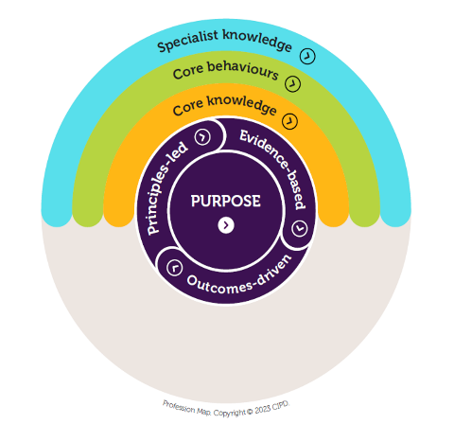
Evidence based practice in people management is about making decisions based on solid evidence rather than guesswork or tradition. This means using the best available information to decide what to do rather than relying on habit or opinion (CIPD, 2025c). To evaluate and integrate sources CIPD recommends using the six A’s, Asking, Acquiring, Appraising, Aggregating, Applying and Assessing. These steps help people professionals turn a question into a structured process. Ask clear questions, acquire internal and external evidence, apply proportionate solution and assess outcomes so the organisation learns what works. (Briner, Denyer and Rousseau, 2009). Using the right questions, finding evidence, checking its quality, combining it, applying it and reviewing the results. (CIPD.2025a; Armstrong, 2019). Evidence based practice blends four evidence sources, research, organisational data, professional judgment and stakeholder views with critical thinking used to weigh trade offs before acting.

Evidence based practice is important as it helps organisations make decisions that are fair, transparent and based on facts rather than assumption or tradition. It reduces the risk of poor decisions and improves credibility and ensures that people practices support business goals. For Technivara this is especially relevant because many processes are still paper driven, moving people analytics. For example: - exit data and pulse surveys would improve accuracy, speed and confidence in decisions (CIPD, 2025c)

On example Technivara could use evidence-based practice by improving the pay and reward system. Pay and benefits play a big role in attracting, keeping and motivating employees. There are many ways to reward people and recognise the value they bring which come with advantages and disadvantages. The most effective reward packages are the ones that meet the needs of employees, support the business and fit with the organisations purpose, culture and performance expectations. (CIPD, 2025b) Technivara could create a fairer and more competitive reward package helping to reduce dissatisfaction, make pay decisions clearer and attract and keep the right people as the business grows. Clear governance and simple dashboards would show whether the changes are working and help leaders decode the next step. (Armstrong and Taylor, 2023; CIPD, 2025c)

A second example is learning and development. Technivara wants to continue growing as a company, but they won’t be able to do so effectively without having reliable data. Technivara need to understand what skills employees currently have and what future support and skills they need. By using evidence-based practice Technivara could review performance, training records, productivity figures and employee feedback to highlight any skill gaps.
Technivara can then combine this with external research on effective methods and current industry skill trends (CIPD, 2021; Breiner & Bruser, 2023). This can be structures as a simple learning needs analysis to identify priority roles, map critical tasks and skills, gather data from managers/learners and assess outcomes at 30-60-90 days (CIPD, 2025c; CIPD, 2021)

Using the evidence would help the company focus on the most important development needs, invest in the right training and ensure employees have the skills to support long term growth (CIPD,2021). Regular review cycles and lightweight evaluation for example: - pre and post checks and manager feedback make it easier to show behaviour change and keep investment focused on what delivers results (CIPD, 2021)

Q2. Evaluate one appropriate analysis tool and one appropriate analysis method that Technivara might apply to recognise and diagnose issues, challenges, and opportunities. (AC 1.2)

People professionals use many different tools and methods to help them understand what is happening inside an organisation and what factors may affect them. These tools could be PESTLE, STEEPLE, SWOT, Porter’s Five Forces, Fishbone diagrams and McKinsey’s 7S. Methods such as interviews, observations, job analysis questionnaires and reviewing HR metrics also help identify issues, challenges and opportunities.

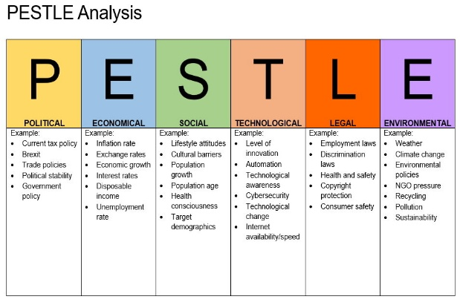
One tool that would be useful to Techinvara is PESTLE analysis. This will help the organisation examine external factors like political change, economic pressures, social trends, new technologies, legal requirements and environmental expectations. CIPD explains that PESTLE is a diagnostic tool that helps organisations understand how these external influences may shape future decisions and planning (CIPD,2025; Perkins and Robinson, 2025).

(Image 1 - impact innovation)

For Techinvara PESTLE can highlight issues linked to the fast-moving technology industry such as changing customer expectations, the need for up-to-date skills, economic pressures on pay or new employment laws. As Techinvara continues to grow and plan for expansion this tool helps the people practice team spot risks early and identify opportunities, supporting safer and more evidence-based decisions. However, PESTLE does have its limitations as it only considers external factors and cannot identify internal issues such as Techinvaras outdated paper-based HR processes or resistance to change. It also depends on predicted future trends which may not always be accurate.

People professionals also use analysis methods to collect further information. A suitable method for Techinvara is employee interviews which allows HR to ask staff about their experiences, challenges and ideas for improvement. Interviews are useful for uncovering internal issues such as training needs, frustrations, communication problems or barriers to performance. Research shows that interviews help HR understand engagement levels and areas where staff may need more support. (Bessant, 2019; Ranked Tutorials,2024).

Although interviews can be time consuming and rely on employees feeling confident to speak openly, they remain valuable for Techinvara because they provide insight into internal issues that external tools like PESTLE cannot identify. Together PESTLE and interviews give Techinvara a balanced view of both internal and external factors helping Sue young and the people practice team make stronger evidence-based recommendations as the business modernises its people practices (Perkins and Robinson, 2025).

Q3. Explain the main principles of critical thinking including how these might apply to your own and others’ ideas to assist objective and rational debate at Technivara (AC 1.3)

Critical thinking means taking time to think clearly and logically before making decisions. This helps people avoid making choices based on emotions, habits or personal beliefs. CIPD explains that critical thinking is essential because HR often deal with complex problems that need reliable evidence rather than assumptions (CIPD, 2025; Taylor and Woodhams, 2016).

Everyone is influenced by beliefs, emotions, culture and personal experiences. Critical thinking involves recognising these biases, so they do not affect decisions. CIPD training highlights the need to challenge your own thinking and stay alert to bias in others (Taylor and Woodhams, 2016; CIPD, 2025). At Techinvara this means being aware that Bill prefers traditional methods and Sue may avoid change and making sure these biases don’t shape decisions without evidence.

Critical thinkers do not accept information at face value. They ask questions such as: -

- Where did this come from?
- Is this fact or opinion?
- Is this evidence reliable?

CIPD stresses the importance of checking the quality of information before using it to make decisions (CIPD, 2025). This is important for Techinvara because many HR processes are paper based and may not provide accurate or current data.

Critical thinking focuses on logic rather than emotion. This includes breaking information down, comparing different view points and thinking through consequences. HR resources show that rational thinking leads to clearer decisions and stronger arguments. (Annelise Pretorius, 2025). For Techinvara this helps ensure decisions about modernising HR systems or introducing new processes are based on facts not personal preferences.

Critical thinkers talk through their ideas with others to get feedback and challenge their assumptions. This helps reveal weaknesses in arguments and strengthens final decisions. At Techinvara sharing ideas within the people Practice team encourages better debate and avoids decisions being made by one person’s viewpoint.

To apply my own critical thinking and others this means: -

- Comparing ideas fairly
- Checking Clarity of terms
- Separating fact from opinion
- Considering different contexts
- Testing conclusions using more than one source of evidence
Using these steps could help ensure decisions are balanced, fair and evidence based.

Techinvara is growing quickly and many of its HR processes are outdated. Critical thinking helps the company make better decisions. (Taylor and Woodhams, 2016)

Q4. Explain two decision-making processes that Technivara could apply to ensure that effective outcomes are achieved. (AC 1.4)

To ensure effective outcomes in decision making Techinvara could use structured approaches such as De Bonos Six Thinking Hats and Action Learning. These are practical, easy to teach methods that help teams slow down, think clearly and reach decisions people can stand behind.
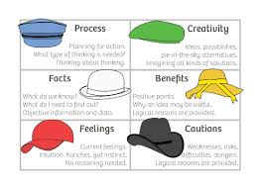
Six thinking hats is a well-established framework that helps teams explore an issue from different angles by moving through six modes of thinking, facts, risks, feelings, benefits, creativity, process and caution. This structured approach reduces conflict, encourages balanced discussions and improves clarity helping teams separate emotion from evidence when reaching decisions (De Bono Group, 2025; Barkas and Dixon-Todd, 2019). Everyone wears the same hat at the same time. For Example: - White for facts, Black for risks, Yellow for benefits. Discussion stays focused and respectful and no on dominates. Typical sequences for example: - Blue-White-Green-Yellow-Black-Red are used in many organisations to move from data, ideas to balanced decisions.
(Image - Agile Coffee)
At Techinvara this method would support the people practice team when deciding whether to modernise HR systems as each “Hat” guides staff to consider data about current delays, potential risks of change, emotional concerns among staff and opportunities for improvement. It also shortens meetings and reduces unhelpful debate by turning argument into parallel thinking” which the De Bono literature and toolkits highlight.

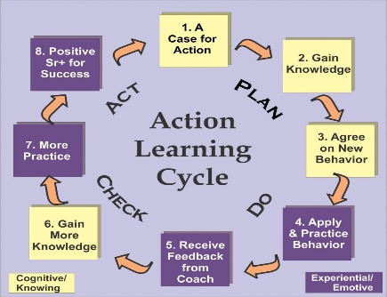
A second process Techinvara could apply is Action Learning, which involves identifying a real organisational problem by analysing, testing solutions and reviewing outcomes. This approach aligns with CMI’s guidance that effective decision making requires gathering relevant information, exploring alternative options and applying structured problem-solving techniques to achieve better results (CMI,2020). CMI also recommends a clear checklist to define decisions, involve the right people, gather evidence, consider uncertainty, choose tools, act then review which fits naturally with an action learning cycle.
(Image - iLE)

Action learning sets would allow Techinvaras people practice team to investigate issues such as inefficiencies in paper-based HR processes, delays in onboarding or skill gaps then test solutions and see what works. For example: - Could trial a small e-form pilot for onboarding, measure cycle time, track errors and share lessons at the next session before rolling it out. Using these processes together would help Techinvara make more rational, collaborative and evidence-based decisions that support organisational growth and improve people practice effectiveness. Its best to start with a short six hats workshop to frame the issue then hand the live project to an action learning set to test, learn and report back. This blends structured thinking with real world version.

Q5. Assess two different ethical perspectives including how these could be used at Technivara to inform and influence decision-making. (AC 1.5)

Ethical perspectives help guide how people professionals make fair and responsible decisions. At Techinvara this is important because decisions affect employees directly and help shape the organisation culture. This aligns with the CIPD profession Map’s expectation that people professionals act in a principles led, evidence based and outcome driven way, building an open, fair and consistent culture.

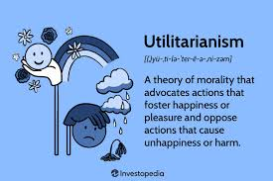
One useful ethical perspective is utilitarianism. This approach considers the likely outcomes of a decision and aims to maximise overall benefits while reducing harm. CIPD highlights that HR professionals often face tough choices, so they must consider the wider impact of their decisions to ensure ethical and transparent practice (CIPD,2025). Utilitarianism is often summarised as choosing the option that brings the greatest overall good for those affected, which helps HR weigh benefits. At Techinvara a utilitarian view might support introducing a new HR system even if its requires short term disruption because the long-term benefits improve accuracy, efficiency and support for employees. (Tardi, 2025; Armstrong, 2019). It also fits UK reporting expectations to explain non-financial drivers and long-term outcomes in the strategic report.


Another perspective that can guide Techinvara is deontology which focuses on doing the right thing based on moral duties and principles rather than outcomes. This view emphasises fairness, honesty and respecting individual rights. According to deontological ethics a decision is ethical if it follows clear moral rules and treat people with dignity regardless of whether the outcome is easier or more convenient for the organisation (Armstrong, 2019; VQ Solutions,2025). Practically, follow rules you could apply to everyone and always treat people as ends not as means. At Techinvara this approach would ensure that processes such as recruitment, performance management or disciplinary decisions seems easier. A deontological approach would require following the correct process to protect employee rights and maintain trust. (Anon, n.d.). Use fair process, truthful records and non-discrimination are non-negotiable.
CIPD also stresses that ethical practice involves being open, fair and consistent in how employees are treated (CIPD,2025). Have clear codes and speak-up routes so people can raise concerns safely.

Both perspectives influence decision making differently. Utilitarianism helps Techinvara consider the bigger picture and choose options that benefit most employees especially during periods of change and growth. Helpful during major change programmes.
Deontology ensures individuals are treated fairly and consistently helping maintain trust and protect employee rights. It protects trust and dignity. Using both views together allows Techinvara to make decisions that are not only effective but also ethical, transparent and aligned with the values expected as people professionals. (Grover, 2019). Use simple two step check. 1. Remove any option that breaks duties. 2. Pick the best overall outcome and explain it for stakeholders.

Q6. Appraise two different ways that Technivara could measure financial and non-financial performance, providing one example of each. (AC 3.1)

Financial Performance
Techinvara can strengthen their decision-making by using more structured measures of both financial and non-financial performance. A useful financial method is profitability analysis such as monitoring the company’s gross profit margin which shows how efficiently Technivara turns revenue from engineered components into profit after production costs. This would help the board see whether continued expansion is sustainable and whether rising demand across sectors like medical and automative is generating healthy returns (CIMA,2023; ICAEW,2024). This means tracking a small set of financial KPI’s like margins that UK guidance expects to be explained in the strategic report so stakeholders can see progress over time. (ICAEW, 2024; FRC,2022). A quick investment appraisal check plus a robust cash flow review helps avoid costly mistakes. Linking the numbers to relevant narrative in the strategic report also meets UK reporting expectations.

Alongside this Techinvara should use non-financial indicators such as customer satisfaction metrics because these act as early signals of future demand and quality issues. A simple widely used option is Net Promoter Score (NPS). A one question metric that has been shown to predict growth when used well. For example, tracking Net Promoter Score (NPS) would allow the company to measure how likely clients in electronics and computing supply chains are to recommend Technivara, helping identify risks such as delayed orders or declining service levels before they effect revenue (CIPD, 2023; FRC, 2022). Keep it practical. Could ask two items after major orders the likelihood from 0-10 of recommendation question and a short “what one thing to improve follow up” and sample regular so the score is reliable. Using both types of measures together would give Bill and the board a more balanced evidence-based view of Techinvaras performance and help justify improvements to outdated people and operational practices. For Example: - After completing major orders Techinvara could send a simple two question survey to gather a score and the main reason behind it. Technivara could review this feedback weekly in team meetings and link quarterly engagement survey results to measures on time delivery to show how people’s issues affect operational performance. This is the kind of linkage between non-financial drivers (people and customers) and future results that UK reporting guidance and CIPD encourage. It also supports stronger workforce reporting to the board, so actions are based on evidence not experience. This supports UK expectations to connect non-financial drivers with future performance in the strategic report (FRC, 2023; CIPD, 2025a).

Q7 Explain how people practices could add value at Technivara and identify two methods that might be used to measure the impact of these people practices. (AC 3.2)

People practices add value at Techinvara by improving how people are recruited, developed and supported which leads to better performance, productivity and retention (Huselid n.d;
Armstrong, 2019). This includes clearer job design and selection methods that improve quality of hire, a stronger employee value proposition that attracts the right candidates and fair consistent policies that build trust. It also supports psychological safety and continuous improvement which encourage problem solving and innovation in day-to-day work. Using an evidence-based approach helps Techinvara make decisions based on reliable data rather than habit or assumptions reducing risk and supporting sustainable growth (CIPD, 2025b). In practice this means combining internal data such as exit interviews/performance data with external benchmark, running small pilots and reviewing results before scaling. Setting clear what you’re testing and how you will measure it and review points helps ensure decisions are timely, proportionate and cost effective. Modernising key practices such as onboarding, induction and skills development helps new starters settle faster, improve early performance and reduce early turnover (Armstrong, 2019; CIPD, 2025). Examples include 30-60-90-day plans, buddy schemes, regular manager checks-ins, micro learning for core tasks and inclusive induction materials. Strengthening line manager capability to coach and give feedback is often the biggest boost to early performance and retention. UK reporting guidance also expects organisations to show how non-financial drivers support future business results, so better people practices directly strengthen Techinvaras strategic reporting (Brandon, 2024). This aligns people outcomes such as skills, engagement, wellbeing and culture. Strategic objectives and risk management improves transparency with stakeholders and support long term value. A structured cycle of monthly dashboards and quarterly deep dives maintains focus on what works.

To measure impact of these people practices Techinvara can use two methods: -

- Cost benefit / Return on Investment Analysis (ROI) which compares the cost of initiatives like training or onboarding with benefits such as faster learning, lower turnover or higher productivity (CIPD, 2025b; Armstrong, 2019).

- Employee surveys and HR Key Performance Indicator’s (KPI) such as engagement scores, turnover, absence and time to recruit show both short and long-term impact, guide improvements, justify investment, build capability and give employees a voice. This helps link people performance to Techinvaras business goals (CIPD 2025a; CIPD, 2025b). Gallup large scale analysis shows that companies with high employee engagement see 81% lower absence, 18% higher productivity, 23% higher profitability and 18% lower turnover (Sorenson, 2023). Evidence that high engagement and good people practices drive results (Harter, 2024). Quarterly surveys could be run and gather open comments to pair up with HR KPI’s to spot root causes.

