Ways of Perceiving - Curation, Commentaries and Compositions
Jordan Aimee Charles
1702786
BA Graphic Design
Ryan Moule

For this assignment I have chosen to investigate the Elsagate scandal which are videos on Youtube targeted at kids which feature seemingly innocent characters such as Elsa, Spiderman, Mickey Mouse and other characters popular with kids partaking in disturbing, violent and inappropriate situations. For example, one video features Mickey Mouse chopping off the ear of Minnie Mouse, another video features Peppa Pig shooting up a school. The issue was wildly discussed on Youtube itself and popular forum site Reddit, with the common questions being asked, are these videos a conspiracy, being intentionally made to mass manipulate an entire generation of people? Or is it incidental based on how Youtube's monetization and recommendation features work?

The artworks I have selected to display aren’t official artworks but an elsagate video from Youtube. The pieces I will talk about are screenshots taken from the video on the channel Yatin Sharma also known as BeepBeep TV and is titled, Frozen Elsa Spiderman Boss Baby Fight Over Bathtub New Episodes! Family Finger Song Nursery Rhymes. The title itself is strange but seemingly innocent, everything suggests the video would be suitable for kids, so when the audience sits down and starts watching they discover that the video features popular children's characters such as Elsa cutting her foot open on glass and bleeding out.

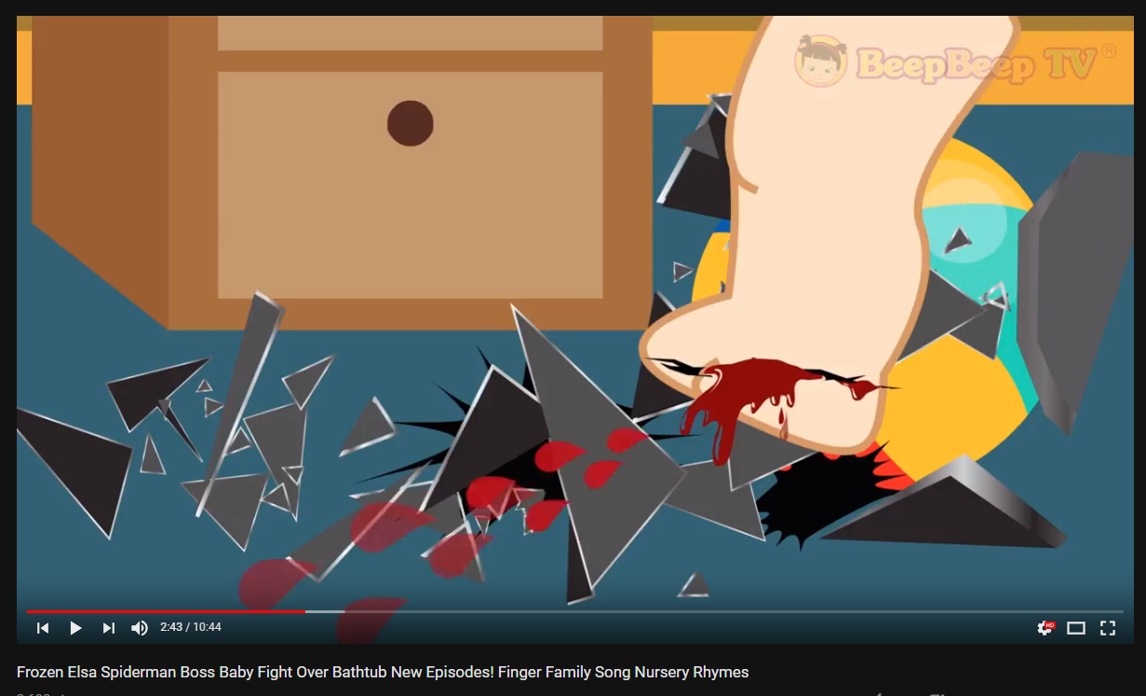
Sharma, Y. 2017

I would then have the following screenshots of the video on either side of the wall in the style of movie posters containing imagery of the characters in an innocent state. Both screencaps were taken either before or after something shocking or unsettling happened so the audience will then realise these videos are not pleasant at all to watch because unlike the young kids and toddlers that watched them, we are aware of what is being displayed in front of us and we understand that it is not okay or normal kid friendly content. The innocent family friendly vibe these screenshots give off will make the audience initially believe that this exhibition is for children but then when you actually sit down and watch the entire video it will contain more of a shock factor when the audience is exposed to the full video witnessing scenes such as The Joker from Batman poisoning other characters or Anna from Frozen being injected with a needle.

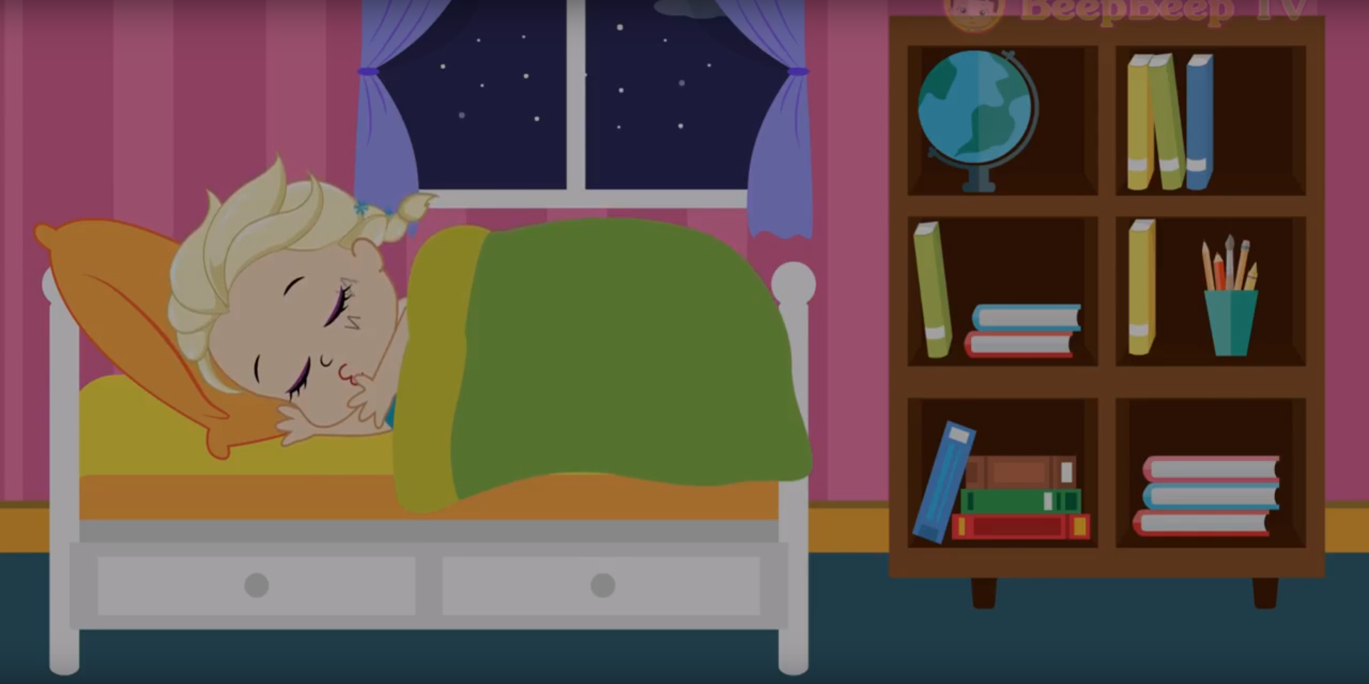
Sharma, Y. 2017
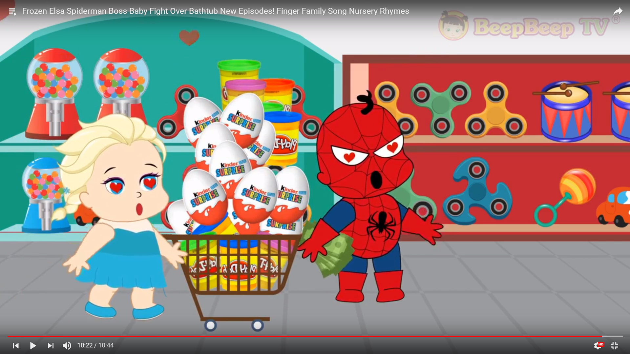
Sharma, Y. 2017

The theorist I have looked into in light of this event is L. Rowell Huesmann and his study on the impact of electronic media violence. This theory is useful to get a brief understanding on the possible impact the video and similar video would have on society and the younger generation if watched repeatedly and for a long period of time. Huesmann stated that since the 1960’s significant exposure to violence from media has led to the increased risk of violent behaviour from the person viewing and consuming this kind of media because they are growing up with the idea of violence being normalised and continuously being exposed to inappropriate media for their age. A quote from an online journal study of this theory titled The Impact of Electronic Media Violence by J Adolesc Health (2007 Dec) states:

‘’It is now not just kids in bad neighborhoods or with bad friends who are likely to be exposed to bad things when they go out on the street. A ‘virtual’ bad street is easily available to most youth now.’’

This directly relates to the Elsagate scandal, due to the amount of kids being exposed to the violent, disturbing content over a long period of time, a child might become unresponsive to that kind of situation later in life because they have grown up watching their loveable characters act that way to each other so might do nothing if exposed to such events in later life and think that it’s normal or they might even act upon the violence or antisocial behaviour themselves not knowing any better, in the theory I have studied this is known as mimicking where the subject imitates specific behaviours shown in the content they consume as stated by J Adolesc Health. In more recent studies, evidence has shown that this affects young people and children, they are more likely to mimic whom they observe, which goes for the content they consume.

According to Russell Brandom, writer for The Verge (2017), the techniques used in these videos are used by cult leaders or torturers due to the repetition of colours, sounds, words etc paired with shocking imagery such as Mickey Mouse chopping off the ear of Minnie Mouse. Unlike past generations where parents were in control of the content you consumed as a child and everything was given an official age restriction which was decided by humans and not A.I’s like they are on YouTube, kids are given free reign on hours and hours of Youtube content both positive and negative. What does this issue say about the future generation and the future of the way in which we consume content.

My exhibition theme is in the style of a cinema and will feature a seating area in front of a large projection which plays the elsagate video that I have chosen, on a loop, signifying the loop which the kids exposed to this content were watching them over and over again for hours. The exhibition will have an age restriction to highlight the inappropriateness of these videos and make it aware to the people who sit down to watch the fact that millions of toddlers and young kids were regularly exposed to this kind of content. This should instil a shock factor into my audience and make them seriously think about the direction the way in which we consume media is taking and what the younger generation is being exposed to. I believe my exhibition will highlight the importance of monitoring children's experiences online or make the audience question the development of the future generation growing up on this new parent called the internet. The main objective of my exhibit would be to make the viewers aware that the internet and virtual world is rapidly growing in a pace in which may not always be good due to the lack of control we have over it and the use of bots and A.I’s. It wouldn’t be surprising if a situation similar to elsagate happens again in the near future.

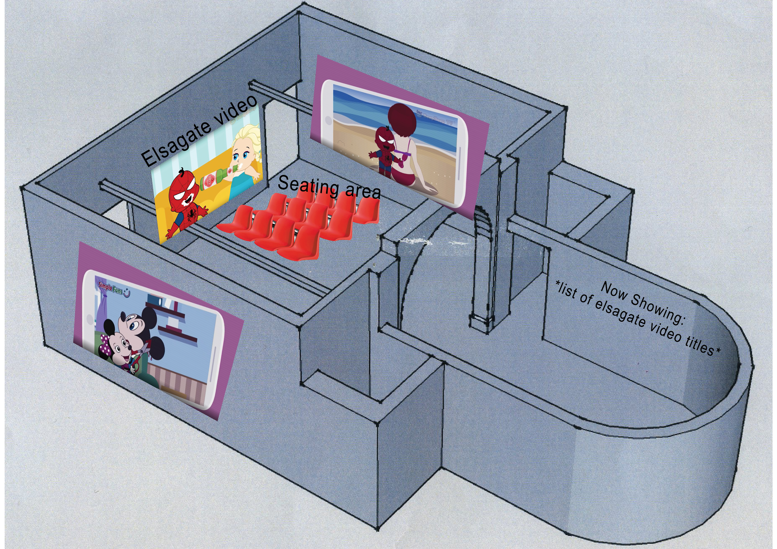

Bibliography

Sharma, Y. 2017. Frozen Elsa Spiderman Boss Baby Fight Over Bathtub New Episodes! Finger Family Song Nursery Rhymes. Youtube.com (online).

J Adolesc, H. 2007. The Impact of Electronic Media Violence: Scientific Theory and Research. www.ncbi.nlm.nih.gov (online).

Brandom, R. 2017. Inside Elsagate, the conspiracy-fueled war on creepy YouTube kids videos. The Verge (online).

Annotated List of References
Inside Elsagate, the conspiracy fueled war on creepy Youtube kids videos

BRANDOM, R. The Verge. (2017). Inside Elsagate, the conspiracy-fueled war on creepy YouTube kids videos (online).
https://www.theverge.com/2017/12/8/16751206/elsagate-youtube-kids-creepy-conspiracy-theory
- This source is not biased as it just gives a rundown of the situation and explains to the public general information about the elsagate and gives an overview on people's experiences and how dangerous and traumatising elsagate is to both children exposed to it and the parents.
- Though it could be favouring the audiences side and not delving too deep into youtubes side of the story.
- A quote from the article states “You have kids, maybe four years old, bombarded all day long in some cases, with these videos of chopping people’s fingers off and burning people and defecating on people.”

YouTube Kids, Startling Videos Slip Past Filters

MAHESHWARI, S. (2017). On YouTube Kids, Startling Videos Slip Past Filters (online). Nytimes.com.
https://www.nytimes.com/2017/11/04/business/media/youtube-kids-paw-patrol.html

- This source gives some statistics about elsagate and youtube and information about how the videos were able to get past youtube's guidelines and filters.
- I was able to find out basic information on how exactly kids were being exposed to these kind of videos.
- This article gave a more detailed description about what kind of content is featured in these videos.

Something is wrong on the internet

BRIDLE, J. Medium. (2017). Something is wrong on the internet (online).
https://medium.com/@jamesbridle/something-is-wrong-on-the-internet-c39c471271d2

- From this article I have gathered lots of statistical information about elsagate and comparisons to other Youtube channels. It gives a lot of information about channels on Youtube kids generating so many views and subscribers for content which probably doesn't deserve such attention.
- A quote from the article regarding a channel on Youtube kids states “since 2010 he seems to have accrued 3.7 million subscribers and just under 6 billion views for a kid-friendly channel entirely devoted to opening surprise eggs and unboxing toys.” making a point of how strange the kids section on Youtube happens to be even without the whole elsagate controversy.
- The article states most of the videos are being created, viewed and commented on by bots.
- The author provides examples of videos and channels which are part of the controversy.

What is Elsagate? – The disturbing videos masquerading as children’s favourites on YouTube Kids

Gelblum, B. (2017). What is Elsagate? – The disturbing videos masquerading as children’s favourites on YouTube Kids (online). The London Economic. https://www.thelondoneconomic.com/news/elsagate-disturbing-videos-masquerading-childrens-favourites-youtube-kids/11/11/

- This is an article published in 2017 and gives a large array of sources about everything you need to know about the controversy. Including links to other articles, people investigating the controversy and a list of everything the videos include, including a list of inappropriate and criminal behaviour which is encouraged in the videos.
- The article is unbiased and gives every side of the story, it’s also a source which gives a rundown of the controversy and why it has happened.
- This source gives a more technical approach to the topic such as how the videos get through and how they are being generated other than my previous sources which focused on the backlash it had on the kids and parents which is very helpful at looking into the other aspects of the issue.

YOUTUBE BRAINWASHING KIDS? #ElsaGate! - Dude Soup Podcast 151

FUNHAUS,. YouTube. (2017). YouTube BRAINWASHING KIDS? #ElsaGate! - Dude Soup Podcast 151 (online video).
https://youtu.be/MOIkxajexLQ

- This source is a Youtube video podcast from the channel Funhaus.
- While this may not be the most reliable source, I still found it incredibly useful. It was very interesting to hear what other people thought and felt about the situation, especially people who put time and effort into their content.
- They make a very interesting argument about the future of technology and about the generation which will be growing up on Youtube and being exposed to content created by bots.
- They also provided a large amount of very valid and researched information about the subject and provided the references for where they gathered their sources. I found this source both helpful and educating to listen to.

The Impact of Electronic Media Violence: Scientific Theory and Research

www.ncbi.nlm.nih.gov. (2007). The Impact of Electronic Media Violence: Scientific Theory and Research. online
https://www.ncbi.nlm.nih.gov/pmc/articles/PMC2704015/

- This is the source of the theorist I have chosen to study which relates to my topic of study.
- The source includes a study on the theorist L. Rowell Huesmann’s exploration of media violence.
- It contains many very relevant points and arguments both for and against the issue.

