PROJECT MANAGEMENT PLAN FOR THE REDEVELOPMENT OF A METROPOLITAN CENTRAL TRANSPORT HUB IN THE UNITED KINGDOM

TABLE OF CONTENTS
PART A: PROJECT PROPOSAL POSTER 3
PART B: CRITICAL REFLECTION ON FEEDBACK 5
1. Introduction 5
2. Key Strengths Identified 5
3. Areas for Improvement 5
4. Changes Made to Final PMP 6
5. Conclusion 6
PART C: PROJECT MANAGEMENT PLAN 7
1. Introduction 7
2. Project Description 7
2.1 Project Overview 7
2.2 Project Justification 8
2.3 Project Objectives 8
3. Project Scope 8
3.1 In-Scope Activities 8
3.2 Out-of-Scope Activities 9
3.3 Assumptions and Constraints 9
4. Work Breakdown Structure (WBS) 9
5. Quad Chart 10
6. Gantt Chart 11
7. Stakeholder Involvement 12
7.1 Stakeholder Identification 12
7.2 Stakeholder Power-Interest Matrix 13
8. Allocation of Resources 14
8.1 Human Resources 14
8.2 Financial Resources 15
8.3 Physical Resources 15
9. Risk Analysis 15
9.1 Risk Identification 15
9.2 Risk Assessment 16
9.3 Risk Response Strategies 16
9.4 Risk Monitoring 17
10. Conclusion 17
Reference List 18
Appendices 21
Appendix 1: Poster 21

PART A: PROJECT PROPOSAL POSTER
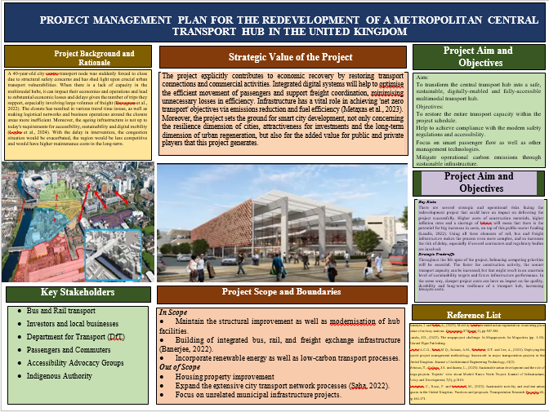

PART B: CRITICAL REFLECTION ON FEEDBACK

1. Introduction
This reflection reviews what feedback I got after presenting a Project Proposal poster on the redevelopment of a metropolitan transport centre. Feedback on the rationale, stakeholder analysis, scope definition, risk management and sustainability situations of the project was provided by both the tutor and peers. I apply Gibbs' Reflective Cycle to critically test the strengths I have isolated in my proposal and weigh up the issues I need to improve upon, along with how the feedback influenced changes to the final Project Management Plan (PMP).

2. Key Strengths Identified
The feedback I got about my project rationale was the most positive, that is to say, regarding how clear my rationale was, and how it related to the challenges of the scenario for the regeneration. The tutor emphasised that I had integrated the concept of infrastructure failure into the broader economic and social implications, showing strategic awareness in both technical aspects of redevelopment and in wider considerations. Feedback was also given that was positive about identifying stakeholders, as I was aware of who the interests of the transport operators, local businesses, environmental agencies and community groups were. Furthermore, the goals of my project were seen as achievable and fitting to the prioritisation of safety, accessibility, sustainability and digital transformation.
The critical component of this feedback was the objective demonstration of a successful project proposal that investment is required and why, and how value will be added to various stakeholder groups. I learned that if the solutions are aligned and the project is credible, this is a major way to build some stakeholder confidence in the solutions at a later time.

3. Areas for Improvement
I picked up some good suggestions on a few areas in need of improvement. The tutor observed that the need for a more clearly defined project scope would help differentiate between project deliverables and those outside of a project's scope. The risk analysis was also found at a general level without assessing the risk probability, impact and mitigation measures. In addition, peers indicated a need for resource allocation to be more transparent, to show how specialist staff and resources would be used. Another practice that was identified as in need of reinforcement was the sustainability strategy, where a stronger case needed to be made and measurable outcomes needed to be demonstrated.

4. Changes Made to Final PMP
I have made an effort to answer all of the feedback by adding to the WBS to enhance project control and task clarity. To enhance engagement planning and communication strategies, I created a stakeholder power-interest matrix. A comprehensive risk register, with probabilities, impacts, and risk mitigations, was added to the risk management section. Key human, financial and physical resources were identified to clarify the availability of resources for allocation. I also reinforced the sustainability strategy by incorporating the features related to low-carbon infrastructure and renewables in both branches.

5. Conclusion
Feedback was an important consideration and also had an absolutely beneficial influence on enhancing my final PMP. In the post-reflection, I found strengths and weaknesses, and centred on improvements and prepared a new all-embracing and practical project plan. During this experience, he learned the practical lesson of continuous improvement and feedback from the stakeholders in project management.

PART C: PROJECT MANAGEMENT PLAN

1. Introduction
A complete breakdown of one of the main transport hubs of a major city in a country in the UK following a structural safety health check has uncovered significant weaknesses in the current transport infrastructure. The hub is an important intermodal freight and passenger transport connection that facilitates rail transit, bus service and freight transportation, and is a critical link for commuter service and an effective supply chain, while enabling opportunities for regional economic development (Solihull, 2018). Its closure has caused far-reaching devastation, causing travel delays, affecting logistics performance and also having a negative impact on local businesses that have a reliance on transport connectivity and passenger flows. Local governments have, in turn, initiated a fast regeneration program, prioritising the reconnection of the city, the improvement of its mobility, but also its needs for safety, accessibility, digital connectivity and environmental sustainability. This Project Management Plan (PMP) is therefore a general plan for the redevelopment of the central transport hub (Nowoczyn and Specht, 2025). It defines and maps out the remit, WBS of the project, its stakeholder engagement approach, resource allocation and project timetables and processes/risk management processes, which will enable the successful delivery of the project in the long-term framework of its urban regeneration.

2. Project Description

2.1 Project Overview
The proposed project will be the redevelopment of a closed Central Transport Hub (CTH) in a metropolitan area in its entirety because it is structurally unsafe. The redevelopment is in the process of updating the long-dated facility to become a modern multimodal interchange with the capacity to manage rail, bus and freight interchange (Mntungwa, 2025). The main results are the installation of the modern transport infrastructure, the installation of intelligent management systems of passenger flow, the introduction of digital logistics management platforms, the improvement of the accessibility of the transport system in line with current legislation, and the introduction of environmental solutions using low-carbon infrastructure. The project aims to achieve a better service provision and long-term transport resilience in addition to restoring operational conditions.

2.2 Project Justification
This is because the project is essential for the safety requirements of the deteriorating infrastructure, which, without intervention, will not meet today's engineering and regulatory standards. In addition, many older transport facilities do not accommodate the safe and easy entry of persons with reduced mobility and/or disabilities (Lin et al., 2022). The economic impact of the continuation of transport disruption on the commuters' productivity, the limitation of freight efficiency, and the impact on local businesses is negative. The redevelopment also aligns with the national efforts to reach sustainable goals, which include energy-efficient technology, less use of transportation vehicles that emit pollution, and more elements that promote a more widely implemented transition to a carbon-neutral economy. So it is an essential investment, as well as a strategic economic intervention for regeneration.

2.3 Project Objectives
- Restore 100% operation of transport hubs within 36 months of project start;
- Ensure 100% compliance with UK safety and accessibility laws in advance of commissioning.
- By project completion, use electronic passenger/freight control systems.
- Cut down at least by 30% on operational carbon emissions from the current facility.
- Expand transport capacity and increase operational efficiency within the first year of operation.

3. Project Scope

3.1 In-Scope Activities
The activities covered in this project include those that are directly imperative to the redevelopment and operation of the central transport hub. Construction of infrastructure: Utilisation and development of modern rail, bus and freight interchange facilities to enhance the capacity of infrastructure and enhance the efficiency of passenger transportation (Niezabitowski, 2024). The project additionally involves the deployment of smart transport technologies, like real-time information systems for passengers, digital ticketing systems, and logistics coordination systems for data-driven transport management. Measures include step-free access, guidance available for people with sight difficulties (tactile), passenger facilities which are accessible, as well as lifts, so that the building meets current accessibility legislation (Reconfiguration, 2026). Moreover, the integration of green energy is a key feature of the project, with the installation of renewable energy sources, energy-efficient lighting, and environmentally friendly building materials to meet environmental performance goals.

3.2 Out-of-Scope Activities
Many activities are not included in the project scope because they are unnecessary to avoid scope creep and defocusing the project. These involve extra urban integration of the transport network beyond the boundary of the transport hub, residential property developments and commercial property staging works (Eze, 2025). These developments could support wider urban development aims, but do not directly support the primary transport hub restoration and modernisation objective, so are not project-led.

3.3 Assumptions and Constraints
It is assumed that adequate funding for the project comes from the public sector throughout the project's life cycle and that qualified contractors, engineers, and technology suppliers will be available within the project's planned procurement schedules (Ang et al., 2022). Project delivery, however, is limited by budgets set to be finite, the adoption of rigorous health, safety, accessibility and environmental guidelines, as well as the high expectations already placed on project time due to the ever-present nature of economic disruptions flowing from the hub closure.

4. Work Breakdown Structure (WBS)
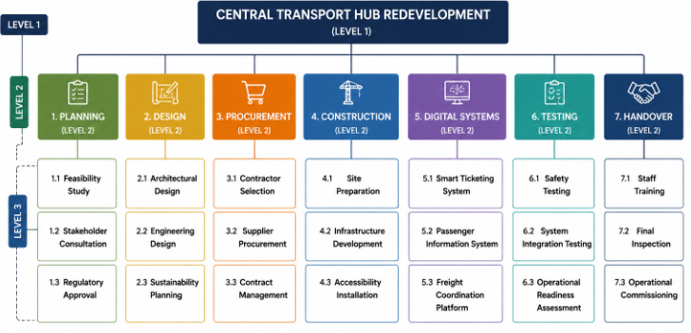
Figure 1: WBS
(Source: self-created)
In Level 1, the WBS defines the top-level project goal, the redevelopment of the transport hub. The project has been broken down into seven major deliverable-oriented phases, namely, Planning, Design, Procurement, Construction, Digital systems, testing and Handover, in Level 2. This hierarchical breakdown captures and aligns all of the critical project activities with strategic goals.
At Level 3, each phase is subdivided into a series of work packages, which provide increased clarity on responsibilities, resources and deliverables associated with each phase (Gil and Vallejo 2024). The Planning phase, for instance, features all feasibility studies, consultation with stakeholders and obtaining regulatory approvals, and the Digital Systems phase features smart ticketing, passenger information systems and freight coordination platforms. This structure shows the natural steps in a project's initiation, development and commissioning as an operational structure.
From a project management point of view, the WBS is an essential element of a tool for controlling projects, because it narrows the scope ambiguity and makes it more accountable. Clear tasks make the estimation of costs, times, resources and risks easier (Ngharamike et al., 2022). Moreover, the hierarchy enables the performance monitoring at the project level since the ability of the project manager to monitor the progress of individual work packages can enhance the overall project delivery effectiveness with improved performance monitoring.

5. Quad Chart
The Quad Chart offers a snapshot of the key areas for review in case the project could be a threat or opportunity to the project. When determining feasibility, the Quad Chart gives stakeholders a strategic overview of the project that can be used to check how well the project fits with the organisation's goals and objectives. The transport recovery, sustainability, and economic regeneration objectives are measured in terms of outcomes in the quadrant that communicates with the objectives (Sartzetaki et al., 2023). A schedule quadrant is used to highlight both key milestones and to serve as a general metric for tracking progress towards both targets and deliverables. The cost quadrant emphasises the financial commitment needed in order to realise the project value from the services to be delivered, with respect to budgetary control and justifying investments. Also, at the end, the technical performance quadrant is a description of the quality, sustainability, and operational benchmarks on which the project's success will be measured (Karagkouni et al., 2023). The Quad Chart improves project governance, communications with stakeholders, and project oversight across the project spectrum by consolidating scope, schedule, cost and performance criteria within a single management tool.
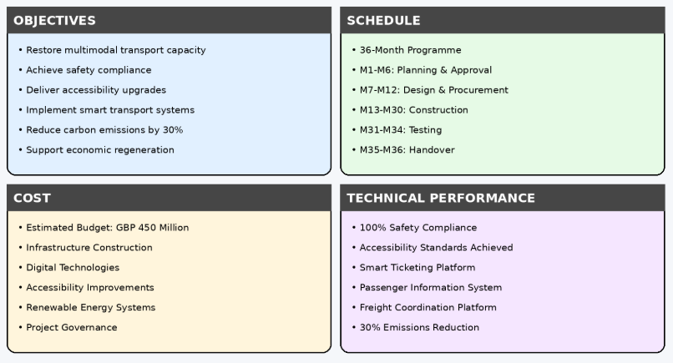
Figure 2: Quad Chart
(Source: self-created)

6. Gantt Chart
This 36-month timeline for the delivery of the transport hub redevelopment project is outlined in the Gantt Chart. The schedule shows the ordered sequence of activities, from initiation to project completion, and allows for the optimal coordination of project resources and project deliverables. The Planning, Design, Procurement, Construction, Testing & Commissioning activities are the main elements of the critical path; if these activities are delayed in any manner, it will affect the overall completion time. Key milestones are critical points with measurable quantities to track progress and to assess project results relative to its goals. In addition, the chart can help in the scheduling of work activities by providing an early indication of any delays if they occur, while identifying any activities which are dependent on each other. The Gantt Chart provides an effective way to achieve project governance, better communication between stakeholders, and increase the probability of successful completion of the redevelopment programme within budget, time and quality.
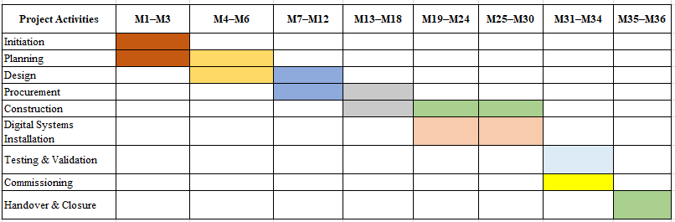
Figure 3: Gantt chart
(Source: self-created)

7. Stakeholder Involvement

7.1 Stakeholder Identification
Large-scale transport infrastructure works projects are frequently striving for multiple objectives of service continuity, environmental performance, costs and schedule, and have competing interests amongst stakeholders, which are the things that create challenges in large-scale transport infrastructure works (Ahmed et al., 2026). External stakeholders include local authorities, the Department for Transport, rail and bus transport providers, freight companies, environmental regulators, local businesses and communities. Misaligned stakeholder expectations can lead to delays, etc. Issues, public resistance, and cost overruns. Therefore, there needs to be a well-planned (structured) approach to engaging stakeholders to keep the project going, enhance communication and provide information for the successful decision-making process during the project's lifecycle.
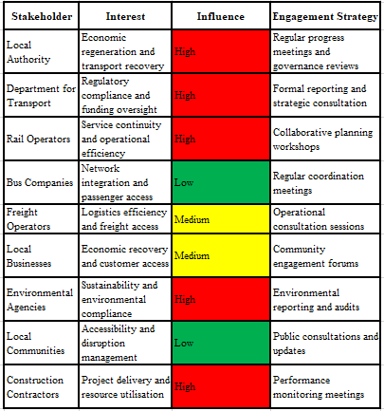
Figure 4: Stakeholder Identification table
(Source: self-created)

7.2 Stakeholder Power-Interest Matrix
The Power-Interest Matrix can be used to help prioritise stakeholder engagement by assigning resources based on stakeholder influence on the project and interest. Stakeholders in the "Manage Closely" category need to be continuously engaged given their decision-making authority, which will directly impact project delivery (Li et al., 2022). When a person is classified as known as ‘Keep Satisfied', they will need specific engagement to reduce the risk of resistance building up from either environmental or operational concerns (Verma et al., 2024). Communication is required to be transparent for stakeholders in the Keep Informed category to retain trust and minimise opposition. Lastly, stakeholders classified as "Monitor" will need to be monitored to detect a topic of concern at an early stage, prior to becoming a project risk. This approach to governance is structured, helps mitigate conflict among stakeholders, and increases the chance of project success.
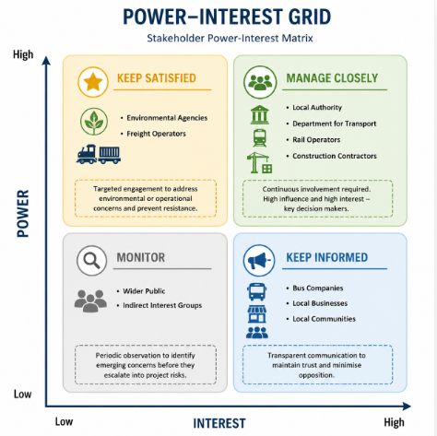
Figure 5: Power-Interest Grid Matrix
(Source: self-created)

8. Allocation of Resources

8.1 Human Resources
The ability to manage the inter-disciplinary nature of the infrastructure would be a key success factor for the overall project in relation to the delivery of the transport hub development. The Project Manager's responsibility is to govern the project, coordinate stakeholders, control the schedule and manage risks (Son et al., 2025). Civil engineers, structural engineers, and transport engineers deliver technical specialist services for the design and construction of the infrastructure, and architects deliver technical specialist services so that operational efficiency, accessibility and sustainability-related requirements will be catered for in the design of the infrastructure. Construction companies carry out works on the construction site, such as site preparation, building facilities, and installation of various equipment. Additionally, IT experts are essential for the deployment of technologies for smart transport systems, digital ticketing systems, platforms for passenger information, and freight coordination systems (Son et al., 2026). Close cooperation between these professionals is crucial to avoid delays, to make better decisions and to achieve project aims.

8.2 Financial Resources
An estimated £450m in funding has been set aside for the project. An overwhelming amount of money goes into infrastructure because of both the size and complexity of developments that fall under Redevelopment. Other funding goes towards digital technology, accessibility initiatives, renewable energy solutions, procurement and project management (Nwaogbe et al., 2025). To keep costs under control and reduce the chances of cost overruns due to inflation, fluctuating supplier availability and unexpected construction problems, continuous budget monitoring is necessary.

8.3 Physical Resources
Heavy construction equipment and machinery for excavation, cranes, transport infrastructure materials, steel frameworks, concrete components, and renewable energy technologies are key physical resources, as well as system hardware for digital systems (Chen et al., 2024). But in order to meet operational and sustainability goals, the use of advanced technology systems, including intelligent ticketing systems, passenger information systems, freight management systems, etc., is essential.

9. Risk Analysis

9.1 Risk Identification
Risk management is highly important in the success of large projects as they are so complex, have extended delivery dates and involve many stakeholders. There are several strategic and operational risks that exist for the transport hub redevelopment project that could have an impact on its performance (Reddy et al., 2024). Adverse weather conditions or contractor issues could cause construction projects to be stalled, labour shortages leading to lower productivity for the project, smart transport integration risks from technical or regulatory-related problems in Smart Transport, Environmental compliance issues and potential penalties from too much inflation and increasing material costs.

9.2 Risk Assessment
This risk assesment also helps to highlight primary risks, maintain budget as well as construction delays to give more direct impact to maintain projects objectives. Therefore, these risks necessitate time and resources for continuous risk management attention.
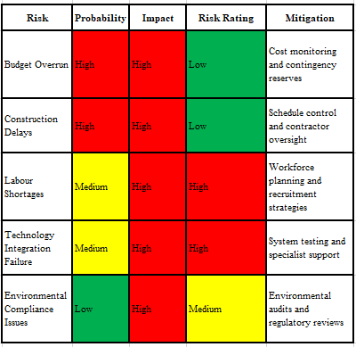
Figure 6: Risk Register
(Source: self-created)

9.3 Risk Response Strategies
Measures have been taken to respond to risks identified. Examples of avoidance strategies are projects with a thorough feasibility study and regulatory evaluation during the planning stage. Mitigation measures include detailed scheduling, contingency budgeting, workforce planning and phased technology testing to contain the risk level and likelihood of the impact (Ragab and Orhan, 2024). Transfer strategies are contractual arrangements, insurance and performance-based procurement arrangements where certain risks are transferred to suppliers and contractors. Contingency reserves and monitoring arrangements are used to provide for low-probability risks where mitigation costs are greater than the risks and consequences.

9.4 Risk Monitoring
It is necessary to monitor them over the entire project lifecycle to be able to control the risk effectively. Emerging threats and the effectiveness of measures to reduce the threat will be reviewed at monthly risk review meetings. Risk status reporting through a formal process will be made to the project board and key stakeholders (Mashaliet al., 2023). A governance framework for the project will be established and will include the Project Manager, risk owners, contractors and local authority representatives, ensuring that the project will be accountable, issues will be escalated promptly and effectively, and decision-making is informed.

10. Conclusion
The redevelopment of the central transport hub is necessary to address critical deficiencies in transport infrastructure, which have created a disruption in transport services, transport-related freight handling and economic activity in the area. This project management Plan has involved the use of useful project management tools such as the Work Breakdown Structure (WBS), Quad Chart, Gantt chart, Stakeholder Power-Interest Matrix, Resource Allocation Matrix and Risk Register for structured project delivery, and effective decision making has been supported. The legislator believes the project will offer high value to the commuter, transport provider, businesses and regulatory bodies for reasons beyond just safety, accessibility and operational efficiency benefits, including sustainability. Strategically, redevelopment enables urban regeneration and economic recovery to support sustainable transport for a smart city and to achieve the net-zero transport objective. The project is very well founded in terms of achieving the desired outcomes effectively: having involved stakeholders, managed risks and engaged in good governance; and will benefit the wider community for the long-term.

Reference List
Adhi, A.B. and Muslim, F., (2023). Development of stakeholder engagement strategies to improve sustainable construction implementation based on lean construction principles in Indonesia. Sustainability, 15(7), p.6053.
Ahmed, M.A., Saeed, M.M., Ibrahim, Y.A., Abas, M.M., Idris, E.A. and Mohammed, R.H., (2026). Design of a Real-Time Public Transport Fleet Management Autonomous System for Smart City Transportation Markets. In Intelligent Transformative Technologies (pp. 59-94). Cham: Springer Nature Switzerland.
Ali, F. and Haapasalo, H., (2023). Development levels of stakeholder relationships in collaborative projects: challenges and preconditions. International Journal of Managing Projects in Business, 16(8), pp.58-76.
Ang, K.L.M., Seng, J.K.P., Ngharamike, E. and Ijemaru, G.K., (2022). Emerging technologies for smart cities’ transportation: geo-information, data analytics and machine learning approaches. ISPRS International Journal of Geo-Information, 11(2), p.85.
Banerjee, I. and Saha, A., (2022). Mobility centre-oriented urban regeneration: examining place value of railway stations. Geojournal, 87(Suppl 4), pp.567-581.
Chen, L., Hu, Y., Wang, R., Li, X., Chen, Z., Hua, J., Osman, A.I., Farghali, M., Huang, L., Li, J. and Dong, L., (2024). Green building practices to integrate renewable energy in the construction sector: a review. Environmental Chemistry Letters, 22(2), pp.751-784.
El Jallad, A.Y., Alozn, M., Ahmed, V. and Alzaatreh, A., (2026). A data-driven framework for measuring multimodal transport success in smart cities: the case of Dubai. Scientific Reports.
Eze, C.C., (2025). Integration of AI-Driven Multimodal Transport Systems for Optimizing Real-Time Urban and Intercity Mobility Solutions. Int. J. of Research Pub. and Reviews.
Gil, E.M. and Vallejo, A.C., (2024). Account based ticketing (ABT) integration for seamless multi-modal transport systems in smart cities. Smart Cities and Regional Development (SCRD) Journal, 8(2), pp.73-80.
Landis, J.D., (2022). The megaproject challenge. In Megaprojects for Megacities (pp. 1-39). Edward Elgar Publishing.
Leyba, A.C.G., Rana, M.Q., Salazar, A.M., Oladinrin, O.T. and Lee, A., (2024). Deploying the hybrid project management methodology framework in major transportation projects in the United Kingdom. Journal of Architectural Engineering Technology, 13(2).
Li, Y., Li, M., Sang, P., Chen, P.H. and Li, C., (2022). Stakeholder studies of green buildings: A literature review. Journal of Building Engineering, 54, p.104667.
Lin, D., Broere, W. and Cui, J., (2022). Underground space utilisation and new town development: Experiences, lessons and implications. Tunnelling and underground space technology, 119, p.104204.
Ma, W. and Hao, J.L., (2024). Enhancing a circular economy for construction and demolition waste management in China: A stakeholder engagement and key strategy approach. Journal of cleaner production, 450, p.141763.
Mashali, A., Elbeltagi, E., Motawa, I. and Elshikh, M., (2023). Stakeholder management challenges in mega construction projects: critical success factors. Journal of engineering, design and technology, 21(2), pp.358-375.
Metaxas, T., Gallego, J.S. and Juarez, L., (2023). Sustainable urban development and the role of mega-projects: Experts’ view about Madrid Nuevo Norte Project. Journal of Infrastructure, Policy and Development, 7(2), p.2161.
Mntungwa, P.R., (2025). Public transport network improvements as a catalyst for integrated land use-transport development: lessons from case studies of Copenhagen, Curitiba, Hong Kong and Seoul.
Munaro, M.R. and Tavares, S.F., (2023). A review on barriers, drivers, and stakeholders towards the circular economy: The construction sector perspective. Cleaner and Responsible Consumption, 8, p.100107.
Niezabitowski, M., (2024). The use of space-its harmony and disturbances. Case studies of three chosen places. Zeszyty Naukowe. Organizacja i Zarządzanie/Politechnika Śląska.
Nowoczyn, T. and Specht, M., (2025). Central transport hub: Analysis of ground and airspace environments. Advances in Science and Technology. Research Journal, 19(9), pp.171-188.
Nwaogbe, G., Urhoghide, O., Ekpenyong, E. and Emmanuel, A., (2025). Green construction practices: Aligning environmental sustainability with project efficiency. International Journal of Science and Research Archive, 14(1), pp.189-201.
Ragab, K.M. and Orhan, M.F., (2024). Evaluating conventional and renewable energy systems for green buildings: A case study on energy efficiency and cost optimization. Case studies in thermal engineering, 63, p.105233.
Ragab, K.M. and Orhan, Solihull, (2018), THE UK CENTRAL HUB Growth and Infrastructure Plan. [Online] Available at: https://www.solihull.gov.uk/sites/default/files/2020-12/Hub-Growth-and-Infrastructure-Plan-2018.pdf [Accessed on: 14th June 2026]
Ravagnan, C., Rossi, F. and Amiriaref, M., (2022). Sustainable mobility and resilient urban spaces in the United Kingdom. Practices and proposals. Transportation Research Procedia, 60, pp.164-171.
Reconfiguration, R.A.I., (2026). Review of Environmental Factors. Health, 2.
Reddy, V.J., Hariram, N.P., Ghazali, M.F. and Kumarasamy, S., (2024). Pathway to sustainability: An overview of renewable energy integration in building systems. Sustainability, 16(2), p.638.
Sartzetaki, M., Karagkouni, A. and Dimitriou, D., (2023). A conceptual framework for developing intelligent services (a platform) for transport enterprises: The designation of key drivers for action. Electronics, 12(22), p.4690.
Son, H., Jang, J., Park, J., Balog, A., Ballantyne, P., Kwon, H.R., Singleton, A. and Hwang, J., (2025). Leveraging advanced technologies for (smart) transportation planning: A systematic review. Sustainability, 17(5), p.2245.
Tampio, K.P., Haapasalo, H. and Ali, F., (2022). Stakeholder analysis and landscape in a hospital project–elements and implications for value creation. International Journal of Managing Projects in Business, 15(8), pp.48-76.
Transportforthenorth, (2023), Strategic Transport Plan Draft for consultation May 2023. [Online] Available at: https://transportforthenorth.com/wp-content/uploads/TFN_StrategicTransportPlan_Master_web_V3.pdf [Accessed on: 14th June 2026]
Verma, S.K., Verma, R., Singh, B.K. and Sinha, R.S., (2024). Management of intelligent transportation systems and advanced technology. In Intelligent transportation system and advanced technology (pp. 159-175). Singapore: Springer Nature Singapore.
Węgrzyn, J. and Wojewnik-Filipkowska, A., (2022). Stakeholder analysis and their attitude towards PPP success. Sustainability, 14(3), p.1570.

