I confirm that I have not used any AI tools in the research and creation of this assignment. I confirm that I have not presented any AI generated materials as my own work. I confirm I have copies of my drafts, notes, and other resources I used, which I may be asked to provide in evidence.

Louise Labbett

Student number: 2215831

Voluntary Placement Reflection Portfolio




Contents Page

- Reflective commentary
- Reflective commentary references
- Additional placement evidence:
- Photographic evidence
- Session observation notes
- School vision and mission statement
- References
- Appendix

Reflective commentary on placement during Thrive and Therapeutic play sessions at Morriston Primary School.

Morriston Primary School ensures all learners, particularly the most vulnerable learners, have their needs met through therapeutic play, Elsa, and Thrive strategies and approaches, while learners can support emotional regulation by calling on strategies in place. A whole school PACE (Playfulness, Acceptance, Curiosity and Empathy) approach is used by staff which leads to improved well-being for all. Thrive assessments are completed, with pupils having access to Thrive strategies, such as individual and group action plans and general classroom strategies such as quiet areas and check in sessions. A Trauma informed TA provides additional well-being sessions where the need is identified and required, including therapeutic play. (Morriston Primary School Development Plan 24-27). It is in this area that I volunteered on my placement with the practitioner I shall refer to as ‘L’ who is also the Trauma informed TA in the school.
In my first placement session, ‘L’ introduced me to some of the well-being approaches adopted by the school. Firstly, the Thrive approach is embraced by the whole school, where all staff have basic training with teachers identifying the children in their class who would benefit from smaller sessions with ‘L’. The children participate in these sessions, either 1:1 or with a friend in the afternoons on a weekly basis. Activities are based on developmental stages and changed each session. The Thrive motto is “let’s help every child thrive”, with the aim of helping children develop their social and emotional skills through the six stages of being, thinking, power and identity, skills, and structure. Another approach ‘L’ uses is therapeutic play, with the sessions looking very similar to Thrive but is about playing with a child on their level rather than just making observations, or parallel playing, as many of the children who attend struggle with authority. ‘L’ advised me that a good icebreaker to use is an open question such as “would you rather...?”, giving the child the feeling of control over the play sessions. As the BACP website informs us, play therapy uses play as a way of helping individuals understand and express their thoughts and feelings. It is used with children who may not be able to say in words how they are feeling, helping them to communicate at their own level using everyday play items. This approach helps them to develop and build on relationships and learn to cope with what they are experiencing.
I found the placement varied greatly from session to session. Having previously worked in the school for 13 years, finishing in 2023, I was very familiar with the setting, which I feel made the experience easier for me than if I was completely new to it. Many of the children remembered me from working there and therefore had no problem accepting my presence. Many of them warmly welcomed me, enquiring where I had been and why I had left. I was quite surprised by this and found it quite touching. My time as a TA there was in a unit with ASD children, and I had not worked in the mainstream for 12 years, so they had only known me from play time in the yard. The sessions with these children were really rewarding, with the fact that they felt comfortable enough with me to share their thoughts during the activities. However, this was not the case with all the children. They were all there for various reasons, all with different needs and problems. Some had issues with authority, others with trust, and I immediately realised that I would only engage with the sessions when appropriate and always following the child’s lead. It took time for some children to feel comfortable enough to invite me to play or to include me in the activities. While accepting this, a part of me worried I was intruding on their safe space, though most of the time I was soon accepted and drawn into the play sessions by the children. However, not every session was positive. On one occasion, I found myself feeling slightly uncomfortable during a session. Even though I had never met the child, I had a feeling that they might not be acting naturally, that they were putting on a performance because I was there. The child also kept looking for any reaction from me while displaying challenging behaviour, at times being quite rude and disrespectful to ‘L’. Throughout, ‘L’s demeanour did not change, remaining calm and always focussed on the child. Initially, I struggled to understand why ‘L’ was accepting the behaviour, then realised this was not the case, ‘L’ was just not reacting to it. After the session was over, I asked ‘L’ if the child had been behaving differently, and she confirmed they had been much more challenging than usual. We both concluded it was almost certainly because of my presence in the room, deciding that I would not attend any more of the child’s sessions as it could be detrimental to their progress. I felt guilty for being the cause of distraction in a play session of a child who had been benefitting from 1:1 sessions with an adult thy had built up trust with, I felt worried I had ruined her valued time there. ‘L’ informed me that the child’s reaction was unexpected, if I found myself in a similar situation, I would better recognise the signs, trust my judgement, and make an excuse to remove myself from the room sooner.
During the sessions where it was inappropriate for me to be involved, I sat quietly and took notes and minutes of some of the conversation, observing how ‘L’ engaged with the children, with my observation notes being presented as evidence. I was impressed by her approach, her congruence, patience, and how calm and positive she consistently remained, even in more challenging situations. With most of the children, ‘L’ had built up rapport and trust, and it was clear they felt it was a safe place for them where they could calm, relax, play, and talk.

Reflection commentary references

BACP: Therapeutic play. https://www.bacp.co.uk/about-therapy/types-of-therapy/play-therapy/
Morriston Primary School: School Development Plan. https://www.morristonprimaryschool.co.uk/policies-and-documentspolisiau-a-dogfennau/
The University of Edinburgh: The Gibbs Reflective Cycle. https://reflection.ed.ac.uk/reflectors-toolkit/reflecting-on-experience/gibbs-reflective-cycle

Additional evidence #1:
Photographic evidence
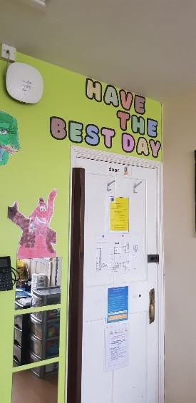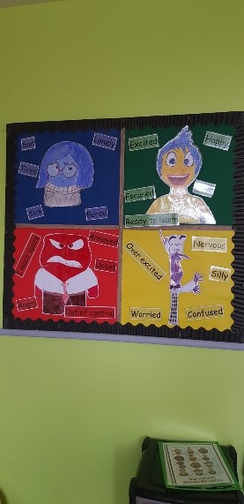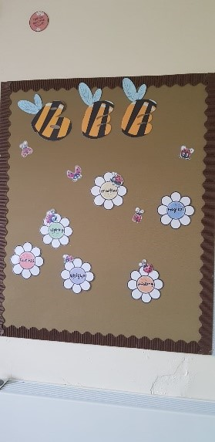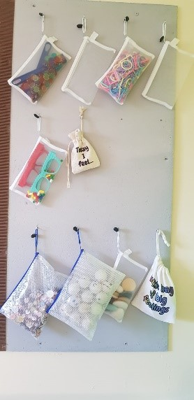
The Thrive room is decorated in bright, cheerful colours with positive messages decorating its walls to help the children feel safe during their time spent inside.

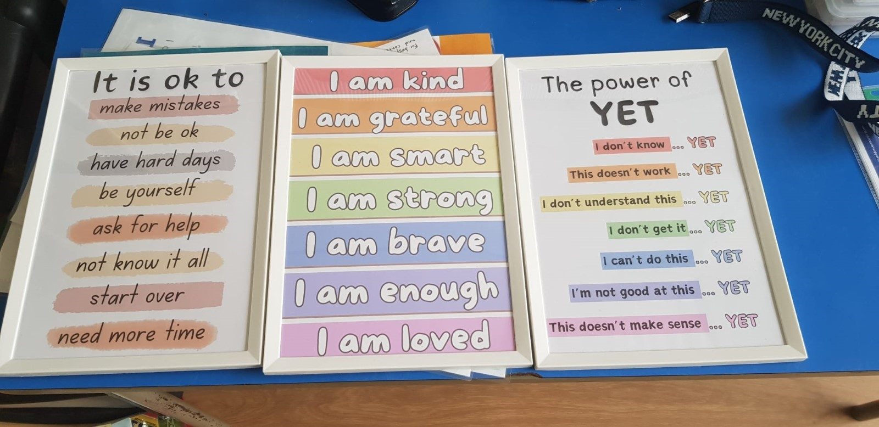 | Positive and encouraging quotes and messages have been framed and hung on the walls to help the children feel supported in their thoughts and feelings around whatever they are experiencing.

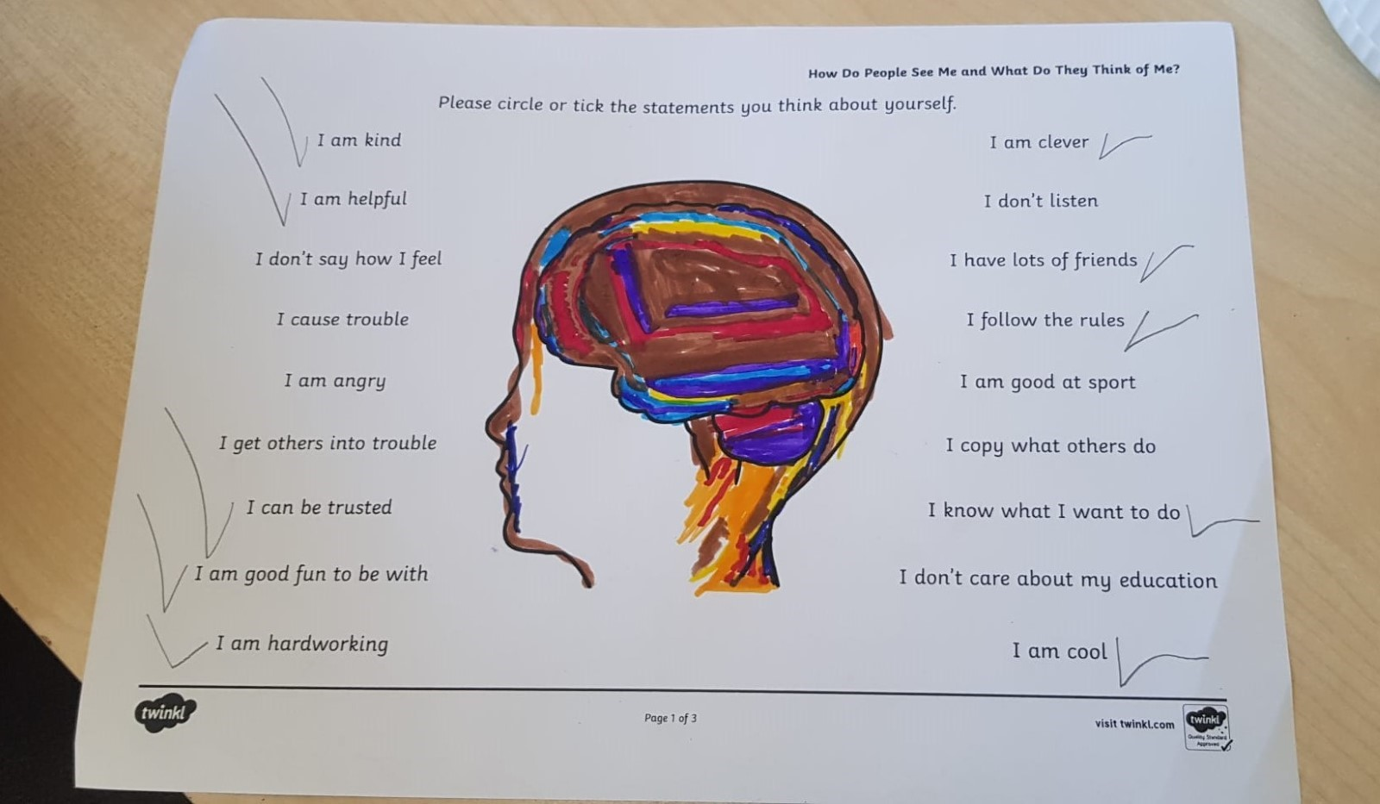 | An activity aimed at building self-esteem. The child is engaged in conversation and encouraged to tick each statement they feel about themselves. Then they can colour in the brain picture with colours to show how they are feeling.

A couple of examples of the types of activities available to use during sessions.
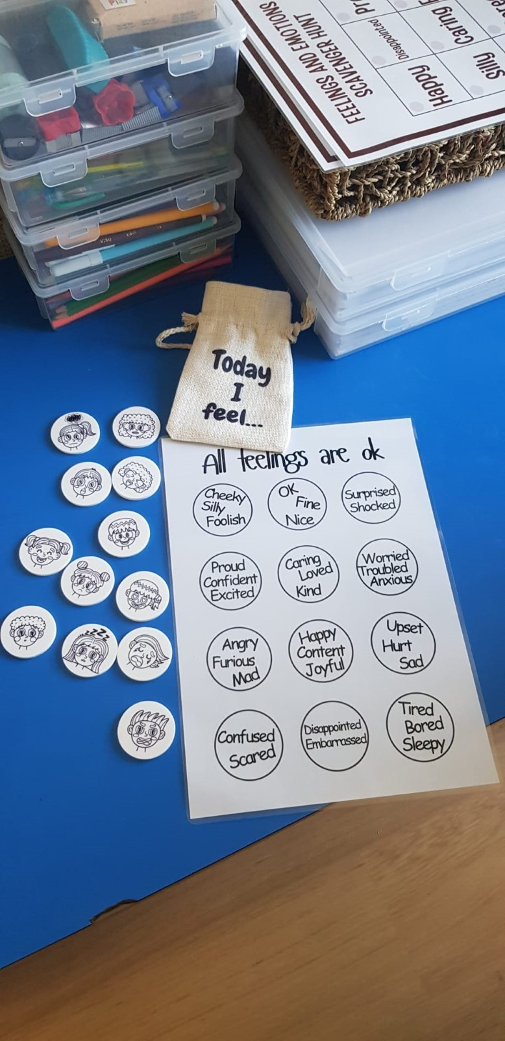 | Activity: "All feelings are ok".  The discs have no words for feelings to allow a child to decipher for themselves what emotion they think the faces are displaying.  The discs are acrylic so can be used in sand or water for a child who likes sensory play.

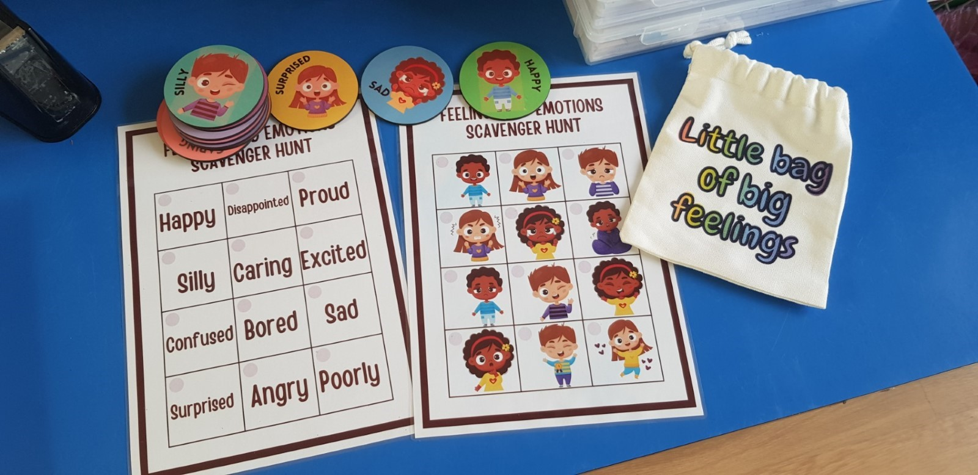 | Activity: "Your feelings".  Match faces to the feelings. Helps with recognising emotions in other people. This also fits in with the Restorative Practice approach of the school.

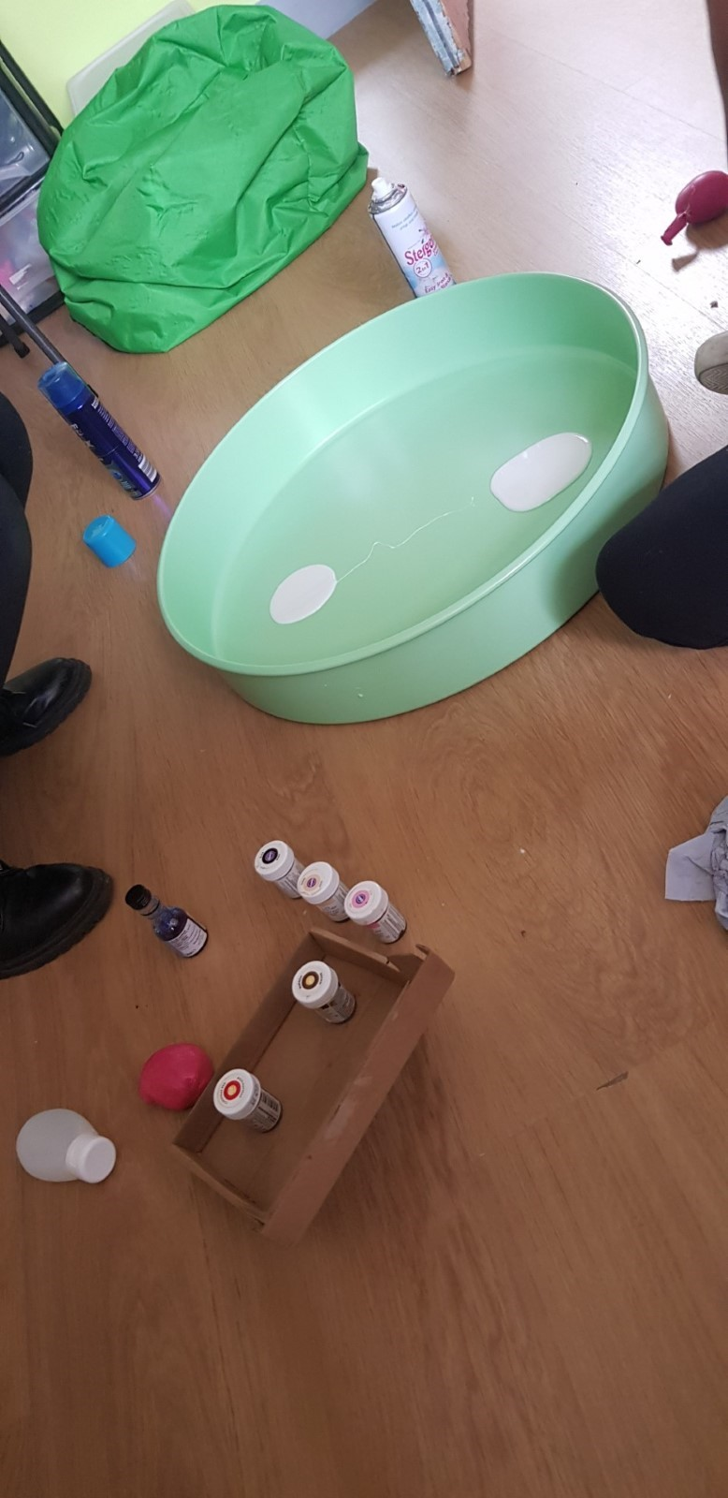 | 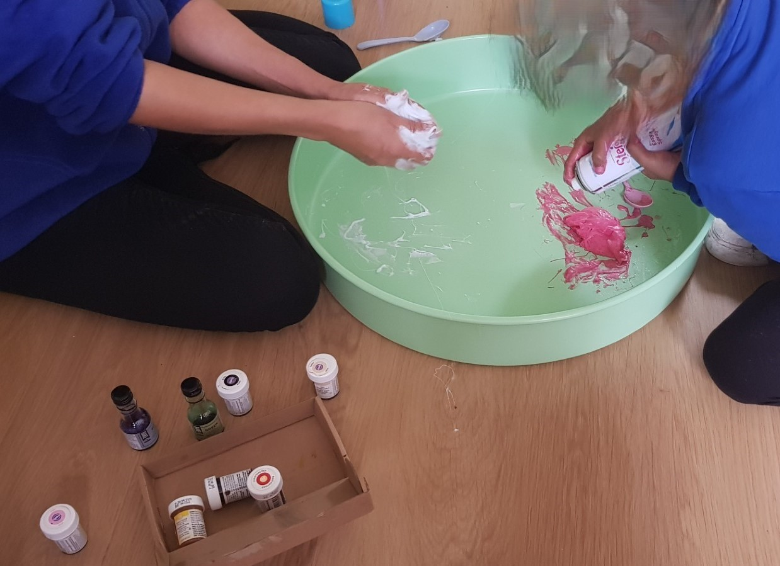 | 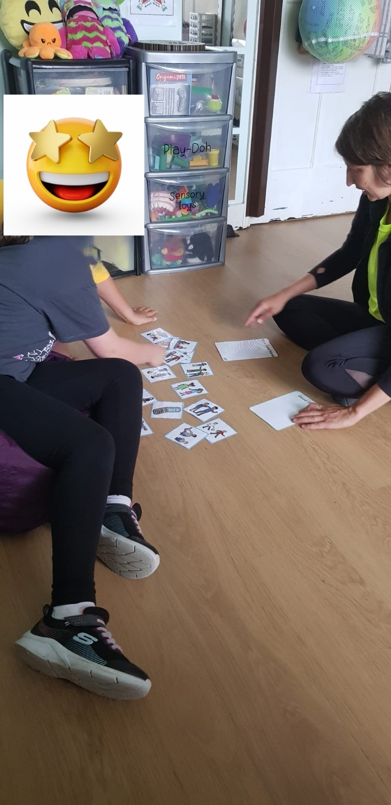

Additional evidence #2:
Session observation notes
My role during the following sessions was that of an observer only and not involved in any counselling position.

09/07/24 - Therapeutic Play session.
Preparation: The room was filled with balloons prior to the child’s arrival to see their reaction.
The point of the balloons and letting child ‘A’ pop them was to let him direct an activity that they wouldn’t ordinarily be allowed to do, creating a memorable and positive experience.
- Initially, child A was happy to see the balloons. One popped, then immediately A tried to find a way to pop the rest. Once all gone, ‘A’ asked for more to be blown up, which ‘L’ did.
- While the balloons were being blown up, ‘A’ got distracted by a ‘lemonade stand’ in the role play corner.
- ‘A’ asked ‘L’ if she would like some lemonade. ‘A’ proceeded to play quietly at the lemonade stand making lemonade.
- ‘L’ continually followed the PACE model to support the development for the child’s resilience for emotional health and well-being.
- The lemonade stand, offers an opportunity to engage in sensory play, it consists of white, yellow and orange coloured rice, plastic ice cubes and pieces of play fruit.
- The games then combined by suggestion of ‘A’, who declared ‘L’ hadn’t been paying for the lemonade. The balloons then became currency to buy the lemonade. ‘L’ provided dishes at the request of ‘A’ to make desserts to sell. Eventually, the cost of the desserts was written on the currency to ‘bank’ it.
- Session concluded making balloon animals to take home.

11/07/24 - Thrive session. (With the target child and a friend for support)
Activity 1: Good friend/bad friend.
Flash cards with pictures of different scenarios of children. For example, a child biting another, someone pinching, throwing food. Two children reading together, playing nicely, etc.
- Children discussed each picture together to decide whether they belong in a good friend or bad friend category on a worksheet then placed the picture cards accordingly. Each picture was then discussed lead by ‘L’ so the children could explain what was happening and why this was a good or bad friend.
- The discussion lead to the difference between being unkind and bullying. The children decided that being unkind was just a thing that happened now and then while bullying was “on-going”.
Activity 2: Buddy or bully. A cut and paste activity with written example of behaviours to be categorised.
Activities were carried out with discussion throughout and afterwards around the topic.

24/07/24 - Therapeutic play session.
Session was unplanned as a child new to the school was struggling in class. Child ‘B’ arrived at the session visibly upset. ‘B’ refused to sit down, ‘L’ accepted this, sat on the floor herself and gently started to enquire why.
- ‘B’ had been arguing with other children during playtime, shouting at peers in class.
- ‘L’ starts to chat calmly to ‘B’ about her interests, ‘B’ likes fidget toys, they have a rucksack full of them in school with them.
- ‘L’ mentions she has a drawer full of them and would ‘B’ like to see?
- ‘B’ nodded, sat down, calmed and started to go through the drawer, chatting about fidget toys. (e.g. Why they liked them, just to play with/to keep calm?)
- ‘L’ steers the conversation to school – how they are settling/made any friends? Whether ‘B’ missed their old school.
- More fidget toy chat, ‘L’ enquires whether ‘B’ used one while in class. To feel calm or while working?
- ‘L’ enquires about ‘B’s old school and where they used to live.
- General chat about Swansea, Halloween and trick or treating/vampires.
- ‘L’ asks if ‘B’ misses their old home. ‘B’ responds that all their friends are there and that they had to miss their friend's birthday. Talk about old home and pets they had there, left pets behind with grandparent. ‘B’ is now chatting very happily, very open and articulate.
- ‘L’ steers the conversation back to school as session is coming to an end. ‘L’ asks what work they were supposed to be doing in class. It was art, self-portrait. ‘L’ asks if ‘B’ is ready to return to class?
- ‘B’s tone changed suddenly, refusing to go back to class. Shouting as they don’t want to (repeatedly).
- ‘L’ slowly starts to tidy toys away, ‘B’ helps. ‘L’ asks what we can do to help ‘B’ feel they can go back to class. ‘B’ does not want to go. It seems their bag has been taken away by the class teach and ‘B’ is very angry about it.
- Eventually, ‘B’ agrees to go on condition they can sit outside and don’t have to go in.
- ‘L’ ends the session by asking if ‘b’ would like to come back for a session next week.

27/09/24 - Thrive session.
Worksheet activity on the topic of self-esteem.
There have been issues over the summer of bullying with things being posted online, police involved. The head has asked ‘L’ to work with child ‘C’ on their self-esteem as it has spilt over into school and affecting ‘C’ emotionally.
- Colouring and filling out worksheet while chatting away. Child ‘C’ is year six, so ‘L’ starts talking about comprehensive school, how ‘C’ is feeling about it. ‘L’ asks about ‘C’s friends in class, this opens dialogue for child ‘C’ to discuss issues being experienced in class and on the playground. It seems there has been problems today between ‘C’ and another Thrive child, they are usually friends. ‘L’ enquires about ‘C’s best friend in class who are going to a different comprehensive.
- Session is coming to an end, ‘L’ suggests it’s time to go back to class, ‘C’ doesn’t want to. ‘C’ gives ‘L’ a hug, ‘L’ assures ‘C’ that they can come and talk to ‘L’ anytime.

30/09/24 - Therapeutic play session
Activity: Making slime (sensory play)
Materials: PVA glue, shaving foam, spray starch and food colouring.
Slime was played with and activator added to make it the correct consistency of slime then squeezed into a balloon to create a handmade stress ball.
- Conversation about favourite colours, ‘L’ steers talk to family, Dad has moved out to another house. Child ‘D’ has also been fighting with younger sibling.
- ‘D’ is quite cheeky and disrespectful to ‘L’ at times, ‘l’ is very patient and accepting of behaviour, focus is always on the child. I struggle with this a bit, the way ‘L’ is taking it in her stride.
- ‘L’ enquires why ‘D’ was under a table in class. ‘D’ has some slime on her clothes, ‘L’ offers to see mum about it at the end of the day.
- ‘L’ enquires about class, there seems to be an issue since moving from infants to juniors, a big change for ‘D’, more work focussed.
- Session is coming to an end, ‘D’ doesn’t want to leave, refuses to go out to play with their classmates, tries to convince ‘L’ to let them stay longer. ‘D’ keeps pulling out different activities, ignoring ‘L’ and continuing to chat about other things.
- ‘D’ is refusing to leave and ends up staying for the whole afternoon which meant the next Thrive session with another child had to be postponed. ‘D’ is still arguing even when it is home time.
Afterwards ‘L’ tells me she could have persuaded ‘D’ to go back but ‘L’ was concerned as there would be a danger of escalating behaviour again and all the benefit of the session would be undone. ‘L’ has ongoing Therapeutic play training every week with a couple more of TAs in the school. ‘L’ plans to speak to her trainer about strategies to best deal with such situations. ‘D’ is also being put forward for assessment by the school, but when this will happen is not known.

Additional evidence #3:
Morriston Primary School Vision and Mission Statement

Our School Vision
Our vision is encapsulated in Article 29 –
‘Your Right to be the best you can be.’
In Morriston Primary School we aim to provide a broad, balanced and rich curriculum. We offer an inclusive environment where pupils are encouraged to be healthy, happy, digitally competent, creative, confident and resilient learners. We challenge our pupils to reach their full potential, equipping them with the skills necessary to continue on their journey of life-long learning.

Our School Mission Statement
‘Together Everyone Achieves More.’
Learning and working together as a community, we challenge and support each other, to achieve our goals.

References

Morriston primary school website: https://www.morristonprimaryschool.co.uk/
Thrive website: https://www.thriveapproach.com/

Appendix
Correspondence evidence
As I am a previous employee of Morriston Primary School, an informal discussion was had via a phone call between myself and the Headteacher, Alison Thomas regarding my placement.
WhatsApp:
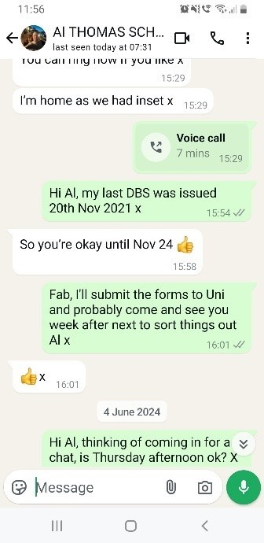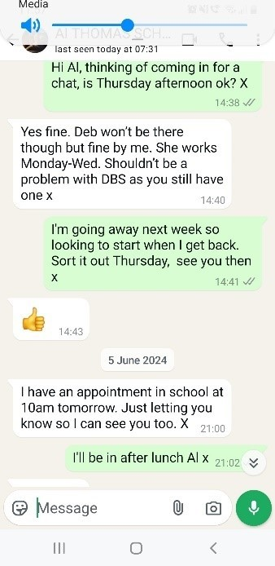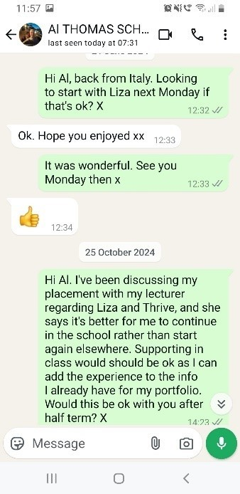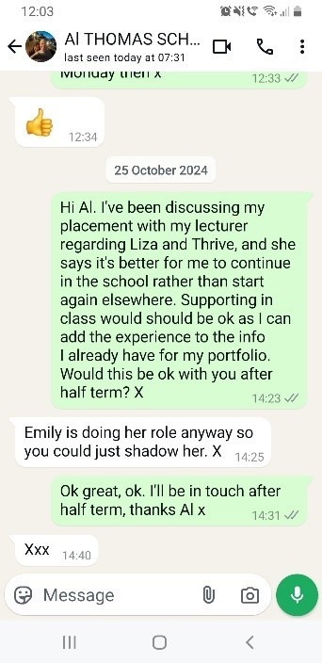
Email between Ruth Groff and Alison Thomas:
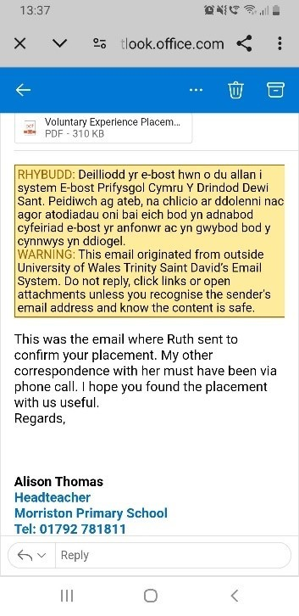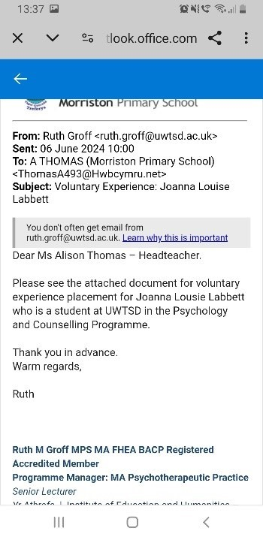
Placement letter:
Voluntary Experience Placement JLL.pdf

Partial placement logbook:
Student Work Placement Logbook

Student Name: | Louise Labbett
Name of Host Employer: | Morriston Primary School. City and County of Swansea

Date: | 24/06/24 - Introduction to school’s well-being programs
Tasks completed: | Introduction and overview to the various well-being programs ran in the school: Thrive, Trauma Informed Schools Practice, Therapeutic Play, and ELSA. Given background on the different programmes, familiarised with the setting and some of the children.
Reflection: | I used to work in this school and left December 2023 after 12 years. Mine was a very different role to the one I was about to be introduced to. It was a bit strange being back there, but good to see some of my colleagues again, I was surprised to see so many new faces among the staff. I was warmly welcomed by some of the children who saw me and remembered me, most of them asking where I had been. One was a boy with ASD who had been in my old class from the age of 3 and had moved on to the STF classes and not really engaged with me after that. When he ran up shouting my name to give me a hug and tell me he missed me I was really surprised and very touched.

Date: | 09/07/24 - Therapeutic Play session
Tasks completed: | Helped L prepare session pumping up balloons and filling the floor of the room with them prior to the child A’s arrival. Observed child A’s reaction, how L responded to child A’s requests, let child A lead the play. Observed L engage in subtle, casual conversation throughout play session about how he was feeling, how school has been, how his siblings/family were all interlaced with play talk. Engaged in play when invited to do so by child A.
Reflection: | I found it a bit chaotic letting child A almost totally lead the direction of play and the room got very messy. I felt it was inappropriate for him to ‘be in charge’ of the adults in the room. But I noticed the change in demeanour of child A as the session went on. He went from being very excitable and quite cheeky to calm, gentle and caring as the session went on, with him inviting me to join in the game halfway through unprompted. This surprised me somewhat as I used to work in the school and knew the child from the playground at break times when I saw him being loud, challenging, often angry and at times aggressive with peers and staff. I noticed how calm and supportive L was throughout, and how she asked questions interlaced with casual chat, and general play talk. Child A was quite content and comfortable talking about everything. L is undergoing trauma informed training, and she informed me after the session that child A and his family had suffered a bereavement of a younger sibling while I was still working at the school. I felt sad for him, and guilty at my previous view about the boy's behaviour whilst not knowing why.

Date: | 11/07/24 - Thrive session.
Tasks completed: | Engaged in play activity with target Child B and a friend (for support), 2 girls aged 9/10. Activity #1 theme “Good friend/bad friend”. Flash cards with different scenarios of children. Activity #2 theme “Buddy or bully”. A cut and paste activity with written examples of different behaviours to be categorised.
Reflection: | Today went well, both girls recognised me and greeted me with a hug, asking where I had been etc. Both girls were very chatty and very quickly involved me in the activity. I followed L’s lead in chatting about positive and negative behaviour and letting the girls lead the conversation.

Date: | 24/09/24 - Therapeutic play session
Tasks completed: | Child led activity, finding out what she enjoyed playing with and providing her with the opportunity to do so.
Reflection: | This session was unplanned as child C was new to the school having moved into the area, neither myself or L had met her before. However, as she was upset and angry in class, the decision was made for her to have some time out with L in the Thrive room. She was upset, unsure and defensive on arrival, and in hindsight, probably quite scared. She was new to the school and was not settling at all, she didn’t know the room or us. As challenging as I found her behaviour, I felt compassion towards her as you could see she was clearly struggling with everything happening to her. I mainly observed L, although child C did engage with me at times, asking questions. I kept a kept a calm, warm and friendly manner throughout the session, mirroring L’s demeanour. I was satisfying and a relief to see child C respond in the way she did, eventually calming and chatting quite freely. This changed at the end of the session when it was time to go back to class, when she became defensive and refused to leave the room. It was quite upsetting to see her suddenly change mood again, she was enjoying her time there and was quite upset at the thought of having to return to class.

Date: | 27/09/24 - Thrive session
Tasks completed: | A worksheet activity around the subject of self-esteem to carry out while offering the opportunity to have a conversation about feelings.
Reflection: | Child D remembered me from when I worked there so was pleased to see me and was comfortable with me being in the room and sitting with them at the table. I followed L’s lead and just engaged in general conversation when prompted. It was a good session, I saw she felt comfortable talking about her feelings and emotions with the activities offering the opportunity for her to do so. I admired L’s approach, her skill at asking the right questions and the way she did so. It was rewarding to watch child D feeling comfortable enough not just with L but with me also in attendance to open up about things to the extent she did.

Date: | 30/9/24 - Play therapy.
Tasks completed: | A sensory form of therapeutic play (messy play), making slime. The activity had been requested by child E as she liked to do it. Helped set up materials and cleaned up afterwards.
Reflection: | Mostly sat out of the activities today, I felt something wasn’t quite right, that child E might have been ‘performing’ a little, not being herself. She seemed to keep looking for reactions from me and after the session was over, I asked L if she thought this was the case? L confirmed child E was acting differently, with much more challenging behaviour than usual. We both agreed it was almost certainly for my benefit and that it would be beneficial for child E’s progress that I did not attend any more of her sessions. I felt initially felt guilty for being a distraction in a play session of a child who obviously benefitted from 1:1 sessions with someone she knew and felt she could trust. I was worried I had wasted one of her sessions, L suggested that it was an unexpected outcome for which the reasons became clearer on reflection of the session.

Placement information form:

Placement Information Form
Name of student: | Joanna Louise Labbett
Proposed placement setting and address: | Morriston Primary School. Neath Road, Morriston, Swansea. SA6 8EP
Proposed dates of placement: | July 2024 to November 2024
Name and position of contact: | Alison Thomas. Headteacher
Email address: | thomasa493@hwbcymru.net
Telephone number: | 01792 781811
Is a DBS required for you to attend this placement: | X Yes  - No  I already have a valid DBS from my previous employment at the school.  If Yes, have you applied for this?  - Yes applied on ___I already have a DBS issued on 20th Nov 2021  - No
Explain how your role in this organisation/on this placement meets the criteria for the assessment for the module  (e.g., what duties/tasks will you be undertaking that are relevant for the module assessment) | I will be observing and assisting in Thrive and Therapeutic play sessions based in Morriston Primary School for the emotional health, well-being, and social skills of a small group of children

ALL information must be provided. Incomplete forms will be returned to the student.
Please return this form to Ruth Groff (ruth.groff@uwtsd.ac.uk) by no later than 12pm on Monday 1st July.

Email confirmation of placement from Ruth Groff.
Placement
To: Ruth Groff
Fri 21/06/2024 10:41
Hi Ruth, hope you are well. As you know I have organised my placement with Thrive sessions at Morriston Primary School. I have been to visit and discuss all the details in person with the Head, Alison Thomas and the Thrive coordinator, Liza Sellere. I am looking to start next Monday. I am aware you've contacted the school. I was wondering if I need the go ahead from you first. Also, do I need to sent an email to the school to contract beforehand?
Thanks, Lou.
RG
Ruth Groff

To: Louise Labbett (2215831)
Fri 21/06/2024 11:20
Hi Louise,
I have received and sent a letter to Alison Thomas, so you are good to go….
I would also again point you to the programme moodle page, where there is an example of a log sheet, as this will help you to reflect on your experience. Take note of any additional training or guidance the school provides as well as familiarising yourself with their policies of safeguarding etc.

You may need this for the assessment. Please be mindful of ethical guidelines and principals for students and the guidance within the school,

Wishing you the best.

Warm regards,
Ruth
From: Louise Labbett (2215831) <2215831@student.uwtsd.ac.uk>
Sent: Friday, June 21, 2024 10:42 AM
To: Ruth Groff <ruth.groff@uwtsd.ac.uk>
To: Ruth Groff
Fri 21/06/2024 12:28
Hi Ruth. I'll do that, thank you. Wishing you a good summer, take care, I'll see you soon.
Lou

