Dissertation Proposal- 03/11/17
Working title:

“The enduring appeal of Streetwear within fashion.”

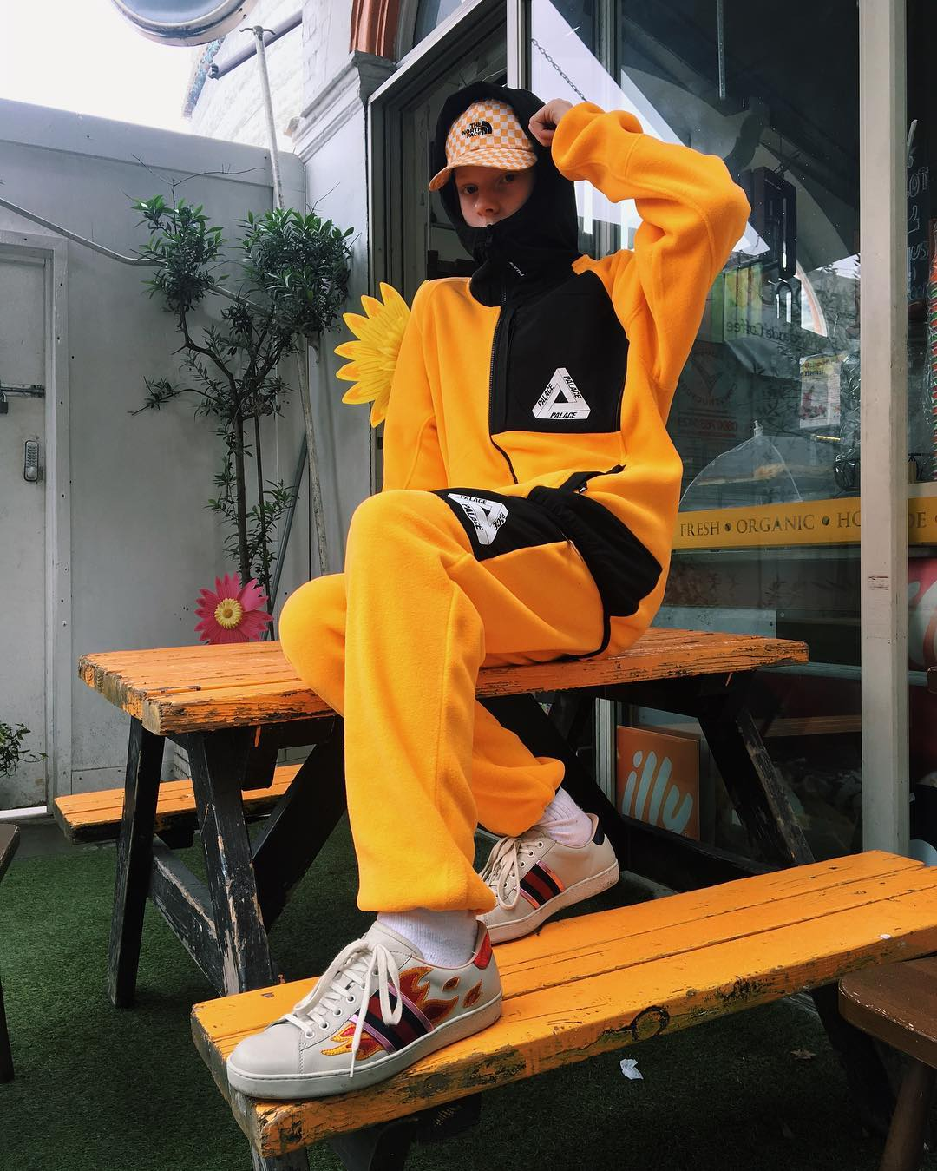

Introduction:
Streetwear is defined as being “casual clothing of a style worn especially by members of various urban youth subcultures.” An example of an urban subculture which is directly linked within Streetwear would be “Hip Hop”. Streetwear is however not easily defined due to the huge diversity of clothing, it can be anything from a graphic tee to a full shell suit.
Streetwear is ultimately what people wear in the streets yet the culture behind it brings a unique and emblematic feel which people can connect with. (Swanson, J, 2016)
The origins of Streetwear began between the late 1970’s and early 1980’s. It is believed to have come from the booming surf culture in Los Angeles. The early Streetwear brands such as “Stussy” which is still having a huge influence on the Streetwear culture were often influenced by the aesthetic look of punk, heavy metal and later hip hop cultures. (Breinholt, J,2009)
This dissertation will be focusing on the mass appeal of Streetwear, looking at why people are so invested in its culture and how it is still trending, growing and evolving.
Aim:
Streetwear is very much seen as a cultural phenomenon, instead of just a regular fashion trend. The aim for the dissertation is to demonstrate why people sought after Streetwear and the culture which it has created.
Research Objectives:
- To examine and review existing academic literature surrounding the appeal of Streetwear within fashion.
- To review the most suited form of research design in order to meet the aim of the dissertation.
- To produce data collected by identifying and studying the enduring appeal of Streetwear within fashion.

Literature Review:
“Until now streetwear has remained a niche interest. However, it is being appropriated by high fashion. Streetwear shapes and staples – sneakers, hoodies, printed T-shirts, tracksuit pants – have been seen at the likes of Givenchy, Vetements and Raf Simons for the past 10 years, but the look truly went mainstream this January when Louis Vuitton collaborated with Supreme. The first model on the catwalk wore a bright redcross body bag with the Supreme logo writ large. Others followed wearing a pattern that combined the Louis Vuitton monogram canvas with Supreme’s logo. A 23-year-old streetwear brand created by a skate scenester was on the runway for the most valuable Parisian brand in the world, one that was founded as a luggage label in 1854 and was valued at £22.5bn in 2016. Highsnobiety ran an article capturing what many within the streetwear community were thinking: “It’s official,” the title ran, “streetwear and luxury fashion are the same thing.” (Cochran, L 2017)
Lauren Cochrane who is head fashion writer for The Guardian newspaper has written the above literature, where she has given an account of her experience at the Supreme store in Soho London. In this dissertation, I want to analyse and demonstrate the reason why Streetwear has seen such a colossal amount of growth since it first came onto the fashion scene in the late 1980’s. This particular account identifies some key brands within the Streetwear culture who are making collaborative projects with some of the most highly sought after luxury fashion brands.
“Nevertheless, new brands keep barging onto the market, and whereas a few years ago, one season would be dominated by one or two strong trends, kids these days are rocking a kaleidoscope of fashions and micro-fashions: Light denim jeans, the 1990s revival, hippie-rock-grunge, dad hats, big logo print sweaters, and that whole “communist athletic” look brandished by skateboarder/designer Gosha Rubchinskiy are all in play – all at the same time. How can retailers and brands stay relevant? “There are all kinds of different fashion trends but there is also your own identity. We are also observing and adapting to new fashion trends but in a more timeless manner,” said Marion Maier at Ragwear, adding: “As a retailer, you should be able to expose the essence of the streetwear – independent from seasons.”
Here I have included a section from the “Men’s Streetwear SS17 trend report” where they have clearly analysed the huge differences in where Streetwear is now and where it was 20 years ago. While there are various articles available to us surrounding the topic of Streetwear, due to the huge hysteria surrounding the culture it has rapidly changed in recent time. Therefore, I feel there are unanswered theories surrounding the Streetwear scene in 2017. The literary review will include the study of a range of different sources which will include, case studies, books, journal articles and websites will prove to be extremely useful.

Strategy and Methodology
This dissertation will require key and informative insight into the subject of Streetwear to be able to give the reader a vivid insight into what it is all about and why it appeals to so many different people. I feel the most suited way of researching this topic is through phenomenology because I will be looking to draw from people’s experience on the subject. This will be carried out through qualitative methods such as interviews, I feel this will be one of my strongest methods of gaining information on the subject from people who are directly linked with fashion.
Both Primary and Secondary sources will be used continuously throughout the research for this dissertation with both providing different angles of insight. The secondary sources will be slightly harder to locate due to the topic of “streetwear” being so niche. However I feel the primary sources will prove to be very important with information coming directly from people who are involved with the fashion industry.
I am aware that sometimes using primary forms of research can sometimes be less structured and to the point than secondary research. However I feel it is important for the topic to be influenced by opinions of people who are directly involved in the culture. An example of a person who I feel would positively influence the dissertation would be Virgil Abloah who is creative director of luxury Streetwear brand Off-White. Below I have inserted a section from Virgil Abloah’ interview with Complex Style one of the leading Streetwear ambassadors.
“100% yes I consider my work ‘streetwear’ or any categorisation that allows anyone to grasp my point of view and where it comes from.” It’s these personal opinions and narratives—the history—that make streetwear a “life held in common.” Virgil reinforces this. “’Streetwear’ is an art movement, it's a way of making things,” he tells me. “It’s a rationale birthed by previous art movements and pop-culture life cycles.”

Logistical and Ethical Consideration
This aspect of the dissertation is extremely important due to the amount of care and attention which need to be taken when involving various people with your work. Ethically I need to ensure that everyone that I contact to conduct interviews or any other method of research have signed consent forms to ensure they are comfortable with there information being used.
Once contacted a information sheet concerning the nature of the study will be sent to them through email.
My main focus will be on contacting people who are someway involved in fashion/retail. I am aware that I will have to contact people who are further afield than Wales, my main aim would be to travel to London and get in touch with some brand owners. I believe an interview with someone involved directly with the Streetwear scene is key to creating an informative dissertation.
I feel the best way to conduct my research through interviews will be to record the interview and then play it back to myself once finished. The main benefit of doing this is to ensure I give my interviewees my undivided attention.
Once the interviews and other forms of research have been completed any recordings will be destroyed due to confidentiality.
​An ethics form has been completed and attached to the proposal which will be filled in by myself and my tutor.

GANTT Chart Timeline

 | NOV 17 | DEC 17 | JAN 18 | FEB 18 | MAR 18 | APR 18 | MAY 18
Complete Proposal and Ethics Form
Identify prospective interviewees
Draft information sheets for Interviewees
Make Contact with prospective interviewees
Conduct Secondary Research
Conduct Interviews
Analysis of primary and secondary information gathered
Draw Conclusions, present dissertation findings

References
http://www.boardsportsource.com/trend-report/mens-streetwear-ss17-trend-report/
https://www.theguardian.com/fashion/2017/mar/29/how-streetwear-styled-the-world-from-hip-hop-to-supreme-and-palace
https://fashionista.com/2016/01/best-fashion-books
Streetwear: The Insider's Guide (7 May 2007 by Steven Vogel )
http://www.complex.com/style/2017/02/what-is-streetwear-by-bobby-hundreds
https://www.vice.com/en_uk/article/59z48a/bobby-kim-on-falling-in-love-with-streetwear

