Website Report

Thomas Janes
2103127
Networking and Cyber Security
Introduction to Web and Database Concepts.
18/04/2022

Table of Contents
Abstract: Page 3
Introduction: Page 3
Implementation: Pages 4 - 8
Evaluation: Page 9
Self-Evaluation: Page 10
References: Pages 11 - 12
Appendices: Pages 13 - 40

Abstract:
In this report I will going over the requirements of the website such as: The Target audience, the purpose and what the website is about. I will also go over the actual website such as what it looks like, why I used certain things, if their was errors and if I fixed them how and if I couldn’t then what do I think the problem is and how I could’ve fixed it. I will then evaluate certain parts of what websites need and why they are needed and then I will go over these things on my website and why they are important.

Introduction:
My website is based around a very popular game called Apex Legends. It has been made so that people who are interested in the game can go onto the website and learn about some of things in the game. Whether they want to know about a certain character ability or why the apex games were made. This website gives readers a little insight into what Apex Legends is and some of the things in the game. The Target audience for my website is anyone who plays Apex or who is interested in learning more about it. The whole purpose of the website is to give some people a little more knowledge about the game whether that be through character abilities or why the games were created or even who made the game, this website gives the reader a little knowledge and could even convince them to look more into the game.

Implementation:

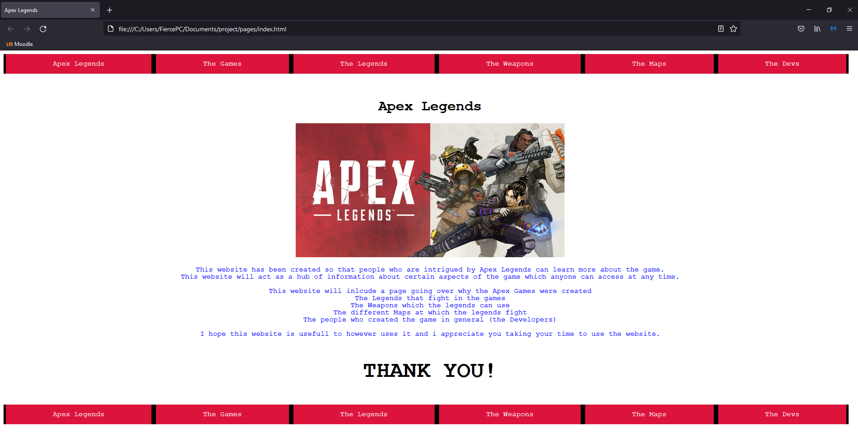
Index:

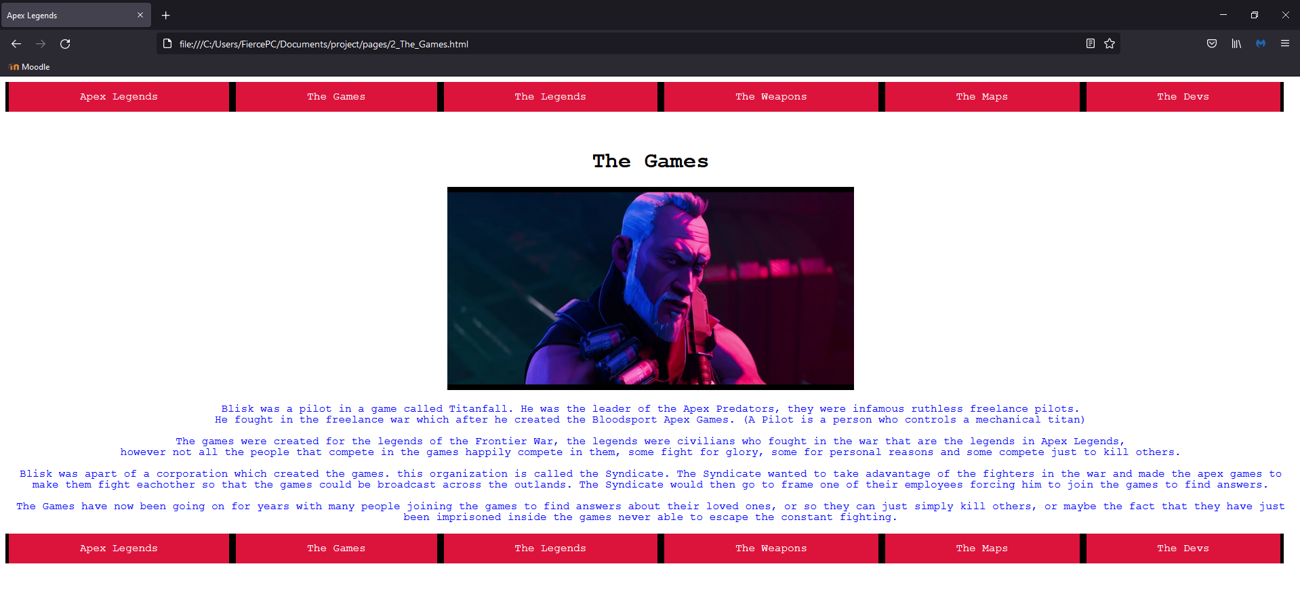
Page 2:

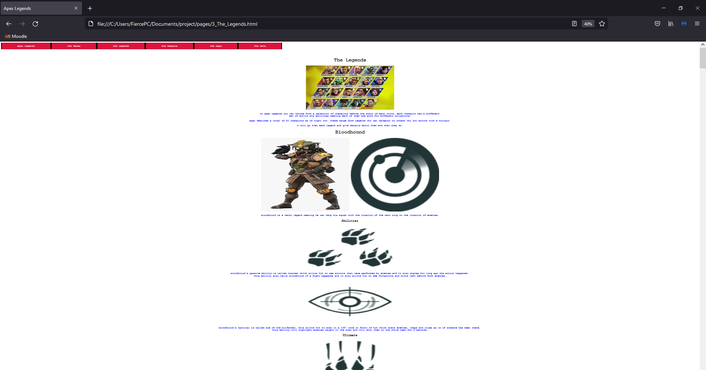
Page 3:

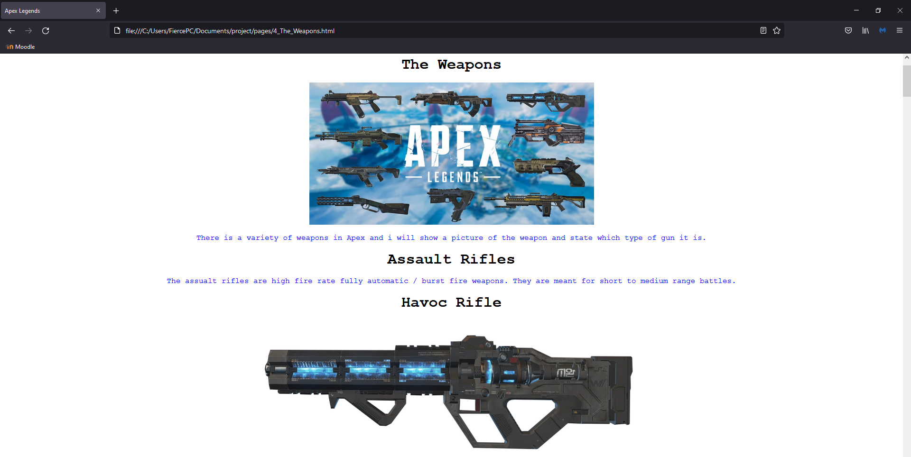
Page 4:
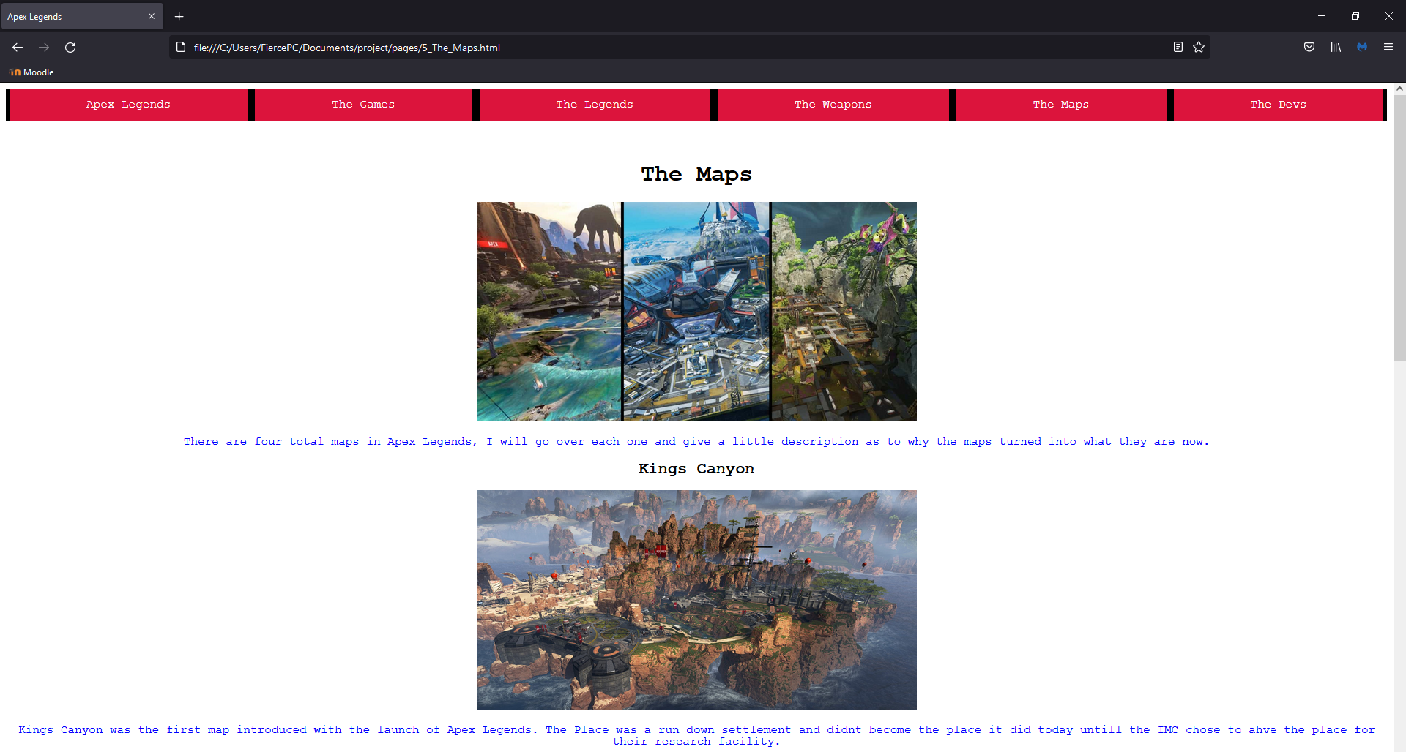
Page 5:

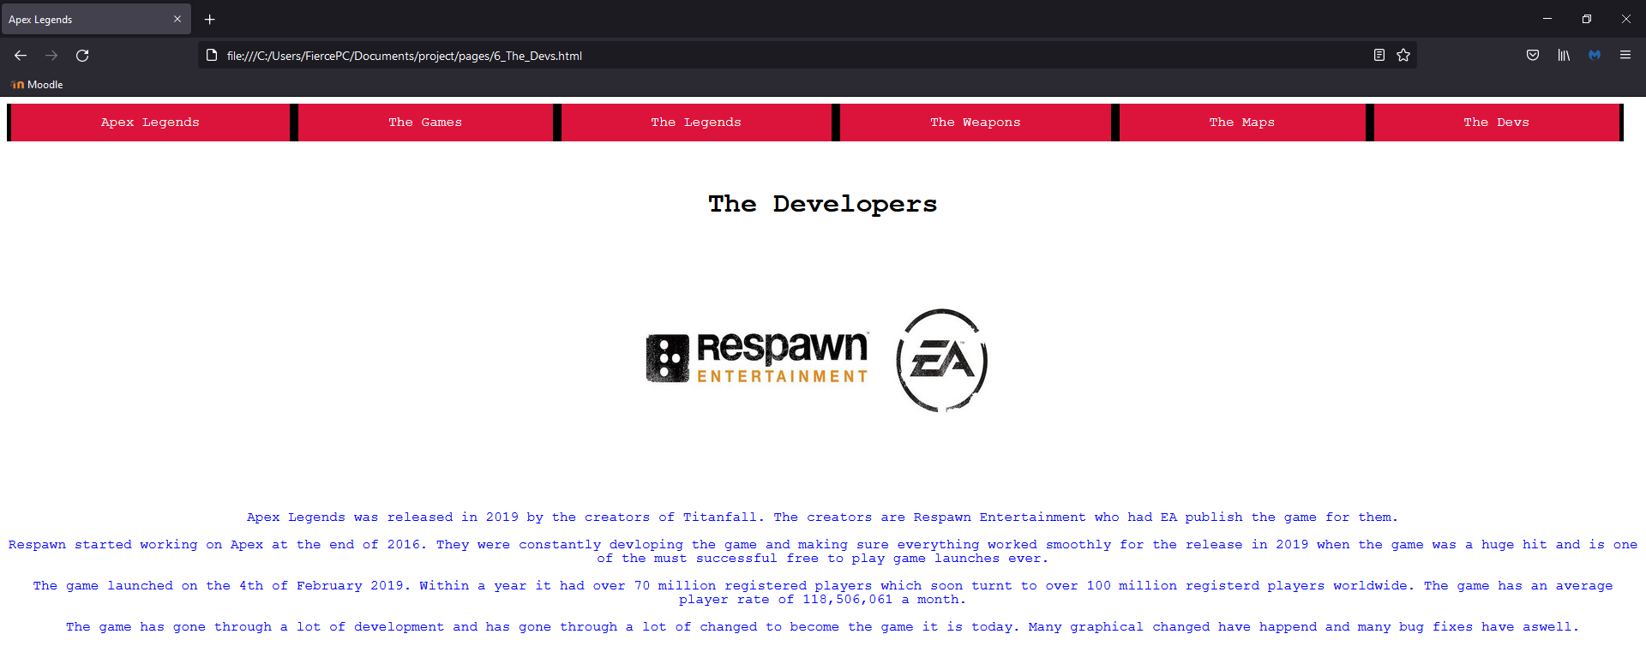
Page 6:

HTML:
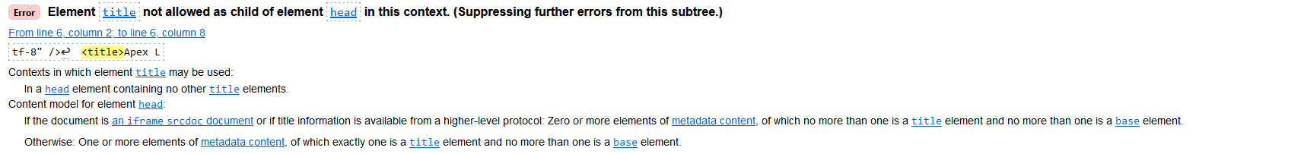
HTML validation of main page

Removed a title which wasn’t needed.

Moved body tag above div class tag.
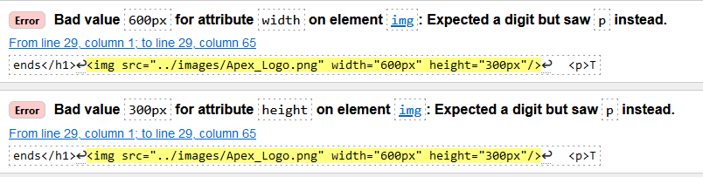
Removed px from after the digit values.
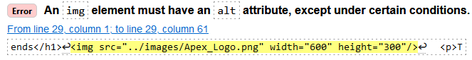
Added alt tag.
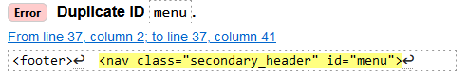
Changed id to menu_1
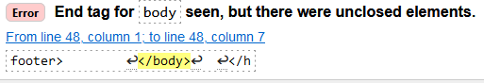
Closed the div class tag.
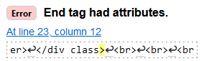
Deleted class tag.
CSS:
Main CSS validation
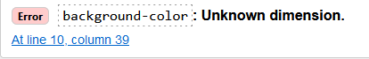
Added # to number.
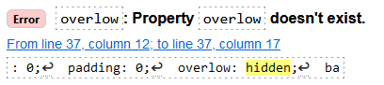
Spelt overflow properly.

Evaluation:
Usability:
Website usability is very important in the creation of a website as this determines how easy it is for a user to use the website overall, this could be from the overall design of the website to hyperlinks situated about pages to navigate through pages quickly. This can also be the choice of images and where the images are placed in order for information to be seen and so everything is easier to locate and look at. Not only is a good to have a usable website it also lets you have a professional looking and feeling website to present to others. The way to have a nice and usable website can be through simple things such as having a nice and clear page that’s nicely laid out and is easy to look at everything without straining your eyes.
[1] “companies must focus not only on complex and attractive website design but also on developing easy-to-use websites. “ The main things needed for a good usable website is how easy it is to use, how simple yet professional and information heavy it is and how the website doesn’t seem like its forcing you to read certain parts and just letting the user have their own flow with it.
Search Engine Optimisation (SEO):
SEO is important on a website as if you have a lot of information on your website and want users to be able to look through this information quickly and effectively then the ability to click on a search bar and look for a specific word which can then bring up a page of information about, he topic is very important and useful. For example, if a user was to search up a keyword of a topic such as Audi then the website would pull up information about the make of car and give information about it rather then the user having to search through a lot information just to find that. But now you don’t need just keywords you can search for things that are like what you are thinking about and you can get the same results. [2] “SEO has evolved over time and, nowadays, is by all means not only about link-building and keywords.”
Accessibility:
Website accessibility is very important as this can refer to letting disabled people access the website and who can use the website and on what device they can view the website too. To help with people with disabilities the creator of the website can make it so the font that the text is typed in is readable and is in neutral colours which don’t collide and make it hard for people who have poor eyesight to read it. Also the creator can make it so that the website can be accessed on any device which can be made compatible so that the website isn’t too big on a phone and is openable on a tablet. One main thing the creator of a website can do is to not overload on images and links so that it can load quickly so that it can also be accessed in the way of how fast it loads aswell. [3] “the web site of the Ministry of Housing and Urban Development showed the least errors in accessibility assessment since the contents were loaded quickly due to less numbers of images and links”
Self-Evaluation:
Usability:
I would say that my website has fairly good usability when it comes to navigation between pages and the fact that the overall design of the website is basic so users can easily get around each page and find what they need. The website on a whole has a fairly functional as it has a lot of information but I could’ve made it better by adding in hyperlinks at the top of some pages to get to other bits on longer pages faster. The look and feel of the website is very basic as my coding knowledge isn’t the best however it also means its not too complex which makes it easy for users to use.
Search Engine Optimisation (SEO):
I don’t really have much when it comes to SEO as the only way you can get around my website is by using the navigation bar at the top and bottom of the page to get between pages. As I stated above if I were to have more time and to improve my website I would add hyperlinks to the top of each page so users can see what will be on the page and to skip to it.
Accessibility:
I think my website is fairly accessible when it comes to the looks of it as it doesn’t strain the eye to read and look at imagers as they are all have good sizes, font colour and are displayed on non-contrasting backgrounds so that it doesn’t hurt anyone’s eyes to be able to see what is displayed on the website. When it comes to being able to use the website on any device I wouldn’t be sure if it would work on any other device other then a desktop pc as it has been created on one and I do not have the knowledge on how to optimise it for other devices yet.

References:
[1]: D. Belanche, L.V. Casalo, M. Guinaliu, 2011, November, Website usability, consumer satisfaction and the intention to use a website: The moderating effect of perceived risk, a Departamento de Direccio ́n de Marketing e Investigacio ́n de Mercados, Facultad de Economı ́a y Empresa, University of Zaragoza, Gran Vı ́a 2, 50005 Zaragoza, Spain
b Departamento de Direccio ́n de Marketing e Investigacio ́n de Mercados, Facultad de Empresa y Gestio ́n Pu ́blica, University of Zaragoza, Ronda Misericordia 1, 22001 Huesca, Spain, https://pdf.sciencedirectassets.com/271706/1-s2.0-S0969698911X00073/1-s2.0-S0969698911001160/main.pdf?X-Amz-Security-Token=IQoJb3JpZ2luX2VjEMX%2F%2F%2F%2F%2F%2F%2F%2F%2F%2FwEaCXVzLWVhc3QtMSJGMEQCIFHBhv%2B1R08E6t7MZsIF%2BveYKWZ0B0Ji%2BO2fsv%2BTCwbwAiBZIkFQUNdm3mXpZJ0eEuIr9pZV%2FDN3uvk6KHySFew%2BOirSBAh9EAQaDDA1OTAwMzU0Njg2NSIM60zXLocmCTkcnhb7Kq8EVI2VyQrGtQwV2PrNhkyJAsm3IHCj0nRFyIhUuB4ozTTiWNdKVOCCMOBwahsxqmxalGtFR8j7YRhJh%2F1ZasS5404Sqyz60OVoe0T3b7eB0pkk4uHKz3aAfyNh2XBlPtW3mc7C%2FVwueseVwUiJjQdCzjO7E84u8G4V3S3JUJztKAbcZQqV1lJg1QrYCyyZYYvPBHCLp7qcaV1NOeVVBdRNhsuQ4HRFjBhkHGYR9JQEFVZi8d%2FZIVQP%2Fxw%2BpflKzM092f0Y6b8EtgB2o7fUITCu7NEIu38lXZmrLiKpoxV9%2BpssFDkoYgtnA5iHOkXXTZPJ9fLtQuFbcIplFryPHZd%2FeVmeK1eouVUswzj2NdUoJDvFo277vcTugmsQYAWSmAiB4v0ONfNfMM8SURk8CjtzO8Q209kE0wp4rlxVeEEyP60We0%2BUEcI1FTrSjjIhXX4%2BGl7%2BdUCAxY72%2BhZNE8ZqCBUMp9o6qsYaOmsoG%2FH0LBtPjUbrhu1IjoB4mR4LBhmZVSYVcIBUzvzdQzrdU0z2D9ql7gsHGB9nGuuIw2cXg82kN8ijjoS6uSuxgo%2FDXNZe1MPzZ44Wtr0Mo8%2BOUIWrEytqXHtVLFUrt6gJd%2FdH4JnfJopLqtL7FwJr9VGZ85JOFYRa8fQ0U6b4HPWs1uqPy%2FfPTVd%2FUKdtvNy92qaqHQbL4Z%2BsAk6EBXxTqzA3BoeHyJIDK98DQv5GG9jxtq%2BDbhQ6hX2KpElI8CA8LOFXGTC44JaTBjqqAWbKi2Qa7%2ByajLYbUp2FlxhkFVIi2%2BLBHhtHamQ%2FKqyndBGP2At66u6SbuKubBfIEElphmzBtQyPtfyazBJsH%2Bq6WxR2Pm928DYYFurZon98cN2HarjEl6FYOYwoxqWT1ZpJZcKzZ8ca%2F5A5k4WIHrYWZq0RVVRHgfnrSCAMKml0KFItz9IgFyUGLcJPqqHZCmQNlsMB1BLE9FJDkTWamfuCFUqcMQFweiL%2B&X-Amz-Algorithm=AWS4-HMAC-SHA256&X-Amz-Date=20220424T203237Z&X-Amz-SignedHeaders=host&X-Amz-Expires=300&X-Amz-Credential=ASIAQ3PHCVTY3EIG3IWK%2F20220424%2Fus-east-1%2Fs3%2Faws4_request&X-Amz-Signature=54929a4961da98f1038b8710969b321e5c7615005fa26b46e1d5eb9cea7729b5&hash=ec0cf70b1606ebeadf8ae246ab9d7e7901bcbc11427c5e6a8b1476e6735a5e87&host=68042c943591013ac2b2430a89b270f6af2c76d8dfd086a07176afe7c76c2c61&pii=S0969698911001160&tid=spdf-12c84296-0b69-4f06-be17-83d97af05416&sid=9801825f9d058341d63bc2951daff6147439gxrqb&type=client&ua=595354515d04095353&rr=70119bf55b22774f

[2]: D. Giomelakis, A. Veglis, 2015, July, Investigating Search Engine Optimization Factors in Media Websites, The Case of Greece, https://www-tandfonline-com.ezproxy.uwtsd.ac.uk/doi/full/10.1080/21670811.2015.1046992

[3]: H. Mohammad, N. Fatemeh, 2010, Web site accessibility evaluation methods in action: A comparative approach for ministerial web sites in Iran, https://www-proquest-com.ezproxy.uwtsd.ac.uk/docview/807491425?pq-origsite=primo&accountid=130472

Appendices:
Index:
<!DOCTYPE html>
<html>
<head>
<title>Apex Legends</title>
<meta charset="utf-8" />
<link rel="stylesheet" type="text/css"
href="../css/apexlegends.css">
</head>
<body>
<div class="container">
<header>
<nav class="secondary_header" id="menu">
<ul>
<li><A href="index.html">Apex Legends</A></li>
<li><A href="2_The_Games.html">The Games</A></li>
<li><A href="3_The_Legends.html">The Legends</A></li>
<li><A href="4_The_Weapons.html">The Weapons</A></li>
<li><A href="5_The_Maps.html">The Maps</A></li>
<li><A href="6_The_Devs.html">The Devs</A></li>
</ul>
</nav>
</header>
</div>
<br>
<br>
<br>
<br>
<br>
<h1>Apex Legends</h1>
<img src="../images/Apex_Logo.png" alt="img" width="600" height="300"/>
<p>This website has been created so that people who are intrigued by Apex Legends can learn more about the game. <br> This website will act as a hub of information about certain aspects of the game which anyone can access at any time.</p>
<p>This website will inlcude a page going over why the Apex Games were created <br> The Legends that fight in the games <br> The Weapons which the legends can use <br> The different Maps at which the legends fight <br> The people who created the game in general (the Developers) </p>
<p> I hope this website is usefull to however uses it and i appreciate you taking your time to use the website. </p>

<h3> THANK YOU! </h3>

<footer>
<nav class="secondary_header" id="menu_1">
<ul>
<li><A href="index.html">Apex Legends</A></li>
<li><A href="2_The_Games.html">The Games</A></li>
<li><A href="3_The_Legends.html">The Legends</A></li>
<li><A href="4_The_Weapons.html">The Weapons</A></li>
<li><A href="5_The_Maps.html">The Maps</A></li>
<li><A href="6_The_Devs.html">The Devs</A></li>
</ul>
</nav>
</footer>
</body>

</html>
The Games:
<!DOCTYPE html>
<html>
<head>
<title>Apex Legends</title>
<meta charset="utf-8" />
<title>Apex Legends css</title>
<link rel="stylesheet" type="text/css"
href="../css/apexlegends.css">
</head>
<div class="container">
<header>
<nav class="secondary_header" id="menu">
<ul>
<li><A href="index.html">Apex Legends</A></li>
<li><A href="2_The_Games.html">The Games</A></li>
<li><A href="3_The_Legends.html">The Legends</A></li>
<li><A href="4_The_Weapons.html">The Weapons</A></li>
<li><A href="5_The_Maps.html">The Maps</A></li>
<li><A href="6_The_Devs.html">The Devs</A></li>
</ul>
</nav>
</header>
<body>
<br>
<br>
<br>
<br>
<br>
<h1>The Games</h1>
<img src="../images/blisk.jpg" width="600px" height="300px"/>
<p>Blisk was a pilot in a game called Titanfall. He was the leader of the Apex Predators, they were infamous ruthless freelance pilots.<br> He fought in the freelance war which after he created the Bloodsport Apex Games. (A Pilot is a person who controls a mechanical titan)</p>
<p> The games were created for the legends of the Frontier War, the legends were civilians who fought in the war that are the legends in Apex Legends, <br> however not all the people that compete in the games happily compete in them, some fight for glory, some for personal reasons and some compete just to kill others.</p>
<p> Blisk was apart of a corporation which created the games. this organization is called the Syndicate. The Syndicate wanted to take adavantage of the fighters in the war and made the apex games to make them fight eachother so that the games could be broadcast across the outlands. The Syndicate would then go to frame one of their employees forcing him to join the games to find answers. </p>
<p> The Games have now been going on for years with many people joining the games to find answers about their loved ones, or so they can just simply kill others, or maybe the fact that they have just been imprisoned inside the games never able to escape the constant fighting.

<footer>
<nav class="secondary_header" id="menu">
<ul>
<li><A href="index.html">Apex Legends</A></li>
<li><A href="2_The_Games.html">The Games</A></li>
<li><A href="3_The_Legends.html">The Legends</A></li>
<li><A href="4_The_Weapons.html">The Weapons</A></li>
<li><A href="5_The_Maps.html">The Maps</A></li>
<li><A href="6_The_Devs.html">The Devs</A></li>
</ul>
</nav>
</footer>
</body>
</html>
The Legends:
<!DOCTYPE html>
<html>
<head>
<title>Apex Legends</title>
<meta charset="utf-8" />
<title>Apex Legends css</title>
<link rel="stylesheet" type="text/css"
href="../css/apexlegends.css">
</head>
<div class="container">
<header>
<nav class="secondary_header" id="menu">
<ul>
<li><A href="index.html">Apex Legends</A></li>
<li><A href="2_The_Games.html">The Games</A></li>
<li><A href="3_The_Legends.html">The Legends</A></li>
<li><A href="4_The_Weapons.html">The Weapons</A></li>
<li><A href="5_The_Maps.html">The Maps</A></li>
<li><A href="6_The_Devs.html">The Devs</A></li>
</ul>
</nav>
</header>
<body>
<br>
<br>
<br>
<br>
<br>
<h1>The Legends</h1>
<img src="../images/roster.jpg" width="600px" height="300px"/>
<p> In Apex Legends you can choose from a selection of champions before the start of each round, each champion has a different <br> set of skills and abilities meaning each of them are good for different situations. </p>
<p> Apex features a total of 20 champions as of right now. These range from Legends who can teleport to others who run around with a minigun. </p>
<p> I will go over each Legend and give details about them and what they do. </p>
<h1> Bloodhound </h1>
<img src= "../images/bloodhound.jpg" width="600px" height="500px"/>
<img src="../images/recon.jpg" width="600px" height="500px"/>
<p> Bloodhound is a recon legend meaning he can help his squad with the location of the next ring or the location of enemies.</p>
<h2> Abilities </h2>
<img src="../images/bh_passive.jpg" width="600px" height="300px"/>
<p> Bloodhound's passive ability is called Tracker which allows him to see actions that were performed by enemies and it also states how long ago the action happened. <br> This ability also tells bloodhound if a fight happened and it also allows him to see footprints and blood left behind from enemies. </p>
<img src="../images/bh_tactical.jpg" width="600px" height="300px"/>
<p> Bloodhound's tactical is called Eye of the Allfather, this allows him to scan in a 125° cone in front of him which scans enemies, traps and clues as to if someone had been there. <br> This ability will highlight enemies caught in the scan and will show them to the whole team for 3 seconds. </p>
<h2> Ultimate </h2>
<img src="../images/bh_ult.jpg" width="600px" height="300px"/>
<p> Bloodhound@s ultimate ability is called Beast of the Hunt, this allows him to use his tactical ability a lot faster and more often, it also gives him a 30% speed boost. <br> His vision will turn black and white however if an enemy is in sight they will be highlighted red, also any footprints will be highlited red so that he can track people down. </p>
<h1> Gibralter </h1>
<img src="../images/gibralter.jpg" width="600px" height="500px"/>
<img src="../images/defensive.jpg" width="600px" height="500px"/>
<p> Gibralter is a defensive legend meaning he can cover an area. </p>
<h2> Abilities </h2>
<img src="../images/gib_passive.jpg" width="600px" height="300px"/>
<p> Gibralter's pasive ability is called Gun Shield. This is an arm shield which pops up when he aims down sights and covers a portion of his body protecting him from damgage until it breaks. </p>
<img src="../images/gib_tactical.jpg" width="600px" height="300px"/>
<p> Gibralter's tactical ability is called Dome of Protection. This ability allows him to throw a disk out which transforms into an invulnerable dome which only allows players to enter and leave. <br> You cannot shoot into or out of the dome. </p>
<h2> Ultimate </h2>
<img src="../images/gib_ult.jpg" width="600px" height="300px"/>
<p> Gibralter's ultimate ability is called Defensive Bombardment. This allows him to throw a smoke grendade which then brings down mortars from the sky and damages players and stuns them. </p>
<h1> Lifeline </h1>
<img src="../images/lifeline.jpg" width="600px" height="500px"/>
<img src="../images/support.jpg" width="600px" height="500px"/>
<p> Lifeline is a support legend meaning she can aid the squad by providing loot or healing.</p>
<h2> Abilities </h2>
<img src="../images/ll_passive.jpg" width="600px" height="300px"/>
<p> Lifeline's passive ability is called Combat Revive. This allows her to revive teammates from the downed state by leaving behind her healing drone to pick them up. </p>
<img src="../images/ll_tactical.jpg" width="600px" height="300px"/>
<p> Lifeline;s tactical ability is called D.O.C Heal Drone. This allows her to deploy a drone which heals players for 20 seconds when placed. </p>
<h2> Ultimate </h2>
<img src="../images/ll_ult.jpg" width="600px" height="300px"/>
<p> Lifeline's ultimate ability is called Care Package. This allows her to call in a care package which can contain armour for the player, healing items and weapon attachments. </p>
<h1> Pathfinder </h1>
<img src="../images/pathfinder.jpg" width="600px" height="500px"/>
<img src="../images/recon.jpg" width="600px" height="500px"/>
<p> Pathfinder is a recon legend meaning he can help his squad with the location of the next ring. </p>
<h2> Abilities </h2>
<img src="../images/path_passive.jpg" width="600px" height="300px"/>
<p> Pathfinder's passive ability is called Insider Knowledge. This allows him to scan beacons which decreases the cooldown of his ultimate ability. </p>
<img src="../images/path_tactical.jpg" width="600px" height="300px"/>
<p> Pathfinder's tactical ability is called Grappling Hook. This allows him to shoot a grappling hook from his arm which he can use to get to areas faster and which are higher then him. <br> He can swing on this hook acting like a swing. He can also use this ability on enemies to pull them in closer to him. </p>
<h2> Ultimate </h2>
<img src="../images/path_ult.jpg" width="600px" height="300px"/>
<p> Pathfinder's ultimate ability is called Zipline Gun. This allows him to shoot a zipline pole to a far distance which can then be used by anyone to zipline to the destination. </p>
<h1> Wraith </h1>
<img src="../images/wraith.jpg" width="600px" height="500px"/>
<img src="../images/offensive.jpg" width="600px" height="500px"/>
<p> Wraith is an offensive legend meaning she specialises in combat and has combat abilities. </p>
<h2> Abilities </h2>
<img src="../images/wraith_passive.jpg" width="600px" height="300px"/>
<p> Wraith's passive ability is called Voices from the Void. This allows her to know if an enemy is aiming at her, if there is traps nearby, if enemies are near or if a lot of people have died in a location. </p>
<img src="../images/wraith_tactical.jpg" width="600px" height="300px"/>
<p> Wraith's tactical is called Into the Void. This allows her to enter somewhere called the void where she is invulnerable to damage and she gains a 30% speed boost, however she cannot see enemies.<br> She also cannot interact with certain objects. </p>
<h2> Ultimate </h2>
<img src="../images/wraith_ult.jpg" width="600px" height="300px"/>
<p> Wraith's ultimate is called Dimensional Rift. This allows her to place a portal where she is standing, <br> she can then run to another location which she then places the other side of the portal which means players can enter the portal either side and end up at wherever the other portal was placed. <br> She also gains a 25% speed boost. </p>
<h1> Bangalore </h1>
<img src="../images/bang.jpg" width="600px" height="700px"/>
<img src="../images/offensive.jpg" width="600px" height="500px"/>
<p> Bangalore is an offensive legend meaning she specialises in combat and has combat abilities. </p>
<h2> Abilities </h2>
<img src="../images/bg_passive.jpg" width="600px" height="300px"/>
<p> Bangalore's passive ability is called Double Time. This allows her to run 30% faster for 2 second when bullets and grenades barely miss her. </p>
<img src="../images/bg_tactical.jpg" width="600px" height="300px"/>
<p> Bangalore's tactical ability is called Smoke Launhcer. This allows her to launch 2 smoke grenades which cover an area and obscure the vision for the area. </p>
<h2> Ultimate </h2>
<img src="../images/bg_ult.jpg" width="600px" height="300px"/>
<p> Bangalore's ultimate ability is called Rolling Thunder. This allows her to throw a flare which then calls an artillery strike which damages and slows enemies. </p>
<h1> Caustic </h1>
<img src="../images/caustic.jpg" width="600px" height="700px"/>
<img src="../images/defensive.jpg" width="600px" height="500px"/>
<p> Caustic is a defensive legend meaning he can fortify an area. </p>
<h2> Abilities </h2>
<img src="../images/ct_passive.jpg" width="600px" height="300px"/>
<p> Caustic's passive ability is called Nox Vision. This gives him immunity to the effects of nox gas which could be his own or an enemies. </p>
<img src="../images/ct_tactical.jpg" width="600px" height="300px"/>
<p> Caustic's tactical ability is called Nox Gas Trap. This allows him to throw gas traps, when an enemy is in close proximity or they are shot they set off and damage enemies and obscure palyers vision. </p>
<h2> Ultimate </h2>
<img src="../images/ct_ult.jpg" width="600px" height="300px"/>
<p> Causti's ultimate ability is called Nox Gas Grenade. This works just like the Nox Gas Traps, however it is in the form of a throwable grenade which also has a wider are of effect. </p>
<h1> Mirage </h1>
<img src="../images/mirage.jpg" width="600px" height="500px"/>
<img src="../images/offensive.jpg" width="600px" height="500px"/>
<p> Mirage is an offensive legend meaning he specialises in combat and has combat abilities. </p>
<h2> Abilities </h2>
<img src="../images/mg_passive.jpg" width="600px" height="300px"/>
<p> Mirage's passive is called Now You See Me... . This allows mirage to turn invisible when he is downed or he is reviving a teammate. </p>
<img src="../images/mg_tactical.jpg" width="600px" height="300px"/>
<p> Mirage's tactical ability is called Psyche Out. This allows him to send a decoy of him self forwards, he can then control the decoy to run around. When this decoy is shot it will ping where the enemy is that shot it. </p>
<h2> Ultimate </h2>
<img src="../images/mg_ult.jpg" width="600px" height="300px"/>
<p> Mirage's ultimate ability is called Life of the Party. This allows him to send out 5 decoys which surrond him and copyu all of his movements. When Mirage uses this ability he will turn invisible for 1 second. </p>
<h1> Octane </h1>
<img src="../images/octane.jpg" width="600px" height="500px"/>
<img src="../images/offensive.jpg" width="600px" height="500px"/>
<p> Octane is an offensive legend meaning he specialises in combat and has combat abilities. </p>
<h2> Abilities </h2>
<img src="../images/oc_passive.jpg" width="600px" height="300px"/>
<p> Octane's passive ability is called Swift Mend. This allows him to start to heal himself by 1 health per second after avoiding any type of damage for 6 seconds. </p>
<img src="../images/oc_tactical.jpg" width="600px" height="300px"/>
<p> Octane's tacitcal ability is called Stim. This increases his walk speed by 30% and his sprint speed by 40% for 6 seconds, however everytime it is used he loses 20 health. </p>
<h2> Ultimate </h2>
<img src="../images/oc_ult.jpg" width="600px" height="300px"/>
<p> Octane's ultimate ability is called Launch Pad. This allows him to throw a jump pad onto the floor which will launch players into the sky and give them an extra jump to use whilst in the air. </p>
<h1> Wattson </h1>
<img src="../images/wattson.jpg" width="600px" height="500px"/>
<img src="../images/defensive.jpg" width="600px" height="500px"/>
<p> Wattson is a defensive legend meaning she can fortify an area. </p>
<h2> Abilities </h2>
<img src="../images/wt_passive.jpg" width="600px" height="300px"/>
<p> Wattson's passive ability is called Spark of Genius. This rechareges wattson's shield after she avoids damage for 6 seconds. she recharges 1 shield every two seconds. This ability also lets her have 2 Ultimate Accelerants. <br>(These allow the player to get a big boost towards their ultimate ability) </p>
<img src="../images/wt_tactical.jpg" width="600px" height="300px"/>
<p> Wattson's tactical ability is called Perimeter Security. This ability lets her place pylons which connect together to make electrified fences betweeen each other. these damage and slow enemies. </p>
<h2> Ultimate </h2>
<img src="../images/wt_ult.jpg" width="600px" height="300px"/>
<p> Wattson's Ultimate ability is called Interception Pylon. This allows her to place a pylon which destroys all incoming grenades and ultimates that go in range. This also repairs damaged shields of anyone who is near it. </p>
<h1> Crypto </h1>
<img src="../images/crypto.jpg" width="600px" height="500px"/>
<img src="../images/recon.jpg" width="600px" height="500px"/>
<p> Crpyto is a recon legend meaning he can help his squad with the location of the next ring or the location of enemies. </p>
<h2> Abilities </h2>
<img src="../images/cr_passive.jpg" width="600px" height="300px"/>
<p> Crypto's pasive ability is called NeuroLink. This allows him to see highlighted things such as enemies and doors which his drone can see within 30 meteres. </p>
<img src="../images/cr_tactical.jpg" width="600px" height="300px"/>
<p> Crypto's tactical ability is called Surveillance Drone. This is a drone that Crypto can move around and scan enemies with and complete a variety of actions including opening doors and collecting banners. </p>
<h2> Ultimate </h2>
<img src="../images/cr_ult.jpg" width="600px" height="300px"/>
<p> Crypto's ultimate ability is called Drone EMP. This emits an EMP blast which damages enemy shields caught in the radius. It also slows anyone that is caught in the radious inclduing Crypto. </p>
<h1> Revenant </h1>
<img src="../images/revenant.jpg" width="600px" height="500px"/>
<img src="../images/offensive.jpg" width="600px" height="500px"/>
<p> Revenant is an offensive legend meaning he specialises in combat and has combat abilities. </p>
<h2> Abilities </h2>
<img src="../images/rev_passive.jpg" width="600px" height="300px"/>
<p> Revenant's passive ability is called Stalker. This ability allows him to be able to crouch walk at the same speed as he walks. He can also climb a lot higher then other legends. </p>
<img src="../images/rev_tactical.jpg" width="600px" height="300px"/>
<p> Revenant's tactical ability is called Silence. This ability allows him to fire a device which damages enemies a little but also disables all abilities. </p>
<h2> Ultimate </h2>
<img src="../images/rev_ult.jpg" width="600px" height="300px"/>
<p> Revenant's ultimate ability is called Death Totem. This allows revenant to place a totem which gives players an extra chance by spawning them back at the totem when they would've died </p>
<h1> Loba </h1>
<img src="../images/loba.jpg" width="600px" height="500px"/>
<img src="../images/support.jpg" width="600px" height="500px"/>
<p> Loba is a support legend meaning she can aid the squad by providing loot. </p>
<h2> Abilities </h2>
<img src="../images/lb_passive.jpg" width="600px" height="300px"/>
<p> Loba's passive ability is called Eye For Quality. This ability lets her see epic and legendary loot through walls. </p>
<img src="../images/lb_tactical.jpg" width="600px" height="300px"/>
<p> Loba's tactical ability is called Buglar's Best Friend. This is a braclet she can throw that she can then teleport to. </p>
<h2> Ultimate </h2>
<img src="../images/lb_ult.jpg" width="600px" height="300px"/>
<p> Loba's ultimate ability is called Black Market Boutique. This is something she can place so that players can access any loot that is on the floor in a 112.5 meter radius. </p>
<h1> Rampart </h1>
<img src="../images/rampart.jpg" width="600px" height="500px"/>
<img src="../images/defensive.jpg" width="600px" height="500px"/>
<p> Rampart is a defensive legend meaning she can cover or fortify an area. </p>
<h2> Abilities </h2>
<img src="../images/rp_passive.jpg" width="600px" height="300px"/>
<p> Rampart's passive ability is called Modded Loader. This ability allows rampart to have larger magazine size and reload speed for LMGs and her Minigun. </p>
<img src="../images/rp_tactical.jpg" width="600px" height="300px"/>
<p> Rampart's tactical ability is called Amped Cover. This allows her to be able to place barriers which have a amped wall on the top which increases damage going through them from one side and blocks bullets from the over. </p>
<h2> Ultimate </h2>
<img src="../images/rp_ult.jpg" width="600px" height="300px"/>
<p> Rampart's ultimate ability is called Mobile Minigun "Sheila". This is a minigun that rampart carries around with her that she can use normally or she can place it to have more ammo and health when using it. </p>
<h1> Horizon </h1>
<img src="../images/horizon.jpg" width="600px" height="500px"/>
<img src="../images/offensive.jpg" width="600px" height="500px"/>
<p> Horizon is an offensive legend meaning she specialises in combat and has combat abilities. </p>
<h2> Abilities </h2>
<img src="../images/hz_passive.jpg" width="600px" height="300px"/>
<p> Horizon's passive ability is called SpaceWalk. This allows her to move faster then other legends after a fall from a high up place. it also gives her better control in the air to move around.</p>
<img src="../images/hz_tactical.jpg" width="600px" height="300px"/>
<p> Horizon's tactical is called Gravity Lift. This is a device which she can throw so that players can ride it to get lifted off the ground and into the air. </p>
<h2> Ultimate </h2>
<img src="../images/hz_ult.jpg" width="600px" height="300px"/>
<p> Horizon's ultimate is called Black Hole. This is a device she can throw which pulls players into where the device is. it can pull the players in from behind doors and walls. </p>
<h1> Fuse </h1>
<img src="../images/fuse.jpg" width="600px" height="500px"/>
<img src="../images/offensive.jpg" width="600px" height="500px"/>
<p> Fuse is an offensive legend meaning he specialises in combat and has combat abilities. </p>
<h2> Abilities </h2>
<img src="../images/fuse_passive.jpg" width="600px" height="300px"/>
<p> Fuse's passive ability is called Grenadier. This means he can carry more grenades and fire the faster and farther. </p>
<img src="../images/fuse_tactical.jpg" width="600px" height="300px"/>
<p> Fuse's tactical ability is called Knuckle Cluster. This is a little cluster bomb which has two charges and can be fired from his wrist cannon which sticks to surfaces and damages enemies. </p>
<h2> Ultimate </h2>
<img src="../images/fuse_ult.jpg" width="600px" height="300px"/>
<p> Fuse's ultimate ability is called The Motherlode. This is a ring of fire that is held in a ball which can be shot into the air and will split open and form the ring on the ground. It marks enemies inside it and damages enemies who touch the outside. </p>
<h1> Valkrie </h1>
<img src="../images/valkrie.jpg" width="600px" height="500px"/>
<img src="../images/recon.jpg" width="600px" height="500px"/>
<p> Valkrie is a recon legend meaning she can help his squad with the location of the next ring or the location of enemies. </p>
<h2> Abilities </h2>
<img src="../images/vk_passive.jpg" width="600px" height="300px"/>
<p> Valkrie's passive ability is called VTOL Jets. This gives her jetpacks which then lets her fly up for a bit. </p>
<img src="../images/vk_tactical.jpg" width="600px" height="300px"/>
<p> Valkrie's tactical ability is called Misslie Swarm. This gives her a swarm of mini rockets to fire which deal damage and stun enemies. </p>
<h2> Ultimate </h2>
<img src="../images/vk_ult.jpg" width="600px" height="300px"/>
<p> Valkrie's ultimate ability is called Skyward Dive. This allows her to take her and her teammates and laucnh into the sky to relocate. </p>
<h1> Seer </h1>
<img src="../images/seer.jpg" width="600px" height="500px"/>
<img src="../images/recon.jpg" width="600px" height="500px"/>
<p> Seer is a recon legend meaning he can help his squad with the location of the next ring or the location of enemies. </p>
<h2> Abilities </h2>
<img src="../images/seer_passive.jpg" width="600px" height="300px"/>
<p> Seer's passive ability is called Heart Seeker. This allows him to hear and see enemies when he aims in. </p>
<img src="../images/seer_tactical.jpg" width="600px" height="300px"/>
<p> Seer's tactical ability is called Focus of Attention. This allows him summon some micro-drones which can go through walls and locate locate enemies. </p>
<h2> Ultimate </h2>
<img src="../images/seer_ult.jpg" width="600px" height="300px"/>
<p> Seer's ultimate ability is called Exhibit. This is a sphere of micro-drones which seer can summon which reveals which sprint or fire their weapons inside the sphere. </p>
<h1> Ash </h1>
<img src="../images/ash.jpg" width="600px" height="500px"/>
<img src="../images/offensive.jpg" width="600px" height="500px"/>
<p> Ash is an offensive legend meaning she specialises in combat and has combat abilities. </p>
<h2> Abilities </h2>
<img src="../images/ash_passive.jpg" width="600px" height="300px"/>
<p> Ash's passive ability is called Marked For Death. This allows her to throuh a knife into death boxes which reveals the location of the dead players killers. </p>
<img src="../images/ash_tactical.jpg" width="600px" height="300px"/>
<p> Ash's tactical ability is called Arc Snare. This is a snare which she can throw that holds the first player that gets too close to it in place. </p>
<h2> Ultimate </h2>
<img src="../images/ash_ult.jpg" width="600px" height="300px"/>
<p> Ash's ultimate ability is called Phase Breach. This allows her to cut a portal through space to another location which players can enter but cant come back through. </p>
<h1> Mad Maggie </h1>
<img src="../images/mad.jpg" width="600px" height="500px"/>
<img src="../images/offensive.jpg" width="600px" height="500px"/>
<p> Mad Maggie is an offensive legend meaning she specialises in combat and has combat abilities. </p>
<h2> Abilities </h2>
<img src="../images/mm_passive.jpg" width="600px" height="300px"/>
<p> Mad Maggie's passive ability is called Warlord's IRE. This allows her to see enemies she damaged through walls. This also gives her a speed boost whilst aiming with shotguns and whilst not aiming with the shotgun. </p>
<img src="../images/mm_tactical.jpg" width="600px" height="300px"/>
<p> Mad Maggie's tactical ability is called Riot Drill. This is a shootable drill which Maggie can fire into obstacles which drills all the way through and produces fire when it has gone through. </p>
<h2> Ultimate </h2>
<img src="../images/mm_ult.jpg" width="600px" height="300px"/>
<p> Mad Maggie's ultimate ability is called Wrecking Ball. This is a throwable ball which releases speed boost pads and knocks back enemies whilst damaging them. The pads give players a 30% speed boost.</p>

<footer>
<nav class="secondary_header" id="menu">
<ul>
<li><A href="index.html">Apex Legends</A></li>
<li><A href="2_The_Games.html">The Games</A></li>
<li><A href="3_The_Legends.html">The Legends</A></li>
<li><A href="4_The_Weapons.html">The Weapons</A></li>
<li><A href="5_The_Maps.html">The Maps</A></li>
<li><A href="6_The_Devs.html">The Devs</A></li>
</ul>
</nav>
</footer>
</body>
</html>
The Weapons:
<!DOCTYPE html>
<html>
<head>
<title>Apex Legends</title>
<meta charset="utf-8" />
<title>Apex Legends css</title>
<link rel="stylesheet" type="text/css"
href="../css/apexlegends.css">
</head>
<div class="container">
<header>
<nav class="secondary_header" id="menu">
<ul>
<li><A href="index.html">Apex Legends</A></li>
<li><A href="2_The_Games.html">The Games</A></li>
<li><A href="3_The_Legends.html">The Legends</A></li>
<li><A href="4_The_Weapons.html">The Weapons</A></li>
<li><A href="5_The_Maps.html">The Maps</A></li>
<li><A href="6_The_Devs.html">The Devs</A></li>
</ul>
</nav>
</header>
<body>
<br>
<br>
<br>
<br>
<br>
<h1>The Weapons</h1>
<img src="../images/Weapons.jpg" width="600px" height="300px"/>
<p>There is a variety of weapons in Apex and i will show a picture of the weapon and state which type of gun it is.</p>
<h1> Assault Rifles </h1>
<p> The assualt rifles are high fire rate fully automatic / burst fire weapons. They are meant for short to medium range battles. </p>
<h1> Havoc Rifle </h1>
<img src="../images/havoc.jpg" width="800px" height="300px"/>
<h1> VK-47 Flatline </h1>
<img src="../images/flatline.jpg" width="800px" height="300px"/>
<h1> Hemlok Burst AR </h1>
<img src="../images/hemlok.jpg" width="800px" height="300px"/>
<h1> R-301 Carbine </h1>
<img src="../images/r3.jpg" width="800px" height="300px"/>

<h1> Sub Machine Guns </h1>
<p> The sub machine guns are very high fire rate fully automatic / brust fire weapons. They are meant for short range battles. </p>
<h1> Alternator SMG </h1>
<img src="../images/alt.jpg" width="800px" height="300px"/>
<h1> Prowler Burst PDW </h1>
<img src="../images/prowler.jpg" width="800px" height="300px"/>
<h1> R-99 SMG </h1>
<img src="../images/r99.jpg" width="800px" height="300px"/>
<h1> Volt SMG </h1>
<img src="../images/volt.jpg" width="800px" height="300px"/>
<h1> C.A.R SMG </h1>
<img src="../images/car.jpg" width="800px" height="300px"/>

<h1> Light Machine Guns </h1>
<p> The light machine guns are high fire rate guns in this game. They are meant for all ranges of battle. </p>
<h1> Devotion LMG </h1>
<img src="../images/devo.jpg" width="800px" height="300px"/>
<h1> L-Star EMG </h1>
<img src="../images/lstar.jpg" width="800px" height="300px"/>
<h1> M600 Spitfire </h1>
<img src="../images/spitfire.jpg" width="800px" height="300px"/>
<h1> Rampage LMG </h1>
<img src="../images/ram.jpg" width="800px" height="300px"/>

<h1> Marksman Weapons </h1>
<p> The marksman weapons are single fire weapons. They are meant for medium to long range battles. </p>
<h1> G7 Scout </h1>
<img src="../images/g7.jpg" width="800px" height="300px"/>
<h1> Triple Take </h1>
<img src="../images/triple.jpg" width="800px" height="300px"/>
<h1> 30-30 Repeater </h1>
<img src="../images/30.jpg" width="800px" height="300px"/>
<h1> Bocek Compound Bow </h1>
<img src="../images/bow.jpg" width="800px" height="500px"/>

<h1> Sniper Rifles </h1>
<p> The sniper rifles are single fire weapons. They are meant for medium to long range battles. </p>
<h1> Charge Rifle </h1>
<img src="../images/charge.jpg" width="800px" height="300px"/>
<h1> Longbow DMR </h1>
<img src="../images/longbow.jpg" width="800px" height="300px"/>
<h1> Kraber .50-cal Sniper </h1>
<img src="../images/kraber.jpg" width="800px" height="300px"/>
<h1> Sentinel </h1>
<img src="../images/sentinel.jpg" width="800px" height="300px"/>

<h1> Shotguns </h1>
<p> The Shotguns are single fire and automatic fire weapons. They are meant for short range battles. </p>
<h1> EVA-8 Auto </h1>
<img src="../images/eva.jpg" width="800px" height="300px"/>
<h1> Mastiff Shotgun </h1>
<img src="../images/mastiff.jpg" width="800px" height="300px"/>
<h1> Mozambique Shotgun </h1>
<img src="../images/mozam.jpg" width="800px" height="300px"/>
<h1> Peachkeeper </h1>
<img src="../images/peace.jpg" width="800px" height="300px"/>

<h1> Pistols </h1>
<p> The pistols are single and fully automatic fire weapons. They are meant for short and medium range battles. </p>
<h1> Re-45 Auto </h1>
<img src="../images/re.jpg" width="800px" height="300px"/>
<h1> P2020 </h1>
<img src="../images/p2.jpg" width="800px" height="300px"/>
<h1> Wingman </h1>
<img src="../images/wingman.jpg" width="800px" height="300px"/>

<footer>
<nav class="secondary_header" id="menu">
<ul>
<li><A href="index.html">Apex Legends</A></li>
<li><A href="2_The_Games.html">The Games</A></li>
<li><A href="3_The_Legends.html">The Legends</A></li>
<li><A href="4_The_Weapons.html">The Weapons</A></li>
<li><A href="5_The_Maps.html">The Maps</A></li>
<li><A href="6_The_Devs.html">The Devs</A></li>
</ul>
</nav>
</footer>
</body>
</html>
The Maps:
<!DOCTYPE html>
<html>
<head>
<title>Apex Legends</title>
<meta charset="utf-8" />
<title>Apex Legends css</title>
<link rel="stylesheet" type="text/css"
href="../css/apexlegends.css">
</head>
<div class="container">
<header>
<nav class="secondary_header" id="menu">
<ul>
<li><A href="index.html">Apex Legends</A></li>
<li><A href="2_The_Games.html">The Games</A></li>
<li><A href="3_The_Legends.html">The Legends</A></li>
<li><A href="4_The_Weapons.html">The Weapons</A></li>
<li><A href="5_The_Maps.html">The Maps</A></li>
<li><A href="6_The_Devs.html">The Devs</A></li>
</ul>
</nav>
</header>
<body>
<br>
<br>
<br>
<br>
<br>
<h1>The Maps</h1>
<img src="../images/Maps.jpg" width="600px" height="300px"/>
<p> There are four total maps in Apex Legends, I will go over each one and give a little description as to why the maps turned into what they are now.</p>
<h2> Kings Canyon </h2>
<img src="../images/kc.jpg" width="600px" height="300px"/>
<p> Kings Canyon was the first map introduced with the launch of Apex Legends. The Place was a run down settlement and didnt become the place it did today untill the IMC chose to ahve the place for their research facility. </p>
<h2> World's Edge </h2>
<img src="../images/we.jpg" width="600px" height="300px"/>
<p> World's Edge was the second map released. This place was also another planet that was fine on its own but was a little run down until the IMC decided that they wanted a rare mineral on the planet so they set up on the planet to mine the material. </p>
<h2> Olympus </h2>
<img src="../images/op.jpg" width="600px" height="300px"/>
<p> Olympus was the third map released. The city was a futuristic floating city untill an experimental facility had an accident causing a huge phase rift to open in the sky which drove mostly everyone out of the city. </p>
<h2> Storm Point </h2>
<img src="../images/sp.jpg" width="600px" height="300px"/>
<p> Storm Point was the fourth map to be released. Once again this was a island that was left alone until the IMC showed up and decided to start expedtions exploring the island, however that didnt last for long as the island was prone to storms and many creatures inhabitited the island so the IMC left. </p>

<footer>
<nav class="secondary_header" id="menu">
<ul>
<li><A href="index.html">Apex Legends</A></li>
<li><A href="2_The_Games.html">The Games</A></li>
<li><A href="3_The_Legends.html">The Legends</A></li>
<li><A href="4_The_Weapons.html">The Weapons</A></li>
<li><A href="5_The_Maps.html">The Maps</A></li>
<li><A href="6_The_Devs.html">The Devs</A></li>
</ul>
</nav>
</footer>
</body>
</html>
The Devs:
<!DOCTYPE html>
<html>
<head>
<title>Apex Legends</title>
<meta charset="utf-8" />
<title>Apex Legends css</title>
<link rel="stylesheet" type="text/css"
href="../css/apexlegends.css">
</head>
<div class="container">
<header>
<nav class="secondary_header" id="menu">
<ul>
<li><A href="index.html">Apex Legends</A></li>
<li><A href="2_The_Games.html">The Games</A></li>
<li><A href="3_The_Legends.html">The Legends</A></li>
<li><A href="4_The_Weapons.html">The Weapons</A></li>
<li><A href="5_The_Maps.html">The Maps</A></li>
<li><A href="6_The_Devs.html">The Devs</A></li>
</ul>
</nav>
</header>
<body>
<br>
<br>
<br>
<br>
<br>
<h1>The Developers</h1>
<img src="../images/devs.jpg" width="600px" height="300px"/>
<p>Apex Legends was released in 2019 by the creators of Titanfall. The creators are Respawn Entertainment who had EA publish the game for them. </p>
<p> Respawn started working on Apex at the end of 2016. They were constantly devloping the game and making sure everything worked smoothly for the release in 2019 when the game was a huge hit and is one of the must successful free to play game launches ever.</p>
<p> The game launched on the 4th of February 2019. Within a year it had over 70 million registered players which soon turnt to over 100 million registerd players worldwide. The game has an average player rate of 118,506,061 a month.</p>
<p> The game has gone through a lot of development and has gone through a lot of changed to become the game it is today. Many graphical changed have happend and many bug fixes have aswell. </p>

<footer>
<nav class="secondary_header" id="menu">
<ul>
<li><A href="index.html">Apex Legends</A></li>
<li><A href="2_The_Games.html">The Games</A></li>
<li><A href="3_The_Legends.html">The Legends</A></li>
<li><A href="4_The_Weapons.html">The Weapons</A></li>
<li><A href="5_The_Maps.html">The Maps</A></li>
<li><A href="6_The_Devs.html">The Devs</A></li>
</ul>
</nav>
</footer>
</body>
</html>
CSS:
Body {
background-color:#7FFFD4;
color:blue;
font-family:Courier;
font-size:16px;
line-height:1em;
text-align:center;
}
h1 {
background-color:#7FFFD4;
color:black;
font-family:Courier;
font-size:32px;
line-height:1em;
text-align:center;
}
h2 {
background-color:#7FFFD4;
color:black;
font-family:Courier;
font-size:22px;
line-height:1em;
text-align:center;
}
h3 {
background-color:#7FFFD4;
color:black;
font-family:Courier;
font-size:50px;
line-height:1em;
text-align:center;
}
ul {
list-style-type: none;
margin: 0;
padding: 0;
overflow: hidden;
background-color: #333;
}

li {
float: left;
}

li a {
display: block;
padding: 10px;
background-color: #DC143C;
}
li a {
display: block;
color: white;
text-align: center;
padding: 14px 105px;
text-decoration: none;
}

li a:hover {
background-color: #A52A2A;
}

li {
border-right: 5px solid #000000;
}
li {
border-left: 5px solid #000000;
}

