Programme: Certificate in Higher Education Business Skills for the Workplace

Module: Enterprise and Entrepreneurship

Module Code: LCLM4006

Assignment Title: Task 1: Individual Written Business Plan

Student Name: Tialanthia Lynch

Student ID Number 2525166

Executive Summary
Core & Community Pilates is a proposed Birmingham-based Pilates and wellness studio providing accessible and professionally instructed mat and reformer Pilates. The business will primarily target women aged 18–45, particularly students, young professionals and beginners seeking an alternative to traditional gym environments.

The studio’s USP will be its combination of professional Pilates instruction, beginner-friendly classes and community support. Through a Community Access Programme, the business will provide subsidised places for local students and lower-income residents, while creating employment opportunities for qualified local Pilates instructors and support staff.

Core & Community Pilates will operate as a private limited company, managed by a Managing Director, Studio Manager and qualified Pilates instructors. This structure has been chosen because it provides limited liability, meaning the company is a separate legal entity from its owners and generally protects their personal assets from business debts. It also provides a professional status that can help build trust with customers, employees and potential partners, while offering potential tax efficiency as the business grows. Although a limited company involves more complex accounts, public records and accountancy costs, these disadvantages are outweighed by the protection and credibility it provides. The business will attract customers through Instagram, TikTok, its website, local partnerships and referral marketing.

The business will seek approximately £50,000 in angel investment to cover initial premises, reformer equipment, studio preparation, marketing, staffing and other startup expenses. The aim is to establish a sustainable and inclusive Pilates studio that meets local demand while making fitness more accessible within the Birmingham community.

Table of Contents

1. Title Page
2. Executive Summary
3. Table of Contents
4. Overview of the Business Idea
6. Market Research
7. Marketing Communications
8. Financials
11. Reference List

Overview of the business idea
Core & Community Pilates is a proposed Birmingham-based Pilates and wellness studio offering accessible, professionally instructed Pilates to individuals seeking to improve their physical fitness, strength, flexibility, mobility and overall wellbeing. The business will primarily target women aged 18–45, particularly students, young professionals and beginners who may feel uncomfortable in traditional gym environments. It will provide a welcoming and inclusive space where individuals of different fitness levels can participate without requiring previous experience.

The core services will include mat Pilates, reformer Pilates, beginner-focused classes and small-group sessions. Customers will be able to attend individual classes or purchase membership packages, providing flexibility for different budgets and levels of commitment. The studio will differentiate itself by combining professional instruction with an inclusive, community-focused environment.

The business idea is supported by growing consumer interest in fitness and wellbeing, alongside the popularity of Pilates as a low-impact form of exercise. Birmingham's diverse population, substantial student community and established fitness industry provide a potentially suitable market for the business.

A key element of Core & Community Pilates will be its commitment to supporting the local community through a Community Access Programme. This initiative will provide subsidised places for local students and lower-income residents who may otherwise struggle to afford specialist fitness services. By reducing financial barriers to participation, the programme will aim to make physical activity more accessible and encourage individuals to prioritise their health and wellbeing.

The business will also contribute to the local economy by prioritising the recruitment of qualified Pilates instructors and support staff from the surrounding area. Partnerships with local universities and community organisations will be explored to provide discounted introductory sessions, community Pilates events and wellbeing workshops. These initiatives will create opportunities for residents to engage in physical activity, develop social connections and access supportive community spaces. Such activities reflect the role SMEs can play in supporting their communities through local employment, partnerships and community initiatives (Forbes Business Council, 2024).

Mariotti and Glackin (2015) explain that competitive advantage can be developed by understanding customer needs and wants while identifying competitors' capabilities. This is relevant to Core & Community Pilates because the business will need to distinguish itself from existing Pilates studios in Birmingham. While competitors may focus on premium facilities or commercial memberships, Core & Community Pilates will differentiate itself through accessible pricing, beginner-friendly classes and its Community Access Programme. This approach will address barriers such as affordability and lack of confidence while responding to the needs of underserved groups.

Through these initiatives, Core & Community Pilates aims to generate social value alongside commercial revenue. Its community-focused approach will support greater access to exercise, encourage healthier lifestyles and create opportunities for local employment and collaboration. The business will therefore seek to balance financial sustainability with a positive contribution to the local community.

The key unique selling proposition (USP) is the combination of professional Pilates instruction, accessibility and community support. Rather than competing solely as a premium Pilates studio, Core & Community Pilates will offer a more inclusive alternative that makes Pilates accessible to a wider range of customers. This creates an entrepreneurial opportunity to meet demand for fitness and wellbeing services while addressing barriers that prevent local residents, particularly students and lower-income individuals, from accessing Pilates and participating in physical activity.

Legal Format and Management Structure

Core & Community Pilates will operate as a private limited company (Ltd). A private limited company is a separate legal entity from its owners, meaning that shareholders generally have limited liability for the company’s debts. This structure is appropriate for the proposed business because it provides a formal structure for growth, allows ownership to be divided into shares and is suitable for a business seeking external investment.

The business will be managed by a Managing Director, who will be responsible for strategic decision-making, financial management and business development. A Studio Manager will oversee the daily operation of the premises, including staff scheduling, customer service and class administration. Qualified Pilates instructors will deliver the classes, while reception or administrative staff will assist with bookings and customer enquiries. This structure provides clear responsibilities while allowing the business to expand its workforce as demand increases.

Market Research

A PESTEL analysis will assess the external factors influencing Core & Community Pilates.

Political: Government and local authority initiatives promoting physical activity and community wellbeing may create partnership opportunities. The Community Access Programme could support local participation in exercise.

Economic: Cost-of-living pressures may reduce spending on discretionary services such as Pilates. The business will address affordability through flexible memberships, introductory offers and subsidised community places.

Social: Growing interest in health, fitness and wellbeing presents an opportunity. A beginner-friendly, supportive environment will attract customers seeking improvements in strength, mobility and posture.

Technological: Instagram and TikTok will support marketing, while online booking and payment systems will improve accessibility and customer convenience.

Environmental: Digital administration, reusable equipment and energy-efficient lighting will help reduce environmental impact and potentially lower operating costs.

Legal: The business must comply with relevant health and safety, employment and business regulations. Appropriate insurance, qualified instructors and risk assessments will help ensure customer safety.

Overall, economic, social and technological factors are particularly significant, influencing affordability, customer demand and marketing opportunities.

Competition

Core & Community Pilates will compete with specialist Pilates studios, reformer businesses and larger gyms in Birmingham. Established competitors may benefit from strong reputations, loyal customers and quality facilities, demonstrating existing demand for Pilates.

The business will differentiate itself through affordability, beginner-friendly classes and community support, offering a more personalised experience than premium studios or larger gyms.

Before launch, competitor research will compare local prices, locations, class types, memberships and target markets. This will help identify market gaps and inform pricing and service development.

Marketing Communications
Core & Community Pilates will use a combination of digital marketing and local community marketing to attract customers. The marketing strategy will focus on reaching the target audience where they already spend time while also developing awareness within the local Birmingham community.

The first major strategy will be social media marketing, particularly through Instagram and TikTok. These platforms are appropriate because Pilates is highly visual and can be demonstrated effectively through short-form video content. The business will produce content such as Pilates exercises, beginner tips, instructor introductions, studio tours, customer testimonials and demonstrations of reformer equipment. This content will help potential customers understand what to expect before attending their first class. Location-based content and targeted advertising could also be used to reach potential customers within Birmingham.
The second strategy will involve local partnerships and referral marketing. Core & Community Pilates could work with universities, local businesses, wellness organisations and complementary health professionals. For example, a partnership with a local university could provide students with discounted introductory classes. This would simultaneously generate awareness, attract new customers and support the business’s community objective.

A referral scheme could also encourage existing customers to recommend the studio to friends or family by providing a discount or reward for successful referrals. This could help generate new customers while strengthening customer loyalty.

The business will also develop a professional website containing information about classes, prices, instructors and the Community Access Programme. An online booking system will allow customers to reserve and pay for classes conveniently. Combining social media, a website, local partnerships and referrals will enable the business to develop both digital visibility and a strong local customer base.
Financials:

Funding Requirements

Core & Community Pilates will require approximately £50,000 in initial funding to establish the studio and provide sufficient working capital during the first month of operations. The preferred funding source would be angel investment, although the business could potentially combine angel investment with a small business loan or personal investment.

Angel investment is particularly appropriate because the business requires significant upfront expenditure on specialist Pilates equipment and premises before it can generate sufficient customer revenue. An angel investor may also provide business expertise, industry contacts and strategic guidance in addition to financial capital. This could be valuable to a new business during its initial growth period.

Although Core & Community Pilates requires substantial initial investment due to the cost of specialist reformer equipment and commercial premises, effective financial planning will be essential to minimise unnecessary expenditure. Examples of entrepreneurs who established businesses with relatively small initial investments demonstrate that careful use of available resources can contribute to business development (This is Money, 2014). Therefore, the proposed £50,000 investment will be allocated towards essential startup requirements, while the remaining funds will provide working capital to support the studio during its early stages of operation.

Starting a new business involves financial risks, particularly because entrepreneurs are not guaranteed a regular income and may struggle to pay themselves during the early stages of the venture. (Mariotti and Glackin 2015) identify financial insecurity and uncertainty as challenges faced by entrepreneurs establishing and operating small businesses. This is relevant to Core & Community Pilates because the studio will need to cover significant initial costs, including reformer equipment, premises and staff wages, before establishing a consistent customer base. Securing £50,000 in start-up investment and retaining sufficient working capital will therefore help the business manage its initial financial commitments while building revenue from memberships and Pilates classes.
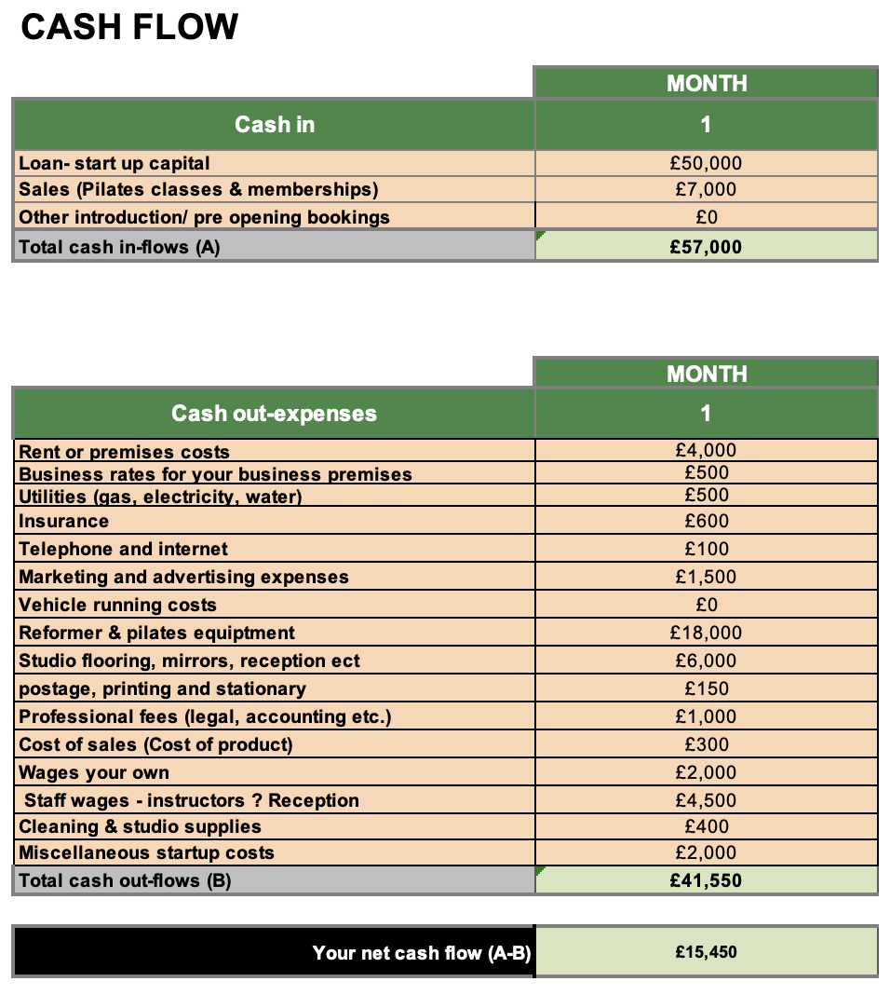
The Month 1 cash-flow forecast for Core & Community Pilates estimates total cash inflows of £57,000, consisting of £50,000 in start-up funding and £7,000 in projected sales from Pilates classes and memberships. The business requires £41,550 to cover initial expenses, including £18,000 for reformer and Pilates equipment, £6,000 for studio renovations and furnishings, £4,000 for premises costs, and £6,500 for the Managing Director’s salary and staff wages. Additional expenditure covers utilities, insurance, marketing and professional fees. The £50,000 funding requirement is intended to establish the studio and support its initial operations, while the projected £7,000 in sales represents income from customers. The forecast therefore produces a positive net cash flow of £15,450, providing working capital to help cover future operating expenses as the business develops its customer base. However, these figures are estimates and will require further research to confirm their accuracy.

Reference list
Forbes Business Council (2024) ‘14 Genuine Ways SMEs Can Give Back To Their Communities’, Forbes, 31 July. Available at: Forbes Business Council (https://www.forbes.com/councils/forbesbusinesscouncil/2024/07/31/14-genuine-ways-smes-can-give-back-to-their-communities/?utm_source=chatgpt.com) (Accessed: 23 September 2026).
This is Money (2014) Top 25 self-made entrepreneurs who started with small sums of money. Available at: This is Money article (https://www.thisismoney.co.uk/money/smallbusiness/article-2809685/Top-25-self-entrepreneurs-started-small-sums-money.html?utm_source=chatgpt.com) (Accessed: 25 October 2026).
Mariotti, S. and Glackin, C. (2015) Entrepreneurship: Starting and Operating a Small Business. Global Edition. Harlow: Pearson Education.
Mariotti, S. and Glackin, C. (2015) Entrepreneurship: Starting and Operating a Small Business. Global Edition. Harlow: Pearson Education.

