The Market Research Project of Tiara Hot Spring Resort
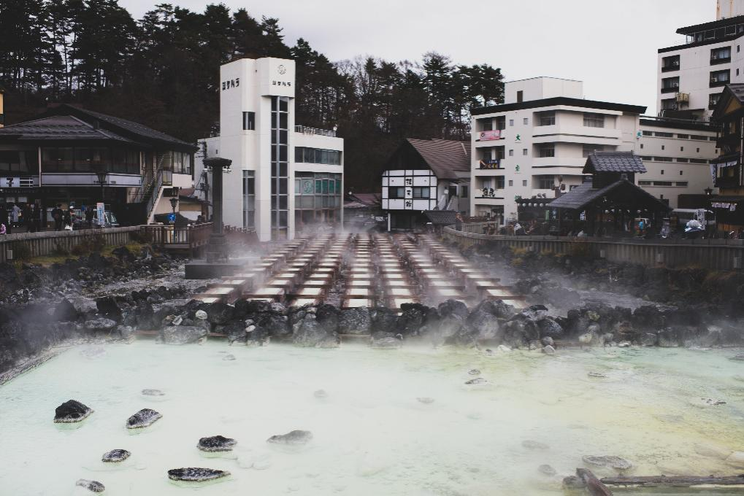

Name:Hang Wen
Number:1801428
Table of Contents
Executive summary 1
1 Project Justification 1
1.1 Project Aim 1
1.2 Project Objective 1
1.3 Project Rationalization 1
2 Business Case and Project Approach 3
2.1 Potential issues for Tiara Hot-Spring Resort 3
2.2 Potential benefits for the organization 3
2.3 Outcomes of the project 3
2.4 Background of the Project 4
3 Research Methodology 5
4 Project Manager 6
5 Project Plan 7
Reference List 8

Executive summary
This report is the initiation document and project description document of consultancy project of Tiara Hot-Spring Hotel in China. This report offers the background and motivation of initiating the project. The rationalization and preliminary analysis of potential benefits and issues are provided. This document is produced referring to the key literature in the field of tourism, market planning and strategy designing.
- Project Justification
  - Project Aim
As one of the leading players in the market, Tiara Hot Spring Resort has well-established resort facility and customer relations before the high-speed railway station was completed. However, even with the growing of domestic tourism industry in China and in these neighboring provinces, the revenue of the company started to decrease from 2017. With competitors emerging in the market and customers turning to online travel agencies instead of contacting the resort directly, the manager of the resort feels it is necessary to introduce the expertise from external consultants to find out what is the reason behind the revenue decrease and how can this issue be solved.
  - Project Objective
This project is targeted to provide reliable market research on the hot-spring and SPA related leisure services in Huanggang City, China for the luxury hot-spring resort-Tiara Hot Spring Resort. It is also set to provide a feasible consultancy report for the managers in the company to expand market and retain revenue growth. The project’s objective is to produce a consultancy report containing a market research to explain the revenue decrease in the past two years, an executable plan for the managers to retain revenue growth in the coming 1-2 years and a proposal for the company to expand the market into major hot-spring tourism sites in China.
  - Project Rationalization
Chinese hot-spring tourism has a long history since the founding of PRC China when many retired officers from the government and military needed a place to relax and recuperate. The Tiara Resort was established at this time as a state-owned resort only open for retired public servants. In the late 1990s, the resort was privatized under the pressure of bad economic situation. As a place dedicated to serve high-ranking government officials, the place has a good reputation of providing reliable luxury hot-spring leisure services. Before the tourists flooded into Xian Ning city after 2012, the resort has maintained a good customer relationship with chief secretaries in some local government offices and many private enterprises. However, after the hot-spring tourism boosted in 2012, the resort began to lose market share to its competitors who are providing more modern leisure services such as private SPA cabins and late-night buffets. With its old connections to the loyal customers, the resort maintained a revenue growth until 2017 when many of its original customers started to spend vacations or conferences in other hot-spring hotels in the city or in other tourism cities such as Lijiang and Gongzhi. From 2017, the revenue of the resort started to decrease which is a serious signal for the company as it only operates in the winter. In the rest of the year it is simply a local hotel. The decrease in revenue means significant deficiency in cash flow and may harm the resort business in the next winter holiday season.
According to statistics, the hot-spring tourism in China has been keeping growing since 2012 when the high-speed rail system was established (Mingle and Fiona, 2016). Tourist from different parts in China can travel to the hot-spring city within half a day and travel back or move on to the next destination on the next day. Many young people are showing interest in spending vacations in the hot-spring hotels to be relaxed instead of sight-seeing all around due to the increasing pressure on the younger generation. The customer base of the entire market is growing. With the help of emergent online agencies, many new hot-spring hotels are emerging without needing to establish a sound reputation. All the above factors are contributing to the high necessity of this project.
- Business Case and Project Approach
  - Potential issues for Tiara Hot-Spring Resort
As a previous state-owned resort for the high-ranking public servants. It is possible that many bureaucracy issues might occur in the consultancy project as in some of the still operating previous Soviet sanatoriums (Ahas et al., 2007; Koenker, 2013). Some senior and experienced managers in the resort might strongly oppose the idea of modernization of the resort in terms of service quality, experience in the resort and basic facilities. It is also possible that consultancy project might be objected by such senior managers as in the cases of some state-owned enterprises in China (Ling and Gui, 2009). Especially in this case as the prior-2017 performance of the resort was good with a growing revenue.
As the execution of the consultancy report required the collaboration of the host company from many departments and many external stakeholders (Sadler, 2001), the success of the consultancy project is not always guaranteed. However, as consultancy is still emerging in the Chinese market especially in the remote cities such as Xian Ning, it might be difficult for the Tiara Resort to accept that the consultancy project might face failure.
  - Potential benefits for the organization
As the consultancy is to bring expertise and up-to-date managerial experience and knowledge into the organizations (Newton, 2012), the Tiara Resort can benefit from this greatly especially in the regional market as there are almost no competitors as global firms. The expertise brought by the consultant team can build competitive advantage for the firm. As a widely used tool for modern enterprises, external consultancy can discover issues and problems that can be hard to reach from within. The adoption of external consultancy as a tool can bring experience for the resort to cooperate with external consultancy in the future.
  - Outcomes of the project
The outcomes of the project concern a variety of organizational changes from human resource management to financial structure. As in many consultancy projects, external consultancy often brings the structure changes in HR management or organizational structure. The change on the target customer group can also be the outcome as the resort has to attract customers from various channels instead of simply relying on old customers.
  - Background of the Project
The tourism industry in China has been exploding during the past decade. In 2018, the revenue of tourism industry in China has reached 578 billion GBP with an annual growth rate of 13%. The number of domestic visitors in China has reached 5000 million people in 2017 with an annual growth rate of 14% (Pine, 2002; Statista, 2018). Though the growth rates of both have been slight decreasing after the 2008 financial crisis, it is projected that the tourism market in China will continue growing in the next decade to come (Turner, 2018). With a booming tourism industry, the hospitality and leisure service providers can benefit greatly from this. According to statistics, China is now transforming into a consumer society with government policies promoting the consuming activities to expand domestic demand (Hsing and Davis, 2007). This stage of transformation also indicates a steady growth in the market size of hospitality and leisure service.
The city of Xian Ning is situated on the boarder of Hunan, Anhui and Hubei province, all of which are the fast-developing regions in China. Xian Ning is renowned for its rich hot-spring resources that have been developed for centuries. As a junction city connecting three provinces, the city has been attracting hot-spring tourists for many years (Lin, 2008). In 2012, the completion of high-speed railway station in the city further boosted the hot-spring tourism in the city.
- Research Methodology
The research methods in this project will be primarily secondary with referring to the reports of the industry and statistic reports of the local market. Information of the Tiara Resort will be from the company’s website. The industry reports and statistical reports will be referred to the reports on Statista (Statista, 2018) and reports published by China Hot Spring Tourism Association (CHSTA, 2018). Some empirical studies concerning the hot-spring tourism and sanatorium will be referred to as well (Pearson, 2006; Lin, 2008; Mingle and Fiona, 2016). The availability of the information and data is well as most information are released online. The bias can stem from the internal information of the resort from the website. The elimination of such bias will be primarily based on prudent information collection and referring to some of the major players in the Chinese market such as Kunming Brilliant Hot Spring Hotel which has public accessible information.
To further guarantee the legitimacy of the information collected, I will refer to some of the major customers in the industry (some frequent travelers) and major customers of Tiara resort. It is designed that information will be collected from multiple channels in different contexts, in which way that the collected information can be cross checked and validated.
- Project Manager
The project manager will be me as a freelance private consultant. The reason why I should be chosen as the project manager is based on the passion of me for consultancy as I always fancy the process of problem identification and synthesize solutions. Beyond the passion I have, I also have profound academic experience in strategic designing and market planning as primary courses. My knowledge in above fields together with international finance and business can help the Tiara resort to expand the market into a new level and bring it into competition with some of the major players in China even in the Asia-Pacific region. Besides, Tiara resort is always an excellent choice for my family vacation. Several times of visiting to the Tiara resort give me an basic understand of its infrastructure, its business model and its management style, which certainly will be an advantage in helping me with this project. A general understanding of its major clients and preferences of major clients will also direct to development ideal solutions for Tiara resort.
- Project Plan
The project plan consists a plan for research including the internal analysis of the resort using SWOT analysis and external environment analysis using PESTEL analysis. Results from both analyses will be referred in the project and included in the final report. The duration of this research will be several weeks up to two months. The exact duration is based on the availability of some online material as some of them require permission from staffs in China. In the beginning, a comprehensive market research will also be produced based on the internal and external analysis. As the SWOT and PESTEL models can both be completed with information acquired online, the time of internal and external analysis will be less than two weeks. After the internal and external analysis, a whole market report will be produced. After that, it comes with second stages. In the second stage of the project I will examine the completion of the project, which means based on the analysis on the beginning stage, a preliminary solution is likely to be formulated. The preliminary solution will be reviewed and keep revised until the final ideal market research. The final step is to archive all steps to write a management consultancy report which records the collection of data, the analysis of data, and the formulation of solution. This is just an estimated plan for the project. unexpected changes are quite normal in the real life. Whenever there are changes, I will adjust the schedule and take some reactive actions to make sure everything goes well.

Reference List
Ahas, R. et al. (2007) ‘Seasonal tourism spaces in Estonia: Case study with mobile positioning data’, Tourism management. Elsevier, 28(3), pp. 898–910.
CHSTA (2018) China Hot Spring Association. Available at: http://www.hstcn.com/ (Accessed: 4 March 2019).
Hsing, Y. and Davis, D. S. (2007) The Consumer Revolution in Urban China, Economic Geography. Univ of California Press. doi: 10.2307/3594079.
Koenker, D. P. (2013) Club red: Vacation travel and the Soviet dream. Cornell University Press.
Lin, L. G. Y. L. (2008) ‘China hot spring tourism’s review and prospect [J]’, Special Zone Economy, 3.
Ling, F. Y. and Gui, Y. (2009) ‘Strengths, weaknesses, opportunities, and threats: case study of consulting firms in Shenzhen, China’, Journal of Construction Engineering and Management. American Society of Civil Engineers, 135(7), pp. 628–636.
Mingle, Z. and Fiona, H. (2016) HOT SPRING TOURISM NEWS FLASH FROM CHINA. Available at: https://www.femteconline.org/china/2013-10 Hot Spring News.pdf (Accessed: 3 March 2019).
Newton, R. (2012) The Management Consultant: Mastering the Art of Consultancy. Pearson Education Limited (Financial Times Series). Available at: https://books.google.dk/books?id=XntmFnh3tIQC.
Pearson, S. V. (2006) The State Provision of Sanatoriums, The American Journal of Nursing. Cambridge University Press. doi: 10.2307/3404187.
Pine, R. (2002) ‘China’s hotel industry: serving a massive market’, Cornell Hotel and Restaurant Administration Quarterly. Sage Publications, 43(3), pp. 61–70.
Sadler, P. (2001) Management Consultancy: A Handbook for Best Practice. Kogan Page (Kogan Page Series). Available at: https://books.google.dk/books?id=oO93wXNU2mMC.
Statista (2018) Tourism industry in China - Statistics. Available at: https://www-statista-com.liverpool.idm.oclc.org/topics/1210/tourism-industry-in-china/ (Accessed: 3 March 2019).
Turner, R. (2018) WTTC Travel&&Tourism Economic Impact 2018 China. Available at: https://www.wttc.org/-/media/files/reports/economic-impact-research/countries-2018/china2018.pdf (Accessed: 3 March 2019).

