

Solid works

Motion simulation, FEA and Topology Study of a robotic arm

William David Arthure

P149138

https://uowtsd-my.sharepoint.com/:f:/g/personal/warthure_149138_student_uwtsd_ac_uk/Elcb8X346c5JuvuD29maLW4B8icCw1OUjTiNwC3SBl8ftw?e=wYiFCF

Introduction

FEA is a method becoming widely used in industry to simulate how a part will act under specific loads and forces without the use of multiple prototypes. This in turn saves the manufacturer time and money by reducing the number of prototypes needed. Parts can be optimized this way during the design stage. FEA is a numerical method of approximating a solution to optimizing a component, it may not be exact to how the prototype would act in an actual test.

This report will undertake a finite element analysis (FEA) on a lifting part used in a robotic arm. The robotic arm designed in solid works has a motion simulation in which it undergoes a small load while lifting a cast iron block. The arm has a stainless-steel end piece which connects to the iron block and undergoes a lot of stress whilst lifting. An FEA has also been used to see where the most stress acts on the part, allowing the part to then be redesigned and strengthened to reduce any stresses and prevent any potential stress cracks or damage to the part when undergoing a load. Once the part was re designed and strengthened, a topology study then shows where the part has material that can be removed without reducing its strength. This in turn makes the part lighter whilst not compromising any strength.

Objectives

- Design and model a robotic arm in solid works
- Assemble parts and create a motion simulation
  - Add motors, gravity and loads to make the simulation as realistic as possible
- Do an FEA analysis on a part in the arm which will undergo large amounts of stress
  - Find where the part has the most stresses
  - Show how the part displaces after undergoing a load
- Redesign the part to strengthen the weak areas
  - Re calculate the FEA to see if the part still has these weak areas
  - Evaluate the stresses and see if the part is improved
- Topology study on the part once it has minimal stresses
  - Show areas of material that can be removed

Background on FEA

Finite element analysis is a method of analysing a material or component to show how it will react when stresses are applied. This analysis can help to show any weak points in a design without the use of numerous prototypes. The programme performs the process by creating a mesh of points over the part which contains information about the material and the part at each point. As well as showing the stresses over the component, an FEA can also analyse the effects of vibrations, fatigue and heat transfer. (Chegg study, 2019)

When building and testing prototypes, it may be that the part breaks before the maximum load is applied. This will require another prototype to be made and improved, the re-tested. This new prototype could then break again slightly closer to the max load and the process will need to be repeated till the maximum load is applied without any failure from the part. This is where FEA can be used to simulate these tests instead of making new prototypes for every iteration. (Value design consulting, 2019)

Motion simulation

When all parts for an assembly are made in CAD, they can be assembled and mated and the mechanism can then be moved around how it would if it was actually manufactured. The model can then be animated with a motion simulation, this provides quantitative information about the movement of the model. These can vary from positions, velocity, acceleration to forces and loads.
In the motion simulation, motors are added to rotating components and given a direction and speed in RPM. The programme will simulate the movement of the model and the duration of this movement can be set. When a change in the simulation is made, it must be recalculated and will continue to perform the motion simulation. Other factors can be added to the simulation, for example gravity, torque and loads.
Once the motors have been added and gravity and loads are applied, the model can begin motion and graphs and equations can be applied to find results of the simulation.

Topology studies

A topology study offers a designer the ability to quickly optimize a component by cutting weight in any way that will not affect the strength of the part. If a part hasn’t been topology optimised, it probably weighs more than necessary. This extra weight can lead to added loads on parts, energy efficiency is lower than it could be and postage for parts can cost more.
The first step in a topology study is to define the fixtures and loads. Fixing the top of a part and loading a weight to the bottom for example. Within the topology study, a design goal can be set for the best stiffness to weight ratio, reducing the mass as much as possible whilst maintaining strength. The constraints set will ensure the required mechanical properties are met, such as a maximum deflection or amount of mass removed.
Preserved regions can be selected which will be areas of the model which will be excluded from the optimization.
The data from the topology optimisation will show areas of the model which can be removed to save mass. The part can then be redesigned on CAD, sketches can be added in to extrude cut areas where material is not required to maintain the strength of the part.

Assembly of robotic arm

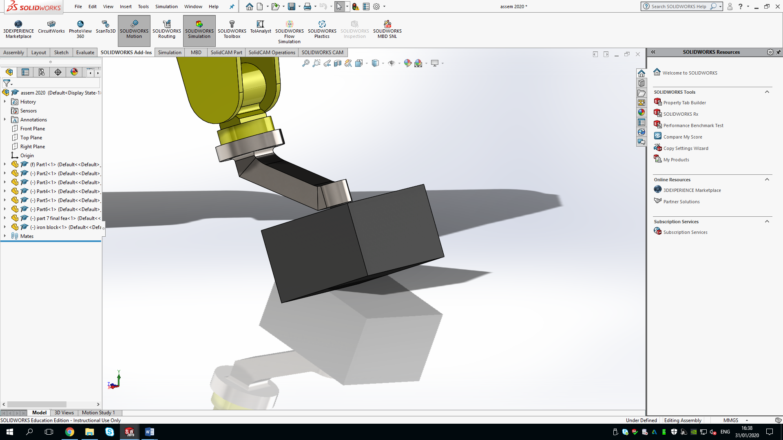
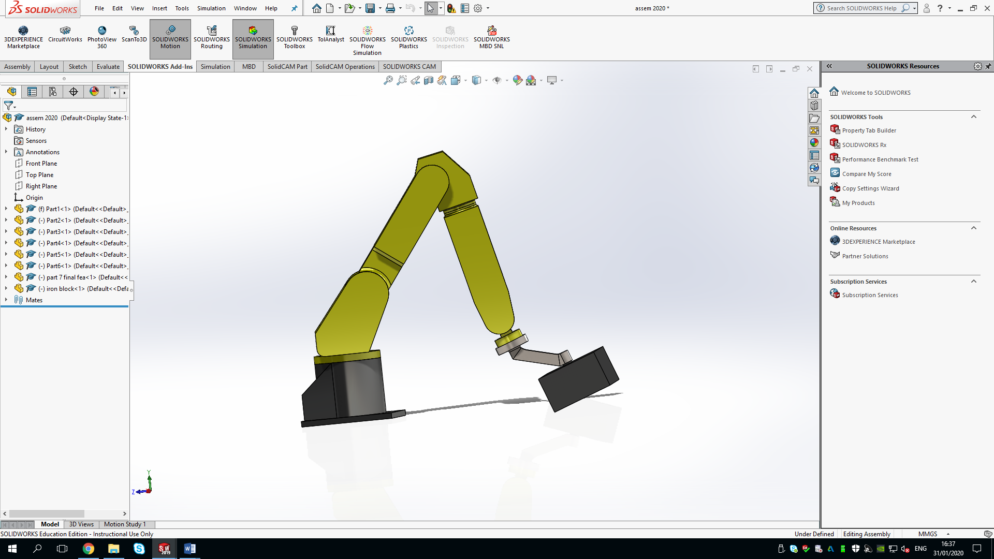
The parts for the robotic arm were made on solid works and then assembled. The arm can be seen in the figures below.
Figure 2
Figure 1

Figure 1 shows a good view of the assembled robotic arm in its starting position, the end connecting piece which picks up the load is made of stainless steel and can be seen close up in figure 2 picking up an iron block. This arm would be programmed to lift the work piece, which in this case is a block of iron, and place it elsewhere.

The iron block creates a force of 7N for the robot to lift, and remains the same through the different tests as a light, load to experiment on.

Motion study simulation.

A motion study was undertaken to simulate the movement of the robotic arm and to calculate stresses on selected components.

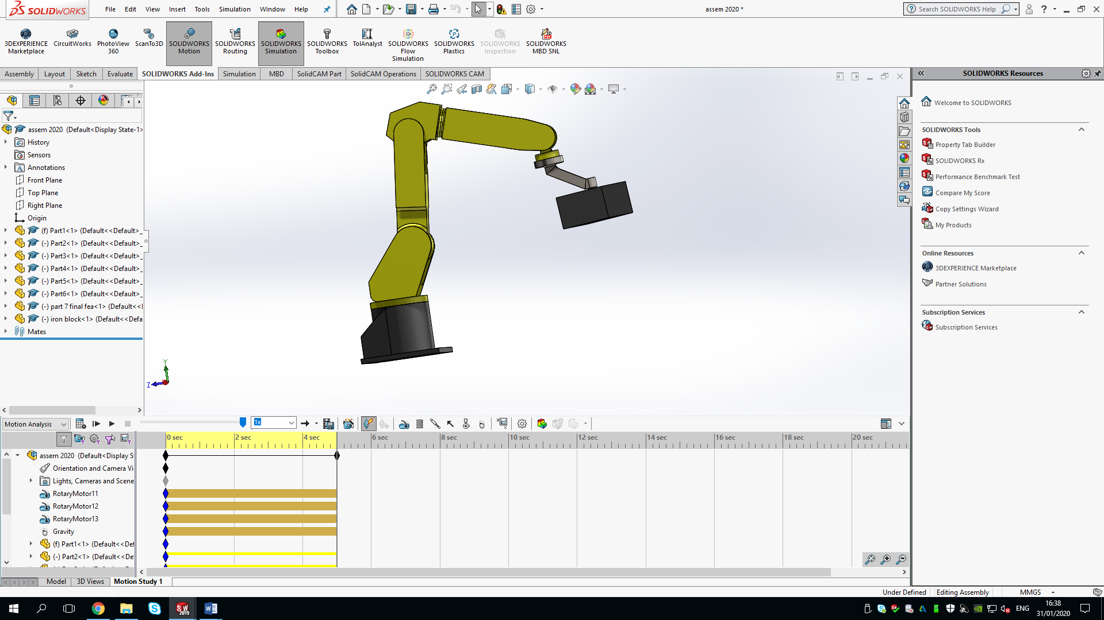
Figure 3 shows the extent of the motion study, with a duration of four seconds to lift the iron block from the starting position to the end position which is seen in this figure.
Figure 3
First the add-in solid works motion must be selected to enable motion analysis to be selected. Three motors were then added to the motion study. The motors were added to the three hinges at the end of each arm seen in figure 3. These motors are set to 1RPM and enable the arm to lift the weight off the. ground. Gravity is then also added for realistic results to be calculated when testing the stresses acting on the arm.

Initial FEA of the lifting arm

A finite element analysis was undertaken in order to understand the stresses acting on the arms lifting part and the displacement.
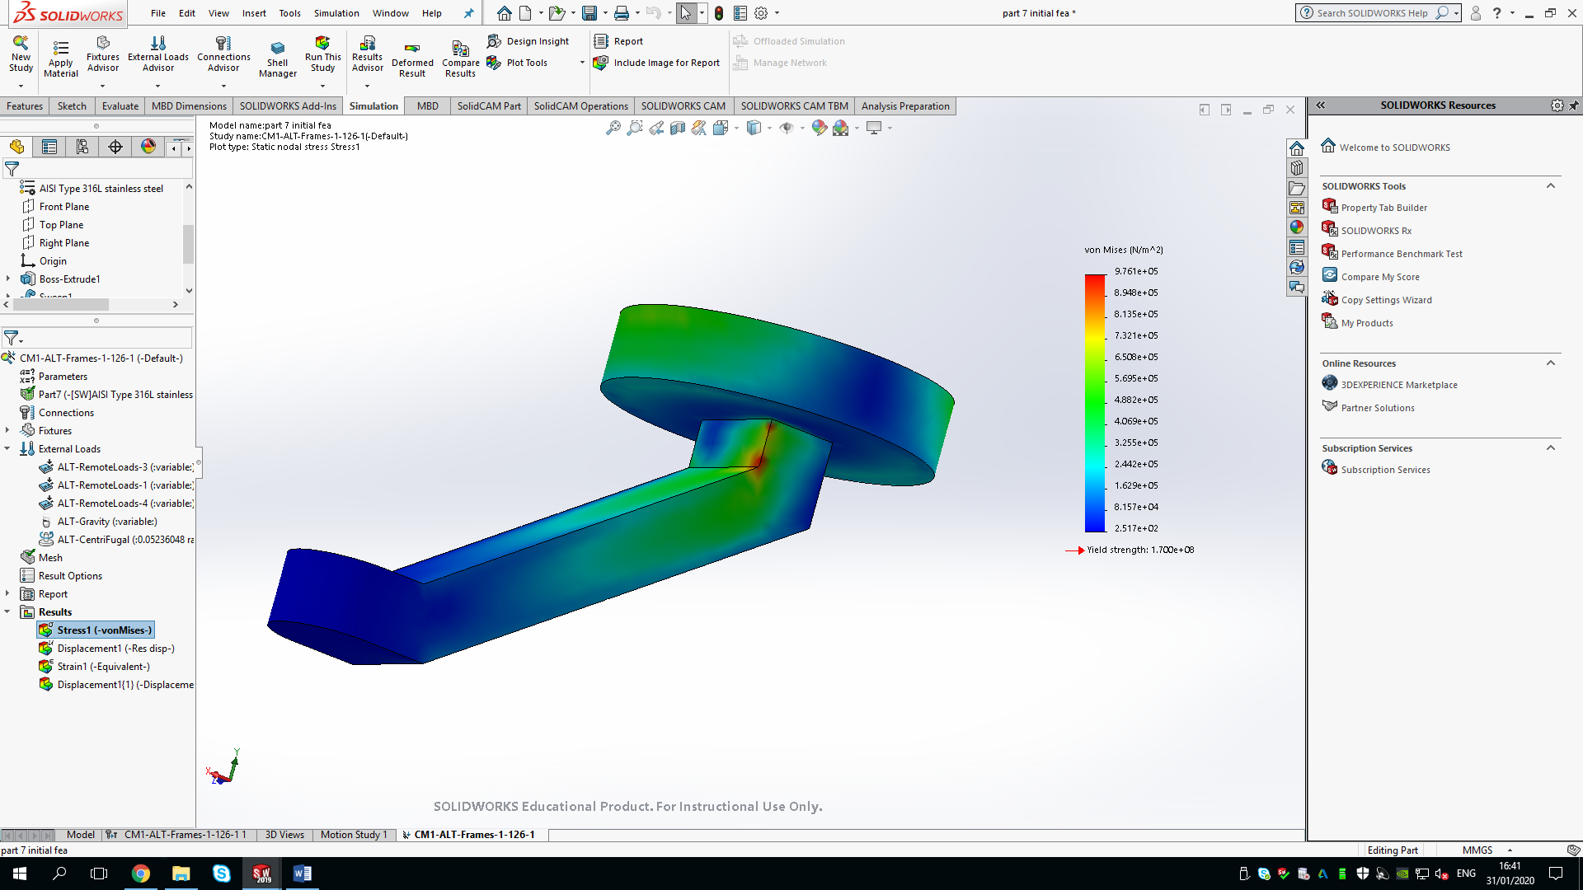
Figure 4

The results of the FEA show one area of slightly higher stressing in the part as seen in figure 4. The colours are shown in the key on the right which represent the amount of stress the part is undergoing, blue being very low and red being high.

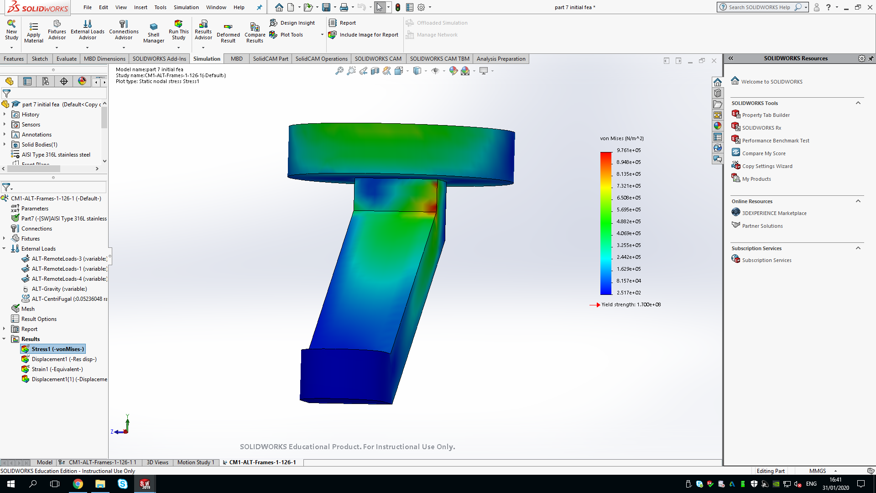
Figure 5

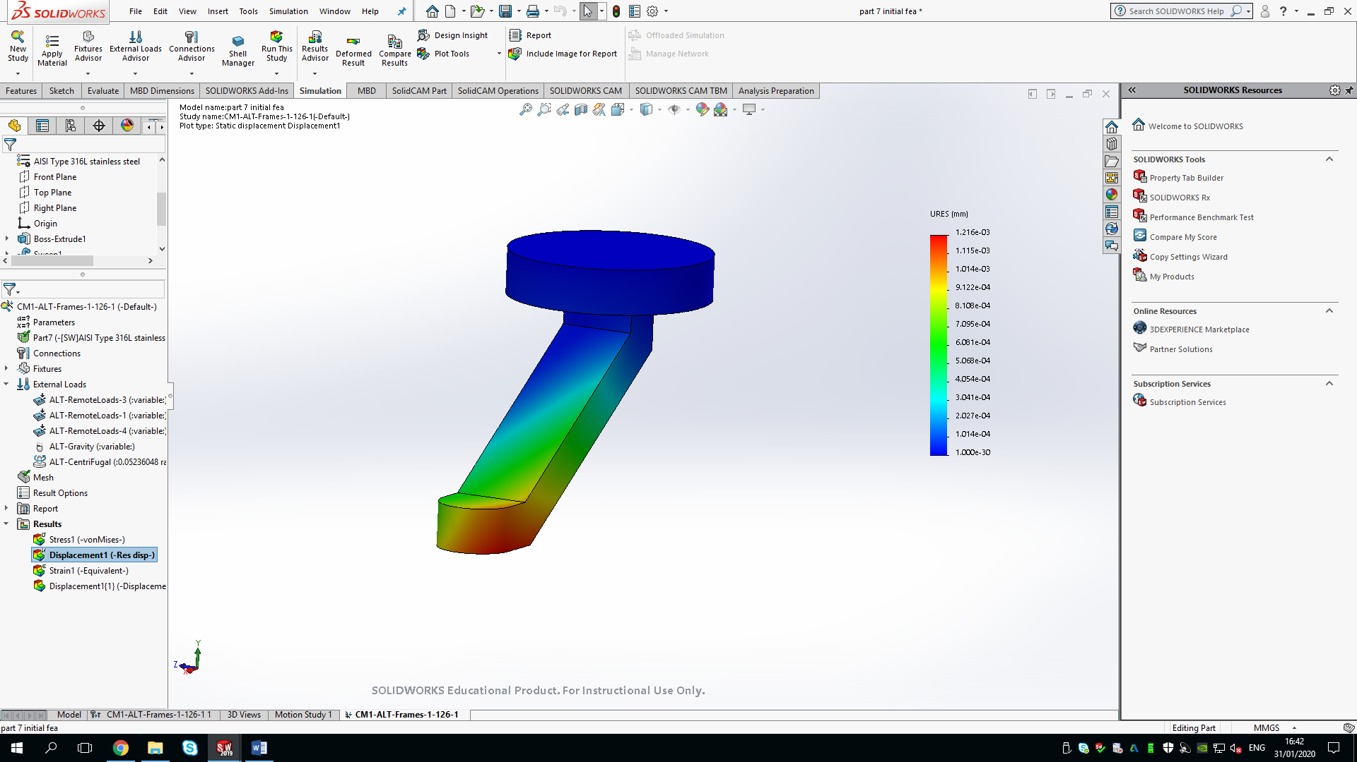
As seen in the colour bar on both figure 4 and 5, the red area shows a stress of 9.76x10^5 which is still very far under the vield strength of the part, which is 1.7x10^8, however it is still a point to improve on.
Figure 6

Figure 6 is a visual representation of the displacement of the part after undergoing the load. The same side as the weak spot in figure 5, there is a tiny displacement of 1.2x10^-3 mm which can be seen in the red area. Whilst this is a very small issue it is still something that can be improved on with a redesign.

Redesign FEA
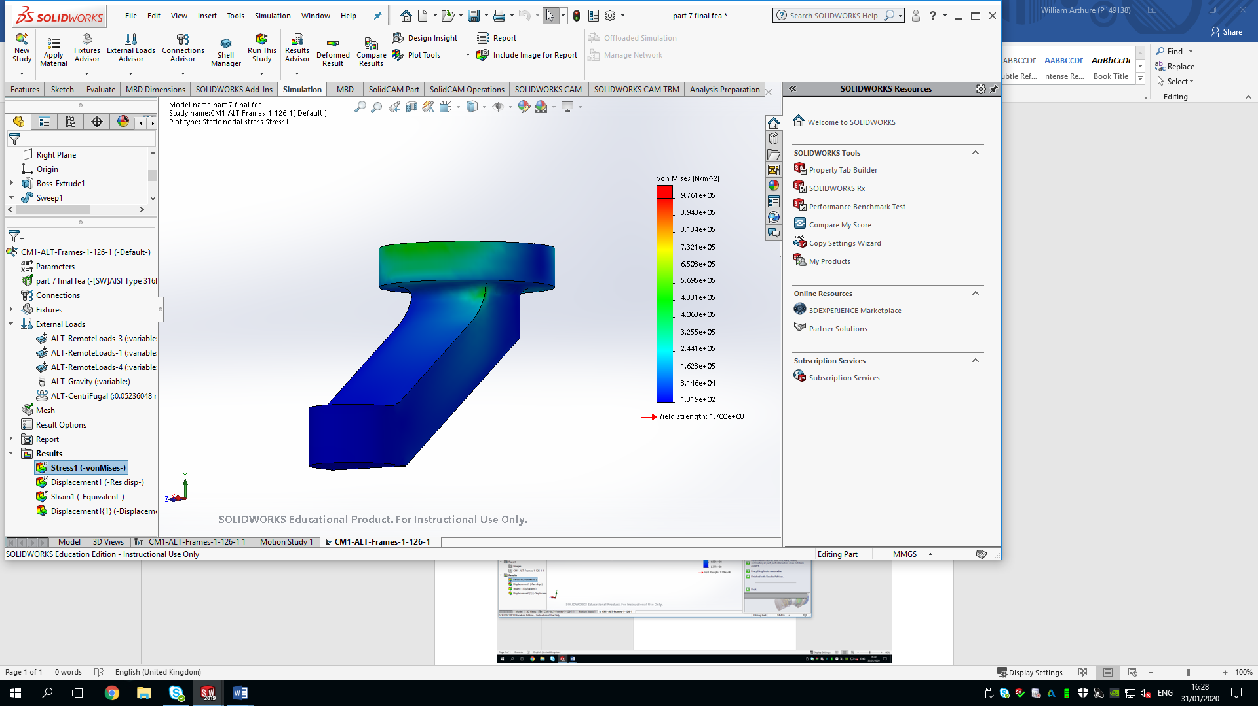
Figure 7
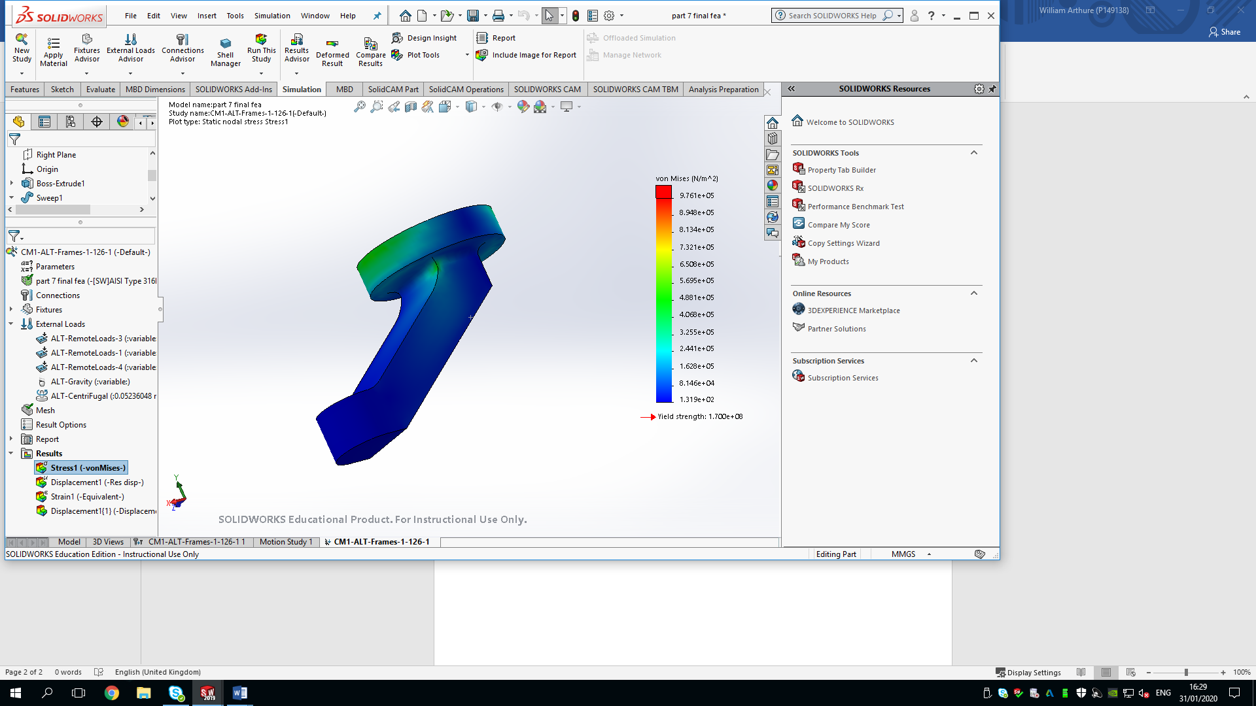
The part was re-designed using the information gained in the initial FEA to improve the strength properties in weak areas.
Figure 8

The re-design included adding 40 degree and 10 degree fillets around the weakened area in figure 4 and widening the shaft to add thickness but also strength.

As seen in figures 7 and 8, the redesigned part has much lower stresses acting on it and doesn’t reach over roughly 5x10^5 N/m^2. This is a significant improvement in strength.

The width of the shaft was increased by 15mm.

Topology optimisation
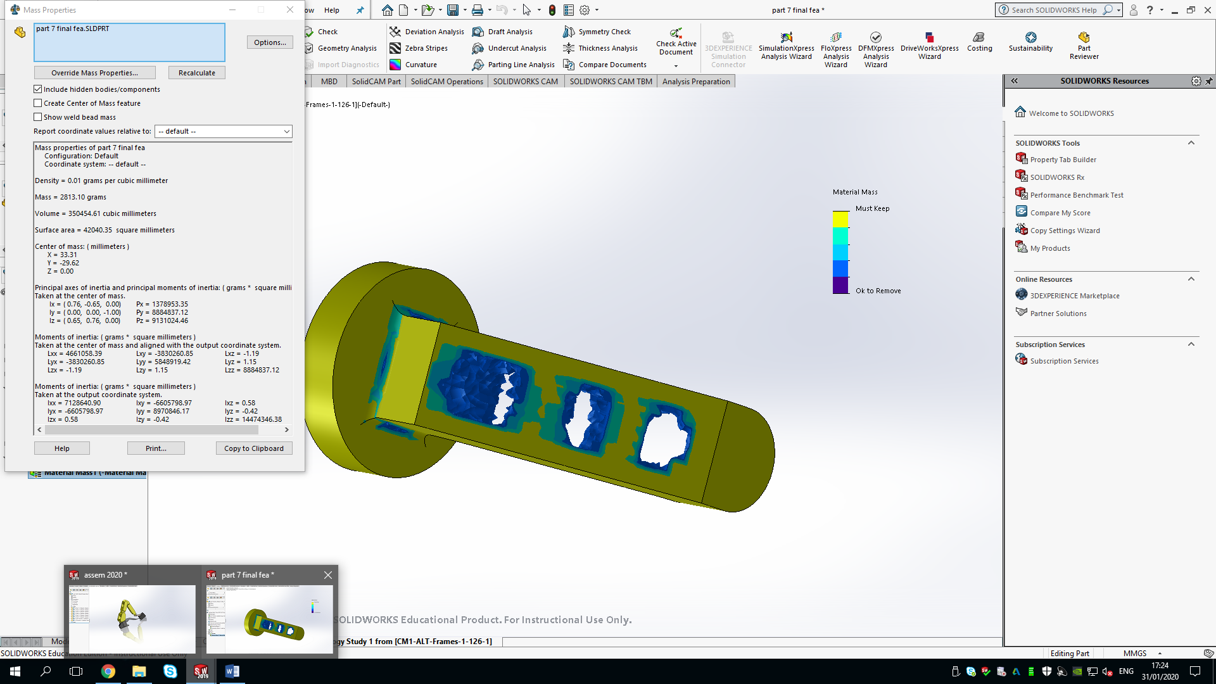
Figure 9
In the topology optimisation study, it can be seen that there are some areas that can be safely removed from the part without effecting its structural integrity.

The green areas of the part are areas that must be kept and blue or already hollowed out areas are okay to be removed.

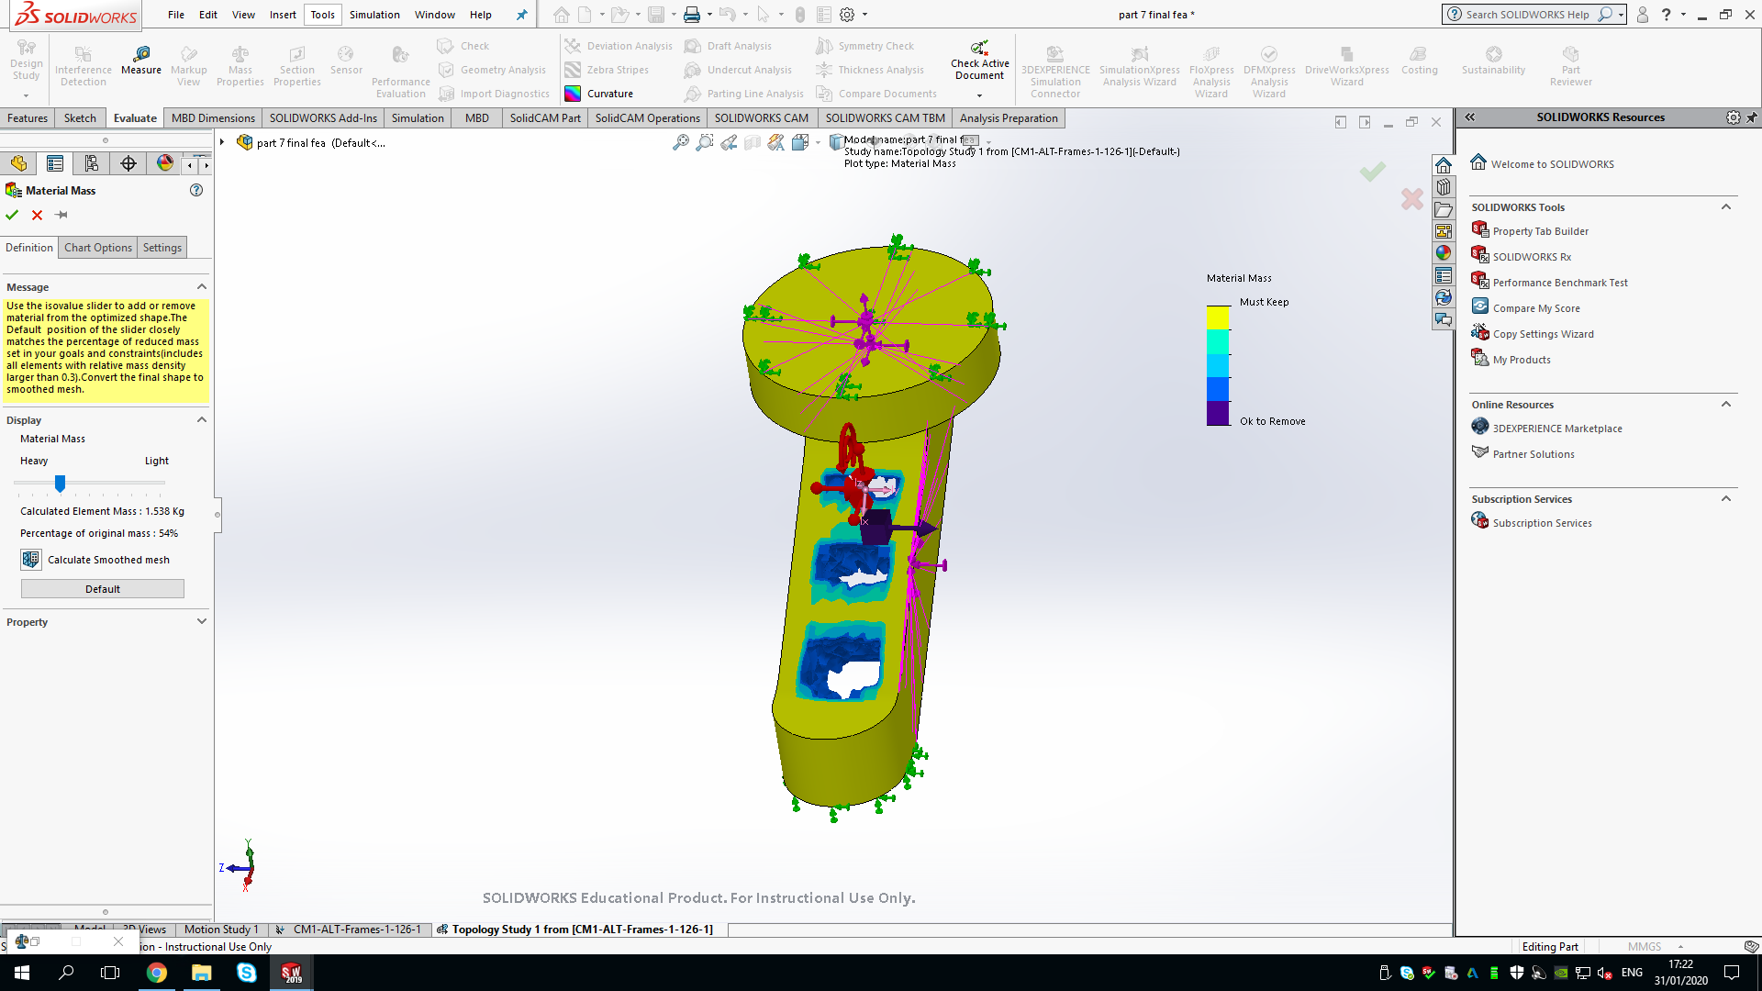
The value for mass before the optimisation can be seen in figure 9, where the mass is 2.81 kg.
Figure 10

Figure 10 however, shows that 46% of the mass of the part was able to be removed in the optimisation, as the part now has a mass of 1.53 kg.
This shows how effective a topology optimisation can be in improving the weight to strength ratio of a part.

The parts design can now be taken back a step in the design process and the areas of blue/hollow that can be seen in figure 10 can now be extrude cut out and the part can be redesigned. Another FEA can then be applied to the new part, which should show positive results in not having any areas of high stress.

Conclusion

To conclude the investigation of this report, the use of FEA and topology optimisation in designing parts before manufacture is beneficial to the company in several ways. From benefitting the design process in providing the ability to create numerous virtual prototypes and making small adjustments to them quickly, to the ability to save money on not having to build numerous prototypes for every alteration. These methods save companies money by reducing the building costs and also allow them to improve their products, making them lighter whilst maintaining their strength properties.

https://uowtsd-my.sharepoint.com/:f:/g/personal/warthure_149138_student_uwtsd_ac_uk/Elcb8X346c5JuvuD29maLW4B8icCw1OUjTiNwC3SBl8ftw?e=wYiFCF

